Dipping One's Toes; The Innovative Use of VoiceThread in Higher Education
Louis Martin and Dave Tapp
Staffordshire University
Corresponding Author: louis.martin@staffs.ac.uk

Abstract
This short reflective paper describes the innovative use of the asynchronous multimedia communication tool VoiceThread. Initially the authors provide an analysis of the growing use of this Web 2.0 cloud based tool for teaching undergraduate law students in Higher Education (HE). The paper then goes on to discuss some of the practical applications of embedding VoiceThread into virtual learning environments such as Blackboard. In conclusion, the authors explore some further opportunities for VoiceThread use.
Keywords: VoiceThread, asynchronous audio communication, asynchronous video communication, interaction, collaboration, Web 2.0.

Introduction
This short paper has two main themes: firstly to share the authors’ experience of their use of VoiceThread (VT) in teaching final year undergraduates studying an LLB (Hons) with Criminology; and secondly to explore how the use of VT can be introduced across the full range of levels and modules on the LLB (Hons) award. This paper serves as a reflective conduit for further more empirically based research in the future.
VoiceThread in HE Educating and Supporting learners
VT is a cloud based computer software package that aggregates a wide range of information from multiple online sources (Educause, 2009). This Web 2.0 technology is used by educators and learners to share images, text, video, drawing, and personal voice messages and responses (Atkinson and Burden, 2008; Holland, 2010). With VT, educators and learners have access to an innovative learning platform that utilises visual and auditory narratives. As VT is a cloud application there is no software to install, however the system requires an up-to-date version of Adobe Flash (Pacansky-Brock, 2011).
Holland (2010), a professor of teaching, leadership, instructional design and technology, provided a detailed analysis of the five ways to post individual or group comments on VT. Users can select a number of options including microphone, telephone, text, audio file (MP3/WAV), or webcam (Smithand Dobson, 2009; Holland, 2010; Koricich, 2013) and upload Adobe PDF, Microsoft Word, Excel, PowerPoint, images, or imported images from Flickr, Facebook, or the web, copyright permitting. VT also has a doodling feature that allows a user to draw or make notes on top of the media as comments are recorded.
The authors teach on the LLB with Criminology at a ‘Post 1992 University’ in the West Midlands. Following the University’s promotion of Technology Enhanced Learning, the use of VT technology was demonstrated to academic staff. Turner and Erskine (2015) discussed how the use of VT can enhance accessibility, enable a variety of learning approaches, offer increased flexibility, support collaboration and communication and encourage the development of skills for a digital age (Wood et al., 2013). Turner and Erskine (2015) adopted a ‘flipped classroom’ approach on a Sport and Performance Psychology third year module. These authors replaced a 50 minute lecture with 2-3 short video lectures (VLs) and utilised a two hour seminar. Turner and Erskine (2015) highlighted the importance of academics adapting to the contemporary student experience, notably catering for early starts for students with caring commitments, parking, illness, difficulty with attendance for part-time working learners who have to pay for education. Turner and Erskine (2015) found that their students reported that VT lectures were enjoyable, beneficial and flexible. Koricich (2013) described how learners were able to create, upload, and narrate their work, and then share the VT with their classmates and instructor in a presentation assessment. He argued that it was far more convenient to arrange and grade presentation based assessments using VT in this way.
A literature review reveals a significant gap in the scholarly research specifically focused on the pedagogical use of VT in Higher Education (Chan and Pallapu, 2012; Johnson, 2013; Pacansky-Brock, 2015). Much of the literature provides more of a descriptive analysis (Brunvand and Byr, 2011; Educause, 2009; Koricich, 2013) and talks about the potentialities of Web 2.0 cloud based technologies.
However, Chan and Pallapu (2012), academics based in the USA, carried out a small scale mixed methods study. These authors explored the use of VT with undergraduate learners enrolled on a Business Award. Learners participated in a VT exercise consisting of an exam review followed by a survey on the use of VT. Of the 22 participants (from a class of 61 graduating seniors), 64% specified they would like to use VT for future learning activities, and 73% indicated they would recommend VT to peers for the purpose of delivering presentations. Chan and Pallapu (2012) found that the use of VT was effective in achieving Chickering and Gamson's (1987) ‘Seven Principles for Good Practice in Undergraduate Education’. They concluded that VT was clearly a promising tool that lends itself to a range of learning activities. Nevertheless, their study was somewhat limited in the sense that it dealt with a very small sample, moreover their research paradigm appeared to be broad based and would have benefited by being far more specific in terms of their ontological and epistemological position.
Carvin (2008), acclaimed journalist and author, blogged about the advantages of VT, then in its early stage of development. He argued that PowerPoint, Keynote or other presentation tools have the potential of being quote ‘dreadfully boring’. He warned that by simply uploading them for others to view the learner is left to put the pieces together solely based on the slides themselves. Taken together it could be concluded that the literature is limited to a small number of studies in the USA. Based on this, the authors sought to further explore the potential for this innovation to be used in UK HEIs.
The Use of VoiceThread on the LLB Award
The authors of this paper decided to upload the lecturers for a criminal justice final year module on to VT and then embed the accompanying PowerPoint presentation into the modules Blackboard VLE site.
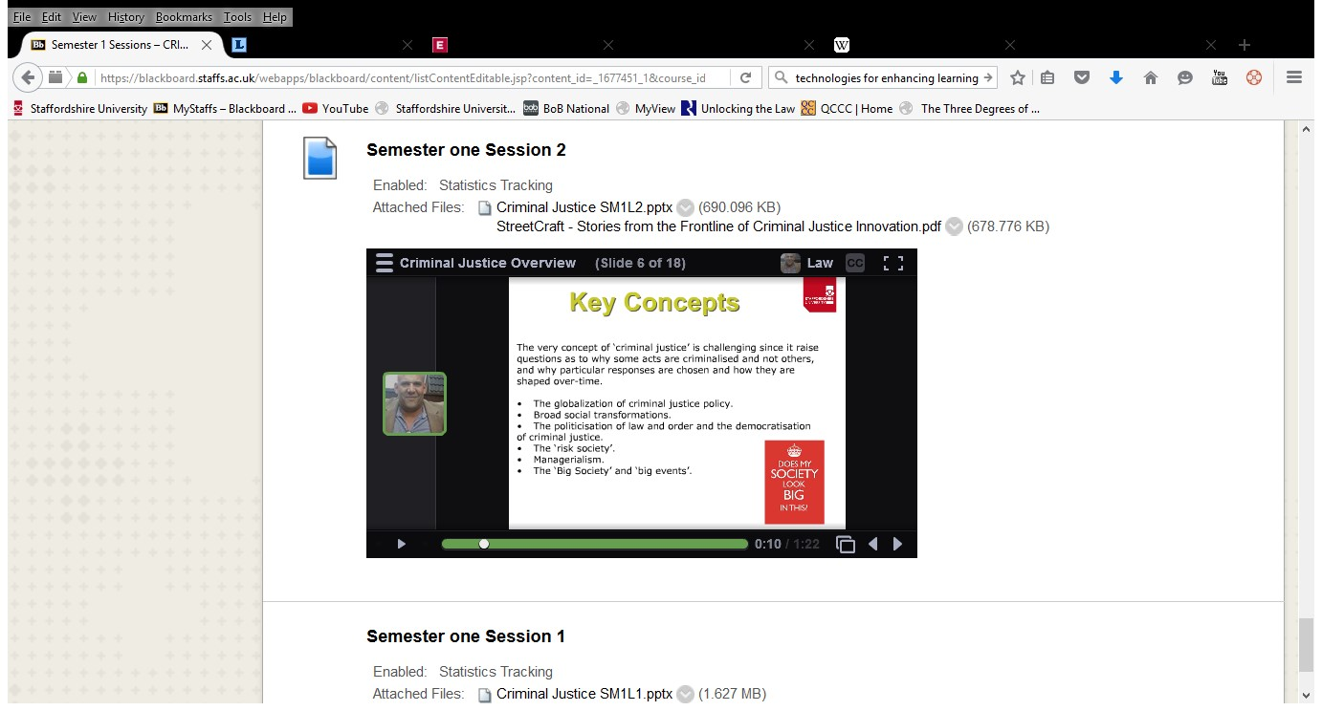
Figure one. A screenshot of a VT lecture uploaded onto Blackboard. (2016)
Figure one above shows a screenshot of a PowerPoint lecture for the criminal justice module. The PowerPoint was initially uploaded on to VT; the author then provided a commentary in a similar manner to a traditional lecture using the podcast facility. The completed package was embedded into Blackboard on the module. Students were then able to watch the presentation and listen to the commentary. Once embedded the session is stored in the VT cloud and can be accessed again as required by the learner. At this stage the learner acts as a passive recipient of the material and is not required to post comments or contribute on VT (Rodesiler, 2010).
The authors also used VT to set problem based questions, attaching required reading in the form of PDFs to seminars and tutorials, and webcam guidance for assessments, where a straightforward piece to camera explaining in detail the requirements of a summative assessment were uploaded. The learners were able to go back and watch or listen to the guidance as many times as they felt necessary. Wakeman (2013, p.3) cited McGovern (2010) reaffirming that learners must be able to learn when it is convenient to them, in a location of their choosing, and more importantly, at a pace that suits their level of absorption or cognitive action.
A noticeable limitation to the authors’ current practice revolved around the lack of commenting by learners. The ‘commenting’ element of VT is crucial as the whole point of the learning package revolves around the ability to use options such as microphone, webcam and audio-file upload. However the learners had the opportunity to burn a DVD, downloading to an MP3 player or other mobile device and this was particularly useful to learners who were visually impaired. VT allows complete security control from private to public, with a default to private (Pacansky-Brock, 2011). In this case only learners on the module got access to the materials.
Conclusion
In essence this short paper provides a flavour of how the authors have ‘dipped their toes’ in the Web 2.0 milieu. The potential for VT in Higher Education is significant. In the USA, VT integrates with the Blackboard and Moodle environments as a single-sign-on tool (Bolkan, 2015). In the future educators and learners at the authors’ institution should be able to sign in to their VLE account, navigate to a course, click on the VT link and use VT without the need to set up individual accounts. All staff should have at least have access to a VT account and receive training and support. This paper argues that VT can be used effectively to support learners by providing a bank of learning materials and by reducing missed opportunities. As discussed earlier, the 21st century learner has to combine study with significant demands on their time. It is reasonable to expect that HEIs and educators make effective and innovative use of the available technology to enhance the learning experience as much as possible. The authors plan to increase the use of VT extensively in the support of teaching and learning on the LLB with Criminology for the next academic year 2016/17. There is a dearth of academic literature relating to the use of VT in the UK and the authors plan to undertake further research to explore the effectiveness of this particular piece of technology.
References
Atkinson, S. and Burden, K. (2008) Evaluating pedagogical affordances of media sharing Web 2.0 technologies: A case study. 25th annual ASCILITE conference, 2008 (Melbourne, Australia) Available [Online] from http://hull.academia.edu/KevinBurden/Papers/73672/Evaluating_pedagogical_affordances_of_media_sharing_Web_2.0_technologies_A_case_study[Accessed 25 March 2016]
Bolkan, J. (2015) Blackboard Beefs up Discussion Tools with VoiceThread. Available [Online from https://thejournal.com/articles/2015/12/07/blackboard-enhances-discussion-tools-with-voicethread.aspx [Accessed 26 March 2016]
Brunvand, S., & Byrd, S. (2011). Using VoiceThread to promote learning engagement and success for all students. Teaching Exceptional Children, 43(4), 28-37. Available [Online] from http://www.voicethread.com/media/misc/support/JTECVoiceThread.pdf [Accessed 26 March 2016]
Carvin, A. (2008). SlideShare and VoiceThread: Not your father's film strip [Online] Available from http://edisontechforteachersspring2008.pbworks.com/w/page/18557286/SlideShare%20and%20VoiceThread [Accessed March 26 2016]
Chan, M. and Pallapu, P. (2012) An Exploratory Study on the Use of VoiceThread in a Business Policy Course Journal of Online Learning and Teaching Vol. 8, No. 3 Available [Online] from http://jolt.merlot.org/vol8no3/chan_0912.htm [Accessed 25 March 2016]
Chickering, A. W., and Gamson, Z. F. (1987). Seven principles for good practice in undergraduate education. AAHE Bulletin, 39(7), 3-7. [Online] Available from http://sphweb.bumc.bu.edu/otlt/teachingLibrary/Technology/seven_principles.pdf [Accessed 26 March 2016]
EDUCAUSE Learning Initiative. (2009). 7 things you should know about VoiceThread. [Online] Available from http://net.educause.edu/ir/library/pdf/ELI7050.pdf [Accessed 25 March 2016]
Holland, J. (2010) Inspiring Active Learning with VoiceThread Technology International Journal of Instructional Technology and Distance Learning Vol. 7. No. 4. Available [Online] from http://www.itdl.org/Journal/Apr_10/article02.htm [Accessed 25 March 2016]

Koricich, A. (2013). Technology review: Multimedia discussions through VoiceThread. Community College Enterprise, 19(1), 76. Available [Online] from http://crawl.prod.proquest.com.s3.amazonaws.com/fpcache/482658dd1ddc0b370c1a3c4c2965f9b3.pdf?AWSAccessKeyId=AKIAJF7V7KNV2KKY2NUQ&Expires=1459164069&Signature=FFwsf8mwz7XmC%2Fwe4nd87OR6I5I%3D [Accessed 25 March 2016]
Johnson, J. M. (2013) Facilitating a Structured Controversy Using VoiceThread. Journal of Nursing Education, 52(12), pp. 720. Available [Online] from http://jolt.merlot.org/vol8no3/chan_0912.htm [Accessed 25 March 2016]
McCormack, V. (2010). Increasing teacher candidate responses through the application of VoiceThread. International Journal of Arts and Sciences, 3(11), 160-165. Retrieved from http://www.openaccesslibrary.org/images/RLN147_Virginia_McCormack.pdf
Pacansky-Brock, M. (2011). How and why to flip your classroom with VoiceThread Available [Online] from https://vimeo.com/30876127 [Accessed 25 March 2016]
Pacansky-Brock, M. (2015) Evaluating the effects of an ebook to support faculty who teach with VoiceThread: An action research study [Online] Available from http://gradworks.umi.com/37/18/3718013.html [Accessed 26 March 2016]
Rodesiler, L., (2010) Teaching Media: Voices in Action: The Potential of VoiceThread in the Media Classroom. Screen Education, (59), pp. 72-74.
Smith, J. and Dobson, E. (2009) Beyond the Book: Using VoiceThread in Language Arts Instruction. In T. Bastiaens, J. Dron & C. Xin (Eds.), Proceedings of E-Learn: World Conference on E-Learning in Corporate, Government, Healthcare, and Higher Education 2009 (pp. 712-715). Chesapeake, VA: Association for the Advancement of Computing in Education (AACE). Retrieved March 25, 2016 from https://www.learntechlib.org/p/32538
Turner, M. and Erskine, J. (2015) Fully integrating video lectures into undergraduate teaching. Technology Enhanced Learning: Staffordshire University Showcase 2015 Available [Online] Available from http://blogs.staffs.ac.uk/tel/2015/05/06/technology-enhanced-learning-staffordshire-university-showcase-2015/ [Accessed 26 March 2016]
Wakeman, C. (2013) The Innovative Use of Screencasts in Higher Education Innovative Practice in Higher Education Vol.1 (3) April 2013 Available [Online] from journals.staffs.ac.uk/index.php/ipihe/article/download/34/75 [Accessed 24 March 2016]
Wood, K. Stover, K. and Kissel, B. (2013) Using digital VoiceThreads to promote 21st century learning Middle School Journal. Vol. 44 Issue 4, p58-64. Available [Online] http://www.tandfonline.com/doi/pdf/10.1080/00940771.2013.11461865? [Accessed 25 March 2016]

