Reimagining reflective practice in the dance technique class

Rachel S. Rimmer

Manchester Metropolitan University

Corresponding author: r.s.rimmer@mmu.ac.uk

Abstract
This paper investigates the potential to challenge pedagogical approaches that may reinforce a teacher-student hierarchy in the dance technique class. With the aim of creating more opportunities for dance technique students to engage with critical reflective thinking and develop their sense of autonomy, the researcher will share the findings of two pedagogical interventions. These interventions were conducted with first year dance technique students at a UK higher education institution. In an attempt to stimulate critical reflective thinking on both the students’ and teacher’s behalf, a range of student-centered learning and teaching approaches were explored. The implications of such approaches will be examined, and the responsibility and expectations of dance students will be considered. Furthermore, consideration will be given to the way in which such approaches might test the dance technique teacher’s own sense of responsibility, challenging them to test the boundaries of their authority. Constructivist educational perspectives and theories of critical reflective practice inform this research.

Key words
Dance technique, pedagogy, critical reflective practice, peer learning, student-centred learning, constructivism.

Background to the study
As a Lecturer in contemporary dance at a UK higher education institution, for some time now I have been reflecting on the way that I teach dance technique to undergraduate students. Traditionally, dance technique classes have, and continue to be a core aspect of a dancer’s training and career. To offer a visual image, typically, one might imagine an expert teacher delivering a series of dance sequences to a class of students, usually in a mirrored studio and with music. Classes normally last around an hour and a half and aim to refine movement skills that are specific to dance: for example, shifting weight, jumping or turning, with the intention of transferring these skills into the domain of dance performance. Stevens (2006) describes the dance technique class as “studio practice primarily designed to enable learners to develop skills in execution and performance (rather than in choreography or dance composition)” (online).

The pedagogy of dance technique classes has undergone discussion in several educational and professional dance contexts (Smith, 1998, Fortin, 1988, Stevens, 2006, Dyer, 2009 & 2010, Stanton, 2011 amongst others). This ongoing discourse is also part of a wider discussion concerning the very notion of ‘dance technique’. Ideas about the definition of ‘dance technique’ in the 21st century mean that it is now a rather loaded and ambiguous term. As dance has evolved as an art form, so have ideas about training the dancing body and consequently, in some educational contexts, the notion of ‘dance technique’ and the formality that it implies is thought to be a somewhat out-dated concept. A full exploration of these ideas is beyond the remit of this paper, although it is important to have a sense of the context from which this research emerges.

Nevertheless, dance technique still remains a core area of study across many Western dance degree programmes. Perhaps now more than ever, dance educators and academics seem increasingly interested in exploring methods for challenging the traditional teacher-student hierarchy that appears to have been perpetuated from one dance generation to the next. Teacher-researchers are interested in creating student-centred learning environments that allow reflective practice to emerge, enabling student dance artists to develop a sense of autonomy (Stevens, 2006: online). Stock (2004) proposes that dance teachers should attempt to create “a learning environment in the studio where students can consciously, actively and effectively apply anatomical knowledge, reflective/motivational skills and theoretical understandings to their dancing” (Pg. 5-6).

The aim of this paper therefore is to make a contribution to this discourse by sharing the findings of two pedagogical interventions that I conducted in a first year dance technique class at a UK higher education institution in Spring 2014. This research is informed by constructivist learning perspectives and theories of reflective practice, and draws on the work of Marlowe and Page (1998), Moon (2004) and Ryan (2015) amongst others. According to Ryan (2015) reflective practice can operate on a range of levels, but in its broadest sense reflective practice includes two key elements; “(1) making sense of experience; and importantly, (2) reimagining future experience.” (Pg. 15) To reach the reimagining stage, she suggests that the learner needs to go beyond personal reflection in order to engage with deeper, more critical levels of reflection that would be associated with academic or professional settings (2015). She states:

Thus, academic or professional reflection involves learners making sense of their experiences in a range of ways by: understanding the context of learning and the particular issues that may arise; understanding their own contribution to that context, including past experiences, values/philosophies and knowledge (Ryan, 2015: Pg. 16)

Ryan states that different forms of knowledge, including those listed above should be used to ‘re-imagine and ultimately improve future experience’ (ibid). In an attempt to address the reimagining stage of Ryan’s reflective model, I invited four members of my class to contribute to a group discussion once the unit had concluded. Moon (2004) suggests that reflection is both an individual and a social process. Thus, through engaging with this discussion, the students were able to begin sharing their experiences of participating in the pedagogical tasks and to reflect on what this revealed about themselves as learners. Although the level of critical reflection was quite minimal at this stage, the students still shared some interesting personal insights that could potentially stimulate deeper, more critical, or even transformative reflection in the future, possibly reimagining their own responsibility as learners of dance technique.

As I was interested in allowing the students to direct this discussion, I adopted a facilitatory role, beginning by simply asking them how they had found the tasks. I used a note-taking method to record their comments and responses to each other and interjected when appropriate. In an attempt to maintain a reflexive position in relation to the data collected, I have endeavoured to convey fairly the range of responses in the feedback from the students by sharing a variety of different perspectives. For ethical reasons, any student comments shared in this paper will be done so using pseudonyms to protect each individual’s anonymity. I also share my findings as a teacher-researcher, drawing from my own observations and reflections.

How do I teach? What am I teaching?
Probably like most teachers in the early stages of their career, I have tended to teach dance technique in the way I was taught as a student, or what Lortie (1975) would refer to as the “apprenticeship of observation”, meaning replicating the examples provided by our own teachers. Typically, my approach has involved devising a series of movement sequences that I perceive as appropriate for the level of study. Each sequence explores specific technical principles that draw from a range of classical, modern and post-modern movement concepts and again, this is reflective of my own training, drawing on my experiences as a dance student and performer. Together with quite detailed verbal instructions, I will demonstrate these sequences to the group standing in front of me, with the assumption that learners will be able to make sense of the movement from my body, within their own bodies.

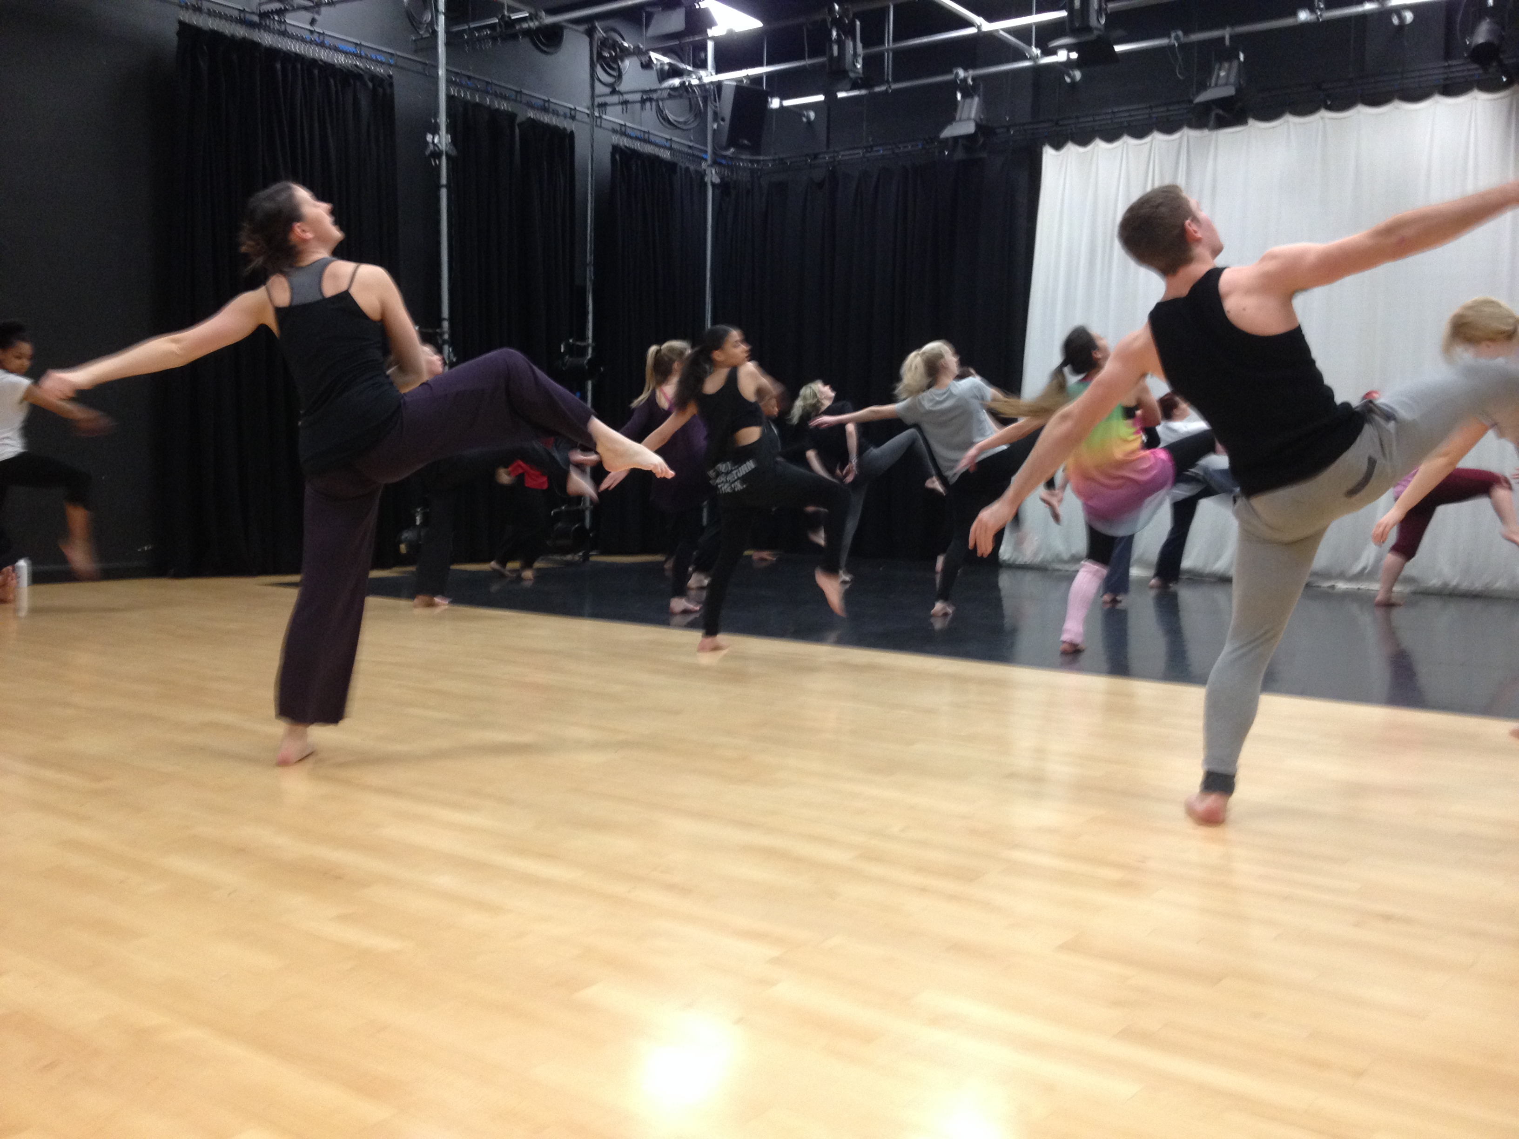

Figure 1. A typical example of me teaching a technique sequence to a group of first year dance students.

About a year ago I had an experience while teaching an extended sequence to a group of first years. This sequence required the students to explore a range of movement concepts, and concluded with a jump that involved flicking the legs behind the body, and pulling the arms backwards in a slapping action.

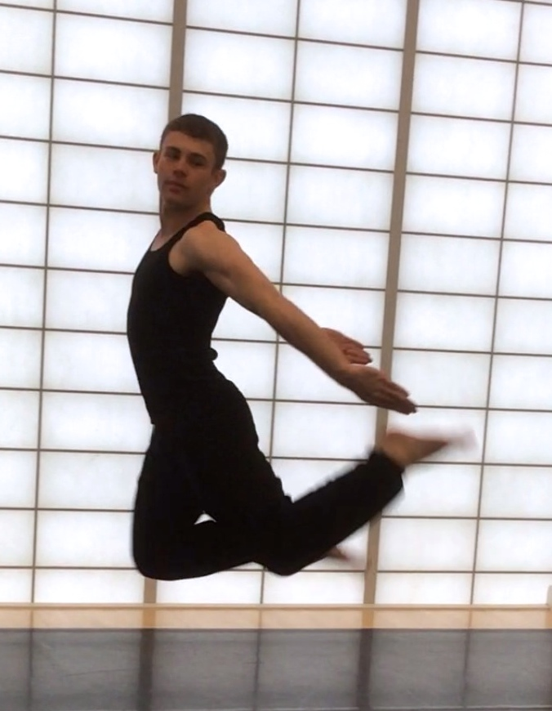

Figure 2. ‘Flicking legs’ jump demonstrated by Manchester Metropolitan University Dance student, Bryn Owen.

After demonstrating the jump several times, one student asked me if the arms in fact went forward, over the head in a circular motion, as opposed to back.

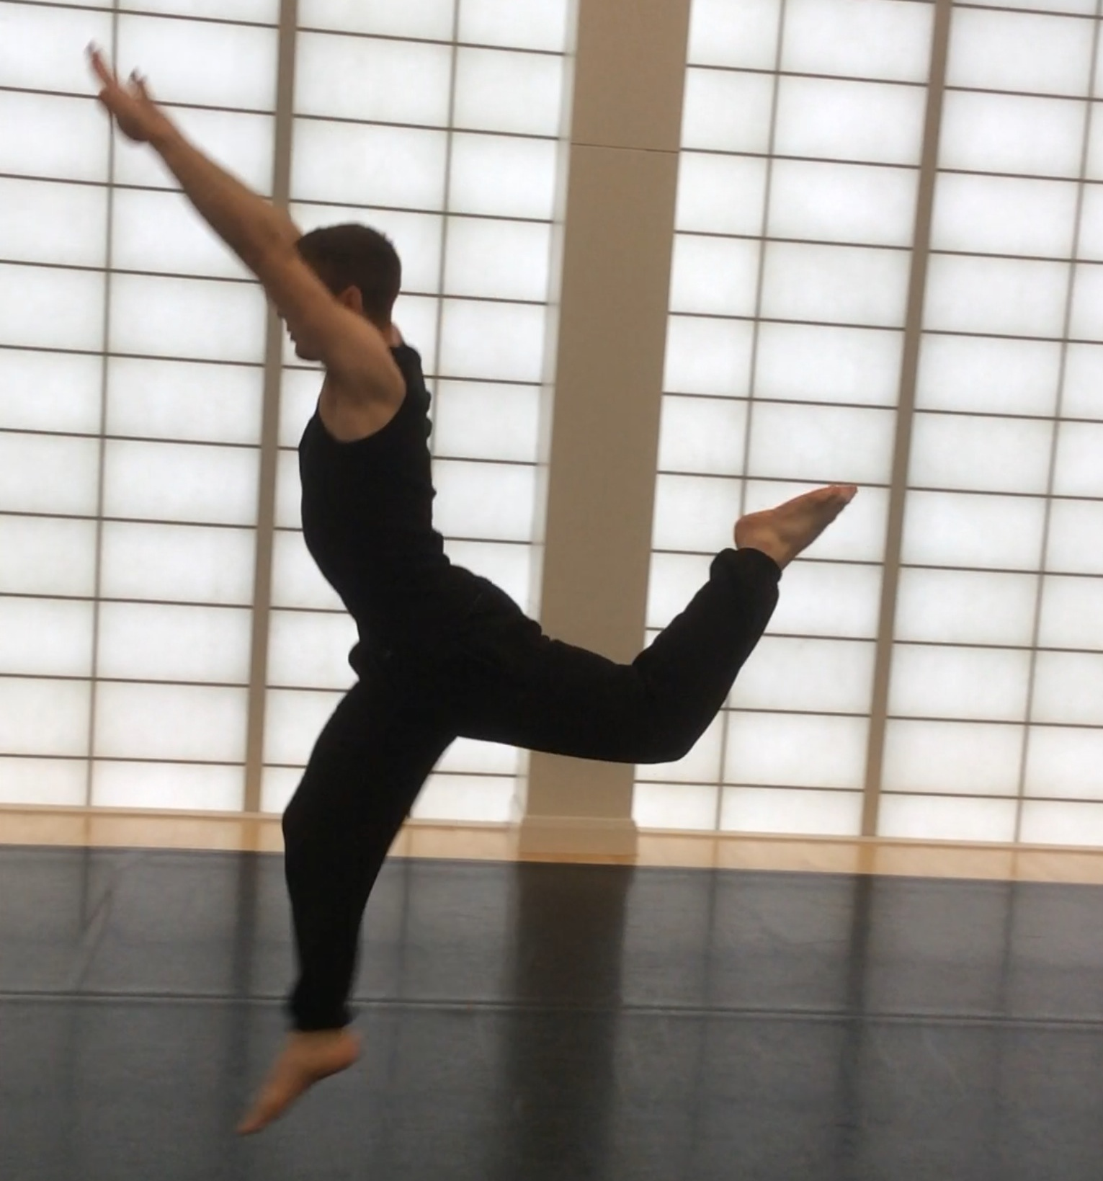

Figure 3. An example of the ‘flicking legs’ jump variation.

In stopping to think about the question, I wondered, had I ever demonstrated it in this way? What if I had? Would I appear incompetent if I changed it now? It was at this moment that I realised exactly how influential my demonstrations were, and just how much this student was relying on me to provide a definitive answer, a ‘right way’ to perform the movement. For some reason, I chose to resist the pressure from the student to do this and my response to her was, “you choose”.

Surprising myself with my response, I recognised the impact of my open-ended answer. Since the technique class is a place where traditionally there are perceived ‘rights’ and ‘wrongs’, ‘corrects’ and ‘in-corrects’, the student looked back at me rather puzzled, as she arrived at the realisation that I trusted her to make her own choice.

Furthermore, I suggested that students might want to play with creating their own version of the jump. While many of them tried this, another student became very anxious about this idea, stating that he did not feel comfortable with this task, as he did not know any other “types of jumps”. This student’s resistance towards playing was interesting to me. Had this been a choreography session, I have no doubt that he would have approached the task without hesitation, but since the session fell under the label of ‘technique’, the idea of offering a creative contribution in this context seemed incongruous. Was he afraid of creating the ‘wrong’ jump? Had I, without realising, implied that only certain ‘types of jumps’ were acceptable? Whatever this student’s anxieties were, it became clear that in this context, he wanted me to provide the material for him, and he was not comfortable with providing material for himself.

This situation exemplified many of the questions and concerns that I had been contemplating for some time. Being a Lecturer on a programme that promotes an ethos of ‘the thinking dancer’, I started to ask myself; what types of thinking am I expecting students to engage with? If critical reflective thinking is what I am trying to encourage, then where and how in the technique class am I facilitating it? Although the frequently used rote method of teacher demonstration, student replication and repetition clearly engages the student in a complex motor learning process, does this model always allow space for reflection? As Stanton (2011) states:

The aesthetic goals for dance technique are not achieved through mindless repetition. Neither is this repetition intended to produce an exact replication of movements; since individual dancers will each be working with different ‘equipment’, the results of the movement are not intended to be the same. (Pg. 89)

With this in mind, it is useful to consider whether over-use of direct rote methods unintentionally establishes a hierarchy between the teacher and student that reinforces the notion that there is only on ‘right’ way.

When debating this issue, Stanton (ibid) proposes the idea of a dance technique “laboratory” where students are encouraged to explore their technique work through a process of trial and error. In this space, the student becomes responsible for leading their learning experience, while the teacher adopts a facilitatory role. Recognising the tension between this explorative approach and other more direct approaches, she states:
In entering this domain, I realise that a delicate balance is in operation: in pursuing learner autonomy, care needs to be taken not to dismiss the effectiveness of observing an expert. (Ibid: Pg.87)

It could be argued that observing an expert teacher is one of the most effective methods for learning dance, particularly the technical aspects. However, is it possible for this method to successfully co-exist alongside other more experimental approaches? Råman (2009) poses the central question here, “can technical skills be effectively acquired through the use of student-centred learning and teaching approaches?” (Pg.76)

In exploring this idea, it is important to consider student expectations of what they believe a dance technique class should entail. Those who have a substantial amount of previous dance experience are likely to have different expectations to those with less experience. Nevertheless, all students will arrive at University with their own ideas of how a technique class operates, and these ideas will be shaped by their prior experiences. Disrupting the traditional teacher-led culture of the technique class in favour of less authoritarian approaches could have a substantial impact on the way students perceive their own role, and the role of the teacher, and this impact may not always be positive. In pedagogical research conducted by Dyer (2010), students were given opportunities to influence the content and direction of the technique class.

They were encouraged to give feedback to their peers and to play a more active role in the feedback they received from the teacher in order to emphasise that they were not “merely ‘passive consumers’” (Dyer, 2010: Pg.123) of the teacher’s knowledge. Dyer’s data revealed that a number of her students deemed this “Freedom of learning and the responsibilities that came with this freedom” as “a burden and a sign the teacher was not working hard enough” (ibid).

In challenging students to reconsider their responsibility in the technique class, teachers of dance technique must also be willing to do the same. As I engage in my own reflective practice, I need to consider how testing the parameters of my authority impacts on my own sense of responsibility. For example, if I choose a more democratic approach, does this destabilise my sense of authority at all? What are the assumptions I am making about how the students expect me to behave as their teacher, and are my assumptions accurate? What are my expectations and perceptions of myself? Again, a full exploration of these questions goes beyond the remit of this paper, but they are ideas I am continually grappling with.

Facilitating opportunities for choice and creative input
Following the incident with the jump, I became curious about exploring this notion of choice further. Through my apprenticeship of observation, I had always assumed that the teacher must provide all the dance technique class material, but would there be any benefit for students if I could develop strategies that would enable them to create some of the material themselves?

To explore this idea further, in the Spring term of 2014, I conducted two pedagogical interventions with the same group of students referred to earlier. In this section of the paper, I will be discussing the outcomes of these two interventions in more detail.

On both occasions, the students were asked to engage with tasks that involved movement analysis and creative input; one task had quite specific instructions, while the other was more open-ended. At the end of the unit, I facilitated a group discussion with four students from the unit in order to gain an insight into their responses to the tasks.

This research was conducted in a unit that involves three integrated assessed elements. These are dance technique ability, performance skills, and written critical analysis skills. The dance technique element of the unit is worth 25% of the overall unit mark, and the learning outcome and assessment criteria for this element states the following:

Learning outcome:

- Demonstrate knowledge of the principles of dance technique
Assessment Criteria:

- Knowledge of fundamental principles
- Application of knowledge in performance
- Recognition of professional approach
- Reflection on own development

I made the following two observations about this information:

- Assessment criterion 4 requires students to be able to reflect on their own development.
- Nowhere in the learning outcome or assessment criteria does it state that students must ‘demonstrate knowledge of the principles of dance technique’ in material taught exclusively by the teacher.

Taking this into consideration, if students were responsible for creating some of the technique material themselves, would it still be possible for them to fulfil the learning outcome and assessment criteria for this element of the unit? Could I develop frameworks within which they could create their own technique material? If so, would this method for exploring technical principles enable them to reflect on their own development in this part of the unit more effectively?

Constructivist educational theory was useful in terms of providing a framework around the research idea. Marlowe and Page (1998) suggest that constructivism is not about “the quantity of information a student can memorize and recite” but rather uncovering, discovering and investigating in the “context of a problem, critical question, issue or theme” (Pg.11).

Furthermore, Marlowe and Page (ibid) suggest that in a constructivist classroom, rarely does the teacher stand and deliver most of the content material; learners are seen as active agents of their learning, and not as “passive consumers” to reiterate Dyer’s point (2010: Pg.123). If the teacher-led pedagogical model commonly associated with dance technique is considered in relation to constructivist ideologies, it could be argued that these two approaches are somewhat contradictory.

Intervention 1: Battement Tendu task
In this task, I taught the class a sequence that focused on a movement of the legs and feet called Battement Tendu. This movement originates from classical ballet but is regularly practised in many modern and post-modern technique classes. A series of arm movements (or ‘Port de Bras’ in classical terms) were combined with the footwork. I taught all of this material using physical demonstration and verbal instructions.

After several rehearsals of the sequence, I asked the students to work with a partner to create the next thirty-two counts of movement. The movement had to be thematically linked to the first part of the sequence. In order to assist with this, I provided the following instructions:

- Continue to incorporate Battement Tendus
- There had to be the introduction of Pliés (another movement that originates from classical ballet involving bending and stretching at the knee joint)
- There had to be at least one weight shift where only one leg was supporting the entire weight of the body

I also requested that students created arm movements to accompany the footwork, but there were no specific instructions for this.

As I stood back and observed the group, I noticed that they approached this task with confidence. Working collaboratively with a partner not only seemed to reassure them, as they were able to share ideas, but they were also able to engage in critical conversations about the material and ask each other questions. Although collaborative learning is not exclusively a constructivist learning approach, according to Råman (2009) it is based on constructivist learning theories as it aims to facilitate a learner-centred environment in which students can appreciate their peers’ perspectives on a problem (Pg.78).

Interestingly, the clear boundaries around the task and the clarity of the instructions seemed to give the students the confidence to explore. In many ways, limiting the focus for the task seemed to be liberating as the students did not appear to be overwhelmed by an array of different possibilities. Consequently, there were hardly any questions about what ‘types’ of movements were acceptable. Commenting on this in the group discussion, Ben, a student from a musical theatre background who had danced since his early teens stated that making material was easier, because they were given specific guidelines and not just told to “do anything”.

Intervention 2: Extended sequence task
In this task, I focused on the same extended sequence that I referred to previously, involving the jump with the flicking action of the legs. Working with a partner, I asked the students to engage in some analysis of the phrase by drawing on the Laban Movement Analysis system (LMA), a method for analysing and documenting human movement developed by Rudolf von Laban. LMA draws on key movement concepts including weight, space, time and flow (Newlove and Dalby: 2003). Historically, it has been implemented as a method for analysing and documenting dance across many different contexts.

Through their analysis, the students pointed out the following movement themes:
- Swinging actions in the arms and legs
- Movements have a weighted quality (the image of a pendulum was used)
- Falling on and off balance
- Exploring suspension and release

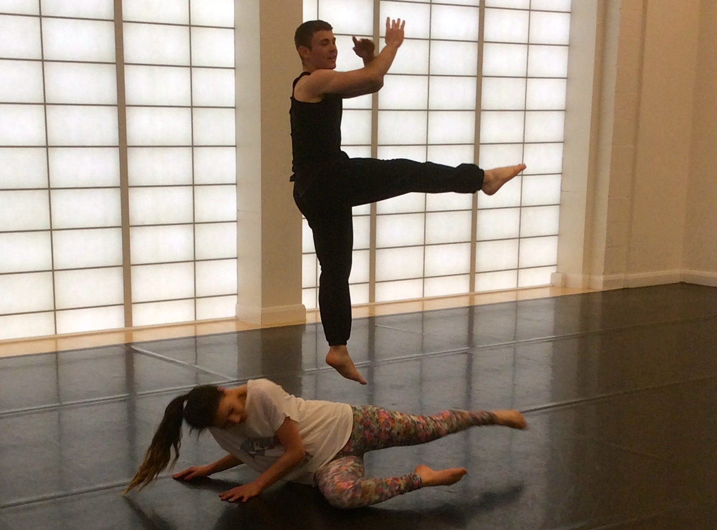
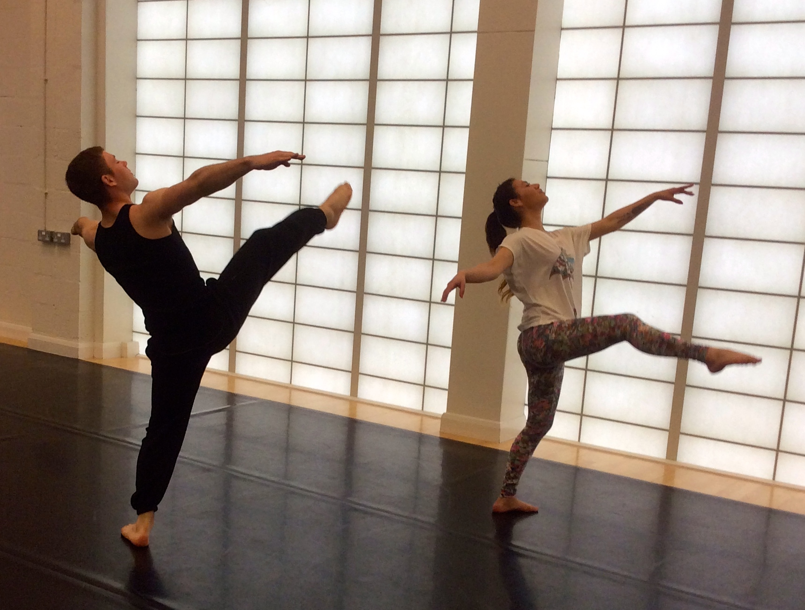

Figure 4 and 5: Moments from the extended sequence exemplified by Manchester Metropolitan University Dance students, Bryn Owen and Maryane Petters.

Following the analysis task, I asked students to work individually to create a short sequence that responded directly to one of the themes above. They had to link their sequence to the end of my sequence, creating a smooth transition between the two. These were my only instructions for the task, so any additional rules had to be created by the students. In comparison to the Battement Tendu task, this was much more open-ended and there were far more movement possibilities to choose from requiring the students to select and edit material accordingly. Marlowe and Page (1998) suggest that an analysis task like this encourages learners to “think critically…to discriminate between the relevant and the irrelevant…it’s about understanding and applying, not repeating back” (Pg.11).

The level of engagement with this task differed between students depending on many different factors. During the group discussion, Danielle, a student who had danced since her early teens and aspired to become a choreographer, stated how she enjoyed the creativity of the task as it allowed her to add her “own flavour” to the movement. The amount of instructions was enough for her, and any more would have made it too restrictive.

James, a student who had only been dancing since the age of sixteen, and like Ben, came from a musical theatre background, stated that he had struggled with this task, as he did not have a big repertoire of movement to draw from. He doubted the quality of his own material and preferred at this level to watch the teacher and learn this way. He wanted to learn new movement from the teacher, not just repeat things he already knew. He felt that the instructions for this task were too open and he would have preferred more direction, similar to the Battement Tendu task.

Ben agreed with James’s point about repeating things he already knew, he stated that for him it was important to keep learning new movements and techniques in order to develop as a dancer. However, Mia, a student with a background in Brazilian dance pointed out that there is a level of repetition in all dance technique practice, and in fact, some refinement of technical movements through repetition can be a positive thing, as long as the dancer is not further ingraining inefficient movement habits.

Evaluating the student response
The diverse feedback from the students reflected their individual engagement with both tasks, and this was dependent on their ability and needs as learners. Through discussion, the students touched on many different areas that require further reflection. These include:

- The varying requests for more and less instructions
- The tension between refining technical skills whilst allowing space for creativity
- The notion of repetition in relation to dance technique practice

All of these areas have the potential to be explored in more depth, both by the students as reflective practitioners and by myself as a teacher-researcher.

In relation to assessment criterion 4 (reflection on own development), Ben said that having the opportunity to create his own technique sequences challenged him to not only question what he was doing, but to go even deeper and consider the how and why. He also stated that working creatively in a technique class context made him think more about the ideas behind the movement, rather than just copying the teacher and doing as he was told. When considered in relation to Ryan’s (2015) two-stage model of reflection, this may demonstrate some evidence of critical reflection from Ben, the second and more advanced stage in the process. Not only was he able to reflect on his existing understanding of technical movement principles, but to possibly re-imagine his responsibility as a dance technique student, and question his reliance on the teacher. Similarly, Mia’s comment about the use of repetition could suggest that she is beginning to think critically about her own approach to practising dance technique, reconsidering when repetition may or may not be useful.

Concluding thoughts: further reflections
One key observation that I made involved the students’ use of focus and sense of awareness as they danced the various sequences. For example, in the moments when they were dancing my movement, I observed that most students would direct their focus towards me, looking for me to lead them. In contrast, when they danced their own movement, they would quickly have to shift their awareness back to their own bodies to remember their movement. Shifting between these two states of awareness was clumsy at first and students would often forget the movement, but with practise, the transition between the two became more seamless and I observed that they started to rely less on me, becoming increasingly more aware of their own bodies. With reference to the learning outcome and assessment criteria 1 and 2, students not only demonstrated knowledge of the fundamental principles of dance technique within my movement, but also within their own movement. Aceto (2012) suggests that “work often looks best when performed by the original owner of the material, the choreographer” (Pg.17), and thus it could be argued that embodied knowledge of this nature perhaps goes deeper than knowledge that is replicated.

Allowing the students to take control gave me the opportunity to actually stand back and see them moving. This revealed to me how little time I actually spend watching each individual. I have found that constantly demonstrating and supplying new movement to a group can be very arduous, whereas this approach allowed me more space and time to see what was happening around me. I talked less, stood back and observed the students working. I noticed how they communicated with each other and I saw them moving in different ways. There were also moments when I could see that some individuals were not fully engaged with the tasks and seemed to be questioning why this was being asked of them. In these moments, I noticed an anxiety in myself and I found it challenging not to slip into my default position and provide them with some movement. This asked something very different of me as a technique teacher, pushing me to relinquish my authority and allow the students find their own solutions.

Going forward, I will continue to research these ideas in the context of a PhD study, which I have recently embarked on. Using educational action research as a methodology, I will develop these initial pedagogical interventions further through several iterative action research cycles. Although I recognise the potentially destabilising effect, I am interested in the way that these alternative teaching and learning methods challenge the habits and expectations of both the students and the teacher. For the students, it asks them to reflect on their existing knowledge of technical principles and to question their reliance on the teacher thus potentially reimagining their responsibility as learners. As a teacher, it has led me to question my own habits, to test the boundaries of my authority and to contemplate when it might be useful to hold back and let the group take control. It has led me to reconsider my overall approach to teaching dance technique, reimagining and exploring alternative methods for delivering material. My concluding suggestion would be that in order to create the most beneficial learning environment for dance technique, these explorative approaches should co-exist alongside more direct approaches, or as Dyer so clearly states:

Rather than taking an “either-or” viewpoint, a more productive attitude would be to envision how the diverse teaching metaphors might compliment each other or couple to form richer learning experiences. (2009: Pg.122)

References
Aceto, M. (2012) Developing the dance artist in technique class: the alteration task. Journal of Dance Education. 12(1). Pg. 14 – 20.

Dyer, B. (2009) Merging traditional technique vocabularies with democratic teaching perspectives in dance education: a consideration of aesthetic values and their sociopolitical contexts. Journal of Aesthetic Education. 43(4). Pg. 108 – 123.

Dyer, B. (2010) The perils, privileges and pleasures of seeking right from wrong: reflecting upon student perspectives of social processes, value systems, agency and the becoming of identity in the dance technique classroom. Research in Dance Education. 11(2). Pg. 109 – 129.

Fortin, S. (1998) Somatics: a tool for empowering modern dance teachers. In Shapiro, S. (ed.) Dance, Power and Difference: Critical and Feminist Perspectives on Dance Education. USA: Human Kinetics. Pg. 49 – 74.

Lortie, D. (1975) Schoolteacher. A Sociological Study. Chicago: University of Chicago Press.

McAteer, M. (2013) Action Research in Education. London: Sage.

Marlowe, B. & Page, M. (1998) Creating and Sustaining the Constructivist Classroom. California: Corwin Press.

Moon, J. (2004) A Handbook of Reflective and Experiential Learning: Theory and Practice. London: Routledge Falmer.

Newlove, J. & Dalby, J. (2003) Laban for all. London: Nick Hern.

Råman, T. (2009) Collaborative learning in the dance technique class. Research in Dance Education. 10(1). Pg. 75 – 87.

Ryan, M. (2015) Teaching Reflective Learning in Higher Education: A Systematic Approach Using Pedagogic Patterns. London: Springer.
Smith, C. (1998) On Authoritarianism in the dance classroom. In Shapiro, S. (ed.) Dance, Power and Difference: Critical and Feminist Perspectives on Dance Education. USA: Human Kinetics. Pg. 123 – 148.

Stanton, E. (2011) Doing, re-doing and undoing: practice, repetition and critical evaluation as mechanisms for learning in a dance technique class ‘laboratory’. Theatre, Dance and Performance Training. 2(1). Pg. 86 – 98.

Stevens, J. (2006) Higher Education Academy: Palatine Report. Re-thinking dance technique in higher education. [Online] Available from: http://78.158.56.101/archive/palatine/events/viewreport/309/ (accessed 27th February 2015).
Wilmerding, V. & Krasnow, D. (2009) International Association for Dance Medicine and Science. Motor learning and teaching dance. [Online] Available from: http://c.ymcdn.com/sites/www.iadms.org/resource/resmgr/imported/info/motor_learning.pdf (accessed 27th February 2015).

