Lecture Theatre Pantomime: A creative delivery approach for teaching undergraduates
Ian J. Turner
University of Derby
Corresponding author: I.Turner@derby.ac.uk
Abstract
Lecture theatre based teaching is common place pedagogic method in Higher Education especially when teaching large classes. Lecture theatre pantomime is an interactive and diverse teaching strategy that uses lecture theatres but aims to make sessions as interactive, diverse and enjoyable as small group tutorials. The Central Dogma of molecular biology was taught using a pantomime approach that included a 3D washing line and a handstand by the lecturer. Overall 90% of students found the pantomime delivery style enjoyable compared to more traditional non-pantomime lectures. Students in the pantomime lecture showed a statistically significant (p = 0.0009) improvement in student exam performance compared to the previous year’s cohort.

Rationale
It is recognised as a growing problem that as class sizes increase in Higher Education (HE) institutions there is an increasing reliance on large lecture theatre based teaching. This is acknowledged as being in direct conflict with the need to make taught sessions as interactive, dynamic and personal as possible. Lectures have been identified in a large number of studies as being an ineffective pedagogical tool for conceptual understanding (Knight & Wood, 2005) and no better than a wide range of methods (including private reading) even for the fundamentals such as transmission of information (Gibbs, 2013).
This conflict can be addressed by adopting creative or interactive approaches to teaching whilst using a wider range of pedagogic techniques and methodologies. Interactive approaches to lecturing can promote active learning, heighten attention and motivation and increase class satisfaction (Steinert & Snell, 1999). Creative approaches can have the additional benefit of increasing the motivation of students in the classroom. Creativity and interactivity can be especially beneficial for students with lower self-motivation levels and/ or who respond poorly to more traditional teaching techniques (Darlington, 2010). Creative approaches may take many forms in the lecture theatre environment but include the use of drama, role-play and pantomime.
Literature Review
Drama in the lecture theatre uses the activity of acting, where drama in partnership with students are used to facilitate learning. The use of drama to teach science in secondary schools is a well-established approach such as ‘analogy role-play’ in which students are asked to represent biological mechanisms, for example nerves cells to demonstrate the passage of impulse down multiple cells (compared to a single cell) and metal atoms to illustrate the vibrational effects of expansion due to heating (McSharry and Jones 2000) and the Grotthuss mechanism (Chemical Bonding verses conductivity of water). This involves the students acting as the molecules and lining up to represent either hydrogen or oxygen atoms. Furthermore, the interactions between the atoms ‘arms and legs’ are used to demonstrate the conductive principles (Sturm 2009).
Drama has been used extensively as a delivery form in Higher Education (HE) especially in medical education. Unalan et al, 2009 used theatrical presentations performed by medical students in a lecture about headaches to make students more active learners. Student volunteers dramatised headache scenarios as part of a session on taking patient medical histories and clinical findings in diagnosing headaches. The authors found that 90% (n=43) of participating students found that the theatrical performance made it easier to understand the topic and that a higher percentage of the correct answers to the headache question in the final exam were produced by students who participated in the theatrical headache lecture.
Shapiro and Hunt, 2003 introduced theatrical performances but used professional actors and patients to deliver dramatised patient perspectives on HIV/AIDS and Ovarian Cancer. The performances were one hour one-person shows composed of drama and song followed by professional discussion and critique by doctors. The authors found that audience response were universally positive for the performances and increased their understanding of the symptoms; empathising with a person suffering from the condition. There was also strong support for similar teaching approaches to be used in future sessions.
Alarek and Baerheim, (2005) used a more interactive theatrical performance in which an actress performed the role of a patient and staged a consultation monitored by a teacher. At a critical point the consultation was stopped and the students individually / in groups tried out their own approaches to the consultation on the subject. The authors concluded that the dramatisation advanced the students’ abilities in mastering difficult conversations.
Pantomime is theatrical entertainment of a story (normally a fairy tale) that often includes comedy; it differs from drama in the lecture room as it encompasses the whole session rather than (typically) being a component of the session. In this paper, pantomime is used as the delivery mechanism in a year two molecular biology lecture. Timpson & Burgoyne (2002) demonstrate how an educator can use performance related techniques to engage students. Pantomime is used as a framework (script) for the whole session to engage and enthuse the student learners thus increasing the transmission of subject matter. It is therefore hypothesised that students perform better in the end of module exam on central dogma questions when the material is delivered using the pantomime format.
Methods and Materials
A session in a second year undergraduate genetics module on the topic of the ‘central dogma’ specifically prokaryotic and eukaryotic transcription, and translation was delivered using an integrated ‘pantomime’ approach. There were 144 students enrolled on the module from three different programmes of study: Biology, Zoology and Forensic Science. The session was three hours in duration and was composed of two times one hour fifteen minute teaching slots with a 30 minute break. The session was delivered using a pantomime approach composed of a number of different elements:
- Traditional PowerPoint – PowerPoint slides containing key points and illustrative diagrams were used throughout the session. These were infrequently related to in the actual session. Instead they were used as an ‘aide memoir’ for the presenter and to allow students to organise their learning, during and post session.
- Videos / Animations – A selection of animations from the core text associated with this module and videos from www.youtube.com were used as part of the session. These were principally used to summarise sections of the ‘pantomime’ and to illustrate processes not possible using the 3D display.
- Visualiser – A Samsung visualiser was used to demonstrate some aspects of the central dogma. Two specific examples are the relationship between template DNA, non-template DNA and RNA and Rho independent termination which were demonstrated ‘live’ on the visualiser using pipe cleaners, paper and a metal ring (see figure 1)
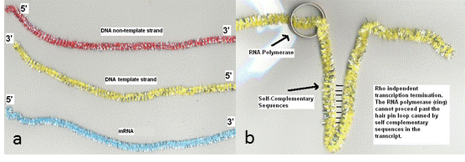
Figure 1: example of using the visualiser in the session a) pipe cleaners used to illustrate the difference between types and orientations of nucleic acids b) pipe cleaner and a metal ring to illustrate Rho independent transcription termination. Labels added after the lecture and made available to students.

- 3D Display – The main focal point of the lecture was a 3D display using a washing line tied across the lecture theatre. Throughout the lecture various elements were attached to the line (template DNA) using clothes pegs. Proteins, promoter sequences and transcription factors were represented on paper plates and laminated sheets. A series of blank plates were taken into the session to allow response to student questions.
- Lecturer Interaction – To illustrate some concepts the lecturer adopted a more interactive approach. For example to demonstrate the 5’ to 3’ orientation on dexoyribose in template and non-template strands of DNA the lecture performed a handstand (with assistance) in the class. The lecturer also donned a builder’s hat and climbed on the washing line to demonstrate / become an enzyme in the transcription process (see figure 2).

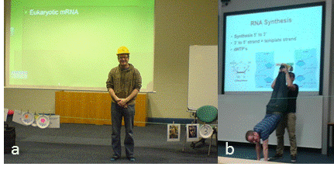
Figure 2: Selected elements of the session a) 3D washing line representing DNA molecule with various factors and proteins attached via clothes pegs b) lecturer demonstrating orientation of deoxyribose in DNA strands by performing a handstand.
- Humour – Where possible humour was used in all other elements to keep the lecture entertaining and enjoyable. Two specific examples are representing the Rho termination Protein by showing a picture of University of Derby lecturer, Graham Rowe and illustrating terminator sequences using a picture of Arnold Schwarzenegger as The Terminator.

The session was evaluated using a mixed method approach; a post session ethically approved questionnaire asked the students to self-evaluate (quantitative) six statements on a likert scale. The statements (full details in figure one legend) captured the students self-evaluation of their understanding of the central dogma concept (prior to and post session). Also, captured students’ enjoyment of both the central dogma and the pantomime delivery style. The questionnaire also included one optional open text (qualitative) question. Invitation to complete the questionnaire was delivered once via the University’s Virtual Learning Environment (VLE).

This lecture is part of a module that is assessed by an end of unit two hour unseen examination. All students are required to complete a question related to the material covered in this lecture. End of examination scores for this year were captured and compared with scores from the previous academic year (similar content and question but different delivery style).

Results
Of the 144 students on the module, 44 students (32%) responded to the request to complete the questionnaire. Students were asked (S1) if they enjoyed studying the ‘central dogma’ material that had been previously been delivered to them as part of their level four (stage one) studies. Half the students who responded to the questionnaire (58%) stated that they ‘strongly agreed’ or ‘agreed’ with the statement (see figure 3). The same question (S2) was asked to students regarding enjoyment of the level five (stage two) ‘pantomime session’ and revealed that all students at least ‘agree’ with the question about enjoyment and that 66% ‘strongly agree’. When asked about the delivery style of the session (as opposed to the content) 87% strongly agreed with the statement about enjoyment (S3). Almost all students agreed that their knowledge of the subject matter had increased during the session; 43% of students strongly agreed and 47% agreed that they now understood the material better (S4).
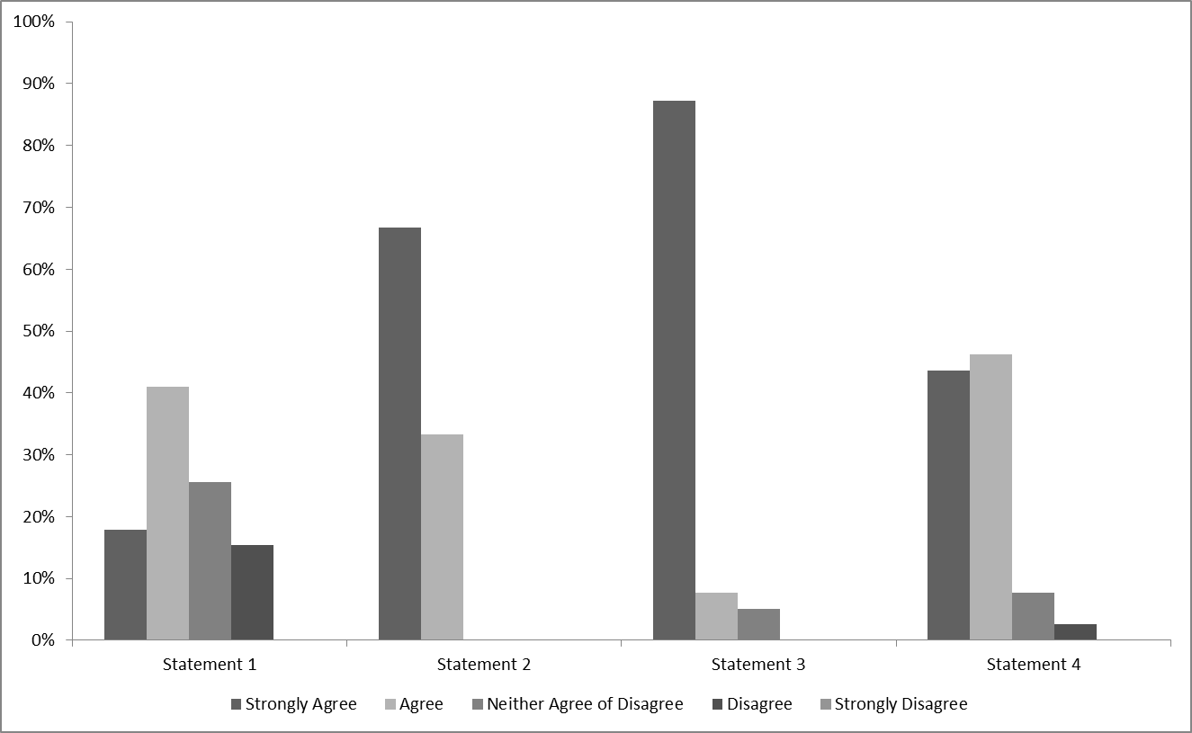
Figure 3: Student responses to four post-lecture questions on the central dogma delivered using the ‘lecture theatre pantomime approach’. Students were asked to state their agreement with the following statements using a scale from strongly disagree to strongly agree (see legend above). Statements 1 ‘I enjoyed studying the central dogma in the first year of my degree’ 2. ‘I enjoyed yesterday’s lecture ‘the central dogma revisited’ 3. ‘I enjoyed the delivery style of yesterday’s lecture the central dogma revisited’ 4. ‘I feel I understand the central dogma better after yesterday’s lecture.
To better understand what aspects of the lecture delivery style students specifically enjoyed, they were asked to rate how enjoyable they found various aspects of the session on a scale from’ very enjoyable’ to ‘hated’ (S5) (see figure 4). The majority of students rated many of the novel approaches in the lecture as very enjoyable including: lecturer interaction (82%), humour (84%), the 3D washing line display (71%) and the use of the visualizer (60%). The two other approaches were rated as enjoyable by the majority of students namely, PowerPoints (62%) and videos (59%). In total, 28% of student either had no opinion or did not like the PowerPoints when considered in isolation.
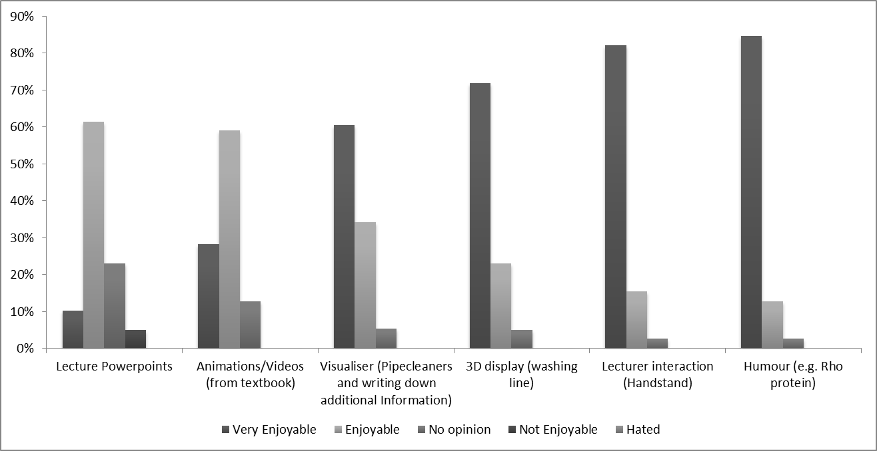
Figure 4: Students response to statement ‘for each of the following (those listed above) delivery modes in yesterday’s lecturer please tick the box that best describes your enjoyment’
Students were asked to rate on scale from ‘very helpful’ to ‘no help at all’ how they found the individual approaches used in the lecture for aiding their understanding of the subject matter (S5) (see figure five). The most useful element was the 3D washing line display; 84% of students rated it very helpful. Three other elements were found by the majority to be ‘very helpful’; the visualizer (67%), Lecture Interaction (59%) and the humour (70%). Both the PowerPoints (62%) and the videos (56%) were rated as ‘helpful’ by the majority of students. No elements were found to be of ‘no help at all’, but all elements except humour and lecturer interaction were found to be ‘not very helpful’ to at least 2% of students.

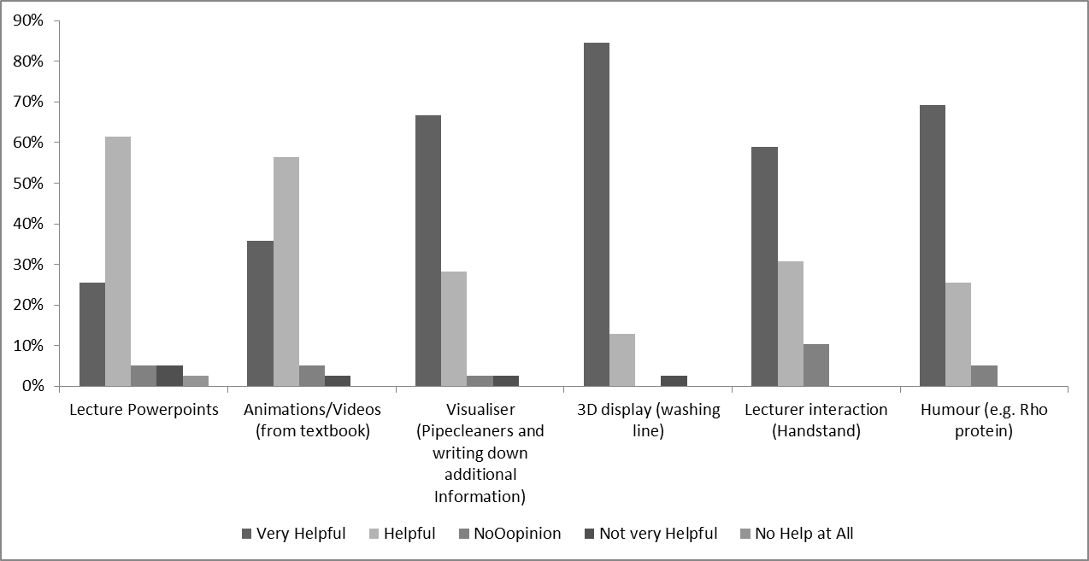Figure 5: Students response to the statement ‘For each of the following delivery modes in yesterday’s lecturer please tick the box that best describes your opinion on its ability to help you understand the lecture material’
In addition to the opinion based questions students were asked to contribute any further comments in an open question. In total 23 students (50%) left an optional comment. All of the comment are positive in nature. A selection of the comments are listed below:
“It was enjoyable especially the washing line. Demonstrating in 3D was extremely useful and made the lecture more understandable. The humour makes the lecture more fun”
“Although I understood the central dogma from last year’s teaching I felt this year’s lecture was really helpful. The visual elements of it increased my understanding and made the topic memorable.”
“The strong interaction and visual displays helped me the most, as it has given me something to link the information to, rather than block text”
“Each component on its own (with a few exceptions) was not very useful, however when combined as a whole, it was. This is to say that doing one of the delivery modes won't make a difference, several of them have to be done together to make an impact. Well done though, as I have never seen a lecturer try so hard to get their delivery right and so varied!”
One comment raises an interesting issue regarding this approach and examination revision
“I felt the lecture PowerPoints are going to be very difficult for me to study off, as there is little explanation and only diagrams. Everything else was absolutely fantastic.”
Word Cloud analysis (see figure six) of the text based comments reveals that the most common words used by students were lecture (most frequent) followed by ‘understanding’ ‘more’ and ‘enjoyable’. All the words used are positive adjectives and verbs, examples include helped, enthusiasm, better and learn. Only one of the approaches in the session, the washing line, appears in the word cloud analysis.

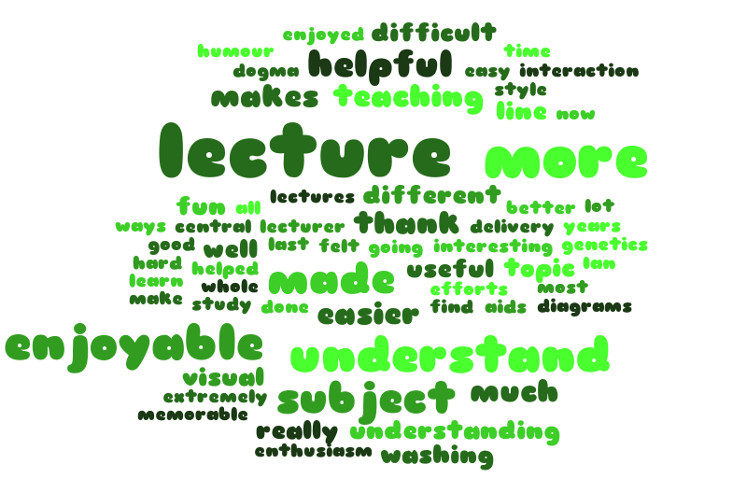
Figure 6: Word Cloud analysis (Frequency >1) of students’ open text comments in response to the question ‘Please type below any comments about the lecture and its delivery mechanism’
Students’ were examined on the central dogma and other module topics in the end of unit examination. Cohort performance in the examination was captured. As part of the examination all students have to complete a question on the central dogma. The mean score for students on the central dogma question was 12.94 (SD 4.87), a grade C. The mean score for other questions on the examination was 10.41 (SD 4.14), a grade D. The hypothesis that students performed better on the central dogma question was statistically significant when tested by a two-way unpaired student t-test (p = 0.000001). To compare the lecture theatre pantomime approach, a comparison was made with the exam question scores from the previous year’s students; a comparable question asked in the same module (taught by a more traditional approach) was used for comparison. The mean score for the central dogma question was 11.02 (SD 5.19) a grade D. The hypothesis that the pantomime approach improves academic performance was statistically significant when tested by a two-way unpaired student t-test (p = 0.0009).
Discussion
Lecture theatre pantomime was well received by students in the lecture theatre. When comparing students’ enjoyment of the central dogma topic using the pantomime delivery with the previous year’s non-pantomime delivery, there was a seven percent increase in the number of students who at least agreed with the statement related to enjoyment of the topic. When teaching using the pantomime approach all the students rated their enjoyment of the topic at least ‘agree’, compared to only 60% of students’ judgements about the topic after the first year non-pantomime delivery. The questionnaire was delivered directly after the pantomime session; this was more than a year after the non-pantomime delivery, it could be that response would have been more positive had the survey been taken directly after the class when the material and delivery style were fresh in the students’ minds.
There was a very high response to the students’ enjoyment of the session’s delivery style (90% strongly agree) which is comparable to the levels reported by Unalan et al, 2009 in a drama teaching students the clinical diagnosis of headaches. The enjoyment rise could be a reflection to the novelty of the delivery mechanism rather than a real appreciation for the way the session was taught. It could be argued that statements one to four were leading in their construction; in order to fully evaluate delivery in a future study, statements would be rewritten e.g. statement one as ‘I found the lecture central dogma revisited’ very enjoyable, enjoyable, neither, un-enjoyable, very un-enjoyable’ Pantomime type delivery if used more frequently in the lecture theatre may still be enjoyable, but possibly would not show such a large impact on student learning and engagement. In fact it may have no or a negative impact if used too frequently or executed poorly.
The response rate for the questionnaire was good considering it was delivered via the VLE. There were a large number of students who chose not to complete the survey, It could be that these students found the session un-engaging and uninteresting. Therefore the percentage of responders are not reflective of the whole cohort’s views. The questionnaire was completed anonymously to encourage honest answers; therefore it is not possible to see how students who responded to the questionnaire performed in end of unit examinations. It would be interesting to see if the students who responded well to this type of delivery and improved their examination performance more than the cohort as a whole.
Nearly all students at least agree that the session improved their understanding of the central dogma. However, students could be over self-evaluating their own skills and knowledge thus such measures should be treated with caution. The students’ opinion of understanding in part corroborated by students’ end of examination performance. Students scored higher on the central dogma question compared to other questions in the end of module exam and higher than a similar question completed by previous cohort (not taught using pantomime). Increased exam performance is a positive finding, however it must be treated with caution as the central dogma material is the first topic in the module (allowing a greater time to revise) and other questions in the examination are more technique based rather than theory based. In addition, comparing two different cohort examination scores is full of variables such as cohort academic ability.
All aspects of the pantomime were found both enjoyable and helpful for learning. Interestingly, PowerPoints were found as at least enjoyable by 70% and at least helpful by 85% of respondents. PowerPoints were not a central part of the session; however they did provide a structural framework for the pantomime and could potentially be used for student note-taking and revision. It could be that students are used to PowerPoint delivery and have adapted their learning style to cope with this delivery mechanism. These PowerPoints did contain diagrams, images and animation, which could have an impacted on the students’ perception (Gibbs, 2013).
The main elements of the pantomime (3D display, humour and lecturer interaction) were judged to be both enjoyable and helpful to learning. All of the pantomime elements (except the 3D display) were judged to be less helpful than they were enjoyable. This is to be expected as aspects such as the humour are included to increase students’ enjoyment, motivation and interest in the subject matter. Student comments were largely positive, while it was interesting that some student responses describe how the whole ‘pantomime’ was enjoyable and helpful but that individual elements on their own would add little value. The comments about individual elements support Darlington’s (2010) comments that making certain the drama it is a central part of the lesson and not just an ‘add-on’ is vital and failure to do so can lead to the session failing. In contrast to McSharry and Jones (2000) and Sturm’s (2009) work, it is difficult in a large group lecture theatre environment to make students part of the ‘drama’ because of the space and time considerations. In this session small interactive elements such as ‘pinning items on the washing line’ kept students alert and involved them in the presentation.
The pantomime session was viewed as enjoyable by the students, but found equally enjoyable by the lecturer. The session taxed academic creativity and lead to immense satisfaction in the students’ responses to the lecture. Pantomime was successfully used to deliver this complex topic because the ‘washing line’ creates a simple but effective analogy which is useful throughout the whole lecture, this common theme may not be so easy to replicate in other topics. Pantomime makes the lecture a ‘total experience’ a lecture that is unforgettable; not its details, but the performance that helps to validate their academic experience and learning (Frudei, 2013).
Pantomime is not a delivery mechanism that would suit all lecturers. It requires a large investment of time to plan and set up (compared to a standard PowerPoint lecture). Furthermore, requires a high level of self-confidence to deliver. Pantomime can be successfully used to help students enjoy their learning and act to improve academic performance.
References
Alraek, T.J. & Baerheim, A. (2005) Elements from theatre art as learning tools in medical education. Research in Drama Education. 10 (1). p. 5-14.
Darlington, H. (2010) Teaching secondary school science through drama. School Science Review. 91 (337). p. 109-113.
Deloney, L. A. & Graham, J. (2003) Wit:using drama to teach first-year medical students about empathy and compassion. Teaching and Learning in Medicine 15 (4). p. 247-251.
Furedi, F. (2013) The Guardian Education. In praise of lectures. [Online] Available from: http://www.theguardian.com/higher-education-network/blog/2013/dec/10/in-praise-of-academic-lecture [accessed 15th February 2014]
Gibbsm G. (2013). Lectures don’t work, but we keep using them. The Times Higher Education Supplement. 21st November 2013
Knight, J.K. & Wood, W. B. (2005) Teaching more by lecturing less. Cell Biology Education. 4. p. 298-310.
Metcalfe, R. A. J., Abbott, S., Bray, P., Exley, J. & Wisnia, D. (1984) Teaching science through drama: an empirical investigation. Research in Science & Technological Education 2(1). p. 77-81.
McSharry, G. & Jones S. (2000) Role-play in science teaching and learning. School Science Review. 82 (298). p. 73-82.
Odegaard, M. (2003) Dramatic Science: A critical review of drama in science education. Studies in Science Education. 39 (1). p. 75-101.
Shapiro, J. & Hunt, L. (2003) All the world’s a stage: the use of theatrical performance in medical education. 37, 922-927.
Steinert, Y. & Snell, L.S. Interactive lecturing: strategies for increasing participation in large group presentations. Medical Teacher. 21 (1). p. 37-42
Sturm, B. (2009) The drama of science. Science in School. 13. p. 29-33.
Timpson, W.M. & Burgoyne, S. (2002) Teaching & performing ideas for energizing your classes. 2nd Edition. Atwood Publishers.
Unalan, P.C., Uzuner, A., Cifcili, S., Akman, M., Hancioglu, S. & Thulesius, H.O. (2009) Using theatre in education in a traditional lecture oriented medical curriculum. BMC Medical Journal, 9 (73). p. 1-5.
Whitman, N. (1991) The art and science of creative teaching. Pathology Education, Human Pathology 22 (7). p. 634-5.

