An innovative approach in supervising undergraduate projects within dietetics and human nutrition courses.
Farzad Amirabdollahian¹ & Ricardo Costa²
¹Liverpool Hope University
²Coventry University
Corresponding author: amirabf@hope.ac.uk

Abstract
We are writing to report an innovative approach that we have adopted for supervising undergraduate research projects within the BSc Nutrition and Dietetics programmes, and to suggest this approach to other colleagues in this discipline. This is based on our experience in investigating Diet, Lifestyle and Health (DLH) of University Students using a collaborative approach. To our knowledge, this collaborative approach including the group supervising of final year undergraduate students is new in the field of Nutrition and Dietetics.
Key Words: Research supervision, Diet, Lifestyle and Health, Collaborative approach

The UK National Diet and Nutrition Survey (NDNS) has identified that the youngest adults (i.e. aged 19-24 years) consumed larger quantities of high calorie, high fat foods, and fewer portions of fruits and vegetables than other adult categories. This indicated British young adults are vulnerable to adhering to obesogenic diet and lifestyle, and potentially inducing micronutrient malnutrition (Hoare et al., 2004).
To date, there exists limited comprehensive research and baseline observational data on the DLH of university students in the UK. Previously within our departments, there have been several final year undergraduate research projects typically assessing a single dimension of DLH variables amongst university students (e.g. dietary fat consumption, body composition, alcohol intake). However, due to limited resources, time constraints and the overall undergraduate nature of these studies, they did not construct a coherent conclusive picture of DLH of the studied population. Students would usually have prioritised the ‘demonstration of meeting the learning outcomes’ of the final year research module (e.g. focusing on the methodology), to finding the answer for the research question. The learning outcomes of the final year undergraduate research module were to demonstrate the skills required for an independent research practitioner to be able to design research, carry out the study, analyse the results, disseminate the findings and deal with the practicalities of conducting the research project.
The collaborative research project entitled “The Diet, Lifestyle and Health of University Students” investigates the general lifestyle and nutritional status (anthropometrical measures and dietary habits) of students of university students. The research team initially comprised of two senior lecturers in human nutrition and dietetics together with several final year undergraduate students of dietetics, nutrition and health who were working together to achieve the aims and objectives of the research collectively and individually.
The research project is intended to run over four yearly phases. Phase one of the research project (delivered in 2009-10), was comprised of 8 final-year university students of Coventry University (5 students from BSc Health & Lifestyle Management, and 3 from BSc Dietetics), who voluntarily joined the project, contributed to the design and resource development, data collection, and data analysis of the study. The second phase of the project (delivered in 2010-2011), comprised of 6 final-year university students (2 from BSc Health & Lifestyle Management and 4 from BSc Dietetics) who amended the questionnaire to make it more understandable, and also continued with data collection and analysis of the project. The third phase of this project is currently on-going, as intra-university collaboration and the investigators are 6 final year nutrition students from Liverpool Hope University, 5 final year dietetics students from Coventry University and 4 final year dietetics students from London Metropolitan University, who are supervised by three senior lecturers in the field. The supervisors work together, share resources, and help each other (e.g. in planning and obtaining ethical approval), but supervise their own local students.
When the idea for this project was originally generated, it was offered to the students during the induction of the final year project module. Students who were interested in this collaborative research approach joined the research team voluntarily. Weekly meetings were held on a regular basis, and included standard minute taking, problem solving, planning for action, and research workshops (e.g. formulating research questions, anthropometry, interview skill training, data management, dietary analysis and statistical software training).
Students were guided to generate their individual research questions, and develop a comprehensive semi-structured interview in accordance with their research question. Subsequently, supervisors accumulated all the individual questionnaires, producing an extensive interview-style questionnaire that included: a food frequency questionnaire (FFQ), a diet history, and open/closed questions regarding DLH of university students.
The interview form was piloted in a sub-sample excluded from the sample population, and subsequently modified for improvement. The dietary assessment method was validated against a 7-day weighed dietary record (as previously reported by Gibson, 2005) in a sub-group of the population. Research students were thoroughly trained on how to conduct the interview efficiently and competently. They were also trained on how to precisely and accurately measure anthropometric indices (e.g. weight, height, waist circumference, body composition), and analyse dietary intake through dietary assessment software.
On initiating the study design, all research students recruited, measured and interviewed other university students as participants, completed the entire interview form for each participant, and analysed the diet history, food frequency questionnaire and 7-day weighed dietary record for the participants they interviewed. Then they added these information to the general spread sheet of the research project. However, they only analysed the raw data corresponding to their own specific research question. To date, a total number of 319 interviews and measurements have been completed within phase one and two (n=139 phase one; n=180 phase two). Research students analysed the data corresponding to their research question and presented and discussed their findings as their final year dissertations. Furthermore, students also successfully submitted their work to several national and international research symposiums (i.e. 3 posters in British Dietetics Association research symposiums, 1 poster in National Nutrition and Health Conference and 5 posters in European Nutrition Conference) and presented their findings.
Regardless of the aforementioned rationale for conducting the project (i.e. exploring the research basis of the university food and nutrition policies), we thought that the project and its research activities are also well justified from the pedagogical perspective:
Firstly, encouraging students to take part in this collaborative research project is an attempt to develop the students’ transferable skills (e.g. teamwork, communication, problem solving), facilitate delivery and presentation of knowledge, promote peer support, and provide a safe and scientifically sound environment for achieving the research module’s learning outcomes.
Brown and Atkins (1988) stated that the development of communication skills, intellectual and professional competencies, and personal growth of students are the goals of small group teaching (Brown and Atkins (1988) cited in MacDonald 1997: 13). Macdonald completed this by adding that small group learning can help students to support each other’s learning, tackle large scale tasks, be a part of a repertoire of teaching methods and permit for the interchange of opinions (Macdonald 1997). Our educational goals seemed to be in line with the aforementioned points concluding that small group learning methods would enable us to achieve our pedagogical goals.
The definition of the students’ ‘transferable skills’ that we tried to develop in this project, is open to debate. Since the 1970’s, there has been a focus towards the study of learning skills (i.e. skills that influence the effectiveness of student learning, such as essay and lab report writing, using the library, minute taking and being organised). Later on (during the 1980s) these evolved to be not only the skills necessary for effective learning but also included many skills that students need outside academia and in their professional activities. This new definition included items such as communication and information skills, task and time management and record keeping and are generally referred to as ‘transferable skills’ (Gibbs et al., 1994).
We based our definition on the simple list of transferable skills suggested by Oxford Brooks University (Gibbs et al., 1994). We believed that conducting the final year project as an undergraduate collaboration, with the weekly ‘small group’ meeting format, would give an opportunity to develop these skills.
At the end of phase one and two of the research project, considering the research students’ success (all successfully passed their dissertations and seven research students are disseminating their findings at national and international conferences), this seemed to be a potential way forward in undergraduate research supervision. However, on reflection, we soon realised that many of the skills required for implementation of the research design were discipline-specific (e.g. interview techniques, anthropometrical measures) were basic skills for our BSc Dietetic research students, but not for the BSc Health & Lifestyle Management research students. Therefore, we needed to constantly assess and modify the supervisory plan of delivery based on the requirement of transferable skills. Furthermore, observing each other in practice, research students realised that sometimes they lacked the skills that were expected, and being responsible for part of the project, they needed to seek strategies to develop these skills. This approach was in line with Kolb’s experiential learning cycle (Kolb 1984) that was used in our project for developing the small group’s transferable skills (Figure 1).
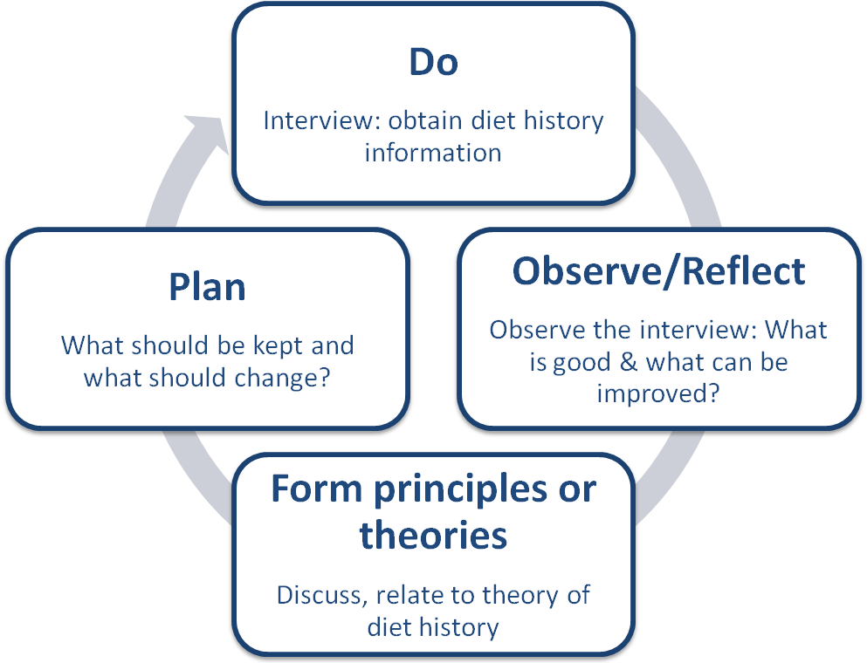
Figure 1 Developing the students’ diet history interview skills using Kolb’s experiential learning cycle (1984)

At the end of phase one and two, and in term of impact of this research on teaching and learning practice, we have some interesting findings:
One of the main educational outcomes of conducting this collaborative undergraduate research project was developing ‘peer support’ among the students. As a result of developing peer support among these students, toward the end of their research project procedures (prior to submission), they rarely needed supervisory support as they were typically able to raise their questions among the research team. Whereas, undergraduate research students who conducted individual projects, usually found this period a difficult and stressful time when they required additional support and attention from their research supervisors.
Biggs (1999) refers to the strong body of evidence, supporting the effectiveness of this student-student interaction. He mentions that by developing peer support, students can elaborate on known content (i.e. hear of interpretations that they themselves have not thought of), derive standards for judging between these interpretations, and finally obtain an awareness of how one arrives at a given position or conclusion (Biggs 1999).
We agree with Biggs on that developing peer support in our group helped our students to achieve effective learning outcomes. Promoted peer support practiced in this project not only had significant educational outcomes, but also helped us in achieving our main goal of developing transferable skills among these students. For example, when a student helps another student by explaining a concept, this would increase his/her self confidence, communication skills and knowledge based on the assumption that ‘s/he is able to teach or solve the problem’ (Biggs 1999).
On the other hand, we accept that developing peer support has its own downfalls. For example, supervising this research project, we have noticed how sometimes a very active member of the group could bring a misconception or a misunderstanding into the group and because of the substantial role of the student in the small group; s/he dictates the idea to the others. Therefore, while peer support can have a substantial positive role in achieving learning outcomes, this does not undermine the role of supervisor or group leader, who need to direct the group and oversee the discussions.
With regard to the alignment with institutional and national priorities, conducting the final year undergraduate project as collaboration is well justified:
From the start of the academic year of 2009/2010 in the Faculty of Health and Life Sciences (HLS), Coventry University, undergraduate research supervisors were advised to reduce supervision hours to 5 hours per research student, and wherever possible see research students in groups. Practising the new guidelines, lecturers were concerned that this inadequate time allocated to supervision of undergraduate projects might negatively affect the quality of our undergraduate research. By designing this group undergraduate project, we managed to adhere to the new guidelines of the faculty and yet improve the quality of our undergraduate research (assessed by success in dissemination of the research findings of the research project).
At national level, the recent document of the (UK) Higher Education Academy on the ‘Developing Undergraduate Research and Enquiry’ clearly emphasises the importance of engaging undergraduate students in research (Healy 2009). Considering the model in Figure 2, our research project engaged undergraduate research students in all four aspects of the model, while many other undergraduate projects fail to do so. For example, many undergraduate students conduct a systematic review or an extensive literature review, which might not necessarily offer the primary understanding and experience.
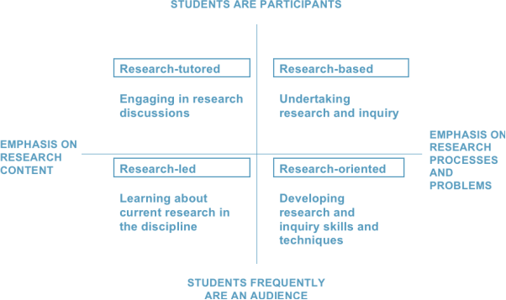

Figure 2 The nature of undergraduate research and enquiry

Adopted from Healey M. and Jenkins A. Developing undergraduate research and inquiry. The Higher Education Academy; 2009, p 7
Whilst all four main methods of engaging students with research are important and valuable, Healey and Jenkins (2009) emphasise that an appropriate undergraduate curricula must include all of these elements. In many BSc Dietetics courses, too much attention is given to the theoretical model of developing research skills, methodology, techniques, and learning about evidence based practice in the discipline; at the same time perhaps overlook and limit the experience of our undergraduate students in undertaking the research and engaging in research discussions. For example, some lecturers are content in letting undergraduate students perform a library based study during their final year “research project”, or encourage students to conduct simplistic research with the main agenda of passing the research module and subsequently completing the BSc course. We argue that this does not really provide an in-depth learning experience that will increase students’ transferable skill and knowledge.
Gibbs and Habeshaw (1992) refer to some of the quotations from the lecturers about group projects being problematic from the assessment point of view, because the assessments are not straightforward and individual skills may remain overlooked or unrewarded. While we accept that this is a challenging area and a major threat for precise and accurate assessment of group projects such as ours, we refer to several strategies mentioned by Gibbs and Habeshaw, which can address the issue (e.g. agreeing on ground rules for supervision, clarifying the assessment criteria, fieldwork visits) (Gibbs and Habeshaw 1992). Furthermore, anticipating the possible difficulties of the assessment, we asked students to formulate their own specific research questions and only concentrate on them, which greatly helped us to assess the final dissertations, meeting assessment criteria with consideration that this has been a group project.
On account of all aforementioned benefits of conducting a collaborative final year undergraduate research project, we would like to promote this approach to other colleagues who are supervising final year undergraduate students in this field. We have been practicing to conduct our postgraduate research project as a collaborative research project for several years and we suggest that the same could be done for final year undergraduate projects.

References

Biggs JB. (1999) Teaching for quality learning at university: what the student does. Philadelphia: Society for Research into Higher Education: Open University Press;

Gibbs G. and Habeshaw, T. (1992) (eds.) Preparing to teach: an introduction to effective teaching in higher education. 2nd edn. Bristol: Technical & Educational.

Gibbs G, Rust C, Jenkins A, Jaques D. (1994) Developing students' transferable skills. Oxford: Oxford Centre for Staff Development.

Gibson RS. (2005) Principles of nutritional assessment. 2nd edn. Oxford: Oxford University Press.

Healey M. and Jenkins A. (2009) Developing undergraduate research and inquiry. The Higher Education Academy [Online]. Available at: http://www.heacademy.ac.uk/assets/documents/resources/publications/DevelopingUndergraduate_Final.pdf (Accessed: 10 April 2011).

Hoare J, Henderson L, Bates CJ, Prentice A, Birch M, Swan G. (2004) The national diet & nutrition survey : adults aged 19 to 64 years, Volume 5: Summary Report. London: TSO.

Kolb DA. (1984) Experiential learning: experience as the source of learning and development. London: Prentice-Hall.

Macdonald, R. (1997) Teaching and learning in small groups. Birmingham: Staff and Educational Development Association.

