Modelling a constructivist approach to continuing professional development through e-Buddies
Steve Hall
Staffordshire University
Corresponding author: s.j.hall@staffs.ac.uk

Abstract
When changing roles, responsibilities and even careers, the need to get oneself ‘up to speed’, particularly in the context of a constantly evolving technological environment, is paramount. Accessing information and new knowledge however, is only part of the process – it is the making sense of that knowledge and being able to develop the skills to practise what has been learned that makes continuing professional development (CPD) effective and worthwhile.
The need to provide support for professional learning within an online environment is as important as face to face ‘training’, and the role of mentor and/or coach is important in helping to ‘scaffold’ learning until the learner develops sufficient self-confidence and self-efficacy to become a self-organised learner.
This case study provides an opportunity to reflect upon a constructivist approach to professional learning in an online environment through the support of an e-buddy. Taking the step of joining the initial e-Treat, engaging in the event and finding a first e-buddy was the initial ‘hook’. Being drawn in to explore the use of Concept Maps with my own students and to then take part in an in an ‘Ask the experts’ event – a title that still makes me smile as it sat so incongruously with me at the time – was what helped the e-buddy relationship to grow. With that support and a scaffolded approach to professional learning (Walmsley, 2011), I was drawn in.
Keywords
professional learning; coaching for learning; concept mapping; self-organised learner
Introduction
Having started a new career in HE at Staffordshire University after 35 years in schools’ education, I needed to absorb, as quickly as possible, significant amounts of information in order to get up to speed in this new working environment.
Such a change of career requires the support of fellow professionals by taking on both mentoring and coaching roles. In 2005 the Department for Education and Skills (DfES), in partnership with the Centre for Use of Research & Evidence in Education (CUREE), published a National Framework for Mentoring and Coaching which defined mentoring as
‘a structured, sustained process for supporting professional learners through significant career transitions’
and coaching as
‘a structured, sustained process for enabling the development of a specific aspect of a professional learner’s practice.’
I was acutely aware of the need to identify colleagues who could take on these roles to support my induction into the HE environment and my continuing professional development.
I was also conscious that the pedagogical approaches to the courses I was running in the Education Department, particularly at MA level was not making sufficient use of new technologies in order to model approaches to learning which were appropriate to the 21st century. I was keen to move towards a more constructivist approach in which students took on more of a strategic responsibility role for their own learning (Claxton, 2002).
I therefore enrolled on an internal ‘Technologies 4 Learning’ course run by the Learning Development and Innovation team at Staffordshire University, subscribed to two learning discussion forums on LinkedIn and joined Helen Walmsley’s e-Treat in August 2010 (Walmsley, 2011). The distinctive feature of that event was the e-Buddy concept to which everyone involved in the event subscribed and it was that event followed by an online discussion around mind-maps and concept maps which led to further contact between myself and Helen as a follow-up to the E-Treat.
It was the desire to change the delivery methodology of the MA Education programme to one which is both constructivist and connectivist in nature, with students co-constructing both the content and direction of the modules (Hargreaves, 2005), which led me to introduce concept mapping as a formative activity at the start of a new MA module (Vanhear, 2008). This, in turn interested Helen such that we set ourselves up as e-Buddies for that practical outcome of the E-Treat, leading into an ‘Ask the Experts’ online forum to which I contributed an input on Concept Mapping using e-Learning tools.
Development
The commitment to the other person within an e-buddy relationship is similar to that of a mentor/mentee or a coach/coachee relationship. Clutterbuck maintains that it is the development of a professional relationship which lies at the heart of successful mentoring (2004). Authors who offer practical advice for coaches and mentors tend unsurprisingly to use frameworks to organise the techniques, skills or qualities they describe and analyse. The following four categories provide a simple and flexible version of such a framework:- Relationship Building; Communication Skills; Handling Emotion; Commitment to Action and of these, arguably the two most important within the emerging e-Buddy relationship between myself and Helen, have been the establishment of trust through relationship building and the mutuality of commitment to action.
Relationship building takes time, effort and honesty and to illustrate this, Cunningham provides a summary of the hopes and fears of trainee college teachers in relation to their mentors, gathered from anonymous surveys over a four year period, 2000-2004. Their views emphasise the importance of the quality of the relationship between mentor and trainee;
‘genuine concern...support and encouragement...takes a genuine interest...someone who will be friendly...approachable’ (Cunningham 2005)
Whilst the development of a good working relationship between Helen and myself as e-Buddies secured a sense of mutual trust, the commitment to meet either in person or in the cyber-space of Second Life, was crucial to sustaining a commitment to action on both sides. Rowley emphasises the challenge of establishing a productive relationship, especially between a mentor and someone who is starting out on a new career or a new direction of an existing career;
‘If any two people endeavouring to build or maintain a relationship fail to find the time and the space to meet and have honest and respectful dialogue, the relationship is likely to be arrested at a relatively low level, or may fail completely.’ (Rowley 2006)

The concept of building trust through the development of the e-buddy relationship enabled the partnership to explore key questions with respect to how the e-Buddy role was effective as a tool for moving learning forward within a mentoring/coaching framework. Brockbank and McGill (2006) describe and analyse a range of ways of mentoring and coaching which follow from the answers to three key questions:-

- PURPOSE Is the mentoring/coaching undertaken for the benefit of the individual or the organisation?
- PROCESS Does the power in the relationship lie with the mentor/coach or with the client?
- LEARNING OUTCOME Is improved performance or transformational change the intended outcome?

Without realising it, we repeatedly and consistently self-referred back to this model during the learning conversations during which we adopted mentor/mentee roles, as well as the more mutually supportive roles of co-coaches and/or e-buddies. Through reflecting on the development of the e-buddy role over time, it is clear that the locus of responsibility for learning within the relationship experienced a shift, according to functions of time, expertise and self-confidence, across the spectrum of mentor – coach – co-coach. A strength of the relationship has been the total acceptance by both of us of the constantly changing nature of the role according to the needs of the situation at the time.

The success of this e-buddy case study can therefore be attributed to a greater extent through two aspects of the e-buddy relationship:- 1) the relative ease of role transition from mentor to coach to co-coach; and b) an ongoing, shared commitment to action

Commitment to action, ie making sure that something happens as a consequence of mentoring, is given substantial attention by Megginson and Clutterbuck. Chapters entitled:- ‘Dealing with Roadblocks, Stimulating Creative Thinking, Deciding What To Do and Committing to Action’ are all about helping to ensure that the learning which is facilitated by the mentoring is put into practice (2005). This was always likely to be the Achilles heel of the e-Buddy relationship with two busy people, regularly being approached to take part in additional, new initiatives with the subsequent potential for distractions to derail the partnership.

Megginson and Clutterbuck suggest specific challenges which can cause a mentor/mentee relationship to falter:-
- anxiety about the consequences of implementing a new course of action
- a feeling of lack of capacity in terms of the time and energy required
- difficulty in identifying priorities
- uncertainty about what might work
Certainly I could identify with the second and third of these factors when facing up to many forms of procrastination as distractions from (or even avoidance of) taking action and seeing projects through to completion. Overall however, rather than faltering, the e-Buddy relationship has both broadened and strengthened through being mutually accountable for a commitment to action. Not only have I benefited personally from the element of commitment and accountability, but in addition, the opportunity for dialogue about developing pedagogical practice through e-Learning has expanded my own thinking about learning and how I might put this into practice in my teaching.

In relating theory to practice, the capacity to become a more reflective practitioner from my own perspective has been greatly enhanced and I have gained the confidence to try new approaches. For example when considering theories of how learning takes place, especially adult learning in the workplace, the following is often postulated as a cyclical, four stage process of learning through reflective practice;
1) Activity or Experience which through...
2) a process of Review and Analysis...
3) leads to Generalisation and Conceptualisation...
4) which can be Applied to new Activities or Experiences.
The use of Concept Mapping at the start of my MA Education modules has not only strengthened students’ capacity to conceptualise the issues raised within the module, but has developed their capacity for critical reflection and evaluation.
Bryan Cunningham highlights the significance of looking at learning from this viewpoint;
“Experiential learning is probably the one single theoretical perspective likely to be of special utility to mentors. The term is perhaps most frequently associated with the work of Kolb although there are a number of other writers- both before and after Kolb- who examine the key dimensons of learning from experience. Dennison and Kirk (1990), for example, adopting the brilliantly succinct formula, ‘Do, Review, Learn, Apply’. (Cunningham 2005)
When applied to e-learning activities, this kind of framework bears some resemblance to Helen’s Best Practice for e-Learning Model:-
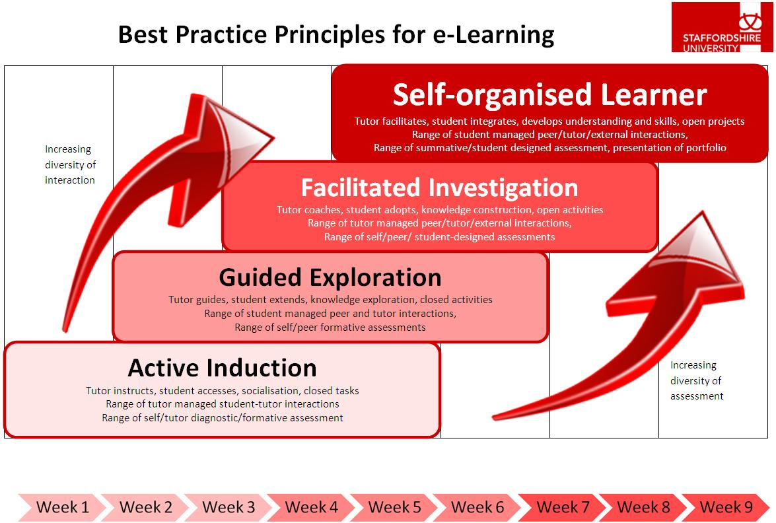
(Walmsley, 2011)
The Best Practice Model of e-Learning, itself suggests similarity with another maturity model which BECTA utilised during the training it facilitated to headteachers, school leaders and ICT subject coordinators through its Strategic Leadership of ICT (SLICT) programme which ran from 2002 to 2007:-

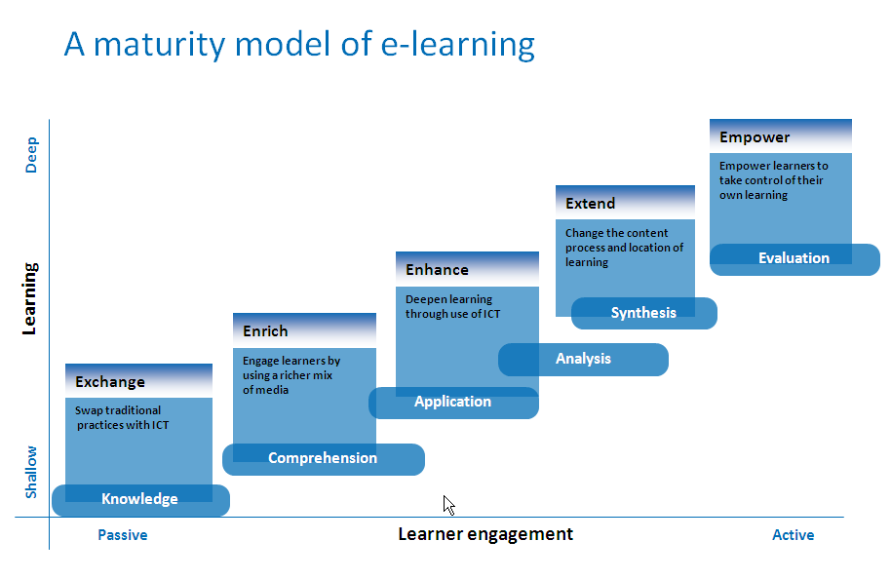
(BECTA, 2001; e-Confidence, slide 8)

In each of these models/frameworks, the locus of responsibility for learning and e-learning undergoes a notable ‘shift’ from expert to apprentice, from the self-confident to the self-effacing, from the ‘teacher’ to the ‘learner’. The corresponding journey of increasing confidence, competence and co-construction with regards to learning is highly dependent upon the quality of the e-buddy relationship. A sustained period of sharing of skills, knowledge and understanding through an e-buddy approach, as with any sustained period of coaching and/or mentoring, results in more permanent ‘shifts’ in the locus of responsibility and as such this model of providing support, in a collaborative and mutual manner, has a strong message for learning in the technological world of the 21st century.

This manifested itself in the ‘thrown in at the deep end’ nature of the evolution of my own e-confidence following the introduction of the concept of e-buddies in 2010. Having signed up for the e-Treat event in August 2010, one of the discussion forums during the event settled on the subject matter of mind-mapping and concept-mapping as tools for structuring learning within an HE undergraduate or postgraduate environment. Recognising this as an aspect of learning in which technology was enhancing understanding of ‘bigger picture’ concepts, I was drawn in as a user of mind-mapping and an enthusiastic learner of concept-mapping. Whether by luck or design, I was hooked and did not want to let go.

Indeed, the sequence of events from attendance at the e-Treat in August 2010 and the subsequent follow-up request from me to Helen for us to become e-Buddies in order to develop a wiki for concept mapping, through to contributing to the ‘Ask the Experts’ event in December 2010 have had a profound effect on my practice and my pedagogical outlook.

I have since introduced the collaborative use of Concept Mapping to one of my MA Education groups at the beginning of their Interprofessional Working module. The initial reaction of group was to humour me, going along with the request to work in pairs and threes on a very basic outline of a concept map on Interprofessional Working in hardcopy A3 poster format for them to note down their thoughts and ideas or concepts directly onto the map.

After a very short introduction to concept mapping from video resources made available on the e-Treat site within the university’s VLE, the MA Education students were invited, after some collaborative dialogue and contributions onto the paper version of the concept map, to add to the electronic version of the map on the PC which was driving the software and was connected to an interactive whiteboard.

A useful additional tool was the record function which allowed me to track each and every alteration to the map and this was to prove useful when it was played back to the students the following week so that they could reflect on the collaborative concept map as it grew from their contributions into a summary document of their collaborative efforts. This function also allowed me to demonstrate the activity I had used to introduce the idea of concept mapping to my students, when I was asked by Helen to contribute to the ‘Ask the Experts’ event in December 2010. Not only had the e-buddy relationship, by that time, given me the confidence to try new approaches to teaching and learning, but it also challenged me to contribute to an event in which, in the past I would have been a spectator rather than active participant.

The impact of introducing concept mapping to this module, on interprofessional working was profound;

‘when we were introduced to the concept mapping exercise and started to explore what was meant by interprofessional working I suddenly got it, I understood what it was all about’ (MA Education student, 2010).

In previous assessments of this module, students had struggled with the concept, resulting in a set of assignments which were ‘ok’ but nothing stunning. By changing pedagogical approaches in a very practical way, students had locked on much more effectively to their learning in this module and their assessments reflected that. As a result of the e-buddy scheme therefore practice has been changed, pedagogical approaches have been modified and students’ assessment grades have gone up!

Looking ahead

The extent to which the e-Buddy experience has affected my approach to teaching and learning has been profound. Not only has it encouraged me to try new ideas in my own teaching, it has also enabled me to focus on a model for learning which summarises where my thoughts on pedagogy are currently being drawn.

David Hargeaves, in the series of booklets outlining his vision for Personalising Learning (2004), describes a model of 9 Gateways through which learning could be effectively personalised, each gateway needing to be developed in order to achieve deep rather than superficial pedagogical practice. Grouping these ‘gateways’ into 4 themes or ‘Deeps’, Hargreaves went on to extend his model to one in which the Deep Experiences of curriculum development and new technologies, merged with Deep Learning, Deep Support and Deep Leadership as outlined in the following mindmap illustration of his model:-

Adapted from Hargreaves ‘Clustering the gateways to PL: the deeps’ (2006, 7)

It is this framework which drives my own rationale for making learning engaging, meaningful, authentic and contextualised for the individual learner. It also provides a focus for developing three key elements of Deep Learning, namely ‘Learning to Learn’, ‘Assessment for Learning’ and ‘Learner Voice’. ‘Learning to Learn’ and the ability to know oneself as a learner will continue to be a driving force for the development of the courses that I run and the metacognition training programme, Let Me Learn, devised and developed by Christine Johnston (1998), provides the momentum for this aspect of Personalising Learning.

However, the relevance of the Hargreaves model of PL to my experience of the e-Buddy relationship which I have shared with Helen, lies in the Deep Support elements of both ‘Mentoring and Coaching’ and ‘Advice and Support’. It also provides a link with the Deep Experience of ‘Curriculum’ and ‘New Technologies,’ the latter being the context for Helen’s vision for the e-Treat, her Best Practice Model for e-Learning and the mutually supportive role of the e-Buddy.

It is my intention to build on these aspects of pedagogical development initially within my own MA Education modules, by personalising learning to the extent that students develop the following characteristics, as identified by Hargreaves (2005,3):-


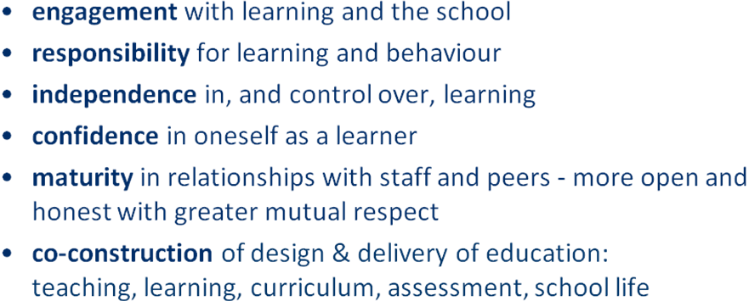
Although originally constructed with schools in mind, this framework also lends itself to both FE and HE settings, for younger learners and adults alike. In a maturity model format it offers a tool for both self-assessment and/or tutor assessment of a student’s capability to take greater strategic responsibility for their own learning, ie for the locus of learning, as identified within the e-Buddy coaching and mentoring model, to move from teacher to learner, from expert to skilled apprentice, from a prescriptive to a constructivist approach.

The future of the e-Buddy model of support, whether seen as a coaching or mentoring relationship or some other kind of supportive collaboration, is key to the concept of learning in the 21st Century and of learning with and through new technologies.

Epilogue
Further dialogue with Helen during the writing up of this e-Buddy experience has introduced many new conversations and ideas. One of particular note and interest to my own professional learning is that of metacognition, knowing oneself as a learner. As mentioned within the article, my interest in the ‘Let Me Learn’ programme led me to invite Helen to complete a Learning Connections Inventory so that I might offer her suggestions as to which learning patterns she might ‘use first’, ‘use as needed’ or ‘avoid’. It occurred to me that through the sharing of one another’s learning pattern profile in this way, that the insights into knowing how your e-Buddy learns and having a shared language for discussing and understanding learning would be an immensely valuable tool for being an effective online (or face-to-face) for that matter e-Buddy, mentor, coach or co-coach. In fact how could you be really effective in any of those roles without having that knowledge and understanding of how yourself and others, learn. To be continued……

Additional Information
If you would like to know more about Concept Mapping and the ‘Let Me Learn’ programme, please contact me at s.j.hall@staffs.ac.uk

Bibliography
BECTA (2001) Strategic Leadership of ICT; Training Materials BECTA
Brockbank, A. & McGill, I. (2006) Facilitating Reflective Learning Through Mentoring & Coaching Kogan Page
Claxton, G. (2002) Building Learning Power: Helping young people become better learners TLO Ltd Bristol
Clutterbuck, D. (4th edition 2004) Everyone Needs a Mentor Chartered Institute of Personnel and Development
Clutterbuck, D. & Megginson, D, (2005) Techniques for Coaching and Mentoring Elsevier Butterworth-Heinemann
Cunningham, B. (2005) Mentoring Teachers in Post Compulsory Education A Guide to Effective Practice David Fulton
Department for Education and Skills & CUREE (2005) National Framework for Mentoring and Coaching DfES
Dryden, G. & Vos, J. (2005) The New Learning Revolution Network Continuum Education
Dweck, C.S. (2008) Mindset: the new psychology of success Ballantine Books
Gilbert, A. & Chakravorty, I. (2002) Go MAD about Coaching – helping people to think in a Solution Focused Way Go MAD Books, Leicester
Hargreaves, D (2005) Personalising Learning 5: Mentoring & Coaching and Workforce Development Specialist Schools and Academies Trust
Hargreaves, D (2006) A New Shape for Schooling? Specialist Schools and Academies Trust
Hattie, J (2009) Visible Learning: a synthesis of over 800 meta-analyses relating to achievement Routledge, Oxford
Johnston, C. (1998) Let Me Learn Corwin Press
Lucas, B. & Claxton, G. (2007) The Creative Thinking Plan: how to generate ideas and solve problems in your work and life BBC Books
Lucas, B. & Claxton, G. (2010) New Kinds of Smart: how the science of learnable intelligance is changing education Open University Press
Melevede, P.E. & Bridoux, D.C. (2004) Mastering Mentoring and Coaching with Emotional Intelligence Crown House
Perkins, D (2009) Making Learning Whole Jossey-Bass, San Francisco
Rhodes, C., Stokes, M. and Hampton, G. (2004) A Practical Guide to Mentoring, Coaching and Peer-Networking: Teacher Professional Development in Schools and Colleges. London: Routledge Falmer
Rowley, J. (2006) Becoming a High-performance Mentor: A Guide to Reflection and Action Sage Publications Inc (USA) - Corwin Press
Stoll, L., Fink, D. & Earl, L. (2003) It’s About Learning (and it’s about time): What’s in it for schools? Routledge-Falmer; London and New York
Turnbull, J. (2009) Coaching for Learning – a practical guide for encouraging learning Continuum International Publishing Group
Vanhear, J. (2008) Concept Mapping, Vee Heuristics and the Learning Process: towards a meta-learning experience Journal of the 3rd international conference on Concept Mapping; Tallinn, Estonia & Helsinki, Finland
Walmsley, H. (2011). Best Practice Models for e-Learning. [Online]. Retrieved March 19, 2012, from http://learning.staffs.ac.uk/bestpracticemodels/
Walmsley, H. (2012). Case study: A community of practice for constructivist professional development in e-Learning. Innovative Practice in Higher Education, 1(2), 1-11.

