Case study: A community of practice for constructivist professional development in e-Learning

Helen Walmsley (e-Learning Models Coordinator)

Staffordshire University

Corresponding author: H.Walmsley@staffs.ac.uk

Abstract
Communities of practice, social learning and constructivist learning are all increasingly seen as models for workplace learning but have rarely been applied in educational institutions for professional teacher development. This case study describes the use of both a constructivist and community of practice approach to e-learning skill development through two online events – the ‘e-Treat’ and ‘Ask the Experts: Mind-mapping’. These events have been designed using an e-Design template in order to embed constructivist principles of e-learning that support and scaffold learning. The ‘e-Treat’ also incorporated an e-Buddy system to provide peer-support and mentoring to participants. These events suggest that it is possible to plan, design and deliver effective professional development that incorporates a constructivist pedagogy in a community of practice approach.

Keywords: Teacher development; e-learning; community of practice; social learning; constructivist; learning design

Introduction
Since the 1990s a revolution has been taking place. The traditional theories of learning following a transmissive model (whereby content is delivered by a teacher to a learner and therefore ‘learned’) have largely been swept away by the tide of social constructivist theories that suggest learning occurs by activity, by interaction with others and by constructing our own understanding.

In their preface, Jonassen and Land say of these contemporary learning theories,

“At no time in the history of learning psychology has there been so much fundamental agreement about the epistemology, ontology, and phenomenology of learning.”
(Jonassen & Land, 2000)

This shift in learning theory has implications for both teaching and learning and for the professional development of teachers, especially those trained more than a few years ago. For example, constructivist approaches suggest the following kinds of learning approaches/activities should be utilised for effective learning:

- the significance of learners' previous knowledge, beliefs, conceptions, and misconceptions
- paying attention to learners' meta-cognitive and self-regulative skills and knowledge
- an emphasis on negotiation and sharing of meanings through discussion and collaboration
- the use of multiple representations of concepts and information
- the need to develop instructional methods that take into account the situational nature of learning and thus integrate knowledge acquisition and knowledge use
- the need to develop assessment procedures that are embedded in the learning processes, focus on authentic tasks and take into account learners' individual orientations and foster their meta-cognitive skills
(adapted from (Tynjälä, 1999)

As professional teachers we are encouraged to use these constructivist approaches and utilise a range of activities, interactions, discussions and group work to support effective learning. However, e-learning professional development for teachers has all too often been composed of training programmes planned by managers along a transmissive model that consists of isolated workshops with little room for constructivist activity, interaction with peers or sustained reflection. These workshops are generally designed to achieve an institution’s strategic plans for the integration of e-learning in teaching and learning and can be planned up to 18 months in advance. Alternatively, teachers are sometimes offered access to accredited e-learning programmes that deliver a prepared curriculum that may be planned years in advance and have their own set of learning outcomes that are not necessarily linked to those of an institution. So how can these constructivist principles be embedded in professional development? As Jones puts it:

“It’s my argument that there exists a dissonance between the philosophical underpinnings expected of good teaching and learning and the philosophical underpinnings of how universities attempt to encourage and enable good teaching and learning, especially in e-learning.”
(Jones, 2011)

At Staffordshire University e-learning staff development is delivered through a range of initiatives. This includes the integration of e-learning modules into accredited CPD modules; an integrative approach that blends workshops with bespoke activities, and the Best Practice Community of Practice (Stiles & Yorke, 2006). Communities of practice are “groups of people who share a concern or a passion for something they do and learn how to do it better as they interact regularly.” (Wenger, 2006) This approach can enable interactions, activities and collaborations to take place that can support the ongoing professional development of practitioners in a social constructivist setting (Wenger, 1999). By allowing more flexible and practitioner-centred activities, this approach also enables a naturalistic approach to professional development. A naturalistic approach takes account of the complexity, changeability and inherent ‘unknowability’ of the interactions between the practitioners’ learning needs, the institution’s needs and the learners’ needs (Kurtz & Snowden, 2007). In addition to supporting the individual learning of the practitioner, Professional Learning Communities can improve classroom learning and achievement (Saunders, Goldenberg, & Gallimore, 2009; Vescio, Ross, & Adams, 2008). The Best Practice Models for e-Learning community of practice is an online facilitated space that plans and supports activities based on constructivist principles. These activities are aligned broadly with the aims of the institution, but are flexible enough to allow practitioners to focus learning on their own interests and needs.

So how can professional development for e-learning exemplify social constructivist theory and so enable effective learning by practitioners? Can activities be developed that allow practitioners to both experience constructivism as learners, and develop the expertise needed to apply it in practice? This case study describes how two staff development activities facilitated constructivist learning for practitioners in a community of practice, and led to one participant (SH) changing his teaching practice to include a constructivist activity using technology. The companion case study by SH (Hall, 2011) describes his experience as a new member of staff accessing these events and the impact it had on his learning and performance.

Methodology
This case study aims to describe the design, delivery and outcomes of two related professional development training sessions. Yin (Yin, 2009) argues that case study research is an all-encompassing methodology that focuses on a contemporary phenomenon in its real-life context and relies on multiple sources of evidence. This case study has therefore attempted to include details of the pedagogic design principles, the delivery methods and data from user surveys. In addition, the case study is presented in this volume with the companion case study authored by one of the participants to offer an alternative perspective.

The Best Practice Models for e-Learning Community of Practice
The Learning Development and Innovation team at Staffordshire University started the Best Practice Models for e-Learning project in 2006. This aimed to make available a range of existing models for e-learning activities in an online environment accessible for interested practitioners from within the university and the wider educational community. A range of discussions, workshops and events has been facilitated to support engagement with, and sharing of the different models. There are other examples of e-learning professional networks that are informal and unstructured such as the ILT Champions and MirandaNet, but the scaffolded, activity-led approach taken by the facilitator for the Best Practice Models community has enabled focussed discussions on carefully selected topics using specially commissioned case studies. Since the project started, a number of different types of workshops and events have been designed and run. For example, the series of ‘Ask the Expert’ sessions included a small selection of (usually commissioned) case study presentations followed by a discussion in the online forum. These events usually included the synchronous and asynchronous use of a forum, and latterly, the use of a web-conference for the case study presentations. The case studies and discussions were still available to the community after the event for review and reference. Feedback suggests that these events were an effective way for practitioners to both share their experience, and to learn about the application of e-learning. These popular events provided a space for practitioners at all levels of development to learn from each other, share expertise and network. (See appendix 1 for access to this site.)

The scaffolded learning design for these online events is based on the e-Design template. This is a new model developed on constructivist principles from a range of guides and models (mostly available in the Best Practice Community). It is intended to support practitioners when creating learning designs for e-learning. The template embeds principles to guide the development of quality e-learning and scaffolding to guide the development of learners. These principles are:

- E-Learning is designed in timed chunks that emphasises time on task and expectations
- E-Learning is assessed using a range of types (self/peer/tutor) and options/choices
- E-Learning includes a variety of interactions between student/ tutors/ peers/ externals
- E-Learning is accessible, activity-led, collaborative and designed in phases that support, scaffolds and increases learner independence
(Walmsley, 2011)

The principles are mapped to the e-Design template that can be used to plan and share learning designs:

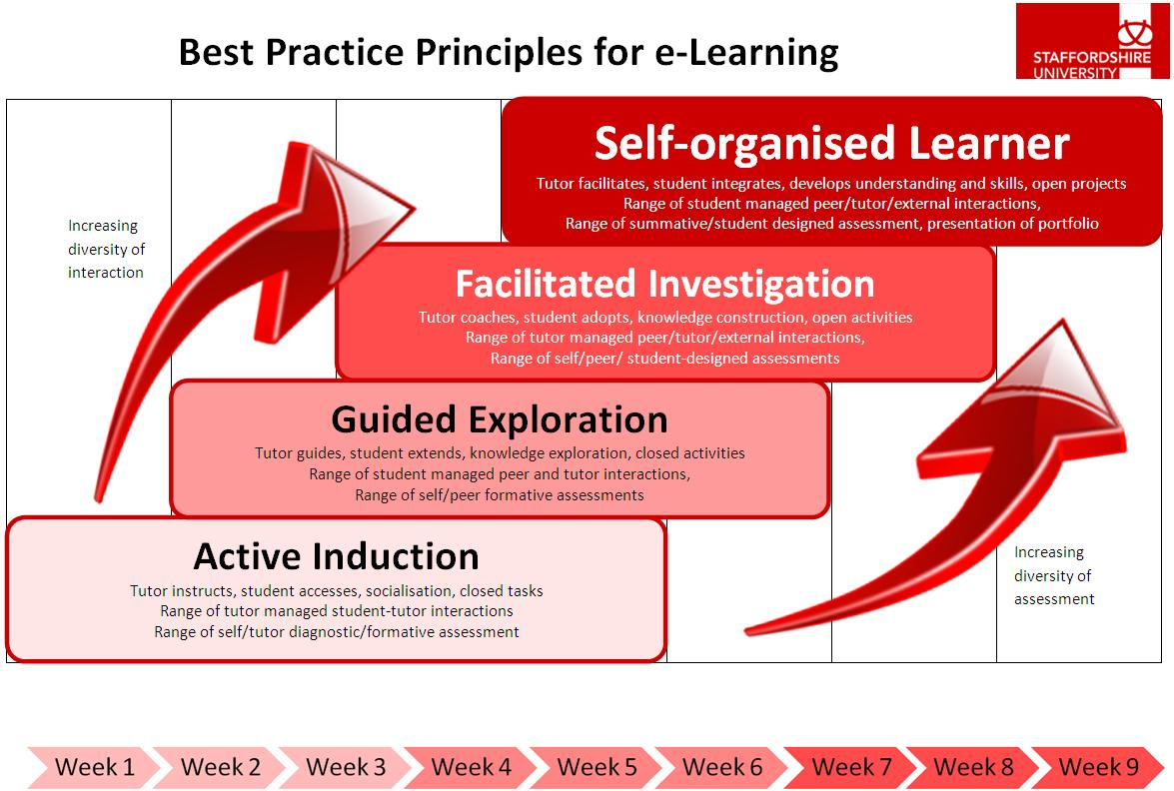

The scaffolding is comprised of online learning activities that begin as teacher-managed and closed-task which gradually change to learner-managed and open-task. This approach enables the learning design to both support the novice online learner as well as gradually facilitate more challenging tasks for expert online learners. It also models the change from a transmissive to a constructivist learning environment. This case study explores the learning design and the experience of learners in two online workshops, the ‘e-Treat’ and the ‘Ask the Experts: Mind-mapping’.


The e-Treat (August 2010)
The e-treat concept was inspired by a case study of a successful face-to-face writers’ retreat that enabled participants to take time away from home and work to focus entirely on writing for publication. To what extent is the success of a writers’ retreat due to the psychological space created? Could this be converted to a virtual space? E-Learning practitioners and designers often work individually or in small teams and can feel isolated. During the summer of 2010 the facilitator planned a new format for an online event that would enable practitioners to come together in a virtual online space to work on their own project, support and motivate each other and offer feedback on progress. In addition, an ‘e-Buddy’ was introduced to increase the peer support available.

The e-treat consisted of three days of virtual online activity. There were a small selection of optional web-conferences and discussions, but the bulk of the time was set aside for participants to work on their project. The programme was as follows:

Day 1
09:30-10:00 Post a short introduction to yourself and your project
10:00-10:30 Send your assigned ‘e-Buddy’ a message and arrange a meeting
12:00-12:30 e-Learning Design: Join the web-conference
16:30-17:00 Round-up of day 1 in the web-conference room
Day 2
09:00-10:00 Tell us an inspiring e-learning story in the forum!
12:30-13:30 Lunch with your e-Buddy
16:30-17:00 Forum Discussion: How can technologies save time for tutors?
Day 3
09:00-09:30 Evaluating e-Learning: Join the web-conference
12:30-13:30 Lunch with your e-Buddy
15:00-16:00 Show-and-Tell: Congratulations! You've completed the e-Treat!
16:00-16:30 Reflect and Evaluate

The learning design mapped to the e-Design template is as follows:

Active  Induction | Guided Exploration | Facilitated Investigation | Self-organised Learner
Activity 1: Post a short introduction to yourself and a summary of your plans for the 3 days in the forum  Feedback given by tutor in forum  2: Round-up of day 1 in the web-conference | 3: e-Learning Design: Join the web-conference  4: Evaluating e-Learning: Join the web-conference | 5: Tell us a story about e-learning to excite and inspire us in the forum!  6: Forum Discussion: How can technologies save time for tutors?  Feedback given by tutor in forum | 7: Show-and-Tell  Feedback given by tutor in forum  8: Reflect and Evaluate

The learning design was created to embed the principles, as well as moving from tutor-managed, closed-task to learner-managed, open-tasks. The participants in this event had a wide level of experience of using online technologies and their skills ranged from expert to novice.

Five practitioners from the university and the wider educational community provided an outline of their projects to focus on during the e-treat. These included plans to write e-learning modules, staff development courses and explore a specific tool etc. Each participant shared their thinking and progress on their own topic, and participated in most of the online events. They shared their progress on their work so far in the final ‘show and tell’, and most had achieved a high level of quality work together with reflections on the process. The feedback gathered at the end of the e-Treat was very positive about both the event itself and the role of the e-Buddy. Specific comments about the e-Buddy included:

“A buddy was a great idea, it helped to share experience and to take time out. It helped to re-motivate me when my energy levels were dropping.”
“The buddy was a first port-of-call each morning and had the technology been better on my side there are several possibilities for talking things through before posting to the forum.”
“Great, supportive and timely buddy!”

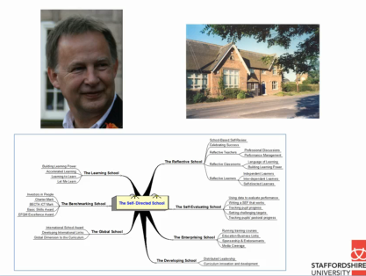
Following on from the event, SH (a colleague from the Business School at Staffordshire University) approached me to say that he’d found the e-Buddy idea very helpful and wondered if it would be possible to continue this with me as his e-Buddy? He wanted to develop his work on the mind-maps and to try to use them with his students. We agreed and it was suggested that he might be interested in presenting a short case study of his findings in one of the forthcoming ‘Ask the Expert’ online events in the Best Practice Models for e-Learning community. We then agreed an action plan and arranged follow-up sessions to review progress and prepare for the online event. SH’s chosen topic to develop further was one that had arisen from his previous experience and was not defined by the institution. See the companion case study by SH (Hall, 2011) for full details of the e-Buddy experience from the practitioner’s perspective. We are now working together to both explore the topic in practice and then present the outcome to the community. This will model the constructivist approach to learning, as well as situating the activity in a community of practice.

‘Ask the Expert: Mind-maps’ (Dec 2010)
The ‘Ask the Expert: Mind-maps’ event was arranged for Dec 2010 and the members of the Best Practice Community were invited to participate. In addition, some members volunteered to present case studies of their experience of using mind-maps in various ways. Several days prior this event, the 20+ participants were able to review the case studies and a number of other resources around using mind-maps in teaching and learning. The event consisted of an open discussion forum in the community with the presenters and the participants. There were 3 case studies presented, including SH’s screen-cast and a lively forum followed where practitioners discussed and shared their learning. The learning design for the event mapped to the e-Design template was as follows:
Screenshot of SH’s screen-cast for the online event http://www.screenr.com/PTq

Active Induction | Guided Exploration | Facilitated Investigation | Self-organised Learner
1: Introduce yourself in the forum  2: Read/watch case studies | 3: Select and read/watch appropriate and relevant resources | 4: Discuss case studies with presenters and participants in forum

A selection of forum postings is given below:

SH: “I'm just starting to explore concept mapping as a means of making connections between one idea and another and making them more explicit. I find that with mind-maps I put the ideas down in single words or short phrases but the connectivity with other 'branches' stays in my head rather than articulated on the map.”
MJ: “I quite like the idea of using Mindmanager as it allows stitching together. I can see how useful it would be in group based work. It is certainly worth trying.”
HJ: “Although I'm a very verbal person, I'm also someone who seems to be just permanently frustrated by ways information is presented and shared with others on our course (colleagues think I just want to work in advertising/ marketing, given the way I bang on about fonts, displays, use of pictures, colours etc!), so I got interested in these tools because I wondered if it would feel like a more organic way to develop thinking, see the 'whole' and work collaboratively with people who think differently from me. I'm a little wary, though, that it can be too easy to get caught up with the software for its own sake.”

The participants ranged from those completely new to using online mind-maps in their teaching, to those who had experience and expertise. The discussion included a wide range of responses between peers that demonstrates the opportunity for constructing meaning through social interaction. However, the scaffolding of activities and combined asynchronous and synchronous timing allowed ease of engagement and high value for busy practitioners.

The feedback from participants shows a high level of satisfaction with the event:
# | Question | Agree strongly | Agree | Disagree | Disagree strongly | Responses | Mean
1 | My IT Skills have improved due to this workshop | 1 | 7 | 1 | 0 | 9 | 3.00
2 | My IT confidence has improved due to this workshop | 2 | 5 | 2 | 0 | 9 | 3.00
3 | I am more enthusiastic about applying this technology/skill due to this workshop | 3 | 6 | 1 | 0 | 10 | 3.20
4 | I will be trying out this technology/skill within the next month due to this workshop | 3 | 5 | 1 | 0 | 9 | 3.22
5 | This workshop has inspired me to experiment with this technology/skill | 5 | 4 | 0 | 0 | 9 | 3.56
6 | This workshop has inspired me to innovate in my teaching | 4 | 5 | 0 | 0 | 9 | 3.44
7 | I would recommend this workshop to my colleagues | 7 | 3 | 0 | 0 | 10 | 3.70

Since the ‘Ask the Experts’ activity, SH has continued to explore his use of online mind-maps with his students and has been reflecting on their effectiveness.

Conclusion: A model for staff development?
This case study demonstrates that professional development has been enabled through the combination of an online community of practice and a constructivist approach to learning activity.

The Best Practice Community is a Staffordshire University initiative that attempts to encourage innovation whilst also managing the institutional tensions that can arise from innovation by providing models of best practice and a supportive community of practitioners in which reflective development can take place (Walmsley & Yorke, 2010). Activities that take place in the community draw on constructivist principles, for example, the opportunities for participants to share their own knowledge, collaborate and site their learning in their own authentic work contexts.

Practitioners in the ‘e-treat’ and the ‘Ask the Experts’ event were able to learn and develop through the process. In addition, the support of an e-Buddy has been significant in providing the commitment to action necessary for the preparation and presentation of a case study on progress back to the community. Thus the learning community both learns and shares its learning. The process of SH’s personal development can be mapped to the e-Design template to illustrate the way the principles and the scaffolding have been embedded:

Active  Induction | Guided Exploration | Facilitated Investigation | Self-organised Learner
- Attend e-treat and participate in activities  - Peer informal assessment of project outcomes in e-treat | - Buddy sessions to explore mind-mapping in more detail  - Buddy informal evaluation | - Presentation at ‘Ask the Experts’ event on experience of using mind-maps  - Peer informal evaluation | - Reflection on own learning progress.  - Buddy sessions to plan and support work on written case studies  - Authentic assessment of peer-reviewed and published case study

Hart (Hart, 2011) suggests that workplace learning be measured in terms of performance improvement, rather than quantifiable metrics, and SH’s evaluation of the impact these two events have had on his own performance is significant:

“As a result of the e-buddy scheme therefore practice has been changed, pedagogical approaches have been modified and students’ assessment grades have gone up!”
(Hall, 2011)

In conclusion, it can be seen that a community of practice and constructivist approach to professional development can be both effective and empowering. Additional e-treats, online and face-to-face workshops are planned that will encourage professional learning in a constructivist community. In addition, the e-buddy scheme is being expanded with the option for staff to identify their own learning requirements and be supported in achieving their learning and sharing it with the community.

Appendix 1
If you would like access to the Best Practice Models for e-Learning online community, then please see the website:
http://learning.staffs.ac.uk/bestpracticemodels/ Once you have created an account, access the community with the key BP06 (case sensitive)

References
Hall, S. (2011). Modelling a constructivist approach to continuing professional development through e-Buddies. Innovative Practice in Higher Education, 1(2).
Hart, J. (2011). Social Learning doesn’t mean what you think it does: PART TWO Learning in the Social Workplace. [Online]. Retrieved September 15, 2011, from http://www.c4lpt.co.uk/blog/2011/09/13/social-learning-doesnt-mean-what-you-think-it-does-part-two/
Jonassen, D. H., & Land, S. M. (Eds.). (2000). Theoretical foundations of learning environments. Mahwah: L. Erlbaum Associates.
Jones, D. (2011, March 2). The dissonance between the constructivist paradigm and the implementation of institutional e-learning. [Online]. Retrieved May 10, 2011, from http://davidtjones.wordpress.com/2011/03/02/the-dissonance-between-the-constructivist-paradigm-and-institutional-e-learning/
Kurtz, C. F., & Snowden, D. J. (2007). Bramble Bushes in a Thicket: Narrative and the intangibles of learning networks. In M. Gibbert & T. Durand (Eds.), Strategic Networks: Learning to Compete (pp. 1-25). Oxford: Blackwell.
Saunders, W. M., Goldenberg, C. N., & Gallimore, R. (2009). Increasing Achievement by Focusing Grade-Level Teams on Improving Classroom Learning: A Prospective, Quasi-Experimental Study of Title I Schools. American Educational Research Journal, 46(4), 1006-1033.
Stiles, M. J., & Yorke, J. (2006). Technology supported learning – Tensions between innovation, and control and organisational and professional cultures. Journal of Organisational Transformation and Social Change, 3(3), 251-267.
Tynjälä, P. (1999). Towards expert knowledge? A comparison between a constructivist and a traditional learning environment in the university. International Journal of Educational Research, 31(5), 357-442.
Vescio, V., Ross, D., & Adams, A. (2008). A review of research on the impact of professional learning communities on teaching practice and student learning. Teaching and Teacher Education, 24(1), 80-91.
Walmsley, H. (2011). Best Practice Models for e-Learning. [Online]. Retrieved May 11, 2011, from http://learning.staffs.ac.uk/sun/pg/pages/view/4391/
Walmsley, H., & Yorke, J. (2010). eLearning Models: a Web 2.0 approach to staff development in Higher Education. In D. Parkes, L. Hart, & G. Walton (Eds.), Web 2.0 and Libraries: Impacts, Technologies and Trends. Oxford: Chandos Publishing (Oxford) Ltd.
Wenger, E. (1999). Communities of Practice: Learning, Meaning, and Identity (Learning in Doing: Social, Cognitive and Computational Perspectives). Cambridge: Cambridge University Press.
Wenger, E. (2006). Communities of practice: a brief introduction. [Online]. Retrieved May 17, 2011, from http://www.ewenger.com/theory/
Yin, R. K. (2009). Case study research: design and methods (4th ed.). London: SAGE.

