Crafting strategic thinking: Creative pedagogy for management studies

Clive Holtham¹, Monica Biagioli², Allan Owens³, Anne Pässilä⁴,

¹Bayes Business School, City, University of London
²London College of Communication University of the Arts London
³University of Chester
⁴LUT University, Lappeenranta, Finland

Corresponding author: c.w.holtham@city.ac.uk

Abstract
This paper presents a format from the creative arts, refocused for application in management studies, as a method to enhance and support the development of strategic thinking. It involves the application of multi-page paper constructions (zines) within facilitated sessions to enhance imaginative strategic thinking by both management learners and practitioners. It draws on a longitudinal case study of the six-phase evolution of affordances of a zine as a method for reflective, creative and connected thinking. The focus moves from purely personal private reflections to the possibility of deploying zines for collective reflection and action. Specific examples are provided of zine workshops and events. Strategic thinking relates to volatility, uncertainty, complexity and ambiguity (VUCA). The affordances of zines relating to tangibility, efficiency and mental processes appear well-suited to a VUCA context. The paper concludes with reflections on the nature of multi-disciplinary and trans-disciplinary collaborations such as this one.

Keywords: zines, reflection, VUCA, embodiment, paper-folding, innovation

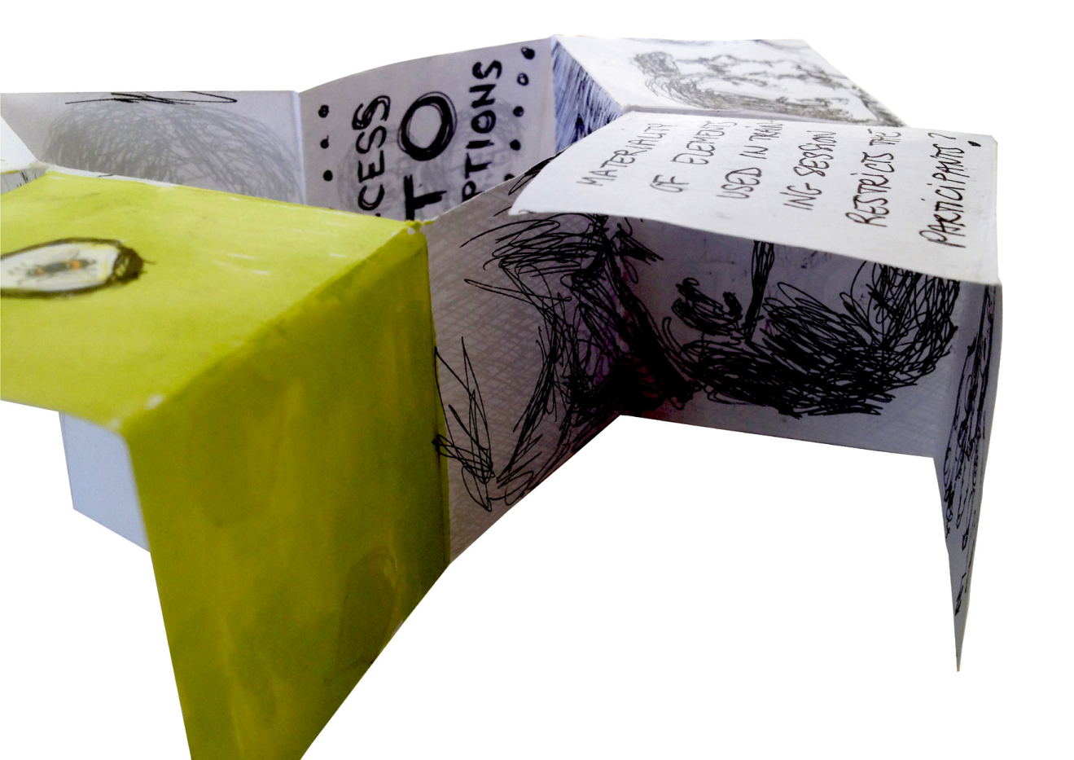
Figure 1: Zine from Dresden workshop 2016

Research question
This paper traces the evolution of a multi-year case study involving the application of an ancient craft (paper-folding) to provide an innovative modern tool for personal reflection and analysis and, latterly, to provide a distinctive vehicle to support organisational change in business and management. The discipline of art and design continues to develop innovative tools and methods, such as, the method presented here applying multi-page format publications (‘zines’; e.g. Figure 1) for developing self-reflection and analysis capacity. The research question addressed was: how can we best apply the ‘zine’ method to support the development of strategic thinking within management studies to enhance self-reflection and promote creativity in addressing management questions in a VUCA (volatility, uncertainty, complexity and ambiguity) framework?

In the final sections of this paper, we address the question: what are the barriers and accelerators to transposing the “zine” method to unrelated disciplines such as business and management?”

Research methods
Referencing Hamilton (2011) this case study “focuses on the idea of a bounded unit which is examined, observed, described and analysed in order to capture key components of the ‘case’.” In this paper, the bounded case consists of an educational innovation, as evolved and extended by a loose group of four collaborators over a seven-year period. Using Stake’s (1995) terminology, this is an “instrumental or delimited” case study, with a narrow focus on an issue within the case, here specifically the barriers and accelerators to transposing zine tools from art and design to business and management. Miles (2015) argues, in a way which relates particularly to the diverse data drawn on in this paper:

“it is the diverse methods of data generation that are enabled through case study – interview, observation, document, survey, artwork, image and photographical representation – and through which provide an account of practice situated in time and space, contributing to the epistemological representation of practice.”

Given the potential problems with case studies written by participants (Cochran-Smith, 2005), we have taken specific steps to reduce some of those problems. Firstly, there has been a strong emphasis on documentation of all events, not least use of photography and, where possible and desirable, audio or video; latterly audio tracks have usefully produced transcripts automatically. Since November 2019 all key documentation gathered since 2016 has been backed up to a shared online repository. Secondly, each event since 2018 has had explicit written contemporaneous after-action reviews by one or more collaborators. Thirdly, at least one and sometimes more than one collaborator has kept a reflective journal relating not only to the events, but also to the collaboration process. Finally, retention of emails since 2014 has enabled quick cross-checking of both content, and above all dates, which were sometimes dramatically inaccurate based on memory alone.

This case study evolving since 2014 can be portrayed as educational action research (Ulvik et al., 2018), but since this was not explicitly articulated by the co-authors until 2019, this does not seem currently appropriate.

How the affordances of zines aid learning
Paper folding and zines
To better comprehend the application of ‘zines’ outlined here, it is important to trace some key historical reference points. The ‘technology’ of paper-folding has origins both as art and as craft, as well more instrumentally in printing. The history of paper folding as a craft is well understood in relation to origami, although the particular approach used in this case study is in fact kirigami, which involves cutting as well as folding the paper. However, what might be called the artistic perspective on paper folding has tended to attract more attention than a more instrumental approach, namely the creation of publications through folding larger sheets of paper. In the modern era, folding down large sheets is established within artist book production (Golden, 2010). However, in terms of their evolution as a tool for learning and innovation, zines are connected more with the fanzine movement.

Zines (small (maga)zines) have roots in the do-it-yourself movement (Piepmeier, 2008). The idea and use of the zine has emerged over time, from the early leaflets and pamphlets produced by independent publishers in the late 18th century, to the amateur press movement of the 19th and 20th centuries, to the subculture of fandom that emerged in the 1930s in science fiction. In the Post-World War II period, with the growth of duplication and then photocopying, many different genres of zines evolved, often representing protest and challenges to the status quo; most notably as part of the punk and riot grrrl movements (Thomas, 2008).
In this paper the term zine is used to describe a folded paper artefact that is primarily designed for individual reflection. However, since a key purpose of the folded paper artefact in this case study is to create a publication (if only a single copy), this can also be regarded as part of the enterprise of making low circulation publications, known as ‘zines’. In this way, the approach aligns with the do-it-yourself resonances and the accessibility of the method that the term implies. Still, our focus is on the design response of the ‘zine’ as a means for self-reflection and to improve communication, not only as a way to package and distribute content.

Six-phase evolution of the zine: from reflection to innovation
Our application of zines as affordances within development processes can be traced in six phases: from an exchange of underlying principles that led to initial collaboration (phase 1: 2014); to an initial prototype and application of the ‘zine’ as affordance (phase 2: 2016); to the expansion and enhancement of the method as part of a three-year international research project (phase 3: 2017-2019); to a re-framing of the method for business audiences (phase 4: 2019); to adapting the method for fully-online deployment (phase 5:2020); and, finally, to evolving the method to its current iteration as a means to address problematic change in the organisational context (phase 6: 2021).

This retrospective division into phases was determined by the interplay of three factors:
- Roles of the key participants
- Distinct differences in the nature or purpose of the zine activity
- Place - physical or virtual

The 6 phases of the collaboration have been used as an organising framework for the whole paper: Table 1 below provides a breakdown of the phases. There have been four individuals centrally involved in the evolution during at least one phase; the only person who has been involved in all six phases is the art and design academic, Monica

Table 1 The six phases of the case study
Year | Phase | Partners |  |  |  | Key activities
 |  | Allan | Anne | Monica | Clive
2014 | 1 | X | X | X |  | Initial contact by Monica with “art of management” community; support from Allan & Anne
2016 | 2 | X | X | X |  | Prototype: Exposed by Allan, Anne and Monica to business learning and knowledge experts at conference
2017-2019 | 3 | X | X | X | X | Became core reflective tool of multi-national research network, led by Allan and Anne, of which Monica and Clive were members
2019 | 4 |  |  | X | X | Re-framing for business audiences by Monica and Clive
2020 | 5 |  |  | X | X | Adapted by Clive, with Monica, for fully online deployment
2021 | 6 |  |  | X | X | Monica and Clive evolve for problematic change in organisations

Although the artefacts involved retained their recognisable historic forms, what happened over the seven year evolution of the method, was that the processes through which individual artefacts were created by learners, was subject to constant experimentation, evolution and enhancement. Although initially the artefacts had a strong focus on playful, artistic creativity, other purposes evolved, most notably as a vehicle for business creativity, and latterly to provide an approach to addressing problematic organisational change. The organisation into phases and the analysis of the steps have been conceptualised entirely retrospectively, in fact as a result of the writing up of this case study.

The shifting evolution of the method can be summarised through the stages investigated in this paper: the trajectory of focus of the application from self-reflection to innovation; the transposition of the method for business pedagogic application; and reflection on the nature of trans-disciplinary collaboration. Later in the paper, this trajectory will be augmented to take account respectively of the online/face-to-face distinction, as well as the nature of the disciplinarity involved.

Case Study from Phase 3: Vic, Spain workshop. 2017.
The initial phase (phase 1) provided the context for the collaborative work that followed, with an emphasis on arts based methods applied to innovation processes. Phase 2 was the initial stage of prototyping the constructions and developing a method for deploying the affordances within a process. Phase 3 was a refining stage of applying the affordance within a process, evolving the constructions, the delivery of the sessions, and their focus through a three-year focused research development. The case study of a zine method workshop provided here is from phase 3 and is foregrounded because it became a template for future sessions. The workshop was conducted by C with the express aim to provide an immediate flavour of the application of zines to the research team as a whole.

The workshop was conducted during an Erasmus research group working session at the University of Vic, Catalonia in May 2017 and was part of the UK research team contribution on Key Theory & Practice. Monica set up the stage for her session by creating a mini-exhibition of a variety of zine constructions in acid green and metallic grey paper stocks. Tables were set up for working with mats, cutters, paper stocks, markers and pencils and stickers. The session began with a short digital introduction to set up the context of the session and frame the application of the method as a pedagogic device for reflection and communication during a process. This was followed by a demonstration of the range of constructions accessible in the mini-exhibition.

After this introduction, participants were led through a step-by-step instruction of how to create the zine construction template (Figure 2). All participants created their own zine during the session and then were invited to exploit their affordances throughout the rest of the working group sessions. Monica incorporated a level of agency into the process, so that participants had the choice to show their work in progress and submit their artefacts to the researcher. To conclude the research working group session as a whole, there was a final showcase in Barcelona, Spain the following week (called ‘the Multiplier’ session) and the zine construction method was chosen as the method for the public to participate in the event. Figures 3 and 4 provide examples of public participation in the zine method during a conference in Barcelona later in the research project inspired by this application (phase 3).

The Vic workshop became a template for how to set-up and conduct sessions applying multi-page formats within a development process, with a ‘show-and-tell’ phase at the beginning, a ‘do-it-yourself’ activity to create the constructions, followed by a focused application of the format as part of a development process, and concluded with a public showcase of exemplars provided by the participants. The emphasis on agency that evolved throughout Phase 3 has become a core element of zine method application, with clear instructions delivered at the start of the sessions that enable participants to choose the level of their engagement and how much they reveal as part of a larger research project.
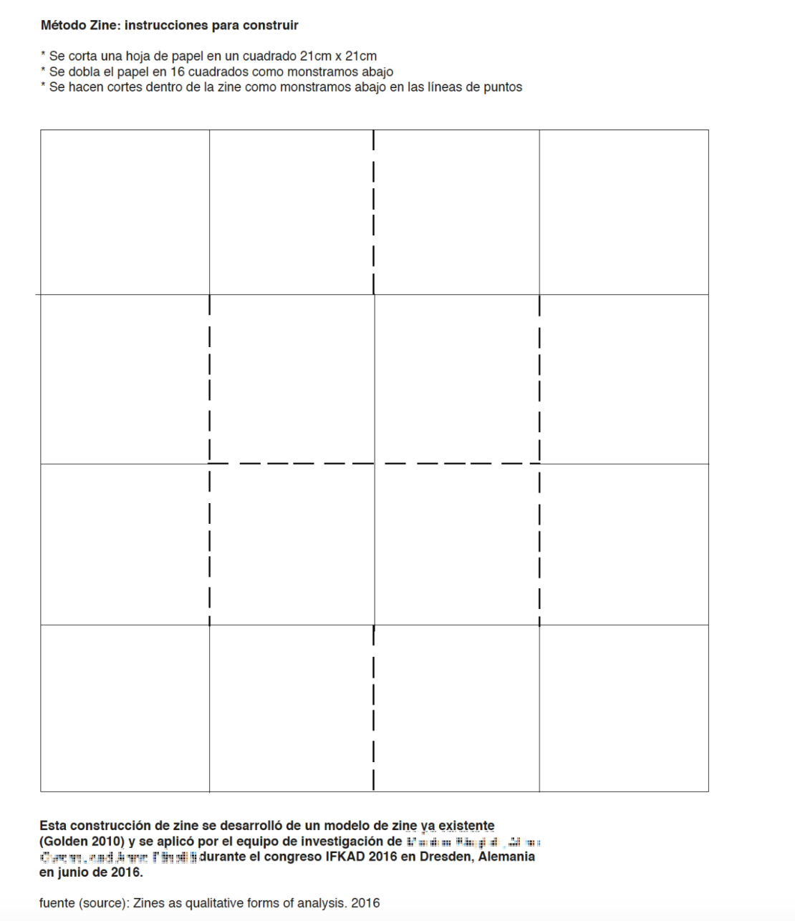
Figure 2: Zine method construction instruction sheet provided to participants of Phase 3 Vic session. 10 May 2017.

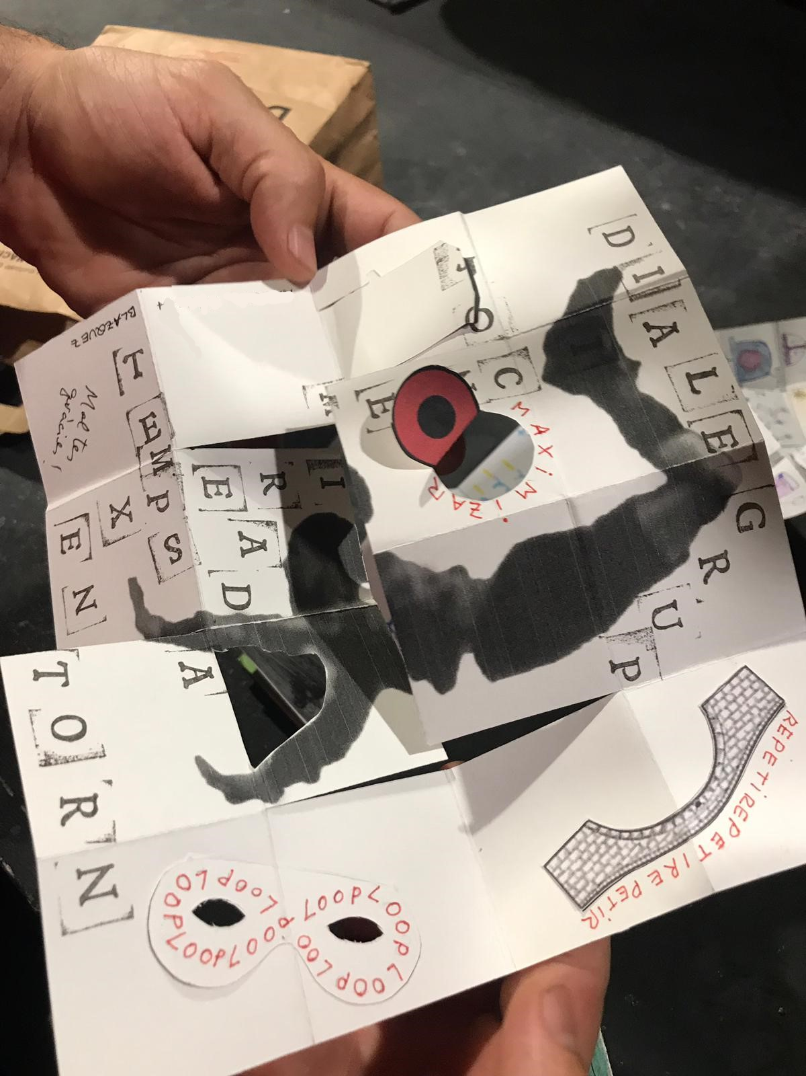
Figure 3: Zine method construction developed in Phase 2 applied at Catalunya conference in June-July 2019 during phase 3.
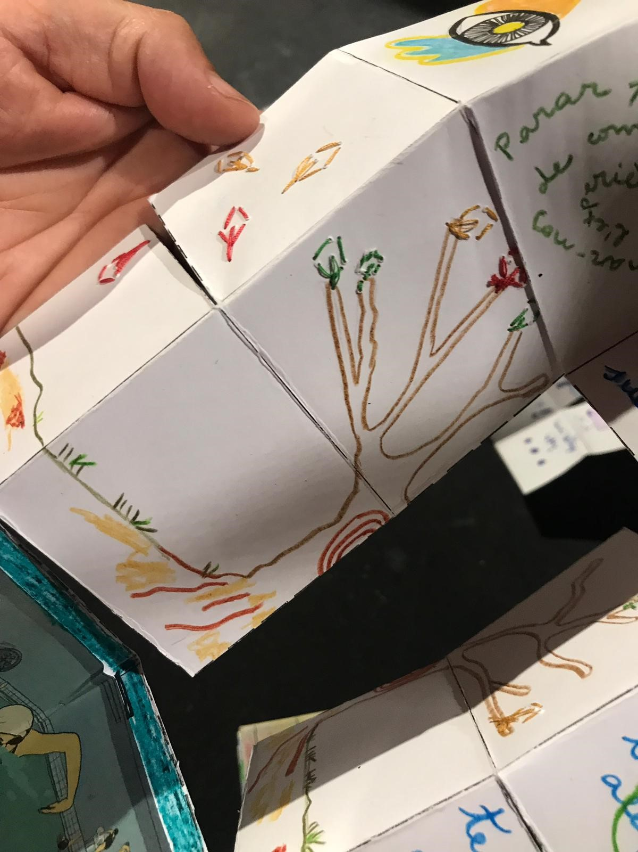
Figure 4: Zine method construction developed in phase 2 applied at Catalunya conference in June-July 2019 during phase 3.

Zines: self-reflection into management studies (phases 4-6)
In phase 2 and phase 3, Allan, Anne and Monica explored the affordance of the zine as a method for reflective, creative and connected thinking. This took the application of the zine - commonly understood as a means to express collective voice from the ground up through more informal printing and distributing methods - and inverted its recipient focal point to be the person creating the publication. Zines can be handcrafted in rough method or can be beautifully designed and produced and the nature of the zine construction also became a strong focal point during the early phases, as through their aesthetic treatment they could express more fully and holistically the expressions being ‘self-distributed’.
In the context of workshop sessions in phase 2 and phase 3, zines were applied as a method for active reflection during a process. Through extensive research and application during those phases, they have been found to be an effective qualitative method of collecting and analysing data, allowing for holistic and subjective participant responses within a contained format.
As the research team of Monica and Clive have progressed the method in phase 4, phase 5, and phase 6, one aim is to demonstrate the value of arts-based learning in management practice and to provide a guided methodology for addressing that. The work in phase 4 initiated an ongoing research collaboration co-designing the use of the zine in resilience training through participatory and making activities constructing and using of the zine in a guided session. Our aim for this activity is to use the arts to conduct high quality research, assessment, and evaluation through practice, not only through text. This use of the zine as a process aligns within the area of ‘informal learning’.
“Informal learning is nondidactic, is embedded in meaningful activity, builds on the learner’s initiative or interest or choice (rather than resulting from external demands or requirements), and does not involve assessment external to the activity” (Rogoff et al., 2016).

Are zines an educational innovation?
Zines have been actively used in higher education for decades, not least in art and design. But their use as explicit tools of reflection has been much more limited in scope, and certainly would be regarded as novel in the field of business and management. Henderson and Clark (1990) identified four types of innovation – radical, incremental, architectural and modular. In the view of the authors, the use of zines as described in this paper involves taking an existing tool, then extending its application. This would be an incrementally innovative approach, which:

"..refines and extends an established design. Improvement occurs in individual components, but the underlying core design concepts, and the links between them, remain the same" (Henderson and Clark, 1990, p2).

Affordances of folded paper zines
The word affordance derives from the work of cognitive psychologist James J. Gibson, who defined it as follows:

“the affordances of the environment are what it offers animals, what it provides or furnishes, for good or ill” (Gibson, 1979 p. 127).

We would distinguish between affordances which are intrinsic to the artefact, and the applications of the artefact which, while they may exploit those affordances, also particularly reflect (including by exclusion) the viewpoint, interests and imagination of the teacher or facilitator.

From our experience of zines, we have identified three clusters of affordances:

- tangibility affordances -
- Public/private
- Portability

- efficiency affordances
- Low cost
- Universally accessible
- Online-ready

- mental process affordances
- A “slow” technology
- Reconfigurability promoting serendipity
- Immense diversity of widely available formats promoting customisation
- Enable collecting and analysing ideas, facts or fragments to retain more of the shape of the complete experience (Dewey, 1934))
- Allow and encourage intuitive responses to emerge

Applications: zines can be solely for private consumption (self-reflection) and can therefore act as containers to process difficult emotions, such as the ones that emerge in problematic and contested contexts. Through our research activities, we have found zines enable a surprising diversity of applications:
- a way to progress understanding iteratively by applying the format to map the decisions, debates or negotiations ahead: use as a metaphor; brainstorm ideas.
- a way to reflect subjectively on one’s own role in the process: each zine can focus on different points of views and contributions to future interactions.
- a self-reflection tool to check “what is going on with yourself.”
- a contained way to address complexity and ambiguity: each zine can map and record uncertainties within a contested process and the role emotion plays in that; help find relationships out of random placements; and connect elements previously disconnected to make sense of a situation.
- apply it as a tool for generating individual ideas to be subsequently shared; one of our collaborators pointed out that when applying zines to organising collective voicing “It is more about collective reflection and meaning making rather than problem-solving.”
Of course, there are numerous other existing tools of reflection which can be used. Conventional or digital reflective tools are widespread. Shared tools such as repositionable notes allow create individual ideas to be shared, or plastic bricks can embody ideas which can be shared visually and orally. What has influenced the author’s thinking is that various affordances of zines – privacy, economy, 3D – are surprisingly well suited to particular forms of reflective practice and indeed articulating strategic thinking.

A current focus in our investigation is the act of folding that takes place in the construction of the three-dimensional form, which we believe has great potential for unlocking key affordances of the zine while folding and refolding. There is literature that refers to the act of folding and unfolding as conceptually leading the participant into a thought process, but uses it more as a metaphor rather than as the physical act of folding. Sergio Aliste (2011, p. 13, in an article on the urban grid of contemporary India, discusses “metaphors of folding, and sometimes the physical action of folding (or unfolding), show alternatives and can propose solutions to many of the problems of contemporary Indian urbanism.” But this is more of a mental folding exercise, like the one applied as ‘iterated mental paper folding’ to reinforce representations of space mentally. The same goes for a study that examined practices of folding paper swans as a means of creating a mental model of experienced reality. These applications either in imagined folding or constructing, or actual making, focus attention on the cognitive reasoning potential of the exercise: to construct a reasoned model that ‘makes sense’. Spatial reasoning is understood to be “a critical skill in many everyday tasks and in science, technology, engineering, and mathematics disciplines” (Moen et al, 2020).
The application of folding and constructing which we discuss here, is in a way doing the opposite: deconstructing the ‘known’ to allow new understandings and connections to be made via the emergent framework of the zine and through the actual construction phase. What we propose as a method privileges intuitive thinking processes temporarily, allowing the participant to ‘rest’ cognitively and allow understanding to emerge iteratively through the process itself.

A Four Step Process for the deployment of zines
Two dimensions of the zine
So far, the zine has primarily been considered as a free-standing artefact, as a learning technology or as a support more generally to thinking and knowledge acquisition, and this indeed was a viable approach for early prototypes during 2016. However, as practice has evolved, it has become clear that a crucial second dimension is the setting within which the artefact is created and used. In the examples here so far, this is primarily an educational setting. The zine does not exist in isolation but as one element within and interacting with educational and knowledge processes. The expectations of participants, and boundaries of what they are encouraged to achieve via zines, are crucially shaped by the nature of these processes. It was only over time in this collaboration that this was fully grasped, and its full realisation led to extensive evolution in the educational and knowledge processes within which zines were subsequently deployed.
Emergence of four steps
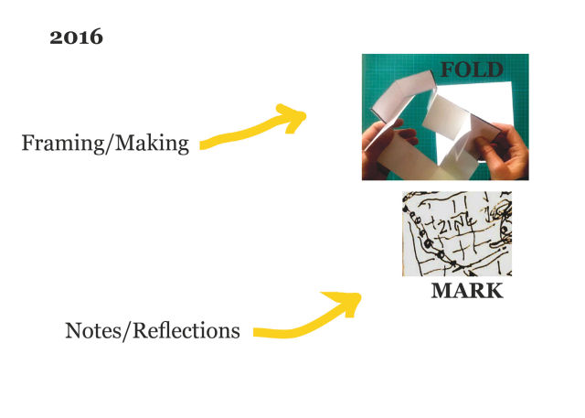
Figure 5: 2016 Prototype

The evolution of the method started with two steps (Figure 5), which subsequently expanded to four. The starting points for the 2016 workshops were the introduction (framing), then folding of the paper to male a blank zine. The second and concluding phase was inscribing or marking the paper with text or imagery by way of either or both note-taking and reflections.

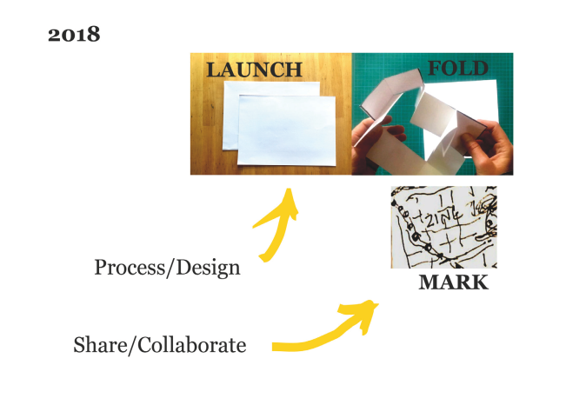
Figure 6: 2018 Extension

By 2018, as the workshop attendees broadened to include a much wider range of participants, a preliminary phase was added, which we now call “Launch” (Figure 6). This is the much deeper introduction to the activity, emphasising the rationale for reflective/imaginative thinking, the role that art-based activities can play in this, and emphasising the importance of embodying ideas in a material form via the zine.

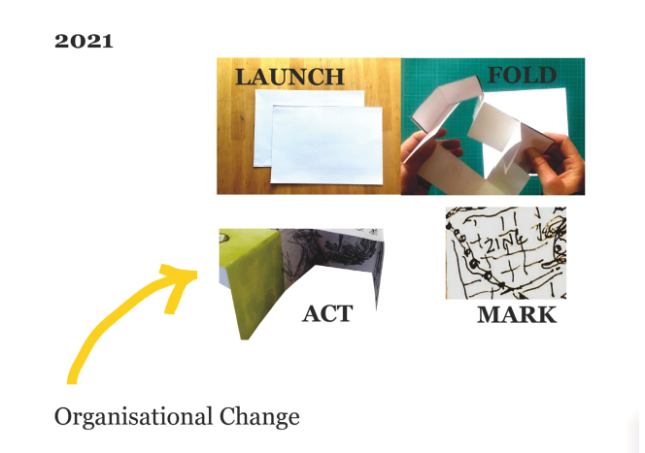
Figure 7: 2021 organisational focus

As the nature of sponsors and participants widened still further from 2020 onwards, it became clear that zines of this type could play a role not simply in private reflection, but also in the co-ordination of collective action, hence the articulation of the fourth phase, “act”, which particularly relates to collective action, such as organisational change (Figure 7). The completed list of steps, summarised in the acronym LFMA, also provided clear signposts to the nature of the reflective task in specific points of the workshop, and is utilised later in the summary Table 3.

Strategic thinking and reflection in a VUCA world
After just two decades, the twenty-first century has faced three major crises. These were the financial crashes of 2000-2001 and 2007-2008 and the 2020+ pandemic. Although the financial crises had been predicted, institutions, regulators and governments failed to anticipate them, and perhaps even more worryingly, failed to take sufficient actions subsequent to them. The 2007 financial crash did lead to some deeper reflections, and a particularly valuable study was by McGilchrist (2009), who argued, in using the left brain as a metaphor for rationality and the right as a metaphor for intuition that:

“despite its inferior grasp of reality, the left hemisphere is increasingly taking precedence in the modern world, with potentially disastrous consequences”

In business and management during this period, more use began to be made of the term VUCA (volatility, uncertainty, complexity and ambiguity), with the implication that with the loss of historic stability, it was necessary to develop new routines; indeed to “unlearn” now-inappropriate old approaches, and re-learn new ones. Global problems such as sustainability and inequality could be regarded as “wicked problems” (Grint, 2008), which simply could not be addressed, let alone solved by conventional discipline-based methods.

Strategic leadership under VUCA (Stiehm, 2002) needs a capacity for ongoing transformational changes. This involves commitment of time, knowledge and energy for cross-disciplinary collaborative sense making and solution finding. And there would need to be engagement with stakeholders to secure commitments to actions across and beyond disciplines and organisational boundaries. Senior executives with polished social skills often find it surprisingly difficult to make essential time and space for authentic personal reflection to address VUCA.

For around twenty years there have been a variety of organisations, including the “The art of management and organisation conference” which have argued the case for arts to be an essential augmentation of the over-rational classic management approaches (Adler, 2006). In his comprehensive study of how arts can be of value to business, Schiuma (2011) listed soft skills which typically would be influenced by, and benefit from, arts-based learning:
- Creativity
- Imagination
- Risk-taking
- Improvisation
- Observation
- Criticism
- Awareness
- Flexibility
- Energising self and others

Clive introduced an artistic perspective into an MBA degree in the late 1990’s and based on subsequent experiences, he produced a framework which, while echoing Schiuma’s list, combined together both rational and intuitive qualities of the “complete” leader in six spectra (Holtham (2017) Figure 8). When used by managers and leaders, we have typically observed that zines explicitly support the self-awareness, reflective and imaginative dimensions in particular.
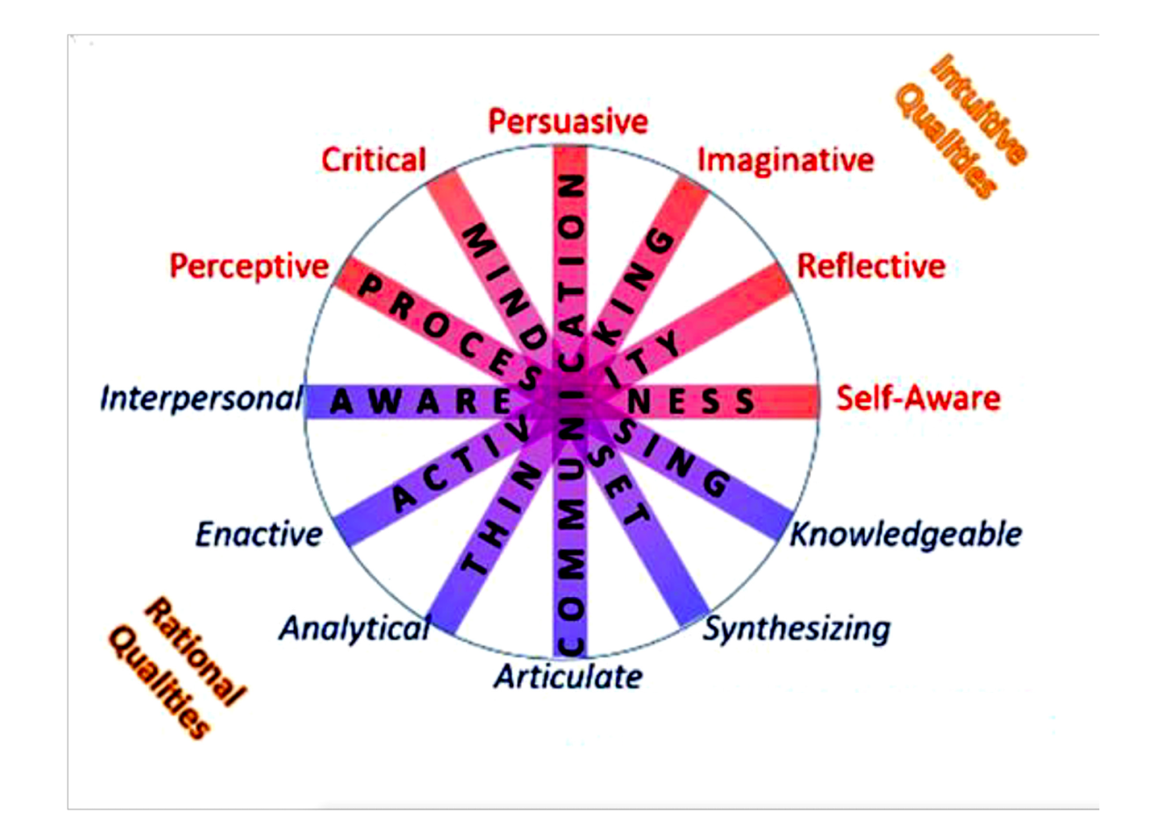Figure 8: Qualities of the “complete” manager (Holtham, 2017)
Examples of specific usages of zines
After dividing the experiences since 2014 into broad phases, the authors began to focus in narrowly on key milestones or "pivotal events". Table 2 lists the eventual list of six such events:
Table 2: Pivotal events
Phase | Pivotal Events in evolution of the zine process | Date
1* | Copenhagen Art and Management Conference | August 2014
2 | Initial prototype Dresden conference – zine workshop d final keynote | July 2016
3 | Beyond Text – Vic, Catalonia zine workshop | May 2017
4 | Kaunas, Lithuania: first solo use of zine | October 2019
5 | Basilicata, Italy - academic and student zine events on successive days | December 2019
6 | Online Expert workshop based on zine | Sept. 2020

We provide examples below from 5 of the 7 events. The Vic event has already been outlined early in this paper.

Copenhagen conference stream.
In August of 2014, Monica presented a paper at Art of Management and Organization conference in Copenhagen in the Integrative Arts-Based Initiatives for Enhancing Strategic Design and Business Stream. Her aim then was to imagine ways:
“to maintain fine art activity in close proximity to business, so as to cross-pollinate and support via osmosis. This will be a difficult process to quantify as this more holistic approach depends on a network of interdependent participants, not component parts that can be separately analysed and quantified” (Biagioli, 2014).

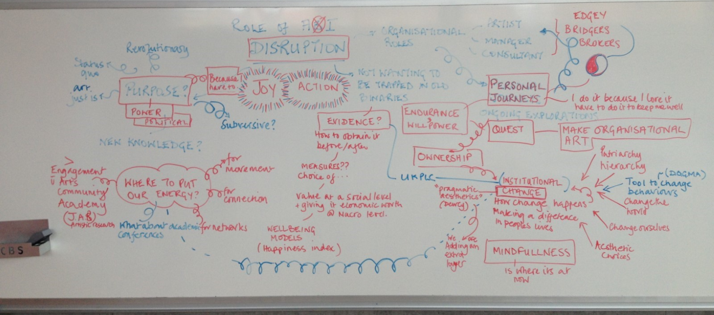
Figure 9: Image taken by Monica during the conference stream.

IFKAD Conference in Dresden 2016
With co-researchers Allan and Anne, Monica made the decision ‘not to present’ in Dresden but instead to use the time slot of a presentation as a mini workshop. Monica introduced a zine process and handed out templates and drawing and writing implements, asking session participants to document the session using the template (Figure 9). Clive invited Monica to exhibit works produced during the session at their keynote presentation later that day and made direct reference to zines during the keynote speech. This was the first time that the works were exhibited in the form currently being developed - as individual holistic representations of an individual’s reflection during a process (Figure 10).

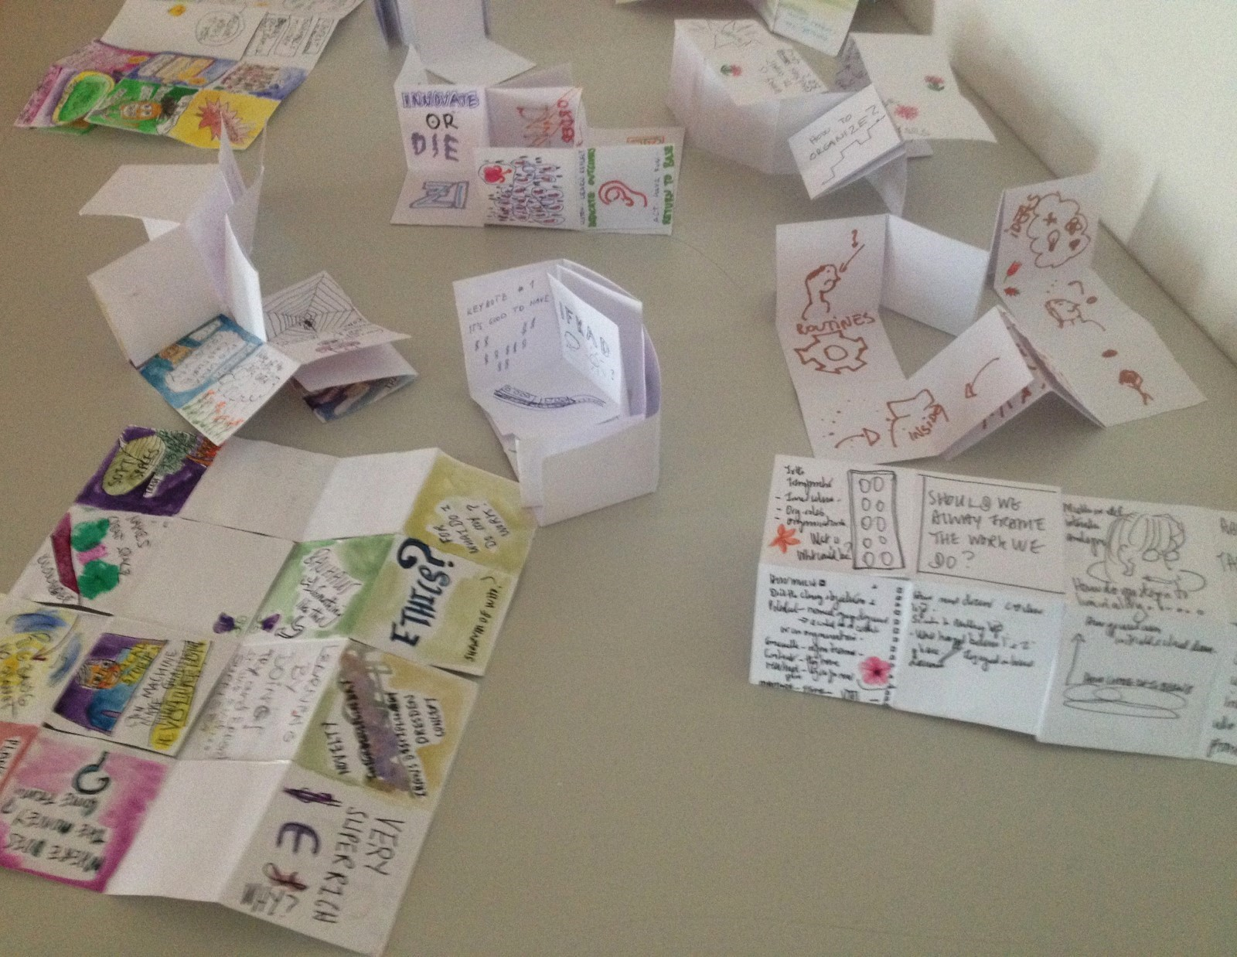
Figure 10: Zine exhibition during D keynote presentation at IFKAD 2016 in Dresden.

University of Basilicata; Matera and Potenza December 2019.
Matera and Potenza proved to be a collaboration watershed. Monica and Clive delivered a workshop session for a conference session in Matera involving creative facilitators. On the organisers’ invitation, Monica and Clive additionally delivered a session the following day to students in management of innovation at the main campus in Potenza. Developed at very short notice, for the first time the co-researchers choreographed and delivered a zine session in a large, raked lecture hall (Figure 11). Working in tandem with the researchers at the University of Basilicata, the session was designed to give an overview of imagination and the arts and their role in developing qualities for leadership.

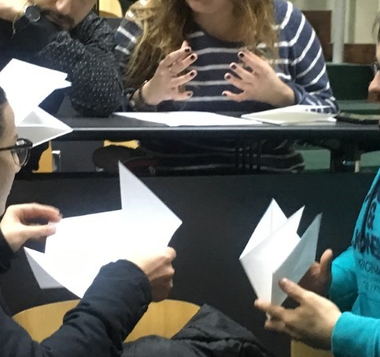
Figure 11: University of Basilicata Potenza session. Students looking at zine construction and discussing potential uses.
Kaunas, Lithuania MSc Education workshop
The initial years of zines discussed above were largely based on blank pieces of paper being folded and then inscribed. However, Clive’s practice with reflective journals has involved partly pre-printed sheets being deployed. In the example in Figure 12, the “front” side hosts the 8 numbered panes, while the “reverse” side is used for folding instructions etc. This was a generic blank template, although instructions were translated into Lithuanian.
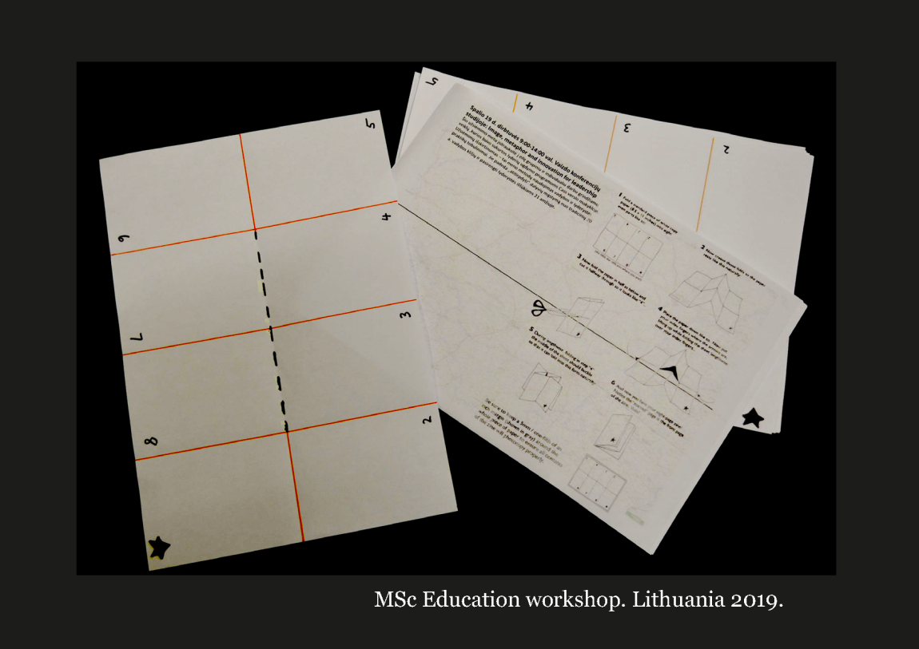
Figure 12: A3 sheet before cutting and folding

This creativity workshop had a tight schedule, and involved providing introductions to methods which could be readily taken up by educators. As usual, the folding stage is an important aspect of embodiment and the front cover of the zine was an opportunity for playful personalisation. In the time available, reflective challenges were set for specific numbered pages, and the face-to-face environment enabled quick sharing of some of the pages. For a longer or more specialised workshop, there would scope for customised content to be printed on at least some of the pages.
Online expert workshop
As a way to launch a Thinking by Making publication, Monica and Clive organised a soft launch online event. The publication was posted to invited close collaborators and expert guests prior to the one-hour event. The session was informal and focused on drawing out any responses to the publication. As part of the event, the initial activity involved making a zine construction which participants were then invited participants to use during session. Then participants were encouraged to share their ongoing reflections with each other; Figure 13 is one such output.

Discussion
If a consultant or teacher is routinely repeating events of a similar type, improvement by increments is relatively straightforward. But in this case, the events occur only irregularly, so every forthcoming event had to be regarded as an opportunity to innovate, despite the potential high-stakes involved. Then the issue of reputational and professional risks arises. Sporadic events did provide the physical platform for innovations to be introduced publicly, but in practice much of the collaborator discussion about innovations has taken place independent of any named event, and held in reserve for an opportunity to put it into practice. Interestingly, the group where the authors were most reluctant to take risks was full-time students, while it was possible in intimate face-to-face events, even for very senior people, to introduce slightly risky new ideas. In one notable case, an unusual approach was introduced to third year undergraduates with the words "Don't worry, we tried this out last month with chief executives".

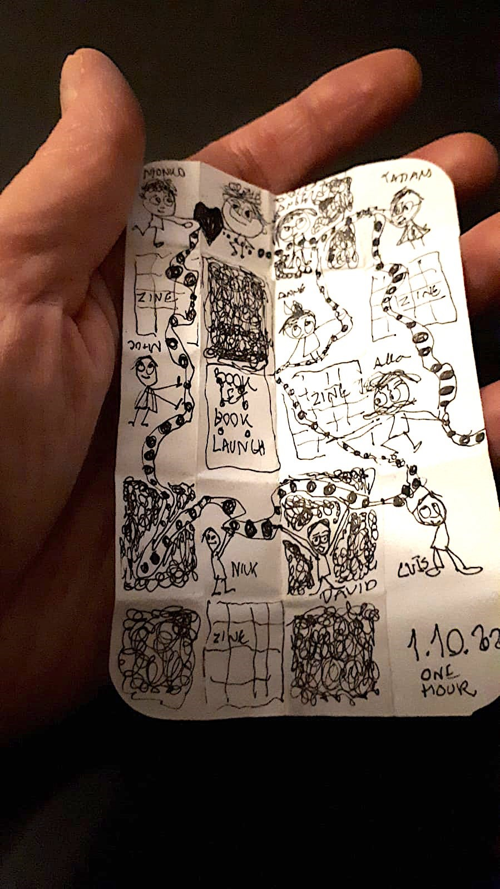
Figure 13: Zine construction created by B during the event.

Phases revisited
The LFMA acronym (Launch-Fold-Mark-Act) has also been used in table 3, whose abbreviations are: D= Disciplinary; MD=multidisciplinary; TD=transdisciplinary
FTF= Face to face; OL=online

Table 3: Steps, disciplinarity and physicality of the phases
Year | Phase |  | Steps |  |  |  | Disc. | Mode
 |  |  | L | F | M | A
2016 | 1 | Initial contact with “art of management” community |  | X | X |  | D | FTF
2016 | 2 | Prototype: Exposed to business learning and knowledge experts at conference |  | X | X |  | D | FTF
2017-2019 | 3 | Became core reflective tool of multi-national research network |  | X | X |  | MD | FTF
2019 | 4 | Re-framing for business audiences | X | X | X |  | MD | FTF
2020 | 5 | Adapted for fully online deployment | X | X | X |  | MD | OL
2021 | 6 | Evolve for problematic change in organisations | X | X | X | X | TD | FTF +OL

The move to fully online
Up to the March 2020 lockdown, all zine workshops and events had been entirely face-to-face in operation. Digital technology was used to preprint A4 or A3 double sided sheets, and a digital cutting machine could be used to score or cut sheets to a high degree of precision. But the use of paper zines in the context of webinars, for example, had not been considered at all. After lockdown it became essential to develop a format which would work in a wholly online context, and there were two parallel scenarios which evolved
(a) higher stakes (or higher funded) events, where it was feasible to design, print and mail out a custom semi-printed physical zine.
(b) standard events where participants had to source blank A4 paper and related materials themselves.
In standard events, what proved to be of particular value was to make one to three minute videos demonstrating the basic making of a given zine using an overhead camera. These could be shared live, or as we have preferred for bandwidth reasons, to be run locally by each participant via a URL (this also has the advantage they can replay in whole or part, if something is not clear at the first attempt). After writing or drawing on individual pages, participants will be invited to share a sample of what they have done, typically by holding it up to their webcam. Some collaboration environments have explicit facilities for sharing images en masse, which are particularly helpful in zine webinars.

Review – innovative learning method
The initial intentions with the 2016 prototype are summarised in Figure 14. These have all continued through to 2021, but the evolution of the method itself has meant that the intentions have expanded in three ways. Firstly, the zine is itself seen as an explicit vehicle for disrupting or unlearning traditional approaches to knowledge acquisition and transmission. Secondly, it has been found to be useful for adults in workplace settings. And potentially the most important, thirdly it can be evolved not just for personal reflection, but as a vehicle to support group collective action.
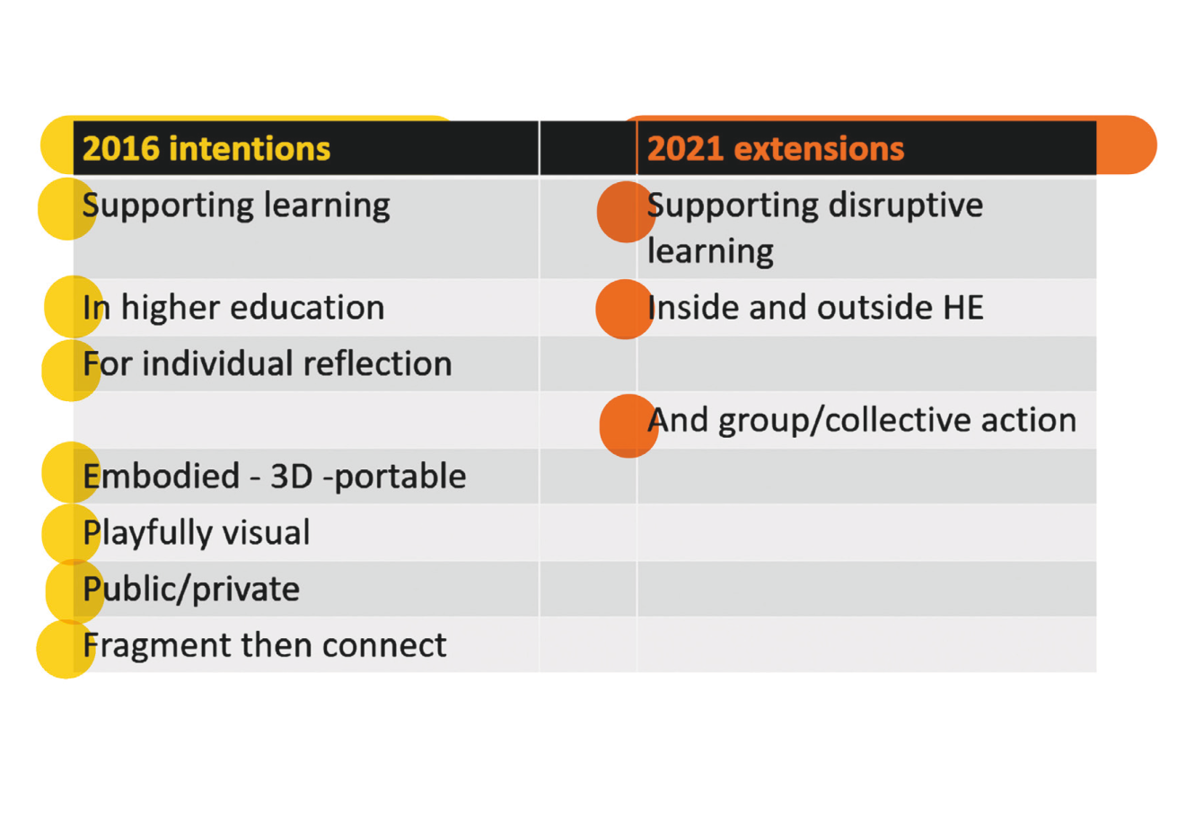
Figure 14: original intentions, and extensions which evolved

Review – new areas
An explicit research question was posed at the start:

“what are the barriers and accelerators to transposing the “zine” method to unrelated disciplines such as business and management?”

This case study written by two centrally involved participants, draws from a rich base of documentary evidence gathered during research sessions and workshops. The role of this documentation has been key in being able to construct a map of how the method evolved and what followed what, especially as the method and its applications and uses has evolved over a long period of interconnected research involving various researchers at different stages of the process. Since it has become routine to ascribe some element of innovation to good luck, there is some reluctance to draw on that here, however there was a major piece of luck in being invited in Basilicata at short notice to lead a workshop for business students in a large, raked classroom. This forced a new approach to be developed, for dealing with large numbers, and this subsequently proved particularly useful in the transition to fully online. The third element in the successful evolution of the method was the use of persuasion to encourage conference organisers and institutional practitioners to make place for a novel method within their programming and pedagogic structure. This flexibility of approach requires rigorous preparation and clarity in delivery to make the method accessible to audiences unaccustomed to arts-based methods in pedagogic delivery of their subject. This involves customising of formats and shaping the delivery of content to address a particular set of learners and achieve specific goals within a session, co-designed with institutional hosts. We would summarise the barriers in this case as being around needing passion and determination, being able to respond opportunistically, and being able to attract and retain allies and accomplices who are also willing to take time and professional risks.

Review – Disciplinarity
Dogan and Pahre (2019) argued that “innovation in the social sciences occurs more often and with more important results at the intersection of disciplines”, though were sceptical of the significance of inter-disciplinarity. There is little doubt that all four academics involved in the work behind this paper, from four distinct disciplines, participated partly due to their search for innovation in
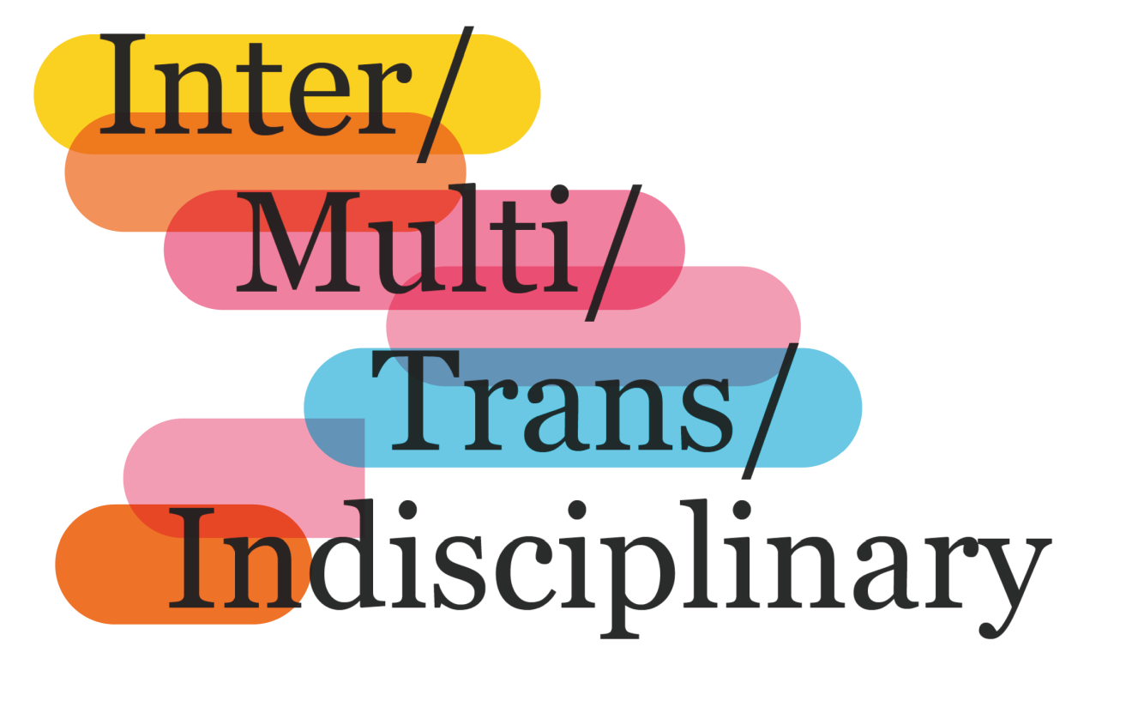
Figure 15: Disciplines: Graphic by Monica
learning methods originating from other disciplines. Figure 15 is our own symbolic representation of such approaches. Nicolescu (1997, p1) helpfully summarised three disciplinary approaches, but felt that multidisciplinarity and interdisciplinarity both remained too much within the framework of disciplinary research. He advocated transdisciplinarity:
“transdisciplinarity concerns that which is at once between the disciplines, across the different disciplines, and beyond all discipline. Its goal is the understanding of the present world, of which one of the imperatives is the unity of knowledge. Is there something between and across the disciplines and beyond all disciplines?”
Figure 16 sets out to visualise three main alternatives in education. In the disciplinary approach, the faculty take a single discipline approach to a class or workshop. The participants could be in any discipline. This was the approach which characterised phase 1 of the zine initiative, while phases 2-4 were multi-disciplinary in nature. In a multi-disciplinary context, academics from two disciplines will combine forces but each from their own distinctive discipline. Phases 5 and 6 aimed at a transdisciplinary context, where the academics engage with each other in depth to produce an outcome that reflects the interweaving and blending of their disciplines, not simply the addition of the two.
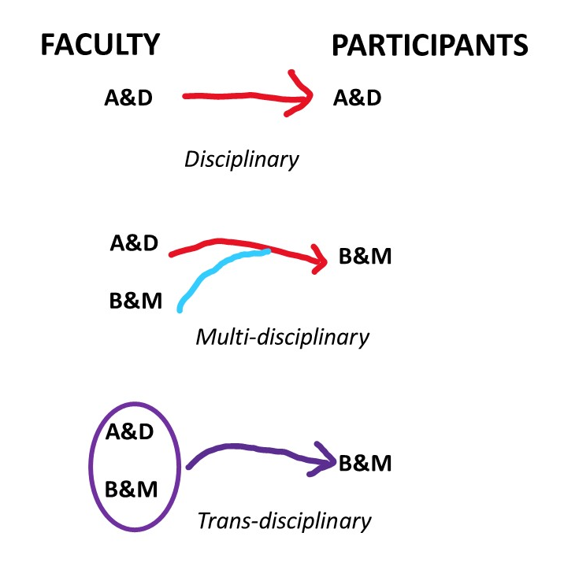
Figure 16: Alternative disciplinary forms (Art & Design; Business & Management)

Future Developments
The most significant next step would be to introduce zines as an explicit dimension to a large-scale problematic organizational change programme, particularly where it is important to create an authentically dialogic approach, and where implicit or explicit resistance to change may be expected. Within higher education this could include curriculum reforms, equality, diversity and inclusion initiatives and so on.

Conclusion
This collaboration started with a focus purely on zines supporting the thinking of individuals, but has extended into collective thought and action. There are, of course, dozens of other art-based and non-art based techniques for supporting reflection and collective action. But one of the most striking comments made by workshop participants, particularly during the pandemic, was that to start with an ordinary A4 piece of copy paper felt like “a very humble beginning”. And some of our collaborators are in the global south, for example, where elaborate colour printing and other facilities may not be readily available. But pretty much everywhere in the world, colleagues can come up with a single piece of A4 paper. The zines as evolved in this collaboration have promoted reflection through conscious making, with the zine as a piece of artwork, however humble, able to address complexity and ambiguity, without at times even needing words. They demonstrate the transformational potential of creativity across disciplines. We hope that these cross-disciplinary experiences working with reflective zines will extend collective understanding and stimulate debate on the role of arts-based methods across widely diverse social, educational, and enterprise contexts.
References

Adler, N.J. (2006). The arts and leadership: Now that we can do anything, what will we do? Academy of Management Learning and Education, 5(4), 466-499.

Aliste, S. (2011). Doblando y desdoblando la trama urbana en la India contemporánea/ [Folding and unfolding the urban grid in contemporary India.], Román.Anales de Historia del Arte, suppl. Volumen Extraordinario; Madrid, 451-462.

Biagioli, M. (2014). Fine art installations: Expressions of cultural identity and catalysts for intuitive business models. In: The 7th Art of Management and Organization Conference, 28 - 31 August 2014, Copenhagen Business School, Copenhagen, Denmark.

Biagioli, M. (2019). Zine Method, pp 154-161 in Benmergui, R., Owens, A. Passila, A. (Eds.), Beyond text: Arts based methods for research, assessment and evaluation, Erasmus + EU: Beyond Text Partnership. eBook https://beyondtext.weebly.com/ [accessed 28th May 2021]

Cochran-Smith, M. (2005). Teacher educators as researchers: Multiple perspectives. Teaching and Teacher Education, 21(2), 219–225.

Boosting Resilience (2019). Boosting resilience: Survival skills for the new normal. https://www.boostingresilience.net/ [accessed: 28th May 2021]

Dewey, J. (1934). Art as experience. London: George Allen and Unwin Ltd.

Dogan, M. and Pahre, R. (2019). Creative marginality: Innovation at the intersections of social sciences, New York NY: Routledge.

Gibson, J. (1979) The ecological approach to visual perception. Hillsdale NJ: Erlbaum.

Golden, A. (2010). Making handmade books: 100 bindings, structures and forms. New York NY: Lark Crafts.

Grint, K. (2008). Wicked problems and clumsy solutions: The role of leadership. Clinical Leader, 1 (2), 54–68.

Hamilton, L. (2011). Case studies in educational research, British Educational Research Association on-line resource. https://www.bera.ac.uk/publication/case-studies-in-educational-research [accessed 28th May 2021]

Henderson, R.., Clark, K. (March 1990). Architectural innovation: The reconfiguration of existing product technologies and the failure of established firms. Administrative Science Quarterly, 35 (1), 9-30.

Holtham, C. (2017). Artful inquiry: resilience in an ambiguous world of VUCA. Beyond Text Workshop 9-11 May, University of Vic, Spain.

McGilchrist, I. (2009). The master and his emissary: The divided brain and the making of the western world. New Haven CT: Yale University Press.

Moen, K. et al., (2020). Strengthening spatial reasoning: Elucidating the attentional and neural mechanisms associated with mental rotation skill development. Cognitive Research: Principles and Implications, 5:20 pp. 1-23.

Miles, R. (2015). Complexity, representation and practice: Case study as method and methodology. Issues in Educational Research, 25(2), 309-318.

Nicolescu, Β. (1997). The Transdisciplinary Evolution of Learning. Proceedings of the International Congress on What University for Tomorrow? Towards a Transdisciplinary Evolution of the University. Locarno, 30 April-2 May 1997, 1-11.
http://www.learndev.org/dl/nicolescu_f.pdf [accessed 28th May 2021]

Piepmeier, A. (2008). Why zines matter: materiality and the creation of embodied community. American Periodicals, 18 (2), 213-238.

Rogoff B., Callanan M., Gutiérrez K.D., Erickson F. (2016). The organization of informal learning. Review of Research in Education. 40 (1), 356-401.

Schiuma, G. (2011) The value of arts for business, Cambridge: Cambridge University Press.

Stake, R. (1995) The art of case study research. London: Sage.

Stiehm, J. (2002). The US Army War College: Military education in a democracy.
Philadelphia PA: Temple University Press.

Thomas, S. (2018). Zines for teaching: A survey of pedagogy and implications for academic librarians. Libraries and the Academy, 18 (4), 737-758.

Ulvik, M., Riese, H., and Roness, D., (2018). Action research–connecting practice and theory. Educational Action Research. 26 (2), 273–287.

Statement of disclosure
All materials included in the article represent the authors’ own work and aything cited or paraphrased within the text is included in the reference list. The work has not been previously published not is it being considered for publication elsewhere. There are no actual or potential conflicts of interest which might have influenced the authors in reporting their findings completely and honestly.

