Build your own equipment: Sustaining creative practice at home
Jade Lord and Elinor Sykes
University of Huddersfield
Corresponding author: j.e.lord@hud.ac.uk

Abstract
In March 2020, the United Kingdom Covid-19 response created a huge challenge for the creative sector within higher education. With staff and students in lockdown, facilitating the study of practice-based subjects from home, without access to specialist equipment, became difficult. In response to this challenge, staff at the University of Huddersfield employed an innovative approach; demonstrating how students could build their own equipment at home from basic household items. This paper gives a personal account of this innovative approach to lockdown teaching, which has resulted in a wider re-thinking of our teaching practice. Adaptation to changing circumstances led to the evolution of teaching delivery. We include a rationale for our analogue approach and reflections on how our findings may be applicable to teaching across the creative sector and beyond.
Keywords: Creative Practice, Problem Solving, Experiential Learning, Low-Tech, Equipment, #homemadeknittingmachine
Introduction
For many creative degree programmes, practice-based work is a key component of the curriculum. Students studying on these courses have the expectation of building a physical portfolio of work, and practical skills are integral to the graduate skillset demanded by industry. These practice-based skills are commonly taught on-campus, through experiential learning, often using specialist machinery that is not otherwise accessible.
Before 2020, very few courses in the creative sector, with the exception of the Open College of the Arts, had considered the delivery of practice-based skills beyond the existing on-campus model. Following the lockdown of campuses in the United Kingdom (UK), as a result of the Covid-19 pandemic, educators were forced to quickly adapt to changing delivery. In the first instance, perhaps supported by the shift to online teaching, many turned to digital solutions; students created virtual outcomes that could be shared through online portfolios. As a short term solution, this was effective in the development of transferable digital design skills. However, not all skills can be learnt through digital platforms. The skills needed to operate specialist machinery and equipment, which rely on experiential learning, are one example. This presented a considerable challenge; how could we take a distance learning approach to delivering these skills as the pandemic continued?
As a small specialist team within the Fashion and Textiles department at the University of Huddersfield, we have always strived to put the student experience at the centre of our approach to teaching. Following the first stage of response to lockdown teaching, we reflected on our delivery of practice-based skills to develop a subsequent adaptation. This paper follows the journey of the development and delivery of our approach to remote practice-based teaching and evaluates the benefits we believe have arisen from this approach.
Working with specialist equipment
Across creative sector courses, students may be working with a range of specialist equipment. Knit specialist students at the University of Huddersfield usually have access to knitting machines in workshops. These machines are expensive, cumbersome, heavy and often require specialist technical maintenance. In the knit workshop students can access a range of industrial knitting machines; single bed machines (Figure 1), V-bed machines (Figure 2) and digitally automated machines (Figure 3).
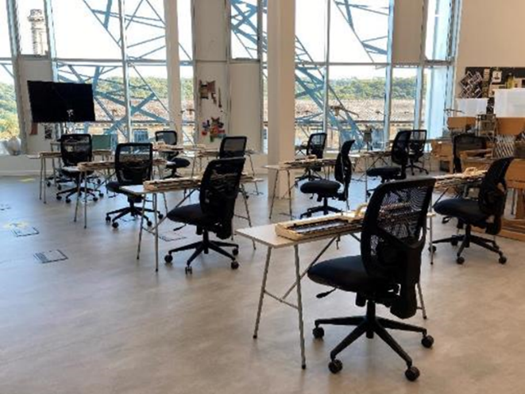
Figure 1 Single bed machines. Image: Authors Own

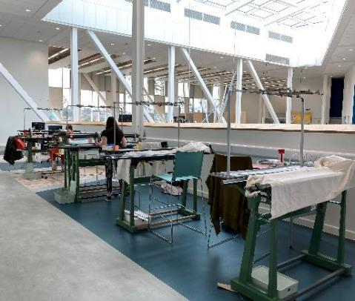
Figure 2 V-bed machines. Image: Authors own

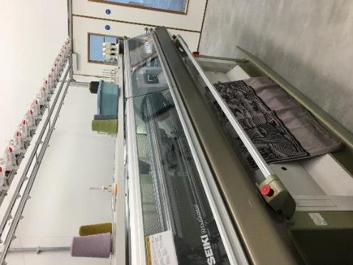
Figure 3 Automated machine. Image: Authors own.
Upon starting a fashion or textiles degree, a large proportion of students have never seen or used a knitting machine, and therefore the mechanics of the machine are novel. For the purposes of this paper, we will give a basic overview of how a flat-bed knitting machine works. In hand knitting, multiple stitches are worked on one needle. In essence, this needle is a stick, and through the movement of sticks and fingers, interlocking loops are continually formed with the yarn. Developing from this basic technology, a flat-bed knitting machine is mechanically automated with a ‘bed’ or flat plane of latch hook needles, with a needle needed for each knitted stitch. Figure 4 demonstrates how a latch needle works.
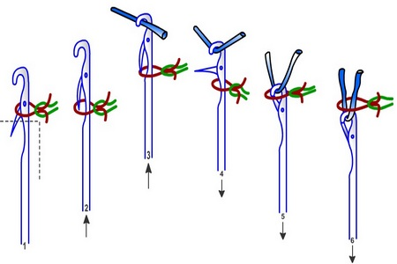
Figure 4 How a latch needle forms a new knitted loop
When the ‘carriage’ or cam system is moved across the needle bed it simultaneously moves the needles and puts the yarn in the right position to create a new knitted loop (Woolmark 2020).
Working on knitting machines prepares students for industry, as most commercially produced knitwear and knitted products are created on a machine. The learning of the skills to use these machines is advanced through experience.
Experiential Learning
It is argued that humans learn best through experience; knowledge is created through the transformative experience of doing (Kolb 2014). In a traditional teacher-centred approach to learning, information is passively received by the students, often in a text-based format, and then memorised and repeated (Friere 1974). As a teaching method, this is not particularly effective instimulating learning. This is especially critical in the creative sector, where students are contending with abstract concepts and processes rather than irrefutable facts.
Throughout the history of art and design education, experiential learning has been integral to curriculums. For example, the ‘study of materials and tools’ was layered through the Bauhaus three-year programme of study (The J. Paul Getty Trust 2021). Many creative sector degrees involve the creation of physical outcomes, such as garments, sculpture, models, ceramics, textiles, and so on. To produce physical outcomes requires mastery of materials and processes. The Quality Assurance Agency for Higher Education subject benchmark for Art and Design (QAA 2019) states: ‘An honours degree in an art and design discipline also confirms that the holder, in conjunction with conceptual knowledge and understanding, has acquired relevant technical knowledge and practical skills.’ The technical knowledge and practical skills required to master such disciplines would be nearly impossible to acquire through the reading and memorisation of text alone.
Further to its lack of effectiveness, passive teaching styles rarely address the wider function of education. Bruner (1960) argues that the purpose of education is to stimulate inquiry and skill in the acquisition of knowledge, rather than memorising a body of knowledge. Experiential learning occurs through reflection on doing (Felicia 2011), with an emphasis on the process rather than the outcome. The Lewinian model of experiential learning (Kolb 2014) demonstrates how creative practice builds skills and stimulates enquiry (Figure 5). As students reflect on their experience of practice, they develop the ability to think abstractly about that practice in order to advance their ideas.

Figure 5 The Lewinian model of experiential learning (Kolb 2014)
This process of deriving concepts from experience fosters concept development skills that are desirable in creative sector graduates. These skills allow graduates to work in industry roles where they are working with commercial manufacturers; they understand enough about the process of making to communicate design ideas without having to make anything themselves. For many students, developing the skills they need to gain graduate-level employment is a primary motivation for undertaking a degree. The work of McGuinness (2003) suggests that ‘for the majority of students, the choice of university is less important than choice of subject and degree performance in determining labour market success’ (pg. 1943).
Following the lockdown of UK university campuses in March 2020, the delivery of teaching was forced to quickly adapt. It was still possible to deliver experiential learning in the format of digital design software, which for some disciplines was sufficient to replicate on-campus delivery. However, for creative courses that involve physical making, and the use of equipment, the learning objectives of developing technical knowledge and practical skills were difficult to achieve. Possibilities for experiential learning through making were restricted as specialist equipment was locked away on closed campuses.
Focusing on the specialism of knitting textiles, Gaston & Scott (2020) state ‘Successful knit requires knowledge of materials, fabric structure, technology & aesthetics’. The experience of making is key to the development of the skills and understanding needed to be a knitted textile designer. Making allows for hands-on problem-solving. Learning occurs as ideas, physical phenomena and the inherent constraints of making are negotiated (Hsu et al. 2017). For example, to successfully produce textiles on any knitting machine you need an understanding of yarn properties, loop size and tightness, which is often developed through the sense of touch.
We understood that digital design software could not deliver the skills and understanding our students needed to develop. The problem we faced was working out how knit specialist students could continue to learn through the experience of making, without access to on-campus workshops and equipment. Referring back to the Bauhaus approach to art and design education, Josef Albers developed his students' basic understanding of the relationship between materials, construction and technology by encouraging the use of simple materials and tools (Siebenbrodt & Schöbe 2009). Students can still gain valuable technical skills and understanding from lo-fi technology. We decided that the analogue act of making did not need to be deemed impossible by the teaching restrictions, and we endeavoured to find a feasible solution.
The Homemade Knitting Machine
When considering possibilities for how experiential learning could continue at home we began to question if the students could make their own simple machines. This led to a process of analysis, and the development of a lo-fi knitting machine that could be made from materials found around the home.
Analysing other basic knitting tools, we realised we could simplify the flat-bed knitting machine to its most basic parts and use lollipop sticks as needles. The homemade knitting machine mimics the domestic machine by replacing needles with lollipop sticks, and like hand knitting, the carriage is replaced by the movement of yarn by hand. This led to the homemade knitting machine prototype, which can be seen in Figure 6. As the prototype was created during the lockdown, it was made from materials that were available around the home. The blueprint for the homemade knitting machine was created.
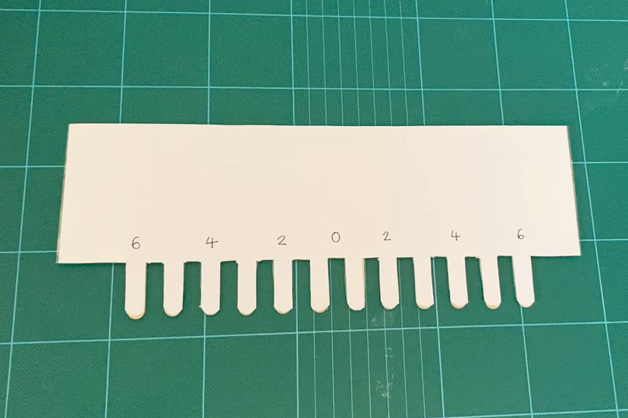
Figure 6 Homemade Knitting Machine prototype.
Image: Authors Own.
To launch the homemade machine project, students were given a pack of materials with which to make their own machines (Figure 7). The pack contained materials to make the machine (two pieces of card, twelve wooden lollipop sticks, Sellotape and double sided tape), tape to secure the machine to a surface, and materials to use to weight the knitted fabric during production (bulldog clips and Plasticine). The packs were distributed in September in case of self-isolation or lockdown. Students were guided on how to construct and use their homemade knitting machine in either an on-campus or online workshop. This was accompanied by a series of instructional videos shared through a virtual learning environment (Homemade Knitting Machine 2020). Techniques were demonstrated on how to produce a range of knitted sample, and students were encouraged to experiment further. The hope was that this open-source kit would inspire invention. However, at this stage, we were unsure if this would work, or how novice knitters would respond.
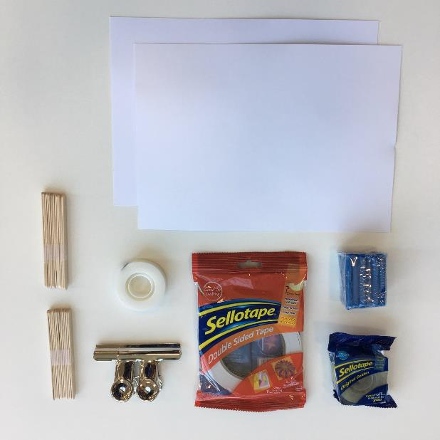
Figure 7 The Homemade Knitting Machine Pack.
Image: Authors Own.
We were keen that the knowledge on how to create a machine, and then knit with it, remained open source and could be accessed freely by anyone. The term open source is most commonly associated with the field of computer software. There may not be a single definition of the term but it is generally used to ‘describe programs whose source code is publicly available under certain licenses’ (Tozzi 2017). However, within the field of computer code, the term ‘open’ is interpreted differently by different people. Tozzi elaborates further on this explaining,
Some contend that sharing source code when requested makes it open. Others argue that allowing third parties to incorporate the code into their own work is an additional requirement for openness. Some suggest that sharing code but not documenting it or making obvious how it works does little to make the code truly open.
If we think of ‘code’ to mean the knowledge of how to make and use a homemade knitting machine, then we envisaged embracing all of the above definitions of ‘open’. We were open to sharing our knowledge of the homemade knitting machine and allowed users to adapt and incorporate the homemade knitting machine in their work. We documented how the machine is made and used through publishing instructional videos on a freely accessible Youtube channel (Homemade Knitting Machine 2020).
Packs were given to knit students in all years in Fashion & Textiles, so they were used by both experienced and novice knitters. In theory, all techniques that would normally be taught on the single bed knitting machines we have in the workshop could be taught on the homemade knitting machine. This allowed us to run a similar curriculum of workshops and tutorials despite further lockdowns.
Reflections
Although our teaching adaptation was initially a response to an unforeseen obstacle and was not consciously underpinned by pedagogical theory, we quickly recognised the potential of the project. We reflected on the outcomes of the homemade knitting machine project using unstructured observation. Unstructured observation is the process of approaching observation with no preconceived ideas of what will arise, and documenting reflections as and when they happen (Hickman 2008). This section of the paper outlines the key observations and reflections.
As teaching returned to campus in September 2020, the homemade knitting machine was optimal for blended learning. The same techniques could be taught on all machines, on-campus or online, giving necessary flexibility to self-isolating staff and students. The more we taught using the homemade knitting machine the more we recognised the potential to develop techniques. For example, the machines in the workshop can only knit with two colours at one time, whereas the homemade knitting machine can knit with multiple colours of yarn at one time.

Although the homemade knitting machine was initially taught on campus, it was when we went into further lockdowns that we started to observe how inventive the students were being with their machines at home. To borrow another term from computer science, as we started to deliver homemade machine sessions using the kit, we realised that machine making was endlessly ‘hackable’. The term hackable is being used here to imply that the machine design is adaptable, requires no specialist tools or materials to make, and can be easily customised to create different fabrics.
The hackable nature of the machine encouraged students to question ‘what if?’ What if the needles were a different size? What if I used a thicker yarn? This demonstrated engagement with the mechanics of how machine knitting works, supporting our idea that making develops an understanding of technology and technique. The students were continually modifying their expectations and ideas based on their experiences of the machine.
By making their own machines students developed skills in invention and creative problem-solving. For example, one student sellotaped kebab sticks to a pizza box to make a machine. This led to the delivery of sessions where the kit was not used, and students were shown how they could improvise to make a machine with household items such as knife handles. Further to this, students started to make their own versions of machines. In Figures 8 and 9 you can see student experimentation with making needles with a range of different materials including a machine using 2 sets of needles to mimic a V-bed machine. This supported our theory that the hackable nature of the machine would encourage student customisations.

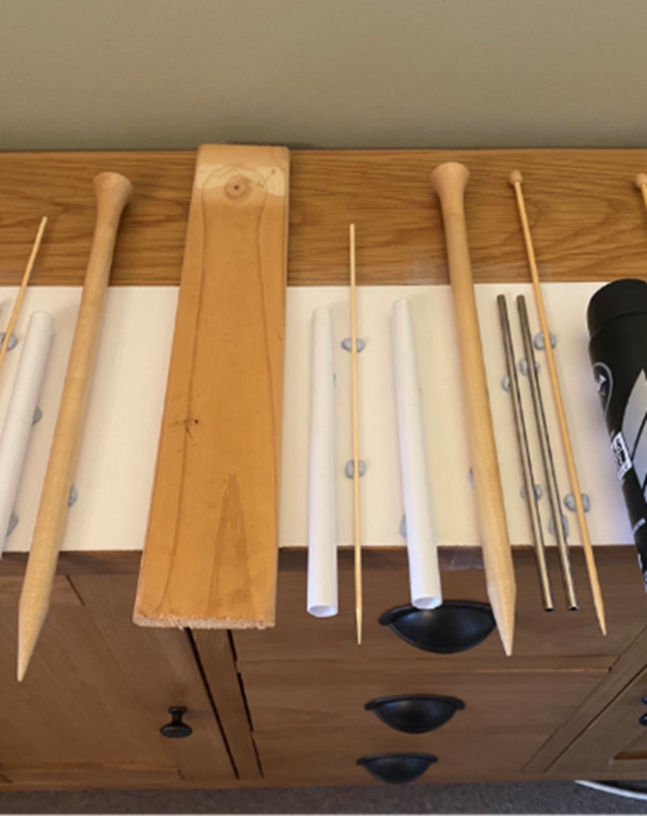
Figure 8 Student customised machine.
Image: E. Waterton [used with permission]

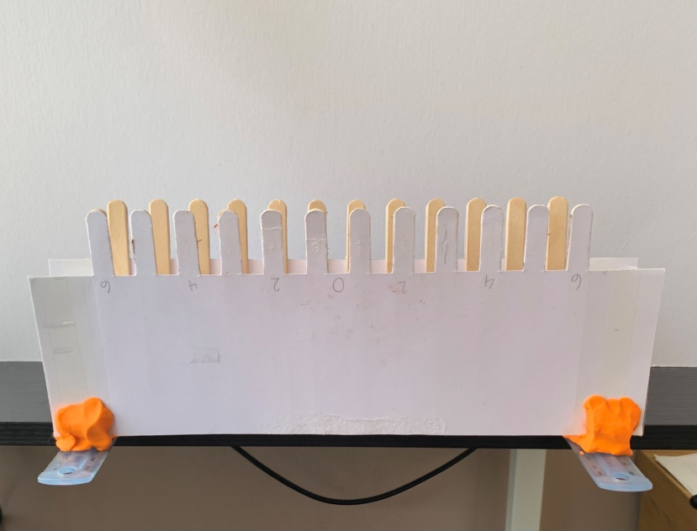
Figure 9 Student customised machine.
Image: L. Brown [used with permission]
The ability to continually remake the homemade knitting machine to a range of specifications is one of its key benefits, and one of the main reasons we wanted it to be open source. Rather than keep knowledge of the homemade knitting machine within the confines of teaching at the university we wanted this knowledge to be shared with the outside world thus democratising and somewhat demystifying machine knitting. We were excited to see what other people could create from the basic ideas behind the homemade knitting machine. This approach has similarities to the Copyleft movement. Copyleft is a reworking of the term copyright. Whereas copyright keeps all the rights of modifying, distributing and performing work in the hands of the owner of the copyright, Copyleft is still ‘legally protected, and part of that protection is that it must always be free to use, distribute and modify’ (Frantsvog 2012). The idea that anyone that uses our homemade knitting machine blueprint should then freely share what they have created appealed to our philosophy on education.
Whilst developing the homemade knitting machine we soon realised that students would not necessarily have access to yarn at home. Rather than see this as an obstacle, we decided it would be beneficial for students to try and make their own yarn out of things they could find around their home. In the same way that the creation of the homemade knitting machine had opened up a new area of knitting to us, making our own yarn reinvigorated how we looked at materials and making.
We experimented with making yarn from plastic bags, old tights, plastic wallets and toilet rolls (Figure 10). Once we had demonstrated it was possible we shared our enthusiasm for making yarn with the students and they responded by creating yarn out of bread bags, tissue paper and newspaper (Figure 11). We also encouraged students to adapt any current conventional yarn they may have had by showing them how to dye it with Sharpie pens and vodka. This meant that any yarn they were creating was bespoke to them.
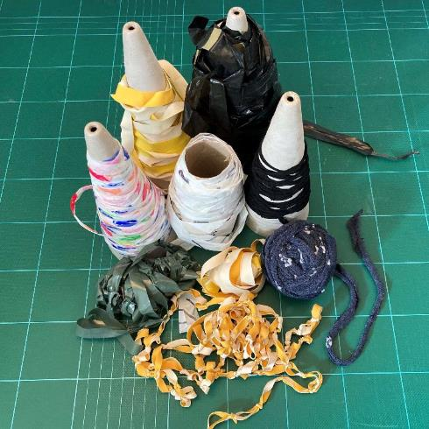
Figure 10 Our homemade yarns.
Image: Authors own

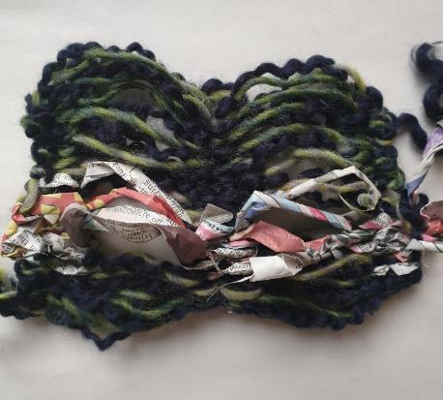
Figure 11 Student work using homemade newspaper yarn.
Image: J. Shackman [used with permission]
This resourcefulness has many benefits including the understanding of materials properties, re-use of materials, development of bespoke yarns and cost-saving. Using yarn made from unusual materials, and having to physically move the yarn around the machine by hand, allowed us to talk about the material properties of the yarns the students were using. For example, ‘is the yarn stiff or stretchy?’, ‘is the yarn fluffy or smooth?’, ‘how do these differing properties affect how easy or hard it is to move the yarn over the needles?’. This further developed the students understanding of the relationship between materials and technology.
The reuse of materials fits with a sustainable agenda. According to the Sustainable Skills Survey (2020) around 83% of students surveyed feel sustainability should be actively incorporated into their study, contrasted with 35% who say the efficient use of resources has been covered on their course thus far. Within fashion and textiles, the efficiencies of resource use are a key concern, with 300,000 tonnes of clothing going to landfill every year in the UK (WRAP 2017). Such issues can be difficult to embed into practice-based delivery. Encouraging the creative reuse of materials seamlessly incorporated sustainable approaches into the curricula.
The students understood that we were having to work around issues of access to equipment and materials. Although we did not take a problem-based learning approach, the students learnt from observing our problem-solving process. The kit we developed offered an entry-level to them to take charge of their learning. It had a positive effect that students were still able to create and make work whilst stuck at home; they had autonomy over their practice at a time when a lot of circumstances were out of their control.
Conclusions and Implications
Applying inductive reasoning, we have considered the more general implications of our approach for other practice-based courses in the creative sector. However, we recognise that our reflections are based on the outcomes of one academic year, and further research would strengthen these initial conclusions. This section will outline the key implications of our reflections, including those specific to the specialism of knit.
The adaptations that we made to our teaching were motivated by an unanticipated event; the 2020 global pandemic. We were forced to change the way we delivered teaching, or risk students not meeting learning objectives. Much like adaptation in the natural world, a dynamic evolutionary process can lead to increased fitness for purpose. We have found this to be the case as, through necessity, we simplified our approach to the most fundamental elements. This supported student learning beyond pre-Covid curricula. Despite the pressure that educators have been under in adapting to teaching in a pandemic, innovations have flourished.
Many of our students have flourished within this new way of working. One Textiles final year developed a range of functional knitting machines made from ice, bringing a performative aspect to their practice. This work has been recognised for its originality by external examiners, and has won external awards. Other students have achieved more modest outcomes; progressing through first year modules despite the difficulties of lockdown learning. Students have been resoundingly positive in their response to the homemade knitting machine.
Our work has shown that low-tech approaches to teaching are viable. Digital technology has been incredibly useful in allowing teaching to continue during the pandemic, but it is not the only form of technology that can support distance learning. Making their own simple machinery gave students a greater sense of possibility, and it has empowered them to sustain practice after graduation when access to industrial machinery can be limited. Although we have focused on knit specific equipment, this analogue approach could, in theory, be applied to a variety of creative disciplines. This could be explored through further collaborative research.
Beyond these more generalisable benefits, developing the homemade knitting machine concept has made us reconsider how we teach knit. Experiential learning is the approach we have always taken to teaching knit. However, this year we have advanced that learning to deepen the students' understanding of the mechanics of their making process. This has created questioning practitioners who think critically and confidently about technology, materials and fabrics, despite working within constraints. Generous access to materials and equipment alone does not necessarily cultivate deep understanding.
Moving forward, we have been considering how our work could contribute to Maker Spaces, and we would like to integrate yarn and machine maker spaces into our knit workshop. One of the key things we have taken from this experience is that playfulness and invention can help to develop student confidence and foster resilience. It will be interesting to observe how the current cohort of students will continue to sustain their practice, and adapt to post lockdown teaching.
It is too early to reflect on the implications of making the project open source. Specific to the context of knitted textiles, we recognise there is further potential for the homemade knitting machine to be used for outreach activities and public engagement to demystify machine knitting and dispel stereotypes often held about knit.
References
Bruner, J. S., (1960). The Process of Education. New York: Vintage Books.
Felicia, P., (2011). Handbook of Research on Improving Learning and Motivation through Educational Games: Multidisciplinary Approaches. Hershey PA: Information Science Reference.
Frantsvog, D. A., (2012). All rights reversed: A study of copyleft, open-source, and open-content licensing. Contemporary Issues in Education Research. 5(1), 15-22.
Friere, P., (1974). Pedagogy of the Oppressed. New York: Continuum.
Gaston, E. & Scott, J. (2020) Colour trans:form:ation: The application of knit as knowledge. Journal of Textile Design Research and Practice. 8(2), 193-208.
Hackman, R., (2008). Research in Art & Design Education: Issues and Exemplars. Bristol: Intellect Books.
Homemade Knitting Machine, (2020). Homemade knitting machine: How to make one. Available at: https://youtu.be/ONIROg6NVmo [accessed 03 June 2021]
Hsu, Y. C., Baldwin, S. & Ching, Y. H., (2017). Learning through making and maker education. TechTrends. 61(6), 589–594.
Kolb, D. A., (2014). Experiential Learning: Experience as the Source of Learning and Development. 2nd Ed. London: Pearson Education.
McGuinness, S., (2003). University quality and labour market outcomes. Applied Economics. 35(18), 1943-1955.
QAA (2019). Subject benchmark Statement: Art & Design. Available from: https://www.qaa.ac.uk/docs/qaa/subject-benchmark-statements/sbs-art-and-design-17.pdf?sfvrsn=71eef781_16 [accessed 27 August 2021]
Siebenbrodt, M. & Schöbe, L., (2009). Bauhaus 1919-1933: Weimar-Dessau-Berlin. New York: Parkstone International.
Students Organising for Sustainability (2020). Sustainability Skills Survey 2019-2020. Available from: https://uploads-ssl.webflow.com/6008334066c47be740656954/602faaf925b36340571eb467_20201005_SOS-UK%20Sustainability%20Skills%202019-20_HE_FINAL.pdf [accessed 03 June 2021]

The J. Paul Getty Trust., (2021). Principles and Curriculum: Bauhaus. The Getty Research Institute Presents Bauhaus: Building the New Artist. Available from: https://www.getty.edu/research/exhibitions_events/exhibitions/bauhaus/new_artist/history/principles_curriculum/ [accessed 03 June 2021]
Tozzi, C., (2017). For Fun and Profit: A History of the Free and Open Source Software Revolution. Cambridge MA: MIT Press
Woolmark, (2020). m5 t9 Knitting Action Domestic Machine. Available from: https://youtu.be/01U1K7jjNh8 [accessed 03 June 2021].
WRAP., (2017). Valuing our Clothes: The Cost of UK Fashion. Available from: https://wrap.org.uk/sites/default/files/2020-10/WRAP-valuing-our-clothes-the-cost-of-uk-fashion_WRAP.pdf [accessed 27 August 2021]

Disclosure Statement
All materials included in the article represent the author's own work and anything cited or paraphrased within the text is included in the reference list. The work has not been previously published nor is it being considered for publication elsewhere. There are no conflicts of interest which might have influenced the authors in reporting their findings completely and honestly.

