A Table-Top Role-Playing Game (TTRPG) for Developing Higher Education Employability Skills
Ian Turner and Louise A. Robinson
University of Derby
Corresponding author: i.turner@derby.ac.uk

Abstract
Employability provision in Higher Education is traditionally delivered in-curricula and adapted to the values and skills sets of programmes. In addition, extra-curricula & co-curricular employability activities are often available on demand to students. This paper presents the use of a table-top role-playing game (TTRPG) as the pedagogic delivery mechanism an extra-curricular employability skills session. The TTRPG involves players trying to navigate their way through a series of puzzles that are designed to develop specific employability skills. The game was delivered both physically and digitally to 42 players with unified positive feedback. TTRPG show potential as a tool for students, in an abstract way, to explore and realise their own employability skills.
Key Words
Employability, TTRPG, role-playing, Dungeons & Dragons, Game-based Learning

Introduction
Employability Skills in Higher Education
The Browne review (BIS, 2011) introduced a national debate on the effectiveness of Higher Education and the ‘value for money’ offered by elements of its provision. The Auger Review (2019) placed further spotlight on the ‘value’ of degrees specifically those courses that do not deliver graduate outcomes in line with the expectations of the students studying. Graduate level employment metrics such as the Longitudinal Employability Outcome (LEO) and Graduate Outcomes (GO) are examples of measures that UK Higher Education Institutions (HEI) have used to report on their course’s employability value. These metrics inform national measures such as the Teaching Excellence Framework (TEF) and University League Tables. The introduction of the Office for Students (Higher Education Research Act, 2017) has further changed the regulatory landscape of Higher Education, as well as managing the TEF, the organisation has key objectives directly aligned to employability.
These measures have led to HEI taking increased ownership of the employability agenda and employing new approaches and frameworks for the embedding of employability skills in the curricula (Middaugh, 2007; Pegg et al., 2012; Blackmore et al., 2016). HEI Employability provision is traditionally delivered in-curricula and adapted to the values and skills sets of programmes. In addition, extra-curricula & co-curricular employability activities are often available on an optional basis to all students. Delivery is typically led by career practitioners with support from academic staff and employers.
The term employability is common discourse in HEI but often subject to multiple interpretations. For this study, the six dimensions of employability outlined by Römgens et al., (2020) namely, applying disciplinary knowledge, transferable generic skills, emotional regulation, career development skills, self-management and self-efficacy are used. The specific ‘transferable generic skills’ required for any graduate outcome vary based on the underlying subject and there is frequent discussion of the universal (or transferable) employability skills that are required by graduate employers. The exact nature of these employability skills and their relative importance is much debated, the 21st century skills for example outlines the most important skills for an emerging workforce as outlined by a wide range of stakeholders (Partnership for 21st Century Skills, 2009). Though the exact nature and composition of employability skills can be viewed in multiple ways, they can broadly be subdivided into three categories:
- Learning – analytical skills, creativity, critical thinking, collaboration, decision making skills, innovation, oral & written communication, and problem solving.
- Digital Literacy – ICT proficiency, information literacy and media literacy.
- Career Skills – adaptability, confidence, flexibility, Initiative, leadership, organisational skills, persuasion & negotiation, resilience, and teamwork.
Game-Based Employability Skills
Game-based learning as a pedagogic tool is routinely used in primary and the early stages of Further Education, however its direct application in Higher Education is less, widely reported. Game-based learning, the direct use of games (in the broadest sense) for a learning or educational purpose have been evaluated (e.g., Ariffin, et al., 2014) in a wide range of education contexts for example student achievement (Lei, et al., 2022) and student experience (Zhao, et al., 2022); and using variety of game types e.g., digital games (Wang, et al., 2022), mobile games (Krouska, et al., 2022) and board games (Cardinot & Fairfield 2022). This paper reports an extra-curricular employability skills session that uses a table-top role-playing game (TTRPG) as the pedagogic delivery mechanism. TTRPG achieved mainstream popularity with the development of Dungeons and Dragons in 1974 (Gygax and Arneson). Generally, TTRPG revolve around a group of players (adventures) describing the actions of their characters as they engage with a fictious world. The layout of the world and any non-player characters are controlled by single player called the game master (GM). Most of the game takes place in the collective imaginations of the players, though maps and miniature figures are frequently used. The game is a story driven narrative often with the added element of chance, brought in by rolling dice (often twenty sided). The dice are used to check if a character’s actions are successful e.g., a player’s decision to climb a wall could be checked by rolling a twenty-sided dice (D20) to see if it is supported by their climbing ability. A player normally records their characters basic information such as abilities, skills and attributes on a document called a character sheet.
Table-Top Roleplaying Games & Employability Skills
Several studies have explored the potential of TTRPG for the development of a skill or attributes that align to what HEI recognise as employability skills. For example, creativity is prominent part of a TTRPG creating a realistic fictious world that exists solely in the imaginations of the players. Spinelli (2018) showed in a study of 85 young adults (age range 18-25) that participants scored significantly higher in tests for creativity if they played a TTRPG, than those who did not (one-way multivariate ANOVA showed a significant difference (F(2, 82) = 6.972, p < .05, partial η2 = .106) with Tukey’s HSD to determine the differences between the groups. Dyson et al (2016) show that TTRPG can lead to an improvement in creative potential in a group playing TTRPG for four consecutive weeks and Chung (2013) showed that TTRPG players scored higher in a divergent thinking test (predictor for potential creativity) than both non-players and electronic role-playing games (RPG) groups. Karwowski and Soszynski (2008) developed a TTRPG inspired training programme which resulted in participants scoring significantly higher in fluency and originality tests for creative imagination.
TTRPG have shown to help self-recognition and appreciation of different perspectives, for example the use of TTRPG in theatre and drama context has shown how TTRPG can help people become aware of their different prejudices, stereotypes, concepts, and attitudes. Rivers et al. (2016) used the Davies IRI survey to measure the empathetic capacity and the Tellegen Absorption Scale to assess absorption scales of 127 TTRGP players. The author’s observed players have a higher reported level of empathy with others compared to a control group. Participants completed validated empathetic capacity survey tool. Bowman (2010) showed that TTRPG allows players to encapsulate alternative perspectives in state environment (identity alliteration). Bowman (2010), alongside Harviainen and Lieberoth (2012), have argued that changes in the cognitive, affective & behavioural dimensions of learning are emphasised in TTRPG.
Though not the primary function, TTRPG have been shown to provide therapeutic assistance in a range of context such as Daniau (2016) and Brown (2018) who argue that therapeutic role play, and TTRPG are viable tools in improving social skills and personal mental health. Whereas Blackmon (1994) highlighted the individual case study of a patient whose 2yr therapy programme had no success. In this particular case the TTRPG helped the patient experience their own feelings through a character with the support of a community / peer groups.
TTRPG, contrary to popular belief, can have positive impact on a player’s sociability and social connections. In Kowert & Oldmeadow’s (2013) study of 515 (online) gamers they disputed prevalence of social ineptitude in game players and highlighted the links between game play and skill development. Adams (2013) applied a thematical analysis to a TTRPG chatgroup on Facebook over a three-year period and found evidence that several real-word needs; a need to belong, need for spontaneity & need to be moral were all met in-part by the game. Tresca (2011) showed that the development of alternative personas in a TTRPG allowed players to understand experiences outside of their real-world identity.
TTRPG have been indirectly used as a tool to promote written communication and creative writing, Kaylor (2017) using structured interviews showed a neutral to positive effect on teenager’s literacy skills when using TTRPG in fictional writing. Whereas Hergenrader (2011) found creating and playing characters a post-apocalyptic TTRPG improved fiction writing and collaborative writing in a creative writing course. Mather (1986) suggests that fantasy TTRPG can be a motivational tool for reading, comprehension, spelling plus creativity in specific learners.
Daniau (2016) showed the transformative effect RPGs have on range of skills and attributes such as knowledge acquisition, strengthening team building, creativity and exploring one’s personal development. Clarke (2019) developed a TTRPG to help facilitate student self-reflection, with players capturing their experiences in a journal for reflection. In a small-scale study (n =11) they showed the study was positive for all non-gamers and outlined steps for further research.
The TTRGP
The game is set in a pseudo-real world. The students play themselves but with a small element of fiction. The games story begins with all the players studying together in the University library, where they accidentally doze off at their desks. They wake up in what transpires to be a series of interconnected rooms that have a similar décor joined by a securely locked door. Each room has a puzzle (s) that the players must work together to solve to open the door. The game ends when the players exit the rooms and see a barrier back to the library. They must first convince a guardian of their worth by demonstrating the skills utilised in the adventure.
As an example, the first room the adventurers find themselves in is paved with slabs of a grey rock that are cold to touch, the walls are composed of bricks made from a similar material. The celling is not visible, but a sense of height is perceived from the eerie darkness. The room is lit with a pale-yellow light but where it comes from is a mystery. The room has single door (3 meters by 1 meter) on the west wall. The door is made of a thick looking reddish wood. The door has no obvious handle or lock and gives the impression of age.
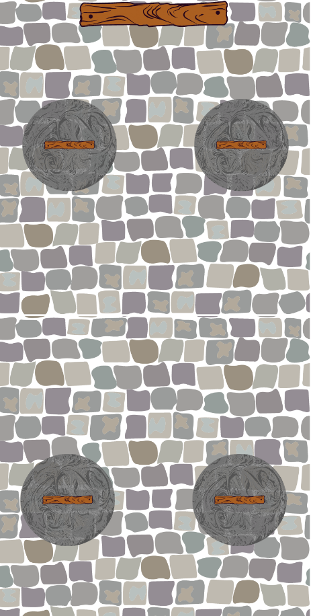
Figure One: A floorplan illustrating room one, the starting point for the adventure. Displaying the map can help players with the visualisation of the story (authors (IT) own illustration).
In the room are four (adapted to the number of adventures) circular concrete plinths made of a greyish stone. Each of them has a red wooden handle (looks like the same material as the door) protruding from the middle of the plinth. This handle moves up and down when manipulated. An individual handle when moved down creates an echoey ‘clunking’ nose from the vicinity of the door, then resets itself. Nothing else happens. Only when all four handles are simultaneously pressed will the clunks be louder and audible click will be heard from the door. The door can now be pushed open. The game is supplemented by a floorplan (see figure one) but the description is provided by the GM and the full scene created by the players imagination.
Employability Skill Alignment
Each room’s puzzle is aligned to specific employability skills (see table one). The example in this room requires problem solving (exploring and establishing the lever solution), oral communication (explaining the solution coordinating a simultaneous pull of the levers) and teamwork (working together to pull the levers). Anytime a character displays any of these employability skills they are passed a small token by the games master. Other employability skills are also recognised for example if an adventurer demonstrates enquiry by establishing the levers and door are made of the same material and therefore linked.

Table 1: A selection of rooms and corridors from the TTRPG adventure with the nature of the puzzle and the employability skills demonstrated in solving them outlined. 1. Analytical Skills, 2. Confidence, 3. Creativity, 4. Decision Making Skills, 5. Initiative, 6. Leadership, 7. Oral Communication, 8. Organisational Skills, 9. Patience, 10. Persuasion & Negotiation, 11. Problem Solving, 12. Resilience, 13. Teamwork and 14. Written Communication.

Location | Nature of Puzzle | Employability Skills
 |  | 1 | 2 | 3 | 4 | 5 | 6 | 7 | 8 | 9 | 10 | 11 | 12 | 13 | 14
Room One | Simultaneous pulling of levers |  |  |  |  | x | x | x | x |  |  | x |  | x
Corridor One | Hidden switch | x |  |  |  |  |  |  | x | x |  | x | x
Room Two | Hidden clues provide directions through a maze | x | x | x | x |  | x | x | x |  |  |  |  |  | x
Corridor Two | Repeating pattern | x |  |  |  | x |  |  |  |  |  | x | x
Room Three | Correct answers to talking statue |  |  | x |  |  |  | x |  |  | x |  |  | x
Corridor Three | Removal of barrier |  |  |  |  |  | x |  |  | x |  | x |  | x

The overall game has a conceptual map linking it to skill development (room puzzles) and the presentation of these skills in an interview setting (end game). The record of skills on the character sheet is akin to a curriculum vitae and supports this narrative.
Flexibility - Each room has potential ‘red herrings’ such as assuming the levers need to be pulled in a specific sequence rather than simultaneously. You should allow players to explore these up to a limit (see clues). The exploration of ideas (another employability skill) is a key aspect of the game. The gamemaster should use some common sense on how to respond to the suggestions made by the adventurers.
Adaptability - Each room is adaptable for example in this room the adventurers may instantly suggest simultaneously pulling the levers, to open the door. The GM may change the solution to involve the levers being pulled in a correct sequence to add more challenge and team discussion. Likewise, if the adventurers spend a long-time exploring sequences the GM may reward the players (and move the game on) by making one of these correct. The object is to allow adventurers to discuss and demonstrate skills rather than ‘win’ or ‘complete’ the game in the quickest time.
Clues - If the players really struggle a non-player character (NPC) ‘Itch the Imp’ appears in a cloud of bellowing and grey smoke in a corner of the room. Itch is approx. 1.5m tall and completely grey. Describing him ‘as a creature you recognise from books as an imp’ is normally sufficient for players imagination. Itch will deliver a short message such as “work together, play together, succeed together” before disappearing again in a bellow of smoke. The NPC offers the opportunity to direct the adventures without spoiling the narrative of the game. These clues are normally sufficient for the players to solve the puzzle without directly providing the answer. Additional direction from Itch can be provided if the players still struggle.
Progress – The game plan has four rooms and four corridors each with their own puzzles. However how many and which of these elements to use depends on the speed of the players and the skills which the GM wishes the players to demonstrate. It also offers the ability to adapt the game for different lengths of play.
End-Point – The game ends when the GM directs the players to an open green space protected by a large opaque wall which contains a single door. As the players approach, a shadowy figure appears and explains that this door leads back to the real world. However, only the most successful adventurers may proceed! They have one minute each to make a convincing argument as to why it should be them. The players then, with the aid of Itch the Imp, have to reflect on the skills they have demonstrated in the game by looking back at the tokens. They will then construct a one minute ‘pitch’ of the skills for the shadowy guardian. This adds the sense of the competitive nature of applications in the real world but in this scenario, every player will ‘win’ and be allowed entry (akin to making the selection process for interview). The approach mirrors the concept of an ‘elevator pitch’ that used in Higher Education to aid students in showcasing their skills in a time constrained environment (Begley, 2017 & Ferrando-Rocher & Marini, 2021)
Running the Game
The game is typically run in a 60-90-minute session with 4-6 players. No previous experience of playing TTRPG is required by players. The game begins with character set-up before proceeding to the game. The session closes with a summary and signposting to career and employability services in the host institution.
Character Set-up
Players are guided at the start of the adventure in creating a character sheet (see figure two) that allows people to allocate scores to their employability skills. The total of these scores is indicated by dice rolls, allowing student to be both strategic about their allocations and a little less self-conscious about how their scores compare to their peers. These sheets are revisited alongside the skills developed in the game (the tokens) as part of the ‘end of game’ activity.
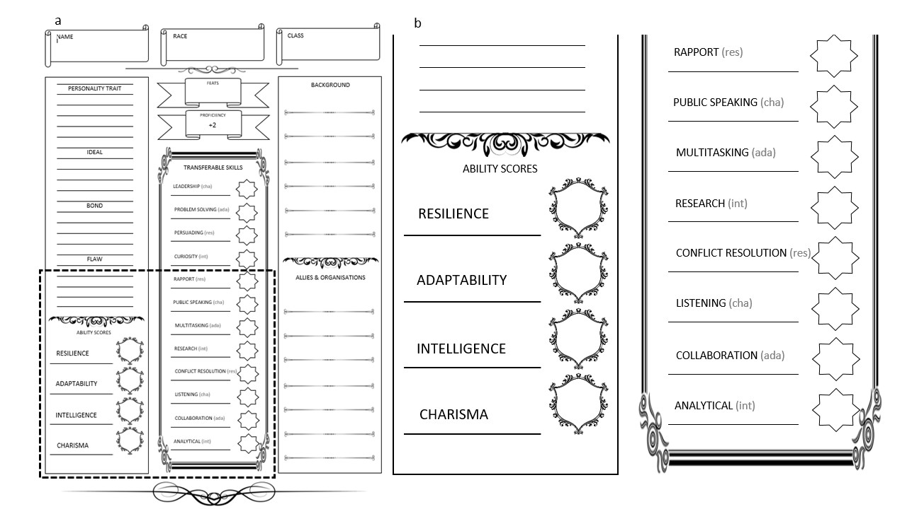
Figure Two: a) Full character sheet used by players to record their initial aptitude in a range of employability skills b) excerpt demonstrating some key employability skills used within the document (authors (LR) own illustration).

Narrative
The game is run by the GM, whose oral description supported by a map (see figure one) is critical to the success of the game. The overview of the adventure and each room should be clear prior to commencing by form of a script for the person acting as GM. The detailed descriptions are best left to the imaginations of the players where possible, with clarification being provided only when requested. There is no need for players to speak or interact any different from a normal conversation dialogue.
A common occurrence is lack of, or over engagement by a few players.
Lack of engagement – A common initial concern is players not knowing what to do or how to interact. In such situations it is often useful for the GM to ask each player in turn what they are doing. If a player states something like “I am going to ask if anyone can hear anything” or “I am going to pull a lever” you should tell them to address their fellow adventurers. Gradually withdraw the more scripted approach as the players become comfortable with the environment.
Over engagement – If one specific player is dominating the conversation in a room you may decide they need to be silenced for a short period. One way to easily achieve this is to build into the narrative the player walking into a thick spiderweb at the next opportunity. This web has clogged their mouth for the next X minutes (you can secretly role a dice to determine this).
Evaluation
The complete game has been run on four occasion, three face-2-face and once digitally. All games ran for one hour and were taken by 5-6 players except the digital game had 25 players, with the scenario adapted (see below) to accommodate this number. The attendees in all games were a mixture of academic staff, career professionals and students. The sessions were all optional and advertised through HEI internal communications. In total only 2 of the 42 attendees reported previous experience with playing a TTRGP.
Participation Reflections. Data was collected informally during the events; informed consent was gained from the participants and the study was ethically approved by the authors institution. The feedback format in each session was varied. The. The unified theme was one of positivity with players fully embracing the TTRPG;
“The immersive nature from the get-go” “The TTRPG was soo much fun!”(student participant)
The potential it offers for employability skills;
“I can see how the idea can be adapted for class. I like the idea of a series of challenges, related to a particular course with a sort of 'why should I progress' bit at the end which exemplifies what has been demonstrated through the tasks” (career practitioner)
and the broader application of TTRPG
“Courage to use TTRPG mechanics in learning by considering the structure Ian demonstrated and using the 'interview' at the end as intended learning outcome confirmation” (academic staff)
GM Reflection. One of the authors acted as GM on all occasions and made notes on each session which were used to construct these reflections. Each of the games was a completely different experience despite the underlying story being the same. The games all progressed at different speeds with the range of solutions proposed quite surprising in such a small adventure. In all games there was a general reluctance to ‘start’ and knowing how to speak to each other in the games setting. Employing the tricks mentioned (section) the players all adapted, and the GM voice was used less frequently as the adventure proceeded. In every case the full scheme of rooms was not used, upon revealing this in the session debrief there was consensus in the disappointment and a request to ‘play these’. The sessions went really well, the post session link to the HEI career and employability services was vital in contextualising the activity and allowing player to further explore any employability skill limitations identified in the game.
The Potential of TTRPG for Employability Skills
Games have the potential to change behaviour, a fact long utilised in all sectors of the world including Higher Education (Hammady & Arnab, 2022). TTRPG are a specific category of game under-utilized as a pedagogic tool despite the potential they offer. TTRPG have been reported to develop a wide range of skills and attributes in its players which in many cases align to the same skills that employers strive for in graduates. In a culture of teaching excellence and active learning, it would be remiss to not explore such opportunities for simultaneously creating an excellent teaching experience and enhancing graduates awareness of their own employability skills.
There is some stigma attached with the use of TTRPG, maybe in part due its association with the “Dungeons and Dragons” troupe and the stereotypes this conjures (Curran, 2011) TTRPG at their heart are very similar to simulation and role-playing activities which are much more widely accepted as pedagogical tools. The main variation in TTRPG is the presence of the ‘table’ a communal focal point for the discussions and the scope of the game (much larger in TTRPG). TTRPG are co-created by all players under the guise of the GM, co-creation and student-staff partnerships are common principles / philosophies in the learning and teaching strategies of HEIs. It is recognised that the idea of a TTRPG could act as barrier to engagement to some students. The transition to remote education in the UK led to this TTRPG being adapted to run digital and to a larger group of players (n = 25). In such a scenario the players fall asleep in their halls of residence and when waking, 5 are in the room as previously described. The rest awake looking down on the room from above where they can see their friend’s escapades. Those looking down cannot orally communicate, but their group phone chat is working (the chat box in the VLE) and they can interact. Each time the players move out of a room the narrative switches the players in the room.
The TTRPG subtle use of shared plight creates a sense of teamship and cooperation, the fantasy (faked realism) creates a neutral space where student ‘personas’ (the characters) can explore the world in ways some students find uncomfortable. The varying nature of the puzzles creates opportunities for the demonstration of different employability skills. This is enhanced considerably by the flexible nature of the narrative and GM tricks that allow all players to use their voices (e.g., quieting a talkative player by having them walk into a spider web). The skills themselves are not going to be ‘formed’ or enhanced by a one-hour TTRPG, this is not the purpose. The aim is awareness of both skill and self-awareness of current competency and ability in this area. The skills highlighted in the game could be considered implicit, a behaviour required only in the game e.g., problem solving, or explicit a direct symptom of the game e.g. teamwork.
This TTRPG on its own is not a replacement for any in-curricula employability skills provision offered on a HEI programme. It is best placed as an extra-curricular tool that’s primary purpose is allowing students to, in an abstract way, explore and realise some of their own employability skills whilst gaining confidence in their use.

References
Adams, A. S. (2013) ‘Needs met through role-playing games: A fantasy theme analysis of Dungeons & Dragons’, Kaleidoscope: A Graduate Journal of Qualitative Communication Research, 12(6), pp.69-86.
Ariffin, M. M., Oxley, A., & Sulaiman, S. (2014) ‘Evaluating game-based learning effectiveness in higher education’, Procedia-Social and Behavioral Sciences, 123, pp.20-27.
Auger, P. (2019) Independent panel report to the Review of Post-18 Education and Funding. May 2019. Available at: https://assets.publishing.service.gov.uk/government/uploads/system/uploads/attachment_data/file/805127/Review_of_post_18_education_and_funding.pdf (Accessed 30 March 2023).
Begley G. S. (2017) ‘Using Elevator Speeches to Develop Research & Communication Skills in Biology’, Journal of microbiology & biology education, 19(1). https://doi.org/10.1128/jmbe.v19i1.1405
BIS. (2011) Students at the Heart of the System. London: UK Government: Department for Business, Innovation and Skills.
Blackmore, P., Bulaitis, Z. H., Jackman, A. H., & Tan, E. (2016) Employability in higher education: A review of practice and strategies around the world. Available at: https://www.pearson.com/uk/news-and-policy/reports-and-campaigns/employability-in-higher-education.html (Accessed 30 March 2023).
Blackmon, W. D. (1994) ‘Dungeons and dragons: The use of a fantasy game in the psychotherapeutic treatment of a young adult’, American journal of psychotherapy, 48(4), pp.624-632. https://doi.org/10.1176/appi.psychotherapy.1994.48.4.624
Bowman, S.L. (2010) The Functions of Role-Playing Games: How Participants Create Community, Solve Problems, and Explore Identity. Jefferson, NC: McFarland & Company, Inc.
Brown, K. (2018) Slaying Dragons: The Therapeutic Value of Tabletop Gaming. PhD Thesis. City University of Seattle.
Cardinot, A., & Fairfield, J. A. (2022) ‘Game-based learning to engage students with physics and astronomy using a board game’, in Clarke, S., Jennex, M. E. and Anttiroiko, A. V. (Eds) Research Anthology on Developments in Gamification and Game-Based Learning. IGIG Global, pp. 785-801.
Chung, T. S. (2013) ‘Table-top role playing game and creativity’, Thinking Skills and Creativity, 8, pp.56-71 https://doi.org/10.1016/j.tsc.2012.06.002
Clarke, S., Arnab, S., Morini, L., & Heywood, L. (2019) ‘Dungeons and dragons as a tool for developing student self-reflection skills’, in Gentile, M., Allegra, M., Söbke, H. (eds) Games and Learning Alliance. GALA 2018. Lecture Notes in Computer Science. 11385, pp. 101-109. https://doi.org/10.1007/978-3-030-11548-7_10
Curran, N. (2011) ‘Stereotypes and individual differences in role-playing games’, The International Journal of Role-Playing, 2, pp.44-58.
Daniau, S. (2016) ‘The transformative potential of role-playing games—: From play skills to human skills’, Simulation & Gaming, 47(4), pp. 423-444 https://doi.org/10.1177/1046878116650765
Dyson, S. B., Chang, Y. L., Chen, H. C., Hsiung, H. Y., Tseng, C. C., & Chang, J. H. (2016) ‘The effect of tabletop role-playing games on the creative potential and emotional creativity of Taiwanese college students’, Thinking Skills and Creativity, 19, pp.88-96. https://doi.org/10.1016/j.tsc.2015.10.004
Ferrando-Rocher, M., & Marini, S. (2021) ‘Promoting Students' Soft Skills in a Telecommunication Engineering Course with an Elevator Pitch Activity’, International Journal of Emerging Technologies in Learning (iJET), 16(24), pp.273-279.
Gygax, G., & Arneson, D. (1974) ‘=Dungeons and dragons (Vol. 19). Lake Geneva, WI: Tactical Studies Rules.
Hammady, R., & Arnab, S. (2022) ‘Serious gaming for behaviour change: A systematic review’, Information, 13(3), 142.
Harviainen, J. T., & Lieberoth, A. (2012) ‘Similarity of social information processes in games and rituals: Magical interfaces’, Simulation & Gaming, 43(4), pp.528-549.
Hergenrader, T. (2011) ‘Gaming, world building, and narrative: Using role-playing games to teach fiction writing’. In Proceedings of the 7th international conference on Games+ Learning+ Society Conference (pp. 103-108).
Kaylor, S. L. (2017) Dungeons and Dragons and literacy: The role tabletop role-playing games can play in developing teenagers' literacy skills and reading interests (Graduate Research paper, University of Northern Iwoa).
Karwowski, M., & Soszynski, M. (2008) ‘How to develop creative imagination?: Assumptions, aims and effectiveness of Role Play Training in Creativity (RPTC)’, Thinking Skills and Creativity, 3(2), pp.163-171. http://dx.doi.org/10.1016/j.tsc.2008.07.001
Kowert, R., & Oldmeadow, J. A. (2013) ‘(A) Social reputation: Exploring the relationship between online video game involvement and social competence’, Computers in Human Behavior, 29(4), pp.1872-1878 https://doi.org/10.1016/j.chb.2013.03.003.
Krouska, A., Troussas, C., & Sgouropoulou, C. (2022) ‘Mobile game-based learning as a solution in COVID-19 era: Modeling the pedagogical affordance and student interactions’, Education and Information Technologies, pp.1-13.
Lei, H., Chiu, M. M., Wang, D., Wang, C., & Xie, T. (2022) ‘Effects of game-based learning on students’ achievement in science: A meta-analysis’, Journal of Educational Computing Research, 60(6), pp.1373-1398.
Mather, N. (1986) ‘Fantasy and adventure software with the LD student’, Journal of Learning Disabilities, 19(1), pp.56-58. https://doi.org/10.1177/002221948601900112
Middaugh, M. F. (2007) ‘Creating a culture of evidence: Academic accountability at the institutional level’, New Directions for Higher Education, 2007(140), pp.15-28. https://doi.org/10.1002/he.277
Partnership for 21st Century Skills. (2009) A framework for 21st century learning. Tucson: AZ: P21. Available at: www.21stcenturyskills.org. (Accessed 30 March 2023).
Pegg, A., Waldock, J., Hendy-Isaac, S., & Lawton, R. (2012) Pedagogy for employability. York, UK: Higher Education Academy.
Römgens, I., Scoupe, R., & Beausaert, S. (2020) ‘Unraveling the concept of employability, bringing together research on employability in higher education and the workplace’, Studies in Higher Education, 45(12), pp.2588-2603.
Rivers, A., Wickramasekera, I. E., Pekala, R. J., & Rivers, J. A. (2016) ‘Empathic features and absorption in fantasy role-playing’, American Journal of Clinical Hypnosis, 58(3), pp.286-294. https://doi.org/10.1080/00029157.2015.1103696
Spinelli, L. (2018) Tabletop Role-Playing Games and Social Skills in Young Adults. (honours Project, Pace University).
Tresca, M. J. (2010) The evolution of fantasy role-playing games. Jefferson: McFarland & Company.
Wang, L. H., Chen, B., Hwang, G. J., Guan, J. Q., & Wang, Y. Q. (2022) ‘Effects of digital game-based STEM education on students’ learning achievement: a meta-analysis’, International Journal of STEM Education, 9(1), pp.1-13.
Yorke, M., & Knight, P. T. (2006) Embedding employability into the curriculum (Vol. 3). York: Higher Education Academy.
Zhao, D., Muntean, C. H., Chis, A. E., Rozinaj, G., & Muntean, G. M. (2022) ‘Game-based learning: enhancing student experience, knowledge gain, and usability in higher education programming courses’, IEEE Transactions on Education, 65(4), pp. 502-513.

