Thinglink: A technological review of a case-based virtual learning environment

James Wilkinson
University of Hertfordshire
Corresponding author: j.wilkinson3@herts.ac.uk

Abstract
‘Thinglink’ is a virtual learning platform, allowing users to upload photos and create realistic online worlds. ‘Misfortune Avenue’ is a virtual street, where paramedic students can meet patients from clinical practice as case studies in a safe, online environment. Academic staff can support the learning of theory content from a live teaching session, by mimicking real-world environments and designing management plans in simulation. Scenarios are designed to become more complex over three stages, with patient presentations constructively aligned against indicative content from each academic level of a paramedic science degree. The design uses scaffolding of the curriculum, allowing students to build an understanding of how an illness might progress through the longitudinal patient journey, created around various patient presentations commonly seen in paramedic practice. The scope of the platform allows interprofessional working between healthcare workers across the wider health service and encourages learning throughout the continuation of the patient journey.
Key words: virtual, learning, simulation, healthcare, education

‘Thinglink’ is a virtual learning platform that allows academic staff in educational settings to create online ‘scenes’ which mimic real-world environments. Staff can upload and share photos, videos and 360˚ images of a chosen environment to Thinglink, in which the content of each image can be tagged and labelled with key information. Conradi et al. (2009) suggest this would be beneficial for professions that involve simulation, placement or kinaesthetic elements of practice, to help visualise real situations virtually or via distance learning. Scenes within scenes allow users to jump between different environments, taking the student on a self-explored journey based on their chosen interactions; or gaining additional information about the scenes via a planned, stepwise approach created by the designer.
In the context of healthcare simulation, Thinglink has been used to create ‘Misfortune Avenue’: a virtual street of patients where paramedic students can visualise themselves immersed in medical emergencies from the perspective of a clinician (Figure 1). Students can design management plans and meet patients from clinical practice as case studies, promoting a safe, effective online learning environment, highlighted by Wheeler and Dippenaar (2020) as highly beneficial to learning. Simulation successfully bridges the gap between theory and practical, as seen with a similar project in palliative care, ‘Ivy Street’ (Clabburn, Groves and Jack, 2020). Thematic analysis of 20 participants using open-ended survey questions noted this positively enabled peer discussion and promoted high-impact student engagement; ‘Misfortune Avenue’ aims to share these outcomes, with data being collected later this year.
There are opportunities to integrate Thinglink with virtual reality, to ensure a fully immersive and interactive user experience. Users can play along simultaneously in the classroom by scanning a QR code, to support case-based learning for the relevant theory session, or it can be embedded online as a revision aid. Thinglink may be particularly beneficial as a simulation tool, when considering the NHS Long-term workforce plan, increasing simulation hours for healthcare students (NHS England, 2023).

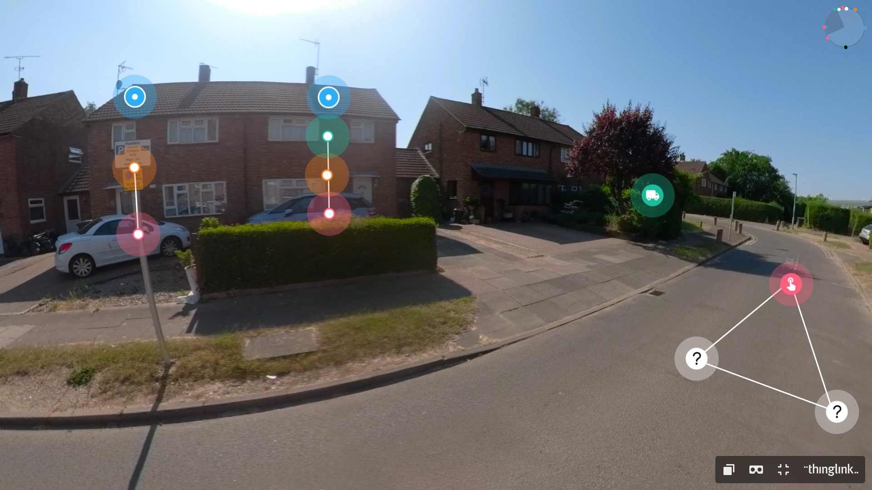
Figure 1- Misfortune Avenue
‘Misfortune Avenue’ uses a Google maps-style design, where students discover a different fictional patient living in each house on the virtual street. Each house represents a realistic clinical scenario, with the same patient having different stages to their illness within the case study. Allowing students to build an understanding of how an illness might progress through the longitudinal patient journey, the design acknowledges Ruge, Tokede and Tivendale’s (2019) scaffolding of the curriculum: in this instance, using indicative content from each academic level of a university paramedic science degree to inform the development. Scenarios can be specifically designed to become more complex over the three stages, and academics can constructively align patient presentations to suit their target audiences’ needs, as outlined by Stamov Roßnagel, Lo Baido and Fitzallen (2021).
Cases are created around a variety of patient presentations commonly seen within the wider healthcare system. However, this feature is not limited to healthcare and can be adopted by any educational programme that utilises scaffolding within the curriculum, or where information would benefit from being presented visually to the student. Scenes would need to reimagined, so they are fit for purpose specific to that programme, but being imaginative with the format is a benefit of the development process for the content designer.
The social constructivist pedagogical approach to case-based learning applied here positively reinforces the strengths of the revised Bloom’s Taxonomy (Alaghbary, 2021). Students can discuss abnormalities within the case studies, learning from their own and each other’s experiences and mistakes. Links to websites, clinical guidelines, YouTube videos or voice narration can be embedded into scenes, to further aid understanding and develop knowledge of each case study. Patient presentations integrate cross-modular elements of the curriculum throughout the three years in paramedic higher education, to establish a holistic approach to patient care and it will be interesting to explore paramedic students’ perceptions of this environment. McLean (2016) suggests discussion of appropriate patient assessment within the case-study consolidates existing theory and builds confidence in the management of particular conditions, particularly for those students who may not yet have experienced clinical practice. The constructivist design applies to any discipline where students can learn from each other and early observations have demonstrated the task promotes teamwork and collaboration, both in-person and online; further data is yet be collected to consolidate this finding.
The scope of the platform encourages academics to embrace technology-enhanced learning (Kirkwood and Price, 2013), allowing interprofessional working between departments across the wider health service. Initial feedback from students has been positive; comments include ease of accessibility, due to the online nature of the platform; a good revision tool whilst on placement to refresh theory; and extremely beneficial for learning with neurodiverse students, which Hamilton and Petty (2023) agree promotes equality, diversity and inclusivity through different teaching methods. Each scenario includes application of underpinning theoretical knowledge, guidance on the completion of clinical skills and inclusion of evidence-based guidelines, providing a universal but unique student experience. Patients in real practice can be contextualised against the case studies, if students wish to later revisit the scenario, to understand the underlying assessment and management in more detail.
Challenges of the platform involve the time constraints in setting up each scene for the specific case studies. The functionality of the platform itself is straightforward for the average academic to grasp. However, it may take time familiarising oneself with the possibilities of the programme and reworking content until a meaningful output exists. Newton and Miah (2017) recognise this virtual, case-based approach may not benefit all students equally, particularly those who may not believe they align with a preferred visual learning style. As such, this is an opportunity for teaching staff to embrace an alternative to traditional pedagogical approaches and accommodate their practices accordingly.
In summary, Thinglink is a virtual learning environment that allows users to immerse themselves in real-world situations, build on theoretical knowledge through simulation and create case-based scenarios to promote peer discussion. The potential for any educator that uses constructive alignment, distance learning or visual learning approaches may find Thinglink highly beneficial to the overall student experience.

Disclosure statement
All materials included in the article represent the authors own work and anything cited or paraphrased within the text is included in the reference list. The work has not been previously published nor is it is being considered for publication elsewhere. There are no potential conflicts of interest which might have influenced the author in reporting their findings completely and honestly.

Reference list:
Alaghbary, G. (2021) ‘Integrating technology with Bloom’s revised taxonomy: Web 2.0-enabled learning designs for online learning’, Asian EFL Journal, 28(2), pp. 10-37.
Clabburn, O., Groves, K. E. and Jack, B. (2020) ‘Virtual learning environment ('Ivy Street') for palliative medicine education: student and facilitator evaluation’, BMJ supportive and palliative care, 10(3), pp. 318–323. doi: https://doi.org/10.1136/bmjspcare-2019-002159
Conradi, E., Kavia, S., Burden, D., Rice, A., Woodham, L., Beaumont, C., Savin-Baden, M. and Poulton, T. (2009) ‘Virtual patients in a virtual world: Training paramedic students for practice’, Medical teacher, 31(8), pp 713–720. doi: https://doi.org/10.1080/01421590903134160
Hamilton, L. G. and Petty, S. (2023) ‘Compassionate pedagogy for neurodiversity in higher education: A conceptual analysis’, Frontiers in psychology, 14, pp. 1093290. doi: https://doi.org/10.3389/fpsyg.2023.1093290
Kirkwood, A. and Price, L. (2013) ‘Technology-enhanced learning and teaching in higher education: What is ‘enhanced’ and how do we know? A critical literature review’, Learning, Media and Technology, 39(1), pp. 6–36. doi: https://doi.org/10.1080/17439884.2013.770404
McLean, S. F. (2016) ‘Case-Based Learning and its Application in Medical and Health-Care Fields: A Review of Worldwide Literature’, Journal of medical education and curricular development, 3, pp. JMECD.S20377. doi: https://doi.org/10.4137/JMECD.S20377
Newton, P. M. and Miah, M. (2017) ‘Evidence-Based Higher Education - Is the Learning Styles 'Myth' Important?’, Frontiers in psychology, 8, pp. 444. doi: https://doi.org/10.3389/fpsyg.2017.00444
NHS England (2023) NHS Long Term Workforce Plan. Available at: https://www.england.nhs.uk/wp-content/uploads/2023/06/nhs-long-term-workforce-plan-v1.2.pdf (Accessed: 12 December 2023).
Ruge, G., Tokede, O. and Tivendale, L. (2019) ‘Implementing constructive alignment in higher education - cross-institutional perspectives from Australia’, Higher education research and development, 38(4), pp. 833–848. doi: https://doi.org/10.1080/07294360.2019.1586842
Stamov Roßnagel, C., Lo Baido, K. and Fitzallen, N. (2021) ‘Revisiting the relationship between constructive alignment and learning approaches: A perceived alignment perspective’, PloS one, 16(8), pp. e0253949. doi: https://doi.org/10.1371/journal.pone.0253949
Wheeler, B. and Dippenaar, E. (2020) ‘The use of simulation as a teaching modality for paramedic education: a scoping review’, British paramedic journal, 5(3), pp. 31–43. doi: https://doi.org/10.29045/14784726.2020.12.5.3.31

Appendix A- Sharing links (website, QR code)
If readers wish to experience Thinglink, they can through the following links:
https://www.thinglink.com/video/1790728144701883236
