The development and implementation of a ‘one stop’ assessment strategy in Psychology
Matthew Brooks, Emma Tarpey, Joanne Ashby
Manchester Metropolitan University
Corresponding author: m.brooks@mmu.ac.uk

Abstract
In this paper we will be outlining the development of an assessment strategy and accompanying online single point of access for all assessment-related processes undertaken by Psychology staff within a higher education setting. We will outline the problem and highlight why the changes were needed. Then we will outline how we created the assessment strategy and single point of access, discuss the preliminary impact, and conclude with next steps.
Keywords: Assessment; Assessment Processes; Assessment Strategy; SharePoint

This paper discusses the development of an assessment strategy for a higher education Psychology department, and an accompanying single point of access for all assessment-related processes using Microsoft SharePoint. In this case study we outline the higher education and institutional contexts that influenced the development of the strategy and single point of access, what we did to set up the strategy and assessment resources, the departmental, faculty and institutional impact of the initiative, and next steps.

About the Authors
The authors are members of the Department of Psychology at Manchester Metropolitan University, with responsibility for education and assessment-related processes within the department. The Department is highly successful at recruiting students across undergraduate and postgraduate level with the majority of programmes accredited by the British Psychological Society (BPS); there are approximately 95 staff members and 1,800 students at any one time. Emma Tarpey is Department Education Lead for Psychology and is responsible for ensuring the implementation of the University Education Strategy. Matt Brooks is the Assessment Lead for Psychology and is responsible for overseeing the implementation of the Department Assessment Strategy and co-ordinating assessment-related processes. Joanne Ashby is the Head of the Department of Psychology and is responsible for providing academic leadership and direction for the department in research and teaching. All have undertaken module leader and module tutor roles.

Context
Assessment is an essential part of higher education as this evaluates student learning, and the achievement of learning outcomes. More broadly, assessment can inform student identities, contributing to the development of their personal and professional identity (Nieminen and Yang, 2023). It is crucial that assessment processes are fair and robust, and underpinned by quality assurance practices (Knight, 2002; Bloxham et al., 2016). In their model of perspectives on assessment in higher education, Atkinson and Lim (2013) note that both students and staff value structure, feedback, consistency, fairness and efficiency in assessment practice, while staff also appreciate clarification of assessment standards and streamlining of marking processes. Assessment is an important component of the student experience and is measured as part of the National Student Survey (NSS), which is a nationwide survey of final-year undergraduate higher education students. Historically, assessment and feedback-related questions achieve overall lower satisfaction scores than other themes within the NSS (Bell and Brooks, 2018), which has also been reflected in the Department of Psychology data at Manchester Metropolitan University.
Assessment-related information and support at Manchester Metropolitan University is primarily provided through three sources. First, the university publishes undergraduate and postgraduate assessment regulations on an annual basis (Manchester Metropolitan University, 2023a, 2023b). The Assessment Regulations provide rules and procedures for all assessed work to ensure all students are fairly and objectively assessed. Second, there is an Assessment Management team who ensure the implementation of the regulations and provide guidance to staff on assessment-related policies. Third, the University Teaching Academy (UTA) provides pedagogical support, leadership, advice and guidance relating to all aspects of learning, teaching and assessment at Manchester Met (University Teaching Academy, n.d.).
In recent years, Manchester Met has moved to online cloud-based systems for file storage and collaboration. Within the Department of Psychology, Microsoft SharePoint is used as a repository for file storage, and a collaboration space for psychology staff, where programme, research and general administrative documents are stored. SharePoint is advantageous in terms of data storage and collaboration, and it also can create personalised pages which can present information from the file repository in an accessible manner (McLeod et al., 2010).
In the Department of Psychology, there are nine different programmes and approximately 100 modules, and staff can often be working on multiple modules across various programmes, that includes staff who are new to module leading. With large departments like Psychology, the challenge for robust assessment processes is ensuring consistency of assessment literacy across module leaders and markers. There are numerous conceptualisations of assessment literacy within the literature (Zhu and Evans, 2022), and for the purpose of this paper, we are focusing on assessment literacy as an awareness of assessment processes, and the application of these processes, policies, and principles to one's work (Xu and Brown, 2016). Literature on assessment practice has largely focused on enhancing student outcomes and developing feedback processes to enhance student assessment literacy, with less attention as to what is expected from staff (Boud and Dawson, 2023). Having clear assessment procedures in place would constitute a ‘practice architecture’ that encourages staff learning the assessment practices in the department, and also supports staff to work more consistently towards a common goal, which is particularly important for staff who are new to Manchester Met and unfamiliar with its processes (Francisco and Boud, 2023). Within Manchester Met, resources for developing assessment-related literacy for staff are available at an institutional level. This includes continuing professional development (CPD) events, professional qualifications in teaching and learning, and online materials. Although there is a wealth of resources available, these require interpretation and adaptation at a departmental level to enable staff to undertake assessment-related activities for their programmes and modules. One aspect of the Advance HE framework (2024) is to implement systems and processes that support assessment practices, and to use technology to help support the assessment cycle. Within Psychology, there was no single point of access for assessment-related processes for module leaders to perform day-to-day assessment tasks. In addition, there was no uniform approach as to how Psychology staff are using the SharePoint library across modules and programmes, resulting in difficulties locating folders and files. Furthermore, a lack of overarching assessment strategy for the department meant that some assessment-related tasks were conducted in a reactive rather than proactive manner.

Aims
Given the issues that we had identified, we generated a number of key actions for assessment in Psychology. The key objectives were to:
- Develop an overarching assessment strategy for the department to provide an accessible framework for assessment-related processes;
- Adopt a standardised and streamlined approach to assessment-related processes in the department;
- Socialise the assessment strategy among departmental staff to increase staff literacy and improve staff experience of navigating assessment-related information and tasks.

What We Did
The first stage was for us to explore what assessment resources and information was already available within the Psychology department. We identified that a lack of uniformity in storage of assessment-related information, with some staff storing information on their personal OneDrive in separate folders, and others using SharePoint. We then explored how other departments were managing their assessment processes and information both within the faculty and other faculties at Manchester Met. We discovered areas of good practice in other departments. For example, another department in the Faculty had developed a helpful local departmental assessment strategy that outlined various principles and processes pertaining to assessment within that department. Additionally, a department in the Business School had outlined their assessment principles aimed at achieving a cohesive approach to assessment design to support student success (progression and good honours) and career readiness (improving graduate outcomes). Finally, we identified that central university services such as the University Teaching Academy (UTA) and the Assessments Team had a wealth of information about principles, processes and regulations relating to assessment design and delivery on their respective webpages (University Teaching Academy, n.d.).
Based on what information we had gathered, we decided that it would be helpful to develop a localised assessment strategy for Psychology, which brought together all assessment-related principles and processes into a single accessible framework. We decided to base this upon the assessment lifecycle (Forsyth, 2015) which provides a transparent and consistent approach to assessment across Manchester Met with the aim of enhancing staff assessment literacy. A condensed version of the lifecycle as outlined on the UTA website consists of five key areas:
- Specifying: Information on assessment design, type, size, weighting, penalties, formative and summative assessment.
- Setting: Information on assignment briefs, marking criteria and feedback plans.
- Supporting: Information on learner development, technology-enhanced learning, library and further study skills resources.
- Marking and feedback: Information on marking, calibration, moderation, and feedback.
- Reflection: Information on reviewing the effectiveness of tasks, module-level data, and staff and student feedback.
Although we recognised that this information was readily available to all staff, we wanted to tailor the information so that it was more applicable to the processes within Psychology. We hoped that by streamlining the information, it would make it easier for staff to access and engage with assessment information and processes. This would promote consistency across the Department and reduce the burden of staff having to access multiple different sources of assessment-related information.
We began by setting out the strategy document with the five assessment lifecycle headings and then identified the processes that corresponded with each of those headings as follows:
- Specifying: Information relating to module specifications, assignment submission dates, and checking submission settings.
- Setting: Information relating to writing assignment briefs, internal moderation and verification of modules, and pre-semester preparation of external examiner packs.
- Supporting: Information relating to support for assessment.
- Marking and feedback: Information relating to assignment marking and feedback, internal moderation of marking, and external moderation of marking.
- Reflection and development: Information relating to relating to checking student results profiles, module and assessment review, and staff development.
Under each heading, tasks are listed alongside a description of what needs to be done, who is responsible, and the timeframe (see Figure 1). Each assessment-related task is listed using clear language that will be familiar to Psychology staff so that they can easily locate the specific details relating to that task. The next column, ‘what needs to be done’, breaks down the task into smaller component parts clearly outlining what needs to be done and provides hyperlinks links to relevant sources of information (e.g., SharePoint template document files, forms, wider university resources). We felt it was important to include all roles within the Department that relate to assessment processes to provide clarity to staff about their role and the role of other people, and to demonstrate the whole-team approach to assessment within Psychology. The final column provides a timeframe or deadline for when the tasks needed to be completed within that assessment cycle. This would allow staff to plan and organise their module assessment and delivery.
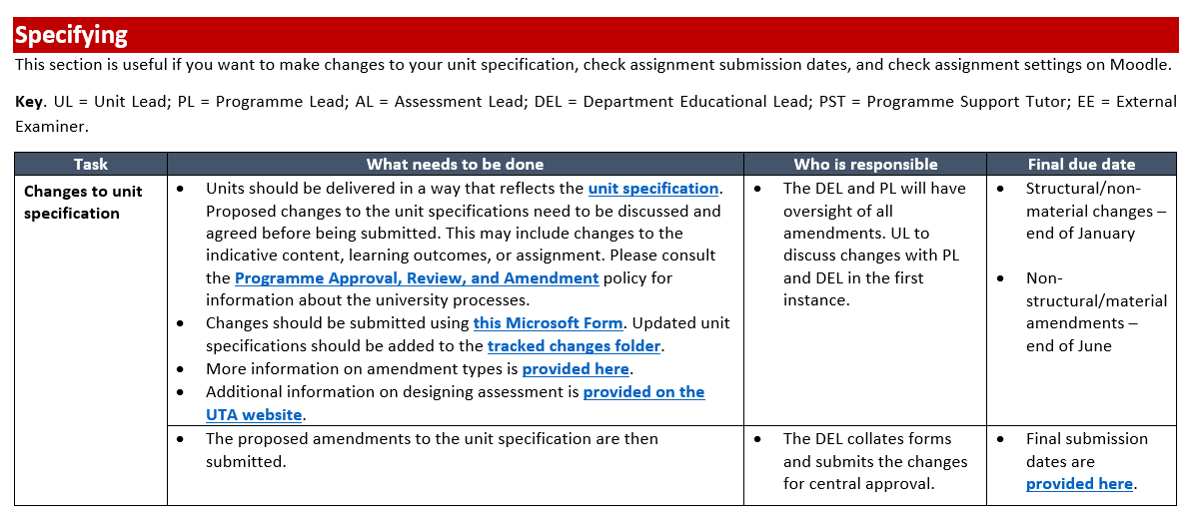
Figure 1. Example excerpt from the Department of Psychology Assessment Strategy.
Once we had formalised all assessment principles and processes in the department into a single strategy document, we thought about how to best communicate and socialise the strategy among staff. We recognised various time pressures on staff and the likelihood of them engaging with the comprehensive document, and considered whether we could make the strategy more accessible.
We already had a pre-existing Departmental SharePoint page for Digital Education which provided digital education resources and information on a single page. Staff had found this useful as a single point of access as opposed to searching through various SharePoint libraries, emails, and updates for digital education information. We felt that this format would be advantageous to promote the Assessment Strategy, as staff were familiar with the SharePoint page layout. It would also allow us to create a dedicated folder in the SharePoint library specifically for assessment-related guidance, support, and information, and an area for staff to store moderation and marking documents.
We had structured the strategy in various stages and believed a visual representation of those stages would further enhance staff accessibility and engagement. We then began structuring the SharePoint page according to the five areas from the Department Assessment Strategy (see Figure 2). For each area, we provided a brief overview of the section accompanied by a relevant graphic. Within each area, we briefly described relevant tasks or procedures, accompanied by an appropriate graphic and hyperlink to a resource, template document, form, file, folder, or webpage. Each section is structured to be intuitive by grouping links into areas where staff can submit, download, upload, or read files or information. Some example information and materials for each section are provided below:
- Specifying: Staff can complete a Microsoft Form to request changes to module specifications.
- Setting: Staff can access the assignment brief template, list of module leaders, moderators, and assessment deadlines, and drop completed assignment briefs and internal moderation forms into the relevant external examiner folder for moderation.
- Supporting: Staff can access links to various central support services, extensions, and Psychology standard refer to tutor (extension) dates.
- Marking and feedback: Staff can upload their module marking spreadsheets and internal moderation forms for external moderation, and drop assignments suspected of plagiarism into a specific folder for review.
- Reflection and development: Staff can download a module reflection template and access information on checking student results profiles and further training.
We also added a ‘Key Information’ area which provides links to useful resources, regulations, and polices that underpin the Department Assessment Strategy. For instance, this includes the Department Assessment Calendar which provides a comprehensive overview of all undergraduate and postgraduate modules delivered within the department, detailing module names, module leaders, module codes, assessment types, number of credits, submission deadlines and board dates. Additionally, staff can access the Department Assessment Map, which provides descriptions of all assessments used in Psychology by module, level, and programme.
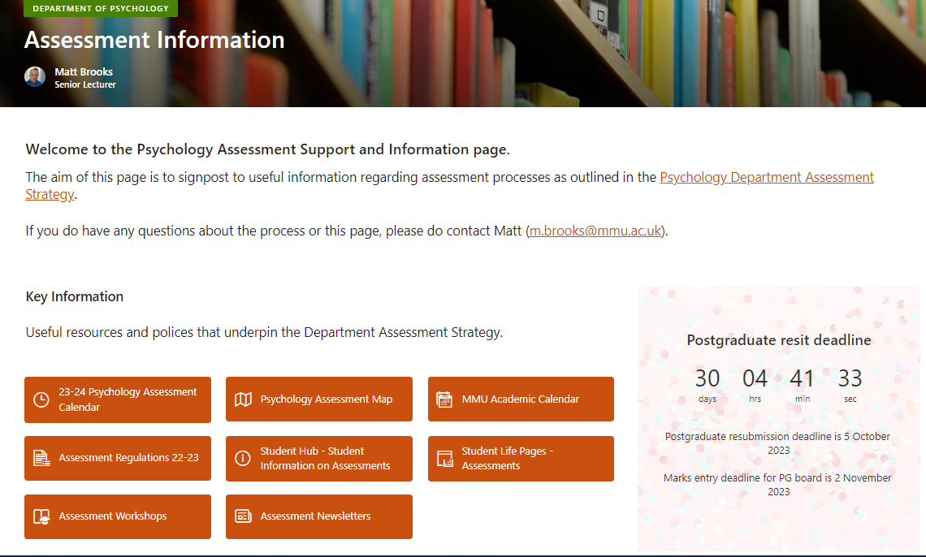
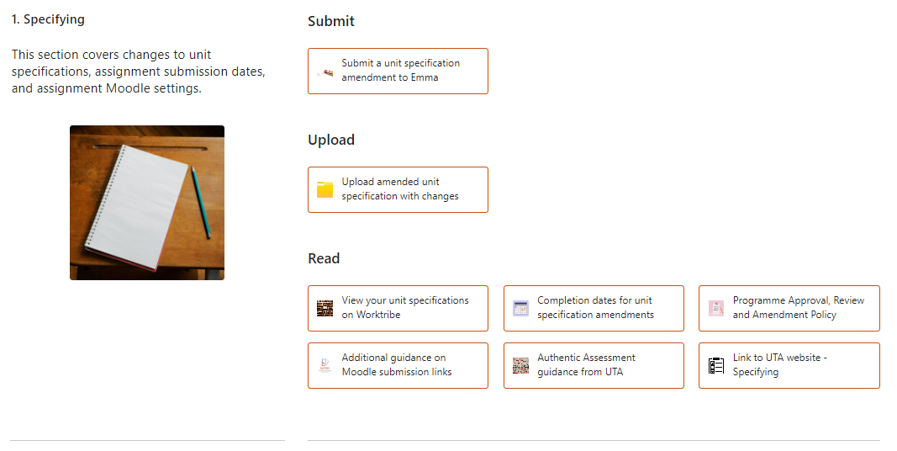
Figure 2. Screenshots of the newly developed Department Assessment page.

Impact
The newly adapted/developed Assessment SharePoint page was made live to the Department in November 2022. Since that time, the page has received over 1,300 hits from over 93 individual members of Psychology staff, who on average have spent about one and half minutes on the page. We have received positive feedback from Psychology staff, in terms of the practical use and application of the page. One staff member commented that the Assessments SharePoint page was “extremely impressive and useful” and has “streamlined many of our processes”. Another member of staff not only spoke about the SharePoint page but also commented upon the strategy that underpins this:
“Many thanks for developing the assessment strategy and assessment support and information SharePoint page, these look brilliant and so helpful! I’m potentially looking to make an amendment to my level 4 unit spec, so having all the relevant information on the SharePoint page is incredibly helpful. Thank you!”
The Psychology Assessment Strategy and SharePoint page were shared with other Department Education Leads in the Faculty to demonstrate the innovative assessment approach and resources within Psychology. The feedback from the Department Education Leads was extremely positive, indicating that they wanted to adopt a similar approach within their departments:
“I just wanted to let you know how impressed I was with the Assessments SharePoint for Psychology that Emma very kindly shared with Faculty DELs. It is really a game-changer and raises the bar for the entire Faculty - excellent innovation.”
As the Psychology Assessment Strategy and SharePoint page gained more interest, we were invited to share this example of good practice with other departments in our Faculty and in other faculties across the university. The page was received positively by colleagues, who commented on the useful layout and design, and the pooling and structuring of all resources and regulatory information into a single page:
“I am impressed by how assessment has been acknowledged as an important element of the SharePoint by having its own area. It then provides this one stop shop which links to the university and department approach to assessment. For staff in the department, I would think it makes things easier with regards to process and then frees up time for them to think more creatively about their assessment. Structuring it in the way it is has a logic and clarity to it and helps staff to understand the key aspects. As I look to develop one for my department and hopeful rollout to faculty it is great to have this as a starting point and template as you clearly have all areas of process covered – it's great.”
The development of the Assessment SharePoint page has benefited the external moderation process, by having all necessary documents ready for review in a clearly organised repository, making communication with external examiners more efficient, and facilitating a smoother process for external moderation (Bloxham et al., 2016):
“For the first time in a long time I am ahead with a deadline! I have managed to spend time yesterday and today reviewing the Level 3, 4 and 5 EE materials and have added all comments in the spreadsheet. Again thanks Matt for making it so easy, the course links definitely saved me lots of time!”
Anecdotally, since the rollout of the Psychology Assessment Strategy and SharePoint page, we have noticed reduced email traffic in relation to assessment-related process queries from Psychology staff. Providing clear instructions with links to the SharePoint page appears to have increased staff engagement and familiarity with the assessment processes, which seems to have reduced the need to request information and documents from staff. An additional benefit is that we have been able to respond swiftly to requests for information (e.g., checking that modules have been externally moderated before going to the Assessment Board), as it has all been collated into a single repository.

What Next?
Creating the Psychology Assessment Strategy and SharePoint page has laid the foundation for the approach to assessment within the Department. We hope that making our assessment processes transparent will have a beneficial effect on our students in terms of developing their understanding of assessment processes and standards, which will allow them to monitor their progress and take responsibility for their own learning (Mui So and Hoi Lee, 2011). In addition, the Psychology Assessment Strategy and SharePoint page has increased staff literacy around assessment-related processes and has also streamlined assessment tasks, which will hopefully have reduced the administrative burden. While we have started to see the impact of these changes for staff, and we recognise that processes are being more closely adhered to, we have yet to see what the impact of this will be on our assessment practices. We are mindful that while the presence of clear and well-developed procedures give the appearance of robustness in assessment processes, and we recognise that this does not necessarily reflect improvements in assessment practice (Crook et al., 2006).
We have identified five key aims to continue to develop our approach to assessment in Psychology, in relation to: the development of a student-facing assessment strategy, gathering feedback from staff about assessment process and practice, further enhancing accessibility and navigation of assessment resources, showcasing innovative assessment practice and CPD, and continuing to share this good practice and collaborate with other departments and faculties.
- Development of a student-facing assessment strategy: We are in the process of developing a student-facing version of the assessment strategy to increase student understanding of assessment-related processes within Psychology, with a particular focus on feedback in response to the National Student Survey. In addition, socialising assessment and feedback practices not only increases transparency but emphasises students as agents of their own learning (Pitt and Quinlan, 2022).
- Feedback from staff: It would be useful to explore the experiences of Psychology staff in relation to how they engage with assessment-related processes, to identify whether there are any barriers to engaging with the assessment strategy, and what could be put in place to improve engagement with assessment-related processes.
- Enhancing accessibility and navigation: We would like to seek feedback on the accessibility and navigation of the page and whether any further improvements could be made in relation to the way information is presented within each section.
- Showcasing innovative assessment-related practice and CPD: We recognise the page serves a functional purpose to streamline assessment-related processes. We would like to develop this further to include more pedagogical assessment-related content (e.g., showcasing innovative assessment practice within Psychology) and also resources to training and CPD delivered within the Psychology Department around assessment.
- Continuing to share good practice and collaborate with other departments and faculties: We have presented our Psychology Assessment Strategy and SharePoint page to several departments with Manchester Met. We would like to continue to share our practice with other departments and faculties within the university to understand the impact and usage of the page in other departments, and to collaborate on innovative assessment practice.

References
Advance HE (2024) Enhancing assessment in higher education. Advance HE. Available at: https://advance-he.ac.uk/knowledge-hub/framework-enhancing-assessment-higher-education?_ga=2.93108381.1238460812.1709213154-230020461.1709047171 (Accessed: 29 February 2024).
Atkinson, D., and Lim, S. L. (2013) ‘Improving assessment processes in Higher Education: Student and teacher perceptions of the effectiveness of a rubric embedded in a LMS.’ Australasian Journal of Educational Technology, 29(5), pp. 651-666. Doi: https://doi.org/10.14742/ajet.526
Bell, A. R., and Brooks, C. (2018) ‘What makes students satisfied? A discussion and analysis of the UK’s national student survey.’ Journal of Further and Higher Education, 42(8), pp. 1–25. Doi: https://doi.org/10.1080/0309877X.2017.1349886
Bloxham, S., Hughes, C., and Adie, L. (2016) ‘What’s the point of moderation? A discussion of the purposes achieved through contemporary moderation practices.’ Assessment & Evaluation in Higher Education, 41(4), pp. 638-653. Doi: https://doi.org/10.1080/02602938.2015.1039932
Boud, D., and Dawson, P. (2023) ‘What feedback literate teachers do: an empirically-derived competency framework.’ Assessment & Evaluation in Higher Education, 48(2), pp. 158-171. Doi: https://doi.org/10.1080/02602938.2021.1910928
Crook, C., Gross, H., and Dymott, R. (2006) ‘Assessment relationships in higher education: the tension of process and practice.’ British Educational Research Journal, 32(1), pp. 95-114. Doi: https://doi.org/10.1080/01411920500402037
Forsyth, R., Cullen, R., Ringan, N., and Stubbs, M. (2015) ‘Supporting the development of assessment literacy of staff through institutional process change.’ London Review of Education, 13(3), pp. 34-41. Doi: https://doi.org/10.18546/LRE.13.3.05
Francisco, S., and Boud, D. (2023) ‘How we do things around here: practice architectures that enable learning in the in-between spaces of the workplace.’ Journal of Vocational Education & Training, 75(5), 910-928. Doi: https://doi.org/10.1080/13636820.2021.1989618
Knight, P. T. (2002) ‘The Achilles' heel of quality: the assessment of student learning.’ Quality in Higher Education, 8(1), pp. 107-115. Doi: https://doi.org/10.1080/13538320220127506
McLeod, J., Childs, S., Lappin, J., and Siggers, G. (2010) ‘Investigation into the use of Microsoft SharePoint in UK higher education institutions.’ In ENTERprise Information Systems: International Conference, CENTERIS 2010, Viana do Castelo, Portugal, Proceedings, Part II. Berlin Heidelberg: Springer, pp. 335-344.
Manchester Metropolitan University (2023a) Taught Postgraduate Assessment Regulations 22/23. Available at: https://www.mmu.ac.uk/sites/default/files/2023-07/Postgraduate%20Assessment%20Regulations%20202223.pdf (Accessed: 17 November 2023)
Manchester Metropolitan University (2023b) Undergraduate Assessment Regulations 22/23. Available at: https://www.mmu.ac.uk/sites/default/files/2023-06/Undergraduate%20Assessment%20Regulations_0.pdf (Accessed: 17 November 2023)
Mui So, W. W., and Hoi Lee, T. T. (2011) ‘Influence of teachers’ perceptions of teaching and learning on the implementation of Assessment for Learning in inquiry study.’ Assessment in Education: Principles, Policy & Practice, 18(4), pp. 417-432. Doi: https://doi.org/10.1080/0969594X.2011.577409
Nieminen, J. H., and Yang, L. (2023). Assessment as a matter of being and becoming: theorising student formation in assessment. Studies in Higher Education, pp.1-14. Doi: https://doi.org/10.1080/03075079.2023.2257740
Pitt, E., and Quinlan, K. M. (2022). Impacts of higher education assessment and feedback policy and practice on students: a review of the literature 2016-2021. Advance HE. Available at: https://www.advance-he.ac.uk/knowledge-hub/impacts-higher-education-assessment-and-feedback-policy-and-practice-students-review (Accessed: 29 February 2024)
University Teaching Academy (n.d.) University Teaching Academy UTA. Manchester Available at: https://www.mmu.ac.uk/about-us/professional-services/uta (Accessed: 17 November 2023)
Xu, Y., and Brown, G. T. (2016) ‘Teacher assessment literacy in practice: A reconceptualization.’ Teaching and Teacher Education, 58, pp. 149-162. doi: https://doi.org/10.1016/j.tate.2016.05.010
Zhu, X., and Evans, C. (2022) ‘Enhancing the development and understanding of assessment literacy in higher education.’ European Journal of Higher Education, pp. 1-21. doi: https://doi.org/10.1080/21568235.2022.2118149

Disclosure Statement
All materials included in the article represent the authors own work and anything cited or paraphrased within the text is included in the reference list.
The work has not been previously published nor is it being considered for publication elsewhere.
The authors declare no conflicts of interest.

