‘A space to question the current ways of life’ —fostering creative possibilities through
liminal experiences

Clare Conway, Aybige Yilmaz
Kingston University
Corresponding author: c.conway@kingston.ac.uk

Abstract
There is an extensive body of work that explores the transformative power
of co-creation of curriculum in learning and teaching with students as partners. This article builds on the existing research but focuses on the
co-curricular activities as a lesser explored aspect of the student experience
in co-creation literature. We employ the concepts of liminality and third space initiated with students between 2020-2023. We argue that the flexibility afforded through non-curricular activities produces an under-utilised space
for participants, stimulating new ways of interdisciplinary thinking, exploration, and creative outputs. In doing so, such projects can be powerful mechanisms to shape/inform staff and student experience of what university learning should be about.

Keywords
Co-creation, Co-curricular, Collaboration, Learning spaces, Liminality,
Third space, Interdisciplinary, Students as partners, Belonging.

Context
The last fifteen years has seen an increasing body of literature on working with students as partners in co-creating their learning experience. This is a highly positive body of work that argues for the transformative power of
co-creation, and its ability to improve both staff and student experience
of higher education (Bovill et al., 2016).
Much of this work focuses on staff and students working in partnership on curricular co-creation such as assessments, teaching approaches, course design and even training material for lecturers in the context of faculty development projects (Bovill et al., 2016; Cook-Sather & Felten, 2017).
Both sets of authors argues that “co-creation of learning and teaching occurs when staff and students work collaboratively with one another to create components of curricula and/or pedagogic approaches.” Here, the fundamental goal is undoubtedly to kindle student engagement and passion for learning: drawing them in, getting them more involved with their curricula, giving them ownership over key components of their learning so that they will be more invested learners. However, what sets co-creation pedagogy apart from other engagement strategies and makes it a distinctive approach to education, is the emphasis on collaboration and partnership where both students and staff equally derive value from the experience (Dollinger & Lodge, 2020). In this context, students and staff gain a deeper understanding of learning and enhanced meta-cognitive awareness; increased engagement, motivation, and enthusiasm; and more collaborative relationships with one other (Bovill et al., 2016). Research additionally highlights how these projects result in stronger feelings of trust, and belonging, can create communities of practice and an environment of co-production (Brown, 2019, Cook-Sather & Felten, 2017).
When defined through the lens of partnership, co-creation activities demand
a ”reciprocity” in relationship and a rethinking and redistribution of power (Cook-Sather et al., 2018). By working in partnership, hierarchies between students and university staff and can be challenged and positive relationships can be built based on a common sense of belonging. Understood in this sense, co-creation becomes not only a dialogic, but also a democratising process where curricula can be continuously negotiated, turning the classroom into a space where democracy can be played out (Green, 2021).
Sharing power and responsibility in return nurtures an environment conducive to inventive exploration: it enables creative risk-taking (Lubicz-Nawrocka, 2023) and as case studies have shown, yield innovative curriculum design (Beckingham 2020; Brown 2019). Lubicz-Nawrocka stresses the centrality
of creativity within curriculum co-creation processes and argues that it is a creative process facilitating inclusion, empathy, and resilience in both students and staff, attributes which help practitioners to engage in authentic learning and teaching experiences.
Working within an arts school context, and as creative practitioners, we wanted to explore this notion of creativity further. We are particularly interested in how co-creation pedagogy can foster the development of creative products (Lubicz-Nawrocka, 2019) as well as how it can facilitate
a critical notion of creativity for all participants.
To encourage this process, we chose to focus on co-curricular, rather than curricular projects. With few exceptions that we have come across in our investigation, the literature on co-creation of education and learning focuses predominantly on the curriculum, therefore our work diverges from this body of research in terms of application. Our rationale for choosing to explore the potential of the co-curricular space is largely informed by our own experiences of teaching and working with students. While the strong pedagogic rationale for collaborating on student learning through the curriculum may seem obvious, this is not a simple or easy task. Even when there is enough motivation and willingness, navigating institutional structures, practices and norms can be a key challenge (Bovill et al., 2016). Unsurprisingly, a recent Jisc report has confirmed that engaging students as co-creators in curriculum and learning design is more of an aspiration than a realisation for many UK HEIs (MacNeill & Beetham 2022). We wanted to explore how we can use the flexibility afforded through using the non-curricular space to work on creative projects that complement or respond to topics that enhance their curriculum and challenge their perspectives.

The learning space beyond the curriculum
The last ten years has seen a growing research interest in extracurricular and co-curricular activities which make up an important part of the student experience. Extracurricular refers to a broad range of activities that students engage with beyond the requirements of their degree, and with no obligation, such as involvement in university clubs and societies; paid and voluntary employment; internships; voluntary work (Clark & Hordosy, 2018). Co-curricular activities are similarly voluntary, and sit outside students’ formal course of study, but they are facilitated by the university and complement
the curriculum (Jackson & Bridgstock, 2021; Mulrooney, 2017). There is considerable overlap between the two terms, and depending on the context
of HE, they might even be used interchangeably (Stirling & Gretchen, 2015; or Jackson & Rowe, 2023) definition of co-curricular learning opportunities.
In this paper we will be using co-curricular and co-curricular projects to refer specifically to activities that we initiated as course teams. Each project was offered to students on a voluntary basis, to support, complement and enhance their learning experience in their specific disciplines.
Whether a distinction is made in the terminology or not, a frequent starting point for researchers examining spaces outside the formal curriculum is an acknowledgement of the changes in the Western HE landscape, notably the intensified marketisation of the sector, and the re-conceptualisation of students as consumers. In the increasingly competitive HE market, universities have become responsible for enhancing students’ career prospects through their courses, and additionally through activities that fall outside the formal curriculum so that investments, by students, the taxpayer and government, could be repaid through employment (Dickinson, Griffiths & Bredice, 2020; Buckley & Lee, 2021). There is a growing body of literature on extracurricular and co-curricular activities which respond to the narrative of employability, and despite differences in specific focus, converge on a discussion around whether these activities can be another mechanism for developing the necessary skills for graduate employment (Buckley & Lee, 2021; Jackson & Bridgstock, 2021; Clark & Hordosy, 2018; Dickinson, Griffiths & Bredice, 2020; Moxey & Simpkin, 2021; Kerrigan & Manktelow, 2021; Mulrooney, 2017; Chapman et al., 2023; Jackson & Rowe, 2023). It is outside the scope of this paper to provide a thorough survey of the literature, however there is a visible preoccupation with the employability narrative, and only a small number of case studies that examine how the space just outside the curriculum can be utilised for collaborative co-creation projects that result in creative outputs and innovative practice (Brown, 2019; Beckingham, 2020).

Spaces of learning
The collaborative projects that we will discuss below not only sit on the peripheries of the curriculum but also sit outside of most collaborative work projects with clear set goals and plans. Brown has found that the collaborative work commonly described in literature relates to definitive projects that are purposefully set up and entered into (Brown, 2019). Brown’s collaborative research projects on the other hand had a certain element of ‘messiness and uncertainty’ which diverged from common traditional collaborative projects but did not limit the collaborative learning. She argues that the organic, dynamic development of a trusting relationship and community of practice encouraged her students to take risks and innovate. Similarly, our collaborative projects also have an element of messiness, rather than well-defined boundaries and goals, or targets that we wanted to improve. They are iterative and exploratory. They are co-curricular projects, relying on students’ voluntary participation, but were designed with the ambition of informing future curricula. We see them as occupying a different in-between learning space.
Here we find the concepts of third space and liminal spaces helpful in reflecting on the collaborative projects. Bhabha’s concept of third space where contradictory knowledges, practices and discourses come together to challenge the dominant norms, conventional hierarchies and boundaries and delineations is well known in education studies. However, we find Lubicz-Nawrocka's application particularly relevant, where she examines co-creation through the lens of Third Space (Lubicz-Nawrocka, 2019b) and argues that co-creation of the curriculum can foster new ways of working in learning and teaching and challenge student/teacher identities and encourage civic engagement within and beyond the university. Furthermore, curriculum co-creation projects can potentially involve working with community partners and applying their knowledge to solve problems, encouraging civic engagement and impact within and beyond the university.
Liminality, defined by Turner as a transitional or indeterminate in-between state, ‘a realm of pure possibility whence novel configurations of ideas and relations may arise’ (Turner, 1969, 1974), offers another useful lens when examining collaborative projects. This is a space that refuses to adhere to ‘classifications that normally locate states and positions in cultural space’ (Turner, 1969) and Cook-Sather and Felten (2017b) use it to describe an
ideal space for higher education institutions. When someone is in a liminal space, they are “ambiguous, neither here nor there, betwixt and between
all fixed points of pure possibility whence novel configurations of ideas and relations may arise” (2017b: 181). Similarly, Lam et.al., highlight Turner’s linking of liminality to creative spaces with potential for new beginnings
(Lam et al., 2018). The authors argue that co-design and creative practices demonstrate characteristics of liminal spaces: they instigate transformations in the mindset, knowledge, emotions, and social relations of the participants, enabling them to detach themselves from existing ways of thinking, norms, values and/or rules, and adapt themselves to new ways of seeing/thinking/behaving, norms, rules and values.
Our co-curricular initiatives transcend traditional disciplinary boundaries and foster a culture of interdisciplinary learning, thereby rendering the concept
of liminal spaces particularly useful for understanding their transformative potential. This has been discussed as a liminal space where students move beyond disciplinary constraints to enable cross-fertilisation and synthesis of disciplinary perspectives within theme-based/problem-based collaborative experiences (Thompson Klein, 2005) as our first and second case studies
also demonstrate. This distinctiveness provides opportunities to view a topic through a new lens, nurturing richer insights and understanding within student learning. It also challenges the specific language of objects, things, processes and approaches, in addition to its assumptions, ideologies and beliefs that each discipline holds (Oudenampsen et al., 2023). The barriers
to meaningful interdisciplinary learning within the curriculum can be compounded by student/staff perceptions of other disciplines, and by the constraints of content-rich curricula that make it difficult to take creative risks and learn from one another “across the boundaries.” (Massey, 1999).
Kligyte et al., demonstrate that both Third Space and Liminality are related and that “the creative possibilities attendant to liminal states relate to the notion of third space […] where conventional hierarchies, boundaries and delineations are diminished.” (Kligyte et al., 2022). These are “Generative third spaces [which] embrace diversity, difference, experimentation, participation and co-creation to stimulate new ways of thinking and creativity.” The authors use these concepts to examine their experience
of curriculum co-creation through work integrated learning with students
and call for designing of “exciting and engaging liminal learning experiences to include more fluid, emergent, creative and transformative opportunities
for learning beyond the ‘contained’ traditional parameters of educational delivery.” (Kligyte et al., 2022).
In the following three case studies, we will discuss our own attempts at creating such transformative experiences, for both staff and students, through creative collaborative projects that move beyond disciplinary boundaries.

Our research practice
Our research practice is informed by the autoethnographic inquiry, which seeks to describe and analyse personal experience in order to extrapolate understandings about wider cultural experience (Bochner & Ellis, 2022). Similarly, our research questions are inseparable from our identity as lecturers, and our analysis is focused on understanding and meaning-making of our experience as academics. In this, we as the researchers are
the subjects of our research and we are also the object of our research, or
at least, our experience and account of collaborating with students is.
This choice liberates us from some of the preoccupations of more empirical research methods, such as objectivity and neutrality. For example, we are aware that our meaning-making is subjective relying on “hindsight” (Bochner, 2017), retrospectively making connections we may not have thought out before in the three collaborative projects we examine. Additionally, we are aware that our research and reflection cannot be detached from our emotional investment in these projects, which we initiated, not as an experiment to test whether they would work or engage students, but because we wanted to work creatively with students.
This approach also limited us in our use of data we had access to. Because
it is not research of students’ experience, we could not use any of the conversations, dialogues, and insights they provided us with during the research. For example, when analysing Case Study 3, we limited the student quotes we used to those that were included as part of the collaborative animation project and we had to, reluctantly, leave the rich volume of transcribed student commentary that did not make it to the final cut. By keeping the focus on our narrative account, we have attempted to provide
“an experience of our experience” for colleagues (Bochner, 2017), who may be interested in similar co-curricular collaborations, or questioning their value.
Following Harland’s work, we have decided to present the three projects as case studies. Harland adapts auto-ethnography as a research method and sees case studies as contextually unique phenomena that provide insight into the researcher's lived experience (Harland, 2014). The analysis of the case studies requires a recursive and iterative process, depending on “what the researcher already understands from their experience and what they read in the published literature,” moving “between the data, published articles and the researcher’s developing ideas and then back to data.” The learning value of the case study will be not in the descriptive account of what has happened but how researchers are “making sense of their experiences as they inquire into their own work.”
In what follows, we provide our own attempt at making sense of our collaborative experiences with students.

Case Study 1: A Space for interdisciplinary collaboration
Clare Conway and Matt Hams, Kingston University.
In COVID-19: A Boon or a Bane for Creativity? Mercier et al., explore whether creativity was the one positive outcome to emerge from the pandemic, highlighting the significance of solitude and uncertainty as central to creative thinking (Mercier et al., 2021). Arguably, solitude fostered a sense of isolation and a desire to (re)connect to share and discuss ideas. Indeed, post-pandemic student voice feedback highlights the ongoing desire to collaborate beyond disciplinary silos to create “communities of belonging” where students and staff learn to learn together to “nurture connections, discoveries and exchange” (Sadowska & Ingham, 2021).
In this first case study, we explore how co-curricular projects can provide
a liminal space that highlights the value of interdisciplinary collaborative opportunities with students, alumni, and staff as co-creators, fostering innovative communities of practice within and outside the curriculum, as discussed in our section on Spaces of Learning. Using the interdisciplinary project William Morris: Wallpaper Man as an exemplar, we examine how the pandemic facilitated agile responses to the development of collaborative activities, enabling hybrid practices to emerge and new modes of learning from one another.
William Morris: Wallpaper Man was a hybrid series of exhibitions and online events held between October 2020-July 2021. It featured new work developed during the pandemic by members of the Kingston School of Art undergraduate and postgraduate student, alumni, and staff interdisciplinary group: The Storybox Collective (SBC). Founded in 2017, SBC originated from student/staff desire to create an extended interdisciplinary community of practice beyond the curriculum to facilitate opportunities to connect and discuss ideas “in terms of shared experiment, collective trial and error.” (Sennet, 2008).
Launched in January 2020 as a co-curricular initiative in collaboration with the William Morris Society, the project—inspired by Morris as visionary thinker and “protector” of natural and man-made environments—explored the resonance of his work in the context of the ecological and political issues of today. This theme linked with the Society’s intentions to communicate Morris’s legacy
to new and diverse audiences. The project recruited 40 undergraduate and postgraduate students across 8 different disciplines, in addition to 10 core Storybox Collective alumni/student/staff members. Students were attracted by the central theme of the project and the chance to collaborate across disciplines, broadening their horizons in unexpected ways.
The first national lockdown in March necessitated an evaluation of the feasibility of collaborative practice. We entered a transitional state or liminal gap between space dominated by uncertainty. We grappled with the viability of the project; to do nothing and not to act.
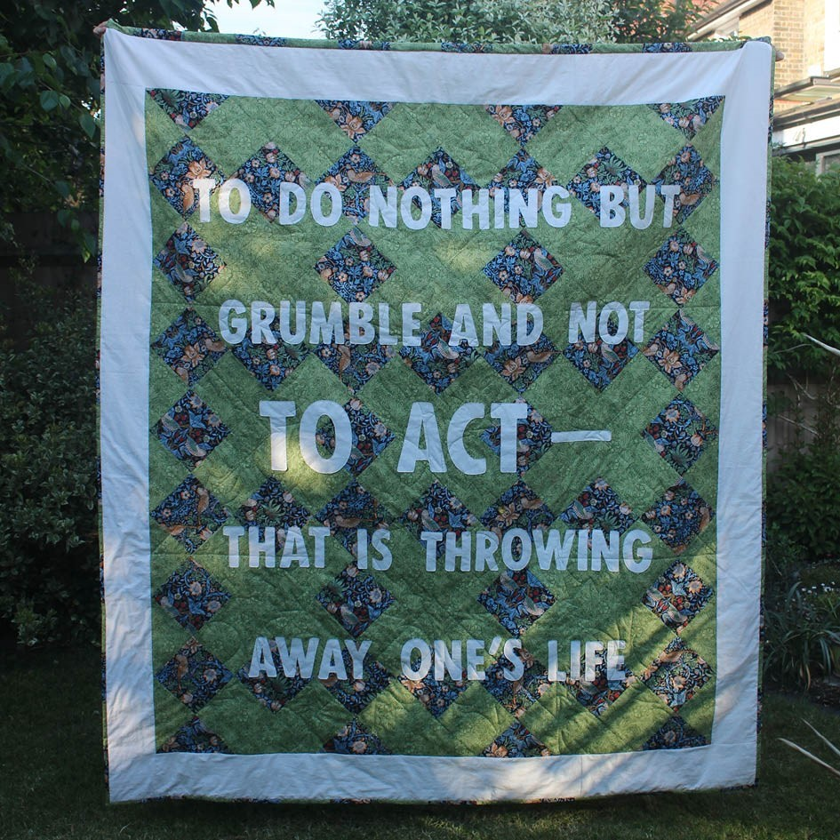
Fig:1 Graphic Design student’s work, William Morris Wallpaper Man (2020)
Fuelled by the isolation of global lockdowns, Collective members began to reconnect and experiment with agile approaches to the development of collaborative practice by exploring a variety of digital tools and environments. The communication platform SLACK was introduced as a repository to share individual research, encourage collaboration, and discuss work-in-progress. Members described projects as celebrating:
“… the idea that technology can be a tool to liberate an individual’s creativity or accelerate craft skills, whilst having positive social impact.” (Noble & Lee, 2020).
Regular SBC online fora demonstrated that “social interaction, communication, and collaboration are key elements in creativity” (Barrett et al., 2021) with participants adapting their practice from focusing on individual outputs to meaningful online conversations around process, materials, and new ways of working beyond disciplinary constraints.
A key finding was that approaches to making and materiality evolved as the project progressed. Participants were constrained by the materials they had to hand, empowering them to actively experiment with new ideas and unfamiliar techniques in response to collective feedback on work-in-progress:
“We learned the value of this project in slowing down the making process … it was as much about the process as
the outcome.” (Coderch, 2020)
SBC social media posts attracted new members who were keen to connect to be part of an online global community. As one student later commented on
in an email:
“Becoming a member of Storybox Collective was an impactful part of my journey as a maker, especially during COVID. The sense of community and working towards a collective goal was grounding and gave me purpose. It was an encouraging environment. I felt part of something bigger than myself.”
Within this context, the shared space and meaning of collaborative practice established social togetherness; where individuals experienced “a sense of ‘rightness’ and belonging” (Buechner et al., 2020). Another student reflected on this in an email:
“It became an outlet for creativity during a hard time. I appreciated having access to the SBC community and opportunity to keep creating when everything else came to a halt.”
The work—curated under themes of protest, innovation, and craft—was presented in a Zoom Private View in October 2020. Event preparation focused on co-creating effective ways of curating a global, social, and cultural online experience to best communicate the process of collaborative practice and full range of outputs. Attracting a global audience of 150+, the project’s impact can be measured by its dissemination in further online and physical events and the project being taught into the School of Design postgraduate curriculum in 2021. Students actively participated in exhibitions and events, contributing to 70+ individual and collaborative responses to the William Morris: Wallpaper Man project since its inception.
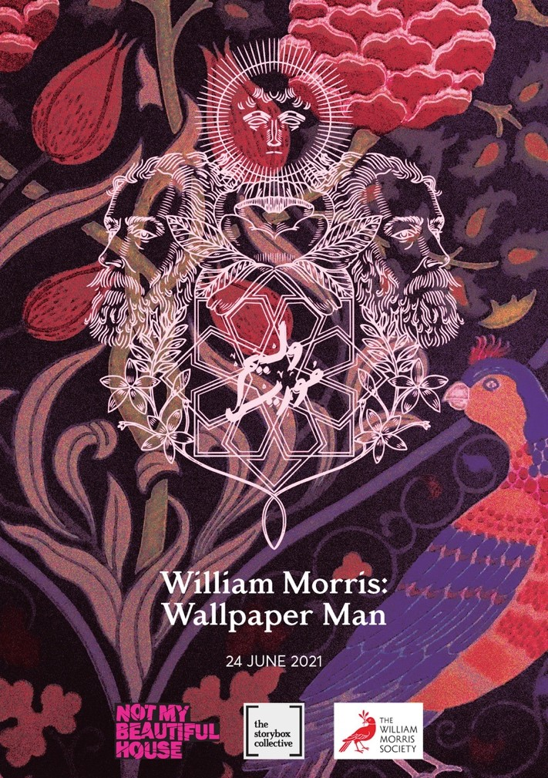

Fig:2 Conway & Nehme (2021) exhibition poster.
Storybox Collective continues to develop co-curricular collaborative projects that lie in the often-neglected space beyond the curriculum. It provides a space for risk-taking and innovation and for its teaching members to ‘embrace the possibility of meaningful change in their teaching and their students’ learning’ experiences (Pleschová et al., 2021). An academic collaborator commented on how this experience has nurtured their identity as an educator:
“Storybox is central to developing how I position myself as
practitioner and educator. It underpins how I encourage students to explore the potential of collaborative-making within design practice.”
(Senior lecturer, Kingston School of Art, 2023).

Case Study 2: A Space for creativity
Clare Conway and Francesca Arrigoni, Kingston University.
Angie Wyman, Royal School of Needlework.
Case study 2 examines the space for creativity within content-rich curricula through the lens of an innovative co-curricular collaboration that brought together students and staff from undergraduate science and design courses. The project aligns with the concept of Third Space (Bhabha, 1994; Lubicz-Nawrocka, 2019b) as a creative in-between place that gives agency to foster new ways of working together in learning and teaching.
The project originated from informal cross-faculties conversations around the possibilities offered by linking seemingly disparate courses through a common theme. “Significant conversations”—formal and informal—enable colleagues to share values and practices in a space where they can be open and “wrestle with the uncertainty, complexity, and even failure that are inherent in teaching” (Pleschová, et al., 2021).
Developed in tandem with a review of the literature on interdisciplinary learning, the scoping of existing practices across Kingston University, and
an evaluation of the potential to implement a university-wide approach to interdisciplinarity within the curriculum, the project was initiated as a
co-curricular pilot involving staff and undergraduate students from Pharmacy, Pharmaceutical Science and Hand Embroidery at Kingston University.
The pilot offered the opportunity to demonstrate:
“Letting arts and science teach together offers up a potent practice for integrating knowledge, skills and insights from different domains, and defying established templates.” (Burnard, et al, 2021).
The benefits of developing it as a co-curricular initiative were:
- Opportunity to spark cross-university conversations on the value of interdisciplinary learning experiences, particularly with courses where connections may not be perceived.
- Eliminate timetabling constraints.
- Autonomy to apply innovative learning and teaching strategies with students as co-creators and facilitators within the learning experience.
Working together, colleagues applied the four-stage model for interdisciplinary learning (Universiteit Utrecht, 2023) to establish common ground and integrate disciplinary perspectives. Botanical art was identified as an overarching theme. Entitled: The Pharmacognosy of Poisons, the project focused on actively engaging students in peer knowledge exchange through workshops and field trips to introduce them to botany and plant structure/function through drawing and mark-making, nature journaling and hand embroidery.
Launched during Reading Week, February 2023, the 5-day project’s central aim was adapted for each cohort:
- Science: to provide a creative space within their information-rich curriculum to engage and independently learn core pharmacology topics.
- Hand Embroidery: to enhance students’ communication and observational skills within an in-curricular project based upon foliage and plants.
Eight level 4-6 science students were recruited. Workshops introduced them to a range of creative learning and teaching strategies, in addition to studying the pharmacological properties of selected plants. Students from levels 4 and 5 BA Hand Embroidery were exploring a range of visual research processes within a module where they would apply observational and evaluation skills to create head adornments.
For the Science students the pilot offered an opportunity to experience drawing as a “fundamental tool of science” (Merkle, 2018) and reflect on whether learning from creative perspectives could improve their understanding of core pharmacology topics (see Fig.3, below).
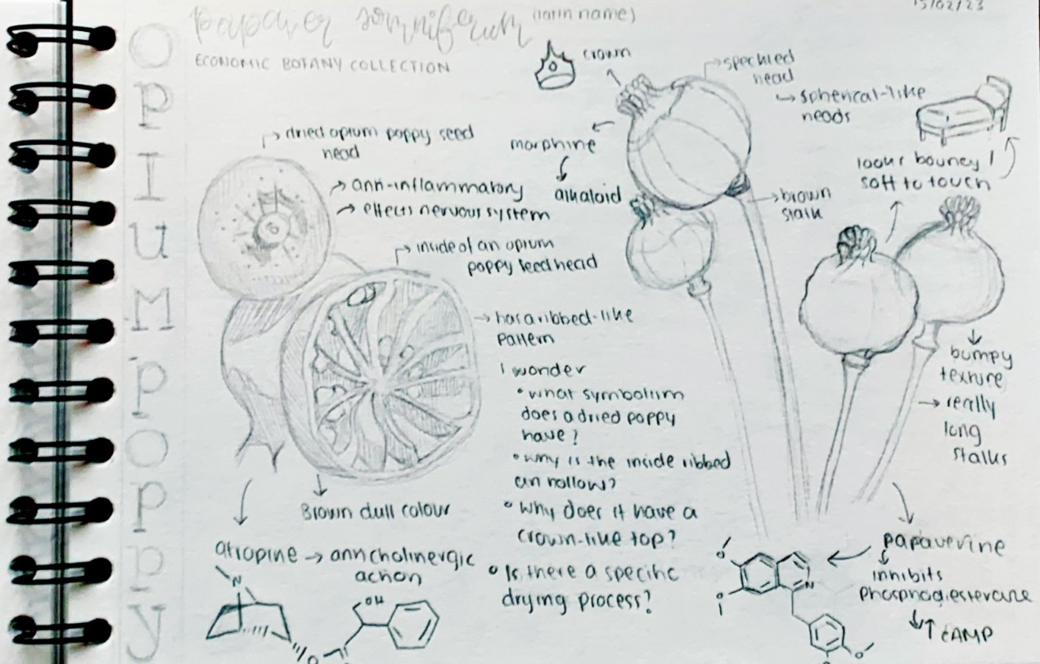
Fig:3 Science student's drawings (2023).

Both cohorts went on field trips to the Economic Botany Collection and Botanical Library at the Royal Botanic Gardens, Kew. They were tasked with recording the visit through notetaking, photography and drawing from primary sources.
Most notable was the transformation in Science students’ drawing abilities (Fig:3); most had not drawn since key stage 3. Their confidence grew as they understood drawing can be a cognitive tool to enhance thinking (Tversky, 1999). This new-found confidence was reflected in the development of their nature journals, evidencing a mastering of materials and techniques (Figure: 4 below).
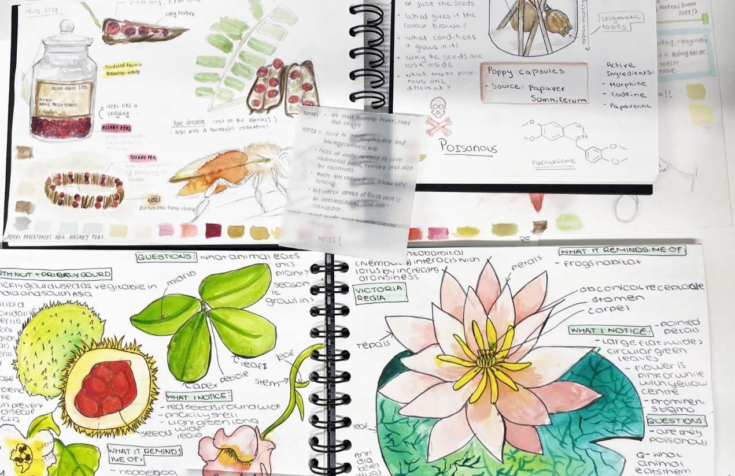
Fig:4 Science students’ nature journals.
On anonymously collected feedback about the project one student identified how:
“science can be used in other different ways to promote learning and make it more enjoyable than just sitting in the library.”
The student-led workshop later that week enabled them to share their work. Science students were encouraged to develop stitched responses to their drawings by the hand embroidery students. The collaborative space facilitated both cohorts to participate in peer learning and knowledge exchange, to explore mark-making together:
“Each honed their fine motor skills and haptic/tacit knowledge using hand embroidery. This cross fertilisation of experiences allowed the science students to see the same topics with a diverse student body from a different perspective.”
(Arrigoni, 2023).
In the anonymous feedback, student collaborators also reflected on the experience and highlighted the value of “meeting new people, learning about different plants, artwork, collaboration. Everything was meaningful.’”
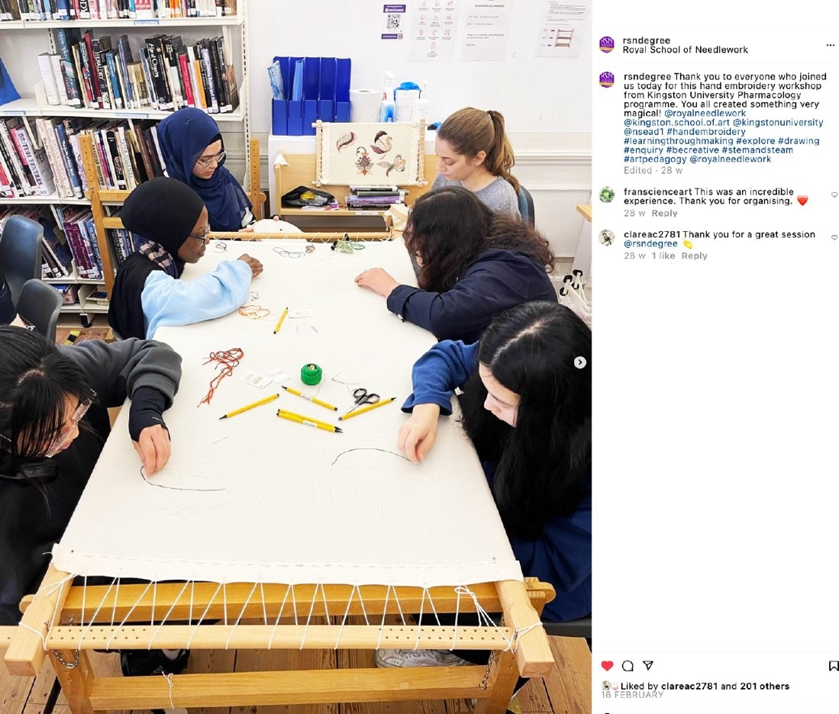
Fig:5 Wyman, A. (2023) Instagram post: Science and Hand Embroidery students.
It can be argued that within the interconnected world of the “Fourth Industrial Revolution” knowledge is continually updated and teaching discipline-specific knowledge without inclusion of creative competencies leads down an “erroneous path” if we wish to create transformative learning opportunities (Conradty et al, 2023).
The pilot’s significance for the Science students was they were able to view learning within their discipline through a new lens. Each experience over the five-day project developed their confidence, motivation, and willingness to embrace alternative strategies to learning (see Fig:6).
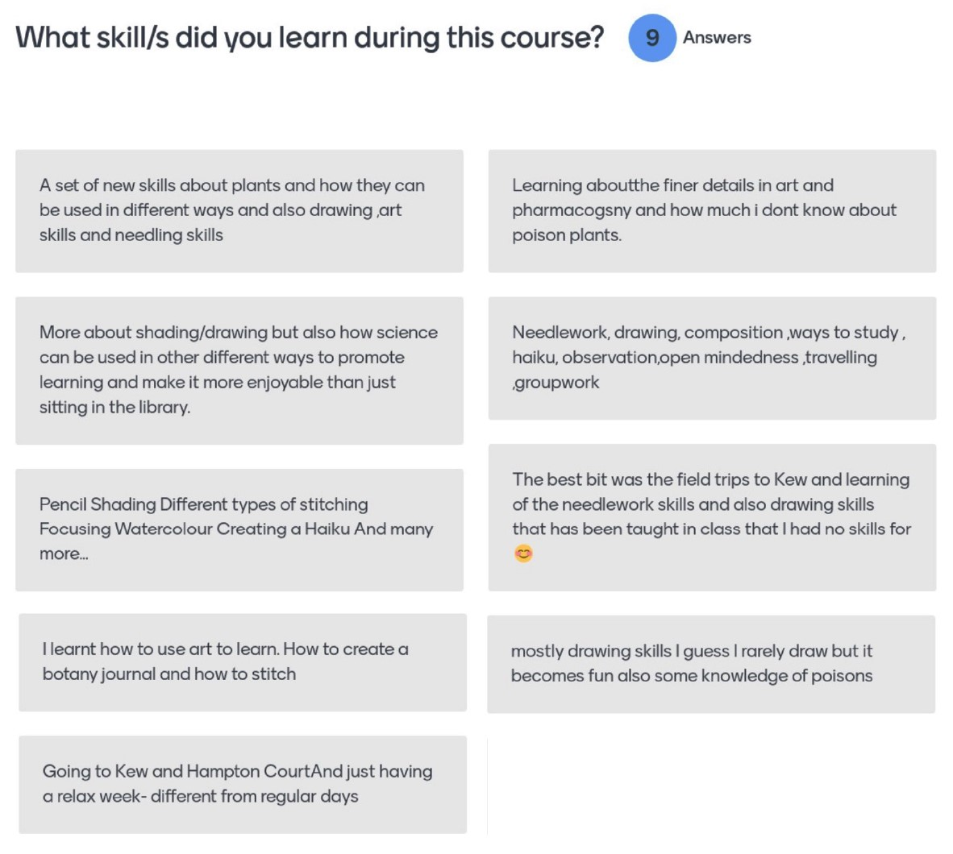 Fig:6 Mentimeter feedback, Science students
Hand embroidery students’ confidence was enhanced by being given autonomy to deliver the workshop, to share their skills and discuss ideas with peers from another course. Within this collaborative, student-led learning space the language of disciplines dissolved, transformative learning occurred as they worked together to create “something very magical” (Wyman, 2023) (see Fig 5).
Joy is a word not often spoken about today’s market-oriented universities. But there should be joy in learning, in making
knowledge, in solving problems, in sharing, in making new
things possible (Connell, 2022).
Dissemination of the project has resulted in bringing together colleagues from across disparate subject areas to create new opportunities for collaboration and shared learning.

Case Study 3: A Space for questioning
Aybige Yilmaz and Clare Conway, Kingston University.
Writing on the Ethics of Academic Leadership’, Cook-Sather and Felten call attention to the dehumanising business oriented neo-liberal rhetoric influencing higher education which is replacing teacher-student with producer-consumer hierarchies (Cook-Sather and Felten, 2017). To re-humanise the system, the authors argue we must focus our attention on the processes of teaching and learning which “constitutes an uncharted, unpredictable journey into self-awareness, self-understanding, and knowledge of the world in which we live; and try to develop an inclusive and collaborative relationship between teachers and students.”
Although Cook-Sather’s definition of collaboration mainly refers to “… design or redesign of courses … and the development of programmes and research partnerships that catalyse institutional change,” their discussion seems relevant when reflecting on our final case study. Not only do they point towards how collaboration can provide a counter narrative to neoliberal discourses of education, but the authors additionally suggest that partnerships can provide “powerful means to construct liminal spaces where assumptions can be challenges and novel configurations of ideas and relations may arise.”
Our creative project originated from a discussion in a level 6 Media module
on consumer culture, where students had been critically examining various aspects of consumer culture and neoliberalism. During the final week of the module, we wanted to finish our interrogation with a provocative student-led discussion on HE. We invited them to question the discourse of students as consumers and reflect on their own identity as students. The highly sophisticated discussion that emerged from the session and discovering that many of the students wanted to focus their assessment projects on this topic, encouraged us to explore producing a related creative output. Our aim was to introduce student voice into the highly contested discussion: what is university education for? Although we knew our project could have no claims of representation, it could contribute to the debate by adding authentic student voice rather than statistical figures or quotable narratives from the literature. We wanted to create a space for participants to step in and define HE for us.
Once assessment deadlines had passed, we reached out to Media students who had already expressed an interest in this topic and who would soon be our graduates, to ask if they would be interested in creating a 3-minute talking-heads documentary-style animated response to what HE is for. Additionally, we connected with members of the Collective (see case study 1 of this paper), asking for expressions of interest to help diversify the perspectives beyond those already engaged with the topic as part of their module. Two undergraduate Journalism students, a Graphic Design student and a Product Design graduate responded positively. Finally, working with student communities within our network, we reached out to two classes in two different local sixth form schools, one was a sociology class exploring education as part of their curriculum, the other an art class.
To participate in the project, university students were asked to send their individual responses to the short question: What is HE for via text or soundbites of approximately 150 words or 60 seconds in duration. Sixth form student responses would be captured as a two-minute response in the form of a teacher-led classroom discussion, without identifying individual responses. A recent Illustration Animation graduate was commissioned to work on the animation and given complete freedom in imagining the output. As lecturers initiating the project, our input was limited to collecting responses and identifying and discussing the common themes with the Illustration Animation graduate who would develop them into the creative output. Participants were kept informed on the animation’s progress and were given opportunities to voice any concerns as well as being sent the animation before it was published on the university Instagram account.
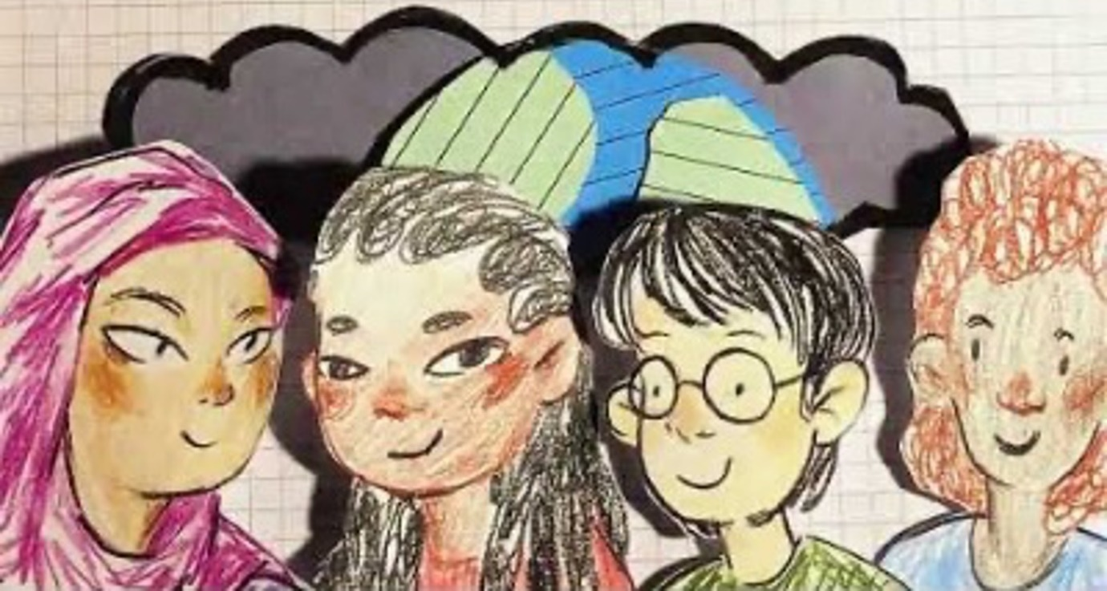
Fig:7 Screenshot from A Question of HE (2022).
We started collating responses without knowing what responses we would receive, yet it was interesting to see that knowledge and the expectation to challenge and question existing knowledge was the strongest recurring theme. Most of the student responses provided for the project (McEvoy, 2022) imagined university as an inclusive and safe space:
“It should be a place for everybody, can feel safe to ask particular questions.
Students could interrogate the status quo … which might lead to more knowledge about the world that we inhabit … a place to explore and to learn to ask the right questions, to be always curious.
A place to question the current ways of life and all its moral and philosophical dilemmas.”
The responses also showed that students expect universities to be a space
of self-discovery and transformation through knowledge:
“… maybe finding yourself or, you know, expanding your knowledge.
… universities are there for us as individuals to come together, create connections, expand on knowledge and skills, and be the sort of foundation blocks for us really mastering ourselves and figuring out who we are, and what we want to do with our futures.
… discovering yourself outside your home where you have been nurtured.”
One participant disarmingly describes how her time at university “felt like being in a pressure cooker for change … only to find that there isn't such a thing as fully cooked,” expecting her self-discovery through knowledge
to continue.
Our creative collaboration created a space where we could suspend expectations from our participants as to who we think they are, and what they might expect from us. Students stepped into this space as active citizens who expected university to form its civic mission of transformation through knowledge. This is not to say students do not expect their universities to equip them with the skills and knowledge ready for the workplace. Their responses showed they are acutely aware of the financial burden of going to university, thereby it would be irresponsible to assume they do not care about developing their chances of finding employment upon graduation. However, even the one explicit reference to work we have received frames it as a journey of a self-discovery, expecting to find the “career or … the path you're going to take … the rest of your life.”
Our participants’ highly sophisticated responses in this collaboration point us towards the civic mission of universities: to transforming individuals through knowledge. This is particularly urgent when HE is challenged with the advance of generative AI tools. Dickinson argues that these tools seriously expose the futility of our current assumptions about what a university graduate is or can do, as generative AI will demonstrate most
of those skills. He argues:
“failure to reimagine the curriculum – around the creation and application of knowledge, and the skills and competencies required to be a better person and foster better conditions for others – could leave universities in the UK in particular, looking rather pointless.” (Dickinson 2023).
Collaborative co-curricular creative project like ours can give us rich insight into what students expect from us, so that we can recalibrate our curricula and institutional strategies around what students are telling us, before becoming futile.

Conclusion: A space for belonging
The opportunity to present each of the three case studies featured within this paper at the GLAD Symposium 2023: Gathering Ourselves in September 2023 provided the post-event space to reflect on their combined contribution to the literature on co-curricular and co-created collaborative experiences within HE. We view this as an ongoing process, a work-in-progress where further research is required into the motivation of staff who initiate such co-curricular collaborative projects and students’ motivation to participate within them. By evaluating the significance of each individual project, we identified overarching themes or commonalities that existed despite the projects’ undoubted messiness and uncertainty in terms of approaches to research practice (Brown, 2019) discussed in our section ‘Spaces of learning’. They were entered into spontaneously, each bringing together different sets of colleagues from different disciplines to collaborate with students as
co-creators through “significant conversations” (Pleschová et al., 2021)
and a desire to drive innovation within curricula.
We recognised that the projects were united by the concept of liminality—existing as spaces ”betwixt and between” (Cook-Sather and Felten, 2017)—and Third Space as discussed by Lubicz-Nawrocka (2019b). In addition, we identify that the projects have enabled the burgeoning of a network of possibilities where like-minded individuals—both students and staff—can come together in partnership to share ideas; a space for belonging to “explore and …
to be always curious.”
“… if we all engaged in partnerships through which we reflect and discuss how teaching and learning experiences can include and value everyone, our campuses would become places of belonging.” (Colón García, 2017).

Disclosure statement
The authors confirm that all materials included in the article represent their own work and anything cited or paraphrased within the text is included in the reference list. The work has not been previously published, nor is it is being considered for publication elsewhere. There are no known conflicts of interest which might have influenced the authors in reporting their findings completely and honestly.

References
Arrigoni, F. (2023) ‘Pharmacy, poisons and plants: A transdisciplinary approach to learning pharmacology' BERA Conference 2023. Aston University/ Conference Aston. 12-14 September [Unpublished].
Barrett M.S., Creech A., and Zhukov K. (2021) ‘Creative collaboration and collaborative creativity: A systematic literature review.’ Frontiers in Psychology. 12. doi: 10.3389/fpsyg.2021.713445.
Beckingham, S. (2020) ‘Co-creating learning experiences with students as partners.' The Journal of Social Media for Learning, 1(1), pp. 70-77. doi: 10.24377/LJMU.jsml.vol1article394
Buechner, B., Dirkx, J., Konvisser, Z.D., Myers, D., and Peleg-Baker, T. (2020) ‘From liminality to communitas: The collective dimensions of transformative learning.' Journal of Transformative Education, 18(2), pp. 87-113. https://doi.org/10.1177/1541344619900881
Bhabha, H. (1994). The location of culture, London & New York: Routledge.
Bochner, A.P. (2017) ‘Heart of the matter: A mini-manifesto for autoethnography’. International Review of Qualitative Research, 10(1) pp. 67-80. doi: https://doi.org/10.1525/irqr.2017.10.1.67
Bochner, A.P. & Ellis, C. (2022). ‘Why autoethnography?'. Social Work and Social Sciences Review, 23(2) pp. 8-18. Doi: https://doi.org/10.1921/swssr.v23i2.2027
Bovill, C., Cook-Sather, A., Felten, P. (2016) ‘Addressing potential challenges in co-creating learning and teaching: overcoming resistance, navigating institutional norms and ensuring inclusivity in student–staff partnerships’. Higher Education. 71, pp. 195–208. doi: https://doi.org/10.1007/s10734-015-9896-4
Brown, N. (2019) ‘Partnership in learning: how staff-student collaboration can innovate teaching.’ European Journal of Teacher Education. 42. pp. 1-13. doi: 10.1080/02619768.2019.1652905.
Buckley, P. and Lee, P. (2021) ‘The impact of extra-curricular activity on the student experience’. Active Learning in Higher Education, 22(1), pp. 37-48. doi: https://doi.org/10.1177/1469787418808988
Burnard, P., Colucci-Gray, L. and Sinha, P. (2021) ‘Transdisciplinarity: letting arts and science teach together’. Curriculum Perspectives, (41), pp.113–118.
Chapman, G., Emambocus, W. and Obembe, D. (2023) ‘Higher education student motivations for extracurricular activities: evidence from UK universities’. Journal of Education and Work, 36(2) pp.138-152. doi: 10.1080/13639080.2023.2167955
Clark, T.W. and Hordosy, R. (2018) ‘Beyond the compulsory: a critical exploration of the experiences of extracurricular activities and employability in a northern red brick university’, Research in Post-Compulsory Education, 23(3), pp. 414-435.
Coderch, M. (2020) 3 Furoshikis from south London. Available at: https://thestoryboxcollective.org.uk/Storybox-3-Page (Accessed: 14 February 2021)
Connell, R. (2022) The good university what universities actually do and why it’s time for radical change. London: Bloomsbury Academic.
Conradty, C., Sotiriou, S.A. and Bogner, F.X. (2023) ‘Full STEAM ahead with creativity’ In Pedagogy, Learning, and Creativity. IntechOpen. doi: 10.5772/intechopen.110359
Cook-Sather, A. and Felten, P. (2017) ‘Ethics of academic leadership: Guiding learning and teaching’ in F. Su & M. Wood (Eds.), Cosmopolitan perspectives on academic leadership in higher education, pp. 175-191. London: Bloomsbury.
Cook-Sather, A. and Felten, P. (2017) ‘Where student engagement meets facultydevelopment: how student-faculty pedagogical partnership fosters a sense of belonging.’ Student Engagement in Higher Education Journal, 1(2) pp. 3.
Cook-Sather, A., Matthews, K.E., Ntem, A. and Leathwick, S. (2018) ‘What we talk about when we talk about students as partners’. International Journal for Students as Partners, 2(2) pp. 1–9. doi: https://doi.org/10.15173/ijsap.v2i2.3790.
Dickinson, J., Griffiths, T. and Bredice, A. (2020) ‘It's just another thing to think about': encouraging students' engagement with extra-curricular activities’. Journal of Further and Higher Education, 45(6),pp.744-757.
Dickinson, J. (2023, August 8) ‘Of course, you can’t detect students’ use of AI – so what next?’ Wonkhe. Available at: https://wonkhe.com/blogs/of-course-you-cant-detect-students-use-of-ai-so-what-next/ (Accessed: 20 February 2024)
Dollinger, M., Lodge, J. and Coates, H. (2018) ‘Co-creation in higher education: towards a conceptual model’. Journal of Marketing for Higher Education, 28(2), pp. 210-231. doi: 10.1080/08841241.2018.1466756
Harland, T. (2014) Learning about case study methodology to research higher education. Higher Education Research & Development, 33(6), pp. 1113–1122. doi: https://doi.org/10.1080/07294360.2014.911253
Jackson, D. & Bridgstock, R. (2021). ‘What actually works to enhance graduate employability? The relative value of curricular, co-curricular, and extra-curricular learning and paid work’. Higher Education. (81), pp. 723–739. doi: 10.1007/s10734-020-00570-x
Jackson, D. and Rowe, A. (2023). ‘Impact of work-integrated learning and co-curricular activities on graduate labour force outcomes’. Studies in Higher Education, 48(3), pp. 490-506. Doi: 10.1080/03075079.2022.2145465
Kerrigan, M. and Manktelow, A. (2021) ‘Extra-curricular activities in higher education: enhancing the student experience’. Widening Participation and Lifelong Learning. 23(1), pp. 123-147. Doi: https://doi.org/10.5456/WPLL.23.1.123
Kligyte, G., Buck, A., and Le Hunte, B. (2022) ‘Re-imagining transdisciplinary education work through liminality: creative third space in liminal times’. The Australian Educational Researcher. 49(3), pp.617–634. doi: https://doi.org/10.1007/s13384-022-00519-2
Lam, B., Phillips, M., Kelemen, M., Zamenopoulos, T., Moffat, S. and de Sousa, S. (2018) ’Design and creative methods as a practice of liminality in community-academic research projects’. The Design Journal, 21(4), pp. 605–624. doi: https://doi.org/10.1080/14606925.2018.1469329
Lubicz-Nawrocka, T. (2019) ‘Creativity and collaboration: An exploration of empathy, inclusion, and resilience in co-creation of the curriculum’. Student Engagement in Higher Education Journal, 2(3), pp. 199-213.
Lubicz-Nawrocka, T. (2019b). ‘More than just a student: how co-creation of the curriculum fosters third spaces in ways of working, identity, and impact’. International Journal for Students as Partners, (3), pp.34-49.
Lubicz-Nawrocka, T. (2023) ‘Conceptualisations of curriculum co-creation: ‘it’s not them and us, it’s just us’. Curriculum Perspectives, 43(1), pp. 25–37. doi: https://doi.org/10.1007/s41297-022-00180-w
Massey, D. (1999) ‘Negotiating disciplinary boundaries’. Current Sociology, 47(4), pp. 5-12.
MacNeill, S. and Beetham, H. (2022) Approaches to curriculum and learning design across UK higher education, Bristol: JISC.
McEvoy, I. (2022) A Question of HE: a School of Design, Kingston School of Art Collaborative Project, Available at: https://www.youtube.com/watch?v=88UglqC8Ld8&t=3s (Accessed: 18 November 2023)
McEvoy, I. (2022) Screenshot A Question of HE. Available at: https://www.youtube.com/watch?v=88UglqC8Ld8&t=3s (Accessed: 18 November 2023)
Mercier, M., Vinchon, F., Pichot, N., Bonetto, E., Bonnardel, N., Girandola, F. and Lubart, T. (2021) ‘COVID-19: A boon or a bane for creativity?’. Frontiers in Psychology. 11, p.601150. doi: 18;11:601150. DOI: 10.3389/fpsyg.2020.601150.
Merkle, M.G. (2018) ‘Drawn to science.’ Nature. 562. S8-S9. Available at: https://www.nature.com/articles/d41586-018-06832-0
Moxey, M. and Simpkin, E. (2021) ‘Harnessing the potential of extracurricular opportunities to enhance graduate employability in higher education.’ Journal of Learning Development in Higher Education, 21. doi: 10.47408/jldhe.vi21.631.
Mulrooney, H.M. (2017). ‘Exploring participation in co-curricular activities among undergraduate students’. New directions in the teaching of physical sciences, 12(1).
Noble, M. and Lee, B. (2020) The talisman stacking project. Available at: https://thestoryboxcollective.org.uk/Storybox-2-Page (Accessed: 24 November 2023)
Oudenampsen, J., van de Pol, M., Blijlevens, N. (2023) ‘Interdisciplinary education affects student learning: a focus group study.’ BMC Medical Education, 23(1) p.169. doi: https://doi.org/10.1186/s12909-023-04103-9
Pleschová, G., Torgny, R., Thomson, K.E. and Felten, P. (2021) ’Conversations that make meaningful change in teaching, teachers, and academic development’. International Journal for Academic Development, 26(3), pp.201-209. doi: 10.1080/1360144X.2021.1958446
Sennett, R. (2008) The Craftsman. Berlin: TOC Publishing.
Sadowska, N. and Ingham, M. (2021) ‘Laboratories of learning’: Learning to learn in co-created communities’. Safe Harbours for Design Research: 14th EAD Conference, 11-16 October 2021, pp.1-8. Available at: https://ualresearchonline.arts.ac.uk/id/eprint/17593/1/Laboratories%20of%20Learning_SH_EAD2021-paper_NS_MI_270821.pdf (Accessed: 22 November 2023).
Stirling, A. & Kerr, G. (2015). ‘Creating and documenting meaningful co-curricular experiences in higher education'. Journal of Education & Social Policy. 2(6) pp. 1-7.
Team Interdisciplinary and Community Engaged Learning, Universiteit Utrecht (2023) A four stage model for interdisciplinary learning. Available at: https://www.uu.nl/en/education/educational-development-training/knowledge-dossier/a-four-stage-model-for-interdisciplinary-learning (Accessed: 20 November 2023)

The Storybox Collective (2020) An introduction to William Morris: Wallpaper Man. Available at: https://thestoryboxcollective.org.uk/About-Page (Accessed: 20 November 2023)
Klein, J. (2005) Integrative learning and interdisciplinary studies. Washington, DC: Association of American Colleges and Universities.
Thexton, I. (2020) To do nothing. Available at: https://thestoryboxcollective.org.uk/Storybox-1-Page (Accessed: 24 November 2023).
Turner, V. (1969) ‘Liminality and Communitas’, in Turner, V., Abrahams, R., and Harris, A. The Ritual Process: Structure and Anti-Structure (1st ed.). Routledge, pp.169-187.
Turner, V. (1974). ‘Liminal to Liminoid, in play, flow and rituals: an essay in comparative symbology.’ Rice University Studies (60) pp. 53–92. Available at: https://repository.rice.edu/server/api/core/bitstreams/ede1dfa5-f46d-4f2c-b552-7b501bda2afe/content
Tversky, B. (1999) What does drawing reveal about thinking? Available at: https://www.semanticscholar.org/paper/What-Does-Drawing-Reveal-about-Thinking-Tversky-Tvesky/71cdadafe2a8db461a962c1b637dea877745ab73 (Accessed: 12 November 2023).
Wyman, A. (2023) Hand embroidery workshop. 14 February. Available at: https://www.instagram.com/p/Coux0-3NGgM/ (Accessed: 24 November 2023).
Wyman, A. (2023) Science and Hand Embroidery students working together. Available at: https://www.instagram.com/royalneedlework/?hl=en (Accessed: 12 November 2023).

