**Moving, Sensing, Being – leaning into embodied design education**

**Emma Hogana, Emma Creightonb, Marcus Hanrattyb**

aAtlantic Technological University (ATU), bNational College of Art and Design (NCAD)

Corresponding author: [Emma.Hogan@atu.ie](mailto:Emma.Hogan@atu.ie)

**Abstract**

This paper aims to identify guiding principles for integrating somatic learning and literacy in third-level design education. It forms part of a larger research project, exploring embodied and situated knowledge in design education. The neutral stance, traditionally taught in designer education, contrasts with emerging paradigms and critical approaches in 21st century design education, including post-capitalism, decolonisation, and feminist approaches. Complexities, and ‘wicked’ problems, require designers to think critically about the complex power structures and systems we are part of. This paper proposes pluriversal, situated, and embodied approaches. First, the body is located within contemporary design education. Next, drawing from interdisciplinary literature in body-centred disciplines, as well as design, adult, and early years education, guidelines are identified to scaffold somatic design education. Integrated intelligence, conscious embodiment, somatic literacy, design-specific approaches, and disruption are identified as guiding principles to implement somatic approaches in future practice, in third-level design education.

**Keywords**

Somatics, Embodiment, Design, Higher Education, Soma Design

**Introduction**

’The body,’ writes William James, ’is the storm-center, the origin of coordinates, the constant place of stress in [our] experience-train. Everything circles round it and is felt from its point of view.’ … For purposes of survival, if not also for other reasons, ‘all minds must...take an intense interest in the bodies to which they are attached....’ (Shusterman, 2005, p. 419)

Since the period of the European Enlightenment gave rise to the Cartesian split of mind and body, the body has been disregarded in Western education ‘as a locus of learning’ and considered ‘a distraction to the mind’ (Rodriguez-Jimenez and Carmona, 2021, cited in Hogan and Creighton, 2023, p. 3). In *Teaching to Transgress*, bell hooks (1994) reminds us that to move towards liberation, a classroom must be recognised on its organic level – as a shared space which bodies (racialised, gendered, moving, and autonomous) inhabit. Recognising the embodied classroom creates space for relational pedagogies – for hearing, seeing, and sensing one another in a way that allows for authentic, situated, and collaborative learning.

There is evidence of a growing interest in somatic approaches in design education, with an increasing number of educators exploring embodied approaches (A—Z presents, 2023). Emerging work in somatic design and embodiment builds on an understanding that ‘neglecting to account for the merging of body and mind… (will) not suffice in the coming era’ (Höök, 2018, p. 3). Höök (2018, p. 2) advises designers to be wary of reinforcing the separation of mind from ‘body …(when) all research shows that movements, emotions, experiences, and thinking are inseparable’.

In third-level design education, the prevalence of cognitive intelligence presents as reductive methods, toolkits, and techniques (Boehnert, 2018; Laursen and Haase, 2019). Although it is now widely accepted, in design academia, that ‘designerly ways of thinking’ (Archer, 1979; Cross, 2006) involve cognitive, sensitive, and affective dimensions, the cognitive domain continues to dominate learning outcomes and taxonomies used in design education. While sensitive and affective learning may be implicit in design education, there is value in more explicit reference to affective, psychomotor, experiential, and embodied domains in learning design. This present paper problematises hegemonic, reductive, rational, and extractive approaches in design education, proposing we advance pluriversal, situated, and embodied approaches.

Feminist designer, Place (2024) emphasises the need for designers to think critically about the systems and power structures we are working within, as well as our positionality within those systems. She critiques how, designers are taught to be ‘neutral agents’ and ‘passive observers’ while obscuring the way in which we are ‘critical actors’. In preference to designer neutrality, traditionally taught in education, Place (2024) advocates for ‘situated’ and ‘embodied knowledge’ (Haraway, 1988). She calls for designers to centre experience and stand firmly rooted in situated knowledge in order to become aware of what we see, and, our blindspots (Place, 2024). In keeping with the ‘autoethnographic turn in design’ (Schouwenberg and Kaethler, 2022), there is value in educational and design approaches that look inward rather than outward, and which situate the designer, not outside of the project, but firmly inside of it.

Innovative teaching and learning approaches are needed to prepare students to navigate the complexities of social, economic, and environmental issues. Wizinsky (2022, p. xvi) contends that ‘to systematically address the twin contemporary crises of climate change and social justice, we need to identify new models of practice. To this end, Place supports design as ‘world making’ rather than solutioning or problem solving (Place, 2024). Problem Based Learning (PBL) is a familiar pedagogical approach for design educators. Rather than allowing for complexity, PBL teaches students to hyperfocus on a singular problem, audience, and context at a single point in time. This type of hyperfocus and extraction neglects complexities, connections and relationships across time, and contexts.

Embodiment, in contrast, presents a nuanced, inclusive, feminist approach. It captures feeling, sensing, moving, and other ways of being, doing, and knowing. Bringing bodies into learning requires time and space, developing awareness for shifts, openings, and knowledge to emerge through practice. Dewey’s educational concept of ‘unfolding’ (Eddy, 2007, p. 187) describes education as an unfolding of latent abilities. This is similar to somatic approaches where the knowledge students seek is within them, with the practice of holding space to bring this knowledge to consciousness and understanding. Embodied approaches in education advance pluriversality (Escobar, 2018) and decolonising design education by challenging hegemonic power systems that oppress and remove the body as a legitimate place of knowledge and site for learning (Hogan and Creighton, 2023).

Munro (2018, p. 8), a scholar in the performing arts, attests to the importance of purposefully engaging the body in learning, not ‘willy-nilly’, but by fostering:

‘a deep-structure and a systemic engagement within the learning process so that both a bodyminded experience and a bodyminded understanding are facilitated’.

Munro (2018, p. 8) asks, ‘On what principles, then, do pedagogues from different fields design embodied learning strategies?’.

That is the question at the heart of this present paper. Indeed, this paper aims to identify guiding principles that can be used to lean into, and implement, embodied and somatic approaches in third-level design education. It is not the purpose to create another framework or toolkit. As feminist designer and educator, Place (2024) attests ‘the revolution will not be toolkits’. It is a position of this paper that design education does not need more reductive and extractive tools. Somatics and embodiment require slow learning, listening, sensing, and an open, curious approach, attuned and responsive to nuances and complexities. Such sensibilities are at odds with neo-liberal, business-as-usual ideologies ingrained in our systems and the actors within them. Therein is the challenge, however. In a post-capitalist era, how do we, as designer educators and design institutions, increase the value placed on situated and embodied knowledge? Furthermore, how do we design learning approaches and strategies to implement this value in practice?

Literature is drawn from interdisciplinary areas including education, design, and body-centred disciplines, such as dance and performance. The position and purpose of the research are presented thereafter.

**Researcher Positionality**

I am a communication designer and educator, with a passion for integrative body-centred modalities. My practice includes dance, yoga and somatic experiencingTM. As a designer, educator, and mover, I see value in movement and embodiment. The longer I work in academia, the more I realise my need for movement in order to stay balanced, regulated, and embodied. Education invites us, as educators and students, into our heads. Even *creative* education is ‘heady’, with all the deadlines, modular timetabling, multitasking, and administration. I am in favour of movement and embodiment to support students amidst rising levels of anxiety. Somatics can enhance design education by influencing regulation, body-mind integration, inner/outer coherence, sensitivity, reflexivity, creativity, and interpersonal development (Hogan and Creighton, 2023).

Pressing matters in design education include sustainability and student wellbeing, however, addressing social, ecological, and political crises in a meaningful way can be confronting for students, and educators (Hogan and Creighton, 2023, p. 1). So, how do we support students and educators to address, and really engage with complex social, economic, and environmental issues such as those outlined in the UN Sustainable Development Goals (SDG)? (United Nations, 2015). According to the Inner Development Goals (IDG Foundation, 2023) we are falling short of meeting the 2030 targets set out in the SDGs and lack the inner capacity required ‘to deal with our increasingly complex environment and challenges’. The IDGs promote the need for increased inner development (abilities, qualities and skills) in order to complement and accelerate external approaches towards sustainability.

This paper proposes guiding principles exploring how to be in the body, consciously learn from the body, and apply the body in design education. Such practices aim to support students, and educators, to drop into their bodies, to bring awareness and understanding to sensory experience and, perhaps, to inform design practice and output from a soma-literate way of being.

**Locating the body in design education**

Within design research, Cross (1999, p. 6) offers a research taxonomy focusing on knowledge that resides in people, process, or product: (a) design epistemology: the study of ‘designerly’ ways of knowing (people), (b) design praxiology: the study of the practices and processes of design (process), and (c) design phenomenology: the study of the form and configuration of artefacts (product).

Concern with body-centric approaches and research already exist in this third area: (c) design phenomenology (product), particularly within design fields concerned with understanding user experience, such as Interaction Design and Human Computer Interaction (HCI). Neely (2019) classifies existing approaches in three categories: Body as Input (e.g. gestural/haptic/AR/VR), Body as Data (e.g. sensors, GPS), and Body as Methods (e.g. bodystorming). However, as Neely (2019, p. 126) asserts, the knowledge is less about the nature of bodies in experience and more about product ideation. He describes these methods as ‘utilitarian—that is, they are not *methods for bodies,* they are *methods that use bodies’*.

This present paper is primarily concerned with people and process, rather than product. The people are design students and educators, and the processes are those in design education. In design education, there are vast omissions and opportunities for embodied pedagogy. As a design educator, I reflect on when I feel most embodied and ask myself the following questions. Am I embodied while teaching or when I am researching or writing a paper? Am I embodied while doing curricular planning or administrative work or at meetings? My experience of academia is one of cognitive, emotional, and, in my case, physical endurance. From recent experience of engaging in research about embodiment I have found that even this subject-specificity is not enough to tip the balance in favour of the grounding, and centring that is needed to take me out of my head. In fact, my physiotherapist has stated that PhDs break bodies.

From a student perspective I ask the following questions. When do my students feel most embodied? Do they have capacity to be embodied in an educational environment? Do they know how to regulate and move out of their heads and into their bodies? Self Regulation, Guideline 9, in Universal Design for Learning (CAST, 2018), is significant in learning, particularly in relation to trauma-informed practices. Advances in early years education include interventions such as movement breaks and sensory rooms. Are there similar interventions taking place at third-level? How do we remind our students of the importance of embodiment? Do educators model its’ value in practice? This paper proposes that, with some exceptions, attending to the body is largely neglected at third-level. Furthermore, in relation to situated knowledge and design practice we would benefit greatly from practices to enhance design students’ understanding of their own, and others, embodied lived experience.

Gaps are evident in design approaches related to the experiencing body (Neely, 2019). Attempting to find an understanding (language, aesthetic, role) of the embodied experience was a stated goal before 2009, yet in 2016, HCI and performance researcher, Jocelyn Spence (2016, p. 16, cited in Neely, 2019, p. 127) was still identifying gaps concerning the embodied user, calling for new methodologies that ‘push the bounds of understanding user experience’. If the body is omitted in third-level education, how are we to consider designing learning approaches for the body – an instrument that is not consciously explored, analysed, and understood?

**Somatic learning**

This paper aims to prepare and lay the foundations for experiential learning in embodiment within design education. Guiding principles discussed include: integrated intelligence, somatic literacy, conscious embodiment, discipline-specific pedagogy and disruptive approaches. The intention is to use these principles to design and implement somatic learning approaches in future practice. Discussion and conclusion will then follow.

**Where to start?**

Acknowledging the power structures, the systems, and the actors is important in order to think critically and intentionally about planning and implementing embodied learning design. Whatever the methods – and there are a vast number of differing approaches for somatics and embodiment – it is important first to define who we are designing learning approaches for and examine the systems in which these actors sit.

Privileging of mind over body is deeply engrained in academia and Western cultures (Ellingson, 2017, p. 5), whereby treating the body-mind as separate underpins a value system where the *felt sense* (Gendlin, 1982) is not addressed, taught, or even known to exist (Eddy, 2017). This raises a multitude of questions to be considered. How do we readdress the importance of bodily knowledge in a culture that does not value its existence? How do we teach students to connect, understand, and learn to listen to and trust their bodies and innate wisdom? Can we expect educators to hold space for students to lean into their situated and embodied knowledge? Do educators have the knowledge, confidence, and expertise to hold space for bodily knowledge? Do we have methods and language to enter into meaningful discussion about the ‘living body’ or do we need body-centred subject experts to support us? What are the practical constraints of slow learning in relation to student numbers, timetables, and class sizes? Do we need to consider undergraduate and postgraduate level students differently?

A challenge for educators and students is the disembodied classroom. Particularly in my own discipline of communications design, students sit at desks and screens for long periods. In many cases, due to institutional financial and space constraints, there is a lack of movement in studios and perhaps a lack of interest in doing so. As access to space, resources, and funding comes under more pressure, this is likely to be amplified. Furthermore, moves to online and remote learning bring about an entirely new paradigm of disembodied education.

**Integrated Intelligence**

A guiding principle of embodied learning is the understanding and value of multiple, integrated intelligences. As we now know, studies in neuroscience indicate that the brain is only one part of the huge neural network extending throughout the body. Shusterman (2008) defines the *soma* as the self that is a unified whole of mind and body. In somatic studies, the mind is perceived as existing throughout the body, through nervous system connections (Juhan, 1987).

Integrated Intelligence (Figure 1), described by Blake (2018, p. 242) as a ‘mindful awareness of the whole self’, comprises of five types of intelligence: exteroception, interoception, proprioception, emotional, and conceptual intelligence. Exteroception, interoception and proprioception are collectively embodied perceptions.

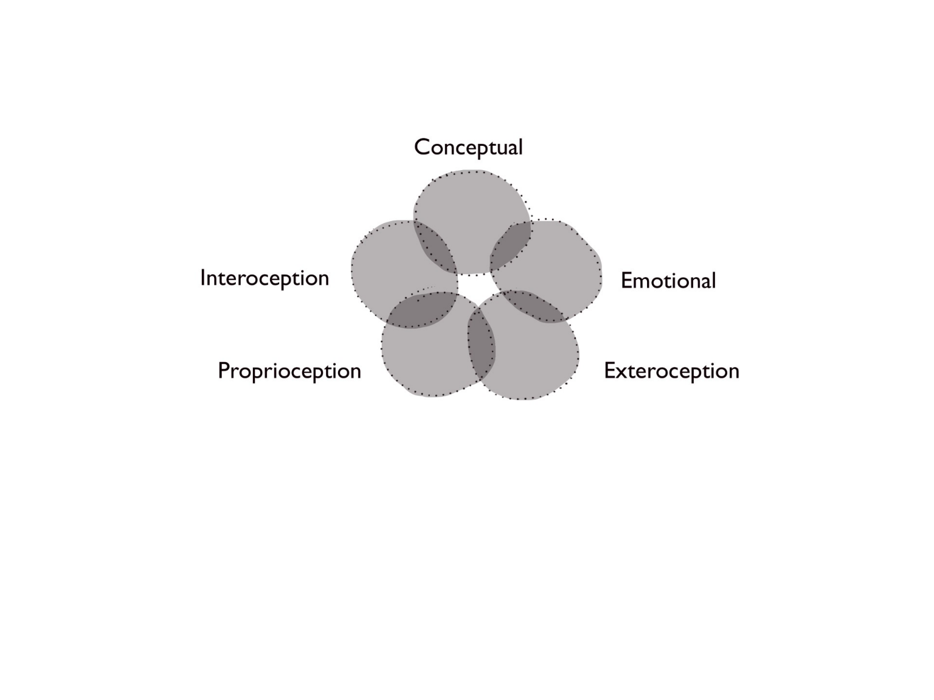

**Figure 1. Integrated Intelligence (Blake, 2018)**

This model of integrated intelligence is one that educators can refer to in learning design. Design strategists, Anderson and Ng (Interaction Design Association, 2020) developed a conscious design framework called *Below the Iceberg*. This model is used for exploring unintended consequences and unseen ramifications behind what we design. Combining Blake’s model of integrated intelligence with the iceberg model (Figure 2) allows us to visualise intelligence and knowledge privilege in contemporary design education.

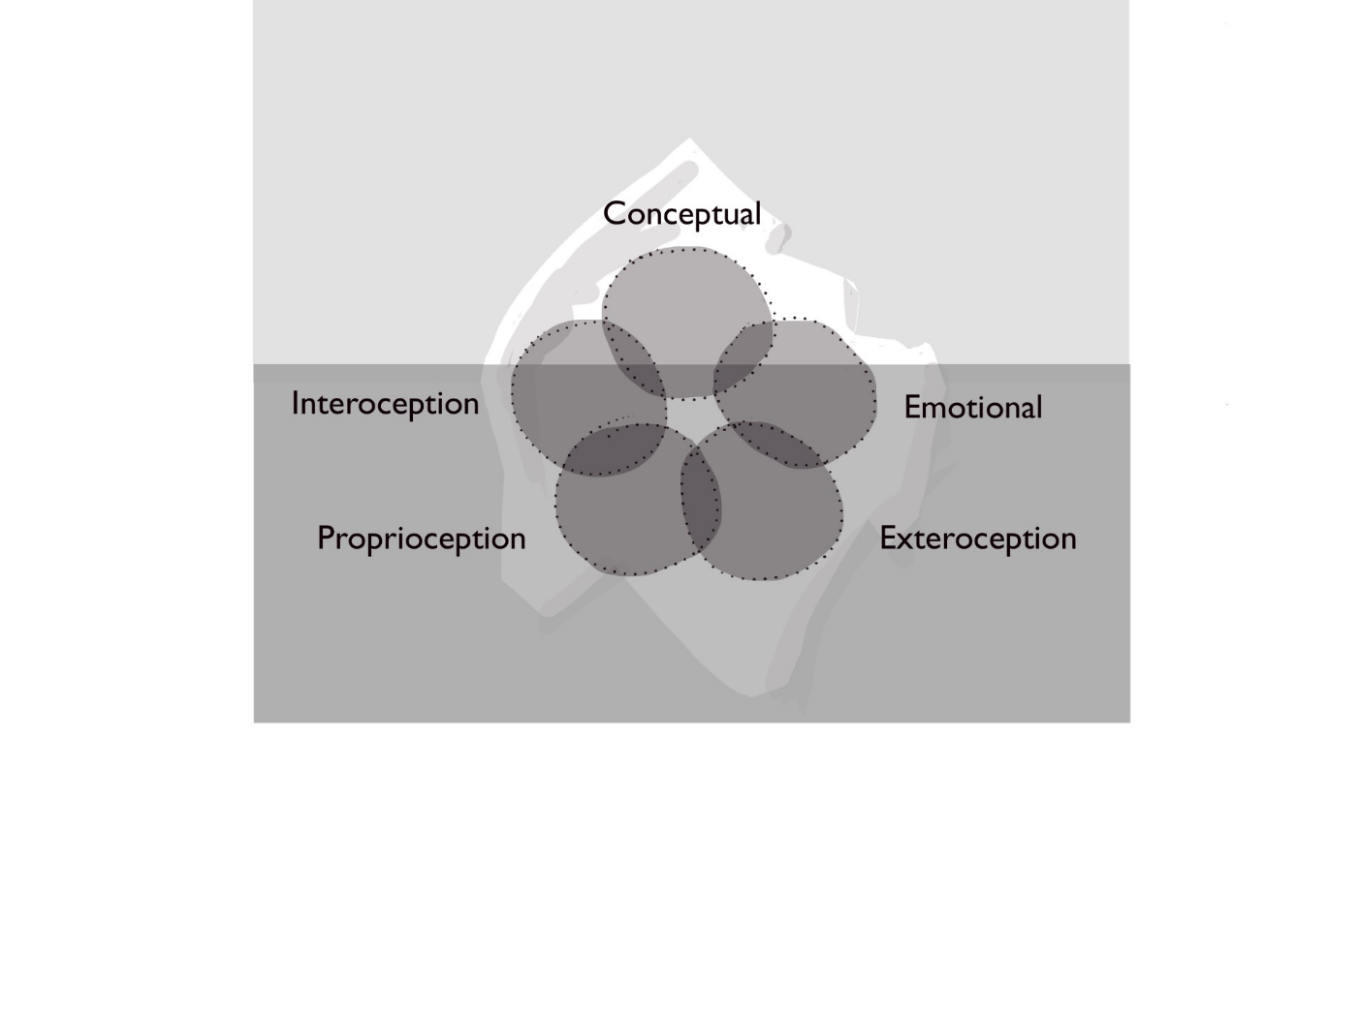

**Figure 2. Integrated Intelligence (Blake, 2018) applied to the iceberg model to illustrate privileging of knowing in design education**

Here, we see, somewhat crudely, that conceptual, neuro-linguistic intelligence is visible, above water, while embodied and emotional intelligences are submerged, or below water. A principle of the iceberg model is that the tip, visible above the surface, is greatly informed and influenced by the ice, or systems, beneath it. Moving to a view of education that encompasses learning and literacy in all five aspects, Blake’s model is worth exploring as a path to more holistic, embodied pedagogy.

Designing learning approaches that consider integrated intelligences can support neurotypical and neurodiverse design students. Amplifying interoception can enhance situated, intrapersonal awareness and inner/outer coherence – where the inner world and values align with outer expression and action. Somatic approaches enhance access to ‘inner’ knowing and can support ‘design students learning to integrate inner values into an external design voice’ (Hogan and Creighton, 2023, p. 6).

Jung describes the body as an intelligence that connects with the rest of life and is conscious in many different and complex ways: What you think with your head does not necessarily coincide with what you feel in your heart, and what your belly thinks is not what your mind thinks (Jung, 1989, cited in Hardman, 2021, p. 3). Navigating this terrain, learning to listen inward and to trust embodied knowledge is a slow process. The pluralist way of knowing and being contradicts with much neo-liberal sentiment promoting a single-minded focus towards productivity. In integrating embodied and situated knowledge, educators will need to adopt flexibility and adaptability that allows for views, values, and perspectives to change. This is at odds with education that falsely promotes knowledge as neutral. As hooks (1994, p. 147) wrote:

‘The erasure of the body encourages us to think that we are listening to neutral, objective facts, facts that are not particular to who is sharing the information’.

**Conscious embodiment**

According to Horst (2008), a guiding principle for somatic learning is conscious embodiment. Horst (2008, p. 5) describes somatic learning as occurring ‘from a conscious intention to invite the body into the learning space’ so that the body is ‘integral to the learning experience’.

Conscious embodiment concerns two factors:

1. intentionally bringing the body into the learning environment,
2. bringing learning from unconscious to consciousness and from embodied to mind.

Horst (2008, p. 2) states that somatic learning supports an opportunity to explore alternatives to mind-based knowledge acquisition. She classifies four dimensions of somatic learning as Kinesthetic, Affective, Sensory, and Spiritual that offer a variety of ways to incorporate the body into adult learning contexts – each with the capacity to centralise the body so that it is integral to the learning experience. Horst (2008, p. 5) discusses how kinesthetic learning offers students opportunities to move, build, and create; affective learning illustrates the ‘power and significance of emotional awareness’; sensory learning incorporates music, artwork, and storytelling into learning; and spiritual learning creates opportunities for self-expression, connectedness, and awareness.

According to Munro (2018, p. 8), successful embodied learning requires a ‘deep-structure and a systematic engagement’ so the body-mind is both experienced and understood. Bringing the embodied experience to consciousness and understanding is a key factor in the learning process. Both Blake (2018), in her model for integrated intelligence, and Horst (2008) agree on the importance of cognitive or conceptual intelligence in somatic learning. Indeed, without cognition ‘the process of learning somatically lacks wholeness’ (Horst, 2008, p. 7).

**Somatic Literacy**

Horst (2008, p. 4) emphasises the importance of bringing internal and external sensory perceptions to awareness and interrogating them. In her research, she found that ‘the discursive element’, which at first seemed contradictory to a study focusing on somatic learning, was valuable to the participants and educator. It opened opportunities for discussion and connections about how to bring embodied practices into learning. Horst (2008, p. 3) highlights the importance of intentionally integrating the body into knowledge sharing via dialogue, reflection, and cognition (Figure 3).

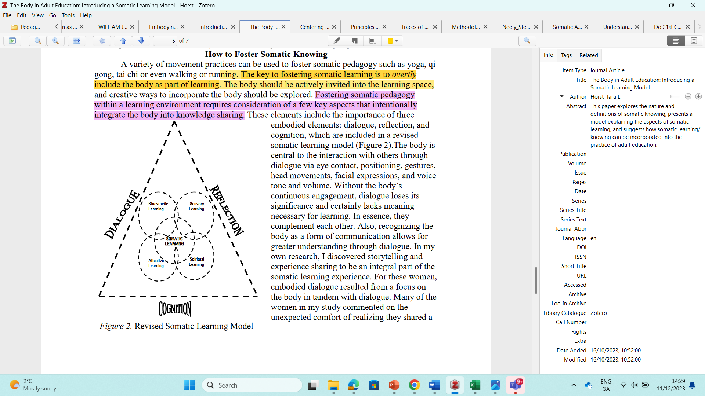

**Figure 3. Somatic learning model (Horst, 2008, p. 4)**

Some researchers and modalities omit ‘literacy’ as a cognitive process that limits somatic experience. Hardman (2021, p. 3) defines language as problematic, as the intellect tries to freeze or fix pieces of reality or experience into concepts or abstract ideas which can be rationally analysed Shlain (1998, cited in Hardman, 2021, p. 3) concurs that one of the ways in which the intellect ‘casts things in stone’ is through language. This type of rigidity is at odds with pluriversal and feminist approaches.

A challenge in somatic learning is ‘the lack of established vocabulary in everyday language around somatic experience’ (Núñez-Pacheco and Loke, 2018, p. 228). As such, participants need reassurance and a safe space for recognition and discussion of the difficult aspects of gaining somatic sensibility. Núñez-Pacheco and Loke (2018, p. 225) find writing and body maps assist in drawing out knowledge ‘arising from the tacit experience, which is generally elusive and hard to access unless scaffolded appropriately’. They elaborate that artists and designers are trained to ‘see’ or perceive in discipline-specific and heightened ways (Goodwin, 1994), and that it is possible to develop somatic language, thereby resulting in an ‘extended sensibility and corresponding vocabulary’ or ‘language of perception’ that is embodied in the sense that it is ‘communicated verbally and nonverbally, through words, sketches, gestures, and energies’ (Núñez-Pacheco and Loke 2018, p. 228). This expanded expression of communication is particularly valuable and suited to designerly ways of working.

Núñez-Pacheco and Loke (2018, p. 228) call for more ‘multi-dimensional tools’ to articulate tacit meaning and make somatic knowledge more explicit and accessible for further reflection in learning. Indeed, embodied, or somatic experience, is not fixed – it is emergent and living. To this end, Hanna (1970) defines the soma as the ‘living body’, emphasising its alive and changing status. This brings up complications and opportunities for learning and literacy that describe experience. Accessing embodied knowledge invites designers to lean into open-ended methods like automatic writing, drawing, and body maps. It offers the opportunity to explore methods that allow meaning to emerge and become conscious over time, with no expectations. Educators can draw attention to the understanding that words are signposts for experience, that they create a vague outline of it, and that our understanding of the experience may change and shift over time. Such nuances and openness require educators to hold space for students while meaning emerges. However, finding this space in third-level institutions can be challenging amidst the capitalist power structures and systems at play there.

**Design-specific pedagogy**

As discussed earlier, body-centric approaches already exist in design disciplines, particularly in HCI, user experience and interaction design fields. The design of products or artefacts is at the centre of much of this ongoing research. This present paper is interested in embodiment in design education with the intention of examining guiding principles for designing transformative learning approaches.

Horst (2008, p. 7) describes how, in fostering somatic pedagogy, ‘for a deeper level of understanding to occur, the body needs to be overtly integrated with the particular subject being discussed or taught’. This infers that within design, somatic approaches need to be relevant to the design discipline, people, and process.

A design process used in many third-level design programmes is a version of Design Thinking. The stages broadly include: *Research*, *Define*, *Ideate*, *Prototype*, and *Test*. When, in the current design process, are students most embodied? When, in the current process, is there the greatest capacity for embodiment?

Design is a suitable discipline to amplify situated, embodied learning. If we take Horst’s somatic learning model (Figure 3) as an example, then we can imagine a spectrum of overlap between design education and kinesthetic, sensory, affective and spiritual learning. Kinesthetics and sensory learning are familiar designerly ways of working, as they include visual and material processes and tacit experiences of organising, building, or creating. Affective learning such as the capacity for empathy is an important facet of human-centred design. However, although empathy maps are useful tools in the design process, somatic approaches, such as embodied interviews, can offer a more dimensional, embodied experience of ‘empathy’ within design practice.

Traditional methods of canonical design can be reimagined using a somatic lens. The ‘crit’, a ‘signature pedagogy’ (Motley, 2016), and other inherited modes of design pedagogy, can be reimagined and innovated with somatically-oriented pedagogy. Moreover, an increasing number of somatic and embodied research methods are used in designerly research such as body maps, embodied writing, drawing and other visual methods. Qualitative measures already shared in design and somatic education include reflective journals, focus groups, and perhaps, in some cases, ‘the body-focused interview’ (Tantia, 2021, p. 165).

With the above in mind, further research is needed to reimagine existing approaches in accordance with embodied and integrated intelligences. Indeed, we need to consider whether we are looking to amplify existing points within design education or reimagine it completely? A problem-solving and ‘solutioning’ approach may fall short when what we need is to lean into radical new forms of embodied, world-making. In fact, we would do well to remember Audre Lorde’s (1984) advisory words that, ‘**The Master's Tools** Will Never **Dismantle the Master's House**’.

Moholy-Nagy included movement as part of Bauhaus curricula, not for object design, but with ‘human development as the purpose’ (Sfligiotti, 2021). Including mindful movement (breathwork, yoga, walking, dance, tai chi, Pilates, or otherwise) can support a culture of embodiment more generally on campus and create opportunities for implicit and explicit learning integration in the studio. Perhaps such broader interventions might also amplify the importance of body-mind approaches at an institutional level.

**Disruption and troubling approaches**

In *Your Body is Your Brain,* Blake (2018) discusses five elements of neuroplasticity that contribute to learning in early years: relationships, emotional engagement, attention, practice, and movement. For new learning in adulthood, Blake (2018) proposes that an additional element is necessary: disruption. Blake (2018) describes disruption as a process of unlearning. It is the interruption of learned behaviours and behavioural patterns, releasing holding patterns that may have been necessary adaptations at some earlier point in life. The disruption of learned behaviours can lead to new perceptions, noticings, openings, changes, insights, and shifts; bringing awareness to previous holding patterns or habitus that led to perceptual blocks or blind spots. Somatic approaches can be designed to challenge habitus in order to transform behaviour and thought. Experimenting with movement patterns opens doors to choice and possibilities. Furthermore, the experience of feeling from inside is a source of knowledge and inspiration that can help individuals, in creative practices, to ‘perceive a situation in a novel way’ (Berger, 2019, p. 4).

In the context of design communications, kinesthetic learning has potential to disrupt students. This is, in part, due to our increasingly sedentary lifestyles and to the amount of time spent working at desks and on screens. Engaging design students in movement activities may be uncomfortable and challenging for students – particularly for the earlier years where they may be self-conscious or unfamiliar with innovative pedagogies. This is worth further consideration by educators and researchers seeking to advance embodied practices.

Eddy’s (2017, p. 5) book *Mindful Movement* presents the view that somatic awareness is a gateway to *connectedness* within a person and that it enhances self-empowerment and critical thinking. *Doing’s Rhythms’s Program* (Eddy, 2017, p. 186) is a dance program that seeks to liberate the soma from ‘rote’ movement and to nurture the individuals’ ‘inner rhythm’. A somatic approach to finding one’s ‘inner rhythm’ could be an interesting, ‘troubling’ approach for student designers who are learning to integrate inner values into an external design voice (Hogan and Creighton, 2023, p. 3). Further, by allowing students time and space to be within themselves, somatic learning can help to ‘compensate for the disproportionate amount of time spent on external focus in test taking and the use of computers’ (Eddy, 2017, p. 191).

However, although some embodied approaches might be classified as disruptive pedagogy in third-level design education, we might also consider that we are simply re-engaging with sensory experiences and play. Thus, while Montessori, Steiner, and emergent play-based curricula include more sensory and textural play-based activities in early years education, we still have progress to make regarding engaging the experiencing body at later stages of education.

**Conclusion**

This paper proposes building upon the guiding principles: integrated intelligence, conscious embodiment, literacy, subject-specific pedagogy and disruption, to develop and implement somatic approaches in practice.

Integrating somatic approaches in design education is challenging, with existing systems and power structures placing little value in supporting open-ended enquiry and slow learning in third-level education. Here, employability and enterprise reign supreme, even amidst signs of educational reform. This present paper proposed five guiding principles for somatic design education: integrated intelligence, conscious embodiment, literacy, subject-specific pedagogy, and disruption. Other sensibilities in guiding somatic learning include ‘sensitivity to timing, flow, choice and tonal delivery of words, and the energetic holding of space to create a supportive environment for participants to pay attention to their somatic selves’ (Núñez-Pacheco and Loke, 2018, p. 229). Schiphorst (2011, p. 153) cites important skills in somatic facilitation as ‘empathic mediation, resonance with the experience of others and personal familiarity with the subtleties of participant experience’. This view proposes a sensitive approach to integrating emotional, affective, and relational dimensions over time; indeed, one beyond a deterministic view of design education.

Núñez-Pacheco and Loke (2018, p. 229) advocate for educators to have somatic training, ‘to develop their own skills of somatic sensitivity’. They point to the need for a community of reflective practitioners for practices of somatic literacy and discernment to flourish. In 2021, The School for Somatic Design Practices, established a collective of international designer-mover-educators, indicating the growing interest in embodied approaches in design education (A—Z presents, 2023).

It is encouraging to see a growing number of design educators exploring embodiment. Engaging the body in third-level education is challenging and complex – as all bodies are different, levels of body awareness vary among individuals, and our relationships with our bodies differ, and change. However, understanding how, and why, we relate to our body may provide an opportunity for inclusive, diverse perspectives and shared connection between individuals and groups. Indeed, individuals ‘vary in their levels of body consciousness as well as in their openness to view learning through an embodied lens’ (Horst, 2008, p. 7). Many people may not be inclined to pay attention to the body, or they may not know how to (Hogan and Creighton, 2023). As such, educatorsmay want to gauge the body awareness of learners by assessing learners’ body consciousness at the beginning of the learning experience.

The present findings support the need for integrated body-mind approaches to learning that involve cognitive processes in order to construct meaning and bring conceptual understanding to embodied approaches. However, although language and discursive knowledge are seen as valuable, findings support designerly methods (body maps, drawing, writing) and a broader language of experience such as words, sketches, gestures, and energies’ (Núñez-Pacheco and Loke, 2018, p. 228). With the above in mind, further research is needed to advance embodied approaches including increased research and publications about the intersection of design education and somatics. Indeed, it would be valuable to share and examine differing somatic approaches by design educators and design schools. And it would be beneficial to examine traditional design curricula and signature pedagogies through an embodied lens.

It is apparent that slow approaches are needed to (re)connect individuals with their inner landscapes, bodily knowing, and core values (Hogan and Creighton, 2023). An intentional and systemic engagement with the learning process can facilitate that connection. Somatic learning can support students, to attune to themselves and others, to emotionally regulate, and to be at home in their bodies. This is especially valuable in design education, where design students are addressing the complexities of climate change and social justice (Hogan and Creighton, 2023).

**Disclosure statement:**

All materials included in the article represent the authors own work and anything cited or paraphrased within the text is included in the reference list. This work has not been previously published nor is it is being considered for publication elsewhere. The authors declare that they have no conflicts of interest to disclose.

**References**

A—Z presents (2023) ‘The A—Z Collective welcomes the School for Somatic Design Practices on Sunday, November 12 from 14:00 to 16:00’ [Instagram]. 8th November. Available at: <https://www.instagram.com/p/CzYMmhLsjIH/?igshid=N2ZiNzVhMjY2OA==> (Accessed: 10 November 2023).

Anderson, Will and Karwai, NG (2023) *‘*‘Below the Iceberg: Conscious Design for the Anthropocene’ *– Interaction 19*. *Interaction Design Association*. Available at: <https://vimeo.com/323338379> (Accessed: 21 November 2023).

Archer, B. (1979) ‘Design as a Discipline’, *Design Studies*, 1(1), pp. 17-20.

Berger, E. (2019) ‘Embodying Design Practice. Designers’ Experience and the Chakra Model’, *International Association of Societies of Design Research Conference 2019*. Design Revolutions, Manchester School of Art.

Blake, A. (2018) *Your Body is Your Brain: Leverage Your Somatic Intelligence to Find Purpose, Build Resilience, Deepen Relationships and Lead More Powerfully.* Trokay Press.

Boehnert, J. (2018) *Design, Ecology, Politics: Towards the Ecocene*. Bloomsbury Publishing.

CAST (2018). Universal Design for Learning Guidelines version 2.2. Available at: http://udlguidelines.cast.org (Accessed: 28 January 2024).

Cross, N. (2006) *Designerly ways of knowing*. New York: Springer.

Eddy, M. (2017) *Mindful Movement. The Evolution of the Somatic Arts and Conscious Action*. Bristol-Chicago: Intellect/The University of Chicago Press.

Escobar, A. (2018) *Designs for the pluriverse: Radical interdependence, autonomy, and the making of worlds*. Durham and London: Duke University Press.

Hanna, T. (1970) *Bodies in Revolt: A Primer in Somatic Thinking*. Novato, CA: Freeperson Press.

Haraway, D. (1988) ‘Situated Knowledges: The Science Question in Feminism and the Privilege of Partial Perspective’, *Feminist Studies,* 14(3), pp. 575-599.

Hardman, T.J. (2021) ‘Understanding creative intuition’, *Journal of Creativity*, 31. Available at: <https://doi.org/10.1016/j.yjoc.2021.100006>.

Hogan, E., and Creighton, E. (2023) ‘A case for Somatic Approaches in Design Education’, in Jones, D., Borekci, N., Clemente, V., Corazzo, J., Lotz, N., Nielsen, L M., Noel, L., (eds.), The 7th International Conference for Design Education Researchers, 29 November - 1 December 2023, London, United Kingdom. https://doi.org/10.21606/drslxd.2024.101

Höök K. (2018) *Designing with the body: somaesthetic interaction design*. Cambridge, MA: The MIT Press.

hooks, b. (1994)*Teaching to transgress*. London: Routledge.

Horst, T.L. (2008) ‘‘The Body in Adult Education: Introducing a Somatic Learning Model,’’ *Adult Education Research Conference*. Kansas State University Libraries: New Prairie Press. Available at: <https://newprairiepress.org/aerc/2008/papers/28> (Accessed: 10 November 2023).

IDG Foundation. (2023). *IDG*. Available at: <https://innerdevelopmentgoals.org> (Accessed: 10 February 2024).

Juhan, D. (1987) *Job’s Body: A Handbook for Bodywork*. New York: Station Hill Press.

Laursen, L.N., and Haase, L.M. (2019) ‘The Shortcomings of Design Thinking when Compared to Designerly Thinking’, *The Design Journal*, 22(6), pp. 813–832.

Livework (2023) *Designing in the anthropocene*, *Livework*. Available at: https://liveworkstudio.com/insight/designing-in-the-anthropocene/ (Accessed: 13 December 2023).

Munro, M. (2018) ‘Principles for embodied learning approaches’, *South African Theatre Journal,* 31(1), pp. 5-14.

Neely, S. (2019) Soma Literate Design – Recentering the Interstitiality of Experience. PhD Thesis. Carnegie Mellon University School of Design.

Loke, L. and Núñez-Pacheco, C. (2018) ‘Developing somatic sensibilities for practices of discernment in interaction design’, *The Senses and Society*, 13(2), pp. 219–231.

Lorde, A. (1984). The master’s tools will never dismantle the master’s house (Comments at the ‘The personal and the political panel,’ Second Sex Conference, New York, September 29, 1979). In *Sister outsider* (pp. 110–113). Sister Visions Press. (Original work published 1979)

Place, A. (2024) *Scratching the Surface*. [podcast]. Available at: https://scratchingthesurface.fm/246-alison-place (Accessed: 20 February 2024).

Popova, K., Garrett, R., Núñez-Pacheco, C., Lampinen, A. and Höök, K. (2022) *‘Vulnerability as an ethical stance in soma design processes.* In CHI '22: Proceedings of the 2022 CHI Conference on Human Factors in Computing Systems (pp. 1-13). doi: https://dl.acm.org/doi/10.1145/3491102.3501994

# Schouwenberg, L. and Kaethler, M. (2022) The Auto-Ethnographic Turn in Design, *Design and Culture The Journal of the Design Studies Forum* Amsterdam: Valiz. Available at: <https://valiz.nl/images/publicaties/Auto-etnographic_Turn_in_Design/Design-and-culture_27-04-22.pdf> (Accessed: 20 February 2024).

Shlain, L. (1998) *The alphabet versus the goddess*. New York: Viking Press.

Shusterman, R. (2005) ‘William James, Somatic Introspection, and care of the self’, *The Philosophical Forum*, 36(4), pp. 419–440.

Tantia, J. F. (Ed.) (2021) *The Art and Science of Embodied Research Design*. New York: Routledge.

United Nations (2015) *The 17 GOALS – Department of Economic and Social Affairs Sustainable Development*. Available at: <https://sdgs.un.org/goals> (Accessed: 11 November 2023).

Wizinsky, M. (2022) *Design after capitalism: Transforming design today for an equitable tomorrow*. Cambridge: MIT Press.

Yee, J.S.R. (2010) ‘Methodological innovation in practice-based design doctorates’, *Journal of Research Practice*, 6(2), Article M15. Available at <http://jrp.icaap.org/index.php/jrp/article/view/196/193> (Accessed: 10 November 2023).