The Gallery in the Expanded Field: Russian art students investigate the diversity of international DIY gallery spaces
Sean Kaye
British Higher School of Art & Design, Moscow
Corresponding author: skaye@britishdesign.ru
Abstract
The Gallery in the Expanded Field is a case study of the development of a pedagogic model which involves art students working with a range of international DIY gallery spaces. Students gain first-hand experience of exploring the possibilities of exhibition making, and how initiating and running a gallery programme can be a creative and empowering activity.
Participants are exposed to different models of what could constitute an art gallery beyond those of simply the museum and commercial dealerships. The gallery spaces that the project has worked with were chosen for their unusual physical manifestations and have included: an iPhone, an overcoat, an art school locker, the grease pit of a former garage, a hair salon, a world-wide shipping container and a small Scottish town. Through their dialogues with artists and gallerists, students start to understand how, through their own agency, they can begin to engage with the art world.
Key Words
Agency, Collaboration, DIY, Gallery, International.
Introduction
The Gallery in the Expanded Field is a case study of the development of a pedagogic model which involves art students actively working with a range of DIY galleries. Students work directly with artists and gallery curators to realise material for a series of exhibitions which foreground this particular approach to exhibition making.
The term the ‘expanded field’ was first used in 1979 by Rosalind Krauss in her seminal essay ‘Sculpture in the Expanded Field’ to discuss art works (namely land art and installation) that employed materials that moved beyond those traditionally associated with sculpture. It has been increasingly used since then in relation to extending traditional notions of other artistic disciplines and the terms ‘painting in the expanded field’ and ‘expanded cinema’ are now in common usage. As Michael Archer (2015) points out in Art Since 1960 “there are no longer any particular materials that enjoy the privilege of being immediately recognisable as art media: recent art is made not only with oil paint, metal and stone but also air, light, sound, words, people, food, refuse, multi-media installations and much else besides.”
Galleries working with education and working through education is explored in some depth in the 2010 anthology ‘Curating and the Educational Turn’ edited by Paul O’Neill and Mick Wilson. In their introduction to this volume O’Neill and Wilson (2010) state ‘curating increasingly operates as an expanded educational praxis’. The Gallery in the Expanded Field explores with art students, the limits of what could constitute a gallery space, requiring them to engage with gallery models that go beyond those of simply the museum and commercial dealerships. The project aims to expose students to the possibilities of multiple DIY models of exhibition making, encouraging them to become proactive in this arena.
The public face of this ongoing project has been made possible as part of the curatorial programme blip blip blip, located at Winzavod Centre for Contemporary Art in Moscow. An exhibition involving thirteen galleries took place here in May / June 2021 (https://blipblipblip.co/the-gallery-in-the-expanded-field) and a further exhibition involving seven galleries took place in June / July 2023 (https://blipblipblip.co/the-gallery-in-the-expanded-field-ii). The project has, to date, showcased gallery spaces from a range of countries including Australia, Finland, Germany, Great Britain, Russia, and the USA.

Background
The project was initiated by Doug Bowen, Sean Kaye and Mikhail Levin, academic staff at the British Higher School of Art and Design in Moscow. By identifying and contacting a range of exhibition programmes that had been established in somewhat unusual spaces, they invited a range of DIY galleries to take part in the project. Bowen, Kaye, and Levin initially relied upon their personal networks, inviting galleries based in both Russia and Great Britain to contribute to a group exhibition. Then, through a series of internet searches, they began to contact spaces from a range of other countries. The intention was to create an opportunity for students to experience exhibition making as an international network. As the project evolved, they began to be contacted by academics, artists and curators drawing their attention to further interesting DIY spaces and exhibition models. This network has proved an invaluable tool in widening the nature and geographic diversity of the project.
he project was undertaken in conjunction with a group of Foundation and undergraduate art and design students from the British Higher School of Art and Design in Moscow. Each student volunteered to take part in the project outside of their core course curriculum. Many participants in the project studied on one of the school’s contemporary art courses, but the demographic also included graphic design, illustration and interior architecture students, deliberately fostering cross-disciplinary approaches to learning. By working directly with artists and gallerists, the participating students were able to develop their contextual understanding, whilst gaining first-hand experience of researching, installing and curating exhibitions. The project foregrounds learning through an engagement with artistic and curatorial practices beyond the university campus and the art school studio. The outcomes, though varied in content, resulted in students making, together with international galleries, co-created presentations exhibited in the public domain.
Around 90% of the spaces contacted by Bowen, Kaye and Levin agreed to take part in the project. The inaugural exhibition, held in 2021, took place before the current conflict in Ukraine began and the second exhibition opened whilst this conflict was ongoing. One gallery that had initially expressed an interest in the project, felt that it was not politically the right time for them to take part. Another gallery that had been intending to send artwork as their contribution to the second exhibition ultimately decided against sending physical work and asked that they be represented by an extensive interview that had been carried out by two of the Russian students.

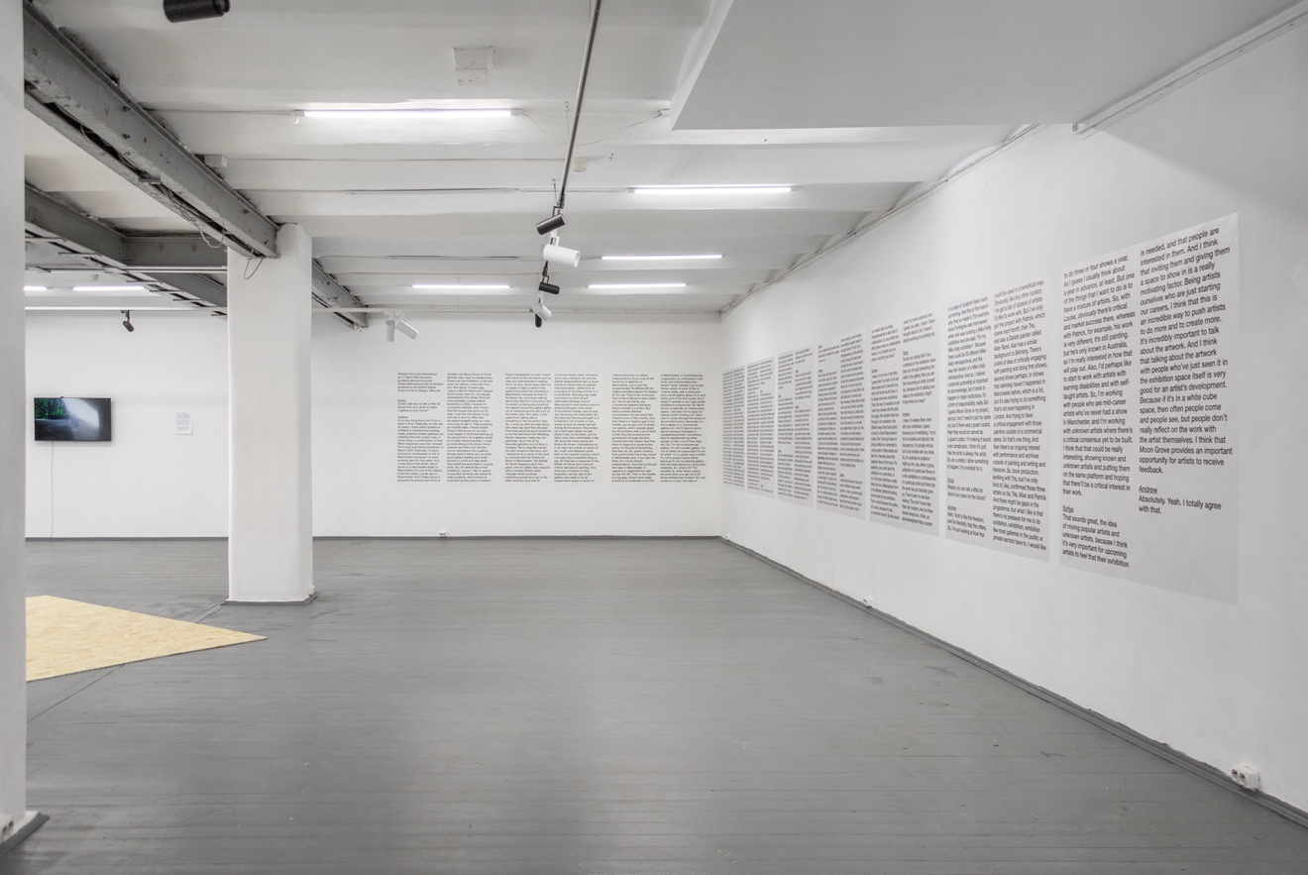
The Gallery in the Expanded Field II, 2023. Image Credit: Fedor Toschev
Methods
Participating students have been involved in practically aiding gallery spaces, most of whom participated remotely, to realise their contribution to an ongoing series of group exhibitions that explore the diverse physical manifestations of what an art gallery might look like. These same students also organised and carried out a series of illuminating interviews with gallerists which have proved highly influential to their understanding of art practice and exhibition making. Extracts from these student-led interviews are used throughout this paper as a demonstration of the investigative experiential learning that is taking place. These interviews articulate, from the perspective of the participants (both students and gallerists) different aspects of exhibition making. The project foregrounds an active mode of learning (Bonwell & Eison, 1991), encouraging and enabling students to build and share a body of knowledge, which, in turn, is then further shared with a wider public through the exhibitions at blip blip blip.
After initial contact with the gallery, a small group of two to three students were then partnered with each gallery space. The students assigned to a particular gallery carried out interviews with the artists, curators, or directors (via zoom, email, and in some case in person) in order to better understand the motives that had led to establishing and running these unusual programmes. The students also worked with their gallery to discuss and prepare the material to be exhibited. Students at the British Higher School of Art and Design are taught in English. The conversations and collaborations that took place between students and gallerists were carried out in English, with the exception of the galleries that were based in Russia. These interviews were carried out in Russian and were subsequently translated into English.
The project attempts to remove hierarchical structures by allowing students to engage equally with artists, gallerists, and art school tutors. In doing so, the project reflects Bakhtin’s concept of the dialogic, as outlined in 'The Dialogic Imagination: Four Essays’ (Bakhtin, 1982), in which he discusses how dialogue gets entangled through shared thoughts and points of view, forming complex interrelationships and in turn shaping discourse. Whilst the interviews carried out as part of The Gallery in the Expanded Field were empowering and illuminating for the students, the questions that students asked, often allowed artists and gallerists to reflect upon and evaluate their own practices.

A Range of Gallery Models
The ‘galleries’ that took part in the project range from the historically significant apartment shows of the group APTART to a short-lived gallery that only had one exhibition before it was blown away in a sandstorm in the New Mexico desert. The diversity of these galleries has served to highlight to the students taking part, the myriad possibilities of DIY exhibition making. This has encompassed an artist establishing an alternative exhibition space within a commercial dealership and an artist ‘performing’ a gallery within his overcoat, through to the socially engaged practices of Deveron Projects, where the whole town of Huntly begins to function as a large art gallery.

Working Collaboratively to Realise Exhibition Material
Students have worked with their assigned galleries in several different ways in order to realise the physical contribution of a particular DIY space to the The Gallery in the Expanded Field exhibitions in Moscow. This has ranged from printing documentation of previous exhibitions and projects to fabricating new works specifically for the exhibition. In some cases, installation shots of the entire past exhibitions of a particular gallery programme have been sent digitally and then printed and presented at blip blip blip (Good Weather), in another case students filmed a scroll through the gallery website to present the programme history in video form (Institute of Jamais Vu). The fabrication of new works has involved students in a range of practical activities from screen printing T Shirts (Disneyland Paris), filming and editing videos (Porcino) to making a scale model of one of the gallery spaces (Futuro Minor). In the first exhibition, this also entailed students creating a 1:1 footprint of each participating gallery in vinyl on the floor of blip blip blip and a gallery plan and works list that communicated this to the viewer.
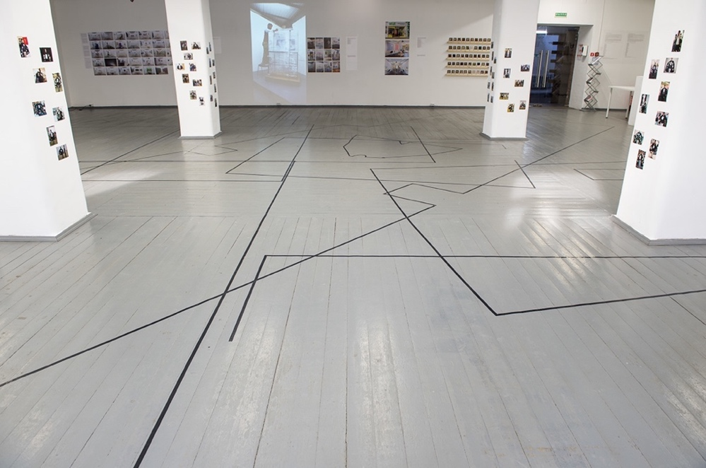
The Gallery in the Expanded Field I, blip blip blip, 2021.
Image credit: Tatiana Dmitrieva
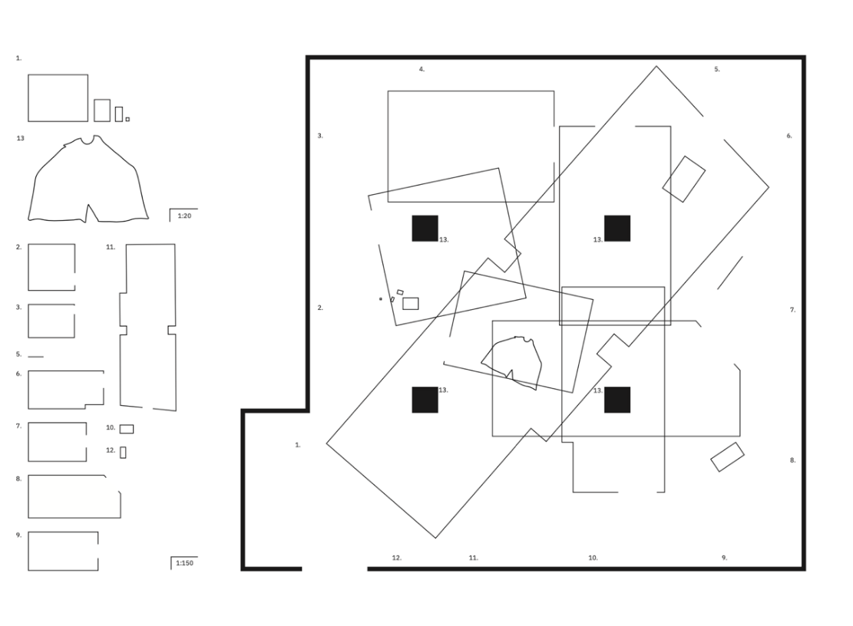
The Gallery in the Expanded Field I gallery guide, blip blip blip, 2021. Design: Nazira Berikbay
Deveron Projects is an arts organization, that is based in the town of Huntly, Aberdeenshire in the northeast of Scotland. Working with the methodology ‘the town is the venue’ they create projects that connect artists, communities, and places by inviting artists, to live and work in Huntly. Through these residencies, artists have contributed artworks to an ever-expanding archive, known as the ‘Town Collection’. These works are not held in one place but are hosted in local shops, public buildings, and local landmarks throughout Huntly, effectively establishing the town of Huntly as a large art gallery.
Marina Koshlina, Olga Popova, and Sonya Zamanskaya, three BA (Hons) Contemporary Art students, worked with Deveron Projects to superimpose the map of Huntly’s ‘Town Collection’ onto the streets of Moscow. Using Deveron Projects headquarters in Huntly and the blip blip blip gallery space in Moscow as their central axis points, they plotted where all the works from the Huntly Town Collection would be if they existed in Moscow. Through the creation of a map, visitors to The Gallery in the Expanded Field were invited to undertake an ‘art walk’ around the streets of Moscow that existed as a parallel walk to the Deveron Projects ‘art walk’ which visitors undertake in Huntly. Stickers displaying QR codes where stuck to specific locations in Moscow, these QR codes directly connected viewers to the artwork found at the parallel location in Huntly via the camera of their mobile phone. The students, together with the curators at Deveron Projects, also undertook a synchronised walk around the streets of Huntly and Moscow which was recorded as a zoom call. This synchronised walk existed as a video work in the exhibition The Gallery in the Expanded Field at blip blip blip.
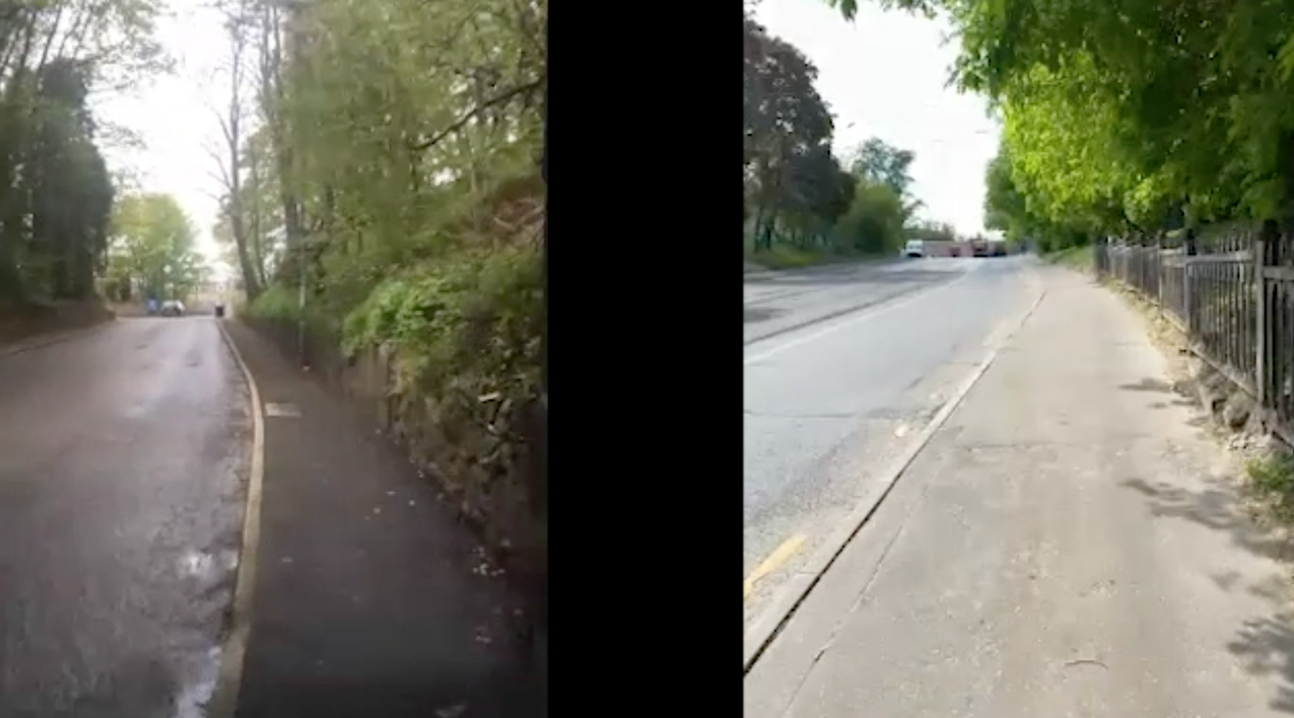
Synchronised Walk Moscow & Huntley (video still), 2021.
Image Credit: Marina Koshlina

Learning Through History
The history of contemporary art practice and exhibition making in the city of Moscow in the 1970’s and 1980’s (whilst still a part of the former Soviet Union) saw artists utilise their own apartments in order to generate a dialogue with a small, like-minded audience, often other artists. These artists included the Moscow Conceptualists and the generation of artists that directly followed them, who became known as APTART. APTART was a short-lived movement, the collective project of which was a series of apartment exhibitions or, as David Morris et al. (2017) outlines in his introduction to ‘Anti-Shows: APTART 1982-84’, what the participating artists at the time described as ‘exhibition-nonexhibitions’ or ‘anti-shows’. The documentation of material from the APTART project exhibited in The Gallery in the Expanded Field included archival images loaned from the collection of Garage Museum of Contemporary Art. Researching, selecting and presenting historical examples of independent exhibition making together with interviewing Alexandra Obukhova, the curator of the Garage Museum archive (which in turn houses the APTART archive) led to the students gaining an informed understanding of the potential cultural significance of DIY exhibition initiatives.
Daria Semenova (BHSAD student): Our main focus of interest for this interview is the APTART group. How did this group originate? Can you tell us about the philosophy, the participants, and the moment of perestroika.
Alexandra Obukhova (curator Garage Museum Archive): Let's clarify, APTART is not a group, APTART is a platform around which a certain number of artists united, and this happened long before perestroika, specifically at the peak of the Brezhnev stagnation. APTART arose as the result of many years of reflection by a circle of artists associated with the Moscow conceptual school about the conditions for exhibiting artwork. If, as an artist, you are not allowed to exhibit, you cannot consider your work from the perspective of seeing it next to the works of other artists, and you cannot openly discuss these works. There is no audience that can see your work. From the very beginning of the existence of unofficial art, this problem was very acute, and artists tried to bypass it in every way possible. The first apartment exhibitions appeared in the late fifties, but it was not until 1982 that the idea was formulated of a space, where regardless of its location, artists close to each other intellectually and spiritually could exhibit.
Roma Soida (BHSAD student): As I understand it, APTART did not have any oppositional character. Wasn’t it somewhat apolitical?
Alexandra Obukhova (curator Garage Museum Archive): The principle was, that social criticism was done by cartoonists, like Vyacheslav Sysoev for instance. For the artists of the Collective Actions circle or the APTART circle, this was not very interesting. If there is a storm in your own backyard, you don't criticise it, do you? It just exists. Soviet power was like the weather - it just existed. It had to be understood not from the point of view of dissident criticism, but from the point of view of the subtle cultural tools with which many of these artists worked: fashion, counterculture, music. Politics was not the primary thing, art itself was.
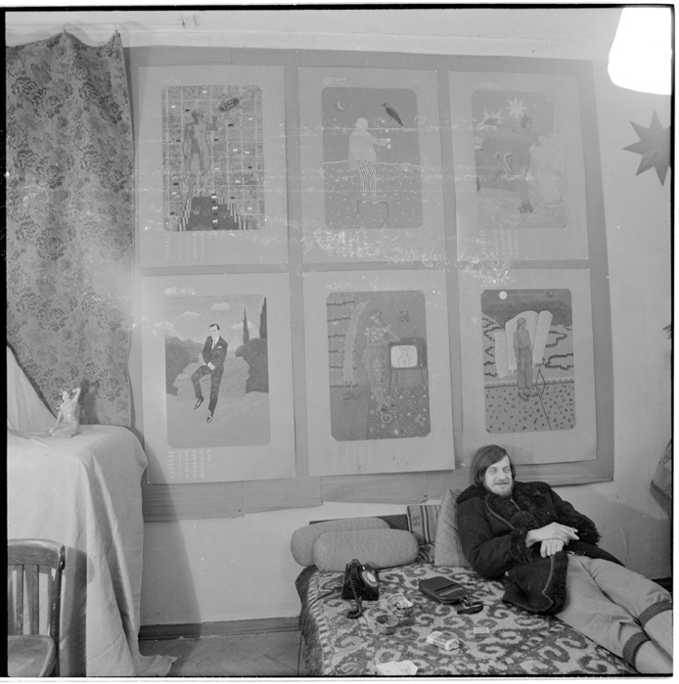
For the Soul and the Little Boy, works by Nikita Alexeev, 1984. Image credit: George Kiesewalter courtesy of Garage Museum of Contemporary Art
Learning Through Former Art School Models:
As well as historically significant moments such as APTART, The Gallery in the Expanded Field has also foregrounded a range of former student projects in order to highlight to the student participants the possible opportunities open to them whilst still at art school. MXXXII was a ‘gallery’ located in locker 1032 in the former H Block building of Leeds Metropolitan University. It was established by the artist Harry Meadley, then a 1st year BA (Hons) Fine Art student, during his first week on the programme. Over a two-year period MXXXII staged 50 exhibitions. Meadley offered his fellow students, from across all three years of the BA programme, an opportunity to use the space in order to test and develop new work. He also made further invitations, via a series of tutorials, to visiting artists and the Fine Art staff of the university. Each exhibition was documented by a single polaroid photograph and these fifty polaroid photographs were exhibited in The Gallery in the Expanded Field.
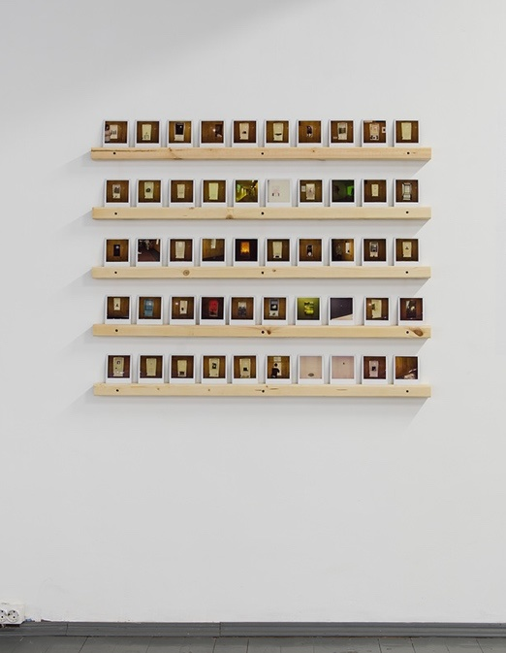
MXXXII, The Gallery in the Expanded Field 1, blip blip blip, 2021. Image credit: Tatiana Dmitrieva

Meadley established and ran his gallery within the art school, as a creative act beyond the requirements of the BA (Hons) Fine Art programme. This allowed him access to students from diverse backgrounds and disciplines as well as to a wider range of staff and professionals, than simply undertaking the prescribed university curriculum would have afforded him. Here Meadley discusses with Polina Efremova (BHSAD student) the benefits of establishing a regular routine during his time at art school and how this disciplined routine provided him with a platform to engage with staff and fellow students, allowing him to learn through observation and dialogue.
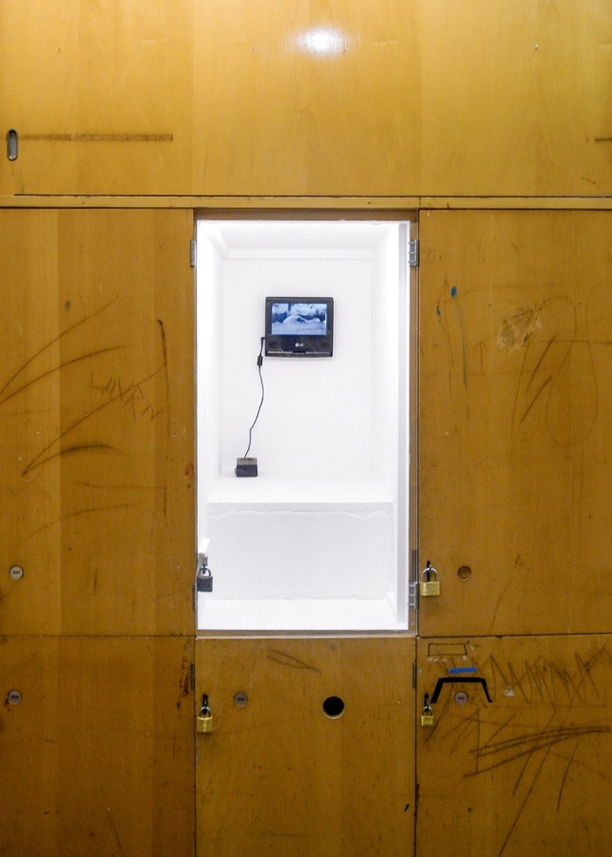
Hardeep Pandhal, MXXXII, 2007. Image credit: Harry Meadley

Polina Efremova (BHSAD student):
Did you think of this gallery as a selfless act? Because whilst it was still your project, your gallery, it also gave other artists a place to present their work. And in that way the gallery was not just about you anymore, right? Did you think about it in that way?
Harry Meadley (artist, established MXXXII):
No, I think all artists are completely selfish. And even when they do something that has selfless qualities to it, there is still always going to be some element of self-interest. But I don’t think that that self-interest is just like ‘oh, I want attention’, or ‘oh, I want success or recognition or whatever’. So, for instance, my self-interest was that it was a fun and enjoyable thing for me to do. I don’t think that the people who showed in the locker gallery were getting a great opportunity or great exposure, but I do think that it allowed them to do interesting and exciting things, to test things out, and to generate a bit of a conversation. I remember thinking quite consciously, that it was a really good way to give myself a routine and to occupy my time. I’d go in, really early on a Monday morning, and install a new show for that week, and then, be around, and be organising the next show. So, first thing every Monday morning the locker gallery sort of functioned to get me into the studio. I’ve never really been a studio-based artist, so, I think that having this locker gallery gave me a routine to come into the studio and be in conversation with people. But ultimately, the selfishness was that it was a learning process for me. I think that it was an interesting thing to do, and that most of the learning was done through paying attention and looking at other people’s work and talking to them about their work. So, you sort of learnt through them, and you learnt from just seeing how other people, other artists, other art students responded to the space. So, in that respect it was totally selfish. Maybe sometimes you have to be selfless in order to be selfish.
Public Space and Institutional Politics
Efremova’s (BHSAD student) thoughtful questioning allowed Meadley to further reflect on ideas surrounding private and public space and institutional politics in relation to his locker gallery.
Polina Efremova (BHSAD student):
I wondered whether the main point of your project was to mix up private and public space by presenting exhibitions in your art school locker?
Harry Meadley (artist, established MXXXII):
Wow, it’s really interesting to hear you phrase it in that way, because at the time I wasn’t thinking about public and private space, but I do think that’s interesting. The corridor where the locker was located was the main entrance to all the art and design courses in the university. But also, people would have to come that way to get to lots of other parts of the university too. So, thousands of people a day walked up and down that corridor. It probably got more visitors if you think about it like that, than any other gallery in Leeds. So, it was an interesting strategy to use this one bit of space that you’ve been given to create something that got this massive, sort of passive audience. But actually, phrasing it in terms of public and private space is really interesting. A university is sort of set in this weird place between the private and the public, but it is essentially a private building. So, as soon as an individual within that structure claims a bit of territory for themselves, and then presents something publicly that the institution doesn’t completely control, that is almost like a reclaiming of a public space or an area in which ideas can have a public audience. And in fact, over the two years that I did the locker gallery, it became a bigger and bigger issue within the university, because they started to realise that they didn’t have any control over what I was presenting. And at various points it caused all sorts of problems. They actually introduced a special health and safety form just for me which I had to fill out before every show, and since that point all other students have had to use that form too, which a part of me feels really bad about.

‘Not Knowing’ as a Form of Empowerment
The Institute of Jamais Vu was another example of a successful DIY gallery project, initiated by a group of undergraduate art students, which acts as a potential model for how students might act collectively to realise ambitious gallery programmes. In 2010, ten ex Leeds College of Art Foundation students were finishing the first year of their BA (Hons) Fine Art courses across a range of London art schools including Goldsmiths, Chelsea, Central St Martins, Wimbledon, Middlesex and Kingston. After calculating the amount of money that they had collectively spent on accommodation during that year they decided to pool their resources and rented a warehouse in Manor House in North London. They proceeded to convert the interior of this building into living accommodation and also constructed a gallery in the centre of the space. Between November 2011 and May 2014, they staged twenty-three exhibitions as well as hosting symposiums that addressed the state of art education. Here members of IJV discuss how ‘not knowing’ and naivety became strangely empowering in the early days of establishing their gallery.
Maria Titova (BHSAD student):
You guys undertook a really ambitious project whilst still art students. Being first year students ourselves, we are slightly nervous and don’t really know how we could begin to establish an exhibition space. From the experiences that you had in establishing the gallery, what advice would you offer?
Jenny Bull (artist, co-established Institute of Jamais Vu):
Just taking it step by step helps, doing the first thing first, then the second thing second and the third thing third. Just do what you are doing in the moment. And then, over time you begin to realise that you’ve actually done a lot of stuff.
Isaac Clark (artist, co-established Institute of Jamais Vu):
There is something empowering about not knowing how big the thing is that you are taking on. We just thought “oh, we want to create a gallery space” not realising what that entailed, not really knowing any of the details, like how do you actually go about building a big gallery space. And doing it almost blind made it easier in some ways. At the time it seemed easy, we just had to find a space and then we just had to invite people to show their work and then invite people to come and see the work!

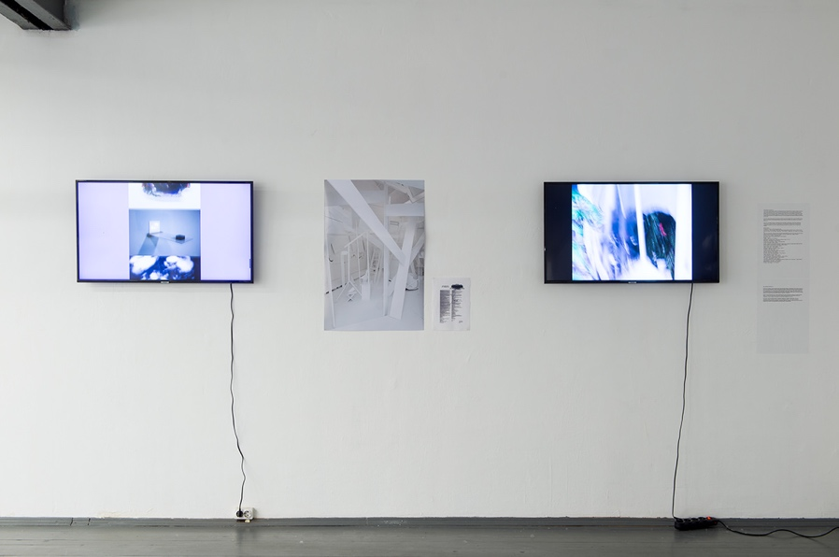
The Institute of Jamais Vu, The Gallery in the Expanded Field I, blip blip blip, 2021. Image credit: Tatiana Dmitrieva

Developing Networks
Haynes Riley established the exhibition space Good Weather in 2012 because there was a lack of galleries and exhibition opportunities in Little Rock, Arkansas. It is a non-commercial space based on resourcefulness and low overheads. Good Weather originally existed in a private garage owned by Riley’s brother in a residential neighbourhood. The director’s family served as gallery assistants throughout Good Weather’s exhibition schedule. Art school provides readymade networks that can be utilised to create exhibition opportunities whilst still in education and later upon graduation. However, it sometimes takes time for students to recognise the possibilities that working collectively offers them. Here Riley discusses the importance of interpersonal connections and forming peer support networks.
Inga Allakova, Darya Panova, and Irina Zharyna (BHSAD students):
How do you select the artists that you exhibit at Good Weather – do you have particular criteria?
Haynes Riley (artist, established Good Weather):
In 2012, when the gallery started, I had just finished graduate school and then eight months before the first exhibition I was selected to do an artist’s residency. And so, in art school, and then on the residency, I met other artists, people that you know through a sort of intense situation, people that you get to know because you spend a lot of time together. So, you get to know someone as a person and then you get to know the work. And these are the qualities that I seek when I’m choosing artists: first getting to know someone as a person and then understanding if I’m interested in the work. The gallery began with those interpersonal connections, with graduate classmates and with artists that I’d met on the residency. I began to understand how I could create a pool of artists.
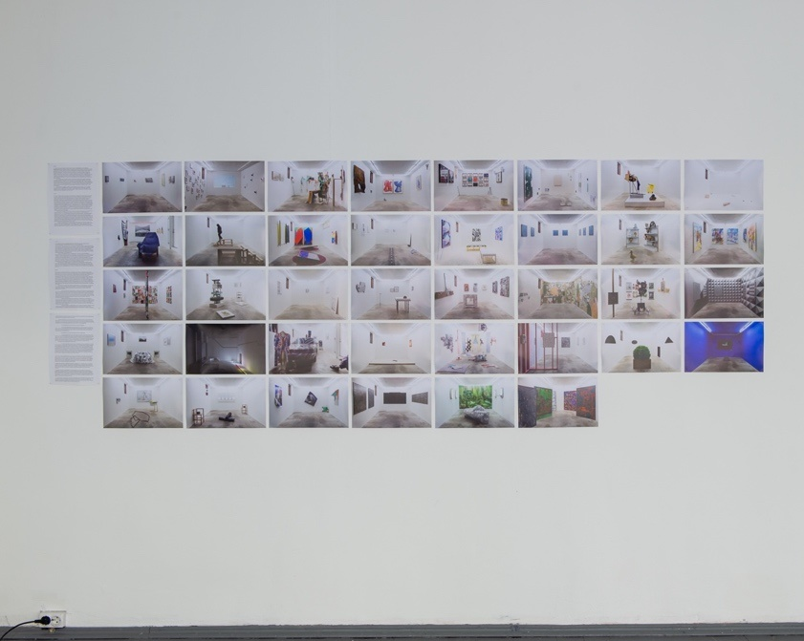
Good Weather, The Gallery in the Expanded Field I, blip blip blip, 2021.
Image credit: Tatiana Dmitrieva

Keeping Going
Often DIY spaces are seen as short-lived projects, but for nearly 30 years now, Alexander Petrelli has been exhibiting the work of other artists through opening his overcoat and has, to date, presented over 400 exhibitions. As Ruth Addison and Kate Fowle (2016) outline in ‘Access Moscow: The Art Life of a City Revealed 1990-2000’, Overcoat Gallery was established in 1995 and was conceived by the artists group Peppers. It is a mobile art institution that exhibits small format works on the lining of Petrelli’s overcoat. The gallery uses the private views of other galleries, museums, and art fairs as the site in which to realise exhibitions. The longevity of this project, and the sheer number of exhibitions presented through such a simple vehicle, opened the eyes of the art students participating in the project to the possibilities of how a long-term practice could be developed, from what at first may have seemed a transitory performance.
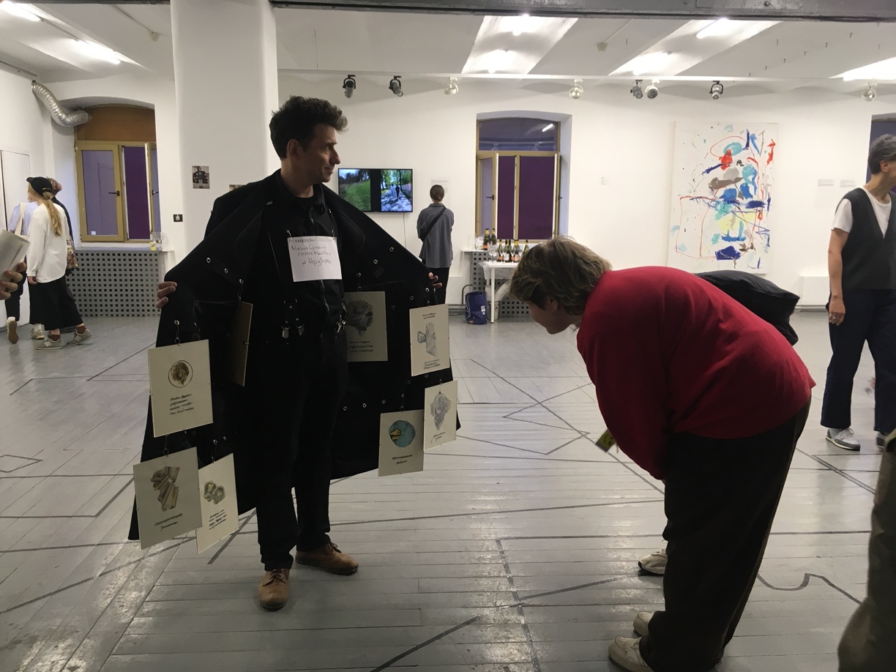
Overcoat Gallery, 2011. Image credit: Sean Kaye

The Professional Versus the Anti-professional
The gallery Porcino was established in 2013 by the artist David Horvitz who is represented by the gallery Chert Ludde in Berlin. Chert Ludde’s original space was a converted car mechanics garage. Horvitz persuaded his dealer to allow him to use the former grease pit of the garage to establish Porcino. Horvitz has gone on to establish further ‘galleries’ utilising other art world hosts.

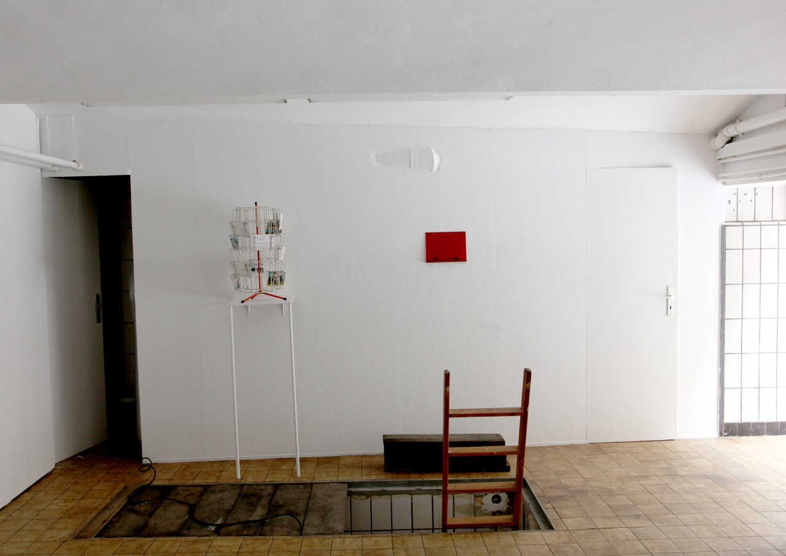
Porcino, 2013. Image credit: David Horvitz
In an interview carried out by BHSAD students Olga Popova and Sonya Zamanskaya, Horvitz discusses how he came to use this awkward space in order to stage alternative exhibitions and his interest in pursuing an anti-professional stance within a professionalised art world. This was of particular interest within an art education context. Often sessions addressing professional practice can seem very formulaic and it was refreshing to hear an alternative perspective being articulated for students to consider. Part art history lesson, part anti professional positioning, Horvitz’s amiable rambling conversation was both captivating and enlightening for the students he worked with.
Olga Popova (BHSAD student):
How did you decide "I'm going to open a gallery within another gallery"?

David Horvitz (artist, established Porcino):
When I first visited the gallery, Jennifer Chert showed me this hole in the floor and I was like, "Oh my God, I wanna do exhibitions in the hole in the floor". And she agreed. And then I was like, oh, it should be called Porcino. One of the reasons for this was that porcino is a mushroom, and this mushroom exists kinda symbiotically. Not all mushrooms are symbiotic, but porcini is symbiotic with the host tree. And so, then it was this kind of metaphor of a space within a space. It's like a space that's a host to another space.
Olga Popova (BHSAD student):
Did your other space in Paris develop because you had previously established Porcino in Berlin?
David Horvitz (artist, established Porcino):
Yeah, that’s called Matsutake. So that popped up as an extension. I thought I could do another alternative gallery in another host space, and that was Yvon Lambert, this really important French gallerist, who's been making these really important shows since, I don't know, the sixties I think, maybe the seventies, but like, early, early conceptual art. Yvon Lambert closed his huge gallery in Paris. He's getting old, so he shut the gallery down and he opened a bookstore. He already had a bookstore, but he wanted to focus on his bookstore where he publishes books and editions and he wanted to also have a little gallery there. I never worked with the gallery, but I know Yvon, and we collaborate. And so, inside the bookstore, there's a small gallery space in the back where they do exhibitions, and in there there's a closet. And it's closed. It's usually used for storage or maybe electrical things. And I was like, “oh, can I do a gallery in there?”
Oh, I need to say something I forgot to say! When Porcino originally started, I would do an exhibition only when I was in Berlin. And for me, that was very important. There were two things, one, it was like a mushroom, which only comes out when it rains, you know, so it's seasonal and there's this unpredictable schedule. I mean, it's like an anti-schedule. It was like, when David comes to Berlin, we do a Porcino show. And we never knew how long a Porcino show would stay up. It could be up for like two months. It could be up for nine months, or it could be up for two years. And to me, that was special, because it's kind of anti-gallery and it’s anti-professionalised scheduling. It was working against the professionalised time keeping of a gallery. And it was spontaneous and random because with most galleries, you want to know when a show opens and when an exhibition closes. And I was like, no, it's just gonna be based around when I'm in Berlin. Again, it's like going back to this relational element, this notion of friendships. And so, when I'm in town, we do a show and I invite my friends.

The Middle of Nowhere
The North London Contemporary Art Outpost was established by the then London based artists Isaac Clarke and Lindsay McMillan when they realised how cheap land was in the New Mexico desert, purchasing a plot 5000 miles away from London for a mere $500. They rented a truck in Albuquerque, bought materials, and proceeded to build a gallery. In April 2013 the North London Contemporary Art Outpost staged it’s one and only exhibition (of work by Francis Lloyd Jones), before it was blown down by a sandstorm. The website of The North London Contemporary Art Outpost embraced this destruction as it was coded so that every time someone visited, it would check the weather at the real location and apply that amount of ‘weather damage’ to the code, slowly collapsing itself. The web browser eventually crashed and has since been replaced by a screenshot of its last functioning moment.
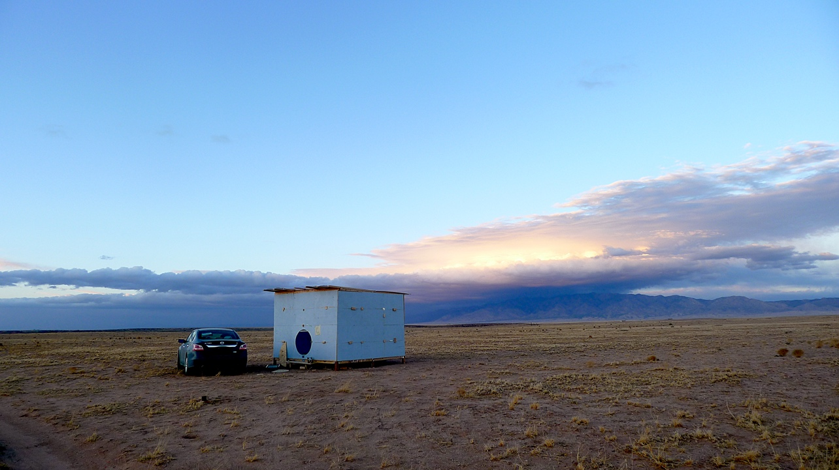
North London Contemporary Art Outpost, 2013. Image credit: Isaac Clarke
atrina Vikhrova (BHSAD student):
In essence, your project is a kind of rebellion and protest against the conservative canons of the public exhibition space. How did you arrive at this?
Isaac Clarke (artist, co-established North London Contemporary Art Outpost):
At the time when NLCAO started we were both nearing the end of our undergraduate degrees. We were also both living in artist-warehouse spaces. I think there was a shared frustration in both educational institutions, the gallery world, and in community art spaces. Maybe it all felt claustrophobic, pressurised, or limiting. An acre of desert in New Mexico felt like outer space, a portal to unknown ways of living, multiple timelines of possible lives to live. A crack in the world we could slip through, a glitch in the matrix.
Katrina Vikhrova (BHSAD student):
From the beginning, this space was going to collapse. You were aware of its fate in relation to the power of the weather, and you programmed your website to be destroyed in sync with it. What do you think should be destroyed in the contemporary art world, what are the stereotypes about exhibition spaces and what should change in the future?
Isaac Clarke (artist, co-established North London Contemporary Art Outpost):
The problems are often found in acting to please an imagined authority; be that an institution, a critic, an audience, art-history, or yourself.
Conclusion
The gallerists that the students have worked with through their participation in The Gallery in the Expanded Field have all emphasised the importance that dialogue, friendship and networks has meant to them as practitioners. They talk about meeting people, talking to people and working with people. From APTART’s word-of-mouth network, created by like-minded artists in the 1980’s, long before social media existed, to the students and staff engaged by Harry Meadley in his locker gallery. From Haynes Riley’s discussion of how his classmates and the artists that he met on residency helped establish Good Weather, to the group of former Foundation students creating The Institute of Jamais Vu and the wider community and conversations that are engaged by the work of Deveron Projects. This continual reiteration of the importance of their peers in relation to learning and agency has been an invaluable lesson for the students who participated in the project.
The process of interviewing gallerists, to better understand the histories and motives that had informed the initiation and development of their programmes, has proved to be an incredibly positive and enabling aspect of the project for the students who took part. Being able to talk to established artists and gallerists at length about their strategies, and about how and why they made certain decisions, has seen many students grow massively in confidence. This has been empowering, leading many of the participants to feel that they can engage with an art world beyond that of art education. Becoming connected to a range of international exhibition programmes beyond Moscow has given the students who participated a sense of ambition in terms of what it might be possible to achieve after graduation.
The level of preparation and insight that the students demonstrated in these interviews was regularly commented upon by the galleries who participated in the project. This led to strong relationships developing between the students and the gallery that they were assigned to. It frequently resulted in extreme levels of dedication and students working long hours in order to realise an element of the group exhibition on behalf of their gallery.
The project has proved influential for those students who volunteered their time and took part, developing their understanding of the possibilities of exhibition making, and what it may mean to be professional, or, to perhaps adopt a position in opposition to the professional. Participation in The Gallery in the Expanded Field has been voluntary and undertaken as an extra-curricular activity. This allowed the inclusion of students from across a range of art and design disciplines, from Foundation to final year undergraduate students, as well as CPD students. The extra curricula status of the project offered a secure learning environment, as students understood that that their participation would not be assessed. However, certain students felt that they couldn’t commit time to an extra-curricula project of this nature because of work or family commitments. Bowen, Kaye and Levin are currently considering the possibility of embedding the project within the curriculum, but this brings its own set of problems. It may prove difficult to maintain the breadth of participation from students from different disciplines and different year groups, as it would probably mean introducing the project as a module to one year group within one specific programme. Alternatively, would it be possible to change the school’s module structure and introduce a cross school interdisciplinary module that could be graded at pass / fail?
One of the aims of the project was to encourage students to initiate their own DIY gallery programmes. Whilst participation in The Gallery in the Expanded Field has empowered students in many ways it has not to date led to students initiating their own DIY spaces in Moscow. Though interestingly, a student who took part in the project and is now studying Curating at Goldsmiths, has recently established a gallery programme which utilises the blinds in his halls of residence. The lack of DIY spaces springing up in Moscow as a result of the project could be due to a number of different reasons. The Covid restrictions were still in place during the first iteration of the project at blip blip blip. These restrictions meant that end of year exhibitions did not take place in 2021 and 2022 and this perhaps curtailed the students ambitions as to what they believed was achievable. The possibility of developing longer term DIY gallery programmes has become further problematised due to the current situation in Ukraine. This has led to many of the students who took part in both of the previous two iterations of the project, leaving Russia to pursue their studies at art schools abroad. The project continues, and we still hope that in the future it will lead to students and graduates feeling empowered to self-organise and to establish exhibition opportunities for young artists in Moscow, whilst also encouraging the possibility of engaging with artists from other cities and from other countries.
The Gallery in the Expanded Field is an ongoing project and there will be a third iteration of the exhibition at blip blip blip in June 2024.
It has not been possible in this paper to discuss the work of all the galleries that have taken part in The Gallery in the Expanded Field. More information and images about the galleries that have been included in the first two exhibitions can be found on the blip blip blip website.

Statement of Disclosure
All materials included in the article represent the authors own work. Anything cited or paraphrased within the text is included in the References section. The work has not been previously published nor is it being considered for publication elsewhere. No conflicts of interest exist that have influenced the author in reporting his findings completely and honestly.

References
Addison, R. and Fowle, K. (2016) Access Moscow: The Art Life of a City Revealed 1990-2000. Moscow: Garage.
Archer, M. (2015) Art Since 1960. London: Thames & Hudson.
Bakhtin, M.M. (1982). The Dialogic Imagination: Four Essays: 1. Translated by M. Holquist and C. Emerson, USA: University of Texas Press.
Bonwell, C. & Eison, J. (1991). ‘Active Learning: Creating Excitement in the Classroom’, ERIC Report No.1.
Krauss, R. (1979) ‘Sculpture in the Expanded Field’, October, 8, pp. 31-44. https:/doi.org/10.2307/778224
Morris, D., Tupitsyn, V. and Tupitsyn, D. (2017) Anti-Shows: APTART 1982-84. London: Afterall Books.
O’Neill, P. and Wilson, M. (2010) Curating and the Educational Turn. London: Open Editions.

