Experience as a transformational practice

Carolina Ramirez-Figueroaª, Gian Luca Amadeiª, Nirit Binyamini Ben Meiraª, Cecilia Martin^{b}, Adam Kaasaª

ªRoyal College of Art, ^{b}Cecilia Martin Cultural Branding Consultancy

Corresponding author: c.ramirez-figueroa@rca.ac.uk

Abstract
The field of Experiential design has gained more relevance as new technological advances change the way we register and document cultural content, audiences are becoming more active in seeking active participation, and cultural organisations are being forced to re-evaluate traditional spaces and approaches to cultural display. As educators working in this field, we are interested in the emergent conceptual spaces created by these advancements and the possible frameworks required to guide our pedagogical thinking. In this paper, we explore how experiential design has the potential to act as a catalyst for exploration and discovery. Through case studies, we explore how alternative ways of inclusivity can be achieved by challenging human-centric perspectives, and how experiential dialogues have the potential to blur the lines between performer and audience. Thus, creating dynamic spaces for exchange, exploration, and collaboration; and how cultural associations facilitate ways to become spaces of possibility where transformative experiences can unfold.

Key Words
Experience, Inclusivity, Representation, Perspective, Dialogues, Spaces of possibility.

Introduction
Technological advances are constantly changing the way we produce and consume culture. Innovations such as Artificial Intelligence (AI) and Extended Reality (XR) are not merely altering the landscape; they are redefining the very essence of how we register, document, and interact with cultural content. However, alongside the boundless possibilities they offer, these advancements also pose profound challenges for cultural organisations, necessitating a re-evaluation of traditional practices and approaches. Traditional spaces of cultural display, such as museums and galleries, are no longer static repositories of artefacts but dynamic arenas for immersive experiences and interactive dialogue. Audiences, empowered by digital connectivity and social media, are demanding more than passive observation; they seek active participation, dialogue, and immersion in cultural narratives.
The evolution of culture spurred by technological advancements has also propelled experiential design to the forefront of artistic expression and cultural engagement. The word “experience” originates from the Latin experiri, which means “to try or to attempt” (Rossman and Duerden, 2019). This underlines the dynamic nature of experience, a constant state of flux and change through times and cultures. Experiential design provides artists, designers and curators with a multidisciplinary platform for sensing, questioning and engaging with the world. By combining elements of architecture, storytelling, technology, and psychology to evoke emotional responses and engage audiences (Poulin and Hornstein, 2017), experiential design crafts environments and narratives that captivate the senses and provoke meaningful interactions, transporting individuals into alternate realities where they can fully immerse themselves in the intended narrative or message.
As educators working in the field of experiential design we are interested in the emergent conceptual spaces created by these advancements and the possible frameworks required to guide our pedagogical thinking. We believe experiential design has the potential to act as a catalyst for exploration and discovery, transforming passive observers into active participants; fostering a sense of curiosity and wonder, encouraging individuals to question preconceived notions, challenge societal norms and explore new perspectives.
In this collaborative paper, we seek to address the multifaceted and complex question of how experiential design is challenging the boundaries of perception and perspectives, opening up new possibilities to represent, or silence marginalised identities as well as generate allyship. The first section focuses on challenging human-centric perspectives to foster new ways of inclusivity to connect, perceive and learn to cohabit in a space with others. Nirit Binyamini Ben-Meir explores how fostering encounters with more than human beings influences the way we connect and engage with other ecologies and helps reshape people’s connection with the environment and ecological systems. In the second section, Adam Kaasa explores how dialogue as performance blurs the lines between performer and audience, creating dynamic spaces for exchange, exploration, and collaboration by uncovering the ethics of consent. Finally, in the last section, Cecilia Martin explores how cultural organisations can become spaces of possibility where opportunities and transformative experiences can unfold. The three sections give an insight into how practitioners are currently testing new ground to explore how designed experiences could be deeply transformative and influence change.

Experiential design for inclusion: challenging current human-centric perspectives
The way we perceive our surroundings plays a crucial role in shaping our encounters with others, ultimately influencing the knowledge and reflections we gain. This knowledge, in turn, has a profound impact on the creative output we generate. Experiential design provides designers and their audiences with a platform for sensing, questioning and exploring surroundings and their influence. This is important as certain forms of knowledge resist representation or articulation, as they exist within intangible encounters and emerge through experiences (Williams, 2019). Involving audiences holds the potential to prompt shifts in thinking and perspectives and enables the inclusion of the voices and input of ‘The Other’. When crafting an experience, designers can engage multiple senses, infusing spaces with light, sound, scent, movement, and touch. This facilitates an information exchange explicitly and implicitly, leading to a more profound and enduring impact, as different channels of perception are stored in distinct types and areas of memory.
Contrary to Buchanan's assertion that a designer, in creating an object, forms an argument that is activated when a user interacts with the product (Buchanan, 1985), experiential design does not necessarily involve designing a product and its corresponding argument. Instead, it entails designing an environment that allows arguments to emerge organically from audience interactions and responses. This poses the question of how experiences influence the thoughts and emotions of the audience, ultimately altering people’s perspectives. It also invites us to explore the possibility of bringing non-human perspectives, by including other beings in the interaction and emphasising their presence in the spaces we share.
One of the potentialities of experiential design is to reshape people’s connection with other ecologies and their environments. Using experiential design, designers can help audiences regain awareness of other beings, the ecosystems and spaces they share and occupy and the repercussions that human actions have on ecosystems, contributing to fostering a more eco-centric attitude. Strategies such as the amplification of signals and responses of other organisms can prompt an examination of power dynamics and hierarchies within human and non-human relationships.
In Plant Reality Set, Yuning Chen proposes a series of technological objects that allow people to sense the world from the perspective of a plant (Chen, 2021). One of the devices transposes very subtle electrowaves to a user's mouth, triggering a sense of taste when exposed to the sunlight. This sensory prompt invites participants to imagine what it would be like to taste light, similar to the way plants feed out of light, fostering empathy with nonhumans. Another example is Liina Lember’s work Moths Spells (Lember, 2021), which explores how moths are impacted by light pollution, disturbing their sense of orientation, as they rely on the moonlight for navigation. In Moths Spells (see Figure 1), Lember explores ways to design and create shared habitats for humans and moths, where light is supportive of the well-being of both species. The proposal suggests a new attitude to designing dwellings and lived environments that are supportive of cohabitation, biodiversity and the wider ecosystems.
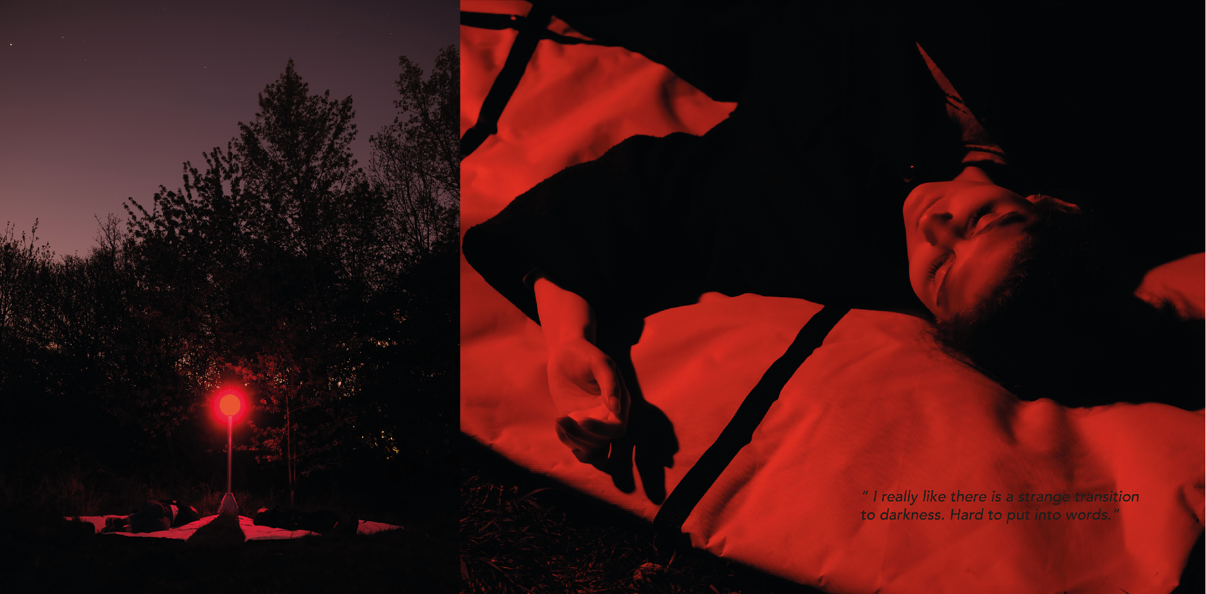
Figure 1 - Lember, Liina. (2021) In-visible Moths Spells [red light installation].
In Destabilised Common Grounds (see Figure 2), Nirit Binyamini uses a rug covered with moss colonies as an interactive and performative installation to invite people to reflect on how their actions impact the moss landscape (Niritbin.com, 2020). Audiences are invited to influence the climate of the moss environment in real-time by being given the option to spray the moss with water or to blow hot air over it. This takes place whilst a magnified view is projected on a large wall revealing the moss’s tiny stems and leaves movement, as they are being affected in response to the climatic conditions and stress. A second view through a red filter amplifies the mapping of the areas that are getting dried out due to the hot air. This action put participants in a dilemma, causing many of them to be reluctant to activate the hot air once they realised the stress it posed to the living organism.
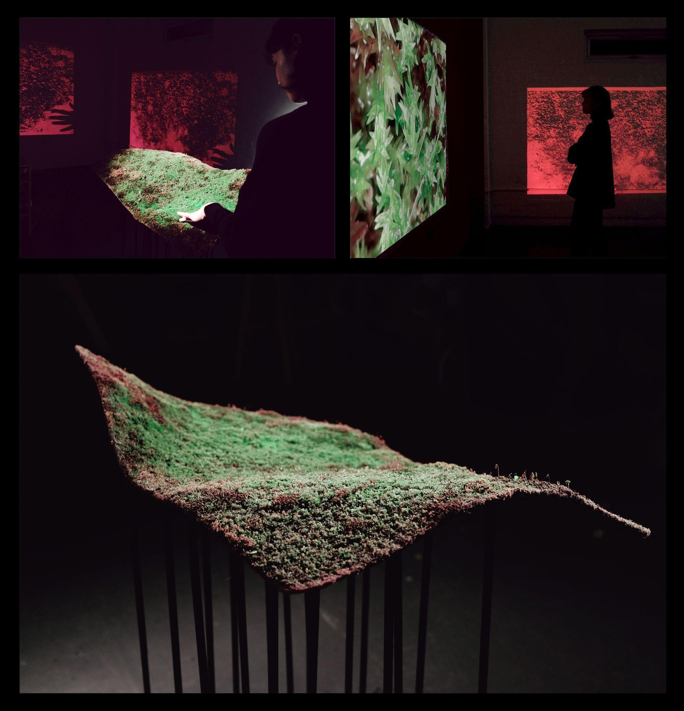
Figure 2 - Binyamini Ben-Meir, Nirit. (2021) Destabilised Common Grounds [participatory installation].
These examples show how experiential design allows for an exploration of relationships and entanglements with human and non-human entities, empowering audiences to scrutinise and question their roles in such environments. Drawing inspiration from Félix Guattari's “Three Ecologies” (Guattari, 2018), experiential design opens the door to addressing and instigating inquiries about:
“The Self (body and psyche): What sensations are we capable of experiencing? What observations can we make? What information can we gather?
The Collective: How do we acknowledge and interact with others?
- The Earth: How do we perceive the world and our environment? How do we interpret the information and interactions that occur?”
According to Guattari, these three ecologies are not isolated arenas for negotiation or potential reconstruction; rather, they function as interchangeable lenses through which reality can be perceived. They don’t function as distinct territories but are formed relationally and transversally. Experiential design, therefore, emerges as a dynamic vehicle for exploring and challenging our perspectives on self, society, and the environment within the framework of these interconnected ecologies.
Designers play a multifaceted role, wielding the power to shape both the experience of their audience and their own. In essence, they conduct experiments through their designs. Their responsibility extends to crafting the affordances of a space, which encompasses the dynamic interactions between organisms and their environment. As articulated by Gibson, “affordances are the offerings of the environment to the animal, providing opportunities for both benefit and detriment” (2014).
When a designer creates an environment or space, they inherently delineate its affordances, engaging in an ongoing process that requires curiosity, flexibility, and an acknowledgement of the necessity for trial and error. It's crucial to note that the designer doesn't possess absolute control over the trajectory of their creation. The designed space sets forth on a perpetual journey, gathering interactions and leaving imprints that are as consequential as its initial conception. The paramount objective revolves around fostering possibilities within a space, enabling individuals to re-evaluate their interactions or relationships with others from a renewed perspective.
Questions arise regarding what opportunities the space presents to its audiences. Can they draw closer to unfamiliar individuals? Can they alter their body positioning in unconventional ways? Can they engage with species previously unknown to them? Observing how people react under novel circumstances and the decisions they make afterwards becomes crucial in understanding the impact of the designed space. However, the most important aspect of the designer's role resides in understanding how the affordances of their work are perceived within a context rich in ecological significance. In echoing Gibson (2014), "Any substance, any surface, any layout has some affordance for benefit or injury to someone. Physics may be value-free, but ecology is not."
Through the lens of experiential design, we discover innovative methods to forge connections, perceive, and learn to coexist harmoniously with others within a shared space. This approach serves as a catalyst for reshaping habits, activities, and perspectives. Leveraging experiential design enables us to inclusively engage others who inhabit our space, granting them heightened presence, visibility, and agency to shape decisions while honouring their needs. By recognising and accommodating non-human entities such as animals, plants, fungi, insects, and microorganisms, we have the potential to cultivate a more inclusive and welcoming environment for humans and other communities alike. This fosters mutual respect and encourages the creation of shared spaces where diverse beings can thrive together.

Dialogue as Experiential Design: Lessons from two durational performances
Experiential design and dialogue as performance serve as potent instruments for cultural exploration, fostering environments where creativity thrives and meaningful connections are forged. However, this raises the question of how to design a dialogue or conversation, including its orientation, momentum, and relationship to space. While we traditionally consider physical settings such as rooms, kitchens, offices, buses, parks, lecture halls, government buildings, clubs, or classrooms, we can also contemplate the spatial sounds, movements of phonemes, vibrations, and gestures. The materiality and sociality of air, breath, mouth, tongue, body, hands, signs, smiles, utterances, noises, glances, blinks, walls, chairs, audience, fans, interviews, motions, walking, movements, meaning, value, reciprocity, names, commonalities, translation, biographies, lost futures, desire, apologies, requests for clarification, expressions of understanding, mutual comprehension. These endless facets of human interaction enrich the multifaceted landscape of dialogue and experiential design.
Within this context of human interaction lies a form of experiential design in which we all participate every day, whether consciously or unconsciously, intentionally or unintentionally, with purpose or by happenstance. If dialogue stands as the cornerstone of democratic ethos and pragmatics, if it serves as the linchpin of knowledge transmission, interpersonal relations encounters with difference and self-interrogation—spanning psyche, somatic and nervous systems—then the imperative to understand how to design for dialogue becomes paramount. This urgency extends to critical spatial dialogues. A thoughtful approach to designing the context for dialogue and conversation is exemplified by two projects emerging from the Fiction Feeling Frame (2020) research collective at the Royal College of Art: RELAY and Critical (Spatial) Dialogues (2023).

RELAY: A private conversation in public
RELAY was a durational performance held on July 15-16, 2021, curated by Thandi Loewenson, David Burns, and Adam Kaasa for the Venice Biennale of Architecture (labiennale.org), see Figure 3. This innovative project involved a 24-hour global conversation that chased the hour between noon and 1 pm across the planet, a remarkable act of transfer that transcended time and space. Participants held time and space for one another, passing ideas on continuously as the conversation moved across time zones while remaining firmly anchored in the present moment. The performance began in Venice at noon, with a two-person conversation. As one participant departed, another joined from a time zone further to the West, ensuring the conversation's continuity. This dynamic continued to unfold across the globe until the following day when it concluded in Venice at noon, completing its remarkable journey.
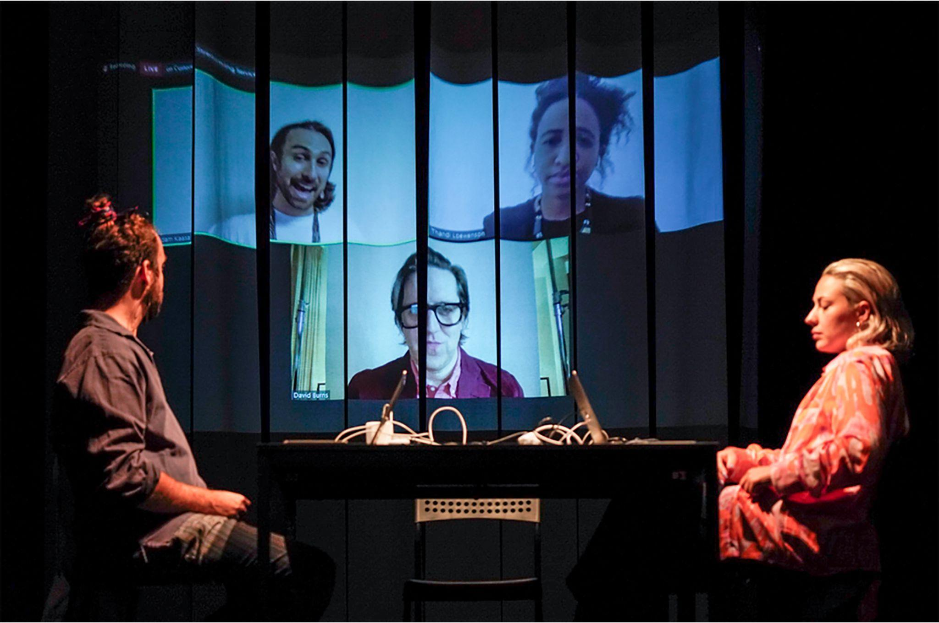
Figure 3 - Stage view of RELAY, 15-16 July 2021, The 17th International Architecture Exhibition at the Venice Biennale. Source: Fiction Feeling Frame, https://fff.industries/
RELAY was not initially conceived as part of the Biennale, and it was only possible because of the pandemic. It was a project born out of a collective's personal, pedagogical, and research crises surrounding the temporal and spatial challenges imposed by the pandemic. It was conceived in the paradoxical climate of hyperconnectivity and restricted mobility, and as such RELAY sought to explore how various mediums of communication have enabled close encounters, forms of gathering and displaced collectivism, in a time of quarantine and its varied registers of isolation and foreclosure. The performance was a direct response to the overarching questions posed by the Biennale: ‘How will we live together? How can we speak to one another? How can we speak together?’
ELAY drew inspiration from a lineage of art performance experiments, including Artangel’s Long Player Assembly (1999), the Serpentine Gallery marathons and the feminist performance work of Lois Weaver like ‘The Long Table’ (2014) Additionally, it was influenced by the collective voice of the Occupy Wall Street’s ‘people’s microphone’ (2011) the early television broadcast through the ill-fated Telstar 1 rocket, the history of the Semaphore, undersea telegraph cables of the 19th Century, and the broadband cables and satellites connecting the sea and the sky. During the performance, participants were encouraged not to present their work or talk about projects, discussions, pitches, or sales. Instead, they were invited to engage in conversation and dialogue with whomever they encountered. The performance was broadcast live from the stage at the Teatro Arsenale, see Figure 4, as well as from London and Nashville, Sydney and Accra at the African Futures Institute in Ghana, with whom a partnership was established.
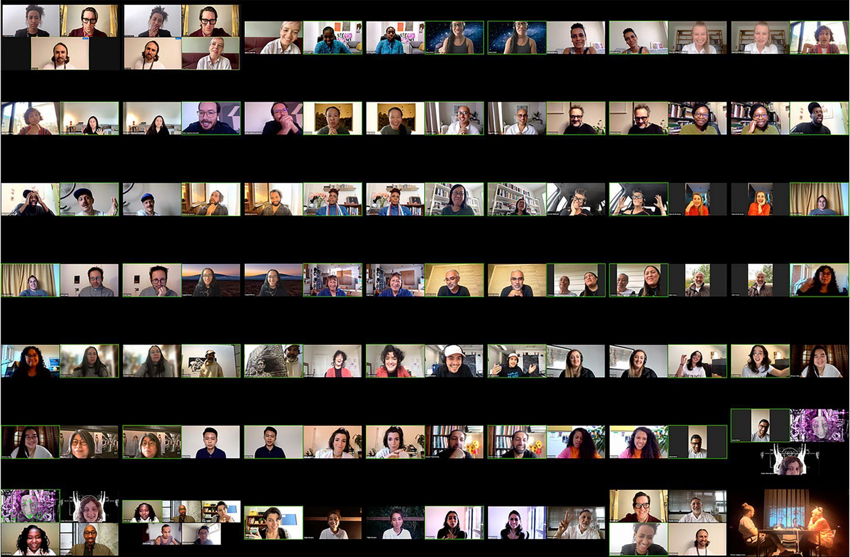
Figure. 4 - Timeline of screenshot of the relayed conversation, RELAY, 15-16 July 2021, The 17th International Architecture Exhibition at the Venice Biennale. Source: https://fff.industries/
Zoom was used for its ability to control speech while YouTube served as the platform for live broadcasting, leveraging its status as a prominent American media and technology giant. However, due to technological constraints, the ‘Zoom’ room only accommodated two people actively engaged in conversation and one person in silent observation—no additional guests were allowed. Therefore, the participants lacked visual cues of an audience, such as participant lists, a traditional theatre setting, or a foyer. Despite the global live broadcast accessible to everyone through a livestream, the collective familiarity and intimacy with Zoom, cultivated through various interactions ranging from work meetings to personal conversations over the previous year of the pandemic, created a sensation of solitude. It felt like a private conversation unfolding in a public setting, characterised by its intimacy, fluidity, challenges, allure, and poignant moments. Thus, reflecting the diverse range of emotions experienced during intimate encounters with kith and kin over the previous year.

Critical (Spatial) Dialogues
Critical (Spatial) Dialogues (2023) started as a Staff-Led Project catering for doctoral students in the London Arts and Humanities Partnership. Building upon the groundwork laid by RELAY (2021), this project extended its investigation into one-to-one dialogue and conversation, but with a novel twist: the introduction of objects into the space (see Figure 5). For example, chairs were strategically positioned to encourage or modify the dialogue dynamics by enabling movement and adjustment within the space. The project commenced with an in-depth discussion delving into various definitions of dialogue and exploring diverse methods of organising and designing experiential spaces to effectively facilitate these dialogues.
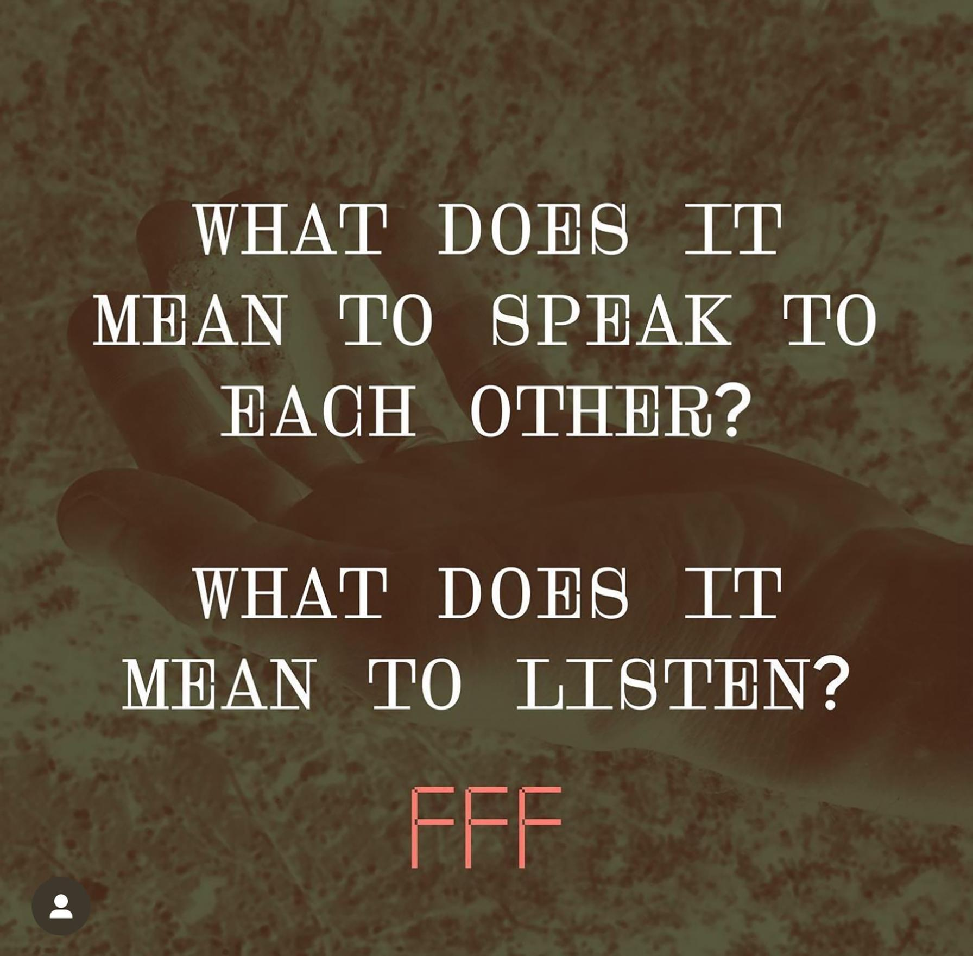
Figure. 5 - Promotional image from Critical (Spatial) Dialogues, 9-10 March 2023, Royal College of Art, London. Source: Fiction Feeling Frame, https://fff.industries/
The performance was designed for 15 students engaging in one-to-one 15-minute dialogues, spanning a duration of four hours. The performance space comprised a room equipped with two Zoom screens, simultaneously broadcasting and recording students participating in the 15-minute conversations. As each 15-minute session concluded, one participant departed while another joined, fostering a dynamic and evolving relational and spatial conversation over time.
Throughout the four-hour duration, the dialogue space underwent significant transformations facilitated by the two chairs and the spatial volume. Some dialogues unfolded with participants seated face-to-face, while others positioned themselves back-to-back. Some participants opted to relocate the chairs to the side and either sit or lie on the floor. Additionally, some individuals moved through the space, engaging in dialogue while walking, while others addressed the Zoom screen as if conversing with a large recording mirror.
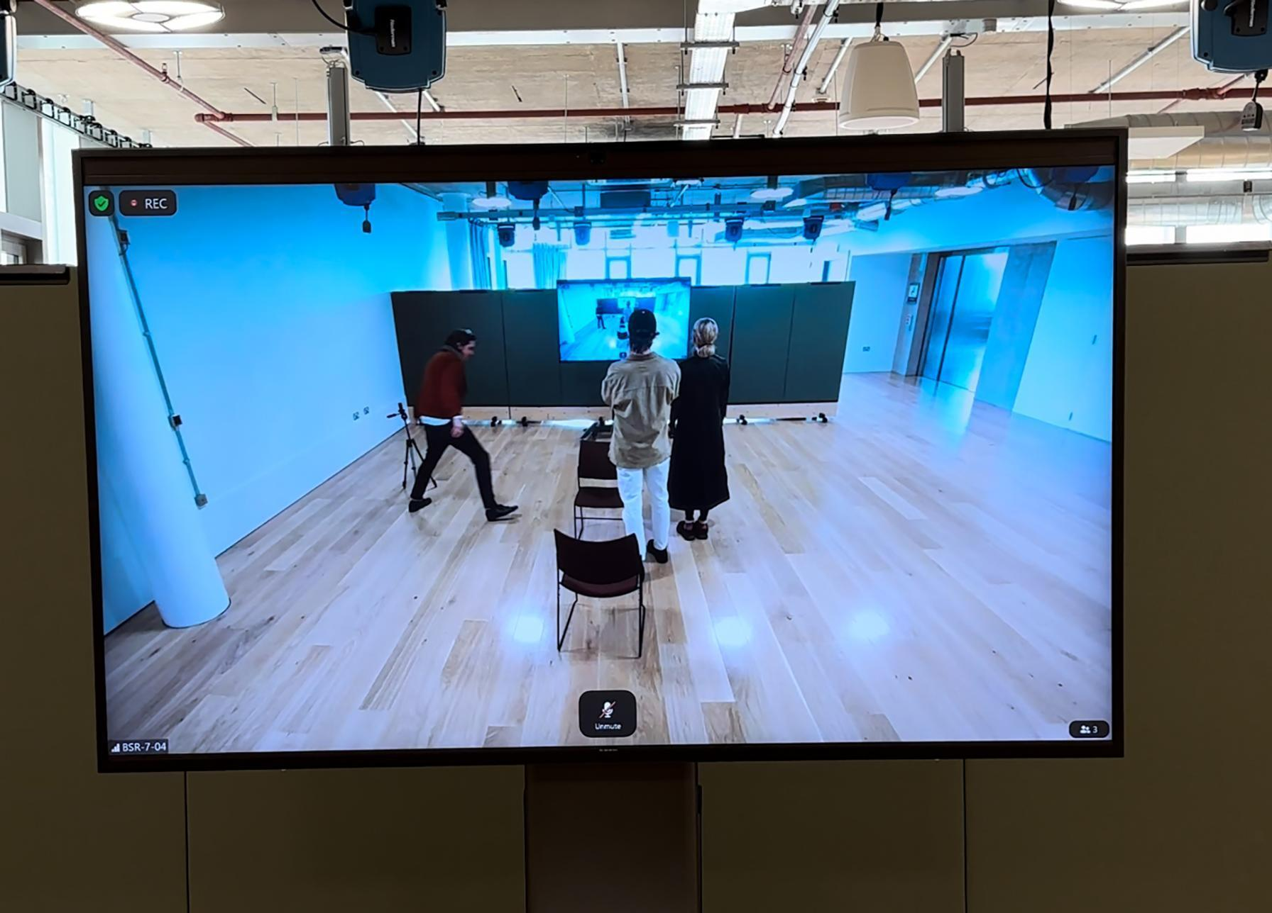
Figure. 6 - The dialogue stage from Critical (Spatial) Dialogues, 9-10 March 2023, Royal College of Art, London. Source: Fiction Feeling Frame, https://fff.industries/
Similar to the format of RELAY, there was no live audience physically present in the room. Instead, the audience experienced the performances from a lecture theatre at the Royal College of Art, where the entire set of conversations was live broadcasted. Critical (Spatial) Dialogues provided a unique opportunity to witness the interplay between performance and its invisible stage. Although the audience was not physically present in the dialogue space, there was a sense of intimacy and immediacy in watching and listening to the conversations unfold in real-time.
Across both RELAY and Critical (Spatial) Dialogues, the question of how to design a dialogue or conversation, including its orientation, momentum, and relationship to space, becomes central. Initiators of these projects found themselves grappling with the challenge of designing intimacy in dialogue among strangers or individuals who had only briefly met. This intimacy extended not only between the participants themselves but also with an audience removed from the live encounter. Consequently, designing experiential dialogue as performance intersected with ethical considerations regarding consent and the delineation between observation, voyeurism, spectatorship, and surveillance.
Furthermore, both projects involved the utilisation of various forms of technology, many of which were proprietary or owned by large private tech companies such as Zoom and YouTube. This technological aspect provides valuable insights into the dynamics of closeness and proximity, the language of performativity, and the concept of liveness as we contemplate how to design for dialogue in contemporary settings.

Spaces of Possibility: Challenging institutional stereotypes
Changing audience expectations, influenced by a desire for active participation, dialogue, and immersion, are compelling cultural organisations to reassess their presentation methods and redefine their approaches to branding and communication. This shift has given rise to innovative methods of cultural engagement aimed at meeting the demands of a hyper-connected and resourceful younger generation. This generation seeks bold, colourful, vibrant, dynamic, and sensorial experiences—a visual spectacle that breathes life into each encounter. They crave interactive learning and tactile experiences that foster genuine connections through active participation, education, and entertainment. As a result, cultural organisations are adapting their offerings to provide immersive and engaging experiences that resonate with contemporary audiences.
Experiential design can lead to profound personal development and learning, encouraging individuals to question, sparking curiosity and developing independent thinking. Most importantly, it has the potential to create change and propel innovation forward and can create spaces of possibility.

Indeed, despite the potential of experiential design, many cultural institutions remain entrenched in static structures. There is a pressing need for these institutions to evolve their power dynamics, shifting from authoritarian figures focused on knowledge dissemination to spaces that foster dialogue and shared expertise.
As a brand strategist for culture, Cecilia Martin has leveraged her expertise to collaborate with international design studios such as NB Studio in London, MoreSleep in Berlin, and Lava Design in Amsterdam. Together, they have worked to inject cutting-edge innovation into cultural institutions, driving transformative change. The following case studies showcase how branding strategies can be utilised to reframe cultural institutions as spaces of possibility. Through strategic branding initiatives, these institutions challenge stereotypes and cultivate transformative experiences, thereby embracing the evolving expectations of contemporary audiences and fostering a more inclusive and dynamic cultural landscape.

Challenge preconceptions
The Philharmonie Luxembourg, a prestigious concert hall celebrated for its iconic architecture and exceptional acoustics, has long been synonymous with classical music in Luxembourg. However, despite its architectural prominence, many were unaware of the diverse musical program and enchanting experiences offered within its walls.
In collaboration with NB Studio, a strategic rebranding initiative was undertaken to dismantle barriers to entry and capture the hearts and minds of a new generation of concertgoers. This transformative work focused on emphasising that the true essence of the Philharmonie Luxembourg (2023) brand lies in the immersive experience of live music (see Figure. 7). By highlighting this core value, the rebranding aimed to reposition the concert hall as a vibrant and inclusive cultural destination, inviting individuals from all walks of life to engage with and appreciate the diverse musical offerings available.
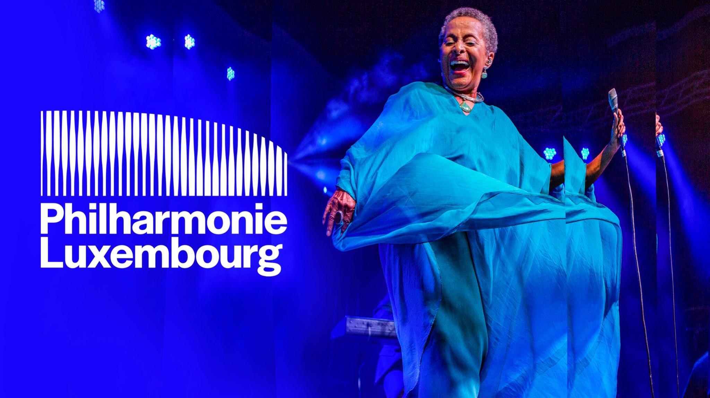
Figure. 7 - NB Studio (2023) Visual identity image.
The logo design by NB Studio for the Philharmonie Luxembourg draws inspiration from its distinctive architecture while transcending a mere replica of the static monument. In the redesigned logo, vertical columns pulsate in response to the rhythm of music, reflecting the diversity of live performances by dynamically changing shape in reaction to sound and music. To empower the Philharmonie to adapt the logo according to different musical genres, NB Studio collaborated with creative coder Patrik Hübner to develop a custom generative logo animation tool. Utilising JavaScript, WebGL, and Vue.js, this innovative tool generates audio-reactive wave patterns based on any sound input. This flexibility allows the logo to dynamically adapt to various musical genres, placing music at the core of the brand, whether it's electro, opera, jazz, or classical.
The vibrant and energetic colour palette employed in the rebranding of the Philharmonie Luxembourg serves to rejuvenate the perception of classical performances, infusing them with a contemporary feel. Concurrently with the launch of the new identity, a brand awareness campaign was initiated to promptly capture the attention of the target audience.
Through extensive research, it was discovered that the Philharmonie was primarily associated with classical music, a perception that was often viewed as elitist, intimidating, and boring. In response, the campaign provocatively challenged these associations by drawing parallels to the audience's everyday lives. For example, one campaign message stated, "Boring is a night on the sofa; shake up your calendar at the Philharmonie" (2023), see Figure 8 . By juxtaposing classical music with relatable experiences, the campaign aimed to disrupt stereotypes and encourage broader engagement with the diverse musical offerings of the Philharmonie.
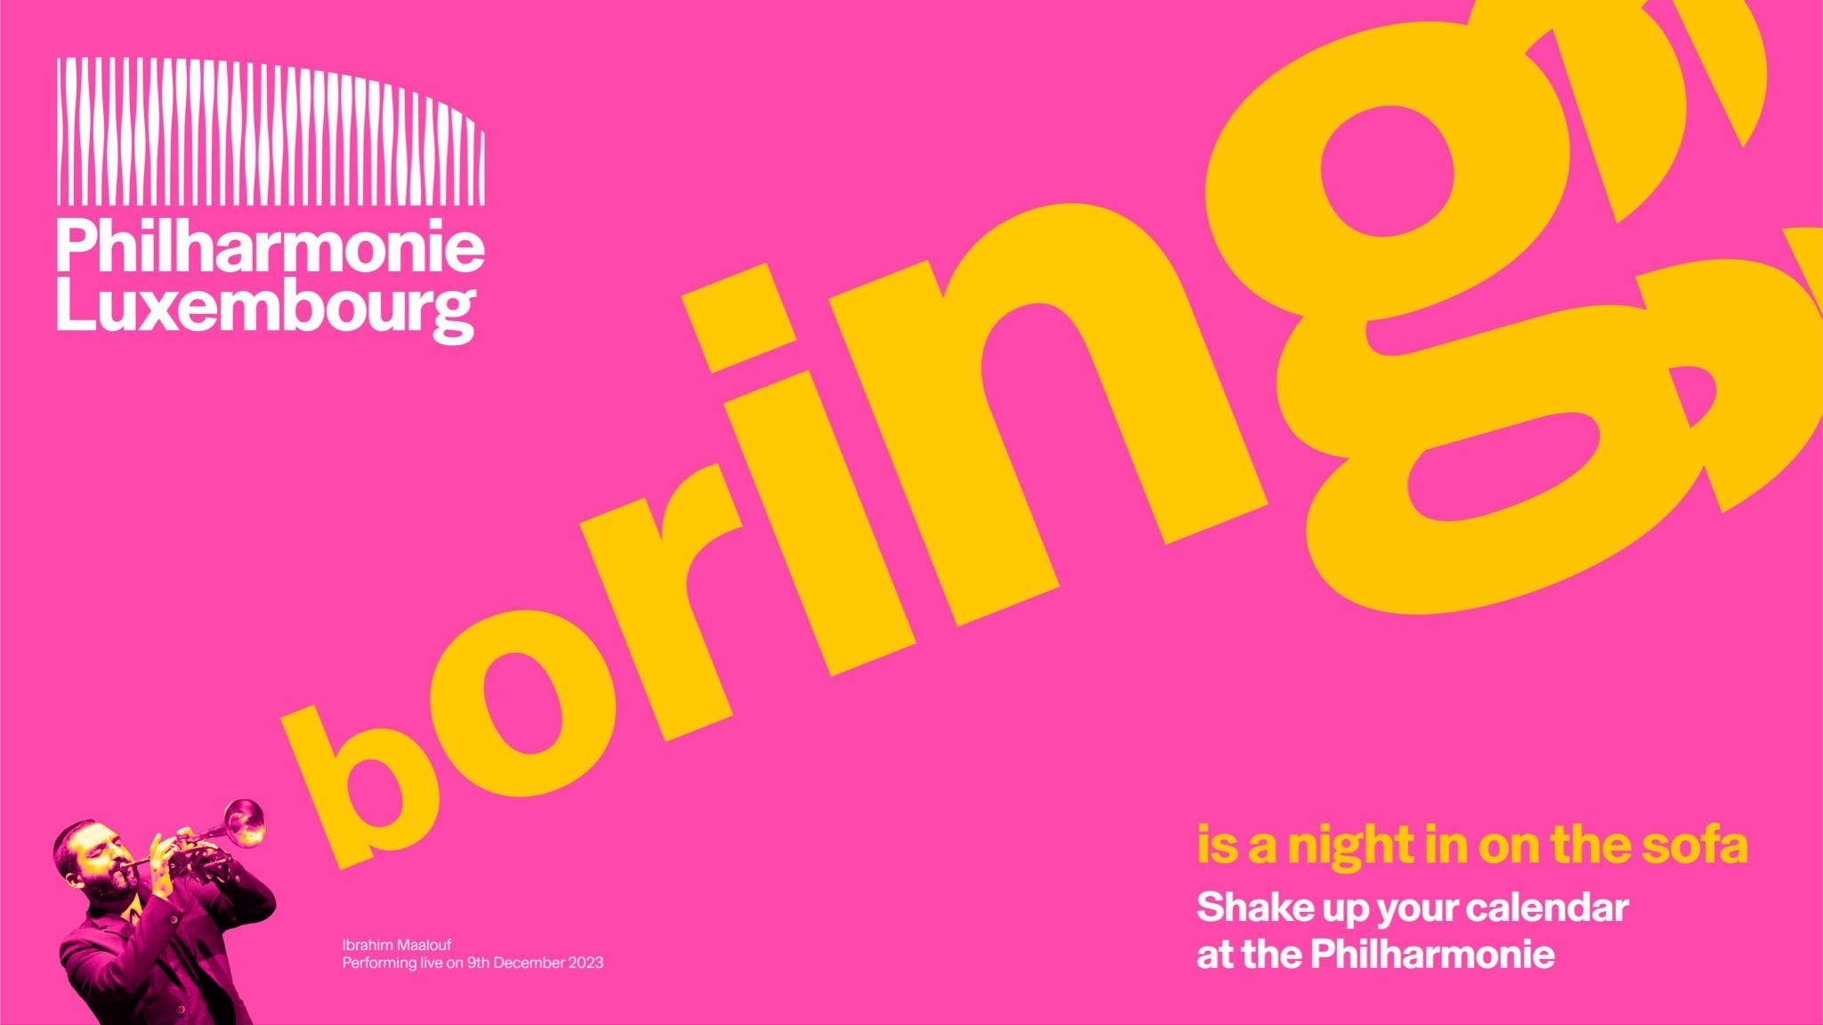
Figure. 8 - NB Studio (2023) Campaign image.

Become nomadic
LAS Art Foundation is a nomadic Berlin-based art foundation that collaborates with artists to create large-scale art experiences both online and offline. Positioned as a new type of arts organisation, LAS interrogates our present and gives form to future imaginaries. LAS’s mission involves delving into the possibilities of tomorrow through partnerships with visionary artists, thinkers, and institutions to pioneer groundbreaking projects and experiences. Collaborating with a diverse array of contributors, LAS explores topics ranging from artificial intelligence and quantum computing to ecology and biotechnology — illuminating the intersections between art, science and technology.
LAS's diverse programme comprises both newly commissioned and existing exhibitions and performances, as well as educational programming, publications and research projects. Curiosity drives LAS to continually reimagine the role of an arts organisation as one that shapes and evolves with their collective futures. However, visibility in each space occupied was crucial. Working with MoreSleep the aim was to develop their identity to reflect the experience they offer and reflect their approach: future-thinking, bold, flexible, and accessible. MoreSleep visual identity design (see Figure. 9) emphasised their empowering nature for artists by placing the artist’s work at the centre and adopting concise communication throughout their platforms to increase its presence. The result is a flexible system that places the art experience at the core, allowing for constant transformation.
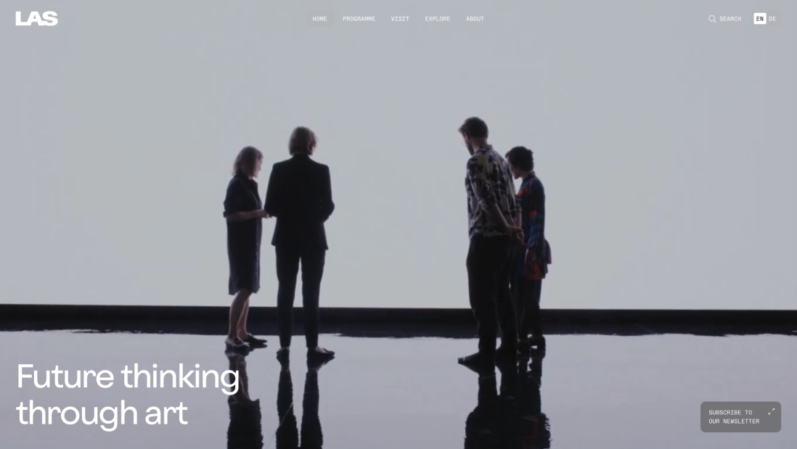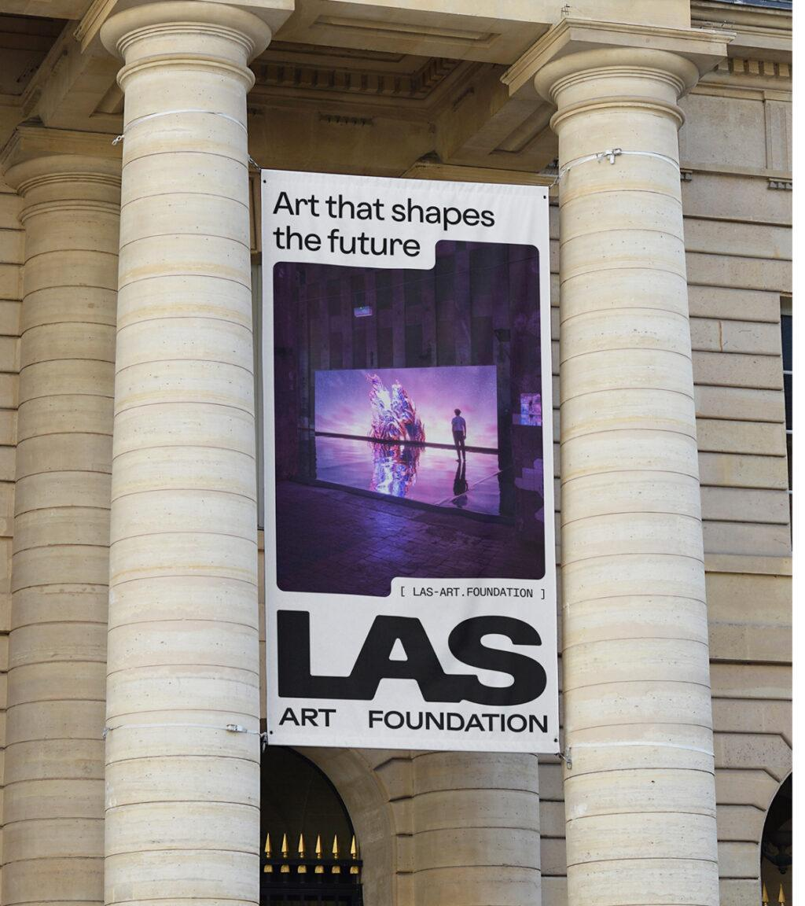
Figure. 9 - MoreSleep (2021) Visual identity design.

Renew perspectives
The Dutch National Museum of World Cultures (NMVW) was established in 2014 through the merger of the Tropenmuseum in Amsterdam, the Museum Volkenkunde in Leiden, the Afrika Museum in Berg en Dal, and the Wereldmuseum in Rotterdam. The NMVW's formation emerged amid public discussions in the Netherlands and other European nations concerning the colonial history of ethnographic collections. These discussions spurred calls for the restitution of African cultural heritage to various countries of origin, raising questions about identity, control, power, inequality, and decolonization. Facing the challenge of unifying four large ethnographic museums that explore world cultures under one brand, in collaboration with Lava Design in Amsterdam, a new brand strategy was developed to embody a renewed perspective on global citizenship, uniting unique individuals (see Figure. 10). The brand architecture established a family of sub-brands connected by unifying typography, allowing for one brand positioning across four distinct sites. Recognizing the significance of presenting diverse museums under a single visual umbrella, our approach prioritised respect and the celebration of global diversity, creating a museum family that embraces both difference and unity.
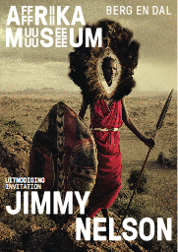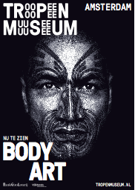
Figure. 10 - Lava Design (2014) Poster designs.
The visual identity designed by Lava Design establishes a connection between the individual and a community—a collective of global citizens framed around the concept of 'human stories from people to people.' Incorporating images of expressive faces and making eye contact was a crucial element of our visual identity, emphasising unique individuals engaging in cultural encounters with audiences. This approach aims to underscore the shared humanity among diverse individuals, transcending differences to recognise our commonality.
The creative use of typography develops a repetitive structure designed to overcome language barriers and offer a seamless experience for visitors across the four sites, showcasing the extensive cultural diversity that enriches the world. Lava Design team prioritised adaptability across diverse touchpoints, spanning from museum signage to online platforms, to guarantee a consistent and immersive visitor experience. The visual identity communicates that culture is a collective of individuals, each possessing unique characteristics, yet sharing a set of universal values and beliefs.
To conclude, to allow for institutions to be at pace with the constantly evolving nature of experiential design there is a need for a paradigm shift: to move from authoritarian cultural institutions to spaces of possibility where opportunities, innovation, and transformative experiences can unfold. This will be a space which allows institutions, designers and audiences to explore, research and experience the multiple and sensorial dimensions of culture. A space of possibility that will imply an approach that goes beyond traditional or rigid structures, allowing for multidimensional, interconnected, and decentralised experiences that bring culture closer to people’s lives.

Conclusion
In this paper, we have explored the dynamic field of experiential design, which continuously evolves in both practice and academia, exerting a significant influence on cultural context and institutions within this realm. Through an examination of relevant creative projects and initiatives, we have offered a concise overview of the ongoing transformations occurring within the current landscape of experiential design.
Through reflective analysis, we have identified three emerging considerations that serve as provocations for further research and experimentation. As evidenced by the case studies presented in this paper, experiential design presents an opportunity to cultivate spaces of dialogue through interactive and sensorial exchanges between designed experiences and audiences. These interactions hold the potential to foster novel and more inclusive dialogues.
Furthermore, we have revealed how creative practitioners are driving innovation and expanding the boundaries of experiential design. They do so by exploring interactions with other species, navigating the constraints and challenges imposed by the pandemic, and navigating bureaucratic systems. These insights highlight the multifaceted nature of experiential design and its capacity to adapt and innovate in response to evolving contexts and challenges.
Experiential design serves as a catalyst for change, challenging stereotypes by reshaping perceptions, sparking provocations, refreshing perspectives, and transcending traditional boundaries. By reaching out beyond the confines of the ivory tower, experiential design meets people where they are, fostering engagement and interaction.
Spaces created by experiential design offer realms of possibility where rigid artistic labels—such as painting, film, dance, or performance—begin to blur, allowing for a more fluid and adaptable approach to the art experience itself. This fluidity encourages a more open and flexible perspective, enabling individuals to explore and engage with art in innovative ways.
Understanding complex concepts requires the ability to interconnect and integrate disciplines through dialogue and shared experiences. Experiential design facilitates this interdisciplinary approach, providing platforms for dialogue and collaboration that bridge gaps between different fields of study and expertise. Through these shared experiences, individuals can gain deeper insights and develop a more holistic understanding of complex concepts.

Disclosure Statement
The authors confirm that all materials incorporated within this article are original and represent their own work. Furthermore, we confirm that the content has not been previously published, nor is it currently under consideration for publication elsewhere. Additionally, we declare that there are no potential conflicts of interest associated with this work.

References
Artangel (1999) Long Player Assembly. Available at: https://www.artangel.org.uk/project/longplayer/ (Accessed: 5 April 2024).
Buchanan, R. (1985) ‘Declaration by design: Rhetoric, argument, and demonstration, in design practice’. Design issues, pp.4-22.
Chen, Y. (2021) Plant Reality Set, Biodesign Exhibition [online]. Available at: https://biodesign.one/Plant-Reality-Set (Accessed: 11 November 2023).
Fiction Feeling Frame Collective (FFF). (2024). Critical (Spatial) Dialogues. https://fff.industries/csd/ (Accessed: 5 April 2024).
Fiction Feeling Frame Collective (FFF). (2024). Fiction Feeling Frame. https://fff.ind(2024)ustries/ (Accessed: 5 April 2024).
Fiction Feeling Frame Collective (FFF). (2024). Relay (2021). Available at: https://fff.industries/relay (Accessed 5 April 2024).
Gibson, J.J. (2014) The Theory of Affordances, in The People, Place, and Space Reader, pp. 56-60.
Guattari, F. (2014) The Three Ecologies. UK: Bloomsbury Publishing.
La Biennale di Venezia (2021) Relay. Available at: https://www.labiennale.org/en/agenda/meetings-architecture-relay-2 (Accessed: 05 April 2024).
Lember, L. (2021) In-Visible Moth Spells. MA Information Experience Design, Royal College of Art, London. Available at: https://liinalember.com/In-visible-Moth-Spells (Accessed: 11 November 2023).
Niritbin.com (2020) Destabilising Common Grounds — nirit+be. Available at: https://niritbin.com/Destabilising-Common-Grounds (Accessed: 9 Dec. 2023).
People’s Microphone. (2011). Occupy Wall Street. Available at: http://occupywallst.org/ (Accessed: 5 April 2024).
Marar, A. (2023). Philharmonie Luxembourg. Available at: https://bpando.org/2023/11/14/music-branding-philharmonie-luxembourg-nb-studio/ (Accessed 5 April 2024).
Rossman, J.R. and Duerden, M.D. (2019) Designing experiences. New York: Columbia University Press.
Split Britches. (n.d.) The Long Table (2014). Available at: https://www.split-britches.com/long-table (Accessed 5 April 2024).
Williams, N. (2019) ‘Practising post‐humanism in geographical research’. Transactions of the Institute of British Geographers, 44(4), pp. 637-643.

