**The Hero’s Journey (in HE) Continues:** **Applying the hero’s journey framework to curriculum planning and course design**

**Alke Gröppel-Wegenera and Robert Farmerb**

aHE consultant: Tactile Academia; bUniversity of Northampton

Corresponding author: [Robert.Farmer@northampton.ac.uk](mailto:Robert.Farmer@northampton.ac.uk)

# **Abstract**

Building on the ideas contained in Farmer's 'The Hero's Journey in Higher Education: A Twelve Stage Narrative Approach to the Design of Active, Student-Centred University Modules' (2019), this current paper takes the idea of using the twelve stages of the hero’s journey as a course design tool, and extends it by adding a series of diagnostic questions linked to the stages, the purpose of which is to develop Farmer’s (2019) theoretical ideas into a more practically-oriented toolkit for educators. In the same spirit, this current paper also includes thoughts from workshop participants who have begun to make use of the hero’s journey as a course design toolkit, drawing the tentative conclusion that, for some people at least, the idea provides a useful framework for course design.

**Keywords:** Active Learning; Learning Design; Hero’s Journey; Inclusive Curriculum; Narrative Framework; Teaching and Learning

# **Acknowledgements**

We would like to thank Amy Rose and Adam Watkins for producing the wonderful illustrations for us, and Megan De St Croix for taking the time to read and comment on an early draft of this article. Special thanks must also go to the staff at our institutions who joined us for workshops, participated with openness and enthusiasm, provided helpful and constructive comments on their experiences of using the hero’s journey as a course design framework/toolkit, and who gave permission for us to use their comments in this paper.

# **Introduction**

*As you set out for Ithaka*

*hope your road is a long one,*

*full of adventure, full of discovery* (Cavafy, 1992).

The purpose of this paper is to present recent developments of a paper previously published in Innovative Practice in Higher Education; ‘The Hero’s Journey in Higher Education: A Twelve Stage Narrative Approach to the Design of Active, Student-Centred University Modules’ (Farmer, 2019). In that paper, Farmer (2019) outlined a multi-stage approach to learning design within HE that was inspired by the narrative model of the hero’s journey as proposed by Campbell (1993) and further developed for the screenwriting context by Vogler (1998). While Farmer’s paper offered an interesting theoretical perspective on how one might design courses with a storytelling/narrative element in mind, one of its weaknesses was that it was limited in terms of the practical guidance it offered, as it was a largely theoretical endeavour based around an examination of the existing literature, along with the author’s own experiences designing and teaching HE units.

In this paper, the terms ‘course’ and ‘programme’ refer to a whole course or programme of studies, such as an undergraduate or postgraduate degree. The terms ‘module’ and ‘session’ refer to those self-contained parts of the course or programme which have defined learning outcomes and assessments, and which, collectively, comprise the programme of studies. We use ‘unit’ as a catch-all term for all these.

The authors of the current paper have sought to develop the ideas presented in Farmer (2019) into a more practically oriented toolkit for educators, which they have done by introducing a series of diagnostic questions closely aligned to each of the stages of the hero’s journey as conceptualised as an educational journey. The intention behind this is that the diagnostic questions being asked at each stage of the journey will act as prompts to assist anyone designing HE units, allowing them to more easily conceptualise how students may be feeling, where they may be, and what they might need at the various stages of the unit.

Presented below are some initial considerations of the importance of narrative, followed by the diagnostic questions aligned to the different stages of the hero’s journey. These questions, while they can be read in isolation, may make more sense when read alongside Farmer (2019). Following on from the diagnostic questions are some initial thoughts and findings from educators who have been introduced to the idea of the hero’s journey as a learning design tool at workshops run by the authors. While these initial findings are not intended to conclusively prove the validity of the idea, or to substitute for more in-depth research, they do suggest that for some educators at least the idea is compelling and of use. In sum then, what we provide here is offered in the spirit of simply letting anyone interested in the idea initially presented in Farmer (2019) know how we have developed it, and what some of the early responses have been to our developments. Additional detail, including the background and context to the idea, along with a literature review, and a theoretical working out of the idea, is available to view in Farmer (2019).

# **Part 1: Why Stories Matter**

The model presented in this paper offers a narrative-based alternative to teacher-centric, content-driven models of course/module design; replacing them with something more student-centred and which tries to take account of the multiple ways in which a cohort of students will experience their studies. The emphasis on narrative was chosen for two reasons; firstly, because of the central place that storytelling has for all human beings, and secondly, because of the stark similarities that exist between the underlying structure of heroic stories (i.e., the monomyth, or hero’s journey (see: Campbell, 1993; Vogler 1998)) and students’ educational journeys. As Mayes (2010. p.11) puts it, “Looking at teaching and learning as an archetypal Hero’s Journey is a good way of talking about education in its psychological and spiritual depths because the Hero’s Journey is fundamentally an educative one”.

Stories are, ultimately, an essential part of our lives, an integral part of what it means to be a person. Stories are simultaneously what makes us human and what makes us humane. Our own life story, our narrative identity, gives meaning and purpose to our lives:

Telling stories is as basic to human beings as eating. More so, in fact, for while food makes us live, stories are what make our lives worth living. They are what makes our condition human. … Every human existence is a life in search of a narrative. … existence is inherently storied. Life is pregnant with stories. It is a nascent plot in search of a midwife. (Kearney, 2002, pp.3, 129-30)

There’s simply no way to understand the human world without stories … Stories are everywhere. Stories are us. It’s story that makes us human. … Stories about people being heroic or villainous, and the emotions of joy and outrage they triggered, were crucial to human survival. We’re wired to enjoy them. (Storr, 2019, p.2)

But stories do not simply make us human, they are also what make us humane. An understanding that, just as we do, others possess life stories too is one of the things that makes us behave with compassion and with empathy, in that it makes us appreciate others as subjects also, and not merely as objects for our (mis)use in the pursuit of, or impediments standing in the way of, our own goals.

We make sense of the events that constitute our life through our narrative identity. A series of potentially disconnected facts coheres and is given meaning when told or understood as a story. Regarding our life, we might say that the story of our life *is* our life. We are natural storytellers, and as new events unfold, we incorporate them into our narratives.

We have, each of us, a life-story, an inner narrative — whose continuity, whose sense, is our lives. It might be said that each of us constructs and lives, a ‘narrative’, and that this narrative is us, our identities (Sacks, 1985, pp.116-7).

So, stories matter, and they matter in a number of different ways. Not only do they make us what and who we are, but they can humanise us (Hammond, 2019) and improve our well-being (Montgomery, 2019). And, importantly for education, stories can provide us with motivation, in the sense of a protagonist trying to restore a disrupted equilibrium (Todorov, 1971), for example, or via the involuntary arousal of curiosity upon the recognition of an information gap (Loewenstein, 1994, particularly the section entitled ‘Involuntary Curiosity’, p.91). How and to what extent university teachers might make use of narrative when engaged in designing courses and teaching their students was the original subject of Farmer (2019) and is extended here through the introduction of diagnostic questions. What we put forward in the current paper is a more practically oriented model, one where the teacher is asked to consider how to take the student through the twelve stages of the Hero’s Journey, and in doing so designing a unit, course, or module as initially suggested in Farmer (2019).

# **Part 2: The Stages of the Hero’s Journey & Diagnostic Questions Aligned to the Stages**

Presented below are the diagnostic questions aligned to the different stages of the hero’s journey. In order to assist readers not familiar with the hero’s journey, each of the twelve stages begins with a brief overview of the stage as it relates to a student’s educational journey.

## **Stage i) The hero is introduced in their Ordinary World**

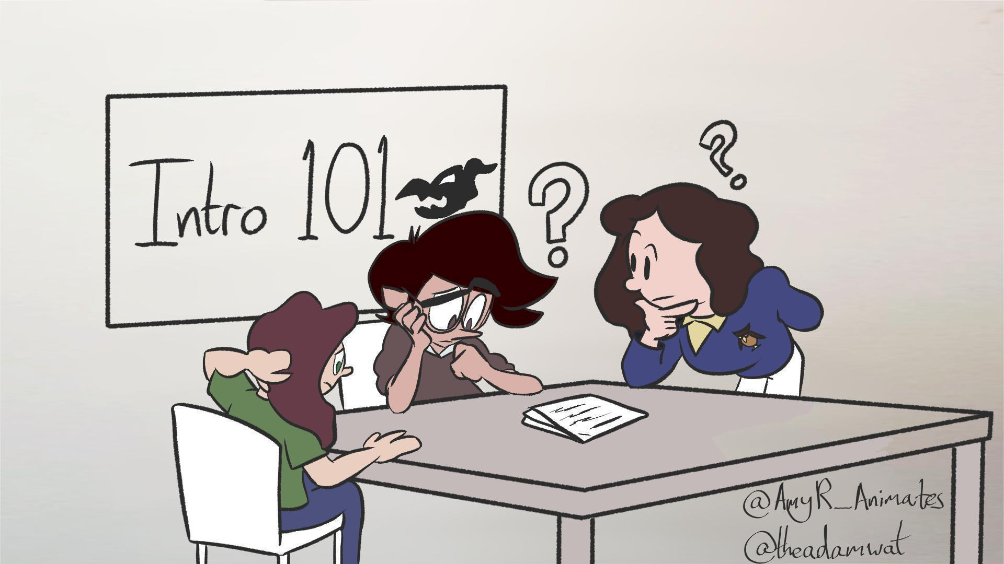

When considering the beginning of the educational journey, it is important to realise that while the world of academia might seem quite ordinary to the teacher, for our students it may be anything but. As Hubbard, et al. (2020, p.68), point out, “As academics we know the rules of the game and have internalised the values and conventions of HE. … [but what] seems obvious to us as teachers may be bewildering to our students.” For students, especially first year students and first generation students, academia might appear alien, full of unfamiliar customs, buildings, people, specialist terminology and jargon, and things they can’t do (yet). Students come from their own ordinary worlds, which differ from the teacher’s, and it is helpful to explore this to make explicit and become aware of the challenges that students face. It is, after all, much easier to support somebody on a journey if you know where they are coming from - what they are familiar with and what they are not, what they already bring with them and what you need to provide them with - so this stage is most usefully about getting to know one another. Importantly, this stage is also part of creating (or contributing to) a sense of belonging. Creating a sense of belonging is important and worthwhile as it can increase students’ motivation and enjoyment of their studies, encouraging them to develop more positive academic habits, leading to higher levels of achievement, improved retention and lower attrition rates. A sense of belonging may be particularly important for first year students and for first generation students (Pedler, Willis, and Nieuwoudt, 2021). Additionally, it may expose the hidden curriculum of HE. For more about the hidden curriculum and the problems it can cause for students entering HE, see Hubbard, et al. (2020). For strategies to mitigate the potentially pernicious effects of the hidden curriculum, see Hubbard, et al. (2020, pp.67-8), and Semper and Blasco (2018, pp.493-4).

This, therefore, is a supportive step in designing a unit which is inclusive: “Inclusive learning and teaching in higher education refers to the ways in which pedagogy, curricula and assessment are designed and delivered to engage students in learning that is meaningful, relevant and accessible to all.” (Hockings, 2010, p.1). All students will benefit from this, but students from groups that face unexplained attainment and progression gaps might benefit specifically because this stage can help in exposing and bridging these gaps.

### ***Diagnostic questions for stage i:***

* How well do you know the students at this point in their journey? Do you know their names? Do they know each other? If not, have you included icebreaking/getting to know you activities? How will you begin to foster a sense of belonging amongst your students?
* Is there information that students need to bring to this unit, such as from prerequisite modules? Have they been informed of this requirement?
* Do you know what the level of knowledge about the subject at hand is with the students, i.e., their learning incomes (Race, 2020, p.5)? Do you include activities to find out?
* Do you know the learning needs of your students? If not, how will you find out? (For example, do you know if any of your students have specific learning difficulties, mental health conditions (including anxiety), Autistic Spectrum Condition, physical difficulties, visual or hearing impairments, etc).
* Do you know which examples your students will be familiar with? Are you familiar with the same examples? If not, do the students have the opportunity to teach you about their examples? Do you need to put something in place to make sure they are familiar with your examples?
* If you feel that a student is not sufficiently up-to-speed, what can you do about this? How will you get them to a point where they can meaningfully engage with the unit?

## **Stage ii) The Call to Adventure**

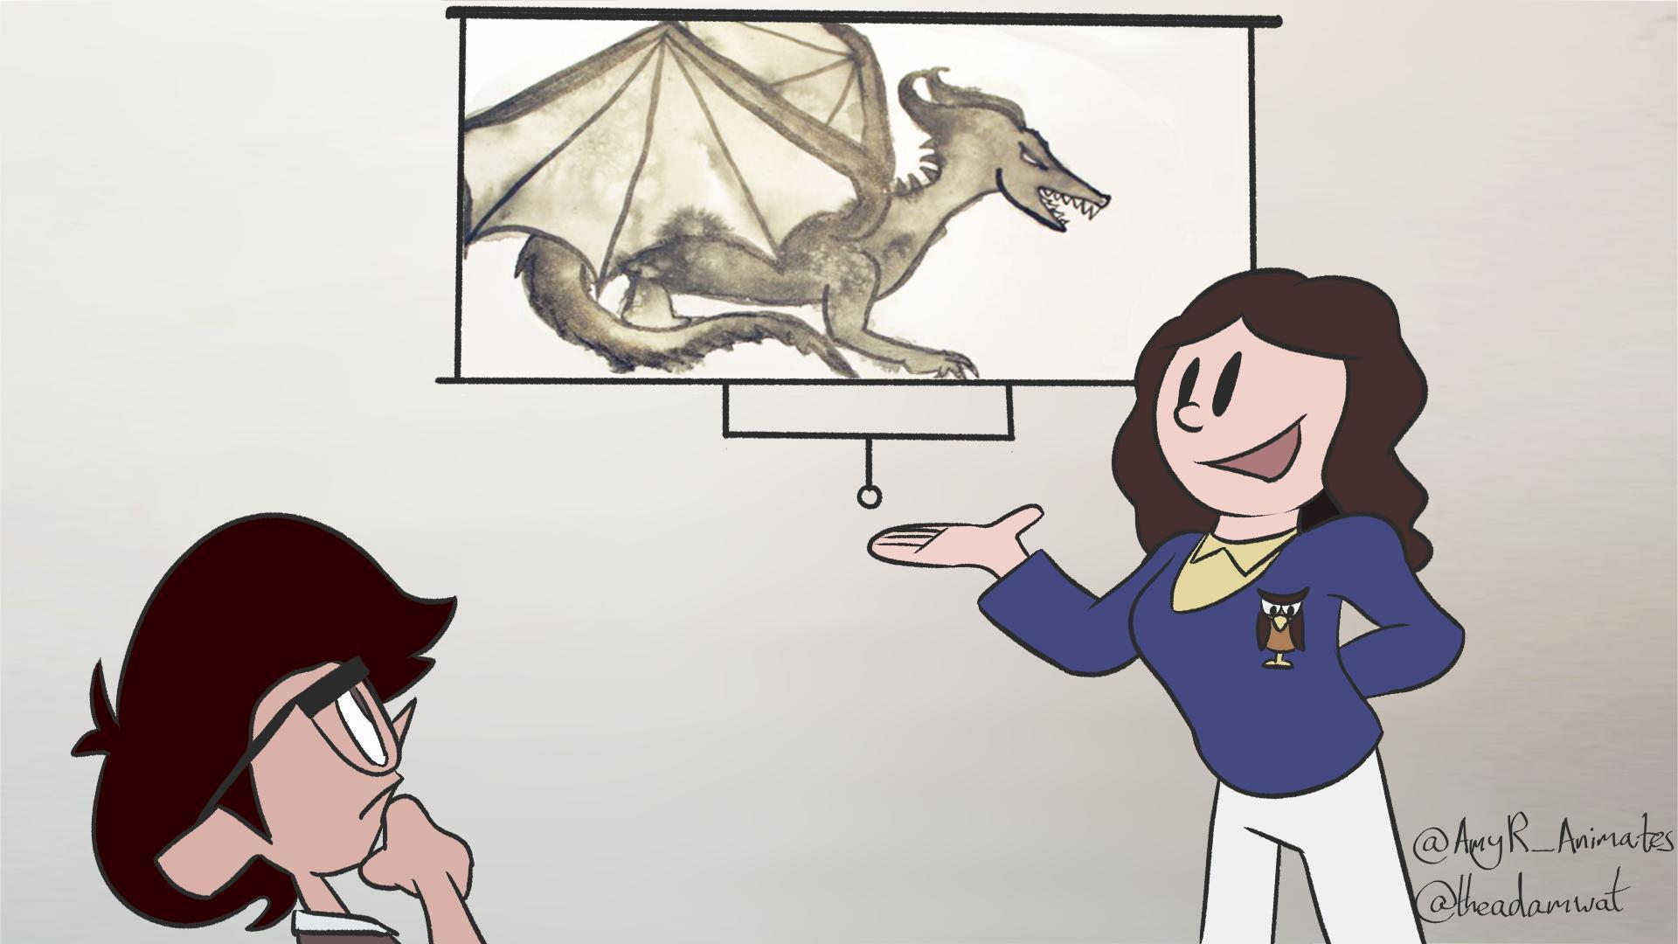

The call to adventure is the impetus to solve a problem or challenge - as described by Bain: “While methods vary, the best teachers often try to create what we have come to call a ‘natural critical learning environment.’ In that environment, people learn by confronting intriguing, beautiful, or important problems, authentic tasks that will challenge them to grapple with ideas, rethink their assumptions, and examine their mental models of reality.” (Bain, 2004, p.18). That is exactly what the unit presents. Understanding a new topic might be that challenge, making links between the new and the old, or maybe practising and mastering a new skill. Additionally, it is worth bearing in mind that for our students, the challenges they face may not be the ones they were expecting to face. Interestingly, Cameron and Rideout (2022, p.679) note that, “... many [first-year university students] were surprised by the nature of the challenges they experienced…they identified their real challenges in first year to be time management, effective studying and exam preparation, and the ability to motivate themselves.” Within HE the call to adventure is an introduction to the content, structure and aims of the unit in question - what we want the students to learn, how we are planning to teach them, what we expect of them, what the intended learning outcomes are and what form the assessment will take (if there is an assessment). This could already signpost potential problems (the dangers and pitfalls that the heroes might come across on their journey - see the next stage), but it should definitely focus on the positives, and how the adventure will be of benefit to the hero. As MacLean (quoted in Bain, 2004, p.39) explains: “On the first day of all my courses ... I devote some time to the promised ‘payoff,’ connecting course themes or required skills to issues or interest likely to be on their minds. Some people might find this crude; I don’t. Or rather, I don’t care if it is: we’re all too busy these days to show interest in something if we can’t see why it might matter.”

### ***Diagnostic questions for stage ii:***

* What will your students be able to *do* as a result of studying this unit with you? This strongly links in with the idea of ‘backwards’ design, i.e., the idea that, “We don’t start with content; we start with what students are expected to do with content” (Wiggins and McTighe, 2011, p.7).
* What are the core challenges/promises or measurable learning outcomes for this unit? For more about outcomes-based teaching and learning and about designing good intended learning outcomes, see Biggs, Tang, and Kennedy (2022, pp.111-127).
* What are the big/major/important questions that this unit will raise, and that this unit is designed to help students answer?
* How is the challenge/promise of the unit presented to the students? Do you clearly brief them on it, or is it somewhat hidden? If you choose to hide it, what is the reason for it?
* How are you setting expectations – do you clearly state what is expected of students? Do you start with a task that ‘talks the talk’? And if you do, do you explain to the student in retrospect?
* Does this unit contain tasks and/or assessments? If not, how will you know that your students are learning? Are these formative or summative? How do you explain to the students what they should be doing, how they get feedback on it and if and how it gets judged, and by whom?
* Do you explain or model the journey as a whole and explain how this unit fits into it?
* Do you explain your teaching philosophy, your approach to teaching, to your students? How do you ensure that your approach to teaching is inclusive?
* If you’re adopting a pedagogical strategy or approach to teaching with which students may be unfamiliar, how do you explain or ‘sell’ this to your students? (For example, challenge-based learning (Gallagher and Savage, 2023; Leijon, et al., 2022), problem-based learning (Savin-Baden, 2000; Barrett and Moore, 2010), peer instruction (Tullis and Goldstone, 2020), etc.)

## **Stage iii) The hero is reluctant at first (Refusal of the Call)**

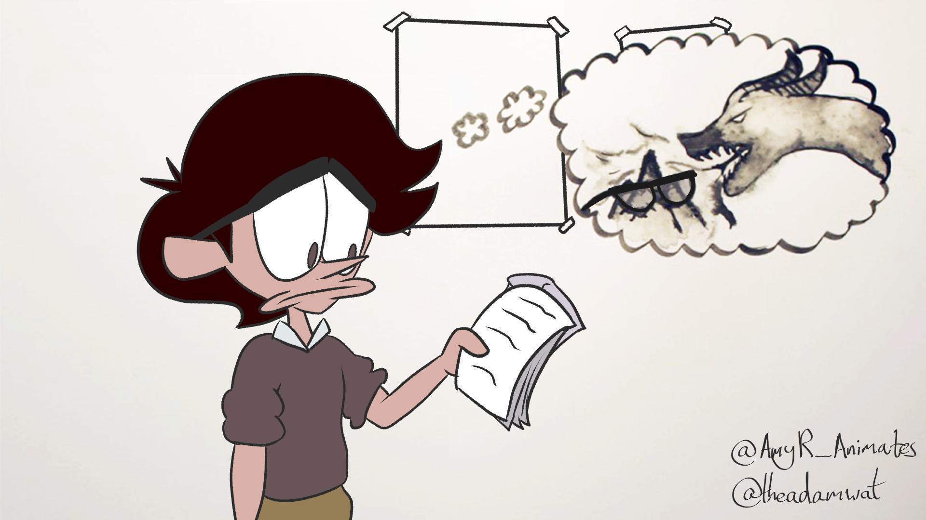

This is a threshold moment where we want students to ‘buy into’ the prospect before them and commit to the work linked to the unit they have been invited to. In practice this is a stage that is easily overlooked, because students are unlikely to openly refuse the call. But doubts or insecurities at this moment in time might lead to less engagement, so it is helpful to tackle them early. Being aware of this and opening the discussion by inviting them to voice their concerns and ask questions will allow the teacher to support the journey/adventure from the very beginning, rather than have to deal with an unmotivated adventurer later on.

### ***Diagnostic questions for stage iii:***

* How do you engage and motivate students to take part in the unit? Motivation requires that students believe that what is being studied in the unit is important, plus the belief that they are likely to successfully pass the unit (Bain, 2004; Biggs, Tang and Kennedy, 2022; Race, 2020).
* Why should students study this unit, other than they need the credits in order to complete the course? In what way is it an important, valuable or worthwhile experience? While some of the value may be in the form of more long-term extrinsic rewards (e.g., how it relates to their career aspirations), it is vital to consider and promote the inherent values or virtues of studying the unit.
* What questions or concerns might students have about beginning this unit? What have you learnt from previous iterations of the unit that can inform the design here? Could you, for example, prepare a list of FAQs for your students based on your past experience?
* Are there different levels of engagement, such as ‘lurkers’, people who mainly observe, or ‘shirkers’, people who avoid taking responsibilities within a group task? Is this appropriate? If not, how do you deal with this?

## **Stage iv) The hero is encouraged by the Wise Old Man or Woman (Meeting with the Mentor)**

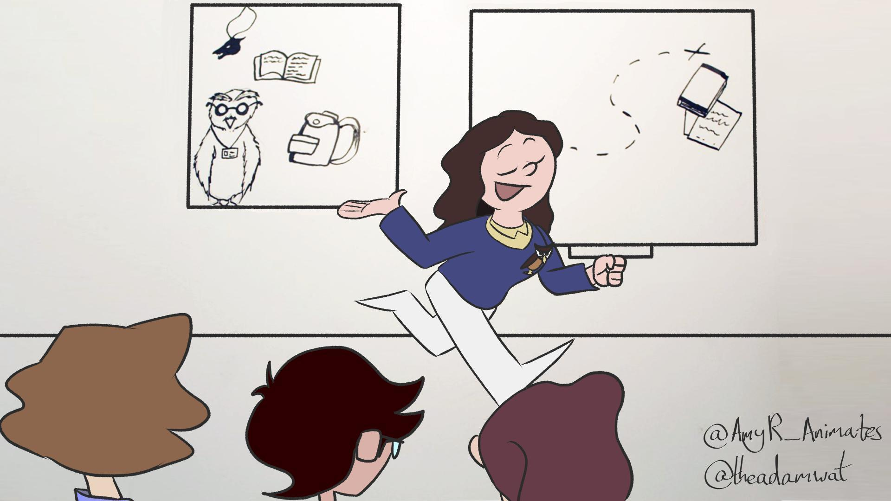

While the mentor figure might change during a learning journey (usually from teacher to peers), at the beginning of the unit the mentor is usually the teacher, which nicely aligns with the wise old man or woman who so often delivers the call to adventure. It can be helpful not to identify too strongly the role of the mentor with the person of the teacher, or convey the impression that the teacher always is the mentor, and that no one else can perform this role. The teacher may not always be a mentor, and mentors may be found in many people and places (including within oneself). Ultimately, the mentor can only accompany the students for part of their journey, and eventually the students will have to stand on their own and demonstrate understanding by themselves. While it is the students who must accept the challenge of education, rather than the teacher, who cannot force the students to learn, the mentor figure(s) is/are important as advisor, guide, supporter and somebody who encourages the student, especially in the early stages of their journey.

### ***Diagnostic questions for stage iv:***

* Who are the mentor figures that will support the students during their journey through this unit? Apart from you, who are the various mentors that students will have to support them during this unit? Could this be other students in the class? Or students from year(s) above? Peer mentors? Study groups? Textbooks, the VLE and other online resources? Other members of academic staff? Technical staff? Library staff? Learning developers/academic support staff? Learning technologists? Student support advisors, and staff who support students with learning difficulties, wellbeing, mental health, financial problems, etc? Here it can be helpful to think about all the things at the bottom of Maslow’s hierarchy (see Maslow, 1943) that need to be in place in order for a student to be in a position where they can learn.
* What can students reasonably expect from you, their teacher? And how can you manage their expectations?
* How can you avoid being overwhelmed by out of class requests for support? How can you create a learning environment in which students are less dependent on you, and more proactive in their learning?
* Do you plan to be the students’ mentor throughout the unit, or will you change role later on, to become, for example, a trickster (Davis and Weeden, 2009; Parks, 1996)? Or will you change role depending on the student, and what they can cope with?
* Are there any other mentors that might change roles? A particular technology, for example, might be considered a shape-shifter – sometimes being helpful, as with a mentor or ally, but at other times becoming a source of frustration, or a barrier.

## **Stage v) The hero passes the first threshold (Crossing the Threshold)**

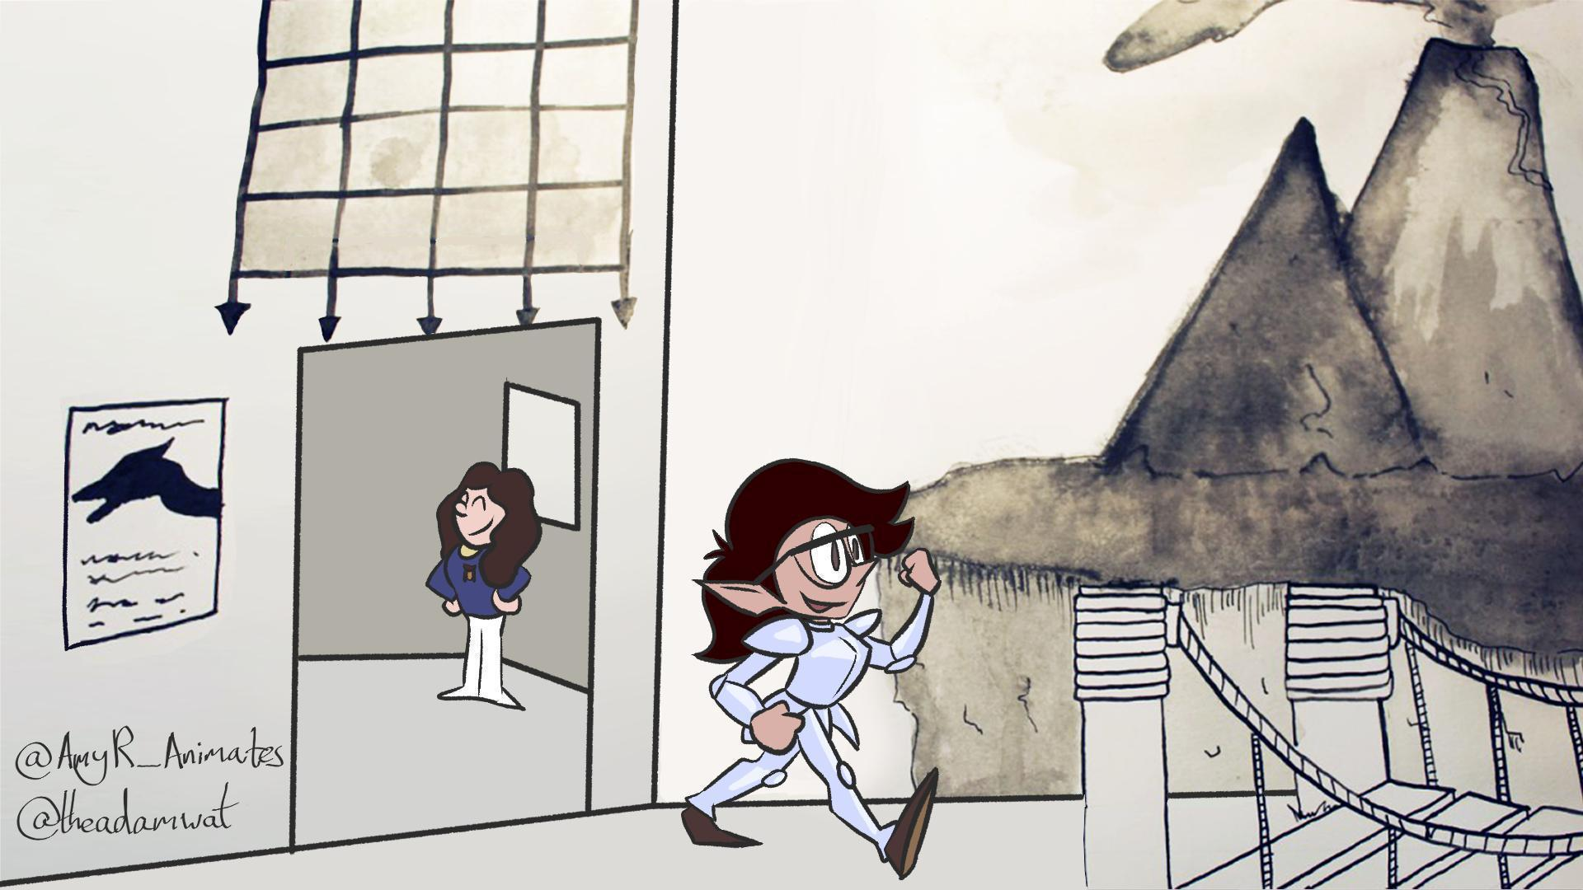

Another threshold moment, this time when the student/hero fully commits to the journey and enters the special world of academia and of the unit. Practically this is stipulated by university regulations - when is the latest point a student can enter or leave this unit? This is clearly a bigger deal if you consider a larger unit - the whole course, rather than a stand-alone session. We would argue that psychologically this is a critical threshold, which is crossed when introductory activities are over, teaching and learning activities begin, and the student/hero embarks on their adventure.

### ***Diagnostic questions for stage v:***

* What symbolic act begins the students’ journey? What activity will students complete in the first couple of weeks that will enable them to feel that, and for you to know that they have crossed the threshold into the special world?
* How will you know when students have ‘bought into’ the unit? When will they have put some skin in the game, so to speak? A quick, early win can help to build confidence, but also can help students to feel that they have invested something in the unit, so have something to lose by not continuing to take part in it.
* What role does the VLE play in the unit, and how can it be used to best effect? Do students understand the function of the VLE as you have designed it for this unit?
* Keep in mind that there might be other thresholds the students are crossing before they get to the unit. For example, a first-time university student might have already crossed the threshold of university accommodations and/or visited a Welcome Week or Freshers Fair. Are you aware of any thresholds like this? Is it possible to link your contents to those experiences?

## **Stage vi) The hero encounters tests and helpers (Tests, Allies, Enemies)**

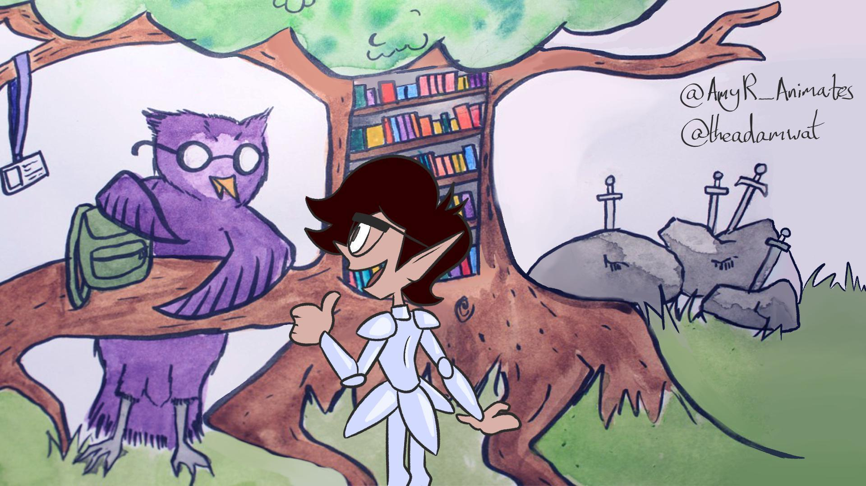

During their time in the special world, the students will encounter allies and enemies, people and other resources which can help or hinder their journey. It is important that students are able to identify these, whether they are members of teaching staff, other gatekeepers, fellow students or even simply technologies they might encounter. With this also come tests, like the need to process difficult theoretical ideas, the mastering of new and difficult skills or the understanding of crucial new threshold concepts (Cousin, 2015; Meyer and Land, 2006). These may take the forms of activities or problems designed by the teacher to challenge the students and encourage them to make use of their allies.

### ***Diagnostic questions for stage vi:***

* Who are the students’ various allies in this part of the unit? How will they find or encounter them? Will you devise activities in order to facilitate an encounter?
* What are likely to be the students’ enemies and challenges in this part of the unit? What knowledge, tools, skills and strategies will they need in order to overcome these enemies?
* In what way will the students be tested in this part of the unit? How will you know how their learning is progressing? More importantly perhaps, how will your students know how well they are progressing?
* Can you, and would you want to, create one or two ‘easy wins’ in order to build confidence and increase motivation?
* In what ways does this stage of the unit prepare your students for the tests that they will face in stage vii (approach to the inmost cave), and stage viii, the ordeal?

## **Stage vii) The hero reaches the innermost cave (Approach to the Inmost Cave)**

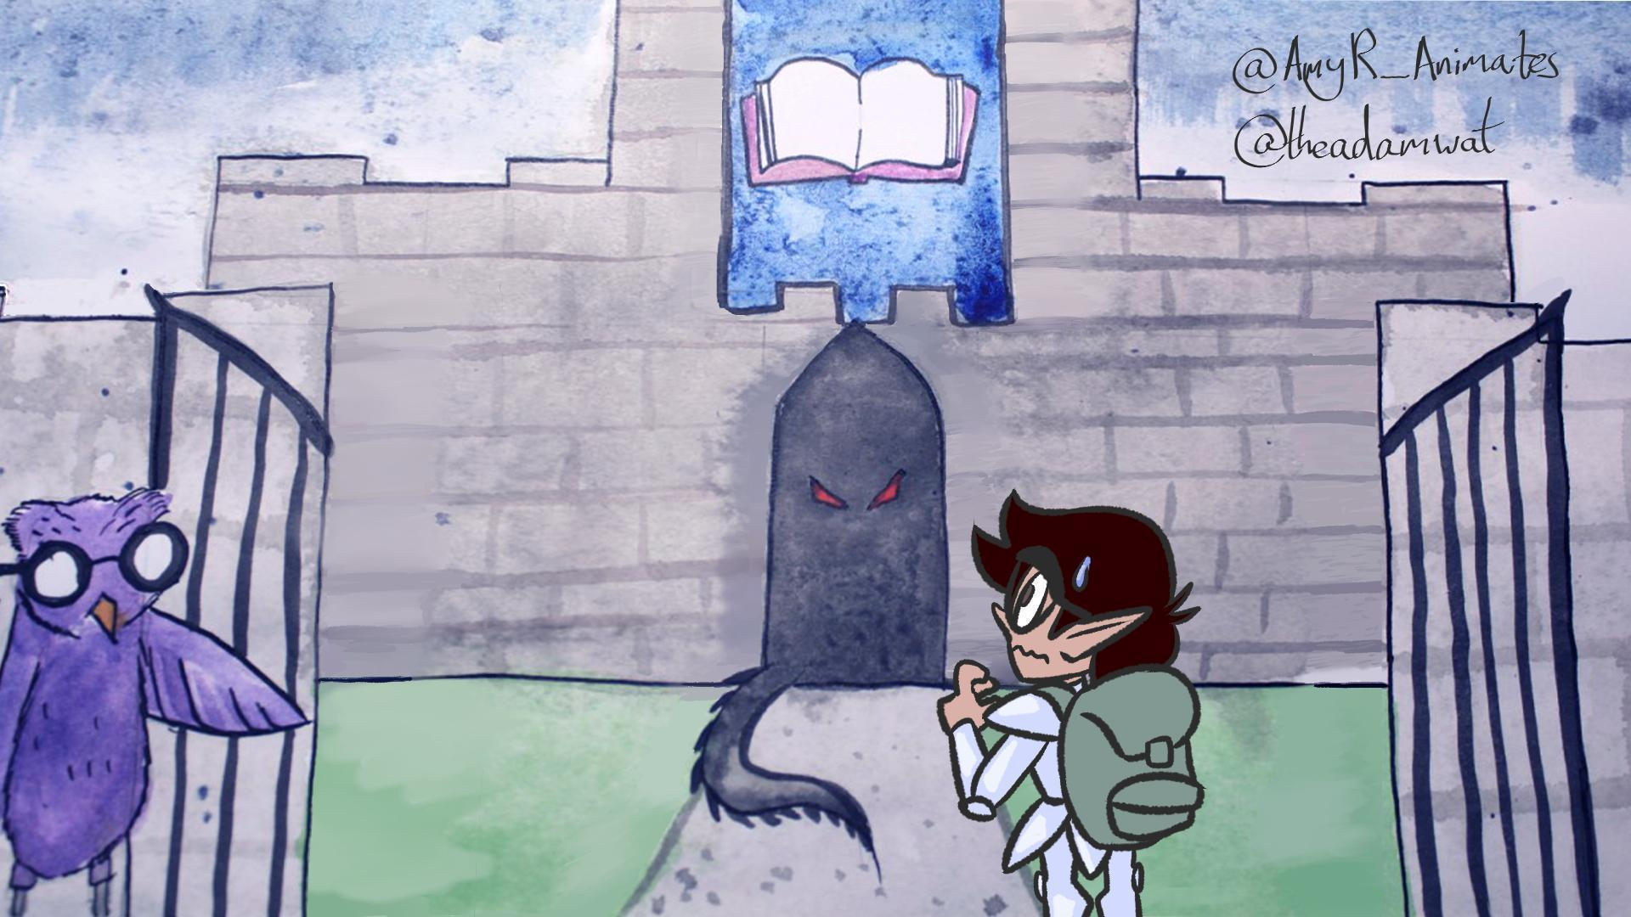

The inmost cave is where the object of the quest is hidden, so this stage could be seen as the time when the first major assessment is approaching. It is a time of support, where students need to be prepared and motivated for this big test (or ‘supreme ordeal’ as we will see in the next stage). They need to be ready to combine skills and knowledge previously acquired in order to apply them to their own work. And depending on the assignment, they are likely to have to face this on their own.

### ***Diagnostic questions for stage vii:***

* This stage is all about preparation for what comes after. What will the students need to do in order to be successful in the supreme ordeal? What knowledge will they need to have? What skills should they have developed? What tools will they need to use? What strategies will they need to adopt? – and how are you ensuring that the students are sufficiently prepared for this? What learning activities are in place to give them as good as possible a chance to be successful?
* Is there anything that is in place that will allow the students to get feedback and/or judge their own progress before they face the supreme ordeal? This could be a formative or summative assessment, the opportunity to sit a mock paper or the chance to submit a draft of an essay, for example.
* How much is this stage about combining skills and knowledge that students learned previously, but separately? How is it managed that students understand this process of collation, application and synthesis, about formative feedback and feedforward?

## **Stage viii) The hero endures the Supreme Ordeal**

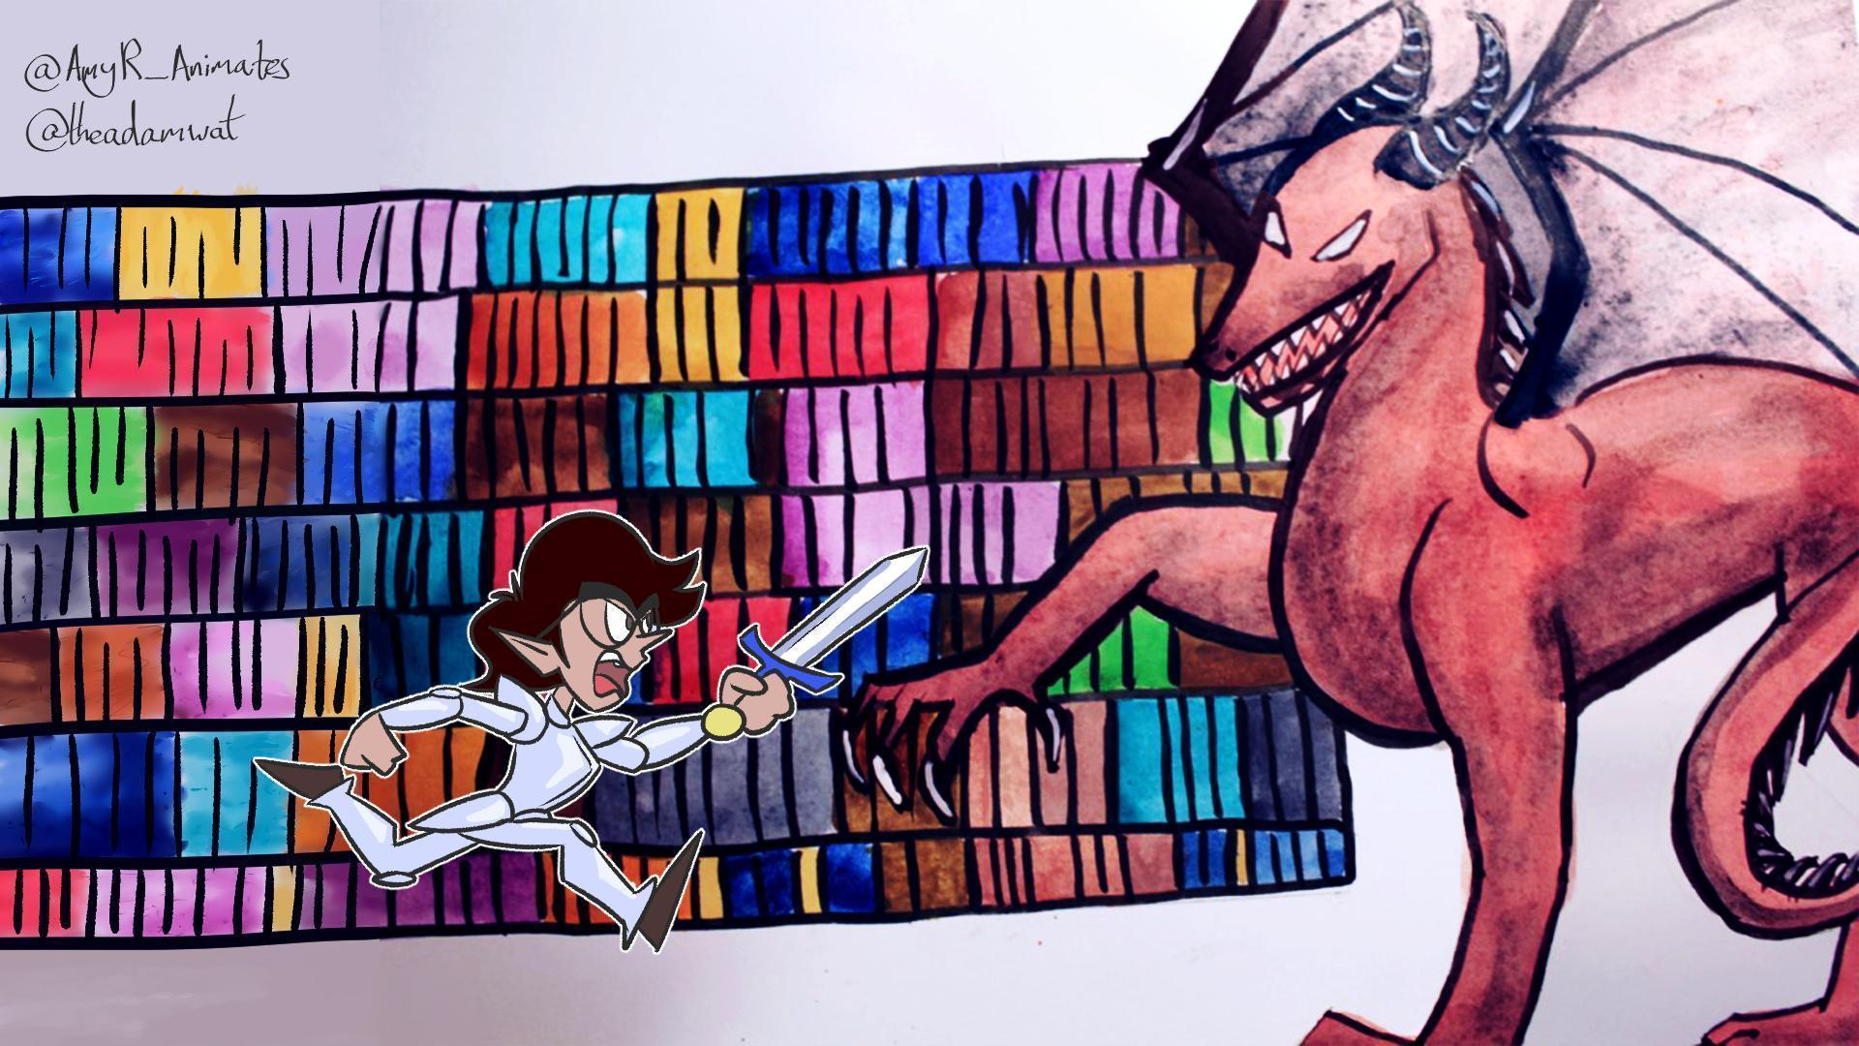

This is where the students face the supreme ordeal in the form of their assessments. In the hero’s journey the ordeal is usually the first major challenge that the hero faces (often alone, without their mentor for assistance). When designing an educational journey, stage viii is more likely to comprise a mid-unit summative assessment, with the bigger challenge of the unit coming towards the end of stage x (the road back). Hopefully such ordeals are not as dramatic as facing a monster, but it is important to realise that they can be a very emotional and overwhelming experience for many students - in particular, when they first experience them at the beginning of their learning journey, or when they enter a new and more difficult stage of their studies and expectations shift.

### ***Diagnostic questions for stage viii:***

* Why does the ordeal look like it does? What is its function within the learning journey?
* What will be the students’ reward for undertaking the supreme ordeal?
* What kind of skills, abilities and knowledge are being assessed during the ordeal? Is this the most appropriate way to assess them? (For a useful exploration of different assessment types, see Race (2020, pp.60-117).
* How will you ensure that the ordeal is sufficiently challenging for all of your students, without it being too easy for some, or excessively difficult or impossible for others?
* How does the assessment constructively align to the learning outcomes and to the teaching and learning activities that led up to it (Biggs, Tang and Kennedy, 2022)?
* What steps have you taken to ensure that your assessments are inclusive and do not exclude any of your students (Nieminen, 2024; Tai et al, 2023)?
* What role does artificial intelligence (AI) play in your assessment(s)? Do you teach, encourage and support appropriate use of AI? Do you ban the use of AI (and, if so, how does that work)? How easily can AI generate a passable or even a good response to your assessment? Do you need to redesign your assessment(s) to take account of AI? (N.B. Although questions about AI are relevant at the time of writing, these questions can be substituted over time for similar ones about the latest technological disruptors.)

## **Stage ix) The hero seizes the sword (Seizing the Sword, Reward)**

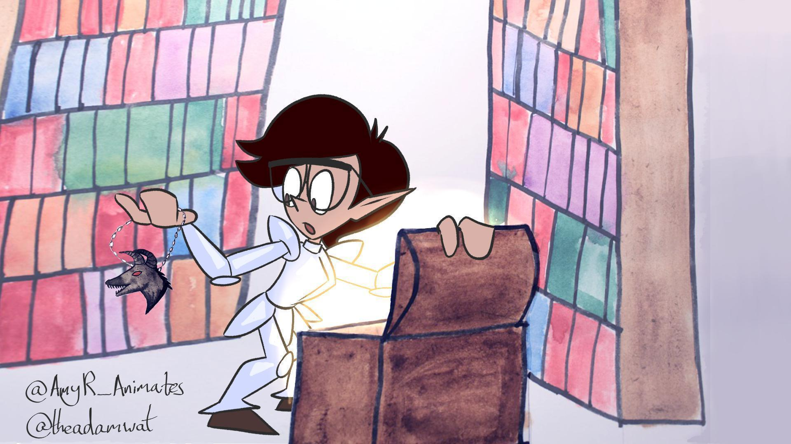

Once the ordeal is survived, students now get access to the treasure, having experienced a level of success/victory. While they might consider the treasure to be the grade they have achieved (or maybe just the pass), the actual treasure is the feedback and feedforward that they receive (either from the teacher or through self-reflection - ideally both) which they can carry forward to help them in future ordeals (Winstone and Carless, 2020).

### ***Diagnostic questions for stage ix:***

* What is the reward for successfully navigating the ordeal? What does success/victory look like?
* What happens to those students who are not successful?
* How do students get their results and feedback/feedforward?
* How can you ensure that both the successful and the unsuccessful students get feedback/feedforward quickly enough for it to be useful?
* Will they know what the grades mean? If not, how can this be included in the unit?
* How are you supporting the students in reading and understanding their feedback/feedforward?

## **Stage x) The Road Back**

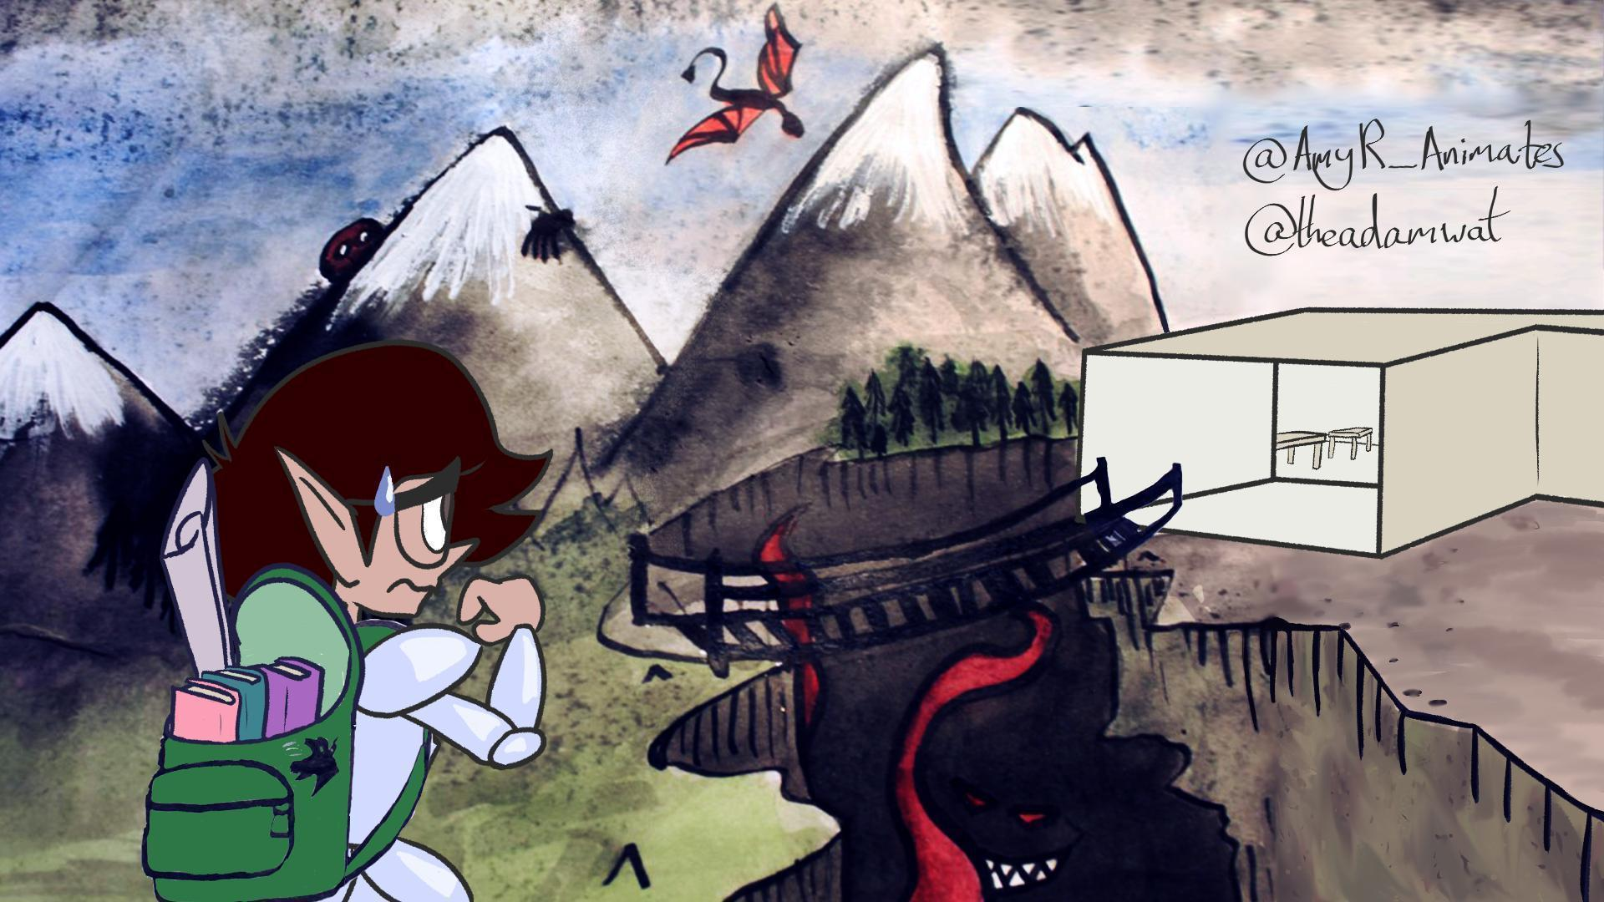

While it might seem that the journey is over, within storytelling the road back is actually the most difficult part of the hero’s journey, where often unexpected challenges come up. Within small learning units that is usually not the case. However, this stage could apply to further assessments and/or final exams when considering a longer learning journey, where the small tests on the way are designed to build skills and confidence for a larger, more complex test or task. For this it is crucial that the students have not just received feedback, but that they are capable of feeding this forward, of learning from it, and improving their behaviour towards assessments for the future.

### ***Diagnostic questions for stage x:***

* What (if any) measures are in place to see/test if students have understood the feedback they have received? Do they have to produce an action plan for future work, for example?
* Do the students realise that they are expected to apply the feedback they have received to future work? Is there a way you can encourage this to happen?

## **Stage xi) Resurrection**

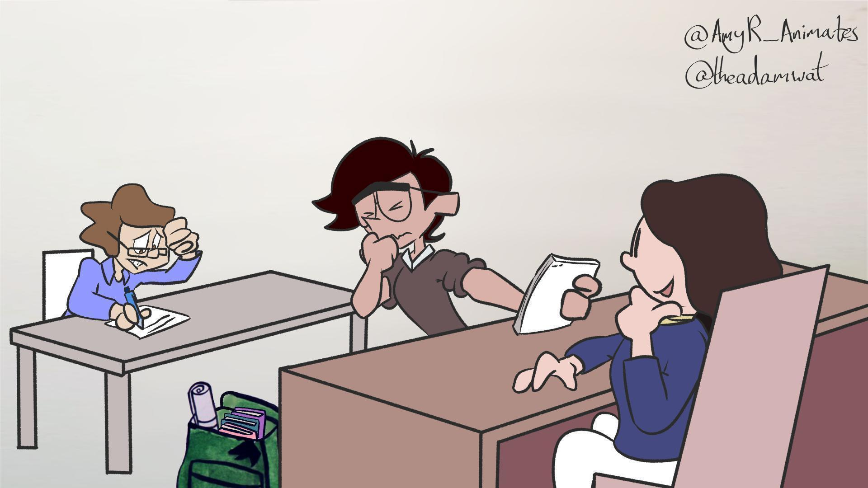

The students finish the unit and in a way leave it behind as if they are resurrected and born into a new life. They leave the special world and are transformed by what they have experienced. While the ordinary world they once came from and now return to has not changed itself, they can view it differently now, from a new perspective allowing them to notice more of its subtleties and complexity. This is the stage when the students can look back on the unit and consider the journey they have just completed.

### ***Diagnostic questions for stage xi:***

* How does the unit end for the students? Is the feedback process here different to feedback within the unit?
* Are there decisions to be made for future units, such as options to select? How is this handled? How much referring back to the recent learning journey is made?
* Are students guided through a reflection process, such as a review of the unit and reflection as part of an institutional Personal Development Planning (PDP) process?

This is also a good time for you to consider the feedback on the unit – is there a monitoring process in place? What does this include? As well as considering what your students thought about the unit, what did you make of it?

* What did you enjoy the most about teaching this unit?
* Why did the unit start where it did, and why did it develop and end in the way that it did?
* What are some of the things that your students did in this unit that impressed you the most?
* What have you learned about the subject from teaching this unit?
* What have you learned about teaching from teaching this unit?
* How will you run the unit differently next time as a result of your experiences?

## **Stage xii) Return with the Elixir**

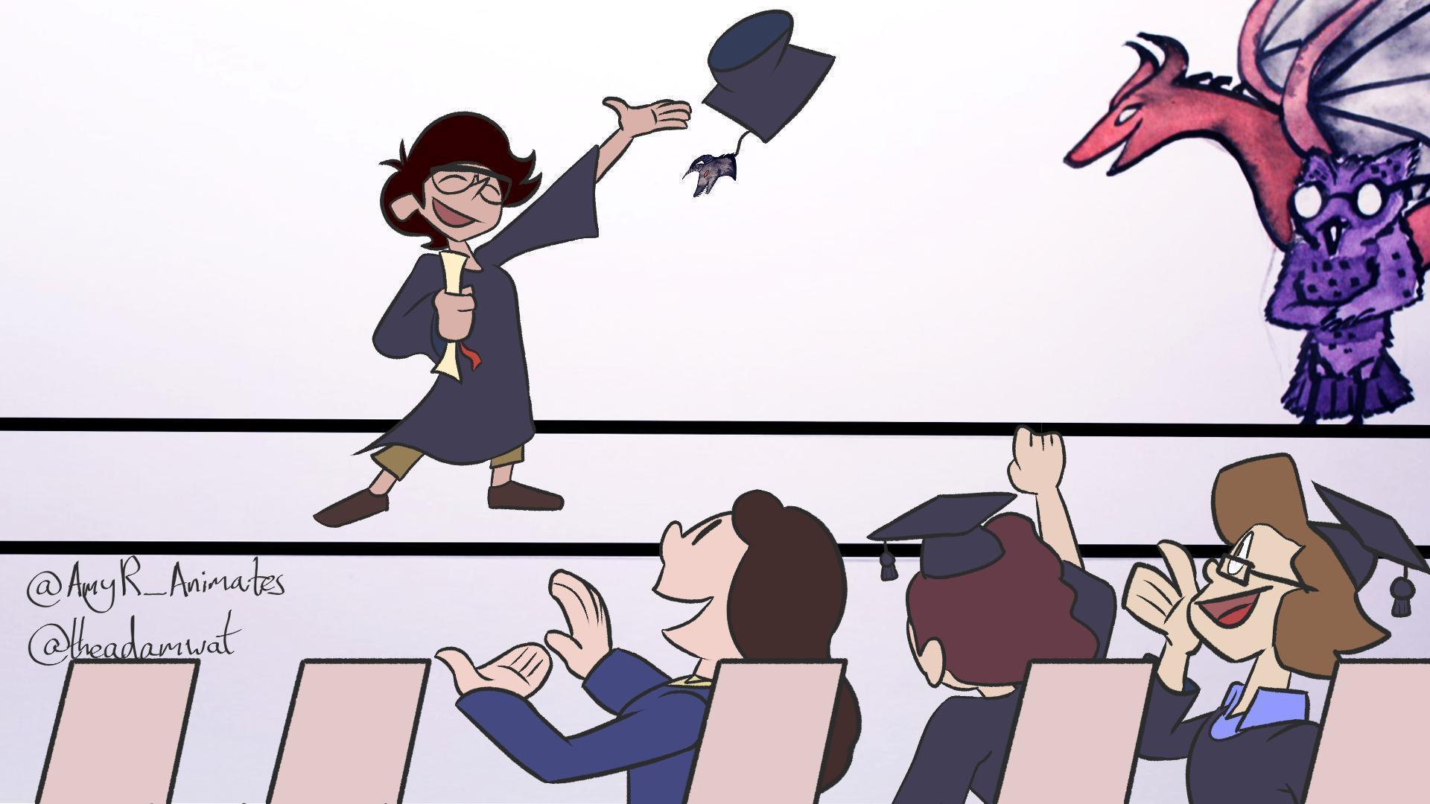

The hero does not just return to the ordinary world changed, they also bring something with them that has the potential to change this world. This final part of the journey does not only consider the unit that has just finished, but looks at the larger context – and this stage is most appropriate when a larger/longer learning journey is considered as ‘the unit’. It is really about the life beyond the learning, of applying it in ‘the real world’ outside of academia.

### ***Diagnostic questions for stage xii:***

Note that this stage might not be appropriate to consider for every unit, but rather for the end of longer learning journeys.

* How is the change/transfer from the special world (i.e., the educational context) to the ordinary world (i.e., the world outside of academia, or academia as a work place, rather than a place for further study) managed? Do students leave with a certificate/portfolio that is easily recognised? Have they been trained to explain their achievements to people outside of the ‘special’ world?
* Are the newly mastered abilities enough for the students to join the ordinary world with a new purpose? If not, do the current learning outcomes need to be re-thought?

# **Part 3: Initial Responses to the Hero’s Journey as a Learning Design Tool**

The paper by Farmer (2019) received positive comments for being an “excellent example of how the hero’s journey can be applied as a conceptual framework for module design” (Wilson, et al., 2022: 140). The authors of the current paper hope that their subsequent work on the hero’s journey in HE, developing the aforementioned conceptual framework into a more practical toolkit, will better enable educators to use this hero/storytelling/narrative model more easily when designing units of study. Particular strengths and features of the hero's journey toolkit are that it allows learning design to be approached from a course deficit (i.e., what’s wrong with my course?) rather than a student deficit (i.e., what’s wrong with my students?) approach, and that it is very flexible, in that it could be applied at various levels; from considering a student’s whole university experience from pre-application to alumnus, to designing multi-year course/programme level journeys from welcome or freshers’ week through to graduation, to working well as toolkit for courses/modules, or for lecturers or small teaching teams to use when designing a series of classes.

The authors of this paper have introduced educators (n=25) to earlier versions of this hero’s journey toolkit at workshops held at UK HEIs, and initial feedback from these workshops and from presentations run by the authors at conferences has, so far, been positive, and we are very grateful to those academics who have kindly given permission for us to use their comments in this paper, which included:

“I think this is a really great tool for helping people generate empathy with students.”

“I can see that framing a student's academic journey as a hero's journey could be motivating for them and stimulate a more thoughtful, engaged, and creative dialogue.”

“Succinctly put, I've never had so much fun teaching and preparing lessons.”

Such comments are, of course, only indicative, and it will require further research to find out to what extent the hero’s journey framework and the diagnostic questions provide a useful learning design toolkit.

Plans for the future include continuing to run workshops in order to get a better understanding of whether, how, and for whom the toolkit is useful, and a longitudinal study, following up with former workshop participants to better understand whether or not the toolkit has had any impact on their thinking or practice. Early indicators received from one educator approximately a year after attending a hero’s journey workshop have also been positive:

“I have found the hero’s journey a really helpful concept from your sessions. It has been helpful in empathising and working with the students to develop the module to ensure it best meets their needs. I often think about it when designing! I genuinely think it was one of the best courses I have been on since starting at [the University]”

To date, if workshop participants and attendees at conference presentations have not felt especially positive about the idea of the hero’s journey as a learning design toolkit, then they have been too polite or reserved to share those thoughts with us. One reason for this is perhaps that our workshop participants all signed up for the workshops voluntarily, and were, it would be fair to say, almost certainly well-disposed towards this novel approach to learning design from the outset. From our perspective this is not a problem as the hero’s journey is not being proposed as something that would appeal to all academics: rather, its intended audience is simply those staff who are open to exploring something new and, perhaps, a little unusual. And, in fact, some participants did offer the comment that while they enjoyed the hero’s journey workshop/toolkit, they felt that it was very ‘Marmite’, and would not appeal to all: a comment that we, the authors, very much agree with.

# **Concluding Thoughts**

The purpose of this paper has been twofold. Firstly, to build on the theoretical framework set up in Farmer (2019) by presenting a series of diagnostic questions aligned with the stages of the hero’s journey as applied to education. The intention being that the addition of the practically focused diagnostic questions will, when considered alongside the theoretical framework, create a toolkit which better enables designers of learning units in HE to make use of the hero’s journey to develop and structure student-centred learning journeys. The second purpose of this paper has been to present some of the thoughts from educators who have been introduced to the hero's journey and diagnostic questions at workshops run by the authors. The hope here is that by presenting some of these very early thoughts, it may suggest to the reader that this is a toolkit which is not entirely frivolous, and which has been at least of some use to those educators with whom we have enjoyed our journey. Of course, attendance at a workshop run by the authors is not at all necessary to understand how to use and apply the hero’s journey toolkit. Anyone who has read this paper and Farmer (2019) will have more than enough knowledge to be able to understand and make use of the toolkit, and to apply it however they feel best given their particular context, and the present authors would be very interested in hearing from anyone who takes this approach.

**Disclosure Statement:** The authors declare that the contents of the article

represent their own work. This article is not under consideration for publication

elsewhere, nor has it previously been published. There are no conflicts of

interest.

# **References**

Barrett, T. and Moore, S. (2010) *New approaches to problem-based learning: revitalising your practice in higher education.* Abingdon: Routledge.

Bain, K. (2004) *What the Best College Teachers Do.* London, Harvard: University Press.

Biggs, J., Tang, C. and Kennedy, G. (2022) *Teaching for Quality Learning at University, 5th Edition*. Maidenhead: Open University Press.

Cameron, R. B. and Rideout, C. A. (2022) ‘It’s been a challenge finding new ways to learn’: first-year students’ perceptions of adapting to learning in a university environment’, *Studies in Higher Education*, 47(3), pp.668-682. Doi: https://doi.org/10.1080/03075079.2020.1783525

Campbell, J. (1993) *The Hero with a Thousand Faces*. London: Fontana.

Cavafy, C.P. (1992) *Collected Poems - Revised Edition*. Princeton: Princeton University Press

Cousin, G. (2015) An introduction to threshold concepts. *Planet*, 17, pp.4-5. Doi: https://doi.org/10.11120/plan.2006.00170004

Davis, K. W. and Weeden, S. R. (2009) ‘Teacher as trickster on the learner’s journey’, *Journal of the Scholarship of Teaching and Learning*, 9(2), pp.70-81.

Farmer, R. (2019) ‘The Hero’s Journey in Higher Education: A Twelve Stage Narrative Approach to the Design of Active, Student-Centred University Modules’, *Innovative Practice in Higher Education*, 3(3), pp.1-21. Available from: https://journals.staffs.ac.uk/index.php/ipihe/article/view/62 [accessed 26 January 2025].

Gallagher, S. E. and Savage, T. (2023). ‘Challenge-based learning in higher education: an exploratory literature review’, *Teaching in Higher Education*, 28(6), pp. 1135–1157. Doi: https://doi.org/10.1080/13562517.2020.1863354

Hammond, C (2019) Does reading fiction make us better people? *BBC Future* [online]. Available from: https://www.bbc.com/future/article/20190523-does-reading-fiction-make-us-better-people [accessed 26 January 2025].

Hockings, C. (2010) *Inclusive learning and teaching in higher education: a synthesis of research.* York: Higher Education Academy/EvidenceNet.

Hubbard, K., Gawthorpe, P., Fallin, L. and Henri, D. (2020) ‘Addressing the hidden curriculum during transition to HE: the importance of empathy’, in Hinchcliffe, T. (ed.)*The Hidden Curriculum of Higher Education*. York: Advance HE, pp.59-76.

Kearney, R. (2002) *On Stories*. London: Routledge.

Leijon, M., Gudmundsson, P., Staaf, P. and Christersson, C. (2022) ‘Challenge based learning in higher education– A systematic literature review’, *Innovations in Education and Teaching International*, 59(5), pp.609–618. Doi: https://doi.org/10.1080/14703297.2021.1892503

Loewenstein, G. (1994) ‘The psychology of curiosity: A review and reinterpretation’, *Psychological Bulletin*, 116(1), pp.75–98.

Maslow, A. H. (1943) ‘A theory of human motivation’, *Psychological Review*, 50(4), 370–396.

Mayes, C. (2010) *The Archetypal Hero’s Journey in Teaching and Learning: A Study in Jungian Pedagogy*. Madison: Atwood Publishing.

Meyer, J. H. F. and Land, R. (eds.) (2006) *Overcoming Barriers to Student Understanding Threshold Concepts and Troublesome Knowledge*. Abingdon: Routledge.

Montgomery, H. (2019) Can reading really improve your mental health? *BBC Culture* [online]. Available from: https://www.bbc.com/culture/article/20190527-can-fiction-really-improve-your-mental-health [accessed 26 January 2025].

Nieminen, J. H. (2024) ‘Assessment for Inclusion: rethinking inclusive assessment in higher education’, *Teaching in Higher Education*, 29(4), pp.841-859. Doi: https://doi.org/10.1080/13562517.2021.2021395

Parks, J. G. (1996) ‘The teacher as bag lady’, *College Teaching*, 44(4), pp.132-6.

Pedler, M. L., Willis, R. and Nieuwoudt, J. E. (2021) ‘A sense of belonging at university: student retention, motivation and enjoyment’, *Journal of Further and Higher Education*, 46(3), pp.397–408. Doi: https://doi.org/10.1080/0309877X.2021.1955844

Race, P. (2020) *The Lecturer’s Toolkit: A practical guide to teaching, learning and assessment, 5th Edition.* Abingdon: Routledge.

Sacks, O. (1985) *The Man Who Mistook His Wife for a Hat*. London: Picador.

Savin-Baden, M, (2000) *Problem-based Learning in Higher Education: Untold Stories*. Buckingham: SRHE and Open University Press.

Semper, J. V. O. and Blasco, M. (2018) ‘Revealing the Hidden Curriculum in Higher Education’, *Studies in Philosophy and Education*, 37, pp.481-498. Doi: https://doi.org/10.1007/s11217-018-9608-5

Storr, W. (2019) *The Science of Storytelling*. London: William Collins.

Tai, J., Ajjawi, R., Bearman, M., Boud, D., Dawson, P. and de St Jorre, T. J. (2023) ‘Assessment for inclusion: rethinking contemporary strategies in assessment design’, *Higher Education Research & Development*, 42(2), pp.483-497. Doi: https://doi.org/10.1080/07294360.2022.2057451

Todorov, T. (1971) ‘The 2 Principles of Narrative’, *Diacritics*, 1(1), pp. 37-44.

Tullis, J. G. and Goldstone, R. L. (2020) ‘Why does peer instruction benefit student learning?’, *Cognitive Research: Principles and Implications*, 5(15), pp.1-12. Doi: https://doi.org/10.1186/s41235-020-00218-5

Vogler, C. (1998) *The Writer’s Journey*, 2nd Edition. Studio City: Michael Wiese.

Wiggins, G. and McTighe, J. (2011) *The Understanding by Design Guide to Creating High-Quality Units*. Alexandria: Association for Supervision & Curriculum Development.

Wilson, C., Knight, G., Leadbeater, W., Shephard, N., Shokr, H., Taylor, J., Vettraino, E., Warren, A. and Higson, H. (2022) *Curriculum design for mental health and wellbeing: guidance and resources for learning and teaching development programmes in higher education.* York, Advance HE.

Winstone, N. and Carless, D. (2020) *Designing Effective Feedback Processes in Higher Education: A Learning-Focused Approach*. Abingdon: Routledge.

# **Appendix**

Presented below for quick reference are the diagnostic questions on their own, without the images, introductory paragraphs, or references.

**Diagnostic questions for stage i): The hero is introduced in their Ordinary World**

* How well do you know the students at this point in their journey? Do you know their names? Do they know each other? If not, have you included icebreaking/getting to know you activities? How will you begin to foster a sense of belonging amongst your students?
* Is there information that students need to bring to this unit, such as from prerequisite modules? Have they been informed of this requirement?
* Do you know what the level of knowledge about the subject at hand is with the students, i.e., their learning incomes? Do you include activities to find out?
* Do you know the learning needs of your students? If not, how will you find out? (For example, do you know if any of your students have specific learning difficulties, mental health conditions (including anxiety), Autistic Spectrum Condition, physical difficulties, visual or hearing impairments, etc).
* Do you know which examples your students will be familiar with? Are you familiar with the same examples? If not, do the students have the opportunity to teach you about their examples? Do you need to put something in place to make sure they are familiar with your examples?
* If you feel that a student is not sufficiently up-to-speed, what can you do about this? How will you get them to a point where they can meaningfully engage with the unit?

**Diagnostic questions for stage ii): The Call to Adventure**

* What will your students be able to *do* as a result of studying this unit with you?
* What are the core challenges/promises or measurable learning outcomes for this unit?
* What are the big/major/important questions that this unit will raise, and that this unit is designed to help students answer?
* How is the challenge/promise of the unit presented to the students? Do you clearly brief them on it, or is it somewhat hidden? If you choose to hide it, what is the reason for it?
* How are you setting expectations – do you clearly state what is expected of students? Do you start with a task that ‘talks the talk’? And if you do, do you explain to the student in retrospect?
* Does this unit contain tasks and/or assessments? If not, how will you know that your students are learning? Are these formative or summative? How do you explain to the students what they should be doing, how they get feedback on it and if and how it gets judged, and by whom?
* Do you explain or model the journey as a whole and explain how this unit fits into it?
* Do you explain your teaching philosophy, your approach to teaching, to your students? How do you ensure that your approach to teaching is inclusive?
* If you’re adopting a pedagogical strategy or approach to teaching with which students may be unfamiliar, how do you explain or ‘sell’ this to your students?

**Diagnostic questions for stage iii): The hero is reluctant at first (Refusal of the Call)**

* How do you engage and motivate students to take part in the unit?
* Why should students study this unit, other than they need the credits in order to complete the course? In what way is it an important, valuable or worthwhile experience? While some of the value may be in the form of more long-term extrinsic rewards (e.g., how it relates to their career aspirations), it is vital to consider and promote the inherent values or virtues of studying the unit.
* What questions or concerns might students have about beginning this unit? What have you learnt from previous iterations of the unit that can inform the design here? Could you, for example, prepare a list of FAQs for your students based on your past experience?
* Are there different levels of engagement, such as ‘lurkers’, people who mainly observe, or ‘shirkers’, people who avoid taking responsibilities within a group task? Is this appropriate? If not, how do you deal with this?

**Diagnostic questions for stage iv): The hero is encouraged by the Wise Old Man or Woman (Meeting with the Mentor)**

* Who are the mentor figures that will support the students during their journey through this unit? Apart from you, who are the various mentors that students will have to support them during this unit?
* What can students reasonably expect from you, their teacher? And how can you manage their expectations?
* How can you avoid being overwhelmed by out of class requests for support? How can you create a learning environment in which students are less dependent on you, and more proactive in their learning?
* Do you plan to be the students’ mentor throughout the unit, or will you change role later on, to become, for example, a trickster? Or will you change role depending on the student, and what they can cope with?
* Are there any other mentors that might change roles? A particular technology, for example, might be considered a shape-shifter – sometimes being helpful, as with a mentor or ally, but at other times becoming a source of frustration, or a barrier.

**Diagnostic questions for stage v): The hero passes the first threshold (Crossing the Threshold)**

* What symbolic act begins the students’ journey? What activity will students complete in the first couple of weeks that will enable them to feel that, and for you to know that they have crossed the threshold into the special world?
* How will you know when students have ‘bought into’ the unit? When will they have put some skin in the game, so to speak? A quick, early win can help to build confidence, but also can help students to feel that they have invested something in the unit, so have something to lose by not continuing to take part in it.
* What role does the VLE play in the unit, and how can it be used to best effect? Do students understand the function of the VLE as you have designed it for this unit?
* Keep in mind that there might be other thresholds the students are crossing before they get to the unit. For example, a first-time university student might have already crossed the threshold of university accommodations and/or visited a Welcome Week or Freshers Fair. Are you aware of any thresholds like this? Is it possible to link your contents to those experiences?

**Diagnostic questions for stage vi): The hero encounters tests and helpers (Tests, Allies, Enemies)**

* Who are the students’ various allies in this part of the unit? How will they find or encounter them? Will you devise activities in order to facilitate an encounter?
* What are likely to be the students’ enemies and challenges in this part of the unit? What knowledge, tools, skills and strategies will they need in order to overcome these enemies?
* In what way will the students be tested in this part of the unit? How will you know how their learning is progressing? More importantly perhaps, how will your students know how well they are progressing?
* Can you, and would you want to, create one or two ‘easy wins’ in order to build confidence and increase motivation?
* In what ways does this stage of the unit prepare your students for the tests that they will face in stage vii (approach to the inmost cave), and stage viii, the ordeal?

**Diagnostic questions for stage vii): The hero reaches the innermost cave (Approach to the Inmost Cave)**

* This stage is all about preparation for what comes after. What will the students need to do in order to be successful in the supreme ordeal? What knowledge will they need to have? What skills should they have developed? What tools will they need to use? What strategies will they need to adopt? – and how are you ensuring that the students are sufficiently prepared for this? What learning activities are in place to give them as good as possible a chance to be successful?
* Is there anything that is in place that will allow the students to get feedback and/or judge their own progress before they face the supreme ordeal? This could be a formative or summative assessment, the opportunity to sit a mock paper or the chance to submit a draft of an essay, for example.
* How much is this stage about combining skills and knowledge that students learned previously, but separately? How is it managed that students understand this process of collation, application and synthesis, about formative feedback and feedforward?

**Diagnostic questions for stage viii): The hero endures the Supreme Ordeal**

* Why does the ordeal look like it does? What is its function within the learning journey?
* What will be the students’ reward for undertaking the supreme ordeal?
* What kind of skills, abilities and knowledge are being assessed during the ordeal? Is this the most appropriate way to assess them?
* How will you ensure that the ordeal is sufficiently challenging for all of your students, without it being too easy for some, or excessively difficult or impossible for others?
* How does the assessment constructively align to the learning outcomes and to the teaching and learning activities that led up to it?
* What steps have you taken to ensure that your assessments are inclusive and do not exclude any of your students?
* What role does artificial intelligence (AI) play in your assessment(s)? Do you teach, encourage and support appropriate use of AI? Do you ban the use of AI (and, if so, how does that work)? How easily can AI generate a passable or even a good response to your assessment? Do you need to redesign your assessment(s) to take account of AI? (N.B. Although questions about AI are relevant at the time of writing, these questions can be substituted over time for similar ones about the latest technological disruptors.)

**Diagnostic questions for stage ix): The hero seizes the sword (Seizing the sword, Reward)**

* What is the reward for successfully navigating the ordeal? What does success/victory look like?
* What happens to those students who are not successful?
* How do students get their results and feedback/feedforward?
* How can you ensure that both the successful and the unsuccessful students get feedback/feedforward quickly enough for it to be useful?
* Will they know what the grades mean? If not, how can this be included in the unit?
* How are you supporting the students in reading and understanding their feedback/feedforward?

**Diagnostic questions for stage x): The Road Back**

* What (if any) measures are in place to see/test if students have understood the feedback they have received? Do they have to produce an action plan for future work, for example?
* Do the students realise that they are expected to apply the feedback they have received to future work? Is there a way you can encourage this to happen?

**Diagnostic questions for stage xi): Resurrection**

* How does the unit end for the students? Is the feedback process here different to feedback within the unit?
* Are there decisions to be made for future units, such as options to select? How is this handled? How much referring back to the recent learning journey is made?
* Are students guided through a reflection process, such as a review of the unit and reflection as part of an institutional Personal Development Planning (PDP) process?
* What did you enjoy the most about teaching this unit?
* Why did the unit start where it did, and why did it develop and end in the way that it did?
* What are some of the things that your students did in this unit that impressed you the most?
* What have you learned about the subject from teaching this unit?
* What have you learned about teaching from teaching this unit?
* How will you run the unit differently next time as a result of your experiences?

**Diagnostic questions for stage xii): Return with the Elixir**

* How is the change/transfer from the special world (i.e., the educational context) to the ordinary world (i.e., the world outside of academia, or academia as a work place, rather than a place for further study) managed? Do students leave with a certificate/portfolio that is easily recognised? Have they been trained to explain their achievements to people outside of the ‘special’ world?
* Are the newly mastered abilities enough for the students to join the ordinary world with a new purpose? If not, do the current learning outcomes need to be re-thought?