Thinking Through Making: exploring global challenges through creative practice introducing curiosity, play and imagination
Bridgette Ashton, Mel Brown
Arts University Plymouth
Corresponding author: melbrown@aup.ac.uk
Abstract
This case study of teaching practice seeks to harness the potential of curiosity, play and imagination as a means to approach and conceptualise global challenges. The UN Sustainable Development Goals are used as a framework to inspire fantastical scenarios for workshops where participants from illustration and design undergraduate courses at Arts University Plymouth are encouraged to generate unconventional and seemingly infeasible solutions. These workshops spark creativity and invite reflection beyond the immediate activities, freeing participants to think optimistically about addressing complex and serious global challenges through the lens of play and imagination. Through workshops focused on tactile exploration, students are encouraged to step away from digital tools to embrace processes of making and imagining. This approach offers insights into how creative problem-solving can open up avenues for innovative thinking where the action of making and experience of imagining are as important as output and outcome.
Key words
Art & Design Pedagogy, Education for Sustainable Development, Global Challenges, Illustration, Design, Higher Education

Background
Education for Sustainable Development (ESD) is defined as a tool to equip learners with the knowledge, skills and values necessary to address complex issues and create a more sustainable world:
It is important to note that ESD is not solely about environmental issues as is commonly misconstrued, but focuses on the connections between economic, social and environmental factors. ESD is an educational change agenda grounded in transformative learning and critical pedagogy. It can be understood as a lens that permits us to look critically at how the world is and to envision how it might be and equips us to deliver that vision. (QAA and Advance HE, 2021)
QAA and Advance HE guidance essentially calls for HE providers to incorporate ESD into their curricula, mapping out UNESCO’s key competencies for sustainability to provide insight into how they ‘align with ways of thinking, ways of practicing and ways of being as part of a transformative journey’ (QAA and Advance HE, 2021). The guidance encourages the development of learning outcomes that align with the following key competencies for Sustainable Development; systems thinking, anticipatory thinking, normative competency, strategic thinking, collaborative competency, critical thinking, self-awareness and integrated problem-solving.
In 2019, Hans d’Orville, Former Assistant Director-General of UNESCO for Strategic Planning, proposed that to achieve long-term sustainability, the world must resort to human ingenuity and creativity:
Creativity is a special kind of renewable resource and human talent. It involves transforming ideas, imagination and dreams into reality, often blending tradition and innovation. The creative ability depends on creative thinking, that is the ability to generate or recognize ideas, alternatives, or new possibilities that may be useful in solving problems, communicating with others, and also entertaining ourselves and others…Creativity drives society toward sustainability through its capacity for imagining and visioning. (d’Orville, 2019)
This case study focuses on a project called The Curiosity Incubator, to explore how creative problem-solving in these uncertain times could open up new avenues for innovative thinking. The authors invited Level 4 students from a range of undergraduate courses at Arts University Plymouth - Illustration, Graphic Design, Fashion Design, Textile Design, Costume Production, Interior Design & Styling and Costume Production - to engage in imagined fictional, simulated scenarios highlighting specific global challenges. The Curiosity Incubator was inspired by the preparation and incubation phases of creativity explored by Graham Wallas in The Art of Thought (Wallas, 1926). Curiosity is aligned with preparation as the moment of gathering information and empathising with others and incubation refers to processes of opening up to ideas in order to work through a problem. We were also responding to Arjun Shankar & Perry Zurn’s call for a ‘critically curious pedagogy’ that is lifted out of its familiar setting in primary educational contexts in order to ‘focus on the question of how to cultivate a culture of curiosity’ across a lifespan in order to embrace transformative learning (Shankar & Zurn, 2020).
In his Transformative Learning framework, Jack Mezirow emphasised that learners should embark on a learning journey with an open mind, to be receptive to new ideas and concepts in order to learn to see differently. ‘Transformations may be epochal – sudden major reorientations in habit of mind [...] or cumulative, a progressive sequence of insight resulting in changes in point of view’ (Mezirow, 2009). For Shankar & Zurn, a ‘critically curious pedagogy embraces the socially embedded and political character of transformative learning’ and two of the key practices they propose as fundamental are ‘developing an empathic stance’ alongside ‘creating and enjoying uncertainty rather than resolving and resisting it’ (Shankar & Zurn, 2020).
We designed The Curiosity Incubator to encourage empathy while harnessing the potential of curiosity, play and imagination as a means to approach and conceptualise global challenges, asking whether the playful integration of ESD can result in impactful transformational learning experiences. Workshops were developed with an emphasis on tactile exploration, stepping away from digital tools to embrace the physical process of making and imagining to ‘better understand how we should interact with materials in a responsible and respectful way, realising that humans do not own or dictate but collaborate with materials’ (Aktaş and Groth, 2020).

Creative Education for a Changing World
At Arts University Plymouth our strategy ‘Creative Education for a Changing World’ sets a vision towards 2030 based on ‘sustainable growth, solution focused teaching & research, and a commitment to impactful social justice and ecological change through its people, culture and place’ (AUP, 2023). ‘Teaching for our Time’, an essential strand of the strategy, maps out our pedagogical principles, valuing practice-based research and enquiry into how the arts,
teach us in a direct and unmediated manner what it means to come into dialogue, be in dialogue and remain in dialogue through the relationship of head, hands and heart. They deepen and broaden the ways we are in touch with the world through our thinking. The arts are intrinsic to the work of the hands and the materials they form, but also to the domain of the heart, where the encounter with art touches us, moves us and inspires the feelings in us to nurture and care for the world we live in. (Felmingham, 2024)
We are certainly not alone in considering how our pedagogical principles might ‘turn students outwards…towards the world’ (Felmingham, 2024). For example, the Royal College of Art embeds ‘environmental sustainability in all forms of teaching and learning so that students can contribute to and work within a more sustainable future’ (RCA, 2024) and University for the Creative Arts maps the content of courses against the UN SDGs to track how ESD is integrated (UCA, no date). In their own guidance QAA & Advance HE, recognise that ‘transforming curricula is not a simple task and takes real commitment from an institution to do so’ (QAA & Advance HE, 2021). In 2020, as a precursor to our 2030 strategy, Arts University Plymouth validated a Common Unit Framework that offers a shared understanding of what knowledge and skills undergraduate students learn and develop, all delivered through the lens of each individual subject. Embedded themes of global citizenship and ESD now run through our curriculum and are a particular focus in two units: Platforms of Exchange completed at the end of Level 4 study and Global Challenges which kickstarts Level 5.

Platforms of Exchange
Through cross-course delivery, working with students across our range of art, design and media undergraduate courses, Platforms of Exchange enables our first-year students to share their subject specific skills in pursuit of thematic enquiry and creative problem solving. The unit centres on critical reflection of collaborative working and the impact of individual contribution in determining creative project outcomes. Design educator Sarah Stein Greenberg states in ‘Creative Acts for Curious People’, that since we live, ‘in an era of ambiguous, messy problems - as well as extraordinary opportunities for positive change - it’s vital to have both an inquisitive mind and the ability to act with intention’ (Stein Greenberg, 2021). As we travel through our lives encountering those ‘messy problems’, it’s important to remember that although we face them together, our lived experiences differ widely. We see Platforms of Exchange as a journey our students undertake together as ‘empathic adventurers’ to consider how they can help drive social change by stepping outside themselves, expanding their moral universe by working with others (Krznaric, 2012).
Projects designed to introduce issue-based learning are devised in advance by unit teams in response to a contemporary theme or real-world issue and students are challenged to explore themes they care about. Through the sharing of ideas they ‘find’ peers who are interested in similar themes, they form creative teams, develop common goals and plan to deliver creative projects. The range of outcomes from the unit so far have offered solutions including: sustainable product design; initiatives to encourage volunteering with local community groups; and awareness-raising campaigns designed to educate and empower. Students have advocated for a wide range of concerns including violence against women, mental health, issues of representation, sustainable fashion, gender expression, plastic pollution, toxic masculinity, animal welfare and the UK housing crisis.
Platforms of Exchange challenges our students to stretch themselves by working collaboratively with new people and researching unfamiliar topics. As anyone who delivers collaborative teamwork projects with their students knows, it is not easy. Sometimes you are dealing with deep set, firmly embedded ‘trauma’ around teamwork which may have come from prior education or workplace experiences.
In order for a critically curious pedagogy to emerge…all those involved must also be willing to create and enjoy an environment of uncertainty rather than resolve or resist it…When we cultivate in students the ability to live with the unknown and remain flexible in their stances, we equip them to engage with their environments without fear of losing their sense of self when faced with differences, unknowns or uncertainties, all of which facilitate critical curiosity. (Shankar & Zurn, 2020)
And it is precisely these uncertainties that are of value when students work with others outside their specific discipline, gaining transferrable skills and managing ‘new and unfamiliar situations such as lingering in the unknown, the courage of engaging in explorative processes beyond disciplinary norms, adapting to new situations and the skill of reflecting and meaning making’ (Aktaş and Groth, 2021).
Throughout the unit we are collectively testing our students’ capacity to become more empathic designers, communicators and creatives and testing Lev Vygotsky’s notion that, ‘individuals learn best when working together with others during collaboration, and it is through such collaborative endeavours with more skilled persons that learners learn and internalise new concepts, psychological tools, and skills’ (Vygotsky, 1978). Through the relationship of head, hands and heart embedded within our pedagogical principles, we hope to establish both critical and emotional engagement as essential components of not only ESD themes but also collaborative working in general.

The Curiosity Incubator
Within the 12-week Platforms of Exchange project called The Curiosity Incubator, we invited Level 4 students from a range of illustration and design undergraduate courses to engage in fictional, simulated scenarios highlighting global challenges. Rather than direct students towards a single, specific issue or theme, we chose to use the UN Sustainable Development Goals (SDGs) as a framework to inspire fantastical scenarios for workshops where participants were encouraged to generate unconventional and seemingly infeasible solutions. We wanted to turn our empathic adventurers towards the world by focusing on the UN SDGs, but the potential for eco-anxiety and information overload made us cautious in case our students responded negatively: emotions of grief, guilt, hopelessness or apathy; a feeling of dread that a positive future is slipping out of reach; or a sense of paralysis of ‘where to start’ when encountering the scale of the challenges we face. In our current climate emergency, precarity and fear can freeze us towards incuriosity, ‘but in order for art education to remain educational, it needs to take the task of grown-up existence with the world seriously[...]the arts provide unique possibilities for engaging with this task’ (Biesta, 2018).
In Playing for Time, Lucy Neal describes the driving force behind her book as a ‘desire to understand the role our imaginations and creative skills play in reimagining a world in which life on Earth is cherished and sustained’ (Neal, 2015). Neal makes a strong argument for play as the space in which we can extend the range of possibilities we draw upon as we explore the world, learning what we need to know to survive. ‘In this analogy of play in a contemporary world, it’s possible artists can be circuit breakers of tragedy, surprising people with alternative ways of seeing, jolting them awake from denial and speeding up a public process of seeing and feeling the ‘truth’ of climate change’ (Neal, 2015).
With Neal’s background as a writer, theatre maker, art producer and educator - and her book co-written by artists and activists - the combination of case studies she presents range across art and performance to community events as a catalyst for change. We, however, were working with students accustomed to commercial, client-led contexts. We wanted to introduce the design students to the fictional worlds explored by illustrators and familiarise all the students with material exploration and hands-on making, removed from design cycle conventions and search engine instincts. Ultimately, what Neal gave us was permission to play, but we needed to determine our own approach - what would ‘play’ look like?
In The Curiosity Incubator we decided to enter the realm of fantasy from the outset, to embrace uncertainty by exaggerating the narrative. Lesley-Anne Noel in Design for Social Change, advocates for posing problems and setting briefs that force people into a far-distant future that encourages them to ‘imagine futures without barriers’ since propelling ourselves forward ‘makes the radical seem less extreme’ (Noel, 2023). Raja Schaar and Chris Baeza describe a similar approach in their use of ‘design fiction’ in teaching design ethics:
Design fiction as an approach to speculative design, affords designers an opportunity to create and solve in an imagined world separate from the realities of the present day. Design fictions allow the designer to not only propose speculative design ideas but also gives license to the designer to imagine scenarios in which the design idea exists, will be made, and used. (Schaar and Baeza, 2020)
Our particular approach to encourage design fiction was to distance ourselves from this troubled planet and situate ourselves on Mars, at a non-determined future date and as a result of an undisclosed Earth event. ESD guidance (QAA & Advance HE, 2021) proposes that the aims of the UN SDGs, and what they seek to achieve, are necessary for a positive future for life on Earth. Through the fictional lens of Mars, we attempted to reframe the sustainability challenges we face on earth, interpreting those aims as the vital principles that would also ensure a positive life on Mars, as if they were the framework on which a world could begin, rather than goals constructed to save another.
The unit began with an intense period of rapid information-gathering we call The Curious Research Method. The whole group became actively curious about a single word, in this case Mars, responding to the following prompts:
- What do you think you know already?
This initial question served as an opportunity to collate the group's general knowledge, immediately setting the premise that the collective can achieve more by working together for a common purpose.
- What do you not know? (could be written as statements or a list of questions)
This question could lead the group towards a sense of curiosity that is born out of a response to an information gap. Defined by Ian Leslie as ‘the curiosity zone – next door to what you already know, just before you feel you know too much’ since ‘we feel curious when there is a gap between what we think we know and what we want to know.’ (Leslie, 2014)
- What if…? What can you imagine and invent?
This freeform stage allowed creativity and imagination to let loose at the point just before research began, just before you ‘know too much’. The group were encouraged to let their imaginations flow as they guessed, predicted or fabricated the answers to some of the questions raised in response to the previous prompt. They might also have fantasised and imagined new narratives or new lines of enquiry.
- Now begin to research to fill the information gaps.
Here the chase was on to follow each line of enquiry in order to build a solid foundation of awareness about the given word. Beginning with dictionary definitions, synonyms and antonyms and word origins before moving on towards basic facts and image searches.
- Deeper research - what else can you find out?
It’s here where curiosity could fully take hold, where there was no right path since ‘curiosity is unruly…preferring diversions, unplanned excursions, impulsive left turns.’ (Leslie, 2014) From asking others (peers, tutors, friends, family, specialists, professionals…) to investigative research using books, journals, newspapers, archives, films, tv documentaries, libraries or museum archives etc.
The Curious Research Method was intended to be performed by the whole group, moving them from a place of individual to collective knowledge. These were rapid tasks that together took no longer than an hour (although that final task of deeper research could extend beyond the session). We encouraged students to find a pace that suited their level of curiosity, to recognise that every time they got bored, curiosity had waned and they needed to move on to the next prompt. On day one of the unit, this approach to collaborative knowledge-building functioned as an active but purposeful icebreaker and moved the whole group towards building a rich appreciation of Mars from the speculative & fictional through to facts & figures or perhaps to an awareness of cultural depictions or mythology. More importantly, it began to provide a basic foundation to support the formation of communities of practice later in the unit, motivating students to connect to each other ‘deepening their knowledge and expertise...through interaction” (Wenger, 1998).
From this shared starting point, through a series of workshops, we then invited students into the incubation phase, exploring processes of ‘opening up’ in order to work through problems as they cultivated artificial ideas about a life on Mars:
How could hostile environments sustain life?
What is needed to support living?
How might those lives be lived?
What will society/culture look like?
What artefacts will be made?
What stories will be told?
There was just one rule in The Curiosity Incubator: creative ideas didn’t have to be feasible – in fact, they might definitely be impossible – but they did at least need to be considered. That process of consideration did not involve the convention of a design cycle or linear design process, instead we wanted to encourage alternative routes to problem solving through hands-on making. We asked students to build, destroy, imagine, play, curate, invent, share, relate, reject, think and question. We wanted to test model-making and working directly with materials to provide ‘a temporary, external store for tentative ideas’ to support ‘the ‘dialogue’ that the designer has between problem and solution’ (Cross, 2011).
Although we used the UN SDGs as a framework for the workshops, there are 17 SDGs in total and beneath them the resulting 169 targets, so we initially focused on just three of those targets. Each workshop was around 150 minutes long and began with an unpacking of keywords linked to the themes and an exploration of art, design and media outcomes exploring those same ideas. We wanted to reassure students that however unfamiliar the workshops may be, creative practitioners had conceptualised and responded to those same themes before. Each workshop had an activity/prompt:
HOME workshop: inspired by a Goal 11 Target: ensure access for all to adequate, safe and affordable housing and basic services. Activity Prompt:
We are situated on Mars. Construct a model of adequate and safe Martian Habitation to house 1 or more people. It can be any design you feel is suitable but you must be taking what we know about the environment on Mars into consideration: from its dusty, rocky surface to its atmosphere, temperature and gravity. Don’t plan, just make!
Once complete, start to collaborate with others by joining your buildings to form an interconnected village. The connections could take the form of walkways, tunnels, bridges, steps, slides, ladders etc. and you might need to alter your structures to accommodate the linking elements.
FOOD workshop: inspired by a Goal 2 Target: end hunger and ensure access by all people, in particular the poor and people in vulnerable situations, including infants, to safe, nutritious and sufficient food all year round. Activity Prompt:
We are situated on Mars. We’ve previously built where we are going to live, now we can begin to explore how we are going to live, how we are going to function.
Specifically, how is this community going to use food? How will we eat food causing minimal waste? How can we create more food, considering that our known ‘earthly’ production methods may not be available to us? What ideas can we develop for non-food use? How might food evolve in the future?
FOLK workshop: inspired by a Goal 11 Target: protect and safeguard cultural and natural heritage. Activity Prompt:
We are situated on Mars. A number of abandoned plastic components have been discovered. These materials are coveted since petroleum-based products cannot be manufactured on Mars. Construct a new artefact that commemorates your chosen component, referring to a past which is no longer attainable.

FOLK workshop
While the Home and Food workshops addressed basic needs - shelter, rest, warmth, food and water - the Folk workshop focused on cultural heritage, a much more complex idea to grasp immediately and one that could have mistakenly been reduced to notions of preservation and protection of sites and objects. Instead, this final workshop attempted to introduce human capability for both creating and experiencing culture. The workshop activity combined a fictional scenario with the creation of treasured relics as memorials to the past. Further detail below of our instructions for students to work to:
In a previous attempt to colonise Mars, a transporter ship containing various non-essential items was sent on ahead and landed on the planet, this consignment was left abandoned until now.
Few of its contents endured the harsh environment, however a number of abandoned plastic components have been discovered, largely fragments from children’s toys and dolls. These materials are coveted since petroleum-based products cannot be manufactured on Mars.
Construct a new artefact that commemorates your chosen component, referring to a past which is no longer attainable. Transform and celebrate your relic through a process of covering, wrapping, adorning & enclosing using only the materials and components supplied. It can become as elaborate as you want but at its core (both metaphorically and literally) should be the plastic pieces. (Fig.1 Brown 2023)
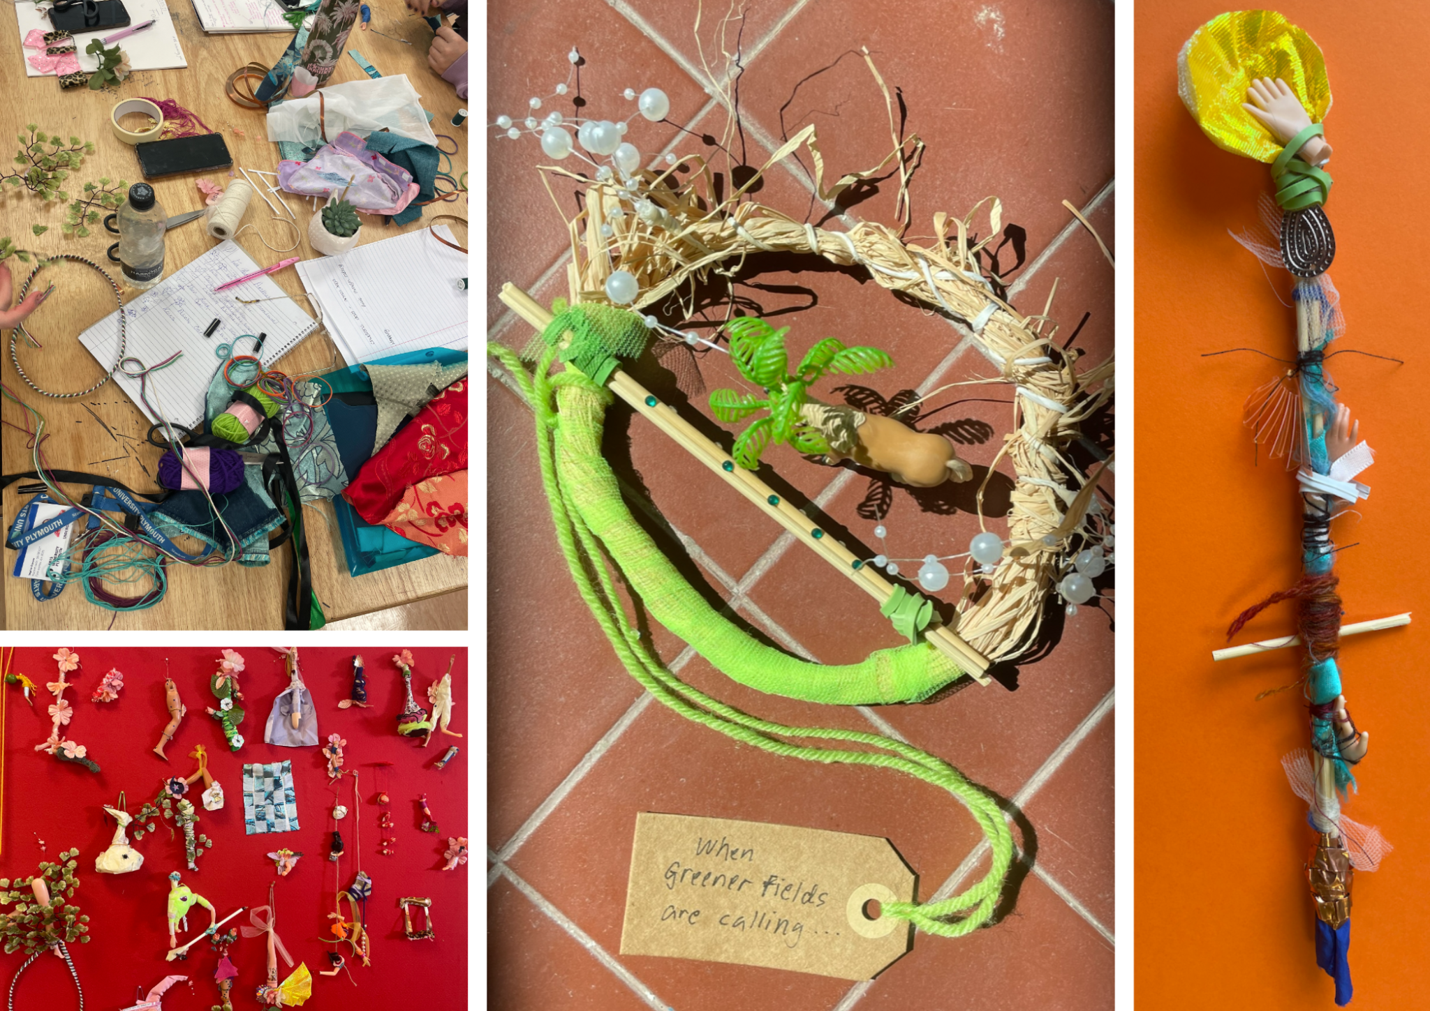Figure 1: Plastic Reliquary: Folk Workshop Artefacts, Photo credits: Mel Brown, 2023 ©
As participants worked, we encouraged them to imagine and invent the narrative behind their artefact, to acknowledge the ritual they were performing, and to write down their story, since ‘imagination can be continued into the situation by talking, writing and so on’ (Dijk & Rietveld, 2020). We invited fantasy, storytelling and mythmaking and we celebrated imagination, fabrication and exaggeration. Subsequently, they presented narrative responses to their plastic relics that were symbolic of notions of endurance and survival. These were predominantly positive messages as they connected both the fictional premise of their outcomes with real-life ‘earthbound challenges’, reflecting on how things might ‘turn out OK’ (Hopkins, 2019).
Through the FOLK workshop, thinking through the act of making facilitated a space for our participants to form a narrative about a fictional ‘situatedness’ - a space they believed possible because it was wrapped in an invented story they believed in, one that had formed organically alongside the actions they had been performing. By creating a fantastical scenario of an imagined situation, participants were able to generate unconventional, seemingly infeasible solutions that pushed beyond what they considered, for them, familiar or conventional thinking. Participants ventured beyond their typical practices (for example illustration, fashion or graphic design) to use only physical, hands-on approaches to create the artefacts. In a world increasingly dominated by the internet and AI influences, our FOLK Workshop encouraged participants to step away from digital tools and instead embrace the unique qualities of analogue making. Their artefacts were documented in the Plastic Reliquary drawings (Fig.2 Brown 2023).
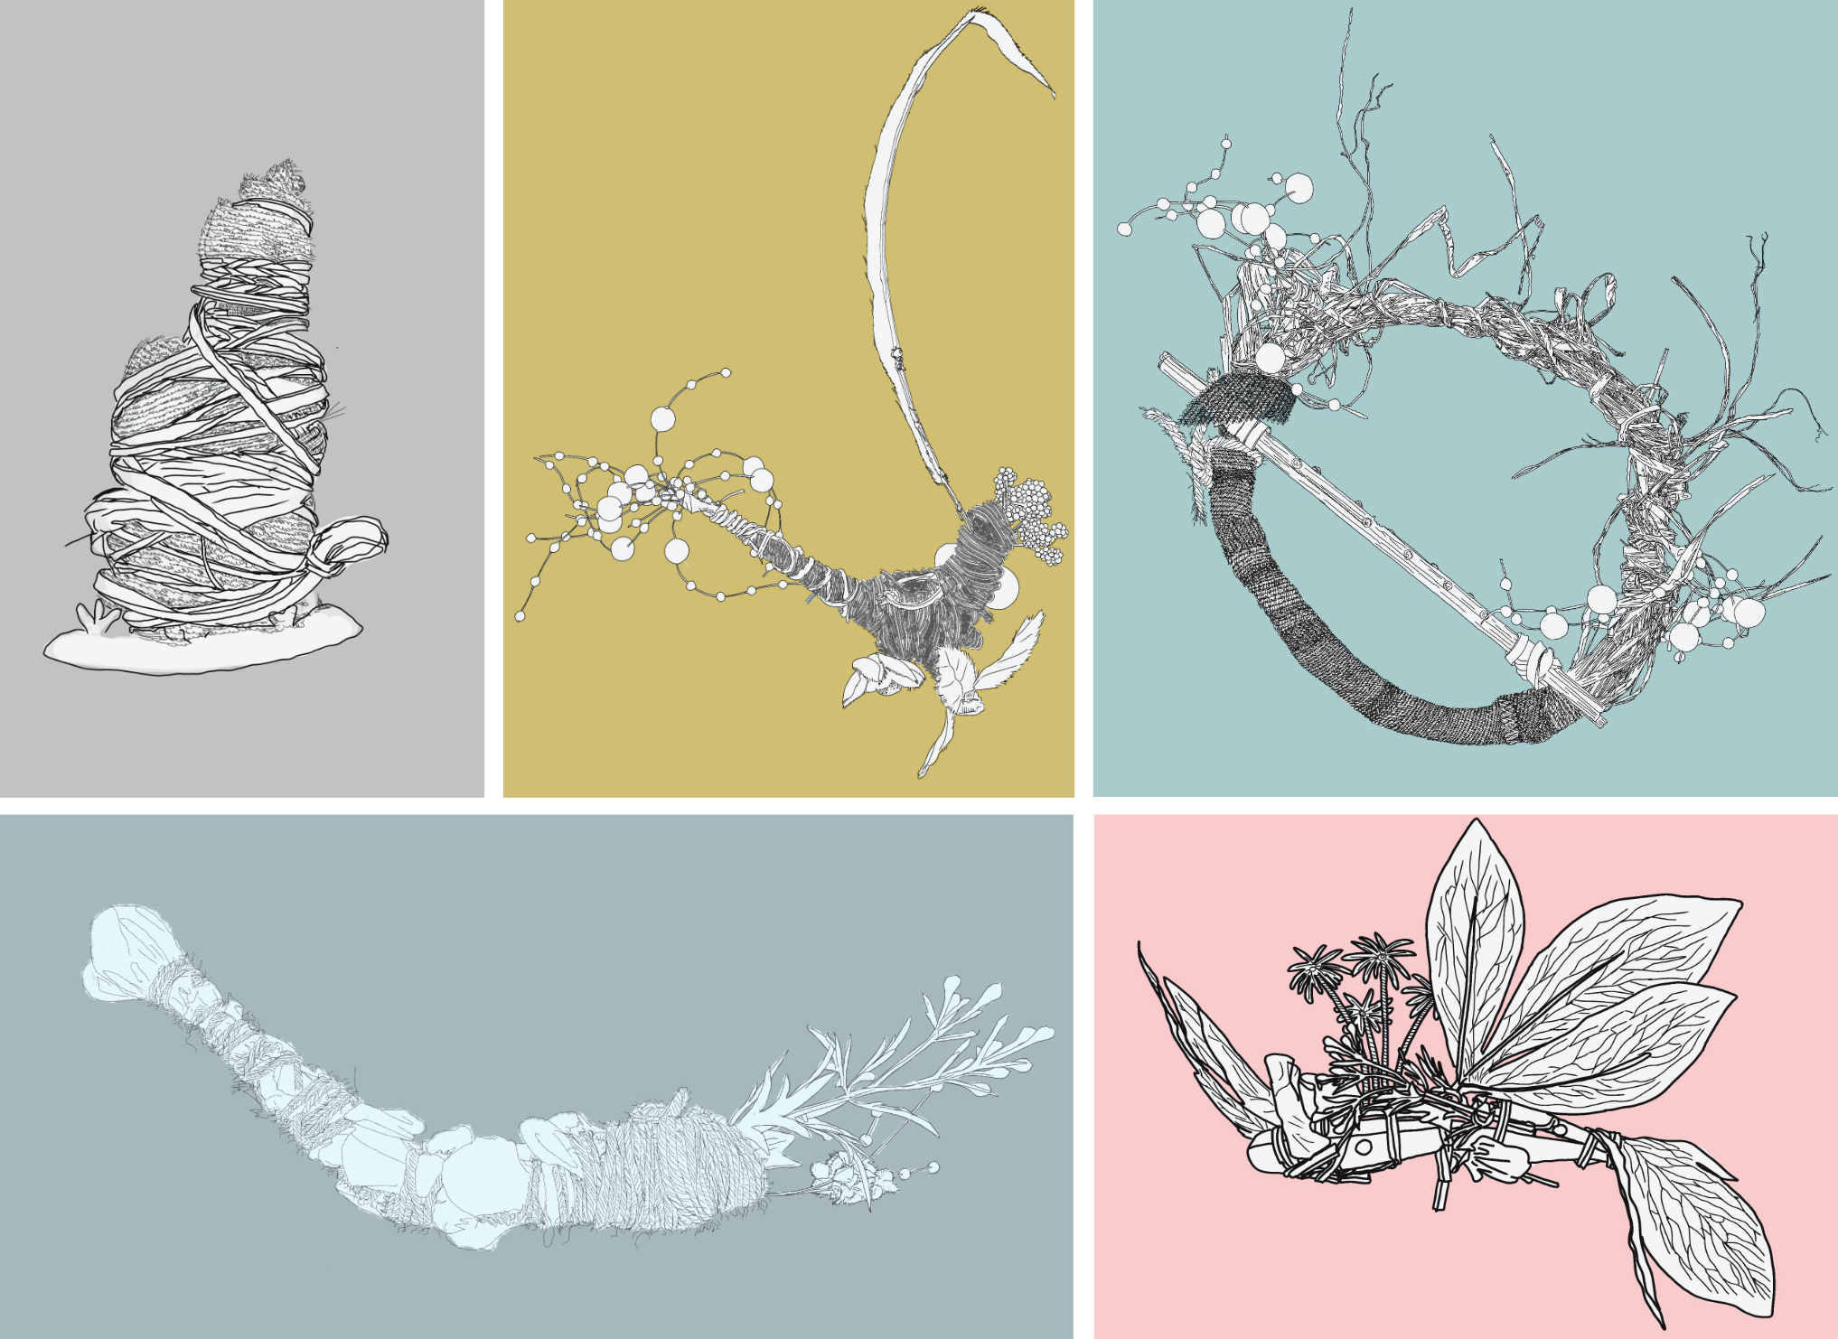Figure 2: Mel Brown, Plastic Reliquary drawings: Folk Workshop Artefacts 2023 ©
On completion of the workshops, students began to elaborate upon our starting points, developing their own narratives before forming teams around projects they cared about. As tutors it was our role to guide the students to tease out what was important to them as creatives in the world today. Each team approached this differently, some jumping straight in and others slowly developing ideas to creatively address and highlight important issues. Returning to our original intent of encouraging our students to become ‘empathic adventurers’, this unit offers a journey that, while enriching and rewarding, can also be unpredictable and at times frustrating. Pathways can be sprawling and littered with crossroads and diversions, or they can be narrow and unnavigable leading to dead ends and obstructions. Decisions need to be made, and directions chosen. As the students travel with others they are constantly negotiating and compromising to try to ensure the experience is valuable for all involved.
Teamwork and collaboration test our students in terms of their resilience and patience and challenge us in navigating and supporting students as they journey through the collaborative projects. For Shankar & Zurn and their call for a ‘critically curious pedagogy’, students working in collaborative environments is vital for inviting discussion and co-creation since ‘community dialogue helps students to understand that curiosity is multiple and can move in different directions’ (Shankar & Zurn, 2020). Our role was to hold the space that encouraged play, imagination and curiosity to thrive.
As The Curiosity Incubator 12-week project drew to a close, the resulting team outcomes covered a variety of themes, for example: world-building explored through character and costume design depicting a story of futuristic sustainable living; the creation of headdresses as artefacts symbolising two different but thriving worlds–one where nature has taken control and conquered everything, the other a world where humans have eradicated nature; and an exploration of traditional craft practices including learning new craft skills and research into how sustainable and environmentally friendly they actually are. In the final phase of the unit, there was a flurry of activity as the students concluded their team projects and together formulated plans for presentation and display to the rest of their cohorts. In their individual evaluation, each team member was able to acknowledge the vitality of their achievements, how their shared skills and resourcefulness enabled them to work together while recognising their individual strengths in contributing to team outcomes.
Beyond delivering the FOLK workshop within the unit, we adapted it for our colleagues in the university’s Making Learning Research Group and then again for participants at ELIA Academy, Evora in 2023. Our aim was to prioritise experimentation and the unexpected, at each Folk workshop we observed our participants directly engaging with the materials, fostering a deep connection with their objects and becoming purposefully lost in the action of making. The task encouraged immersive creative engagement, provoking haptic memories of basic making skills such as wrapping and binding, as well as tapping into mind-wandering and imagination we associated with an incubation phase of creativity (Wallas, 1926).
How do we put creativity at the centre of the debate to address complex global issues, and not on the periphery? Some would say that the ecological crisis is not a technological one, it's an aesthetic crisis. It’s about our relationship with the world, not necessarily our relationship with machines and technical solutions, but with how we love, care for and nurture the world. (Felmingham, 2024)
These analogue methods also fostered tactile awareness through a process of connecting emotionally with materials, particularly well-suited to exploring sustainability and acknowledging our responsibility to care for the planet and its resources.

Global Challenges
Following on from the delivery of Platforms of Exchange, at the start of their Level 5 study, the Global Challenges unit affords students the opportunity to progress their understanding of ESD themes. We have followed the progress of The Curiosity Incubator students into their second year and noted that although they all invariably returned to earth, through the self-initiated projects they developed for the Global Challenges unit, they demonstrate an ongoing development of sustainable values in their practice and a lasting commitment to care for the world and those that inhabit it. For example, outcomes included:
- A Textile Design student who through knitted banners took on a very personal approach to campaign development, breaking down barriers to raise issues faced by deaf students.
- An Illustration Student who created a fully illustrated narrative that aimed to inspire empathy towards people who struggle with anxiety or other invisible conditions that affect everyday life.
- Costume Production students who considered the landscape of ethical and sustainable approaches in the costume industry, creating a Costume Production Sustainability Policy.
- Fashion Design students repurposing waste materials to make high end commercial collections.
- A Textile Design student who explored algae as a replacement colour pigment in ink to find a more sustainable way to print textiles.
- An Interior Design student who responded to the controversial felling of trees in Plymouth City centre to bring home environmental issues that exist on our doorstep.
To bring this work into view, student achievements are celebrated every year in the Global Challenges Awards, initiated by the author Mel Brown, and celebrated through an exhibition and awards event and archived in a publication (Fig. 3 Brown 2023).
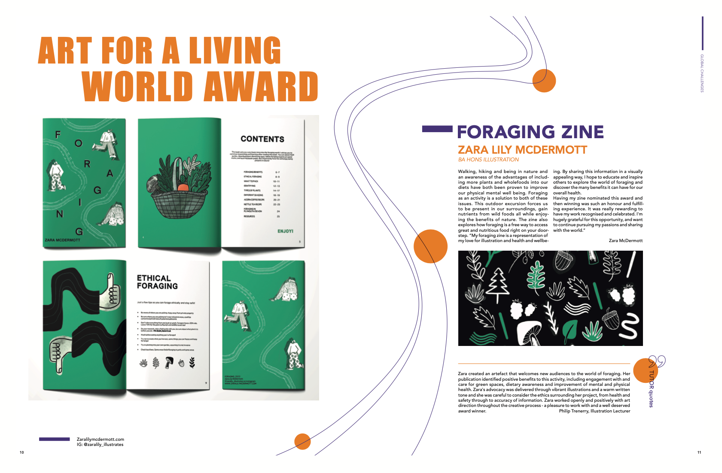Figure 3: Global Challenges Awards archive publication, Mel Brown, 2023 ©
An important feature of the awards is the involvement of the Vice-Chancellor's Executive in the judging process alongside the wider community of students and staff. The Global Challenges unit is given a platform to shine and the whole University now recognises it, sitting at the heart of our students’ undergraduate experience, literally marking the mid-way point in their three-year journey and exemplifying the spirit of our curriculum in its potential to provide a catalyst for personal, professional and cultural transformation.

Thinking Through Making
This case study introduced the development of an Undergraduate project that combines playful thinking, analogue making and imagination as a way of approaching global challenges and asked whether the playful integration of ESD can result in impactful, transformational learning experiences. The Curiosity Incubator project for The Platforms of Exchange unit began with The Curious Research Method, where curiosity is defined as the desire to know or learn something. Research is reframed as ‘being curious’ and researching begins to feel a little less daunting and a whole lot more inviting, as students are encouraged to collaborate and immerse themselves in the simple yet transformative pleasure of finding things out.
The incubation phase followed, as students engaged in workshops inspired by the SDG Goals, opening up to ideas in order to work through the problems we posed using play, imagination and design fictions. The project as a whole was designed to expand students’ experiences beyond their immediate circumstances, empowering them to make imaginative responses to complex and unwieldy problems. One can understand reactions of feeling intimidated or overwhelmed when faced with the scale of trying to contemplate - never mind solve - interconnected global challenges such as climate change, sustainability, inequality and migration. The project was designed to be an engaging and playful way of presenting information so that students could construct their own meanings. Our approach was the playful integration of the UN SDGs as a framework to build the workshops, providing a way of forming connections through the intimacy of making and imagining as a way to pull students:
…“inside” the frame within which knowledge begins to make sense and is able to make sense. It is precisely this act of “pulling” that goes fundamentally beyond all the sense-making that students are able to do, up to the point where they encounter something new, something radically “beyond” their own horizons of understanding. (Biesta, 2022)
We want to continue to develop our interpretation of a ‘critically curious pedagogy’ that seeks to harness the potential of curiosity, play and imagination as a means to approach and conceptualise ‘messy’ and unwieldy global issues. This could involve further investigation into the impact and legacy of The Curiosity Incubator project on the students, looking beyond delivery of the unit, their Global Challenges projects and their final year outputs. We want to further embed these approaches into our teaching outside of the Platforms of Exchange unit, advocating a shift from a mindset of ‘What?’ to 'What-if?’ by stripping back the design process and revisiting the fundamental aspects of making inherent in all of us. By joining our students in trusting the process and believing that something will appear from nothing, we are considering how to open up new avenues for creative problem-solving and innovative thinking where the memorable action of making and the experience of imagining are as important as output and outcome.

Disclosure Statement
All materials included in the article represent the authors’ own work and anything cited or paraphrased within the text is included in the reference list. This work has not been previously published nor is it is being considered for publication elsewhere. We declare there are no potential conflicts of interest which might have influenced the authors in reporting their findings completely and honestly.

References
Aktaş, B., and Groth, C. (2020) ‘Studying Material Interactions to Facilitate a Sense of Being with the World’, The Design Research Society 2020 International Conference: SYNERGY, Brisbane, Australia, 11-14 August. https://doi.org/10.21606/drs.2020.229
Aktaş, B., and Groth, C. (2021) ‘Using creative practice in interdisciplinary education’, in Bohemia, E., Nielsen, L.M., Pan, L., Börekçi, N.A.G.Z., Zhang, Y. (eds.), Learn X Design 2021: Engaging with challenges in design education, 24-26 September, Shandong University of Art & Design, Jinan, China. https://doi.org/10.21606/drs_lxd2021.07.233
Arts University Plymouth (2023) Creative Education for a Changing World. Available at: https://www.aup.ac.uk/strategic-plan (Accessed: 5 August 2024).
Biesta, G. (2018). ‘What if? Education beyond expression and creativity’, in Naughton, C., Biesta, G. and Cole, D. R. (eds.) Art, Artists and Pedagogy: Philosophy and the Arts in Education. London: Routledge, pp. 11–20.
Biesta, G. (2022) World Centred Education: A View for the Present. London: Routledge.
Cross, N. (2011) Design thinking: Understanding how designers think and work. London: Bloomsbury Academic.
D’Orville, H. (2019) ‘The Relationship between Sustainability and Creativity’. Cadmus Journal. 4(1) Available at: https://www.cadmusjournal.org/node/742 (Accessed: 1 March 2025)
Felmingham, S. (2024) ‘Creative Education for a Changing World.’ Latest News, 23rd January. Available at:
https://www.aup.ac.uk/posts/creative-education-for-a-changing-world (Accessed: 5 August 2024).
Hopkins, R. (2019) From What Is to What If: Unleashing the Power of Imagination to Create the Future We Want. London: Chelsea Green Publishing.
Krznaric, R. (2012) RSA Animate - The Power of Outrospection. Available at: https://www.thersa.org/videos/rsa-animate-the-power-of-outrospection/ (Accessed: 31 January 2023).
Leslie, I. (2014) Curious: The desire to know and why your future depends on it. London: Quercus.
Mezirow, J. (2009) ‘An overview of transformative learning’, in Illeris, K. (ed.) Contemporary Theories of Learning. Abingdon: Routledge, pp. 90-105.
Neale, L. (2015) Playing for Time: Making Art as if the World Mattered. London: Oberon Books.
QAA and Advance HE (2021) Education for Sustainable Development. Available at: https://www.advance-he.ac.uk/knowledge-hub/education-sustainable-development-guidance (Accessed: 8 August 2024).
RCA (2024) Education for Sustainable Development: Strategy for Sustainability in Teaching & Learning. Available at: https://www.rca.ac.uk/more/sustainability/education-for-sustainable-development/#strategy-for-sustainability-in-teaching-learning (Accessed: 5 February 2025).
Schaar, R. and Baeza, C. (2020) ‘Using design fiction to teach ethics in design: Preparing students to be ethical entrepreneurs by studying the implications of speculative futures’. Available at:
https://www.idsa.org/education-paper/using-design-fiction-to-teach-ethics-in-design/ (Accessed: 1 March 2025).
Shanker, A. and Zurn, P. (2020) ‘Conclusion: On Teaching Curiosity’ in Shanker, A. and Zurn, P. (eds.) Curiosity Studies: A New Ecology of Knowledge. Minneapolis: University of Minnesota Press.
Stein Greenberg, S. (2021) Creative Acts for Curious People. London: Penguin Business.
UCA (no date) Teaching at UCA. Available at: https://www.uca.ac.uk/about-us/environment-and-sustainability/teaching/ (Accessed: 5 February 2025).
United Nations (no date) The 17 Goals. Available at: https://sdgs.un.org/goals (Accessed: 8 August 2024).
van Dijk, L. and Rietveld, E. (2020) ‘Situated imagination’, Phenomenology & the Cognitive Sciences. https://doi.org/10.1007/s11097-020-09701-2
Vygotsky, L. (1978). Mind in society: The development of higher psychological processes. London: Harvard University Press.
Wallas, G. ([1926] 2014) The Art of Thought. Poole, Dorset: Solis Press.
Wenger, E. (1998) Communities of Practice: learning, meaning and identity. Cambridge: University Press.

