Teaching Illustration in the Age of Generative AI

Nicholas Lewis
University of Sunderland
Corresponding author: Nick.Lewis@sunderland.ac.uk

Abstract
According to Klaus Schwab, the Fourth Industrial Revolution is characterised in part by AI and machine learning (Schwab, 2017). Importantly, he proposes ‘4IR’ as distinct from previous industrial revolutions due to its “velocity”. This paper chronicles the introduction of AI into teaching and learning on an illustration degree programme from 2020 to 2024. During this time, AI developed rapidly and some students who were unaware of its potential in 2020 now express concerns about its impact. Some used AI in their projects, while others regard it with scepticism. This paper explains the selection process used to evaluate the AI tools and recounts how students responded to its inclusion in teaching and learning. Based on experience gained from the study, it proposes an AI monitoring and implementation process that can be used by other courses, and outlines the challenges and opportunities faced by higher education at a time of rapid change.

Key words
AI, Illustration, Design, Generative, GAN, Barthes, IR4.

Introduction
There are many occasions where technology fundamentally changes the nature of work, as the Luddites of the 18th and 19th century would attest. The industrialisation of textile working may seem a world away from that of AI, but parallels can be drawn nevertheless (Merchant, 2023). As illustrators report losing work to AI (AOI, 2025), automation once again appears to be taking work that was once the preserve of craftspeople. Artists are lobbying parliament to protect their rights (Stacey, 2025) and have even tried sabotaging AI tools, echoing the actions of their forebears (Heikkilä, 2023). To compare today's artists and designers with the Luddites may seem pejorative, but their concerns regarding AI may well be justified, as will be discussed. At the same time new technologies provide opportunities and new perspectives on the industries they change. The Fourth Industrial Revolution, partly characterised by the rise of AI and virtual assistants, would appear to be automating parts of the creative process. How then should one teach a subject in the midst of such radical change? This paper chronicles and reflects on the process of integrating AI into teaching and learning within an Illustration degree programme. In doing so, it highlights the challenges facing higher education as it adapts to a fast changing technological and economic landscape.

Literature Review
The following summarises the key technological advances changing the way we produce images and the potential consequences for illustration and higher education. In doing so it provides the context for the integration of AI into the illustration degree course at the University of Sunderland from 2020 onwards. Though some citations could be regarded as ‘grey literature’ (blogs and online articles), they give a sense of the growing discussion around the use of AI and its potential consequences.
Although AI had been used to create images before, Generative Adversarial Networks (GANs) gained particular attention in 2019 by quickly generating realistic or stylized images (Karras, Laine and Aila, 2019). Although they do not produce what could be considered ‘finished’ illustrations, they can generate images that can potentially save time and form the basis for one, just as an illustrator might use a photograph for reference. ‘This Person Does Not Exist’ (Wang, 2019) allows users to generate photoreal images of human faces by simply refreshing the webpage. GauGAN (Salain, 2019) provides an interface with which to paint a picture using flat colours while a near-photoreal image is generated alongside (fig. 1).
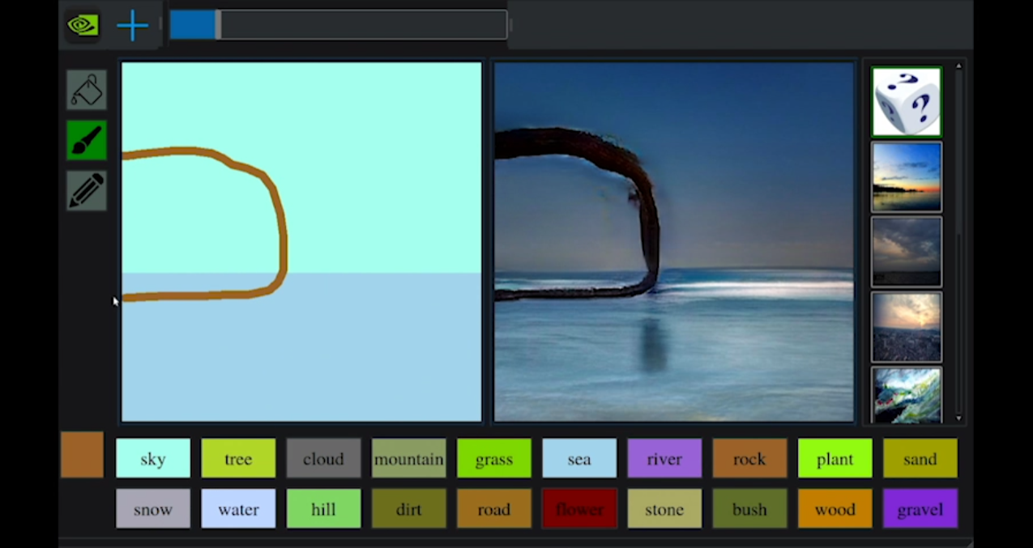
Figure 1. A screenshot of Nvidia’s GauGAN.
StyleGAN2 (Karras et al., 2020) is able to transfer various artistic styles onto photographic portraits, while a more user-friendly GAN-based system appeared in the form of Artbreeder (Simon, 2024), as will be discussed later.
Since 2022, GANs have largely been superseded by ‘Diffusion’ models such as DALL-E 2 and Midjourney. They take a description using natural language (a prompt) and generate an image based on that description. The following example (fig. 2) was generated using Midjourney with the prompt “A photograph of a cat making sushi”:
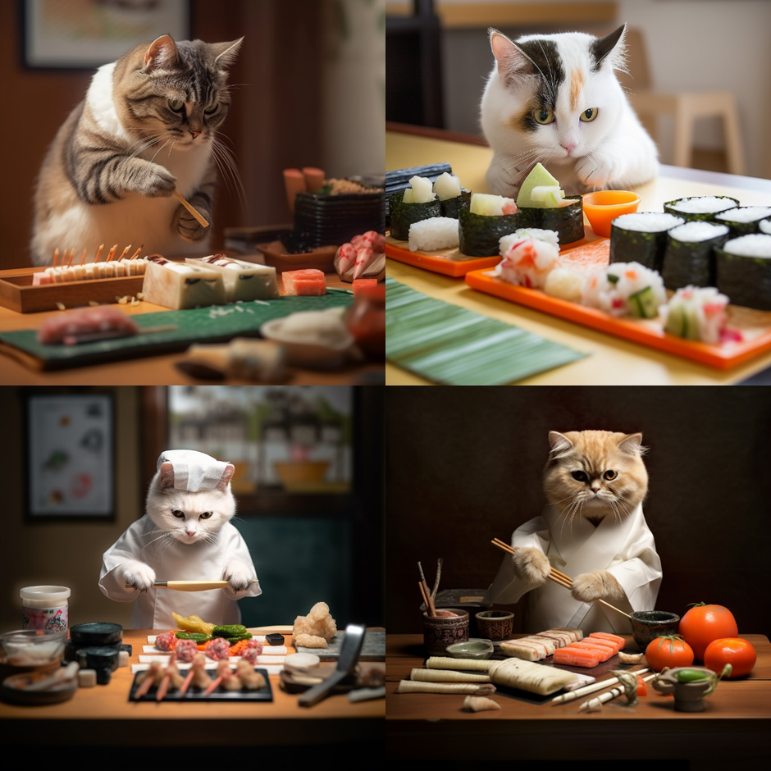Figure 2. Image generated using Midjourney using the prompt “A photograph of a cat making sushi”
AI image generators are created by training a neural network on millions of images and their text descriptions (Open AI, 2022). Using deep learning, they are ‘trained’ to recognise individual objects, and the relationship between them so they can recreate images based on a text prompt, like the following image that uses the prompt “A photograph of a koala bear riding a skateboard in Time Square” (fig. 3):
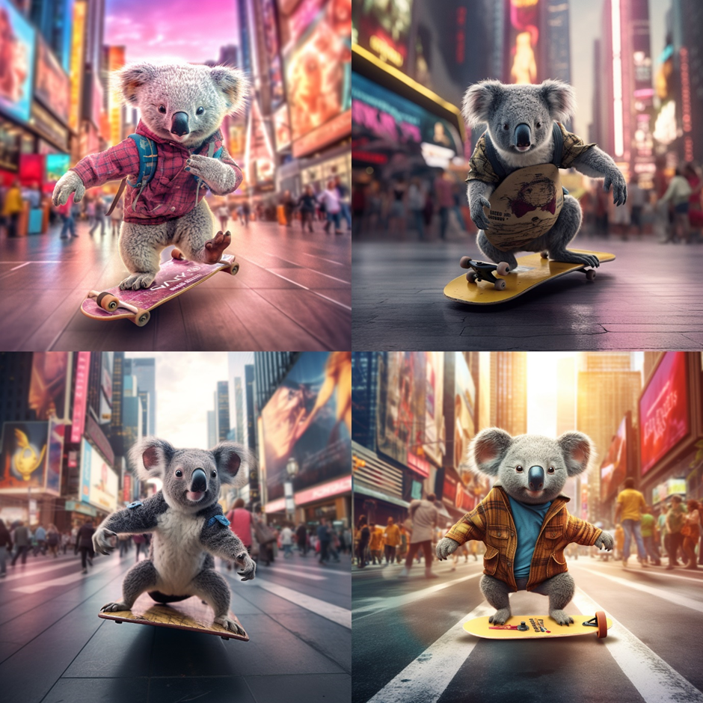Figure 3. Image generated using Midjourney using the prompt “A photograph of a koala bear riding a skateboard in Time Square”
As indicated by the images above, they can provide photorealistic results, but can also include errors, such as the way the skateboard is depicted upside down or incorrectly constructed. They are notable for their ability to match photographic or artistic styles, like the following image which uses the prompt “A watercolour illustration of a cute bunny holding a sign saying, ‘Happy Easter” (fig. 4).
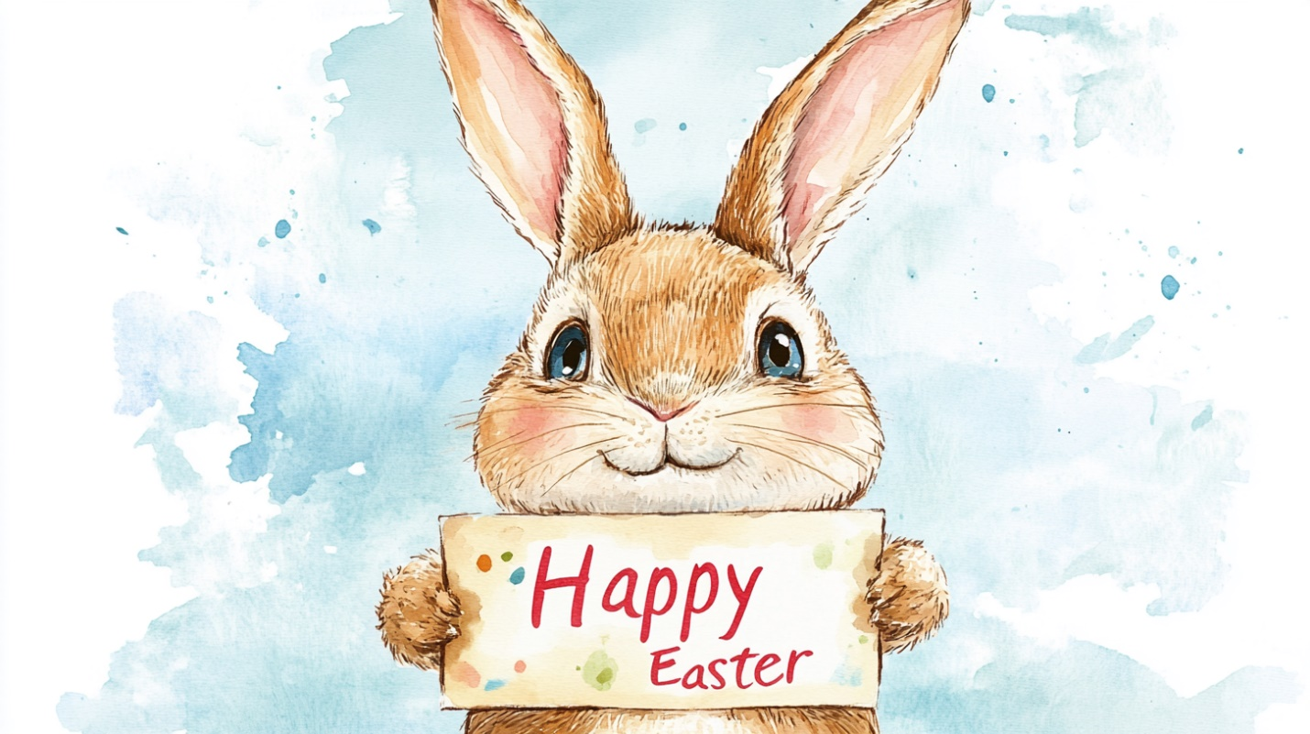Figure 4. Image generated in Midjourney using the prompt, “A watercolour illustration of a cute bunny holding a sign saying, ‘Happy Easter’.

Although the images are not perfect, the quality is often beyond the ability of the average user. Reports of their commercial use appeared shortly after their release, including Zaha Hadid Architects use of AI to develop “most” projects (Bah, 2023) and Blizzard’s AI tools for creating concept art (Plunkett, 2023).
There are limitations in describing an image with text (as will be discussed later), however some ‘multi-modal’ approaches allow users to edit images or begin from a sketch or image. ‘Inpainting’ (fig. 5) and ‘Outpainting’ (fig. 6) allow users to start with an initial image, then erase parts for the AI to fill in using a prompt.

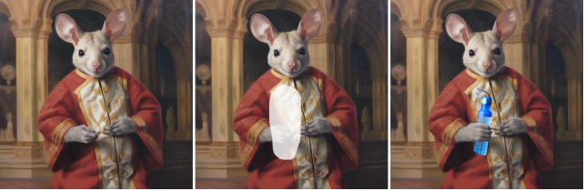Figure 5. Image generated in Midjourney using the prompt “A painting of a kangaroo by Leonardo da Vinci” and edited using Photoshop Generative Fill for ‘Inpainting’, using the prompt, “Holding a water bottle’.
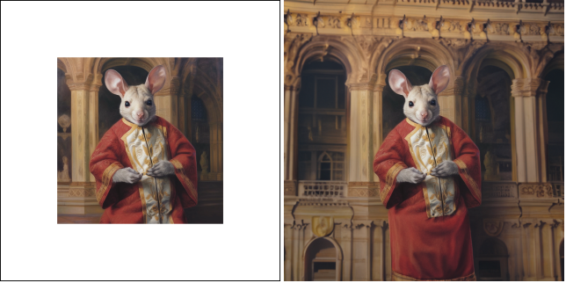Figure 6. Image generated in Midjourney using the prompt “A painting of a kangaroo by Leonardo da Vinci” and edited using Photoshop Generative Fill for ‘Outpainting’, using the prompt, “A palace in the background”.
Although text-prompts are limited to what the user can describe, systems such as Vizcom.ai (Vizcom, no date) can take rough sketches and form a photographic or stylised image from them (fig. 7). Initially it interpreted sketches but has since graduated to interpreting and generating 3D models.

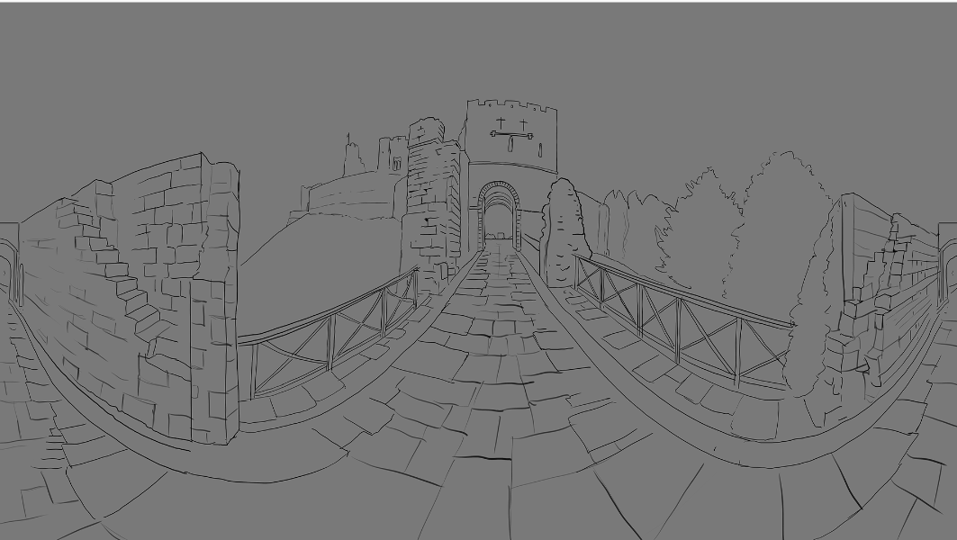
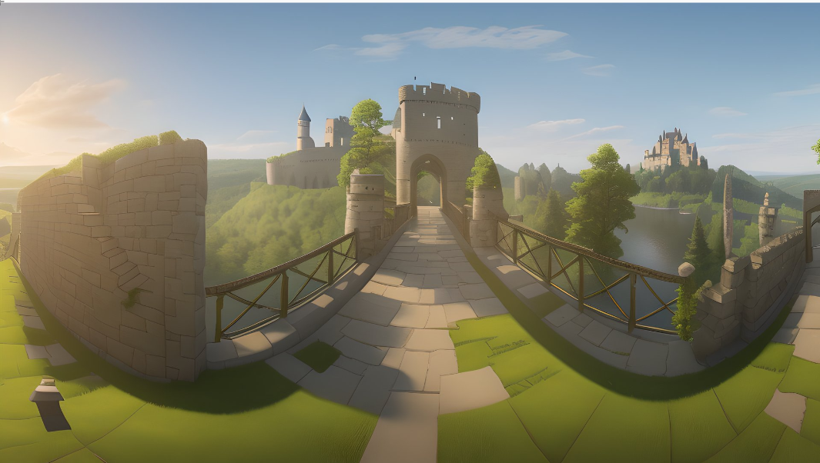
Figure 7. A sketch used as an input into Vizcom and the resulting AI generated image.
Regardless of their capabilities, the use of AI image generators, (both professional and amateur) has not been without controversy, with Lego criticised for using AI to generate artwork (Fear, 2024) and protests erupting on the digital art forum, ArtStation, where artists posted images stating, ‘No AI’ (Whiddington, 2022).
With this in mind, it would be natural to question the introduction of AI image generators into an illustration degree course. Their usage courts controversy, the results are often imperfect, and the work has been accused of being derivative due to the datasets being trained on the work of artists, scraped from the internet. In regard to this last point, Roland Barthes in 'The Death of the Author' (1967) states that writing is "a tissue of quotations drawn from the innumerable centres of culture". This suggests no one can claim their work is truly original but instead must concede it is to some extent influenced by all they have seen and experienced. In effect AI does something very similar, in that it can take a huge amount of data and create something that could be regarded as, if not original, ‘novel’. Anyone looking at the history of illustration (or art and design in general) will see popular styles and mimicry and although there is innovation, commercial illustration is often at the mercy of popular taste, otherwise we would not be able to identify an illustration as looking ‘90s’, ‘Surreal’ or ‘Retro’. AI image generators are also able to blend styles and subjects, which may not result in work that is truly original, but is good enough for commercial purposes. It should be said, however, this author does not equate the scraping of artists’ work for AI datasets as equivalent to one illustrator being influenced by another.
The criticism levelled at companies using AI to generate illustrations is often due to anger at alleged copyright infringement and the undercutting of working illustrators, however it also extends to those who use AI for a purpose that others feel should be an exclusively human endeavour. When Jason M. Allen won the Colorado State Fair’s annual fine art competition (emerging digital artists category), with the AI-generated ‘Théâtre D'opéra Spatial’, it caused widespread fury amongst digital artists (Vallance, 2022). Boris Eldagsen refused a Sony World Photography Award after revealing his entry was AI generated (Glynn, 2023). This shows there are many who regard the creative process as something that is, and should remain uniquely human. In ‘The Work of Art in the Age of Mechanical Reproduction’, Walter Benjamin suggests only the original artwork could possess an ‘aura’ that no mechanical reproduction could emulate (Benjamin, 2010). It seems digital artwork created by a human, however reproducible, is often valued far more than AI generated work, meaning it has its own ‘aura’ of human endeavour. This sentiment is echoed by some of the students interviewed, as will be shown later.
As the commercial use of AI appears to be growing, it is worth considering its economic influence. Although one should be careful not to echo hyperbole, speculation about the widespread commercial use of AI and its impact on jobs has come from many quarters. In the Goldman Sachs report, ‘The Potentially Large Effects of Artificial Intelligence on Economic Growth’ (Briggs & Kodnani, 2023), it is predicted “...25% of Arts, Design, Entertainment, Sports and Media jobs are “Exposed to Automation by AI” (US). A report by the Design and Artists Copyright Society in November 2024 (Design and Artists Copyright Society, 2024) found respondents to the survey “... fear [the use of their work to train AI systems] could undermine their IP rights and contribute to a reduction in small commission opportunities...”. An Association of Illustrators survey (Association of Illustrators, 2025) reported that 32.4% of respondents said they had “…lost work as the result of a client choosing to use generative AI…”. However, some have cited benefits, with a respondent to the DACS report saying, “what used to take a week can now be done in a day”. The Goldman Sachs report described AI as a ‘co-pilot’, stating that AI will, “…Substitute Sometimes, Complement Often”. A franker assessment was offered by Professor Richard Baldwin at the World Economic Forum, when he remarked, “AI won’t take your job, somebody using AI will take your job.” (Marr, 2024).
AI’s impact on teaching and learning in higher education has also come under scrutiny. Concerns were raised shortly after the release of ChatGPT due to its potential for writing essays (Weal, 2023), and AI image generators could also be used by students to ‘pass off’ AI generated work as their own (a concern that has prompted a greater emphasis on documenting process (Bamford, 2023)). But some have cautiously embraced AI as a means to help the creative process. Derek Yates of Ravensbourne University London suggested, “AI has the potential to take the grind out of the creative process and supercharge ideas…”, but concedes, “it brings with it risk and opportunity in equal measure” (Bamford, 2023).
As research institutions, Universities have a responsibility to inform students of emerging technologies that will impact their future, and AI is no exception. There is an argument for introducing AI to students whether they eventually use it or not, so they can at least understand how their skills and knowledge can be used in relation to it. Not doing so might be akin to teaching agriculture in the 19th century without discussing the combine harvester, or fabric weaving without discussing the power loom.
To summarise; though AI tools are not new, the rapid development of highly capable AI image-making tools from 2019 onwards started to redefine how digital images, (including illustrations), could be made. Their increased use in industry shows they have a level of commercial and practical viability, though this is not without its ethical concerns. With regards to higher education, AI is acknowledged to be playing an increasing role in teaching and learning, and it was for this reason AI was introduced into the Illustration and Design degree programme at the University of Sunderland.

Methodology
When AI was included in teaching and learning, it was not anticipated that the resulting work, discussion and outcomes would be diarised, so the data has been organised retrospectively. As a result, this study looks back at the previous four years and separates the study into two sections: Experiments and Implementation. Experiments were conducted to test the viability of the AI tools and find the most suitable ones for teaching illustration. Implementation gives an account of the inclusion of AI in teaching and learning in the curriculum.

Experiments
It was important to evaluate and select tools based on how useful they could be to an illustrator rather than the average user. Basing the criteria solely on ease of use, or level of realism for example, would be of little help, as the quality of an illustration depends not only on one’s ability to depict a subject, but also the idea that underpins it. Equally, the ease by which the user can generate realistic or stylised images using text-prompts gives anyone the chance to visually represent their ideas, not just illustrators. For this reason, AI systems were chosen based on criteria whereby illustrators could leverage skills particular to them:
Knowledge of design theory or art history.
Image as Input - Using the illustrator’s own image (drawing/painting) as input.
Iteration – The ability to iterate and improve an image, as opposed to arbitrarily generating images until a suitable one appears.
Visual Specificity – the ability to specify not only the features of an image, but also their relative positions and orientation within the image.
The AI systems used skew heavily toward the realistic or three-dimensional. However, illustrations requiring a high level of realism (photographic or stylised) are time-consuming and therefore costly to produce and these AI tools offer the ability to reduce both time and cost. They mostly offer a ‘multi-modal’ approach of image generation. As the saying goes, ‘a picture is worth a thousand words’, so the more specific the required outcome, the more words that are required to describe it. Ultimately this is where systems that exclusively use text-prompts become inefficient when trying to produce illustrations. Generating a photograph of a horse in a field is quite easy (fig. 8), whereas generating three horses in a field with specific locations, colours and background features becomes more difficult to describe with text (fig. 9).
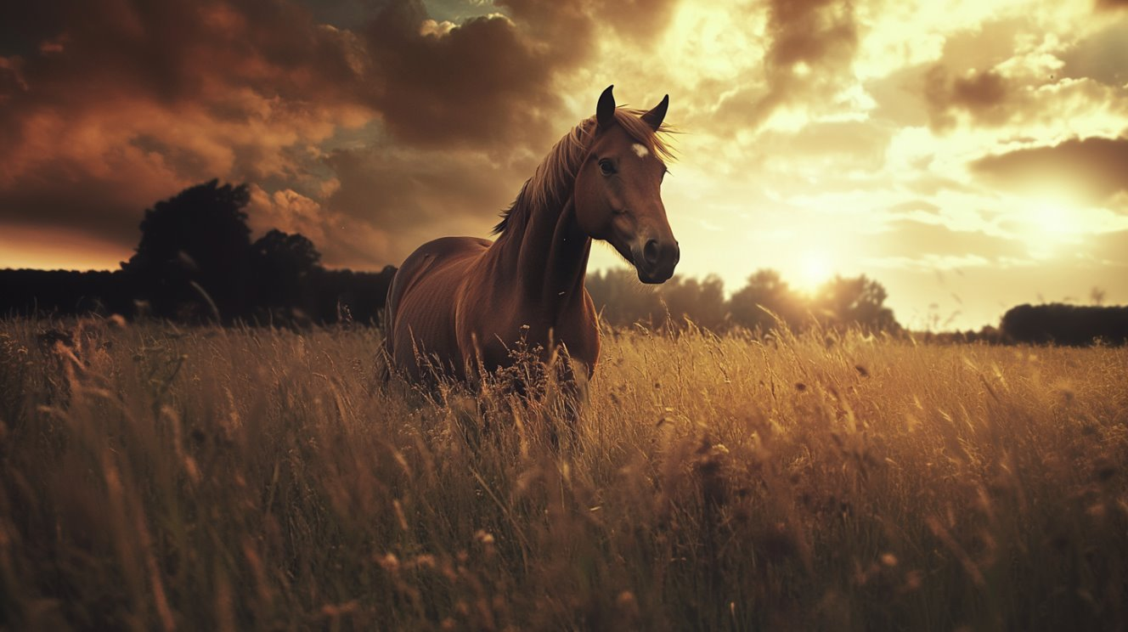
Figure 8. An image generated in Midjourney using the prompt ”A horse standing in a field”.
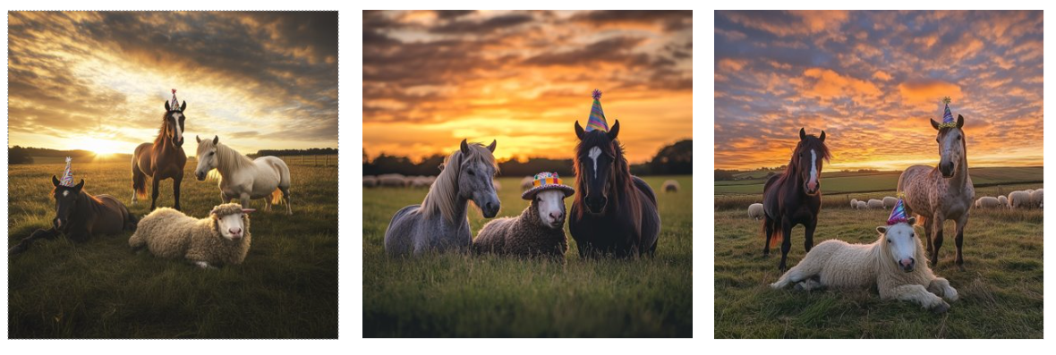Figure 9. Three erroneous attempts at an image generated in Midjourney using the prompt "A photograph of three horses in a field, one jumping, one lying down and one wearing a party hat, with sheep in the background at sunset."
A horse jumping, for example, could be landing or in mid-air, and what if the pose, location or camera angles aren’t quite right? Drawing or painting as an input instead of or alongside text was found to be far more effective at getting the required result. Conversely, images with reduced specificity are far easier to generate. This means tasks like abstract images for album covers, generic greetings cards and fabric patterns could be well within the capability of any user with access to an AI image generator and the time to experiment. For this reason, some alternative AI systems that are (or were at the time of testing), purely text-to-image generators, like Stable Diffusion or Midjourney were not used to any great extent.
Launched in 2018, Artbreeder initially used a series of sliders and fixed criteria to generate images, choosing from set subjects like characters, buildings or landscapes. Users could iterate on their creations (fig. 10) but results could be unpredictable and details such as faces and hands were incorrect (fig. 11), or buildings had strange or indiscernible features.
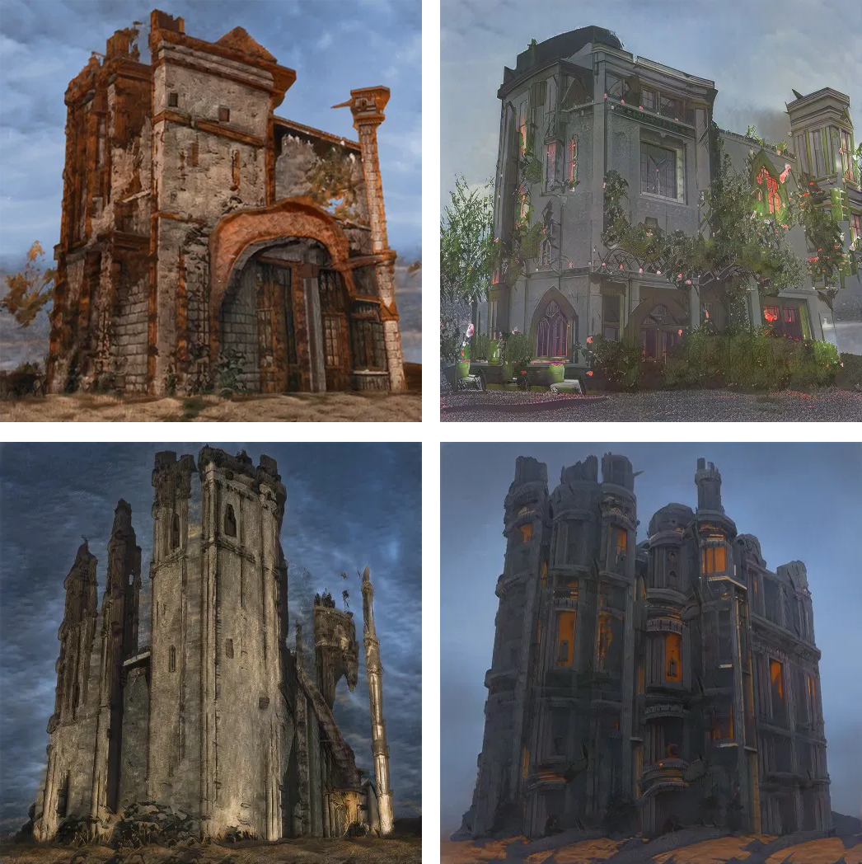
Figure 10. Building design iterations created in Artbreeder (2020).

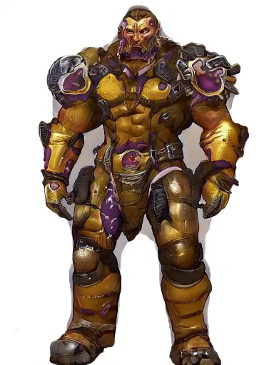
Figure 11. A character design created in Artbreeder (2020)
Adobe Photoshop introduced a series of ‘Neural Filters’ in 2020. One intended for photographers called ‘Smart Portrait’ allowed users to amend a photographic portrait, enabling them to add a smile or change the head direction or age, for example. The filter could also be used to amend an illustrator’s own digital painting of a face (providing it was sufficiently realistic), either by changing its expression or making it near ‘photo-real’, albeit with an uncanny appearance and graphical errors. (Fig. 12 and 13).
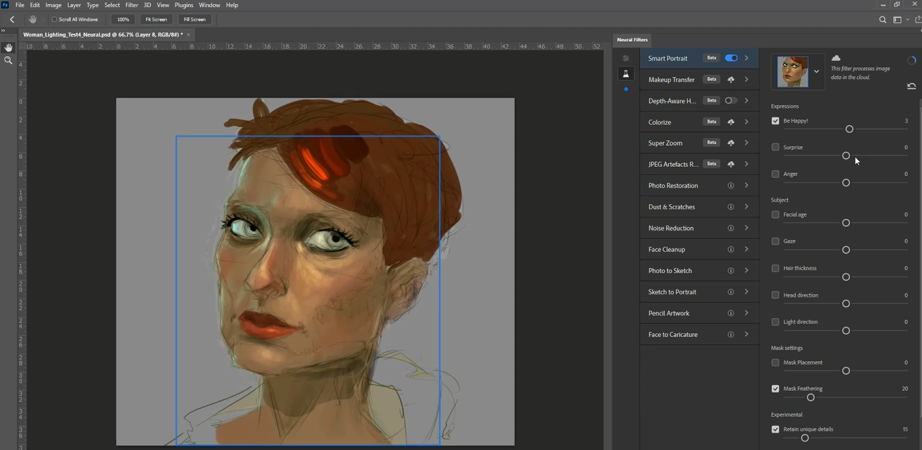Figure 12. A digital sketch of a woman before amending with Smart Portrait.
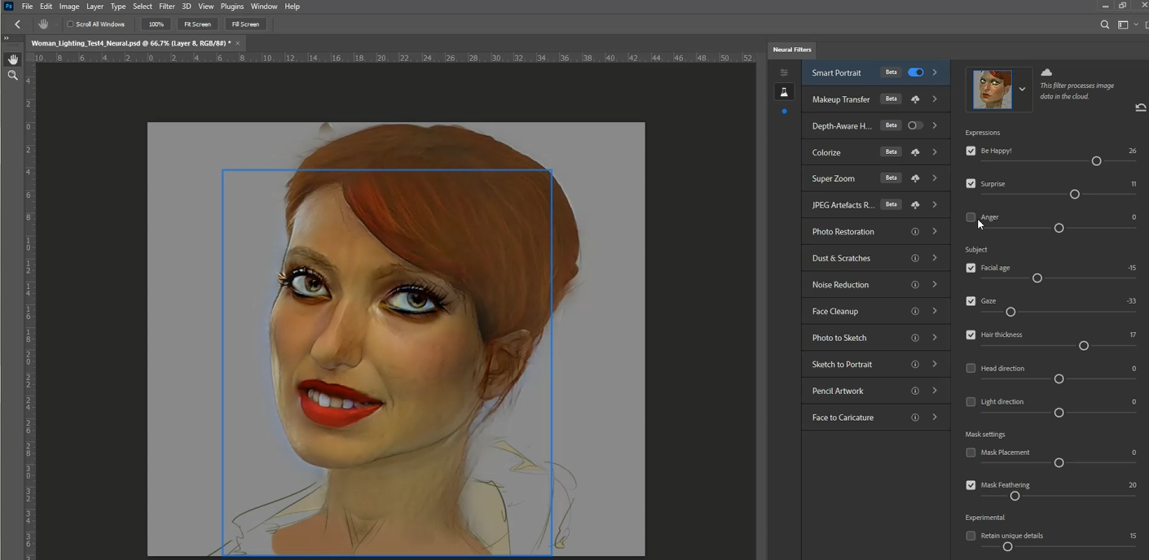Figure 13. A digital sketch of a woman after amending with Smart Portrait.
These tools could not produce completed illustrations but could form the basis for one. Although significant over-painting would be required to produce a finished product, they aided early ideation and reference for form, colour and lighting.
In 2021, Artbreeder added the functionality of uploading a sketch to guide the AI, as can be seen in figure 14. Its results are again a little unpredictable, but it gave an opportunity to direct the composition of an image.
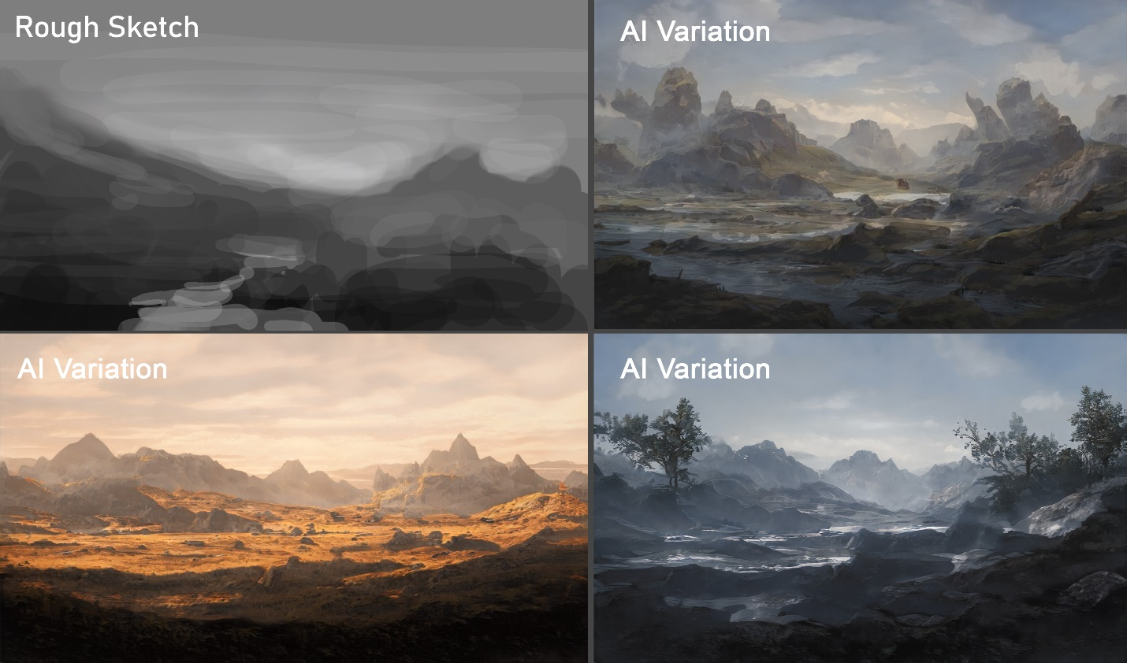Figure 14. The black and white sketch in the top left was used to generate three AI variations.
DALL-E 2 was made available to the general public in 2022 and included the functionality of ‘in-painting’ and ‘out-painting’ (fig. 15 and 16). This enables a level of specificity, in that items could be generated in specified locations and adhere to the given style (albeit with trial and error), such as the hats in figure 15 or the pirate’s body in figure 16.
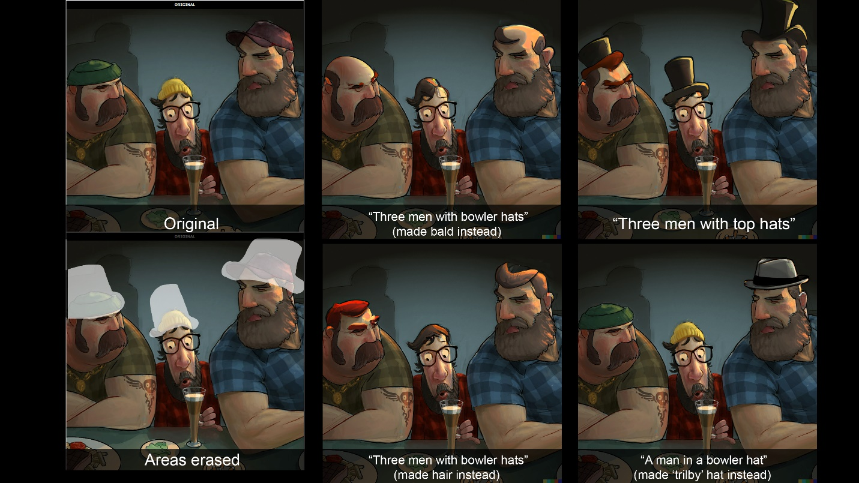Figure 15. In-painting using DALL-E 2.
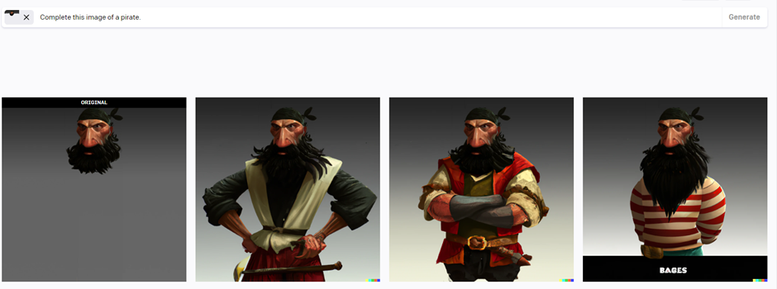Figure 16. Out-painting using DALL-E 2.
At the time of testing, DALL-E 2 was the only system to make in-painting and out-painting publicly available, though other systems have followed, including Photoshop and Midjourney.
As mentioned, the results of text-prompts can be more arbitrary than drawing when it comes to the visual arrangement of an image, however it is possible to leverage a knowledge of art and design. Figure 17 shows ‘An aerial view of a parliamentary building in the desert in the style of Santiago Calatrava’ generated using DALL-E 2. This shows we can specify the name of the architect to dictate the style of the buildings.
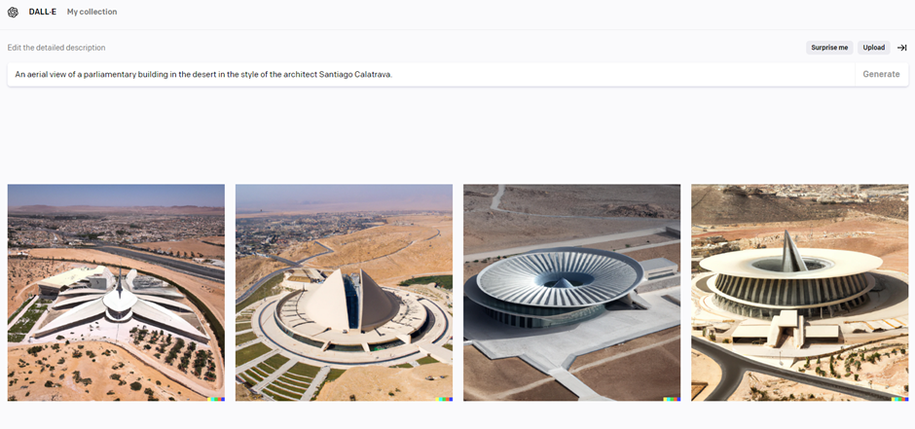Figure 17. An image made using DALL-E 2 with the prompt, “An aerial view of a parliamentary building in the desert in the style of Santiago Calatrava”.
It therefore follows that a broad knowledge of art and design enables the user to pinpoint a wider range of styles and genres. Nevertheless, referencing specific artists or designers within text-prompts is not without controversy or ethical concern, and datasets are likely to be biased toward a Western/Global North view of art and design history (Qadri et al, 2023).
The aforementioned AI image generators could be used to save time during the illustration process either by providing a starting point for an image, (using Artbreeder and standard text-to-image generators), or partially completing work, (in/out-painting in DALL-E and Neural Filters in Photoshop). With regard to the evaluation criteria, illustrators (to some extent) can iterate, use their knowledge of art and design, and their own images as a starting point, but specificity still presents a significant challenge. The general location of the hats on the characters in figure 15 could be specified using DALL-E 2, however the results were still unpredictable and although the basis for some illustrations can be provided by AI, a significant amount of editing and refinement is still required. A system that could effectively use a drawing or rough painting as a basis for an image would allow the user to specify location, position and orientation of features. ControlNet (Zhang, Rao and Agrawala, 2023) is an example of such a system, and introduces ‘Spatial Conditioning’, whereby the user can input a line drawing or a human pose for the image generator to use as a basis for the image. However, some basic programming knowledge is required to run Stable Diffusion and implement ControlNet, and Vizcom.ai has made significant progress in using drawings as an input while retaining a good level of usability.
Founded in 2021, Vizcom.ai was one of the first AI image generators to take a sketch as an input. Initial results were rough, but a sketch could produce a three-dimensional image with consistent lighting and surface texture. The dataset was largely influenced by cars, so drawing a car usually gave a relatively realistic result (Fig. 18).
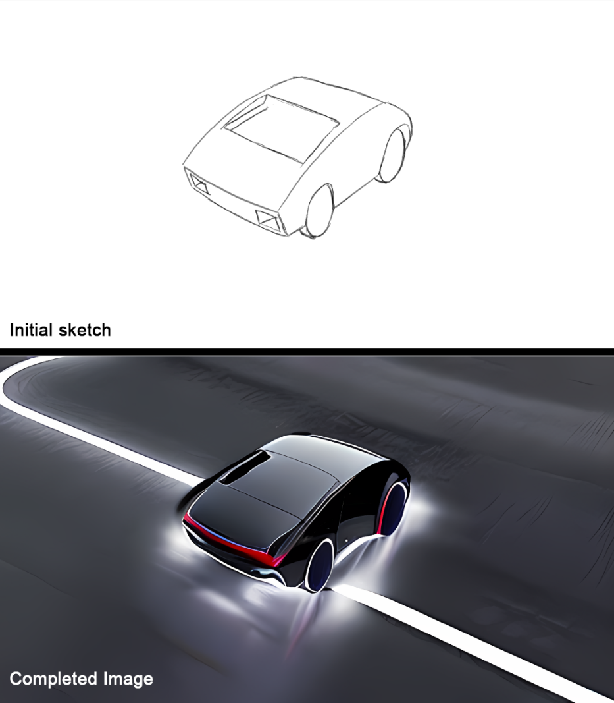
Figure 18. A drawing of a car and AI generated image in Vizcom.ai.
Later versions of Vizcom.ai have become more capable, with the ability to interpret tonal values, generate a wider range of subjects and use 3D models as a prompt. (figures 19, 20 and 21).
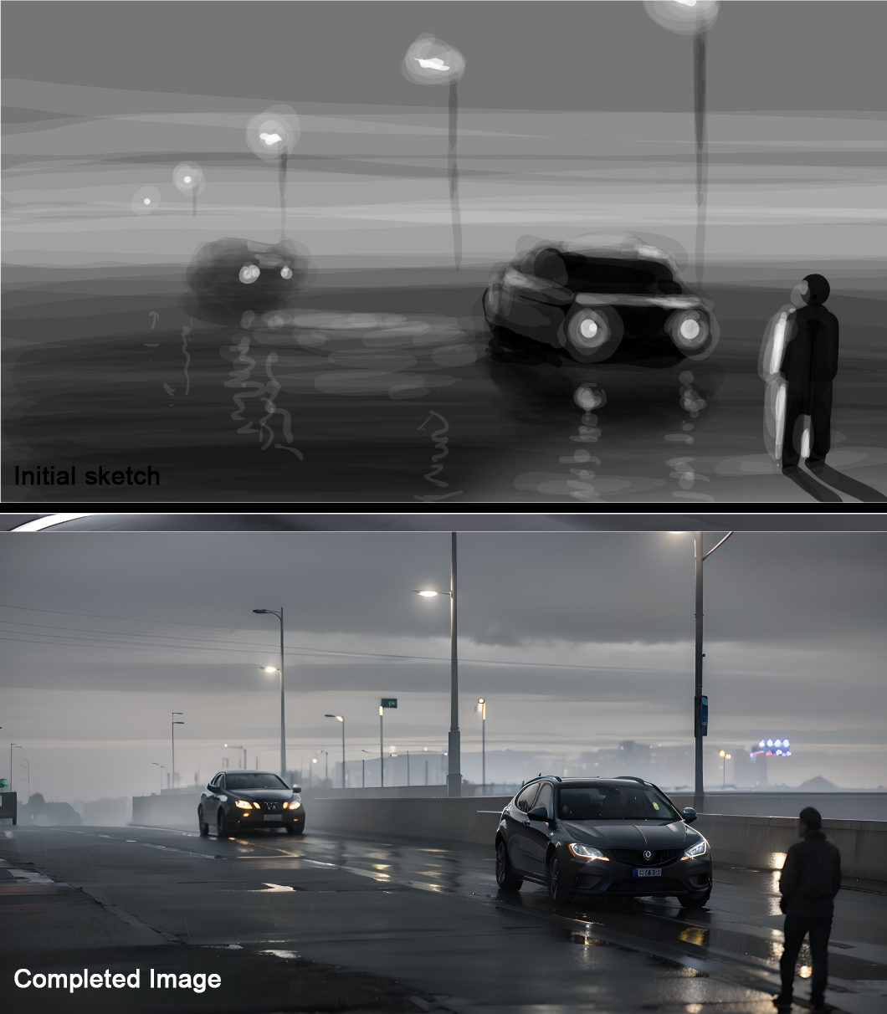
Figure 19. A sketch used as a prompt in vizcom.ai in combination with the text-prompt “Cars on a wet road at night”
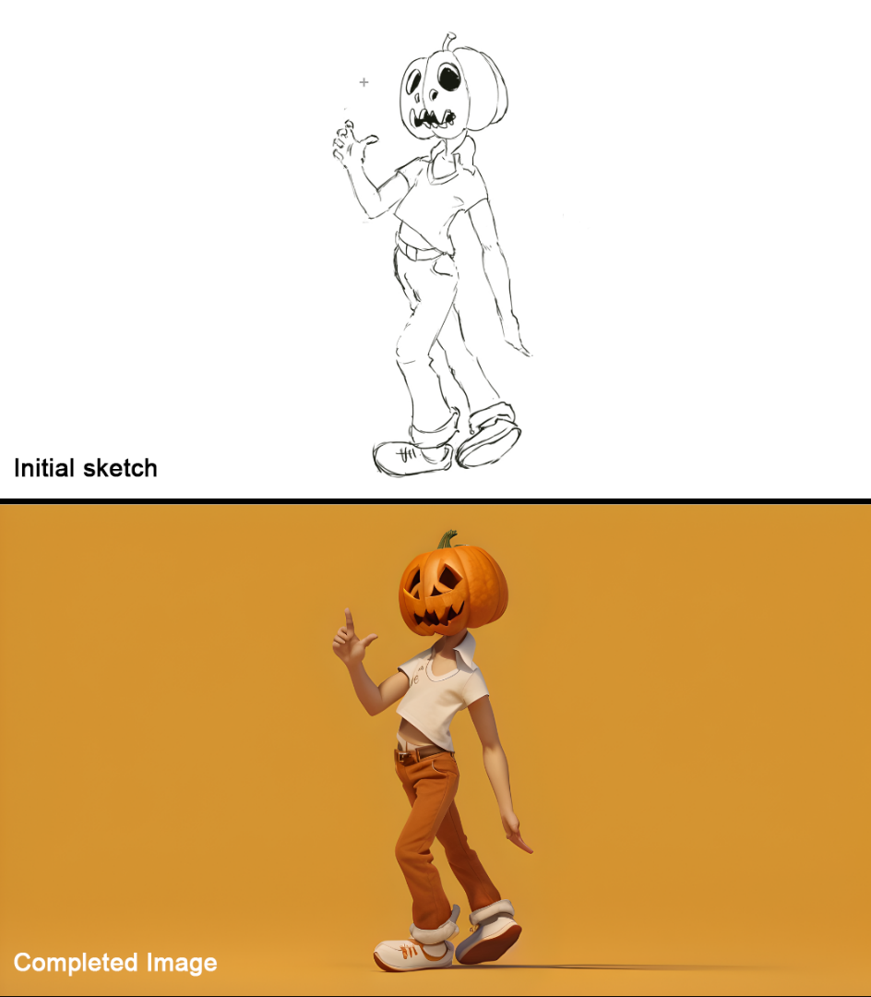
Figure 20. A sketch used as a prompt in vizcom.ai in combination with the text-prompt “A character with a pumpkin head.”
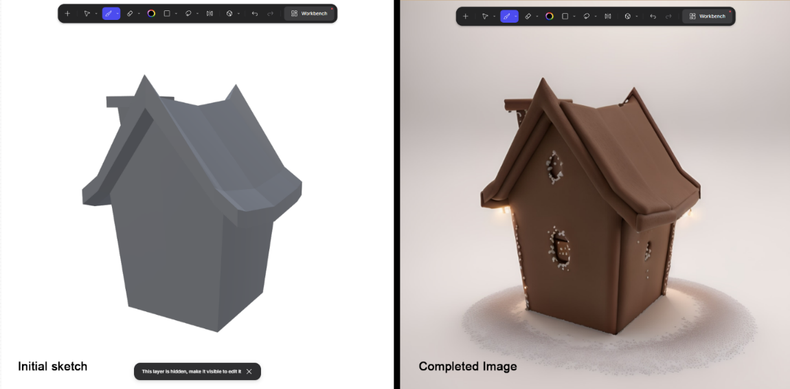
Figure 21. A 3D model used as a prompt in vizcom.ai in combination with the text-prompt “A gingerbread house.”
Vizcom also allows users to upload images for style reference. The following image (Fig. 22.) takes the initial picture of the two cars from figure 19 and generates it in the style of Studio Ghibli. There are errors, and the image would need a number of amendments by a skilled illustrator, however if the aim is to generate an image in this style (for example, the background of an animation, a graphic novel or for a low-budget illustration), it could be argued that with amendments it would be sufficient.
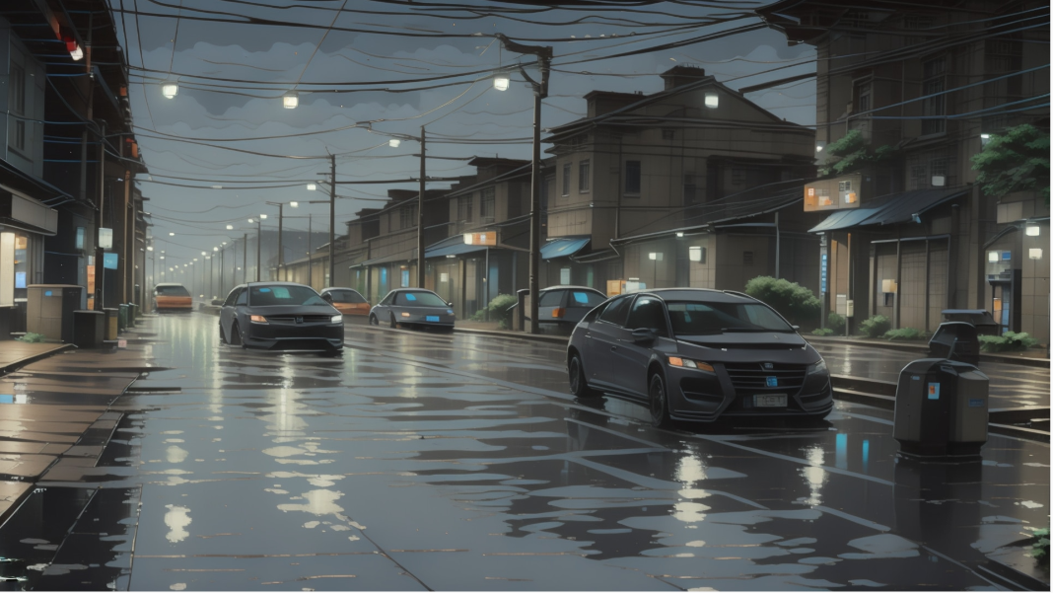Figure 22. An image generated in Vizcom.ai using an AI generated image in the style of Studio Ghibli.

In 2024 experimentation largely focused on systems that could take a drawing or painting as an input. Figure 23 shows a sketch converted into a photograph and then a rough 3D model. A 3D model could potentially be used as reference if an illustrator needed to draw a subject from different angles.

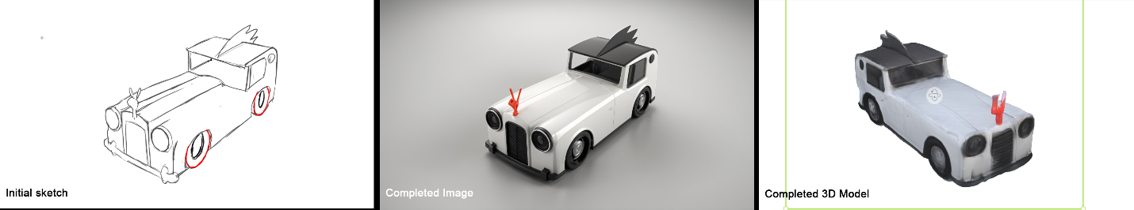Figure 23. A sketch used as a prompt in vizcom.ai to create a photo-real image and a rough 3D model.
Krea.ai allows users to upload images which it then interprets using AI. It enables the user to adjust the strength of the AI using a slider, updating in real-time (Figures 24 and 25). As with most images, there are errors, but basic sketches can have varying levels of shading applied, and in these examples the system ‘fills-in’ by adding more complex shading and folds to clothing, potentially saving time.

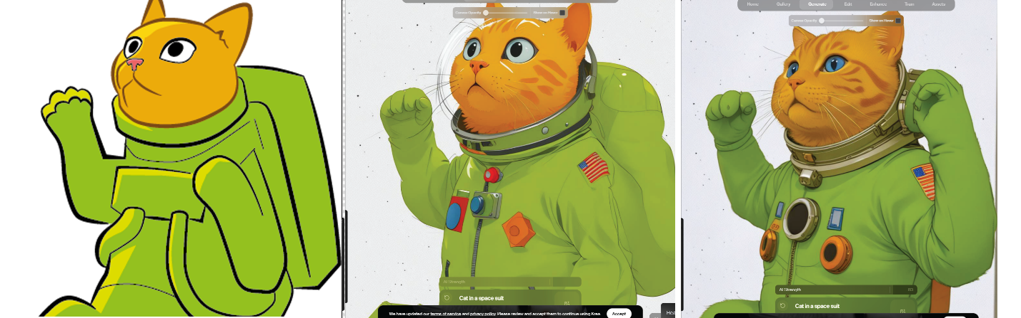Figure 24. The original cat image has varying levels of AI applied, from cartoon-style to more photorealistic.

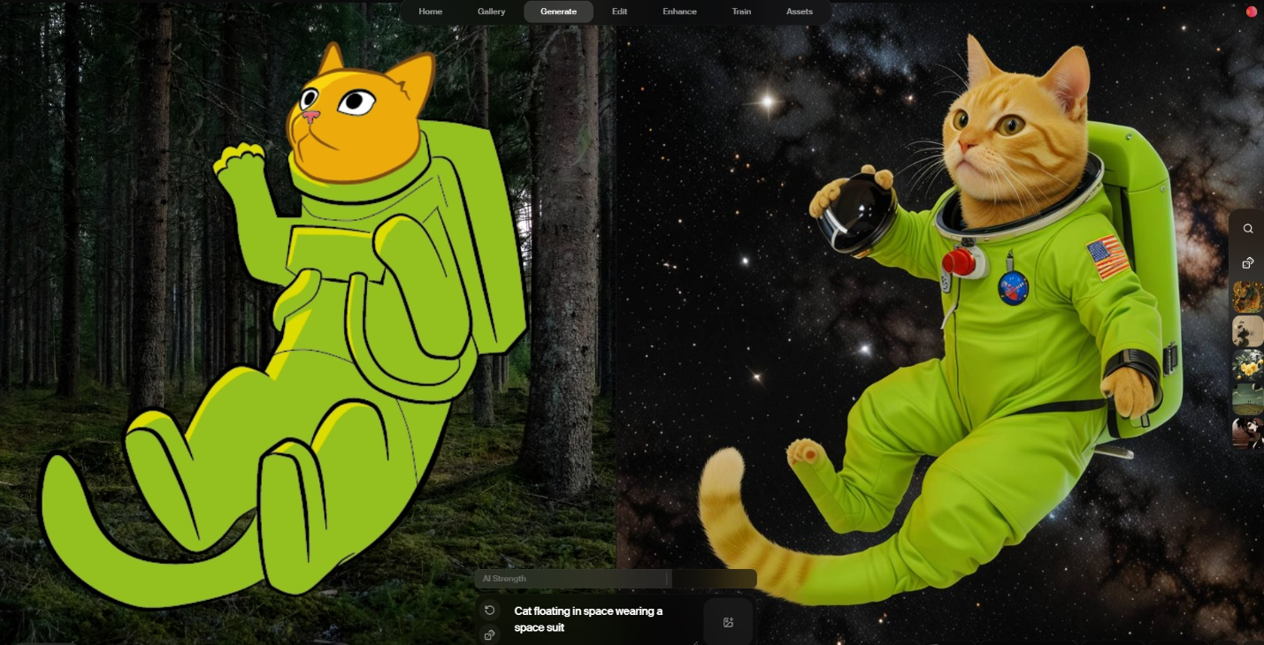Figure 25. The image shows the full picture of the cat (left) and its AI interpretation (right) including rendering errors.
To summarize, AI image generators developed quickly between 2019 and 2024, with increased levels of functionality providing more control over the end product. The focus of later experiments was on image-to-image generation because it requires design skills like drawing, composition and an appropriate concept, all of which allow artists and designers to retain an advantage, and therefore had the potential to be taught to students. Errors still remain in the AI generated images, but many could be worked on further for a finished design, meaning AI could be used to save time.
It should be noted that more abstract styles have been harder to achieve, with the AI interpretation leaning towards three-dimensional subjects, like Figure 26, which attempts but fails to apply a cubist style:
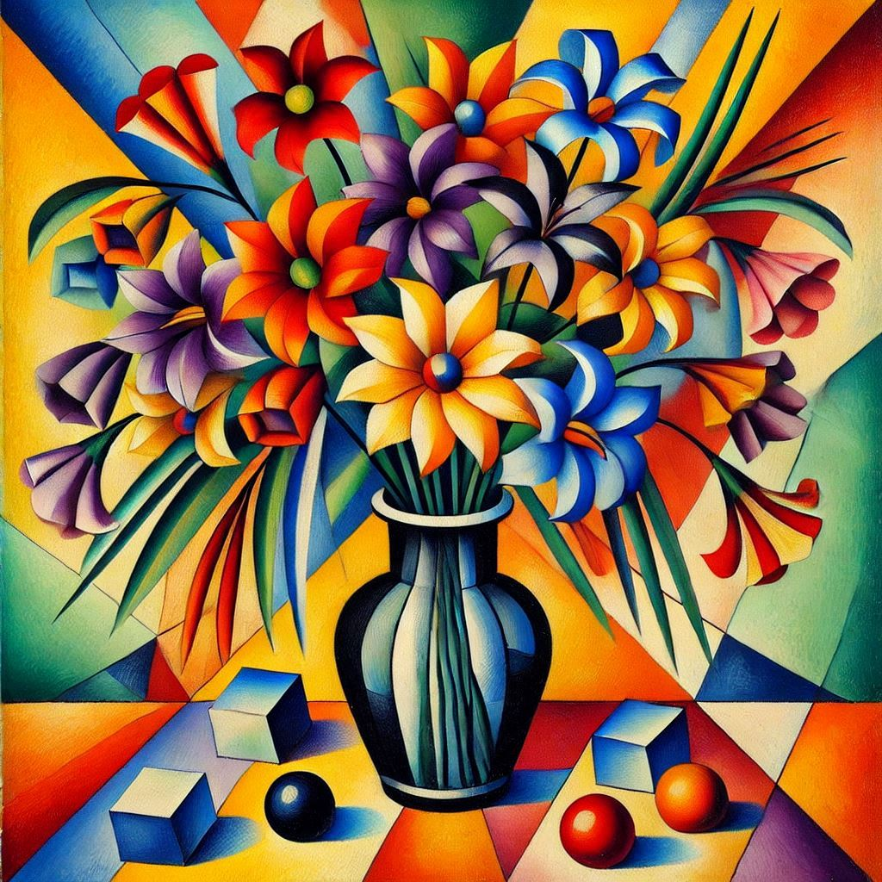
Figure 26. An AI generated image from Microsoft Copilot using the prompt “A cubist painting of flowers”
This, as with other AI errors, would require significant amendments (or even just making from scratch), and may provide some comfort to those who fear AI may take their work. However, AI continues to develop, and what it can’t do now, it may yet be able to.

Implementation
From 2020 to 2024 students were first informed of the potential applications for AI and later, encouraged to use it. The following briefly documents the students’ submitted work and highlights some of the issues when working with AI images. It also features the views of some students, which were gathered via brief online text-message interviews.
In 2020, stage 2 Illustration and Design students were encouraged to discuss AI and its potential uses during a seminar after being introduced to Artbreeder. Four years later, two students were asked to reflect on the session and were asked, “Did you feel it was worth learning about AI when you were at University?”. One responded, “I think we could have benefited from learning more about it. But at the same time, it’s developed so fast I’m not sure it would have made a difference...". Another said, “Absolutely, I wish we had more time to cover it and more of its uses...”.
In 2022 and 2023, students were given the task of generating and then fixing or improving an AI image to demonstrate the challenges inherent in working with AI. The submitted assignments showed the students tended to apply a ‘light touch’ to the artwork by fixing small errors (fig. 27). It became apparent that to amend or improve the image, they needed the level of skill required to have made it from scratch. Where students had gone to the effort of amending more of the image, the changes were often noticeable as they struggled to match the form, lighting and style of the AI generated image (fig. 28).
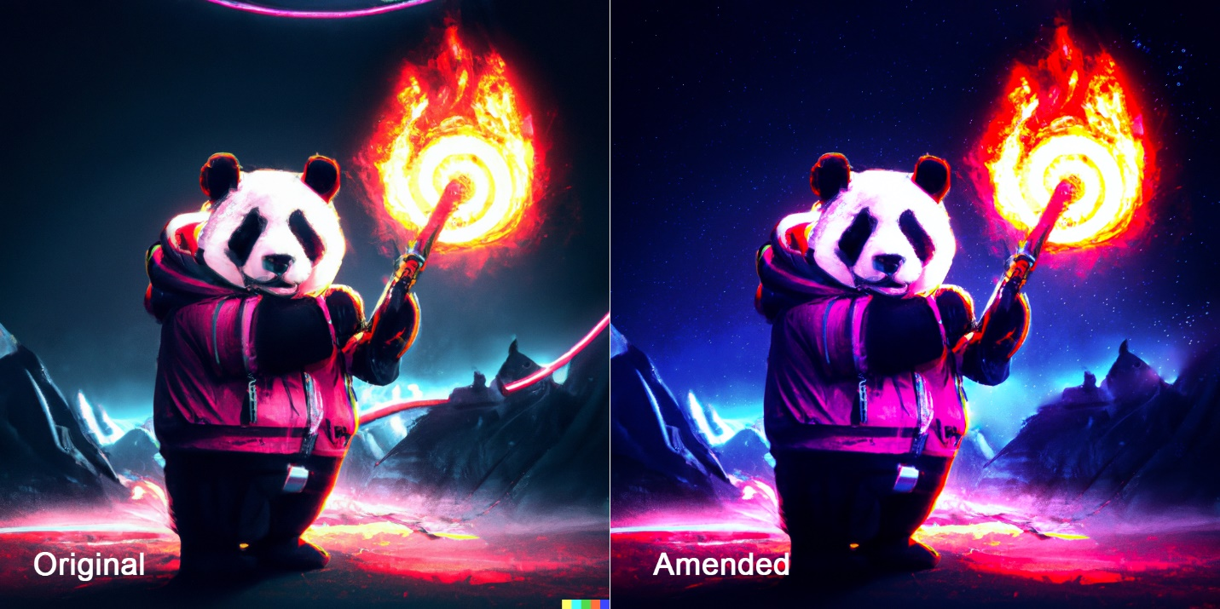Figure 27. The AI image on the left only had minor adjustments applied in the amended image on the right (Ramsden, 2023).
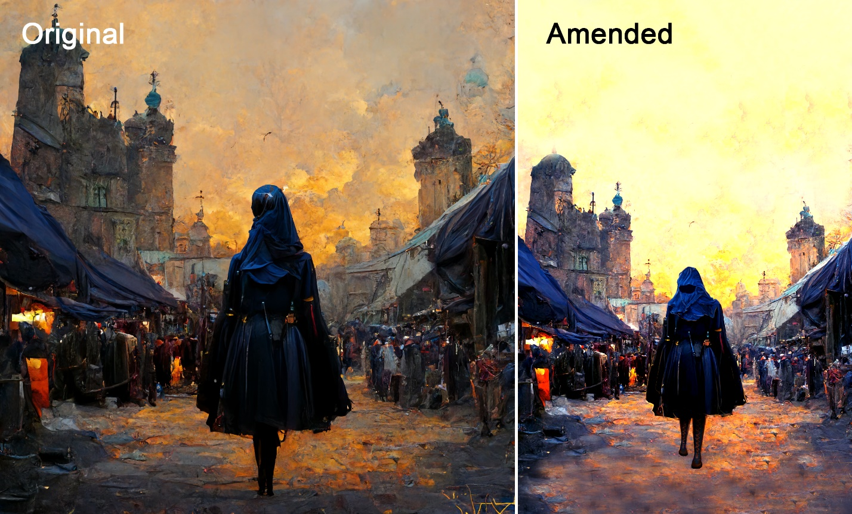Figure 28. The amended AI image on the right shows a repeated pattern and blurring on the ground which breaks the sense of depth, and it could be argued the figure is less ’grounded' in the image as there is no shadow underneath it (Necula, 2023).
Where AI had been used in other projects, errors also surfaced in the finished work. For example, in 2024, AI was used to generate backgrounds for an animation in a Final Major Project. Though the use of AI saved time, errors from the AI generation persisted in the final animation. (fig. 29).
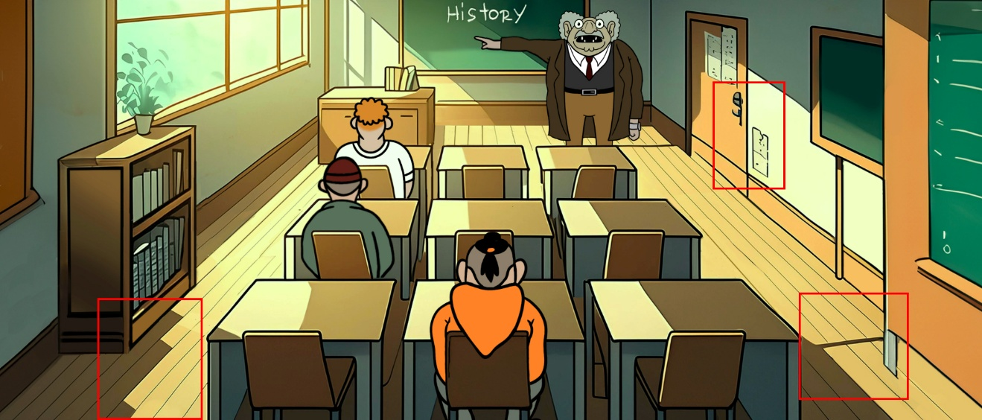
Figure 29. A screenshot from ‘Dreamscapes Forging’. (Ramsden, 2024) with AI artefacts highlighted in red.
These errors suggest that students working with AI may be able to work more quickly or at scale, but must also be able to remedy the errors that inevitably occur as a result of using AI.
In 2024, stage 2 students took part in a workshop entitled, ‘Draw the Box it Came In’. The principle of the workshop is to draw a basic 3D form in which to then draw a more complex form, like a car, (fig. 30) and is based on advice from the book, ‘101 things I Learned in Architecture School’, (Frederick, 2007). The drawing provided a good basis for a sketch that could be used in Vizcom (fig. 31).
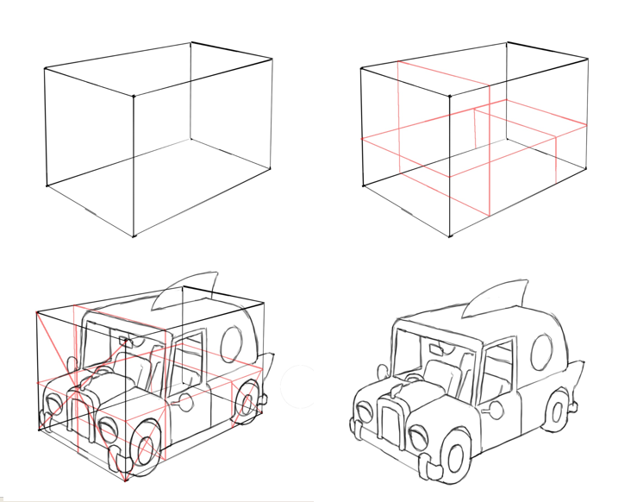
Fig. 30. The ’Draw the Box it Came in Exercise’.

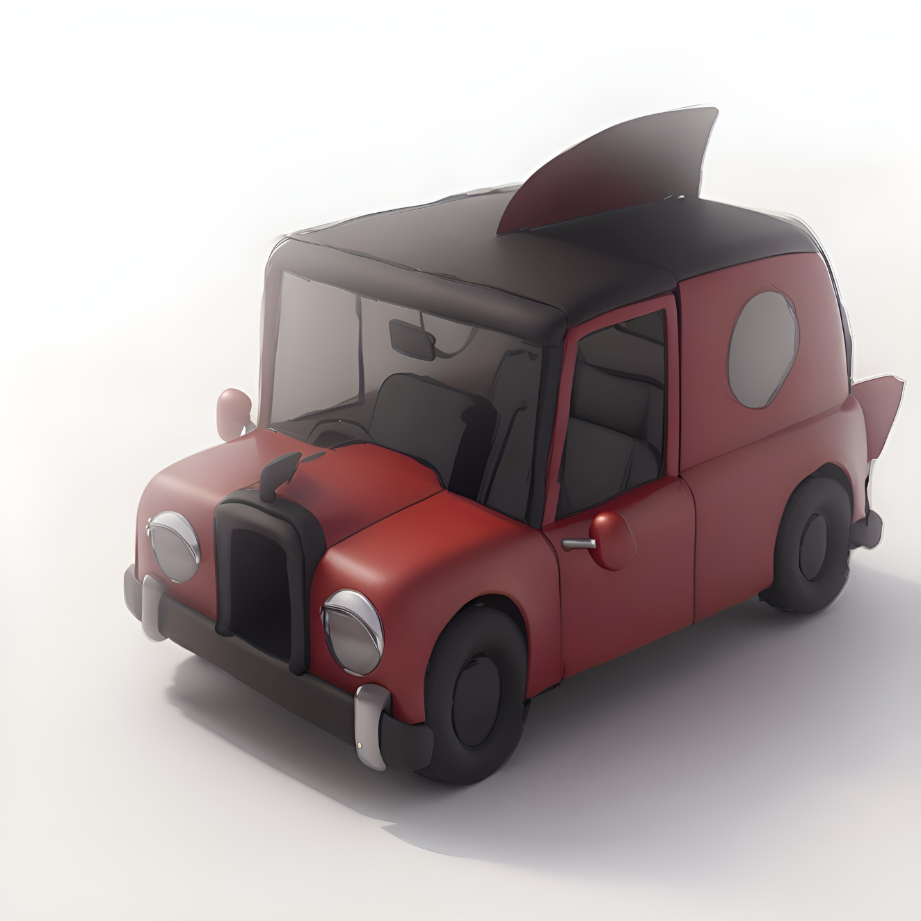
Fig. 31. AI generated car in Vizcom.ai.
The more able the students were at drawing three-dimensionally, the better the result. Conversely, if errors occurred at the sketch stage, they were carried through in the final render.
In an online interview in March 2025, a student was asked, “Did using AI for the car task change your view of using AI?”. They responded, “Sort of. I recognise its use for concept art and for quickly building on your own ideas. But it is also very easy to fall into this trap of relying on the AI or using it for more and more abstracted concepts…”.
All three of the students interviewed were asked, “How do you think AI will affect your future career?”. The respondents who graduated in 2022 replied:
“If I were to have continued down a path more creative for example in graphic design or concept art, I unfortunately think it’s going to make a lot of that side of the world redundant.”
“…I may as well use it to help me, but that’s not what I want to do, I create art myself not [to] feed it into a computer.”
The respondent in their final year replied:
“For now I don't think it will have a huge impact, mainly because of the taboo placed over it by the art community...”
In summary, students valued being taught about AI and in some cases, it has saved time on projects, which reflects how AI has been used on other degree courses (Freeman, 2025). However, good drawing and digital painting skills were needed throughout the process, otherwise AI generated errors were either not amended, or the users' mistakes at the sketch stage persisted in the final image. This suggests that students should maintain their core skills of ideation, drawing and painting, but as AI becomes more of an assistant, they may also have to develop skills in managing its outputs and working at scale. Although the students interviewed acknowledge its potential, attitudes toward using AI seem largely negative, either with regard to its impact on job prospects, the ethical issues associated with copyright or its replacement of human endeavour.

Future Challenges
The following summarises a series of challenges relating to the use of AI in illustration practice that are either current or are likely to occur and will have implications for teaching and learning.
Unlike software developed for one specific purpose (Adobe Photoshop for editing images, Autodesk Maya for creating 3D animation), the latest AI appears to act more like an adaptable ‘black box’ which can be trained on many types of data for many different purposes. DALL-E 2 used a combination of GPT-3 (a neural network deep learning model for understanding and generating text), CLIP (a system for recognising and categorising images) and an image generator. This ability to adapt and combine algorithms by training them with different data, has allowed the rapid development of multiple apps. Many of these apps are produced far more quickly and effectively than using conventional methods of software development. Their proliferation is further enhanced by the open-source nature of development, with a leaked Google memo stating that, “The barrier to entry for training and experimentation has dropped from the total output of a major research organisation to one person, an evening, and a beefy laptop,” (Economist, 2023). It cannot be assumed the pace of AI development will be increased or even maintained, but even combining the current AI tools would change - and are changing - the way we design. Considering the sentiment of the leaked Google memo in particular, it is likely the new tools will develop relatively quickly and will be available to many, furthering the democratisation of design. Imagine then, the effort required of lecturers to keep pace with technology that changes so quickly.
It could be said that the best of AI design cannot compete with the best of human design, but in fact it may not have to. Milestones such as Deep Blue’s victory over Gary Kasparov at Chess in 1996 (IBM, no date), belie the fact that forms of AI such as computer chess games were able to beat many humans for a number of years prior. This means that even at an early stage, AI image generators could well replace illustrators for several tasks. The Luddites fought against the rise of the technology that was making them redundant, but new jobs were created in other sectors of the economy. Their apparent mistaken belief that technological advancement inevitably leads to redundancy has been dubbed the ‘Luddite Fallacy’, yet the Goldman Sachs report suggests technology does threaten to take the jobs of a significant part of the workforce. Fallacy or not, with the threat of disruption, redundancy or reduced wages, it would be natural for prospective illustration students to question their investment in higher education.
As AI completes a larger part of the illustration process, this could put illustrators in a situation where they must be highly skilled but are called upon only to fix and amend designs, (as demonstrated in the student examples). This may mean an illustrator requires a high level of skill, but only works on a small amount of each project, highlighting the objection raised by the student who didn’t want to “feed” their work into a computer. Students who value the endeavour of creating artwork from scratch may be put off a profession that threatens to take away a large part of the work they enjoy.
The development and proliferation of AI image generators comes at a time of increased democratisation within design learning. The use of key design software (Adobe Suite, Autodesk Maya and AutoCAD for example), able to run on affordable computers in combination with online tutorials from YouTube to Massive Open Online Courses (MOOCs), allows potential designers to acquire skills outside of formal education. Meanwhile, social media enables designers of all kinds to promote their work. Cheaper and even free viable alternatives to established software are also increasingly available, with a free 3D Software, (Blender) being used to produce the Oscar winning film ‘Flow’ in 2025 (Brooks, 2025) and popular drawing software like Procreate available for under $12.99. iPads and Apple Pencils (or their alternatives), can do the job of hardware considered specialist little more than a decade ago, such as Wacom Cintiqs. This increased access to free/low-cost training, software and hardware alongside AI design tools may lead some to question whether the (often significant) investment of time and money in higher education is worth it.

Conclusions and Recommendations
The following summarises how design teaching and learning in higher education can respond to the development of AI. Some suggest a continued focus on core disciplines, such as quality of idea generation and critical thinking, and others a level of flexibility and adaptation.
Encourage students to research and apply AI in new ways:
It is likely that students and lecturers will need to be more flexible in their approach, incorporating suitable new AI-aided applications into teaching and learning, as and when they develop. By using AI software students can be made aware of its capabilities and limitations, and in doing so can seek out new opportunities, as well as avoiding tasks that are likely to be automated.
Critical thinking:
Although AI design tools will enable many to create designs, it may not enable them to critically evaluate what they produce. The role of tutors in this regard remains the same - providing discussion and inviting students to reflect on their work, with the added knowledge of the student’s previous endeavours. This is a role that is yet to be replicated by online courses or AI apps.
Working at Scale:
Automating some tasks using AI, like ideation and 3D model creation, will enable students to broaden the scope of projects. An illustrator could attempt a full graphic novel instead of individual illustrations for example. Understanding how to leverage multiple applications within a single project will enable students to create more in less time and is likely to reflect the process in industry. It will be important therefore to encourage students working with AI to consider working at scale to make best use of the technology.
Research and knowledge-sharing:
As research institutions, universities can study and experiment with new AI tools in a way that industry may not have the time or resources for. This provides an opportunity for them to take a lead role in shaping industry practice. At a time when funding is tight, universities could provide short courses in the practical application of AI tools that would benefit both students and businesses.
Adapting degree courses to incorporate AI could involve a procedure like that undertaken in this study. Due to the pace of change, it would require a continual cycle, with the following steps:
- On-going research of AI tools.
- Selection of tools that provide students an advantage by leveraging their particular knowledge and skills. (In relation to illustration this includes drawing and painting, knowledge of art and design history/theory and critical thinking).
- Review and update of teaching resources.
- Review and update of module specifications.
- Monitoring outcomes of students and their experience of AI after graduation.
The time required to research, test and monitor AI would need to be taken into account in work-loading, as well as the regular review and update of teaching resources and module specifications. This reflects the pace of change outlined not only by Schwab, but also the students interviewed in this study. Universities risk falling behind their own students or the general public if they fail to keep up with new AI tools and their subsequent impact on industry and society. The speed of change may vary, but even with current tools, design educators will need to adjust teaching and learning to incorporate AI and shape the expectations of their students so they can be prepared for the changes brought about by The Fourth Industrial Revolution.

Disclosure Statement
All materials included in the article represent the authors’ own work and anything cited or paraphrased within the text is included in the reference list. This work has not been previously published nor is it is being considered for publication elsewhere. We declare there are no potential conflicts of interest which might have influenced the authors in reporting their findings completely and honestly.

Reference List
Adobe. (2023) Meet Adobe Firefly, Now in Photoshop. Available at: https://www.adobe.com/uk/sensei/generative-ai/firefly.html (Accessed: 15 December 2024)
AOI. (2025) UK Government Copyright and Artificial Intelligence Consultation Association of Illustrators Response. Available at: https://theaoi.com/wp-content/uploads/2025/02/AOI-Response-_-Copyright-and-AI-Consultation.pdf (Accessed: 11 March 2025).
Bah, S. (2023) Agenda features Patrik Schumacher on Zaha Hadid Architects' use of AI. Available at: https://www.dezeen.com/2023/05/02/dezeen-agenda-features-patrik-schumacher-on-zaha-hadid-architects-use-of-ai/ (Accessed: 15 December 2024).
Bamford, A. (2023) How are university design courses adapting to incorporate AI?. Available at: https://www.designweek.co.uk/issues/03-july-7-july-2023/ai-design-higher-education/ (Accessed: 11 March 2-25)
Barthes, R. (1967) The death of the author. Aspen.
Briggs, J. and Kodnani, D. (2023) The Potentially Large Effects of Artificial Intelligence on Economic Growth. Available at: https://www.key4biz.it/wp-content/uploads/2023/03/Global-Economics-Analyst_-The-Potentially-Large-Effects-of-Artificial-Intelligence-on-Economic-Growth-Briggs_Kodnani.pdf (Accessed: 15 December 2024).
Brooks, X. (2025) Halt Disney! Flow’s director, and fellow upstart animators, on a new era for the artform. Available at: https://www.theguardian.com/film/2025/mar/09/animation-oscars-flow-memoir-of-a-snail-wander-to-wonder (Accessed: 11 March 2025).
DACS. (2024) ‘The Artist Earnings Survey 2024‘. Available at: https://cdn.dacs.org.uk/uploads/documents/The-Artist-Earnings-Survey-2024_Artistic-Uncertainty-and-the-Pressures-Facing-UK-Visual-Artists.pdf?v=1732286719 (Accessed: 15 December 2024).
The Economist. (2023) What does a leaked Google memo reveal about the future of AI? Available at: https://www.economist.com/leaders/2023/05/11/what-does-a-leaked-google-memo-reveal-about-the-future-of-ai (Accessed: 15 December 2024).
Fear, N. (2024) Lego is the latest brand to apologise for using AI art. Available at: https://www.creativebloq.com/news/lego-admits-to-using-ai (Accessed: 12 March 2025).
Frederick, M. (2007) 101 Things I learned in Architecture School. MIT Press.
Freeman, J. (2025) Student Generative AI Survey 2025. Available at: https://www.hepi.ac.uk/2025/02/26/student-generative-ai-survey-2025/ (Accessed: 11 March 2025).
Glynn, G. (2023) Sony World Photography Award 2023: Winner refuses award after revealing AI creation. Available at: https://www.bbc.co.uk/news/entertainment-arts-65296763 (Accessed: 12 March 2025).
Heikkilä, M. (2023) This new data poisoning tool lets artists fight back against generative AI. Available at: https://www.technologyreview.com/2023/10/23/1082189/data-poisoning-artists-fight-generative-ai/ (Accessed: 11 March 2025).
IBM. (No date) Deep Blue. IBM. Available at: https://www.ibm.com/history/deep-blue#:~:text=Deep%20Blue's%20first%20major%20test,champion%20under%20regular%20time%20controls. (Accessed: 24 March 2024).
Karras, A., Laine, S. and Aila, T. (2019) Style-Based Generator Architecture for Generative Adversarial Networks. Available at: https://arxiv.org/abs/1812.04948 (Accessed: 12 December 2024).
Karras, A., Laine, S. Aittala, M. Hellsten, J. Lehtinen, J. and Aila, T. (2020) Analyzing and Improving the Image Quality of StyleGAN. Available at: https://arxiv.org/abs/1912.04958 (Accessed: 12 December 2024).
Marr, B. (2024) Worried AI Will Take Your Job? How To Stay Relevant In The GenAI Era. Available at: https://www.forbes.com/sites/bernardmarr/2024/03/12/worried-an-ai-is-going-to-take-your-job-heres-how-to-stay-relevant-in-the-generative-ai-era/ (Accessed: 11 March 2025).
Merchant, B. (2023) Blood in the Machine: The Origins of the Rebellion Against Big Tech. Boston. Little, Brown.
Necula, G. (2023) Untitled. [Digital Painting and AI]. Sunderland.
Open AI. (2022) DALL-E 2 Explained. Available at: https://www.youtube.com/watch?v=qTgPSKKjfVg (Accessed: 12 December 2024).
Plunkett, L. (2023) Blizzard's AI Tools Sound Incredibly Depressing. Available at: https://kotaku.com/blizzard-ai-art-stable-diffusion-concept-activision-1850463809 (Accessed: 12 December 2024).
Qadri, R., Shelby, R. Bennett, C. and Denton, E. (2023) AI’s Regimes of Representation: A Community-centered Study of Text-to-Image Models in South Asia. In: Proceedings of the 2023 ACM Conference on Fairness, Accountability, and Transparency (FAccT '23), June 12 - 15 2023, Chicago IL. Association for Computing Machinery, pp.506–517. Doi: https://doi.org/10.1145/3593013.3594016
Ramsden, C. (2023) Untitled. [Digital Painting and AI]. Sunderland.
Ramsden, C. (2024) Dreamscapes Forging. [Digital Painting and AI]. Sunderland.
Salain, I. (2019) Stroke of Genius: GauGAN Turns Doodles into Stunning, Photorealistic Landscapes. Available at: https://blogs.nvidia.com/blog/gaugan-photorealistic-landscapes-nvidia-research/ (Accessed: 12 December 2024).
Schwab, K. (2017) The fourth industrial revolution. New York. Penguin Random House.
Simon, J. (2024) Art Breeder. Available at: https://www.artbreeder.com/ (Accessed: 12 December 2024)
Stacey, K. (2025) UK ministers consider changing AI plans to protect creative industries. Available at: https://www.theguardian.com/technology/2025/feb/25/uk-ministers-planning-to-change-ai-plans-to-protect-creative-industries (Accessed: 11 March 2025).
Vallance, C. (2022) "Art is dead Dude" - the rise of the AI artists stirs debate. Available at: https://www.bbc.co.uk/news/technology-62788725 (Accessed: 13 March 2025)
Vizcom. (no date) Vizcom.ai. Available at: https://www.vizcom.ai/ (Accessed: 11 March 2025).
Walter, B. (2010) The work of art in the age of mechanical reproduction. Prism Key Press.
Wang, P. (2019) This Person Does Not Exist. Available at: www.thispersondoesnotexist.com/ (Accessed: 12 December 2024).
Weal, S. (2023) Lecturers urged to review assessments in UK amid concerns over new AI tool. Available at: https://www.theguardian.com/technology/2023/jan/13/end-of-the-essay-uk-lecturers-assessments-chatgpt-concerns-ai (Accessed: 12 December 2024).
Whiddington, R. (2022) ‘Independent Artists Are Fighting Back Against A.I. Image Generators With Innovative Online Protests’. Available at: https://news.artnet.com/art-world/independent-artists-are-fighting-back-against-a-i-image-generators-with-innovative-online-protests-2231334 (Accessed: 12 December 2024).
Zhang, L., Rao, A. and Agrawala, M. (2023) ‘Adding Conditional Control to Text-to-Image Diffusion Models’, Proceedings of the IEEE/CVF international conference on computer vision. pp. 3836-3847. Doi: https://doi.org/10.48550/arXiv.2302.05543

