An innovative approach in teaching public health nutrition to university students
Farzad Amirabdollahian
Coventry University
Corresponding author: f.amirabdollahian@coventry.ac.uk
Abstract
Recent study suggests that learning principles of public health related topics in programmes concentrating on management of a patient’s clinical condition at individual level, is a problematic area; whilst introducing a variety of educational activities including work and/or experience based learning may offer the potential to address the issue. This paper reports on an innovative approach for enhancing classroom engagement and the overall learning experience of students studying public health nutrition. A package consisting of ten pedagogical interventions such as an animated online environment and role play was introduced. A combination of qualitative and quantitative evaluation was conducted; generally students believed that their overall engagement had improved and all activities were to some extent useful in improving their engagement. Among the activities, the flexible structure of the module, continuous and regular post it note evaluation and role play were the seen as most favourable. All criteria in the module evaluation considerably improved compared with the previous year, providing evidence for the enhanced learning experience. Some of the activities that are included in this study might be applicable to other programmes; however discipline specific research is required prior to implementation. Further research is required to accurately evaluate student engagement.
Key words: Intervention - Educational activities - Student engagement - Learning experience - Public health nutrition

Introduction
Module leadership is one of the main areas of responsibility in my current position and ‘Public Health Nutrition and Dietetics’ is one of the modules that I lead within my department. This is a level three (year four), single module for BSc Dietetics aiming to 1) enable students to apply their knowledge of nutrition to improve the health of the populations and groups in a variety of settings; and 2) provide students with a detailed understanding of current nutrition and health policies and the process of constructing, implementing and evaluating them. Public Health Nutrition and Dietetics is a module that traditionally has not been ‘troublesome’ for us. Students have generally found it straightforward and relatively easy. Usually there has been a good ‘pass rate’ and there has not been a need/instruction to revise or improve the delivery of this module.
So when I started working at my current department in March 2009, I started with a series of observations of the module sessions to get to know the module. I must mention that I am a Registered Public Health Nutritionist (i.e. the field is my area of expertise) and considering that the colleagues who were previously delivering this module were clinical dietitians, my first impression was that they did an excellent job with the delivery of the learning outcomes. Within the class though, there was something peculiar happening.
I realised that the class was generally ‘too quiet’ compared with other modules in the programme. Participation of the students in class activities was limited to three or four students (whom I would consider proactive). The majority of the students generally agreed with the comments of the teacher, neither asked any questions nor answered to the questions of teacher, which considering the famous Perry’s theory of changes in thinking and level of learning (Perry, 1970) did not seem to be right.
Perry’s studies of changes in thinking demonstrate how students develop increasingly sophisticated modes of thinking as they progress through Higher Education (HE) (Ramsden, 2003) and grow from being ‘dualists’ (who believe that ‘right’ answers exist, held by teachers and textbooks) to ‘relativists’, who have learnt about the existence of alternative interpretations of ‘reality’ (Brockbank and McGill, 1998, Ramsden, 2003). Considering the fact that these were the final year students, about to graduate from the university, this lack of participation in class activities and discussions was unusual compared with other level three modules within the BSc Dietetics.
When I later on talked to one of my colleagues, I was given some explanations, which I will try to present in the following paragraph (this conversation took place while we were observing students during group discussions. Students were preparing their answers to be presented to class. This conversation is not transcribed verbatim):
- Aren’t they generally too quiet? Those two groups are just talking about fashion and food…
- That’s the thing. They are always like that.
- But why they are like this? Year four students? (…some dialogue about what kind of students we were and complaining about these new students…)
- Well, they are not the strongest cohort, there is a lot going on in their lives, they have a lot of work in year four and at the end of the day, most of them are going to end up being (acute/clinical) dietitians working in the wards of hospitals (so they might not really need this module: unsaid)
- That’s depressing to watch. Let’s see if I can lift them up a bit. Wish me luck!

- (Me moving forward and talking to the classroom): Right, we are going to have a game based on (TV programme called) The X Factor. Do you watch The X Factor?….
Despite this lack of engagement and interest in the classroom, almost all of the students passed the module without a problem, some of them (the proactive ones?) would get a very good mark in this module and the average module mark (usually between 55-65%) was very good. This made the puzzle even more complicated. So being so passive in the classroom, these students were not developing to be ‘relativists’ (as William Perry would have described) and yet they managed to somehow meet the learning outcomes and pass the module. A few months later (and especially after looking at the coursework), I found a possible explanation.
In clinical and research modules, these students learned about ‘Evidence Based Practice’ (EBP) and the critical appraisal of documents. For the coursework of this module (coursework 1: critical appraisal of a current policy and coursework 2: devising a food and nutrition policy at local level), they would have usually considered and cited several textbooks and articles (and perhaps as they would have done in their other modules), mentioned the strengths and limitations of the theories (maybe regurgitating how different authors supported and/or criticised each other in their books), without acknowledging the completely different aim of this module and understanding it in-depth. For this module, we needed our students to learn the process of nutrition policy making (at international, national and local level) and appraise the current policies via constantly visualising the work with the public and facing the challenges of the outside world (which I think were the missing elements). Ultimately, what was completing this vicious cycle was the fact that the lecturers (excellently delivering the principles of public health nutrition), would have evaluated the students, assessing their knowledge (and maybe not application of the knowledge for improving health), and their expectations would match the minimal (and rather book/article orientated theoretical) perspectives of the students.
In the field of public health nutrition, the students need to be equipped with skills and in-depth understanding to be able to face the challenges of the world of work. This is imperative when the students do not have an opportunity of placement in this field or are not able to shadow a public health nutritionist (e.g. for many international students studying in UK). For these cases, enhancing ‘students’ engagement’ in learning via developing appropriate class activities together with concentrating on work based learning or experience based learning may help to address the issue. This paper aims to report an innovative approach for enhancing student classroom engagement and overall learning experience in teaching and learning public health nutrition.
The concept of student engagement in Higher Education
There is no globally agreed definition for the term ‘student engagement’. Different authors have different definitions, and more importantly, different interpretations of this term (Bomia et al., 1997, Brewster and Fager, 2000, Chapman, 2003, Levy and Campbell, 2008, Natriello, 1984, Riggs et al., 2009). One of the most commonly used definitions of engagement is the one from Bomia et al. defining student engagement as ‘students’ willingness, need, desire and compulsion to participate in, and be successful in, the learning process’ (Bomia et al., 1997).
Among the definitions of students’ engagement, some are not specific to Higher Education (HE) (Natriello, 1984), some consider engagement together, the same as or similar to motivation (Brewster and Fager, 2000, Levy and Campbell, 2008) or cognitive intelligence (Riggs et al., 2009). While I respect the definitions of these authors, I was looking for a particular dimension of student engagement which was appropriate for my purpose and objectives.
Although the concept of students’ motivation greatly overlaps with engagement (motivation being a major determinant of engagement), and many investigators considered the two concepts together, these are not the same, as motivation is not the only predictor of students’ engagement (Fletcher, 2007).
In this paper, when I refer to engagement, I neither mean the engagement in the overall process of learning, nor specific factors such as motivation that are determinants of students’ overall learning. I simply mean the ‘students’ engagement in classroom activities’; referring to ‘student willingness to attend and genuinely participate in classroom activities’. This definition is close to the interpretation of Chapman of the term (Chapman, 2003) and my hypothesis was that enhancing this dimension would improve students’ in-depth understanding of the learning outcomes and would make learning an enjoyable experience for the students.
Rationale for the new approach
National view: ‘Working with students and other stakeholders to ensure a high-quality learning experience that meets the needs of students is one of the Higher Education Funding Council for England’s (HEFCE) strategic plan objectives (HEFCE, 2007). HEFCE is committed to working with various national stakeholders to enable a number of organisations such as the HE Academy, Quality Assurance Agency (QAA) and the National Union of Students (NUS) to work collaboratively together to develop student engagement policies and to inform institutional practice. The report by the Open University’s Centre for Higher Education Research and Information (CHERI) is an example of a national project funded by HEFCE to conduct a study on evaluating and enhancing student engagement (Little et al., 2009). The HE Academy declares that its view of student engagement ‘considers students as active partners in shaping their learning experiences’ and HE academy remains nationally committed ‘to promote the value of student engagement and highlight examples of effective practice’ (The Higher Education Academy, 2010b).
Institutional view: in the recent (2009) results of the National Student Survey (NSS), at some of the academic departments at Coventry University, the average scores of variables related to the teaching, academic support, feedback and personal development that could all directly/indirectly be related to ‘student engagement’ fell below the national average (The Higher Education Academy, 2010a). At the university level, we took immediate action to improve these areas and a successful approach in improving classroom engagement and consequently learning experience could set an exemplar for other modules.
Departmental view: despite the 100% pass rate of this module, in the previous year’s module evaluation, at least in some criteria the students evaluated the module poorly. For example, only 35% of the students agreed or definitely agreed that the module is well organised and only 45% of the students were satisfied overall with the module. Enhancing student engagement could have provided the opportunity for their participation in learning and also an opportunity for the module team to understand the strategies that could improve students’ learning.
Educational view: To my knowledge, there has not been a similar previous approach (i.e. a package of modifications specifically designed to improve the students’ classroom engagement in learning public health nutrition) in this programme and the current intervention is the first of this kind. Interventions included in the package were selected with the view that at least one (or some) of them would help to improve classroom engagement. Educational justifications of the interventions are mentioned in table 1.
Methodology
Design of the intervention
Based on intuition and/or previous research, a package consisting of ten pedagogical interventions aiming to improve the students’ engagement was introduced. The objectives were to:
- Investigate if this set of interventions (as an overall package) can improve the students’ engagement (self assessed by the students).
- Find out what are the most suitable activities for enhancing the self assessed students’ engagement.
- Investigate if, as a result of this intervention, the overall marks of the class and the evaluation of the module improved compared with the previous year.
The activities introduced are summarised in table 1 overleaf:
The second questionnaire aimed to assess the classroom engagement of the students. In order to find out what are the most suitable activities for enhancing the self assessed students’ engagement, the data of the questionnaires were analysed using PASW Statistics 17.0 software (SPSS, Inc., Somers, NY, USA) package. A quantitative value was allocated to each level of agreement with the statements (strongly disagree=0, disagree=1, no strong feelings=2, agree=3 and strongly agree=4). Therefore, the activities with the highest sum or mean were the most popular activities in enhancing the student classroom engagement.
Intervention | Description
Flexible structure of the programme | Source: ‘Allow students to have some degree of control over learning’ (Brooks et al., 1998)  Although students were given a timetable, they were aware that some of the topics may change based on the students’ progress in achieving the learning outcomes. Some of the tutorials (e.g. coursework preparation session) were made optional to attend and this was to provide time on-campus for the student, so they could study together.
Animated online environment | Source: previous studies demonstrated that as a result of learning with integrated animations, the learning experience of students substantially improved (Rosen, 2009)  In the web space of the module, all folders were converted to user friendly pictures and animations
Continuous post-it note evaluations (together with general halfway evaluation) | Source: intuition  Students’ progress (i.e. their view toward their strengths and limitations in meeting learning outcome of each session) was evaluated at the tutorials anonymously every other week
Role play (steering committee on devising local food policies)* | Source: ‘Design projects that allow students to share new knowledge with others’ (Brewster and Fager, 2000)  A four hour role play for simulating a steering committee for devising local food policy was designed. Members of the committee were given not only the task, but also a character. The classroom was significantly converted to be suitable for the role play
Series of related seminars on the nutritional status in disaster management | Source: ‘Ensure course materials relate to students' lives and highlight ways learning can be applied in real-life situations (Lumsden, 1994; Skinner & Belmont, 1991)’ cited in (Brewster and Fager, 2000).  A hypothetical case study (nutritional assessment and intervention in disaster management in Philippines) was given and for three weeks, the seminars were based on the same scenario
Role play (panel for applying for funding) | Source: ‘Ensure course materials relate to students' lives and highlight ways learning can be applied in real-life situations (Lumsden, 1994; Skinner & Belmont, 1991)’ cited in (Brewster and Fager, 2000).  An interview panel of consisting of students and a lecturer, interviewing students in groups, to allocate funding based on the TV programme Dragon’s Den
Online student area | Source: ‘Allow students to have some degree of control over learning’ (Brooks et al., 1998)  Students were allocated an area on the web, where (after approval of the module leader) they could upload their educational material on their online area and make it available to other students
Mandatory seminar group allocation | Source: intuition  Students could not choose their seminar partners. They were allocated to seminar groups, after consulting with more experienced lecturers and the year lead.
Allocation of a particular country to tutorial groups | Source: arousing students' curiosity about the topic (Peñafort, 2010, Strong et al., 1995)  A country was allocated to tutorial groups and they were responsible for constantly updating the class about specific dimensions of health and nutrition policies (learning outcomes) in their allocated countries
Involvement of internal & external speakers* | Source: ‘Ensure course materials relate to students' lives and highlight ways learning can be applied in real-life situations (Lumsden, 1994; Skinner & Belmont, 1991)’ cited in (Brewster and Fager, 2000).  Added to the second part of the module (after Easter and when students were preparing for submission of the other modules). Two external speakers were involved from Coventry City Council and The Heart of Birmingham Teaching Primary Care Trust and two internal speakers were involved from the department. All speakers were given instructions about learning outcomes of the session and to concentrate on their work experience in relation with learning outcomes
Table 1 Summary of interventions implemented to enhance the students engagement
*the intervention had already been in place; however the intervention was modified for the package to be more effective in line with the general aim of the study.
Participants
Overall 34 students (32 female and 2 males, all aged 20 years and over) were enrolled in this module from which 28 students (84%) completed the main evaluation questionnaire and 15 students (45%) completed the engagement self assessment questionnaire.
Data collection and analysis
A combination of qualitative and quantitative evaluation was used to assess the intervention. Post-it-notes were used bi-weekly as a means for formative evaluation together with classroom open discussions (e.g. what did you think about the classroom activities of yesterday?).
Summative evaluation included two questionnaires. The main module evaluation questionnaire aimed to assess the overall learning experience and consisted of Likert scale questions together with open questions for qualitative assessment.
Ethical considerations
The study was conducted in line with the Helsinki declaration for human studies and in accordance with the research code of conduct of the Coventry University. Within the university, the ethics committee was asked whether the study would need approval, but it was found that this type of study did not require ethical approval since it is simply auditing the general service.
Findings
Quantitative evaluation
A bullet point summary of the outcomes of the intervention follows. More detailed summaries of the findings are presented in figures 1 and 2 and the anonymous completed evaluation forms are available for further analysis.
- All (100%) students who completed the evaluation agreed or strongly agreed that their overall engagement had improved.
- Overall, students believed that all activities were useful in improving their engagement. Among the activities, the flexible structure of the module, continuous and regular post it note evaluation of the module and role play were the favourite activities for enhancing student engagement.
- All nine criteria assessed in the module evaluation considerably improved compared with the previous year.
- The overall student satisfaction of the module improved from previous year’s 45% to 93%.
- Overall pass rate and mean mark of the module (100% and 61.93% respectively) did not statistically change compared with the previous year (100% and 62.16%, P>0.05).
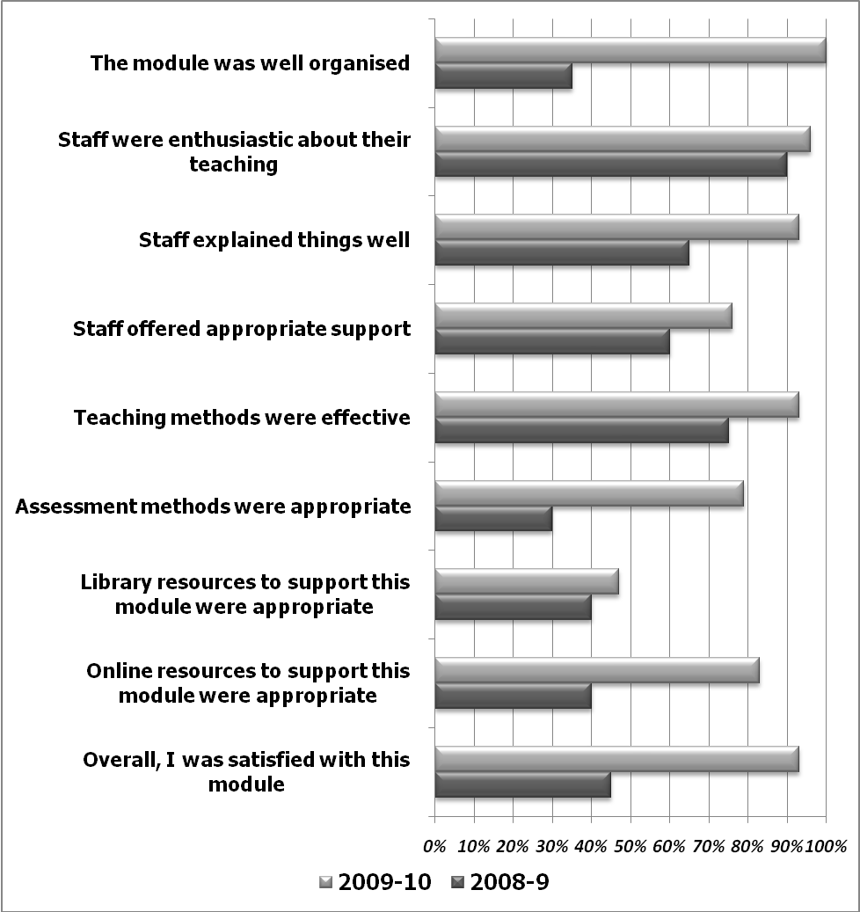
Figure 1 summary of findings of the module evaluation
All activities scored above the average of three, demonstrating that students agreed or definitely agreed that these activities individually contributed to enhancing their engagement (figure 2).
Figure 2 the most suitable activities for enhancing the students’ self assessed engagement
Qualitative evaluation
In the qualitative evaluation of the module, students clearly acknowledged the variety of activities that helped them to improve their learning. Students commended the ‘very different’, ‘interactive’, ‘enjoyable’ and ‘engaging’ module. Some of the direct quotations of the students follow (the quotes are transcribed verbatim):
‘(the approach is) very interactive, involves every member of the class’
‘teaching methods are engaging’
‘(the approach) makes quite a flat subject, interesting’
‘group work to learn from each other and improve communication skills (is useful)’
‘sessions are more interactive than other modules’
‘(I) love having the debates. I feel this is the skill that I need in the future, so it’s good to practice it’
‘everything is put up on CUOnline, which is useful as I do look at other people’s work and can refer back to it, if needed’
‘the group work is enjoyable and helps to put theory into practice’
In terms of feedback from peers, one of the external speakers from the National Health Service (NHS) clearly commented on the enhanced engagement of the group compared with the previous year (this quote is not transcribed verbatim: ‘there is something about them, what have you done? (joking), they are lovely, previous year they were not like this…’) and encouraged students to apply for a job in her department, when there is a job vacancy.
Discussion
Alignment with national, institutional, departmental and educational priorities
Dimensions of the students’ engagement with examples to support a conceptual framework of student engagement at national, institutional, departmental and discipline specific sectors are previously described by the HEA (The Higher Education Academy, 2010b).
With regard to the alignment with national priorities, there are three main principles for the HE Academy’s work on the students’ engagement to A) develop the understanding of the meaning of the term, B) promote a cultural change that sees student engagement as a central aspect of learning and teaching, and C) share evidence based practice on students working as active partners in shaping their learning experience (The Higher Education Academy, 2010b). With regard to the principles of the HEA, the current intervention seems to be a success.
Considering the alignment with faculty and departmental priorities, elements such as developing the students’ learning experience and developing an innovation in the curriculum, which were addressed in this intervention, were in line with the faculty teaching and learning strategy of 2010-2015.
Assessment of the students’ engagement rate is difficult and a self evaluation of the engagement is used in this study. Using a validated method of assessing student engagement should be addressed in further work. If we consider enhancing students’ engagement as an ‘outcome’, the self assessed enhanced engagement overrides evidence of the success of the current innovation. Alternatively, if we consider enhancing student engagement as a means for achieving the outcomes (Markwell, 2007), such as improving the learning experience, the considerable improvement observed in all elements of the module evaluation gives strong evidence for the success of the innovation.
I am not aware of any similar interventions based on a package of changes affecting the classroom engagement of the students. Similarly, direct comparison with the national, institutional and departmental student engagement rate within the subject area is not possible (because of a lack of similar intervention in the programme, as well as difficulties with assessing engagement). On the other hand, table 2 demonstrates how our elevated overall student satisfaction rate moved to higher than the average national and university rate and matched our excellent practice within the department of physiotherapy and dietetics.
 | All HE institutes | CU | PD | 328DT
2008-9 | 83% | 79% | 98% | 45%
2009-10 | 82% | 78% | 96% | 93%
Table 2 Overall student satisfaction rate of the Public Health Nutrition Module (328DT), compared with the average satisfaction rate across all Higher Education institutes, Coventry University (CU) and the Department of Physiotherapy and Dietetics (PD)
Disciplinary-specific aspect of the trial
Although several authors already demonstrated how introducing new activities to the educational processes could improve the learning experience of the students (Davies, 1999, Gibbs et al., 1992, Gibbs and Habeshaw, 1992), and many elements of the current trial can be implemented in other educational settings, the activities of this trial were discipline specific (i.e. specific to public health nutrition) to improve students’ desire, knowledge and skills to face the challenges of the outside world. This seems to be achieved because I understand that three students have already got a job to work as a ‘Community Dietitian’ (public health dietitian) even before they officially graduate from the university and I am aware of two other students who are applying for jobs in this field.
Limitations of the study and direction of further research
With regards to the positive outcome of this programme, one can argue that success is not necessarily down to the innovative programme introduced particularly as we are comparing two different cohorts of students that might have had very different characteristics, and there has been no attempt to control the intervening variables. Whilst I acknowledge these, I restate that firstly the extent of the success of this intervention in improving the classroom engagement and particularly learning experience is so considerable, that even if a part of it, is because of the introduced intervention, the overall success justifies the necessity of the further investigation. Secondly, these changes were the only main changes compared with the previous year’s programme and this minimises the possibility of the major contribution of other factors in achieving success. Moreover, the performance and the module evaluation in other modules have already demonstrated that the current cohort has not necessarily been a cleverer cohort or a cohort generally more satisfied with the course in comparison with the previous year’s cohort.
Although all criteria assessed in the module evaluation improved compared with the previous year, the average mark of the module did not significantly improve compared with the previous year. A possible explanation is that regardless of the changes to the structure of the module, the formal assessment of the module did not change. The innovative activities introduced to the module require innovative assessment methods and this is a priority for teaching public health nutrition in our programme.
A potential limitation of this intervention is the fact that the changes are delivered as part of an educational package and it is difficult to assess what would be the impact of a single intervention (if any). One can argue that the package introduced variety in the delivery and this has been the ‘variety’ that had relieved the classroom boredom. Even if it is so, that would still be an achievement in improving the learning experience of the students. Furthermore, it should be remembered that the introduced intervention is only a preliminary experience in this field and more evidence is required from the replication of this intervention, ideally with better design and particularly more accurate evaluation of the trial.
Interventions that are included in this study (e.g. flexible structure and continuous monitoring of the programme) may be applicable to other programmes, however, discipline specific research is required to provide evidence on the most suitable and effective activities.
Further work at the discipline level could be focused on engaging students in helping to develop local nutrition policies (e.g. for central Birmingham) or in review and critical appraisal of the current local real life policies or in participating in the process of review for the policies that are advertised for consultation.
Conclusion
A package of ten new educational activities was introduced to the public health nutrition module aiming to improve students’ engagement. Written and verbal feedback from students showed that they strongly believed that their overall engagement in classroom activities increased. Among the activities, the flexible structure of the module, continuous and regular post-it-note evaluation of the module and role play were the most favoured activities for enhancing student engagement. All criteria assessed in the module evaluation considerably improved compared with the previous year and as a result, the overall student satisfaction was enhanced considerably. These provide evidence that the trial could improve the students’ learning experience.
The dimension of student engagement discussed in this trial (i.e. improving engagement in classroom activities) and its role in improving student learning experience has been known for many years (particularly for elementary and high school students), however often neglected or taken for granted for university students. In the conceptual framework of the students’ engagement in HE (Higher Education Academy, 2010b), there is substantial emphasis on the students engagement in roles commonly considered ‘extracurricular’ to students; while improving learning experience of university students via enhancing their engagement in classroom activities is overlooked. Further work is required in this field.
References

