Teaching with Teams: An introduction to teaching an undergraduate law module using Microsoft Teams

Louis Martin¹ and Dave Tapp²
¹Staffordshire University, ²De Montfort University
Corresponding Authors: louis.martin@staffs.ac.uk and d.tapp@dmu.ac.uk

Abstract
Microsoft Teams is a cloud app digital hub that brings channels, conversations, meetings, files and apps to Microsoft 365. Teams are made up of channels and channels are used to divide a Teams into topic or in this case undergraduate modules. The paper combines a practical analysis of Teams as a computer-supported collaborative learning (CSCL) process and explains what Teams can offer educators in higher education institutions (HEIs). Moreover, the paper argues that teaching and learning with the app is located within the social constructivism paradigm of educational theory. The paper engages in a discussion about a social constructivist approach to collaborative learning. The paper examines the authors’ use of a Team to teach the Language of Law, a module on a LLB(Hons) course. The authors discuss the use of the assignment tab to facilitate PowerPoint presentations in group workshops, allocate required reading and grade formative assignments.
Keywords: computer-supported collaborative learning, Microsoft, social constructivism,

Introduction

The aim of this short paper is to provide an introduction to the innovative use of the Microsoft 365 Teams app. The paper will explain what Teams can offer educators in higher education institutions (HEIs) and argues that teaching and learning with the app is located within the social constructivism paradigm of educational theory. The paper combines a practical analysis of Teams as a computer-supported collaborative learning (CSCL) process with a discussion about a social constructivist approach to collaborative learning. The paper includes a section which examines the authors’ use of a Team and channel to teach a law module on an LLB(Hons) course.

Literature Review

Woo and Reeves (2007) contended that the development of the Internet and its communication and sharing affordances such as email, chat, web discussion forums and other technologies exposed tutors and learners to significantly more varied and frequent interaction opportunities. Allen and Seaman (2017) found that approximately six million students participated in at least one online course in higher education institutions in 2015, compared to 1.6 million in 2002. Jan et al. (2019) opined that a significant amount of research on online learning relied on Vygotsky’s (1978) social constructivist theories of learning and Dewey’s (1938) concept of student-driven learning through engagement, active learning and collaboration. This paper argues that although the technological advances that have culminated in Microsoft Teams may seem complicated to tutors, the process is just a latest iteration of Vygotsky’s notion of socially co-constructed knowledge (Vygotsky, 1978).
Kukulska-Hulme (2012) considered how universities should adapt to the new external conditions which have an impact on teaching and other activity within schools and faculties. The authors’ own HEIs are post-1992-universities in the West Midlands region of England; one of the HEIs has introduced significant advancements in technology such as social media, online social networking and mobile technologies and entered into a partnership with Microsoft (Donnelly, 2017). Computer-supported collaborative learning (CSCL) studies support the idea that knowledge building is a collaborative process achieved through seamless conversation and shared ideas among students in a learning community (Xing et al, 2015). Martin et al. (2019) asserted that it is important for an online instructor to be proactive and take advantage of resources at their own institution. These authors (2019) explored the teaching of award-winning tutors who used both asynchronous and synchronous learning spaces using a variety of platforms including Desire2Learn, Blackboard, WebCT, Canvas and Moodle. The most important role of the online instructor, according to those interviewed, was that of the facilitator and instructor ‘presence’. Participating tutors stated that ‘being there’ for students and ‘having a presence that the students felt on the course site’ were essential (Martin et al., 2019). Akgün and Akkoyunlu (2013) pointed out that technological innovation in networking and communication has been integrated into education, rich learning environments are becoming more important qualitatively and functionally. Students play an active and constructive role during the discussion process in and during all interactions in fully interactive CSCL environments. Buelow et al. (2018) carried out a survey of 417 students and revealed that students found certain aspects of online discussions and interactive assignments engaging, especially those that prompted students with thought-provoking questions that relate to real-world situations and invited students to share diverse opinions and develop personal perspectives.

An analysis of Microsoft Teams

Microsoft Teams is a cloud app digital hub that brings conversations, meetings, files and apps together in a single Learning Management System (LMS) (Microsoft, 2018). An app is short for application, which is synonymous with a software program. While an app may refer to a program for any hardware platform, it is most often used to describe programs for mobile devices, such as smartphones and tablets (Techterms.com, 2019). Microsoft also uses the term bot in its literature about Teams; Christensson (2019) defined a bot - short for robot - as an automated program that runs over the Internet. Some bots run automatically, while others only execute commands when they receive specific input. A tutor can type “schedule meeting” into a chat, and the bot will gather information and then schedule the meeting and invite other staff members of students (Microsoft, 2018).
Tsai (2018) explained that real-time chat applications that work across multiple operating systems and devices are now ubiquitous. He claimed that some collaborative chat apps such as Teams offer functionality that email cannot, including chat rooms, video conferencing and features that replicate popular social media. Tsai (2018) predicts that Microsoft Teams will experience the most growth over the next two years. By the end of 2020, 41 percent of organisations expect to use Microsoft Teams globally. Tsai’s research included a survey of 901 respondents from various organisations including small-to-medium-sized businesses and enterprises. Respondents came from a variety of industries, including manufacturing, healthcare, non-profits, education, government, and finance (Tsai, 2018). Tsai’s (2018) study is somewhat limited for the purpose of educational research, however, it does provide a flavour of the type of environment students will experience as they transition into the workplace.

Members of staff and students at one of the HEIs were provided with Microsoft Office 365 ProPlus via the Microsoft Advantage subscription. Each license allowed the user to run Office on up to five machines either Mac or PC. Users could also run Office Mobile for Android or Office Mobile for iPhone on up to five mobile devices. The authors initially received basic training on Microsoft products and were provided with a Surface Pro laptop and tablet device with digital pen. The authors could also ‘cast’ their devices to most classroom screens in teaching areas across the Campus (Walmsley-Smith, 2018).

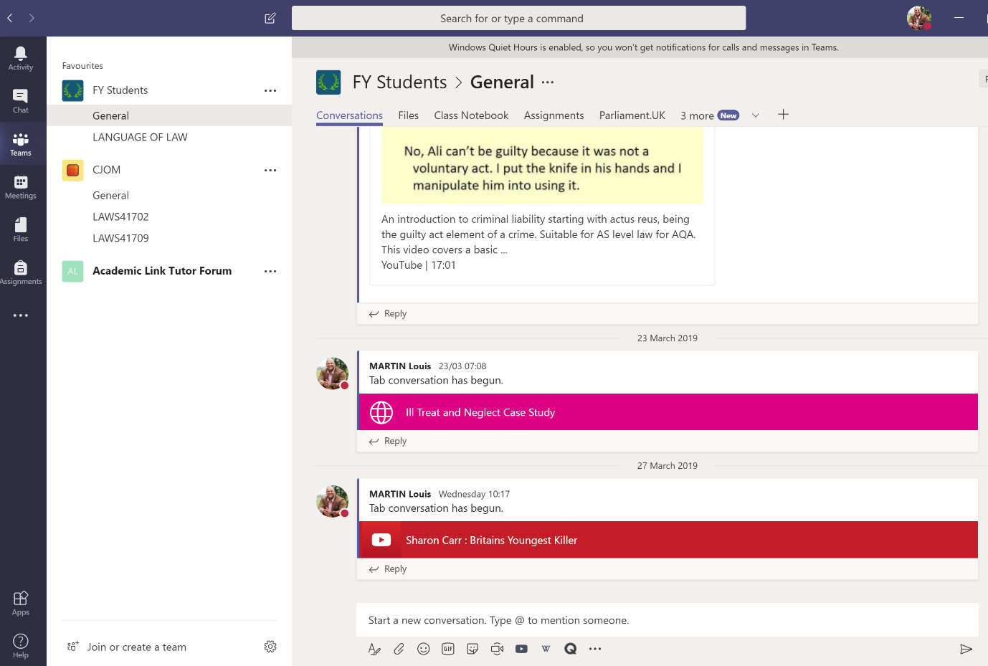

Figure 1. Screenshot of the FY Teams app 2019

Figure 1 is an image of a screen shot of one of the author’s Team app. The app creates a virtual learning environment and is structured in a way to facilitate movement quickly and easily from conversations to content creation (Microsoft, 2018). When a tutor creates a new team, a General channel is automatically added to the Team. The tutor may then create channels within the Team and Figure 1 shows the Course Criminal Justice with Offender Management (CJOM) Team with two channels. The two channels were used to facilitate teaching and learning on two first year modules; by default, anyone on the team can access these channels. The channels are the collaboration spaces within a Team where tutors and learners work collaboratively on tasks or access learning materials (Microsoft, 2018). Members can securely share and co-author documents and iterate on projects using the desktop and mobile applications. A tutor can create a new tab that links directly to a specific file, then select the app for the file type such as a PowerPoint presentation or YouTube clip. The tutor may also browse a built-in store of applications and create a tab using one of the applications available in the store such as Quizlet and Survey Monkey.
All the traditional features of Outlook and instant messaging are provided in Teams but are integrated into the General or channel groups. Tutors and learners can use the chat feature in Teams in place of short emails and this feature is popular on mobile devices (Microsoft, 2018). Sung et al. (2016) point out the diverse functions and types of hardware and software which are available for mobile devices. Teams includes audio, video and desktop sharing leading to a social constructivist focus on an individual's learning that takes place because of his or her interactions in the channels.

Pretorius (2018) discussed how tutors can post assignments to individuals, small groups, or the full class using the assignment function in Teams. Pretorius (2018) explained that in his own practise he could tailor assignments to everyone in his diverse classroom of learning styles and academic abilities. He evaluated the process of assignment submission; the student uploads a document to the Assignment tab and it goes into the Working files folder. The learner can still open it in the Teams Assignment tab and make changes. Once the student has clicked on the Turn In button, it is copied to the Submitted files folder and no longer allows any changes. When the student is ready to submit, he/she turns in the document. Even after submission the tutor can still make comments on the document and the student can still open it and view the comments but can no longer make changes (Pretorius, 2018).

Peterson et al. (2018) identified that the increasing use of synchronous formats, however, has resulted in multiple technologies to facilitate students’ interactions and expanded the modes of interaction available to students. The students on these modules can access all the teaching materials in the teaching room or remotely. The tutor sets activities using the files tab and other relevant tabs. Word documents are uploaded to the file tabs containing lesson plans and instructions for the sessions. Tutors can chat with the group or with individual learners and provide feedback. Phillips (2018) asserted that one of the best ways to engage with students both inside and outside the classroom using Teams is to encourage them to use the mobile app. Students get instant notifications of any mentions, homework or graded assignments.

This paper argues that this process develops collaborative learning as a process of peer interaction that is mediated and structured by the tutor. Discussion can be promoted by the presentation of specific concepts, problems or scenarios, and is guided by means of effectively directed questions, the introduction and clarification of concepts and information, and references to previously learned material (Jordan et al., 2008).

Language of Law

The case study in this section of the paper provides an analysis of one of the author’s deployment and use of a Team and channel in their professional practice. One on the author’s teaching on a foundation year forms part of an LLB(Hons) Award. The foundation year is an access year during which learners develop their skills prior to undertaking the traditional three-year Law Course.

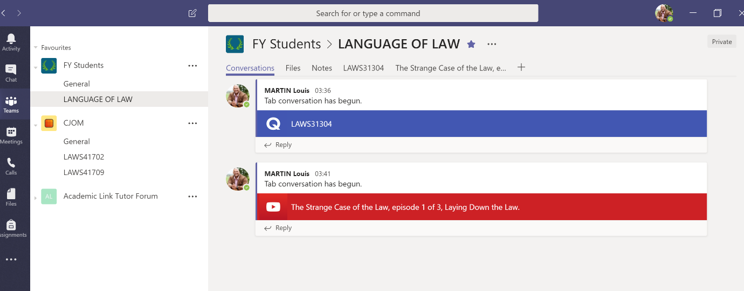
Figure 2 Screenshot of the Language of Law Channel

The students take a module called the Language of Law, this module teaches the students about legal English and covers the key areas of legal English usage for both written and oral legal communication in typical legal situations. Figure 2 is a screenshot which illustrates the Language of Law channel, which sits within the FY Students Team. The learners develop their knowledge of legal terms of art, vocabulary and drafting (Haigh, 2018). In Vygotsky's philosophy, language plays a central role in the theory of human cognitive development. Vygotsky (1934) devoted most of his later work analysing language acquisition and speech and this module aims to develop these skills for law students. The students on the module are required to acquire legal terms of art and legal words derived from Latin and Norman-English (Gray, 2006). Most of the students on the module had never encountered this language before. Learning was centred around a channel on Teams with workshop activities designed and uploaded into the file tabs. Students were then put into groups of four to work collaboratively. The students worked in pairs or as a group of four to learn the new vocabulary and work on syntax and pronunciation. The channel contained YouTube clips to assist with pronunciation, Quizlet flashcards, tests and group chat. The authors have also made effective use of the assignment tab to facilitate PowerPoint presentations in group workshops, allocate required reading and grade formative assignments.

Recommendations for Future Practice

Tutors who use Teams for teaching should provide training on Teams for colleagues and learners on the module. Microsoft have provided a suite of online training videos and guidance for users at all levels of competence (Microsoft, 2019a). Tutors need to avoid duplication and set clear parameters for methods of communication, so tutors should make it clear that a certain channel will use chat as the preferred tool for communicating about the module. Tutors also need to make a clear distinction between the use of Teams and other mainstream LMSs such as Blackboard and Moodle. Microsoft (2019b) announced that Microsoft Teams is now in the process of being integrated with Moodle. This integration will provide greater opportunities for HEIs to collaborate around Moodle courses, and synchronise grades and assignments.

The work on Teams is still in an embryonic stage and the authors intend to adopt the use of Teams across a range of modules and levels of study. The initial results and feedback from learners have been very positive. The authors plan to conduct further qualitative research on the effectiveness of Teams as a computer-supported collaborative learning (CSCL) process. There are very few academic studies about this app but as Microsoft continues to expand and partner with LMSs more significant studies will emerge to test the effectiveness of these teaching processes. It is important to test the use of apps and bots within the context of educational theory and in this case a social constructivist approach to collaborative learning can be applied.

References

Christensson, P. (2019). Bot Definition. [online] Techterms.com. Available at: https://techterms.com/definition/bot [Accessed 18 March 2019].

Dewey, J. (1938) Experience and Education. New York: MacMillan.

Donnelly, C. (2017). Staffordshire University goes all-in on Microsoft Azure for digital transformation. [online] ComputerWeekly.com. Available at: https://www.computerweekly.com/feature/Staffordshire-University-on-going-all-in-on-Microsoft-Azure-for-digital-transformation [Accessed 7 March 2019].

Gray, J. (2006). Lawyer's Latin. (2nd ed.). London: Hale.

Haigh, R (2018). Legal English. (5th ed.). Abingdon, Oxon: Routledge.

Jan, S.K., Vlachopoulos, P., & Parsell, M. (2019). Social network analysis and learning communities in higher education online learning: A systematic literature review. [online] Online Learning, 23(1), 249-264. doi:10.24059/olj.v23i1.1398

Jordan, A., Carlile, O., & Stack, A. (2008). Approaches to Learning: A Guide for Teachers. Berkshire: McGraw-Hill, Open University Press.

Kukulska-Hulme, A. (2012). How should the higher education workforce adapt to advancements in technology for teaching and learning? - Open Research Online. [online] Oro.open.ac.uk. Available at: http://oro.open.ac.uk/id/eprint/30754 [Accessed 11 Mar. 2019].

Martin, F., Budhrani, K., Kumar, S. and Ritzhaupt, A. (2019). Award-Winning Faculty Online Teaching Practices: Roles and Competencies. [online] Olj.onlinelearningconsortium.org. Available at: https://olj.onlinelearningconsortium.org/index.php/olj/article/view/1329/807 [Accessed 10 March 2019].

Microsoft (2018) Welcome to Microsoft Teams [online] Available at: https://docs.microsoft.com/en-us/microsoftteams/teams-overview [Accessed 15 March 2019]

Microsoft (2019a) Microsoft Teams Training [online] Available at: https://docs.microsoft.com/en-gb/microsoftteams/training-microsoft-teams-landing-page [Accessed 15 March 2019]
Microsoft (2019b) Installing the Moodle integration with Microsoft Teams [online] Available at:https://docs.microsoft.com/en-us/microsoftteams/platform/moodleinstructions [Accessed 15 March 2019]

Peterson, A.T., Beymer, P.N., & Putnam, R.T. (2018). Synchronous and asynchronous discussions: Effects on cooperation, belonging, and affect. Online Learning, 22(4), 7-25. doi:10.24059/olj.v22i4.1517

Phillips, T. (2018) Setting Assignments in Microsoft Teams for Education. 18 January. Tonyisherecouk. [Online]. Available from: https://www.tonyishere.co.uk/setting-assignments-in-microsoft-teams-for-education [Accessed 12 March 2019].

Pretorius, M. (2018) SharePoint and Assignments. 15 November. Microsoft Teams for Education. [Online]. Available from: https://techcommunity.microsoft.com/t5/Microsoft-Teams-for-Education/Microsoft-Teams-Assignments-and-SharePoint-Documents/td-p/287119 [Accessed 12 March 2019].

Sung, Y.-T., Change, K.-E., & Liu, T.-C. (2016). The effects of integrating mobile devices with teaching and learning on students' learning performance: A meta-analysis and research synthesis. Computer and Education, 94, 252-275. [online] Available at: https://doi.org/10.1016/j.compedu.2015.11.008 [Accessed 18 March 2019].

Techterms.com. (2019). App Definition. [online] Available at: https://techterms.com/definition/app [Accessed 18 March 2019].

Tsai, P. (2018) Business Chat Apps in 2018: Top Players and Adoption Plans . 20 December. The Spiceworks Community. [Online]. Available from: https://community.spiceworks.com/blog/3157-business-chat-apps-in-2018-top-players-and-adoption-plans [Accessed 07 March 2019].

Vygotsky, Lev (1978). Mind in Society. London: Harvard University Press.

Vygotsky, L.S (1934). Thinking and Speech. [Online]: The MIT Press. [09 March 2019]. Available from: https://www.marxists.org/archive/vygotsky/works/words/Thinking-and-Speech.pdf
Walmsley-Smith, H. (2018) Teaching and Learning with a Surface Pro [online] Available at: https://blogs.staffs.ac.uk/telexplorer/teaching-and-learning-with-surface-pro/ [Accessed 18 Mar. 2019].
Woo, Y and Reeves, T.C (2007) Meaningful interaction in web-based learning: A social constructivist interpretation. The Internet and Higher Education, 10 (1) pp. 15-25

Xing, W., Kim, S.M. and Goggins, S., 2015. Modeling performance in asynchronous CSCL: an exploration of social ability, collective efficacy and social interaction. International Society of the Learning Sciences, Inc.[ISLS]. https://repository.isls.org/bitstream/1/418/1/268.pdf

