Guidance: Authors

Drafting your submission

Thank you for choosing the Journal of Vocational Research and Practice (JVRP) as the potential destination for the dissemination (sharing) of work which you have curated while engaged in work-based learning, e.g., an apprenticeship, degree / master’s with a placement opportunity, or standalone qualification while in full or part-time employment. Please read this document carefully before

Examples of suitable projects

We welcome submissions which yield economic (financial), social, technological, or environmental impact in a particular setting; of which there are lessons which can be learned for our readership who may subsequently implement these in another setting or even use them to influence wider policy and legislation. Some brief example projects include:
- In the healthcare sector, an example project might focus on reducing hospital readmission rates by analysing patient data to uncover key patterns and risk factors. The resulting findings and recommendations might contribute to improved patient outcomes, cost reductions, and better-informed clinical decision-making.
- In industries tackling sustainability, an example project might be a corporate carbon footprint audit. By assessing and proposing strategies to reduce emissions across business operations, such a project could support an organisation’s environmental goals but also offer guidance for similar companies striving to meet regulatory and ethical sustainability standards.
- In education, a project exploring the effectiveness of digital engagement tools in online learning environments might measure student outcomes and satisfaction. This could result in practical insights for educators and a contribution to broader conversations on improving remote learning strategies.
- In manufacturing, an example project involving process optimisation using Lean Six Sigma methodology could generate valuable insights in waste reduction and efficiency improvements. Again, this could enable others in the industry to replicate successful interventions.
- Finally, within the technology sector, an example project might be the implementation of AI-driven solutions such as chatbots in customer service. By evaluating system performance, user satisfaction, and operational cost savings, a project like this could lead to what is essentially a technical report. The outcomes would not only support internal innovation but also influence broader technological adoption trends in service industries.
It is important to note these are merely examples – not categories which your project must fit into.

Submission types

We are keen to cater for a diverse range of submission types which makes publishing in a journal not only accessible, but enjoyable. Our submission routes are:
- Research article (5,000 - 10,000 words) - encompasses a wide scope including work-based project reports, literature reviews, and research papers. Must carry academic rigour and subject to double-blind peer review.
- Poster presentation (10 minutes) - an informative poster with accompanying MP3 audio narration as an alternative format to the above. Not subject to peer review but screened by the editorial board.
- Account of practice / reflection (1,000 - 2,500 words) - a short narrative reflecting on or showcasing a piece of innovative practice or interim (work in progress) findings. Not subject to peer review but screened by the editorial board.
- Hackathon / special issue article (1,000 - 2,500 words) - a short response to a specific theme or topic curated by guest editors to encourage innovative thinking. Not subject to peer review but screened by the editorial board.
- Editorial - expresses the editor's views on a topic of interest or the content of the journal issue. You cannot submit via this route, but you may see editorial articles published from time-to-time.

What do I need before I start?

Before you begin preparing your research project for submission, please download the paper template or poster template (depending on your intended submission route), and the author declaration form. The latter must accompany your submission.

Why is / is not my work subject to peer review?

Only research articles (5,000 – 10,000 words) are subject to peer review. This is a critical step in maintaining the integrity, quality, and scholarly value of published work. During this process, two independent experts in the relevant field assess the submission for originality, methodological rigour, relevance, and clarity. Peer review helps ensure that research findings are valid, well-supported, and presented to a high academic standard. It also provides authors with constructive feedback aimed at strengthening their work prior to publication. Beyond quality assurance, peer review acts as a safeguard against academic misconduct, such as plagiarism or unfounded claims. You should think about the review process as a collaborative step toward refining your work, our independent experts are here to stretch, challenge, and truly get the best out of you.
All other submission types (poster presentations, accounts of practice / reflections, hackathon / special issue articles, and editorials, are not subject to peer review. However, they are subject to scrutiny by a member of the editorial board. These submissions are not subject to peer review because they serve a different purpose from full-length research articles. These concise contributions are typically intended to provide timely insights, stimulate discussion, or share professional experiences, rather than present original research requiring in-depth methodological scrutiny. Subjecting such articles to peer review could delay publication unnecessarily and may not add significant value given the nature of the content. Instead, these submissions are assessed through editorial review, where the journal’s editorial team evaluates them for clarity, relevance, and alignment with the publication’s aims. This approach offers several benefits. It allows for faster publication, which is especially important for time-sensitive topics or emerging issues. It also improves accessibility by encouraging contributions from practitioners, early-career professionals, or policymakers who may not be required to write in an academic way. Furthermore, editorial review supports greater content diversity by broadening the range of voices and subjects featured in the journal. Authors still receive constructive, focused feedback, but without the lengthy process and extensive revisions often associated with peer review.

What does review consist of?

During the peer review process and editorial checks, the peer reviewer(s) and / or editor(s) will consider the following questions. It is helpful for us to share this with you at this stage so you know what you your submission will be assessed against:
- Do the title, keywords, and abstract accurately reflect the content?
- Does the paper offer new insights or findings that make it worth publishing?
- Does the paper show a good understanding of existing literature? Are key sources included?
- Is the methodology / approach appropriate and clearly explained? Was the study well designed?
- Are the results / outcomes clearly presented and properly analysed? Do the conclusions follow logically?
- Does the paper explain how the findings can be used in research, practice, education, or policy? Is the societal impact clear?
- Would readers in other industries find this paper useful?
- Would readers in other countries find this paper useful?
- Is the paper well written and easy to follow, using appropriate language for the journal’s audience?
- Overall recommendation (accept / minor revisions / major revisions / reject)
- Additional comments / general feedback to the author

I am ready to submit – how do I do this?

Once you have prepared your paper or poster using the associated template and completed your declaration form, please follow the below steps to submit.

Step 1: create an account.

You should first create an account with the Journal’s Open Journal System (OJS) platform. Once you have done this, you may log in.

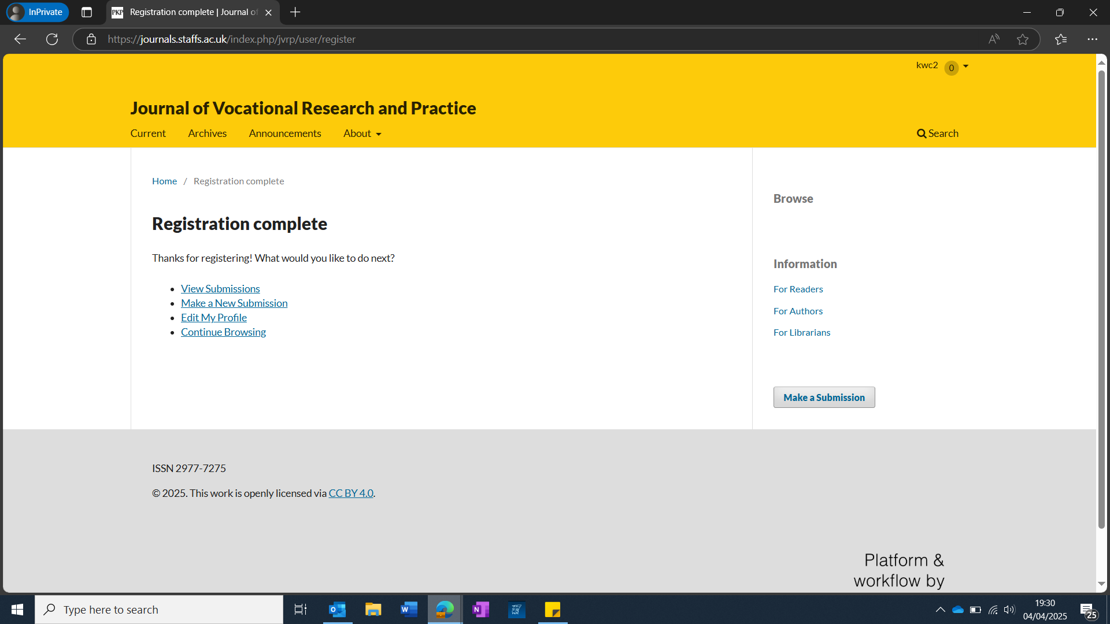
Step 2: begin 5-step submission.

Click on make a submission, and you will see the 5-step screen appear. You will begin on the Start section. This consists of a checklist of submission requirements which you must confirm. There is a box for comments to the editor, here you may declare for example if the submission has been submitted elsewhere. There are also some confirmation boxes to tick regarding copyright.

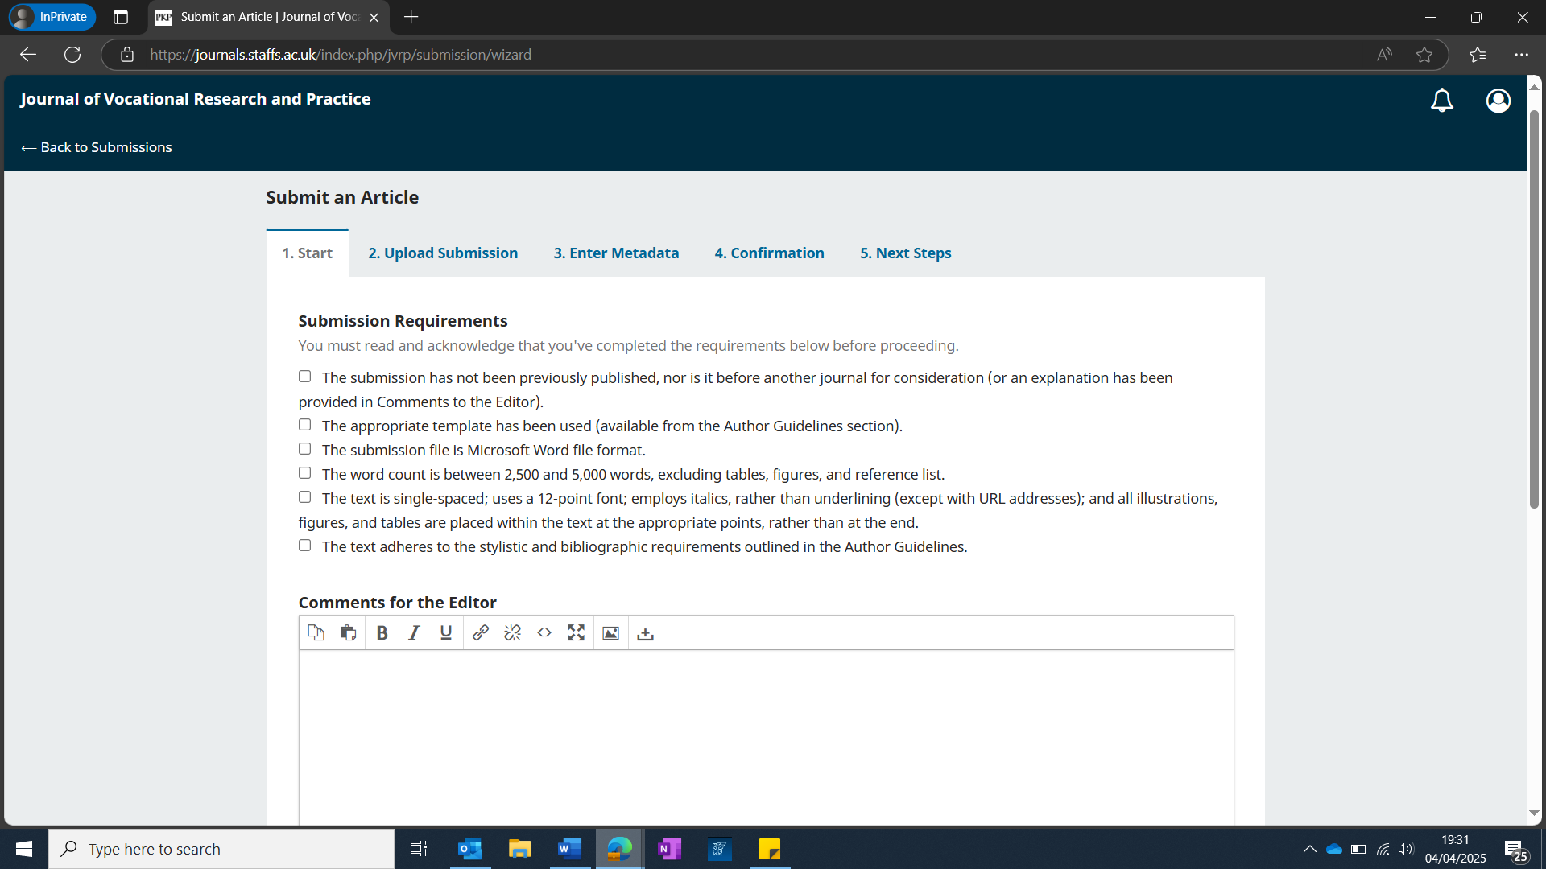

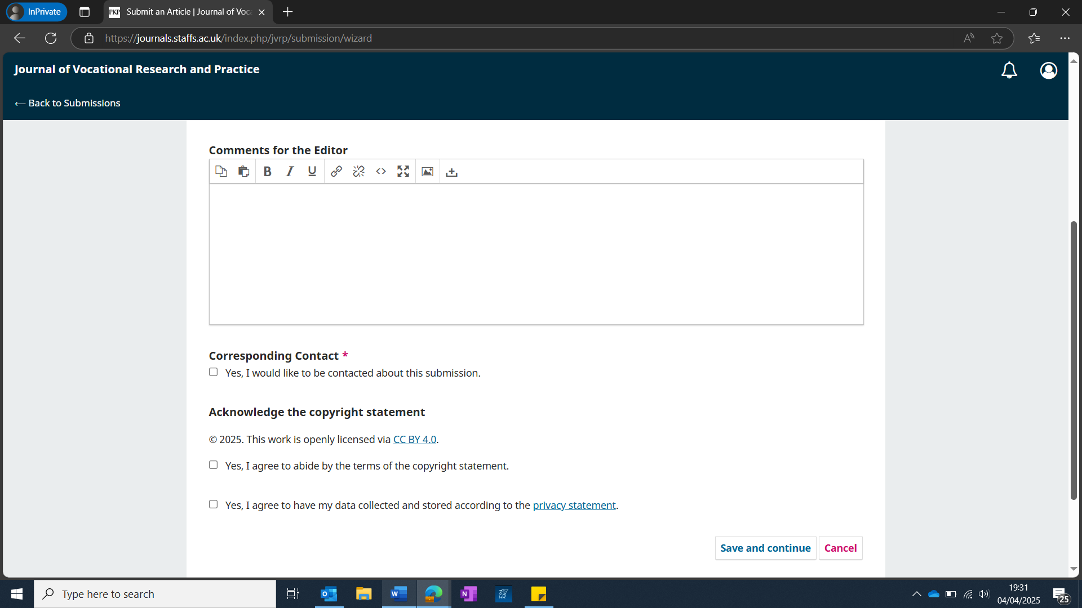
Step 3: upload submission

With this section complete, you can proceed to tab 2 – upload submission. Here, you must upload your manuscript and declaration form. If you are submitting in poster format, you must upload the poster in PowerPoint format and the accompanying mp3 audio file.

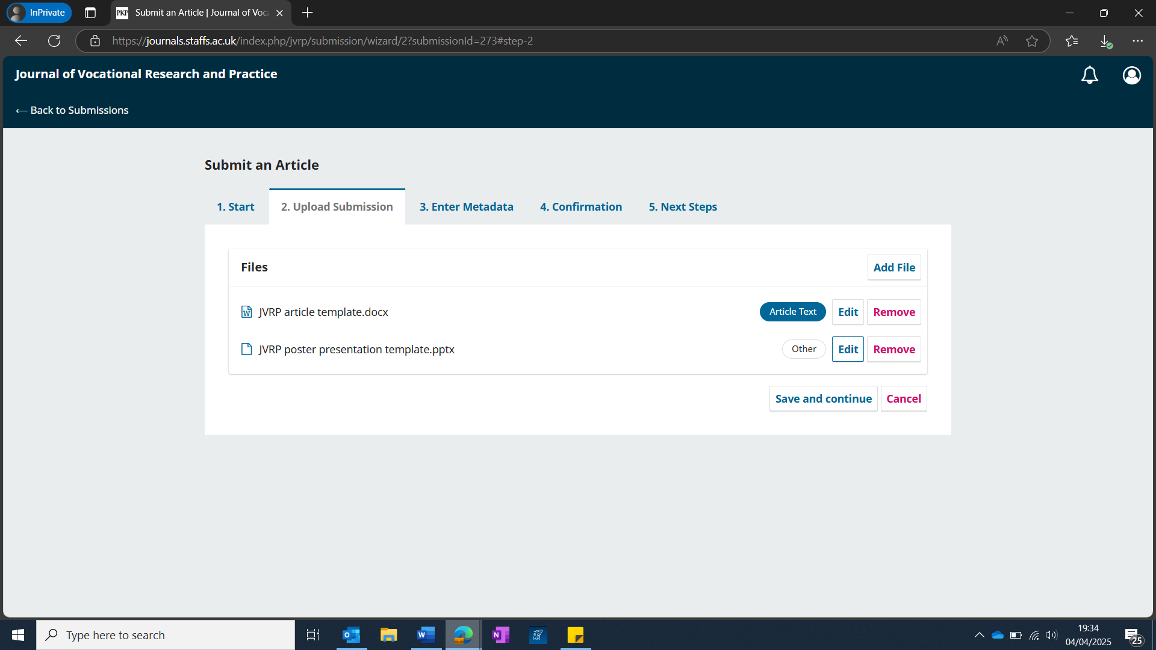
Step 4: enter metadata.

Next, proceed to tab 3, titled “enter metadata.” Here, please disregard the prefix box and enter your submission title. You may enter a subtitle if you wish but this is not essential. Please provide a 150 word abstract in the corresponding box. Please note that this must match the abstract in the paper template (if not submitting via the poster route), so copy and paste this into here. Next, enter the list of contributors (authors), and 5 keywords.

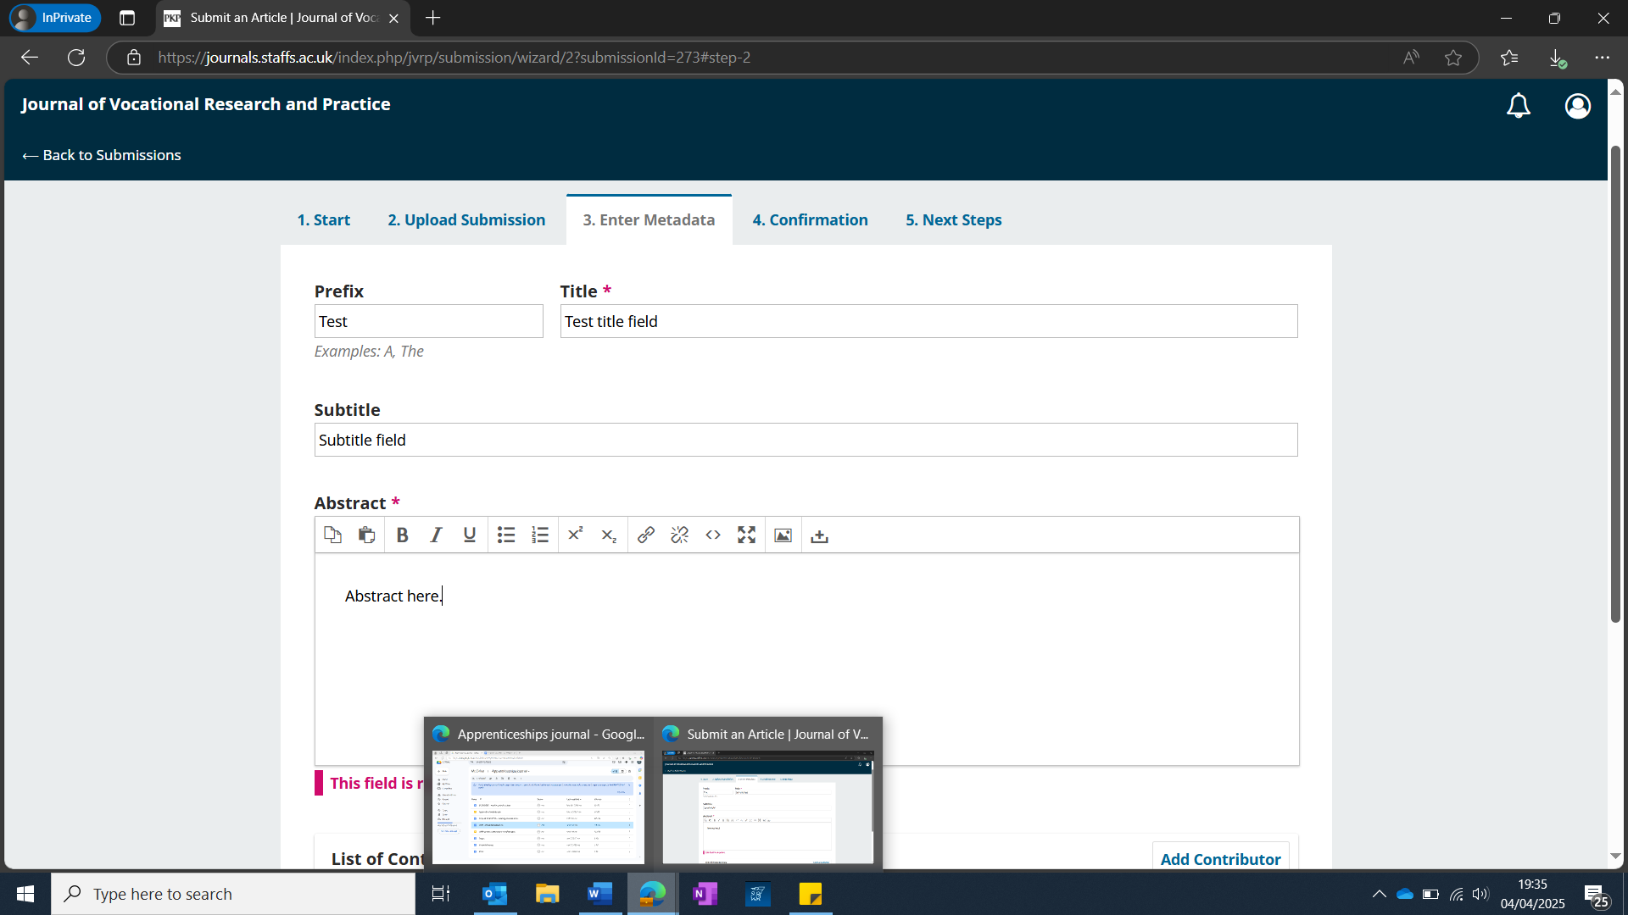
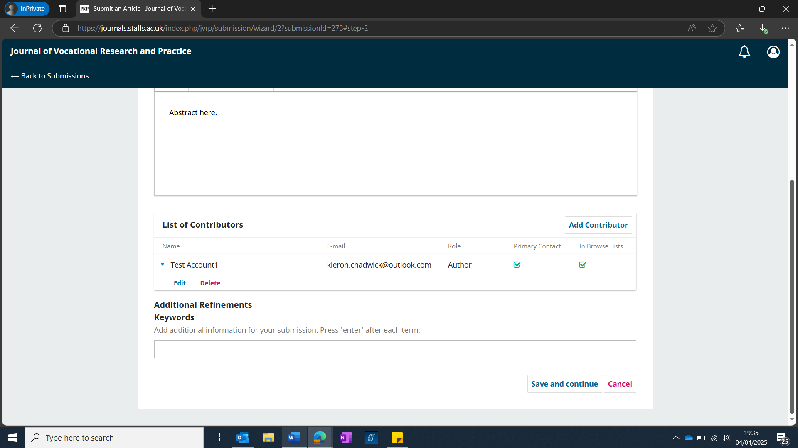
Step 5: submission complete

Proceed through the confirmation screen, and you will then have completed your submission. You should now see the window below, which confirms this has gone through. Congratulations, you have successful submitted!

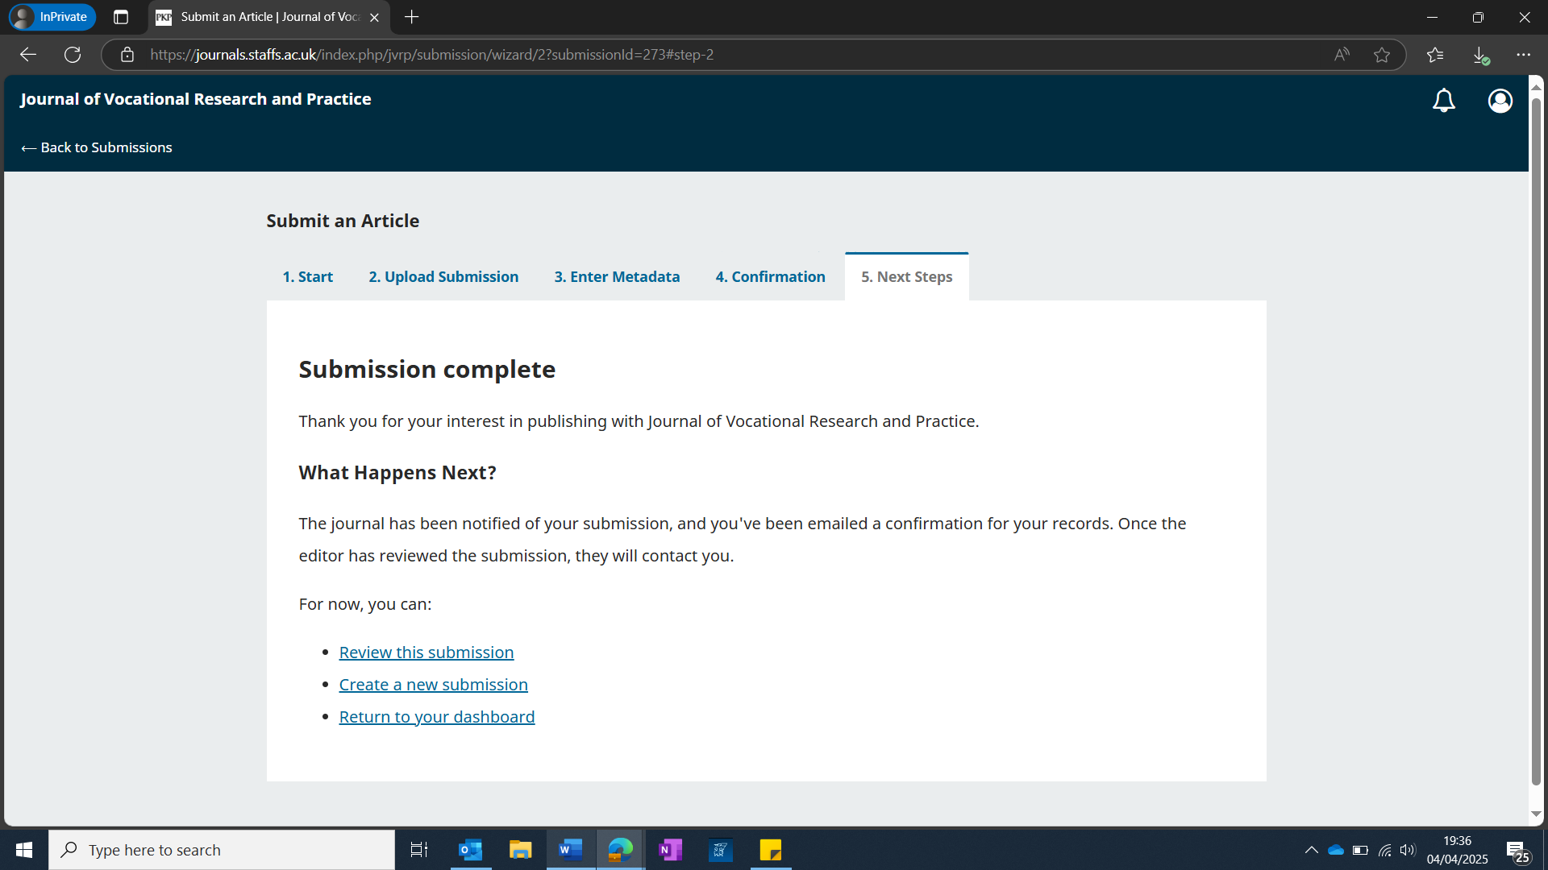
You can return to your account at any time to view your active submissions. You will receive automated updates as and when the submission is acknowledged by an editor, subject to review, and the editor has decided (accept / minor revisions / major revisions / reject).

What happens next?

You should receive an automated email within 72 hours courtesy of the OJS system, confirming receipt of your submission. The editor of that issue (collection) is notified of your submission, and they are then required to either a) assign two peer reviewers, or b) conduct editorial review. This must be done and a decision made and subsequently communicated to you within 4 weeks. If you experience delays in this process, please reach out to our editor-in-chief, Kieron Chadwick, at kieron.chadwick@staffs.ac.uk.
You will receive an automated email from the OJS system when review is complete. This will detail a decision (accept / minor revisions / major revisions / reject). We must, at this stage, reiterate that our intention is to stretch and challenge you, and really get the best out of your submission. Please do not be disheartened by our decisions or feedback but instead strive to make the necessary revisions prior to resubmission. Unfortunately, we cannot discuss feedback with authors. If there are elements of feedback which you require support with, we recommend consulting with your university, college, training provider, or employer who can usually support with this.
If and when your submission is accepted, it then goes through a final set of editorial checks to consider aspects such as formatting, spelling, and grammar etc. At this stage, the editor may communicate with you to clarify any minor errors prior to publication.

How long from acceptance does publication occur?

Once final editing (proofreading) checks are complete and any minor errors, e.g., spelling and grammar addressed, we aim to publish as quickly as possible. We refer to this as ‘early view’ and means your paper / poster will be available in the public domain. However, it is likely it will not have been assigned to a volume or issue at this stage. This happens later on once we have published enough items to consider bundling them together and assigning them a volume and issue number.

Finally…

Once items are published with us, they cannot be published anywhere else. However, we do encourage you to pair JVRP dissemination with other mediums, for example, informal social media and blog posts etc. We thank you for choosing JVRP as your preferred dissemination channel!

