‘Bricks and Mortar’: Reflections on teaching Architecture and Design from an early career academic

Maria Yioutani-Iacovides
University of Salford

Abstract
‘Bricks and mortar’ is used as a metaphor for how we endeavour to ‘construct’ knowledge in Architecture and Design. Teaching Architecture and Design is challenging but rewarding; as an early career academic and a mature professional, this paper sets out my journey and seeks to show how my teaching practice derived from my lived experiences, professional practice, and what has inspired and motivated me along the way. Reflecting on my teaching made me realise that, when it comes to teaching: ‘we have unlimited powers of creativity’ (Robinson, 2017).

For me, my authentic teaching practice derives from my professional and personal identity. It is a combination of many parameters: sharing my knowledge and lived experiences, applying creativity and playful learning, relating assessment tasks to live construction projects and rethinking reassessment strategies. The paper concludes with some lessons I have learnt and outlines the future and ongoing development of my practice.

Key words: Teaching, lived experience, professional identity, early career academic, industry-focused, architecture.

Introduction: challenges and rewards

This paper is a testament to my recent experiences teaching Architecture and Design as an early career academic and mature professional in four different undergraduate (UG) programs: Architecture, Interior Architecture, Architectural Engineering and Architectural Design Technology. I also supervise postgraduate (PG) dissertations in Construction programs.
I reflect on my teaching, its challenges, and its rewards and my aim is to discuss what authentic teaching means to me, and how my practice is received by my UG and PG students. My objectives are to identify what works well for teaching within my discipline, and what I could improve in line with best practice in relation to teaching in Architecture and Design.

The paper focuses on three elements; a) architectural education in relation to course requirements by accreditation bodies, and professional practice, b) what authentic teaching means to me and how my teaching relates to my professional identity and my lived experiences, and c) a literature review of the theories of teaching and learning I apply in my practice. In conclusion I point to how my reflection across these three elements can inform my practice for the future.

Discussions are initiated by giving an account of how accreditation bodies, academics and practitioners perceive how architectural education should be implemented. In teaching Architecture and Design, the requirements focus on empowering students with the knowledge and skills that the construction industry needs, and the accreditation bodies expect. By improving students’ technical and soft skills the aim is to raise employability targets. Architecture educators are therefore challenged to fulfil students’ expectations and provide them with experiences that relate to their future careers and enhance their motivation in learning.

Authentic practice, for me, derives from my professional identity; sharing my knowledge and lived experiences and incorporating these in my teaching.
I reflect on my journey and the theories of learning and teaching that relate to my teaching practice in Architecture and Design, and have inspired me so far, through the inclusion of a brief literature review.

I reflect on my efforts so far, as an early career academic, to enrich students’ learning, by experimenting within my teaching practice through incorporation of techniques which encapsulate:
- Playful learning and creativity in teaching (Robinson, 2017).
- Authentic practice (Weimer, 2011).
- ‘Learning by doing’ (Dewey, 2016); enhancing students’ learning by connecting students’ assessment tasks with live projects, industrial visits, and guest lectures, this has become one of the core elements in my teaching.
- Rethinking my approach to reassessment to facilitate students’ learning and success.

My greatest reward as a reflective teacher, is the students’ progress; their achievements, and successes, both during their studies and after they graduate. I am grateful for their feedback and suggestions which serve as rich sources of reflection for me to refine my abilities as a teacher and help me become a more ‘skilful’ as I draw inspiration from Brookfield’s guidance Brookfield, 2015, p.ix).

The paper concludes by setting out how my reflections can inform my practice for the future. I reflect on the impact my journey has had on my professional development as an academic, asking: What are the lessons learned? What is the vision for the future? What could I do differently? What can I improve and how? The paper also discusses some teaching practices in other institutions which have inspired me and current proposals for future changes in Architectural education in the UK, and how these might relate to, and influence my teaching practice.

Architecture and Design Course Accreditation

Architecture courses should comply with the standards of quality assurance set by the accredited professional bodies: Architects Registration Board (ARB), Royal Institute of British Architects (RIBA), and Quality Assurance Agency for Higher Education (QAA) ‘Subject Benchmark Statements in Architecture’ (QAA, 2020). The ARB ensures that standards in education clearly identify competency, ability and demonstrate understanding in the core elements in Architects’ education and practice; environmental sustainability, Equality-Diversity-Inclusion, wellness, and safety, and building technology (ARB, 2023). The ARB sets the standards for learning providers which focus on the educational contents and assessments, supported by competent leadership, human resources, teaching and learning resources, and student support teams (ARB, 2023a, pp.5-7). RIBA supports and awards accreditation to Architectural courses and ensures that professional standards and quality assurances are met. RIBA’s Manifesto states that ‘Architects and Architecture students need the knowledge, skills and experience required to respond to the challenges facing our world, society, and profession’ (RIBA, 2021).

These organisations are the backbone of British Architectural Education and Practice. Therefore, all courses taught in relation to Architecture in Higher Education (HE) must comply with their requirements. Similar competencies and knowledge are required by professional accreditation bodies for other programs in Architecture and Design; for example, Chartered Institute of Architectural Technologists (CIAT, 2023) for Architectural Design Technologists, and Chartered Association for Building Engineers (CABE, 2023) for Architectural Engineers.

The structures of the courses we run at the University of Salford in relation to Architecture and Design, require that selected modules integrate teaching and learning across the board, focusing on peer and collaborative interdisciplinary learning. Students’ learning is facilitated within their own programs for their core subjects but also is extended beyond, requiring students to collaborate on projects with peers from other disciplines relevant to the construction industry. Learning with professional standards in mind is at the core of the University’s values:

Improving: We work collaboratively to share knowledge, create opportunities, encourage contribution, and drive innovation, for greater impact locally and beyond. Curiosity: We are always learning to enrich our understanding and find new creative ways of doing things better (University of Salford, 2022a).

Professional Practice and Architectural Education

The value of architectural education in architectural professional practice, raises interesting discussions between academics and practitioners. It is important to consider and discuss differing views, as all professionals have their focus on what is best for the next generation of architectural professionals and the profession itself. Patrick Schumacher, Architect and Principal at ‘Zaha Hadid Architects’, strongly expresses his views and argues that architectural education is ‘detached from the profession’ and should focus more on ensuring educators ‘train students for practice’ (Griffiths, 2019).

In his response, Sean Griffiths, Professor in Architecture at the Universities of Westminster (UK) and Yale (USA), argued that, providing for the market should not be the main task of architectural education. In architectural studios a ‘holistic’ approach is more relevant, one which focusses on experimentation and research, on current challenges our world faces and on social and technical issues such as climate change, disability, identity, and individuality (Griffiths, 2019).

In discussions with some of my academic colleagues I sense that their priority is that research should inform their teaching, and vice versa, and that connecting their teaching to professional practice is not particularly necessary. However, academics who teach on the technical programs i.e. Architectural Design Technology (ADT) and Architectural Engineering, have a very different view and maintain that technical issues and professional practice should be at the core of architectural education in all related courses.

These are two conflicting arguments on what benefits architectural education. However, both acknowledge in essence, that a balance is required between academic knowledge and professional practice. Reinforcing the relationship between students, teachers, and practitioners and focusing on the exchange of experience and knowledge and mutual respect can enrich students’ learning. Afterall, most academics are aware of the benefits of professional practice, as they must have at least two-years practical experience before they register as professionals, such as ARB Architects, RIBA Chartered Members, or CIAT Chartered Members.

Having worked previously as a professional architect, and coming into academia late in my professional life, I recognise the value of both arguments. In my efforts to support the idea that a balance between learning and practical applications is beneficial for students’ learning, in my teaching I share my experiences and practicalities of professional life with the students, with the aim of opening up space for lively discussions, stimulating their imagination and motivation, opening up their horizons, and supporting them to envisage their own prospects and career paths. However, I do acknowledge that not all students will follow the same career trajectory and as teachers we should do our best to facilitate their learning in respect to gaining skills useful for alternative career routes; reinforcing the importance of students’ technical, digital, soft and employability skills.

My Professional Identity

I am an early career academic and a mature professional. I qualified as an Architect, RIBA and ARB, and I hold a Masters in Historic Building Conservation and a PhD in Architecture. I recently practiced as an Architect, Conservation Architect and Conservation Officer in the UK, before I pursued a career in academia. As a Conservation Architect, I had the opportunity to work on interventions, repairs, restorations and conservation of historic buildings and historic fabric. My duties as a Conservation Officer included offering advice and giving consent to repairs, interventions, redevelopment projects, encouraging public participation and adding value to heritage assets. My career, spanning almost 3 decades has been full of successes and failures, but never unhappiness. All the challenges I had, I feel, have made me stronger, more adaptable, resilient, and more knowledgeable. Having collaborated with professionals from other disciplines in the construction industry, with local authorities and with heritage amenity societies, and being a member of professional organisations has opened up professional opportunities for me and has made me more confident in my own abilities.

At the University of Salford, my journey started when I worked on an Arts and Humanities Research Council (AHRC) Research project, on intangible cultural heritage. I was interested in taking part in the project, as my research interests focus on the conservation and preservation of cultural heritage (both tangible and intangible). I had the opportunity to participate in a workshop in Damietta, Egypt on local cultural furniture industry heritage and the project is currently included in the UNESCO Global Network for Learning cities (UNESCO, 2021). As soon as the project was completed, I started teaching sustainable design, adaptive reuse, and interventions into the historic context, which is my area of expertise. My interests in the values of regeneration of the heritage assets and the historic built environment are incorporated into all the modules that I teach or contribute to with tutorials for students working across a variety of levels. I feel that, sharing my lived experiences in practice makes my teaching relevant as students understand better the theory when teaching includes practical applications and examples. I believe this demonstrates what Weimer describes as: ‘engaging students with the subject in important and meaningful ways’ (Weimer, 2011, p.2). To me this is integral to authentic teaching.

Authenticity in Teaching: Theory and practice

For me, authenticity in teaching is, as Weimer (2011, p.1) noted: being ‘real’ and ‘genuine’ and for me it comes naturally. Students show appreciation of a sincere, honest teacher with integrity; a teacher who consciously respects educational values and goals, using ‘self-knowledge to establish one’s own identity acting in the interest of learners, caring and wanting them to flourish, care for the subject, and the knowledge and aims to engage students in learning’ (Weimar, 2012 pp.1-2).

Weimer argues that authenticity in teaching has a positive impact on everyone involved: the teachers and the students. The teacher discovers their own abilities and uncovers ‘their real self’ as they endeavour to be real and authentic and authenticity in teaching is significant for students, as it challenges them to ‘pursue their own authenticity’ and can thereby ‘change who they are’ (Weimer, 2011, pp.1-2). To me, this is meaningful teaching because it builds up a genuine and healthy three-way relationship between the teacher, the student, and the subject.

At the same time, authentic teaching guides the students to have a more mature and personal perception of what learning means to them during their studies and later in their professional careers. Authentic teaching practice for me, therefore, is ‘Acknowledging the wider context in which Higher Education operates recognising the implications for professional practice’ (UKSF, 2011, paragraph V4). This clearly resonates with connecting students and the industry. As Powel, (2021) notes, connections with industry support students with ‘resilience building and flexibility, adopting novel approaches to deal with challenges’ (Powel et al. 2021). Powel refers to the research project ‘Creative Branding’, an initiative funded through the Royal Academy of Engineering visiting Professors Scheme, which helped build ‘sustainable networks to ensure participants were best placed for life and cultivate employability skills’ which is very beneficial for the students (Powel at al. 2021).

Connections with the industry cultivate confidence and thereby encourages students to keep an open mind for the different opportunities that may lie ahead for their future careers, it also gives them important insights into professional life. Enriching students’ learning with real lived experiences, encourages them to observe and be involved in discussions that can only be achieved through the curriculum, when the teachers share their own professional experiences, and through the collaboration of our university with our industrial partners, guest lecturers and speakers.

‘Learning by doing’: Connecting theory and practice.

My experience so far as a professional in practice and as an academic has led me to believe that enabling students’ smooth transition to professional practice can happen with the introduction of real-life construction projects within the curriculum and through connecting these with students’ assessment tasks. Dewey was an advocate of ‘learning by doing’, and he contended that students’ learning is about social interaction, life skills, employability, and ‘preparing them to be active members of their communities and society as a whole’ (Aubrey& Riley, 2016, p.6).

Having considered Dewey’s philosophy of ‘learning-by-doing’ in teaching my Architecture and Design modules, I have embedded professional practice in the students’ assessments. The students’ knowledge and understanding are tested with assessment tasks that require critical analysis of inspiring or award-winning adaptive reuse projects in the historic built environment. These largely feature in the northwest region, and in the City of Manchester. One of these projects is the Halle St Peter’s, which was renovated between 2019-2020. I organised for the students to visit the building and I arranged a guided tour led by the director (see Fig. 1). It gave students the opportunity to learn about the conservation, restoration, and adaptive re-use of the building. Until recently, the building was an abandoned Catholic church, but it has now been converted to an events’ venue with an additional floor added for the Halle Orchestra’s rehearsals. The Halle St Peter’s perfectly encapsulates the essence of adaptive reuse and sustainable growth in the built historic environment.
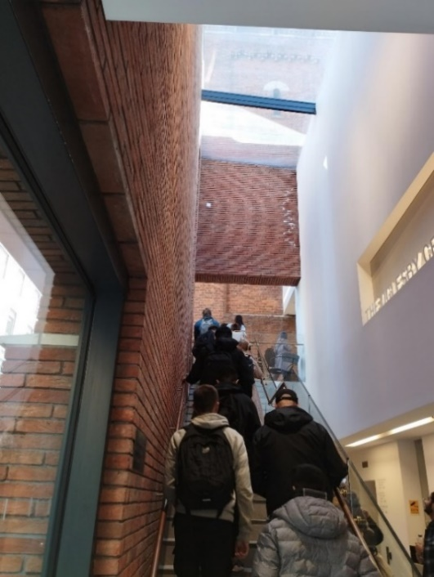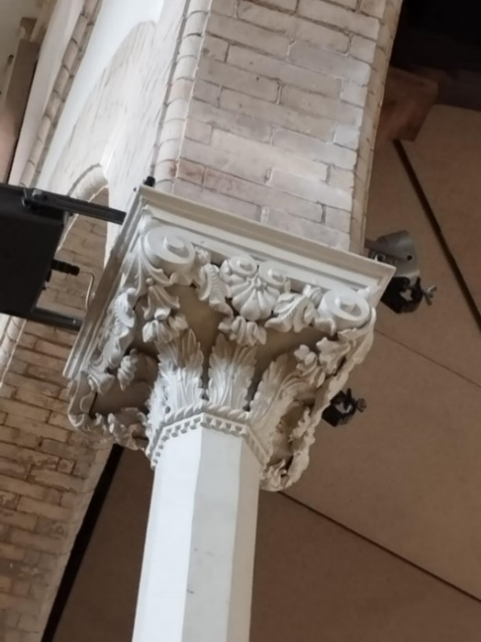
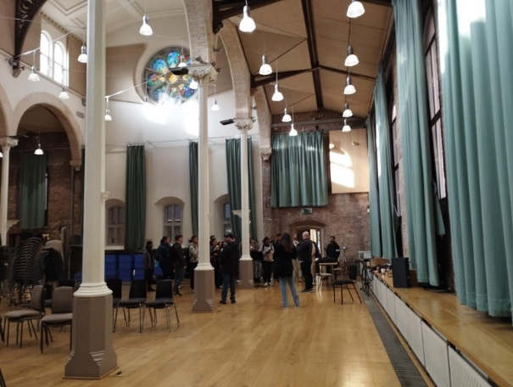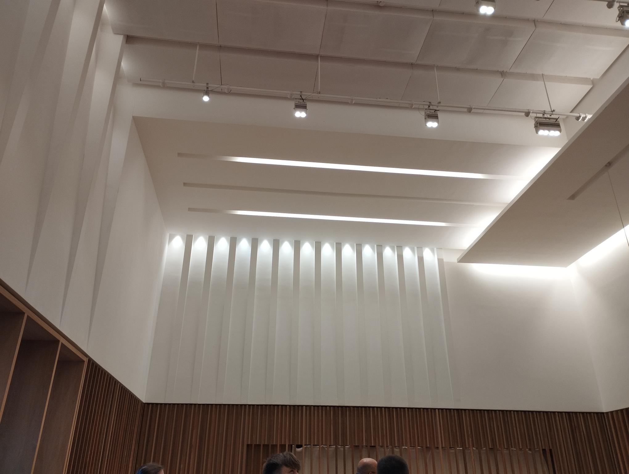
Fig. 1 Photographs from the students’ visit to the Halle St. Peter’s, Manchester (Maria Yioutani-Iacovides, 2022).

In addition, I specifically designed an assessment task which required students to work on a live project. In 2022-23, students carried out a ‘condition survey’ at the Manchester Town Hall which is a ‘live’ and ongoing restoration project (2018-24). Condition surveys are visual, non-intrusive surveys that are carried out by qualified professionals (a surveyor or an architect) and they help identify work needed to maintain the building in use. Similarly, as conservation architects do on real projects, students were asked to propose design interventions that follow the current legislation framework of Historic England’s Conservation Principles, Policies, and Guidance (Historic England, 2008).

Students were asked to work on, prepare, present, and submit their design concepts for interventions to the historic building which follow the current legislative framework. They were guided to come up with concepts that a) are sympathetic to the significance of the heritage asset and, b) enhance the heritage values-historic, architectural, and aesthetic significance-of the heritage assets. Students’ design concepts should consider materiality, forms, shapes, scale, architectural details, buildability and sustainability and they were asked to consider how their proposals relate to the significance of the historic building.

The students were guided to carry out the condition surveys with examples from real conservation projects. I invited guest lecturers, professional heritage practitioners, conservation architects and heritage consultants from the heritage construction industry to present and discuss their work with the students so they could ask questions about the process. Students then had the opportunity to present their own design proposals at an architectural practice to an audience of ten conservation architects. These additional sources of information and opportunities aimed to enhance the curriculum and in turn to support students’ learning by enabling them to relate their learning to professional practice.

Teaching ‘Architectural Conservation’ at any level, requires emphasis to be given to academic research, professional practice, and practical applications. Institutes of Architecture in other countries, such as the Royal Danish Academy, focus on ‘discovery, invention and creation’ (Royal Danish Academy, 2023). I had the opportunity to learn about their teaching practice at an international conference The Architect’s Council of Europe-European Association of Architectural Education (ACE-EAAE) Conference on Education and Practice 2023, which set the scene and shared examples from all over the world. After attending the online conference, I realised the real significance of aligning theory and practice in order to connect students’ tasks with real projects in the construction industry. An example from Danish Schools of Architecture which piqued my interest concerned students being asked to collaborate with local councils and to assume responsibility for the design of new Social Housing as part of their assessment tasks. Students are also encouraged to take part in Architectural competitions, and I was pleasantly surprised when I attended a conference at the Aarhus School of Architecture, in 2023, to discover that the school’s building, built in 2020, embodied the winning design from an Architectural competition which was won by a group of newly graduated Architectural students.

In the UK, universities such as Birmingham City University integrate live projects into the curriculum as they provide ‘a bridge between academia and industry’, and ‘provide students with real-life learning and practical experience in the industry, collaborating or consulting with an external client’ (Birmingham City University, 2023). Architectural Education, in my view, should be connected directly to industry and the profession in two key ways from the very early stages: a) facilitating work on live projects with real clients thereby offering students the opportunity to see their projects getting built, and b) learning from professionals’ lived experiences. Relating students’ projects to real life examples from the architectural profession, in combination with architectural research and innovation within their practice, is key to students’ academic success, and future employability. In addition, engaging with professional guest lecturers from a range of disciplines in the construction industry, and students’ industrial visits can provide further insight in professional practice for students and can widen their participation in learning; opening up their horizons and cultivating their career aspirations. These opportunities can also open industry connections for students, enabling them to begin building important networks for the future.

Proposed changes to the Architectural profession

The future in Architectural Education is rapidly changing and current trends focus on the introduction of apprentice schemes (RIBA-Architecture apprenticeships) and changes in ARB accreditation requirements (ARB, 2023b)., Several universities encourage students to work at an architectural practice during their academic studies and this will be welcomed by the architectural practices in the future, who are on the lookout for young talented individuals to train and mentor. Students are also encouraged to take up opportunities for summer internships and other employment to get acquainted with working in a professional environment in the construction industry.

In other disciplines and courses that require practical skills, like the medical sciences, students spend a few weeks over the summer in placements with rotation, so they can gain wide understanding and knowledge of their professional practice, and potential career paths. Architectural practice now specialises in several sectors: residential, commercial, healthcare, and conservation (amongst others). Some practices focus on specific methods of construction, i.e. newly buildings focusing on Passivhaus standards, or Retrofitting existing buildings to meet energy requirements. These are good opportunities for students to improve their technical skills and knowledge in a variety of construction methods and techniques and to observe practical applications which are directly relevant to their learning during their academic studies.

My experience of teaching part-time students in Architectural Technology who work in the industry while they are studying, has shown me that these students are knowledgeable, motivated, focused and have excellent technical and soft skills. However, overall, sometimes they lack creative skills and can struggle with writing and research skills which they can develop during their academic studies. I realised that students’ connection to industry are invaluable both for the students themselves, and that we, as teachers should constantly be plugged into the relevant knowledge and skills that the industry needs; it is our job to empower students with what is relevant.

Enriching students’ learning, beyond the curriculum with connections to the architectural profession, and sharing lived experiences for meaningful learning, are the most important dimensions of authentic practice in this context. Secondary to this, but also important, are the use of innovative teaching methods, such as playful learning in sessions. Thirdly, a real challenging dimension of teaching is facilitating reassessment for students who fail the first time, this can be a challenge for both, teachers, and learners.

‘Playful learning’ and creativity

In facilitating the students’ learning, I experimented with applying playful learning techniques in my practice; these were introduced to me during my Postgraduate Certificate in Academic Practice (PGCAP). Playful learning can really enrich teaching, providing the opportunity to teach real-life learning situations in alternative ways in ‘ordinary life situations’ (Abbott & Terence, 1999, p.68). To explain to the students how to carry a condition survey of the historic fabric, stonewall or brick wall, and write a report, I constructed a wall using cream biscuits. Bricks and mortar and biscuits have similarities in their production and construction (see Fig. 2 & 3). Baking is like constructing and I used the similarities to demonstrate the possible effects of natural and manmade disasters on structures, and to examine the causes of decay in construction materials. For example, I illustrated how an earthquake can strike and how that would that effect the structural integrity of the whole building and the building fabric. I explained that defects within the building fabric may include broken or dislocated stones or bricks, deterioration of the mortar or cracks and that defects can also arise from rising humidity from the foundations and how these might be avoided. I also showed how defects from water ingress from the roof could cause deterioration to the upper structure.

Students responded with a few specific questions on different types of materials, i.e., the construction of concrete and earthen structures, whose concept is like cake-baking, and interesting discussions were opened up.
On reflection, experimenting with playful learning allowed me to ‘educate while entertaining’ (James, 2020, p.2), and ‘actively construct and reconstruct knowledge’ (Ashton & Stone, 2018, p.3). I felt happy that I had transmitted more information than I expected, as revealed by the students’ questions which initiated further discussions. However, I could have asked the students for their feedback on the session and discussed with them how effective it was in relation to their learning.

Architects, in their everyday professional life, work on all design stages from concept to completion. Similarly, architecture students are asked to work on design projects from the very early stages of their studies and develop their designs through conceptual analysis. They are required to understand the concept or the brief (the client’s requirements), to engage in research, to explore, reflect, create, and present their work. This process is guided throughout the semester with individual and group tutorials and formative and summative feedback. It involves exploration, inspiration, interaction, innovation, and iteration, until students’ design concepts are developed and refined in further detail. Playful learning can facilitate the students’ learning, in many ways if it is used frequently, especially as they enter their studies in the first year, it can also help learners to ‘learn without knowing they are doing so’ (Mosely & Whitton, 2015, p.3).

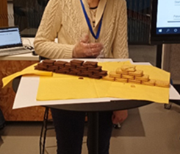

Fig 2. ‘Bricks and Mortar’ -playful learning: my experiment using biscuits. (Maria Yioutani-Iacovides,2022).

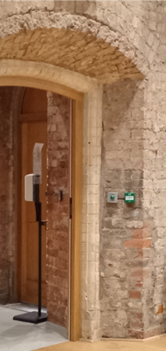

Fig 3. St Peter’s Halle doorway, defects observed on the historic fabric during the students’ visit. (Maria Yioutani-Iacovides, 2022).

‘Variety is the spice of life’ and of education, and playful learning can play an important role in teaching Architecture and Design because, as a subject It has creativity is at its very core. Robinson claims that as humans we have ‘unlimited powers of creativity’ (Robinson, 2017:120). As a subject, Architecture really embodies this creative potential. Creativity can be further induced with multidisciplinary collaboration and in our current modules at Salford, we have cohorts from 3-4 different programs working on the same tasks. In the future, I intend to use creativity in enriching students learning by experimenting with asking students from different programs to work together with real clients, on real life projects, which can be buildable.

Creativity can also be introduced by allowing students to be creative in how they present and submit their work. Students can be encouraged to submit their work in various formats or can be encouraged to collaborate with students from other disciplines and programs to create innovative and interdisciplinary submissions.

Facilitating reassessment

Facilitating students’ reassessments has an emotional load attached and is also time consuming for students and teachers. Students may struggle to understand the assessment brief or the curriculum, or they might misinterpret the quality standards of the work they are required to submit, personal matters might also impact on their studies. Whatever the reason, some students are going to need further support and understanding.

In trimester one in 2022-23, I experimented with the resubmissions. According to university guidance, all resits (in trimester one and two) are scheduled at the end of trimester two and should therefore take place in July 2023. I realised that students might forget some of what they’d learnt and what is required of them in several months’ time, and this meant they might fail again. Therefore, as soon as the marks were given to students, at the end of trimester one, I notified the students who had failed that I would offer them tutorials for early reassessment two weeks after their results. I did this very quickly, and all the students responded positively.
The result was surprisingly impressive; all of the students resubmitted, and all were successful. The university guidance for reassessments focuses primarily on practical issues such as the reassessment dates and content, providing advice that reassessments should have the same assessment task or ‘equivalent alternative version’ (U. of Salford, 2023:15) but there is no reference to how reassessments might be administered in a way that is beneficial for students’ learning. My recent experience made me realised that improvements in the reassessment process can be implemented in the nearer future successfully.

Preparation for success

In my efforts to improve students’ performance, I discussed with students from different modules-programs and year groups whether it would be useful for them to know information contained in their modules in advance, before the start of the academic year. Giving students access to module content such as assessment briefs, an outline of their projects, a reading list, and guidance on software programs they need to learn or improve, would help prepare them for the academic year ahead. This would give students the opportunity to prepare during the summer months and help them improve and refine their skills and familiarise with the content. Early access could work particularly well in preparation for students in the later stages of their studies as these students already know the general structure of the programs and most of the academic staff. Equally it could help students in the earlier stages with their transition to HE studies, supporting them to become better acquainted with independent guided study early on. Early access to module content is therefore a practical approach that I argue could improve students’ performance, but it does require timely preparation in each program.

Reflections on my teaching

My students’ feedback and the outcomes of their submissions has provided me with many opportunities for reflection on my teaching practice. Therefore, in preparation for writing this paper I looked at module evaluations, student surveys, the standard of the quality of the student’s assessment submissions and their overall marks. I selected a module, to extract information from which has the highest number of students (78) and includes final year students from three programs: Architecture, Interior Architecture, Architectural Engineering. In this Module, 97.5% of students were successful in their first attempt, and the rest were successful in their second attempt. Some 60% of the submissions were marked above 60%. The university’s procedures were followed for the brief verification, and internal and external, moderation of the submissions and the external examiners’ comments were encouraging and very complementary.

Examples of my students’ work (see Fig. 4) demonstrate not only an understanding of the curriculum, but an enhanced motivation and this can be further substantiated with reference to their module reviews. One student remarked: ‘The module has enabled not only me but many others to gain valuable experience on site which we have never had the chance’ (Anonymous UoS student 1, 2022). Another responded: ‘Enjoyed the guest speakers. Acoustic labs, VR workshops were very interesting- some of the best topics/ trips we have done at uni. We were always doing trips that helped us learn better to real life things that we were learning about which was great’ (Anonymous UoS student 2, 2023).

The students’ comments reiterate my views that students’ learning, should relate to real life projects and experiences. Students understand that their academic skills are welcomed by perspective employers when they can see how they can support them to apply their learning to real life challenges and they appreciate opportunities to enrich their knowledge and understanding of a topic.

The best reward for me was when, immediately after their studies, a good percentage of my students secured very good jobs in the private and public sectors, and others secured places to continue their studies as postgraduate students on Masters programmes in Architecture both at Salford and at other institutions.

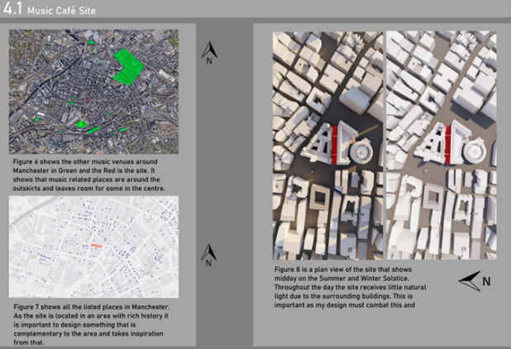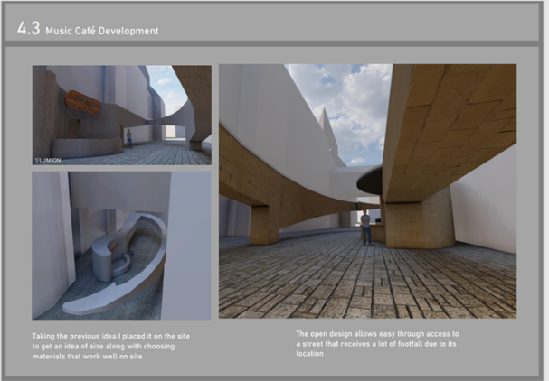
Fig.4 Example of students’ work by William Thomas and obtained with consent (University of Salford, 2022).

Conclusions

For me, authentic teaching practice in Architecture and Design, is about experimenting and being creative. Authentic approaches to teaching can help educators enrich students’ learning in the following ways: through the sharing of professional knowledge and lived experiences, by encouraging students to have hands-on experience of real-life projects and by inspiring students through the use of guest lectures and topical seminars on issues integrally related to current practices in the construction industry. In addition, through the introduction of playful learning techniques and creative approaches which engage students in respect to assessment tasks and by working to facilitate students’ success in and beyond their assessments, authentic practices can support both educators and students to make valuable connections between theory, practice, and industry.

The development of my teaching practice has enabled me to know myself better and through sharing my lived experiences with my students and using examples from my projects I have tried to support students to better understand the topics and to make connections between theory, practice, and industry. For me, authentic teaching feels natural, particularly when I draw from my own knowledge, experience and expertise and this process has certainly helped me to make ongoing improvements and refinements to my practice.

I believe that introducing timely support for early reassessments facilitates success for students who are struggling. After all, some students learn by themselves and teaching them is very easy, whereas the students who are keen to learn but struggle, are the ones who need more support and encouragement to reach their potential. Therefore, facilitating their learning at the time of need is crucial for their academic development and personal confidence.

Innovation in Architectural Education should be a deciding factor in the future of the profession and the future of our built environment. It is important for this to be inclusive and open to collaborations within the Architectural world and with other disciplines. Innovation and creativity in teaching Architecture and Design can therefore be implemented in collaboration with local stakeholders and professionals, or organizations. Supporting students to collaborate locally to find innovative solutions for challenging issues that relate to their own cities where they live, study and work can have much greater impact on their learning and engagement.

Creating a better world to live in is part of Architecture’s purpose and architects’ vision and it is important for educators to keep this at the heart of their approach to teaching. Connecting the construction industry, architectural practice and academia is beneficial for all and collaboration which facilitates the exchange of knowledge and brings continuous professional development is therefore of integral importance for the future of academia, industry and practice.

Acknowledgements:

The students’ site visits took place with the permission, support, guidance of our Industrial partners. The visit to Manchester Town Hall for my Year 3 students from Architecture, Interior Architecture and Architectural Engineering (in total 82 students) took place in November 2022. I expressed my thanks and gratitude to the Purcell Conservation Architects, and the Construction Company Lendlease. For the students’ visit and guided tour to St. Peter’s Halle, Manchester, I am grateful to the events Director. The site visits were all associated with the students’ assessment tasks, which they had to submit as part of their module ‘Recreating the City; Adaptive reuse and Regeneration’ (University of Salford, 2022).

Disclosure statement:

All materials included in the article represent the authors own work and anything cited or paraphrased within the text is included in the reference list.
Written consent was given by the student whose work is included in this paper. The author can confirm that, individuals’ identities are protected in the pictures that are include in the text. The work has not been previously published nor is it is being considered for publication elsewhere. Declaration: no conflicts of interest exist, which might have influenced the authors in reporting their findings completely and honestly.

References:

Abbott, J. and Terence, R. (1999) ‘Constructing Knowledge, Reconstructing Schooling’, Educational leadership, 57(3), pp. 66-69.
Architects Registration Board-ARB (2023) Tomorrow’s Architects: Competency Outcomes for Architects. Available at: https://arb.org.uk/wp-content/uploads/ARB-Competency-outcomes.pdf (Accessed: 10 October 2023).
Architects Registration Board-ARB (2023a) Tomorrow’s Architects: Standards for Learning Providers. Available at: https://arb.org.uk/wp-content/uploads/ARB-Standards-for-learning-providers.pdf (Accessed: 10 October 2023).
Architects Registration Board-ARB (2023b) Tomorrow’s Architects: ARB consultation on education and training reforms. Available at: https://arb.org.uk/tomorrows-architects/ (Accessed: 14 October 2023).
Architects Council of Europe-ACE and European Association of Architectural Education-EAAE (2023) New European Bauhaus: Upskilling X (Education + Practice), 20 April. Available at: https://www.ace-cae.eu/activities/events/2023/ace-eaae-public-conference-neb-upskilling-x-education-practice-20-april-2023-in-brussels-online/ (Participated: 20 April 2023).
Aubrey, K. andRiley, A. (2016) ‘John Dewey - A democratic Notion of Learning’, in Clark, J. (ed.) Understanding and using Educational Theories. London: Sage, pp. 5-18.
Chartered Association for Building Engineers-CABE. Available at: https://cbuilde.com/ (Accessed: 13 December 2023).

Chartered Institute of Architectural Technologists-CIAT. Available at: https://architecturaltechnology.com/ (Accessed: 13 December 2023).

Birmingham City University (2023) Live Projects. Available at: https://www.bcu.ac.uk/architecture-and-design/working-with-industry/live-projects (Accessed: 10 October 2023).

Brookfield, S. (2015) The Skilful Teacher, On technique, Trust, and Responsiveness in the Classroom. (3rd ed.). ISBN 978-1-118-45029-1.

Griffiths, S. (2019) ‘It is emphatically not the job of architecture education to mimic practice’, Dezeen, 2 August. https://www.dezeen.com/2019/08/02/architecture-education-opinion/ (Accessed: 13 December 2023).

Historic England (2008) Conservation Principles, Policies and Guidance. Available at: https://historicengland.org.uk/advice/constructive-conservation/conservation-principles/ (Accessed: 13 December 2023).

James, A. (2020) ‘Making a case for a playful University’, in James, A. and Nerantzi, C. (eds.) The Power of Play in Higher Education: Creativity in Tertiary Learning. Cham, Switzerland: Palgrave MacMillan. doi: https://doi.org/10.1007/978-3-319-95780-7_1.

Moseley, A. and Whitton, N. (2015) ‘Playful learning: Using games to enhance the student experience’, Higher Education Academy, pp.1-14. Available at: https://www.advance-he.ac.uk/knowledge-hub/playful-learning-using-games-enhance-student-experience (Accessed: 14 October 2023).

Power, J., Hawkins, D. and Lawrence, A. (2021) ‘An interdisciplinary approach-connecting beyond the curriculum’, Conference proceedings Eye on TAMK, 22-26 March. Available at: http://eprints.staffs.ac.uk/6865/ (Accessed: 14 October 2023).

QAA (2020) Subject Benchmark Statements: Architecture. Available at:
https://www.qaa.ac.uk/docs/qaa/subject-benchmark-statements/subject-benchmark-statement-architecture.pdf?sfvrsn=3cecf781_14
Royal Institute of British Architects-RIBA (2021) The Way Ahead. Available at: https://www.architecture.com/knowledge-and-resources/resources-landing-page/the-way-ahead (Accessed: 10 October 2023).

Royal Institute of British Architects-RIBA (2023) Architecture apprenticeships. Available at: https://www.architecture.com/education-cpd-and-careers/apprenticeships (Accessed: 10 October 2023).

Royal Institute of British Architects-RIBA (2023a) Becoming an Architect. Available at: https://www.architecture.com/education-cpd-and-careers/how-to-become-an-architect (Accessed: 3 October 2023).

Robinson, K. (2017) Out of Our minds: The Power of being Creative. 3rd edn. Chichester: John Wiley & Sons.

Royal Danish Academy, Architecture, Design and Conservation (2023) About the Institute of Conservation. Available at: https://royaldanishacademy.com/institute/conservation/about-institute-conservation (Accessed: 10 October 2023).

Royal Danish Academy, Architecture, Design and Conservation (2023a) Studying in Denmark. Available at: https://studyindenmark.dk/portal/royal-danish-academy-architecture-design-and (Accessed: 10 October 2023).

United Nations Educational, Scientific and Cultural Organization-UNESCO (2021) UNESCO Global Network of Learning cities: Damietta, Egypt. Available at: https://www.uil.unesco.org/en/learning-cities/damietta (Accessed: 21 January 2024).

Advance HE (2011) UK Professional Standards Framework (UKPSF). Available at: https://www.advance-he.ac.uk/guidance/teaching-and-learning/ukpsf (Accessed 10 October 2023).

University of Salford (2022) ‘Module L6 ‘Recreating the City. Re-use & Regeneration (39800-202310-S1), Tri_1_2022-23’, Student Survey Reviews.
University of Salford (2022a) Our Corporate Strategy, 2022-2027. Available at: https://testlivesalfordac.sharepoint.com/sites/OurCorporateStrategy2022-2027#our-values (Accessed: 13 December 2023).

University of Salford (2023). ‘Environmental Architectural Tech (39803-202310-S2), Tri_2_2022-23’, Student Survey Reviews.

University of Salford (2023) Assessment and Feedback Policy: Version Number 3.7. Available at: https://www.salford.ac.uk/sites/default/files/2023-08/AssessmentAndFeedback.pdf.

Weimer, M. (2011) ‘Authenticity in Teaching. The Teaching Professor’. pp. 1-2. Magna Publications.

