Collective Manifestation: Co-creating a Studio Manifesto

Cróna Connollyª, Catherine Smith^{b}
ªAtlantic Technological University, Ireland (ATU), ^{b}University of the Arts London (UAL)
Corresponding author: c.connolly0620201@arts.ac.uk

Abstract
Studio-based learning has long been a mainstay of arts higher education, but is now at risk in many countries, due to instability caused by the current university funding crisis and ensuing budget cuts. This paper considers the emerging literature on studio pedagogy as a response to broader sector moves away from continued investment in space-hungry studios. The researchers collaborated to design a primary research exercise that sought to explore what arts educators see as the affordances, values, environment and practices of studio education. A participatory workshop was held at the 2024 GLAD conference at Ulster University, Belfast to collectively develop a manifesto for pedagogic studios in the art school*. The resultant co-authored manifesto is presented as a proposition for consideration, alongside analysis. Suggestions for how the manifesto might be activated by other educators are included.
*By art school we refer to creative disciplines' education.

Key words
studio; studio-based learning; studio pedagogy; art school; arts higher education; manifesto

Background
The genesis and production of this article originally came about through serendipity. We – the writers – met through our doctoral research. Cróna teaches design in Atlantic Technological University, Donegal, and is a PhD researcher at Central Saint Martins (CSM), where her thesis questions the typology of the pedagogic design studio in tertiary education. Catherine teaches Academic Practice at the University of the Arts London, and is pursuing a professional doctorate at the University of Dundee, exploring workshop pedagogy in the art school. In the course of organising her fieldwork, Catherine had approached Cróna’s supervisor, CSM’s Spatial Practices Programme Director, Alex Warnock-Smith, to ask whether she could observe any of his programme’s workshops. Alex mentioned Cróna and suggested that we might have overlapping research interests. He introduced us via email, and we met in person at Central Saint Martins in April 2024 to share our research. From this initial discussion it was immediately clear that not only do we share a focus on studio-based learning, but also experiences of feeling isolated due to our PhD study being based long distances from where we live. Both of us work full-time as academics and are pursuing the PhD study part-time alongside. The demands of juggling these time-consuming activities are well documented (Rainford and Guccione, 2023) and so we were conscious of not over-burdening ourselves further with additional side projects. Since the pandemic researcher self-care has quite rightly become foregrounded within doctoral studies discourse (Casey et al., 2022). We agreed that for us self-care was not merely a matter of making time in our busy work and home lives to enable our PhD work to happen, it is also important to create different spaces in which our research can be activated, to give ourselves renewed energy, sense of purpose and connection with the fields we are examining. We decided that building our own micro-network of two would be a collective act of self-care, and of benefit for our separate theses. When we found out that the GLAD 2024 conference was coming to Belfast, it seemed like more than a co-incidence and Crona suggested we submit an abstract for a jointly delivered workshop exploring studio pedagogy, as it is our main over-lapping research interest. It felt like a good opportunity to meet up and make sense of what we have learned about studio practice alongside other interested parties.
The primary aim of this article is to include additional educator-practitioner voices in the growing scholarship on studio-based learning, but a secondary aim has been to extend its existing community of practice to incorporate PhD researchers.

Introduction
What is a studio in the context of contemporary creative arts higher education? This is both an important existential and practical question for those that work in them, whether educator or student. Despite the studio being a highly valued component of the art school environment, proudly displayed during open days and degree shows, much fought over by academic leaders during timetabling discussions, and well-used by its student inhabitants, the art school studio is a resource at risk (Boling et al, 2016; Shreeve, Sims and Trowler, 2010). The current market conditions of UK higher education are not favourable to “spacious” learning (Neary et al., 2010, p. 11). The first quarter of the 21st century is concluding in a climate dominated by a well-documented university funding crisis, (Williams, 2024) associated ever-decreasing departmental budgets, competing pressures on all available resources and concerns about the diminishing pipeline of students into art school (The Creative Education Coalition, 2023, p. 1).
To say the future looks bleak however, does not reflect the vibrant creativity still to be found within our institutions’ ink-splattered and tack-marked studio walls. Workshops, crits and tutorials are being delivered. Learning is happening. Work is being made. Lives are being transformed. The creative practitioners of tomorrow are as busy as ever, harnessing an ever-increasing array of digital skills alongside the analogue, whilst getting their first taste of the studio culture and practices that many of them will go on to borrow from when entering the world of work.

There are many different ways to respond to crisis. One is to pretend that it isn’t happening and carry on with business as usual, another is to collectively build one’s defences. It is perhaps no coincidence that the same time period has marked a slow but steady growth of research into studio-based learning, particularly within the field of design pedagogy (Boys, 2011; Corazzo, 2019; Jones, 2021). A cursory Google search for ‘studio-based learning’ results in hundreds of suggested separate articles from design educator-researchers across the globe. Significantly, these are being gathered together in survey texts such as Bloomsbury Publishing’s forthcoming Studio Properties: A Field Guide to Design Education (Boling et al., 2025). In these challenging times for arts education, it is vital that educators articulate our pedagogies in order that we might lobby not only for their improvement and protection, but also how they might be used by other disciplines where more didactic, less student-centred pedagogies prevail.
One definition of the studio is a space for “learning together” (Corazzo, 2019, p. 1249). This article seeks to join the studio-based learning field, by exploring the nature of the studio through collective means that would methodologically reflect this key aspect of studio ontology. We set out to use a conference workshop as a location for a temporary community of practice to form and conceptualise the studio, quickly, in the raw, without preamble or an overly prefigured outcome. We were interested to see how thoughts on studio-based learning might developed through adopting the same generative, loose ways in which studio learning happens, through open prompts, group work and low-fi making activity. After we had the abstract agreed by the GLAD conference peer review committee, we spent a couple of brief meetings together online designing the workshop structure and pooling a set of PowerPoint slides to use to hold our structure together and provide visual stimulus.

Workshop as Method
Structured into six parts, our session looked at the practical, pedagogic and social aspects of design education, and its delivery in the studio. In our conference abstract we invited workshop participants to join us in exploring their current educational settings and to consider their priorities for this often-contradictory signature learning space.
Eleven conference participants opted to join our Studio Manifesto workshop from a selection of six workshops running concurrently. The studio was a central thematic spine throughout the conference, starting with the keynote presentation by Professor Susan Orr, Pro Vice-Chancellor Education and Equalities at De Montfort University, entitled ‘Studio Pedagogy: The Role of the Tutor in the Sticky Studio’. In her seminal text with Alison Shreeve, Orr defines studio as, “...a space to improvise, experiment and take risks”, going on to recognise that, “these spaces defy easy explanation" (Orr and Shreeve, 2018, p. 129). Orr’s GLAD keynote underscored the centrality of studio pedagogy research within the arts higher education literature, with reference to a number of key articles published during her time as Editor on the Journal of Art, Design and Communication in Higher Education. The keynote was followed by five parallel strands of 39 other talks, workshops and panel discussions. Our workshop was scheduled late in the afternoon, the conference’s diverse programme acted as the perfect primer for the workshop prompting interesting discussion amongst the eleven participants. As is typical at conferences, many of our workshop participants were themselves also presenters and/or researchers, and the workshop benefited greatly from these specialists' expertise and lived experiences.
In her 2005 publication, For Space, Doreen Massey, Professor of Geography, notes “there can be no assumption of pre-given coherence, or of community or collective identity. Rather the thrown togetherness of place demands negotiation” (p. 141). Thrown togetherness aptly conjures the atmosphere of rapid, temporary conference session communities. It also reflects the open-ended and plural understanding of the pedagogic studio space, with its affordance of what bell hooks recognised, that “the classroom, with all its limitations, remains a location of possibility” (Massey, 1994, p. 207). We understood that the participants’ multiple contexts would not result in a mono-perspective on the studio, but we wished to embrace a plurality of ‘possibilities’ during the development of the manifesto in our workshop. Citing Schön, Stefani Ledewitz acknowledges,
the lack of clarity over the purpose and effectiveness of the design studio reflects its complexity as a teaching/learning setting. It is characterized by multiple and sometimes contradictory goals, implicit theories, and inherent conditions of ‘inexpressibility, vagueness, and ambiguity’ (1985, p. 2).
Despite having a great tolerance for ambiguity, having both worked in art schools for many years, we worked together to design the workshop to a fairly tight structure. Given we were only allocated 90 minutes, we wished to enable participants to quickly respond to prompts, without too much time being wasted on didactic input. That said, it was important to frame the event both within our research practices, and with reference to the wider field.
We opened the workshop with a short introduction on our doctoral research projects and the motivation for designing this event. We contextualised the studio using propositions and concepts from a range of spatial, pedagogic and social theorists. The purpose of these provocations was to frame the studio as conceptually contradictory. Research into the design of learning spaces takes several different approaches. Some concentrate on phenomenological qualities such as light, views, optimal temperature, sound levels, etc. (Gallagher et al., 2016), tuning into the lived experience of the tutors and students in the space. Others are guided by the activities of the creative process, for example Williams (2009) identifies five specific environments most conducive to the creative process: Den, Bazaar, Dwelling, Neighbourhood and Model, identifying different requirements for each of these. Thoring et al. (2018) identify five qualities of creative spaces: stimulation, knowledge processor, social dimension, culture indicator and process enabler. Moving onto what the studio space affords, Doorley and Withoft (2012) propose four drivers of creativity inspired by Stanford’s dSchool: Places, Properties, Actions and Attitude. Additionally, Velhhoen (2005) proposes the 5Es of inspiring environments: Efficiency, Effectiveness, Expression, Empowerment and Evolution (p. 43). Building upon these nineteen different categorisations, we devised our own four key dimensions of studio education that we felt warranted further exploration through the workshop. In the simplest terms, we wished to create a studio manifesto that would set out what an education studio should have, be, create and facilitate. For each aspect, we offered an inspirational quote, accompanied by a brief explanation, providing ten minutes for participants to discuss in their table groups, and note their responses on large pieces of paper we had provided before feeding back to the wider group.
Our first interactive prompt asked participants to consider what they thought the pedagogic studio should have. This was explained as any physical objects or tangible items that would make a space suitable for studio pedagogy. We thought it made sense to start with the material aspects of the studio, as these might more easily evoke visuals of a studio setting. As is standard practice in teaching, we thought it wise to scaffold the exercises (Vygotsky, 1978), from the mundane to the more conceptual. We wished to recognise the significance of materiality in scene setting, priming, inviting and affording certain activities and behaviours in the studio. Responses to this prompt included basic items that enable work creation such as tables, chairs, pens and pencils etc. To these practical elements various social enablers such as kettles, fridges and sofas were added. Storage was seen as an important student need due to the physical nature of the work being produced. Talking about storage led to discussions around belonging, ownership and community and the development of a creative and ‘sticky' culture on campus/in the studio (Acker and Miller, 2005; Groves and O’Shea, 2019; Orr and Shreeve, 2018). As Radzikowska et al. acknowledge here, the material and the psychological are intrinsically linked:
The benefits to the students of leveraging materiality and material in the classroom include: pedagogical benefits; efficiency; opportunities for mental reset; and more accurate discipline representation [...] and perhaps most importantly, embodied classroom environments support students more holistically by remembering that makers have both brains and bodies that need physical, psychological and emotional nourishment. (Radzikowska et al., 2019, p. 361).
This embodied aspect of the student experience was further examined during the next activity, where we requested that participants consider what a pedagogic design studio should create. There was scope through this provocation to map the expected outcomes and outputs of activities in a studio as well as consideration of the culture evoked by the space. We used the following quote from Jos Boys to frame this intended duality:
...space is always more than just the activities it contains; it is a scarce resource and negotiable asset in its own right, with speciﬁc properties and ‘affordances’ that affect what it is capable of. (2011, p. 174)
The conversation focussed on the practical impacts of that a space has on the creation of work. For example, if you are assigned a small, constrained space in which to create work then naturally you may be deterred from creating very large-scale work. Likewise, if you are expected to maintain a very clean and ordered working environment then the idea of creating messy experimental work may not seem feasible. The affordances and invitations of a space are important for setting the expectations and aspirations a student has for their work, as Austin says:
…space and built environments not only embody our culture and traditions, they actively shape our feelings, aspirations and actions. Space speaks to us.... we 'read' space by collating the cues and experiencing events in the environment as we move around it... (2020, p. 2)
Participants spoke to efforts made to create cues and enable activities that were not naturally present in given studio spaces, noting how even subtle space interventions and adaptations can reap huge benefits to the student experience.

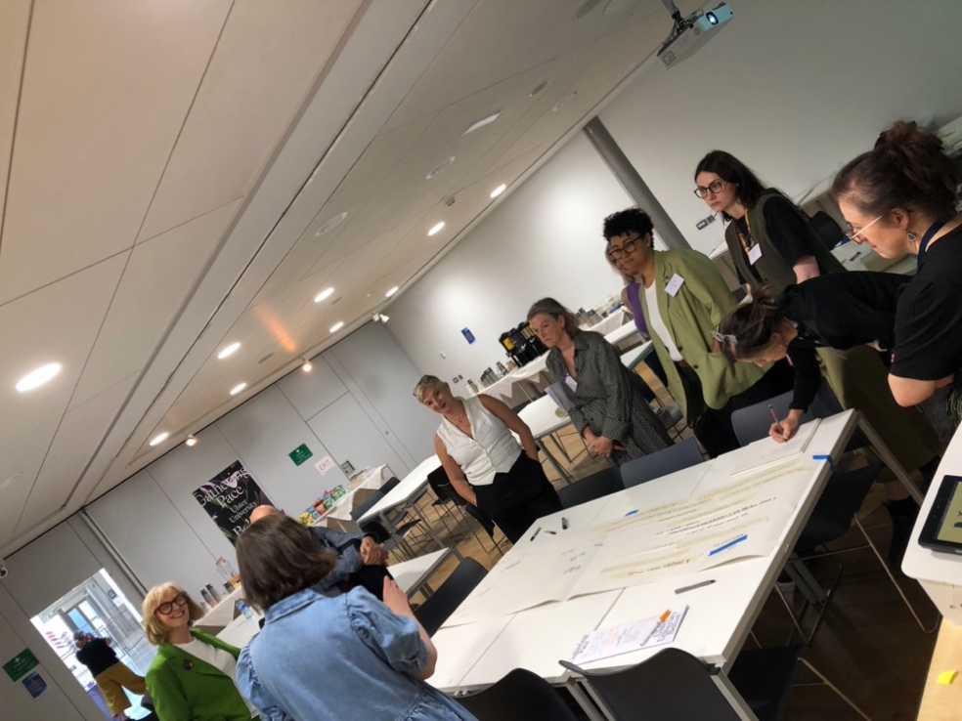
Fig. 1: Photograph of the Studio Manifesto workshop (Cróna Connolly, 2024)
The next section of the workshop asked participants to consider what a studio should be. By this we invited our co-conspirators to consider the phenomenological qualities of this unique space of learning, to be read in both a physical and psychological sense. In designing the workshop, we considered and debated the use of each action verb selected to frame each discussion, but as one participant rightly noted for a manifesto ‘should’ as verb did not have sufficient strength to emphasise the fundamental imperative of many of the features discussed and identified. This sparked a debate around the misunderstanding in many instances of what happens in a pedagogic studio and what affordances were necessary to deliver this unique pedagogy. The lack of understanding has considerable implications with regards to estate management and finance, particularly in multi-disciplinary institutions. These discussions reinforced the pressing need to develop a shared, evidenced rationale and minimum expectations of a studio space. Although our limited time together constrained discussion with regard to what these might look like, it was acknowledged that individual institutions and courses would have particular requirements which should be taken into account. There was consensus that in higher education you are not simply training graduates for industry, but that at equally important personal development is nurtured and facilitated in the studio. However, as Boling et al. point out here, too much emphasis on either can be problematic:
Some particular challenges in studio pedagogy arise from teaching for design character versus focusing solely on skills, knowledge or the cognitive process of our students. (Boling, Gray & Smith, 2020, p. 1)
It would seem that balance is sought after between higher education as preparation for professional practice, and higher education as intrinsic identity transformation. Theorist and educator bell hooks argues that the current neoliberal model of education is deeply flawed, as it reinforces rather than disrupts societal inequalities (1994). She envisages education as a tool for social change, “a practice of freedom” that enables students to “transgress” societal boundaries and challenge the status quo (1994, p. 12). For hooks, the role of education is not just to provide students with technical skills or information, but also to create critical thinkers who are able to challenge the dominant narratives that perpetuate the inequalities she observed. Paulo Freire had an impact on her philosophical position. Freire argues that higher education is often seen as a means for upward mobility rather than a tool for social transformation, perpetuating existing socio-economic inequalities. Although coming from slightly different perspectives, both hooks and Freire are echoed by Alvin Toffler’s statement that, “knowledge is the most democratic source of power” (OWP/P Cannon Design et al., 2010, p. 194) - or the belief that education can be a tool for social change, but only if it is used to challenge and transform existing power structures. There was a definite sense that our workshop participants shared a similar conviction: that the pedagogic design studio can enact Freire’s approach of “the problem-posing concept of education as an instrument for liberation” (Freire, 2005, p. 71). Orr & Shreeve (2018), Tovey (2015) and Boys (2011) all note that the ownership and individuality of open-ended briefs, traditionally used in studio pedagogy, afford the learner this agency. This can be very motivating for students. The idea that studios beget liberation via the development of individual creative practice that takes place within them is expressed eloquently here by Lorraine Marshalsey:
No matter what the size or platform, every studio should have its own identity, character and zones to facilitate privacy, freedom, activism, refuge and expression. (2023, p. 10)
With this over-arching purpose of facilitation in mind, for our final workshop activity participants were asked what they thought a pedagogic design studio should facilitate. This section of the workshop naturally flowed with several crossovers back to the previous discussions, speaking to the relations nurtured and challenged in the pedagogic studio. The richness of this part of the discussion reminded us of Farías and Wilkie’s opinion, that the studio is such a generative space that it must needs provide boundaries in order that the tyranny of anything goes does not become itself a barrier to creativity@
A short visit to any studio, or better yet its storage room [...] is enough to discover that the problem is not to come up with new variations, alternatives and possibilities. The fundamental studio challenge is rather the production of necessity (Farías, 2013), that is, establishing necessary conditions and constraints to close down the infinite span of possibilities, discard alternatives and make decisions. (2016, p. 8).

The Studio Manifesto
In design education discourse it is widely understood that "one of the key characteristics of the sticky curriculum is the pervading sense of uncertainty, where practice is messy and full of unknowns” (Orr & Shreeve, 2018, p. 13). Articulating a “pedagogy of ambiguity” (Austerlitz et al., 2008), we explored the notion of safe and unsafe uncertainty (Masson, 1993, p. 13), embracing ambiguity and the messy contradictions of the studio throughout. The workshop culminated with each participant adding their key takeaway from the conversations and prompts, thus creating the foundation for our studio manifesto. These were written onto strips of masking tape, which were then stuck onto a communal scroll of paper. Once all the ideas were compiled, each workshop participant signed the manifesto underneath in order to document and recognise their contribution.
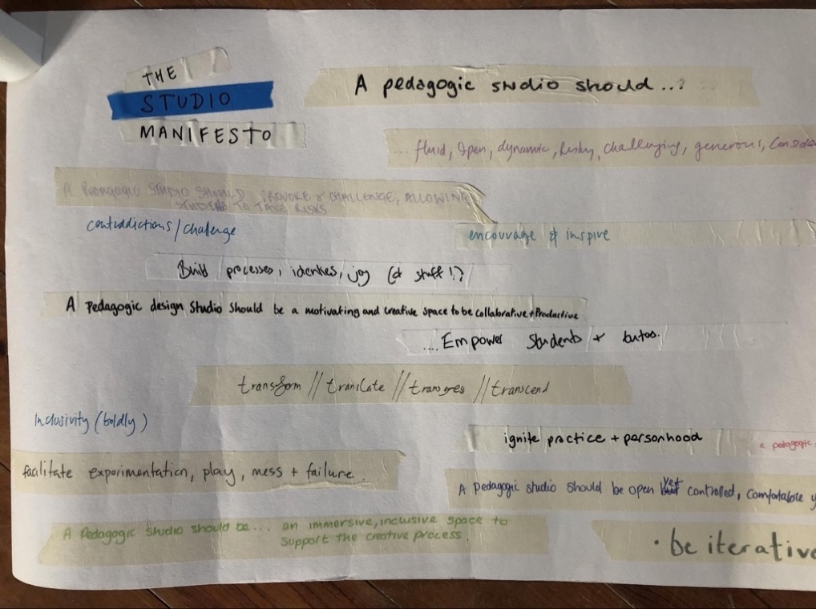
Fig. 2: Photograph of the original Studio Manifesto (Cróna Connolly, 2024)
The words below are the exact statements added to this collective document, as can be seen in the above photograph:
A pedagogic studio should...
- be fluid, open, dynamic, risky, challenging, generous, considered
- provoke & challenge, allowing students to take risks
- contradictions/challenge
- encourage & inspire
- build processes, identities, joy (of stuff!)
- be a motivating and creative space to be collaborative + productive
- inclusivity (boldly)
- empower students + tutors
- transform // translate // transgress // transcend
- facilitate experimentation, play, mess + failure
- ignite practice + personhood
- be open yet controlled, comfortable yet uncomfortable, safe yet challenging
- inclusive, encourage material play, create opportunities to collaborate
- be an immersive, inclusive space to support the creative process.
- be iterative - fit for purpose
- etiquette and ethics.
Given the quick and noisy nature of the workshop environment, we subsequently felt that the above original version of the manifesto required an edit for grammar, clarity and narrative cohesion. This was created during the writing this paper. We present our second version here:
A pedagogic studio must be creative, comfortable, ethical, safe, inclusive, generous and considered.
It should facilitate experimentation, play, mess, risk-taking and failure through materiality.
A pedagogic studio should be fluid, open, dynamic, immersive, iterative, empowering, inspirational and encouraging.
It should cultivate provocation, process, productivity, collaboration, contradiction and challenge.
A pedagogic studio should ignite practice and personhood.
We feel that this new version retains all the original, distinct elements, whilst eliminating the inevitable duplication caused by its genesis as the product of many people simultaneously working on the same activity whilst under considerable time constraints. We curated it into five sub-sections that aim to reflect our workshop provocations of having, creating, being and facilitating. We note that our first provocation of having, with its emphasis on the material elements necessary for a pedagogic studio, was overlooked in the production of the original manifesto. This was despite some debate during the workshop about the spatial elements that constitute a studio, including tactility, large surface areas, comfortable seating, good lighting etc. In hindsight, we wondered if our phrasing of “A pedagogic studio should...” precluded these material elements being included in the manifesto. Perhaps the simple “should” leans towards the phenomenological rather than also encompassing the material qualities that we had imagined would play a central role. However, because we could not sense-check this with our workshop participants post-conference, we decided to leave space and fit-out considerations out of the manifesto, keeping close to its original contents, with their focus upon the existential nature and pedagogic purpose of the studio. This is why we also included some of the general conversation pieces in describing the conference. It could be said that the workshop as method lends itself to the double diamond approach (British Design Council, 2005) to co-creation. Creating this shared perspective of what we wish to manifest for the student experience in the pedagogic studio in turn gives us a framework to expand upon in future. We have identified the needs, evidenced from multiple perspectives; now there is an opportunity to consider how to address these needs (Eames, 1972). This framework would allow individual educators to tailor the principles to their unique context. This was important to us as our intention was never to create a rigid structure for the fluid ecosystem that is the studio. The spatial is the practical elements listed previously, but as spatial theorist Henri Lefebvre (1991) argued, space is not a neutral backdrop against which social relations play out but is itself a product of social relations and plays a crucial role in shaping them. “Representations of space are about the history of ideologies” (Lefebvre, 1991, p. 116) because these are attempts to “explicitly describe particular coherent patterning of the social in space – concrete guidelines for how ‘thought’ can become ‘action’” (Harvey, 2000, p. 203). More than just an area to work in, the studio is a learning culture and space of (Carl, 2011) learning, experimentation, expression, safety - affordances a regular classroom cannot nurture as effectively (Boys, 2011; Spruce, 2007). Carl recognises the “tension between the conceptual field for types and the concrete topographies which we inhabit.” (Carl, 2011, p. 3). This is taken to mean how a person teaches, how the students respond, and their expectations are influenced by the physical configuration and the cultural values of the space (and the appropriateness of the space for the activity being undertaken).
Critical theorist Homi Bhabha urges that we examine the way we theorise and historicise architectural production with a contemporary lens of cultural interrelatedness (Hernadez, 2010). He reminds us that “in a world of increasing transnational traffic, the signature of specificity and locality – the productive signs of difference – often inhere in the telling detail that provides a narrative of the dialogue between tradition and social change” (Hernandez, 2010, p. 20). This is why we feel collective activities such as our workshop are so important, to question the status quo of a traditional, singular typology, and instead co-create a revised, relevant, evidenced adaptable vision akin to Massey’s “location of possibilities” (Massey, 1994, p. 207).

Discussion
As noted above, there were a number of common threads that emerged from the workshop dialogue and the list of characteristics prioritised by the group. In this section we will analyse each separate manifesto statement, with a view to exploring possible reasons for its inclusion, both from the workshop discussion itself and the literature. Firstly:
A pedagogic studio must be creative, comfortable, ethical, safe, inclusive, generous and considered.
Here emphasis is placed on the affective dimension of studio pedagogy. Discussion repeatedly circled back to the need for studio tutors to facilitate inclusive spaces that feel safe to learn in. Workshop participants agreed that educators should cultivate discursive critique practices that do not exclude or accidentally cause harm to students as they engage in free experimentation followed by very public demonstration of their work in progress, potentially exposing them to criticism at a vulnerable time during the early development of their nascent creative practice. This would seem to echo the wider contemporary rhetorical turn towards compassionate pedagogy, care and belonging in contemporary creative Higher Education (e.g. Bunting & Hill, 2021). This is a positive move away from historic traditions of studio cruising or crit as take-down, and is perhaps reflective of the growing professionalism of the HE sector, through initiatives such as Advance HE’s Professional Standards Framework (2023) which promotes core values such as “respect individual learners and diverse groups of learners” (Advance HE, 2023, p. 5). In addition, we note that widespread take up of institutional staff development programmes such as postgraduate certificates in Academic Practice or Learning and Teaching have influenced an academic understanding of the need to design learning experiences that are welcoming of all voices and do not marginalise or exclude anyone, for any reason.
The second statement concentrates on the types of activities that should take place within a pedagogic studio:
It should facilitate experimentation, play, mess, risk-taking and failure through materiality.
Whilst no specific activities were listed, from this we interpret that the everyday usage of a diverse range of materials and material practices within studio pedagogy enables a positive sense of the provisionary. By this we mean that the work produced in the studio should be seen less as artefacts, but rather as propositions, unfixed and possibly incomplete:
In order to optimise creative potential, there is a need to tolerate the discomfort of an ambiguous situation long enough so that what is produced is the best possible solution. (Harding & Hale, 2007, p. 3)
Rather than this open-endedness being viewed as a deficit, in the studio it is embraced as healthy iteration towards an improved future outcome. The pedagogic studio anticipates future work and is therefore a place of latent possibility. Moving beyond the traditional notion of products of learning, to learning as product in itself.
The third statement lists qualities that speak to the celebrated (and sometimes troublesome) openness and ambiguity of the studio and studio pedagogy (Boys 2011; Orr & Shreeve 2018; Shreeve et al. 2011, 2012; Tovey 2015):
A pedagogic studio should be fluid, open, dynamic, immersive, iterative, empowering, inspirational and encouraging.
Unlike empirical disciplines such as the natural sciences, design does not yield singularly correct solutions to problems (Frost, 1992). Instead, design fosters a distinct way of thinking, working, and learning within its unique cultural framework (Maitland, 1991). Cousin (2006) highlights the importance of creating a learning environment that embraces confusion as a necessary phase of the design process. This requires allowing students the time to shape their individual learning experiences under the guidance of their tutors, reminding us that "Studio education is not delivered. Studio education is forged" (Orr & Shreeve, 2018, p. 3).
The presence of inspiring mentors and role models significantly influences students, as Palmer asserts: “Having mentors and role models who inspire and guide students can greatly impact their motivation and aspirations” (Palmer, 2007, p. 89). The scaffolding approach to design education (Orr & Shreeve, 2018; Tovey, 2015) aligns with this perspective, emphasising the incremental increase in task complexity to help students develop competence, confidence, and a belief in their ability to meet future challenges.
French sociologist Bourdieu underscores the personal cost inherent in self-improvement, stating: “The work of acquisition is work on oneself (self-improvement) as an effort that presupposes a personal cost...” (Grenfell ed. 2014, p. 244). In the studio, when students engage with challenging yet achievable design briefs and receive constructive feedback, they are more likely to cultivate a sense of mastery, self-belief and professional identity.
The fourth statement:
It should cultivate provocation, process, productivity, collaboration, contradiction and challenge.
Central to this was that the pedagogic design studio is much more than just a physical space - it is an inclusive, transformative and iterative environment that empowers its participants to experiment, collaborate and grow as independent creatives. Shulman’s concept of “signature pedagogies” (2005) remains relevant, with the manifesto’s emphasis on how distinctive cultural features of the pedagogic practices lend themselves to preparation of future designers, who will be equipped with professional, contextual awareness that will support them to adapt to the creative workplace upon graduation.
Finally, the manifesto concludes that,
A pedagogic studio should ignite practice and personhood.
This phrase links professional skillsets with identity. The studio should be a space where individuals not only produce work but also construct and reconstruct their sense of self as they engage with materials, processes, and ideas. A safe space for experimentation and failure as noted above, it should also push individuals beyond their comfort zones, challenging them to grow through discomfort. This dynamic tension is crucial for igniting both practice and personal development.

Conclusion
This research tentatively set out to explore whether it would be possible and beneficial to curate a collaborative vision for the pedagogic studio. We designed and delivered a workshop for the 2024 GLAD conference that attracted arts higher education experts into the discussion. During the workshop a first draft Studio Manifesto was devised through structured dialogue and collaborative editing process. We later edited this, clustering the elements for coherence. We then analysed it through the lens of pedagogic literature. We conclude that our experiment is indeed reflective of wider debates in contemporary studio pedagogy.
We therefore propose that the resulting manifesto, whilst admittedly limited in terms of its potential for specific application, might be activated by design educators who are looking to induct students into the practices and purposes of the very specific learning environment of the pedagogic studio. For example, it might be a tool which could inform the co-design of a learning agreement with a new cohort of first year students. In this way studio pedagogy might be made more transparent (Winkelmes et al., 2016) and inclusive. It captures foundational principles that could inform conversations with estates and management on the 'must haves’ of the pedagogic studio, and we hope that this paper provides supporting evidence to communicate these. Additionally, the manifesto might act as a reminder of the agency educators and students have in this dynamic space and as an inventory of new products, practices and culture that can be incorporated to improve their experience.
As we draw this article to a close, we find ourselves happily reflecting on the lucky experience of our meeting, and the scholarly enjoyment of discussing our mutual research interest with another PhD student who has read the same texts. The easy-going nature of our conversation encouraged us to take a professional risk in co-writing the original GLAD conference abstract, then collaboratively designing and delivering the workshop. The positive and generative nature of our partnership has led to us co-authoring this research paper, which we have somehow managed to do over a couple of writing sessions in December, with its customary end of term workload pile-up, family commitments and PhD chapter deadlines looming in January. We have indeed had our research practice and identities ignited by the studio!

Acknowledgements
We would like to thank everyone who came to our Studio Manifesto workshop at the GLAD Gathering Pace conference on Friday 6th September 2024: Jacqueline Butler, Majella Clancy, Pauline Clancy, Anna Duffy, Matt Hawthorn, Emma Hogan, Jessica Longmore, Lynsey McDougall, Samantha Moore, Susan Orr, Jane Wayles. We would also like to thank Louise O’Boyle and her colleagues at Ulster University for their support in helping us make it run smoothly. Lastly, we would like to thank Alex Warnock-Smith of Central Saint Martins for introducing us.

Disclosure Statement
All materials included in the article represent the authors’ own work and anything cited or paraphrased within the text is included in the reference list. This work has not been previously published nor is it is being considered for publication elsewhere. We declare there are no potential conflicts of interest which might have influenced the authors in reporting their findings completely and honestly.

References
Acker, S. and Miller, M. (2005) ‘Campus learning spaces: Investing in how students learn’, EDUCAUSE Center for Applied Research Bulletin, 8, pp. 1-11.
Advance HE (2023) ‘Professional Standards Framework’. Available at: https://www.advance-he.ac.uk/teaching-and-learning/psf (Accessed: 13 December 2024).
Austin, T. (2020) Narrative Environments and Experience Design: Space as a Medium of Communication. New York: Routledge.
Austerlitz, N., Blythman, M., Grove-White, A., Jones, B., Jones, C., Morgan, S., Orr, S. Shreeve, A. Vaughan, S (2008) ‘Mind the gap: expectations, ambiguity and pedagogy within art and design higher education’, in Drew, L., (ed.) The Student Experience in Art and Design Higher Education: Drivers for Change, Cambridge: Jill Rogers Associates Limited, pp. 125-148.
Bhabha, H. (2007) Places of Culture: A Postcolonial Theory, Paris: Payot.
Boling, E., Brown, J.B., Corazzo, J., Gray, C.M., Jones, D. and Lotz, N. (forthcoming, 2025) Studio Properties: A Field Guide to Design Education. London: Bloomsbury.
Boling, E., Gray, C., and Smith, K. (2020) ‘Educating for design character in higher education: Challenges in studio pedagogy’, in Boess, S., Cheung, M. and Cain, R. (eds.), Synergy, Design Research Society International Conference, 11-14 August 2020. Doi: https://doi.org/10.21606/drs.2020.120
Boling, E., Schwier, R. A., Gray, C. M., Smith, K. M. and Campbell, K. (eds.) (2016) Studio Teaching in Higher Education: Selected Design Cases. London: Routledge.
Boynton, P. (2020) Being Well in Academia: Ways to Feel Stronger, Safer and More Connected. London: Routledge.
Boys, J. (2011) Towards Creative Learning Spaces: Rethinking the Architecture of Post-Compulsory Education. London: Routledge.
Bunting, L. and Hill, V. (2021) ‘Relational Reflections: How do we nurture belonging in creative Higher Education?’, Innovative Practice in Higher Education, GLAD-HE special edition, pp. 139-165. Available at: https://journals.staffs.ac.uk/index.php/ipihe/article/view/20 (Accessed: 13 December 2024).
Carl, P. (2011) ‘Type, Field, Culture, Praxis’, Architectural Design, 81, pp. 38-45. Doi: https://doi.org/10.1002/ad.1187
Casey, C., Harvey, O., Taylor, J. Knight, F. and Trenoweth, S. (2022) ‘Exploring the wellbeing and resilience of postgraduate researchers’, Journal of Further and Higher Education, 46(6), pp. 850-867. Doi: https://doi.org/10.1080/0309877X.2021.2018413
Connolly, C. (2023) How the studio becomes an intimate space of creative learning, Confirmation Document, Central Saint Martins, UAL (unpublished).
Connolly, C. (2024) ‘The Tertiary Pedagogic Design Studio’ [poster], GLAD Gathering Pace Conference. September 5-6, 2024. Available at: https://www.gladhe.com/home/2024conference (Accessed: 20 June 2025).
Corazzo, J. (2019) ‘Materialising the Studio: A systematic review of the role of the material space of the studio in Art, Design and Architecture education’, The Design Journal, 22(1), pp. 1249-1265. Doi: https://doi.org/10.1080/14606925.2019.1594953
Cousin, G. (2006) ‘An introduction to threshold concepts’, Planet, 17(1), pp. 4–5. Doi: https://doi.org/10.11120/plan.2006.00
Doorley, S. and Witthoft, S. (2012) Make Space: How to Set the Stage for Creative Collaboration. Hoboken, NJ: Wiley.
Eames Office (1972) Design Q & A, Interview with Mme. L. Amic [video]. Available at: https://www.youtube.com/watch?v=bmgxDCujTUw (Accessed: 10 December 2024).
Elkington, S and Bligh, B. (2019) Future learning spaces: Space technology and pedagogy, Future Learning Spaces: Space Technology and Pedagogy | Advance HE. Available at: https://www.advance-he.ac.uk/knowledge-hub/future-learning-spaces-space-technology-and-pedagogy (Accessed: 10 December 2024).
Farías, I. and Wilkie, A. (2016) Studio Studies: Operations, Topologies and Displacements. London: Routledge.
Frost, R. (1992) ‘A Converging Model of the Design Process: Analysis and Creativity, the Ingredients of Synthesis’, Journal of Engineering Design, 3(2), pp. 117–126. Doi: https://doi.org/10.1080/09544829208914751
Freire, P. (2005) Pedagogy of the Oppressed. New York: Continuum.
Gallagher, M. S., Lamb, J. and Bayne, S. (2016) ‘The Sonic Spaces of Online Distance Learners’, in Carvalho, L., Goodyear, P. and de Laat, M. (eds.), Place-based spaces for networked learning. New York: Routledge, pp. 87-99.
Grenfell, M. (2014) ‘Ireland and the Field of Higher Education – A Bourdieusian Perspective’, in Loxley, A, Seery, A. and Walsh, J (eds.) Higher Education in Ireland: Practices, Policies and Possibilities. Palgrave, pp. 96-109.
Groves, O. and O’Shea, S. (2019) ‘Learning to ‘be’ a University Student: First in Family Students Negotiating Membership of the University Community’. International Journal of Educational Research, 98, pp. 48-54. Doi: https://doi.org/10.1016/j.ijer.2019.08.014
Harding, J. and Hale, L. (2007) ‘Anti-Creativity, Ambiguity and the Imposition of Order’. In: Creativity or Conformity? Building Cultures of Creativity in Higher Education, 8-10 January 2007, Cardiff. Available at: http://www.arts.ac.uk/cltad/47894.htm (Accessed: 10 December 2024)
Hernandez, F. (2010) Bhabha for Architects. Abingdon: Routledge. Abingdon: Routledge.
hooks, b. (1994) Teaching to transgress: Education as the practice of freedom. New York: Routledge.
Jones, D. (2021) ‘Making little things visible’, Design and Technology Education: an International Journal, 26(1), pp. 8-11.
Ledewitz, S. (1985) ‘Models of Design in Studio Teaching’, Journal of Architecture Education, 38(2), pp. 2-8. Doi: https://doi.org/10.1080/10464883.1985.10758354
Lefebvre, H. (1991) The Production of Space, translated by Nicholson-Smith, D, Oxford: Basil Blackwell Ltd.
Maitland, B. (1991) ‘Problem-based Learning for an Architecture Degree’, in Boud, D. and Feletti, G. (eds.), The Challenge of Problem-based Learning, London: Kogan Page, pp.2023-233.
Massey, D. (2005) For Space. London: Sage Publications.
Massey, D. (1994) Space, place, and gender. Minneapolis: University of Minnesota Press.
Mason, B. (1993) ‘Towards positions of safe uncertainty’, Human Systems, 4, pp. 189-200. doi: https://doi.org/10.1177/26344041211063125
Marshalsey, L. (2023) Sensory Affect, Learning Spaces and Design Education: Strategies for Reflective Teaching and Student Engagement in Higher Education. London: Routledge.
Neary, M., Harrison, A., Crellin, G., Parekh, N., Saunders, G., Duggan, F., Williams, S. and Austin, S. (2010) Learning Landscapes in Higher Education. [Project Report]. Lincoln: University of Lincoln. Available online: https://cpb-eu-w2.wpmucdn.com/blogs.lincoln.ac.uk/dist/3/85/files/2012/05/Learning-Landscapes-in-Higher-Education-2010.pdf (Accessed: 7 November 2024).
Orr, S. and Shreeve, A. (2018) Art and Design Pedagogy in Higher Education: Knowledge, Values and Ambiguity in the Creative Curriculum. London: Routledge.
OWP/P Cannon Design, VS Furniture and Bruce Mau Design (2010) The Third Teacher: 79 Ways You Can Use Design to Transform Teaching & Learning. New York: Abrams.
Palmer, P. (2007) The courage to teach: Exploring the inner landscape of a teacher’s life. San Francisco: Jossey-Bass.
Radzikowska, M., Ruecker, S.,and Roberts-Smith, J., (2019) ‘Forget to clean up when you’re done.’ in Börekçi, N., Koçyıldırım, D., Korkut, F. and Jones, D. (eds.), Insider Knowledge, DRS Learn X Design Conference 2019, 9-12 July, Ankara, Turkey. Doi: https://doi.org/10.21606/learnxdesign.2019.09071
Rainford, J. and Guccione, K. (2023) Thriving in Part-Time Doctoral Study: Integrating Work, Life and Research. London: Routledge.
Shulman, L. (2005) ‘Signature Pedagogies in the Professions’, Daedalus, 134(3), On Professions & Professionals (Summer, 2005), pp. 52-59. Available at: https://www.jstor.org/stable/20027998 (Accessed: 16 June 2024).
Shreeve, A., Sims, E. and Trowler, P. (2010) ‘‘A kind of exchange’: Learning from art and design teaching’, Higher Education Research and Development, 29(2), pp. 125-138. Doi: https://doi.org/10.1080/07294360903384269
Thoring, K., Mueller, R., Desmet, P., and Badke-Schaub, P. (2018) ‘Design Principles for Creative Spaces’, DESIGN 2018 15th International Design Conference. Dubrovnik, Croatia, 21-24 May, pp. 1969-1980. Doi: https://doi.org/10.21278/IDC.2018.0233
Tovey, M. (2015) Design Pedagogy: Developments in Art and Design Education, Surrey: Gower.
Veldhoen, E. (2005) The art of working, Den Haag: Academic Service.
Vygotsky, L. (1978) Mind in society: The development of higher psychological processes, London: Harvard University Press.
Williams, A. (2009) ‘Creativity Syntax: An Emerging Concept for Creativity in the Workspace’, Design Principles and Practices: An International Journal, 3(5), pp. 192-202.
Williams, T. (2024) ‘‘Vultures circling’ as cash crisis forces universities’ hand’, Times Higher Education, 27 August. Available at: https://www.timeshighereducation.com/news/vultures-circling-cash-crisis-forces-universities-hand (Accessed: 16 December 2024).
Winkelmes, M., Bernacki, M., Butler, J., Zochowski, M., Golanics, J. and Weavil, K. H. (2016) ‘A Teaching Intervention that Increases Underserved College Students’ Success’, Peer Review, 18(1-2), pp. 31-36. Available at: https://www.proquest.com/docview/1805184428# (Accessed: 14 December 2024).
#ArtisEssential (2023) Creative Education Manifesto. Available at: https://cvan.art/wp-content/uploads/2023/09/ArtIsEssential-Manifesto-01.pdf (Accessed: 6 December 2024).

