Embodiment in Design Education: expanding pedagogy to meet contemporary challenges

Emma Hoganª, Emma Creighton, Marcus Hanratty
ªAtlantic Technological University, Ireland (ATU), ^{b}National College of Art and Design, Ireland (NCAD)
Corresponding author: Emma.Hogan@atu.ie

Abstract
This paper examines two embodiment workshops in design higher education (HE). The workshops form part of a larger research project exploring the use of somatic practices to address dominant challenges impacting design education. Facilitated by a design educator and a choreographer, the workshops guide undergraduate students through four stages: Arrive, Move, Create, and Gather, using movement and creative exercises to bypass cognition and amplify embodied knowing. The study highlights the relevance of embodied practices to contemporary societal and environmental challenges, including student well-being, emotional regulation, and the development of ethical and sustainable design practices. Data collection includes body maps, questionnaires, group discussions, and observational notes. Despite a small data set, findings reveal participants’ receptiveness to embodied practices, emphasising their capacity to deepen self-awareness, regulate emotions, and access creative insights. The study demonstrates the potential of embodied practices to expand design pedagogy and foster critical, responsive approaches to contemporary challenges.

Keywords
Design education, embodiment, somatics, pluriversality, regulation

Introduction
As a lecturer in design communications (Graphic Design & Illustration) my current concerns centre around student wellbeing and teaching design in a time of global crises. Amidst the rise in students disclosing anxiety related issues, it feels pertinent to question how best to meet and teach students in a trauma-informed way while also addressing sustainable, ethical, and ecological challenges such as those such as those outlined in the UN Sustainable Development Goals (United Nations, 2015). Within design education, students often confront the gravitas of climate crises, systemic inequalities and social justice challenges, making emotional regulation essential (Hogan & Creighton, 2023). It is a position of this research, that addressing such ‘hot’ topics calls for expanded, pluriversal pedagogies that prioritise student well-being, challenge dominant Western epistemologies and cultivate alternative ways of knowing.
Embodied practices present promising ways to nurture student well-being and also the sensitivity, depth and ethical awareness required for complex, “wicked” problems (Hogan & Creighton, 2023, p. 2)​. This paper discusses an explorative workshop titled ‘Embodiment in Design’ that took place on two dates in February 2024. The workshop offers participants an opportunity to engage in somatic experiences through conscious movement and creative activities. Curricula is designed to enable learners to drop into their bodies, explore their inner experience and ‘felt sense’ and articulate their experiences in visual and verbal form via body mapping, automatic writing and discussion.
Research questions guiding these workshops include:
- How receptive are students to embodied practices within a higher education design context? What challenges exist?
- Will these approaches enable an insight, shift or new dimension of knowledge to emerge?
- How might embodied pedagogies transfer into design studio practice to enhance alternative ways of knowing in design?
This paper is divided into 5 parts: introduction, literature review, workshop design, discussion and conclusion.

Literature Review: Embodied Cognition and Somatic Pedagogy in Design Education
Hegemonic design pedagogy emphasises cognitive and rational frameworks, often overlooking embodied, sensory dimensions of knowledge acquisition (Hogan and Creighton, 2023)​. Recent scholarship highlights the limitations of cognitive-focused design methods like Design Thinking, for the tendency to reduce complex issues to manageable stages, often simplifying or ignoring affective and embodied experiences central to creative processes (Laursen & Haase, 2019; Boehnert, 2018; Hogan and Creighton, 2023). While Akama reminds us to be ‘weary of mind-constructed categories that measure each as separate, like the Life Cycle Analysis or Triple Bottom Line’ (2018, p.288), Höök states that underestimating the significance of bodily experiences and awareness as critical components of design is a mistake (2018, p. 3).
Studies in neuroscience now tell us that the brain is only one part of a huge neural network extending throughout the body (Bainbridge Cohen®1993; Juhan 1987; as cited in Eddy, 2017 p. 6) and that intelligence runs throughout the ‘soma’, or living body, through nervous system connections. Accordingly, when learners actively engage with bodily sensations and internal experiences, they can access preconceptual knowledge and insight, which are often inaccessible through purely cognitive means (Eddy, 2017).
While contemporary design education prioritises cognitive methods, embodied approaches can feel unfamiliar or even uncomfortable to students (Hogan et al., 2023). However, historically the Bauhaus and Black Mountain College (BMC) demonstrated how embodied approaches can be integrated into design education (Marshalsey, 2017). Joseph Albers (1888-1976), who taught at both, encouraged the class to stand and move around to develop an enhanced awareness of what they were seeing. Johannes Itten (1888 –1967), taught a fundamental awareness of the body as a sensory stimulus at the Bauhaus encouraging students to use their senses and their intellect (Itten, 1975; Droste, 2006; Saletnik and Schuldenfrei, 2009; Zifcak, 2013 as cited in Marshalsey, 2017). Moholy-Nagy included movement in his Bauhaus curricula, not for object design but with “human development as the purpose” (Sfligiotti, 2021).
The concept of situated knowing (Haraway, 1988) provides a theoretical foundation for integrating embodiment into design education. It challenges the notion of the designer as a neutral agent, advocating instead to amplify the designer's position as “critical actor” (Place, 2023). Situated knowing aligns with an emerging focus on design responsibility and ethical awareness, essential for addressing global challenges such as climate change and social injustice (IDG Foundation, 2023). New educational tools, like The Positionality Wheel (Noel, 2023), assist students in identifying their positionality in order to inform their approach to design - helping them to become more critically aware of their history, goals and ethics for social change. Such tools are especially timely in a globalised world where sustainable design solutions increasingly necessitate designers’ awareness of personal, local and global power structures (Hogan et al., 2023). Hogan and Creighton (2023) propose that embodied practices can foster intrapersonal knowing and reflexivity — qualities that can enrich the creative process and support ethical awareness. Somatic methods offer pathways for student designers to access “inner coherence” and align personal values with professional actions, fostering holistic development (Hogan and Creighton, 2023, p. 6).
Additionally, somatic practices have been shown to regulate emotional states, helping students manage stress and develop greater emotional resilience (Eddy, 2017). With design education viewed as being “emotionally saturated” involving aspects such as experiential learning, reflective processes, exposure, and self-disclosure (Austerlitz et al., 2002, p. 87) increasing the need for trauma-informed pedagogy.

Embodiment as a Path to Pluriversality and Decolonisation
Embodied practices in education support pluriversal approaches by disrupting Western-dominated epistemologies and fostering alternative ways of knowing (Hogan & Creighton, 2023). The persistence of mind-body dualism (also known as the Cartesian split) in academia reflects a bias toward intellectual knowing. As such, the mind prevails “as a locus of learning” with the body considered “a distraction to the mind” (Rodriguez-Jimenez & Carmona, 2021). As Johnson (2003) observes, formal education often disassociates students from their inherent capacity for embodiment, promoting intellectual detachment over personal attunement to bodily knowledge.
Value placed on ways of knowing and knowledge can be seen as cultural and political in that the mind is associated with masculinity, rationalism, and the intellect and the (reproductive) body with femininity, intuition and emotion (Haraway, 1988). Hogan and Creighton (2023) emphasise that somatic design practices disrupt hegemonic narratives that privilege cognitive knowledge by centralising and validating the body as a source of knowledge. Somatic practices validate intuitive and emotional experiences, offering an expanded view of knowledge and a counterpoint to rational, intellectual knowing.
Incorporating somatic approaches into design education aligns with the call for inclusive and sustainable practices that address the complexities of today’s world. By creating space for embodied learning, educators can foster deeper connections between students' internal experiences and their external creative outputs, contributing to more sensitive and perhaps, more innovative design processes. These practices resonate with feminist and decolonial aims, advocating for a more equitable and holistic approaches in education.

Embodied Knowing and the Felt-sense
Central to this study is the value of the "felt sense," a term coined by Gendlin (1982), to describe embodied knowing that is experienced more deeply through physical awareness than intellectual reasoning. Embodied methods often facilitate profound insights and creative breakthroughs, enabling students to access preconceptual knowledge and alternative ways of knowing, feeling and sensing (Eddy, 2017). Such approaches can uncover insights and perspectives that may remain hidden in traditional, cognition-focused pedagogies. A question herein is whether somatic approaches can help students uncover new perspectives on design challenges and generate transformative shifts in understanding.
To bring embodied knowing into education, Eddy (2017) emphasizes the importance of allowing students time and space for introspective practices, to counterbalance the external focus prevalent in contemporary education systems. She advocates for somatic learning to help “compensate for the disproportionate amount of time spent on external focus in test taking and the use of computers” (2017, p. 191).
Questions explored in this research are ‘what do our bodies know’ and ‘how do we bring this knowing forth?’. How can we learn to trust, validate and amplify embodied knowing in HE design? What opportunities and challenges exist in doing so within our current system?
These workshops aim to make space and time for embodied exploration. They are designed to guide participants inward to explore their inner experience and felt sense and to articulate their experiences in visual and verbal form via body mapping, automatic writing and discussion. A description of the workshop methodology follows.

Workshop overview: Participants
Funding for two workshops was obtained from the N-TUTORR project, an initiative of the European Union and Next Generation EU (N-TUTORR, n.d.). The workshops were part of a weeklong programme of N-TUTORR activities focused on ‘Transforming Learning’. In order to recruit participants emails were sent by N-TUTORR to University staff and students, across all programmes and campuses. See Figures 1 and 2 for Promotional images (A and B). Expressions of interest and registrations were made by reply. In total, there were 30 spaces available for two workshops.
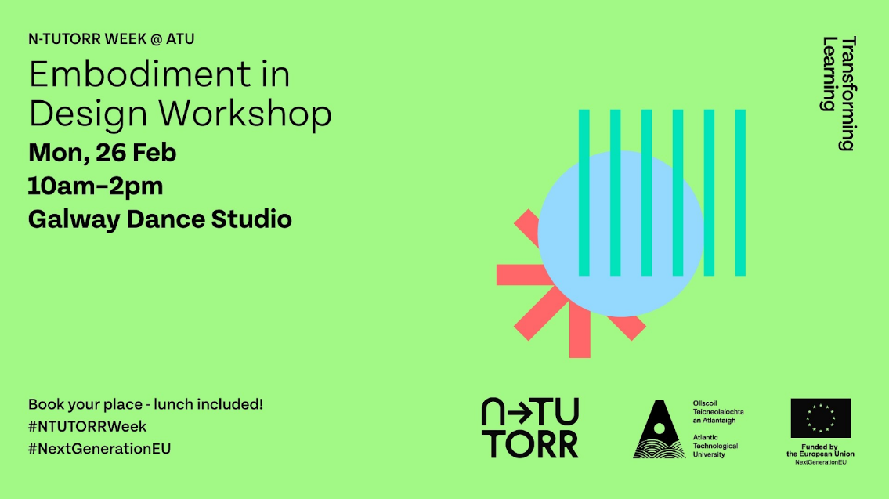
Figure 1: Promotional image A
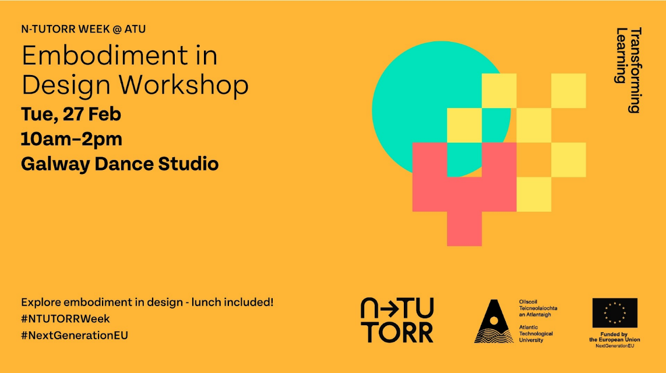
Figure 2: Promotional image B
The workshops were also promoted locally in the Centre for Creative Media & Arts (CCAM), Galway. Although the workshops were open to all disciplinarians, most participants came from CCAM with a high signup from BA Design (Graphic Design & Illustration). The researcher lectures into this programme hence the potential for increased interest by these students. Participation was voluntary and informed consent was required.
Twenty-five registrations were made however the final number of attendees was fifteen. Five participants at workshop 1 (W1), plus the participant researcher, and ten participants at workshop 2 (W2). W1 was composed of students from different years and undergraduate programmes: three Design Communications students, one Fine Art, one Heritage and one participant researcher. W2 was composed of nine 2nd year and one 4th year BA Design (Graphic Design & Illustration) students.

Facilitation
The sessions were designed and co-facilitated by a design educator and a dancer/choreographer to ensure a blend of design-oriented and somatic perspectives.
Bringing in a movement specialist provided a way to consciously and mindfully support the inclusion of somatic approaches. As Eddy (2017) attests, when a somatic approach is woven into education it can create a culture shift. Hogan and Creighton (2023) suggest, within the current context of third level design education, to consider involving a somatic or movement specialist to support individuals and groups. Having a movement expert guide participants in conscious embodiment provides sensitivity, safety and experience that is valuable in holding space for embodied approaches.
During the workshops, the movement expert led the conscious movement and creativity phases (Move and Create) while the designer-educator framed the workshop and led the research methods (Arrive and Gather). See Figure 3 for the full workshop outline.

Setting
The workshops took place at The Galway Dance Studio. The dance studio is a large open space with wooden floorboards, one wall of mirrors and one wall of floor to ceiling windows. The choice of location was to facilitate a break from the classroom, and access to an open space designed for movement with no chairs, desks, computers, or other furnishings. Another reason for choosing this setting was that a similar large, empty space is not currently available on the CCAM campus. The researcher felt that a break from the classroom would benefit participants and allow time and space away from workload and assessments. In order to move comfortably participants were asked to wear loose clothes and to remove their shoes for the workshop.

Workshop Structure and Activities
The workshops were structured around somatic activities designed to bypass cognition and foster embodied awareness and felt-sense. The workshop structure comprises of four stages: Arrive, Move, Create and Gather. The workshop outline is detailed in Figure 3 below.
ARRIVE.
On entering the space (a dance studio), participants remove their shoes, put their belongings aside, and find a place to sit (on the floor).
- Body map A
MOVE.
- Warm up: Participants are guided through light warm-up movements.
- Conscious movement: Participants are guided through conscious movement activities, moving from head to body and from external to internal focus.
- Guided body scan / meditation: Eyes closed guiding participants to bring attention to internal focus.
CREATE.
- Mindful drawing exercise, focusing on the hand (90 sec)
- Word associations (90 sec)
- Memory mining (90 sec)
- Automatic writing (7 mins)
- Participants are prompted to walk through the space (as a group) reading their automatic writing aloud.
- Grounding exercise.
GATHER.
Participants sit on the ground.
- Body map B
- Questionnaire and written reflection.
- Facilitated discussion.
Figure 3. Workshop outline
Data Collection
Individual packs with body maps and questionnaires were distributed to participants at the start of the workshop. Four data collection methods were employed:
Body Mapping: Body maps are visual documents, where embodied experiences can be drawn onto an outline of the human body. They can be used to capture complex emotional states and felt sensations and provide a way of collecting embodied data that cannot be simply spoken (Cochrane et al., 2022). Here, the purpose of body maps as a research method is two-fold. First, they help bring the participants' attention to their bodies inviting them to locate sensations, feelings and experiences and to express them visually. Such ephemeral states, sensations, and feelings may be difficult to identify and verbalise otherwise. Secondly, the body maps provide data for the researcher and, in this instance, to changes in experience over a duration. Analysis involves comparing pre- and post-workshop body maps plus examining the variety, intensity, and placement of markings as indicators of embodied change.
Questionnaire: Questionnaires were distributed to assess openness to embodied practices, and perceived impact and value. The questionnaire was designed to collect quantitative and qualitative data including a reflective narrative of participant experiences.
Group Discussions: Hand-written notes were used to collect data from facilitated group discussions. The discussion provided additional qualitative data on participant experiences and an opportunity to discuss the potential, and challenges, of the transference of embodied methods to studio practice.
Observation: Field notes were made by both facilitators and shared after the workshops. An expanded discussion of shared learning followed W2 and included comparative notes on similarities and differences between the two workshops. The design educator acted as participant researcher in W1 and as observer in W2, taking observational notes, photos and an audio recording of the Move and Create phases. See Figure 4 samples of W2 photography:
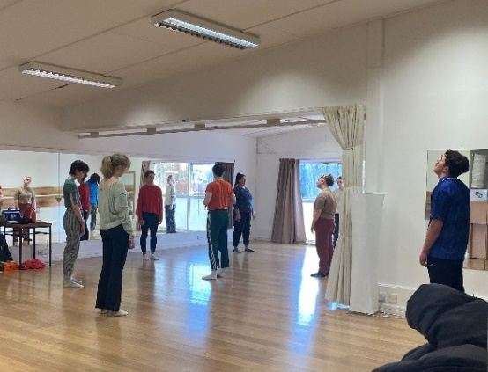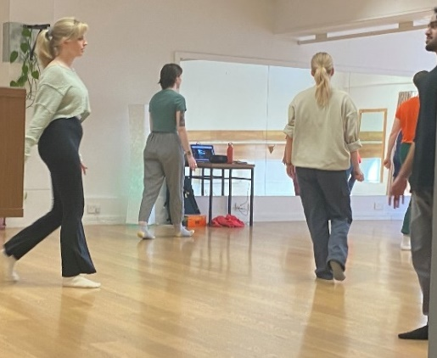
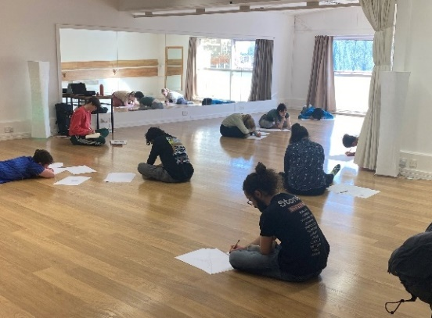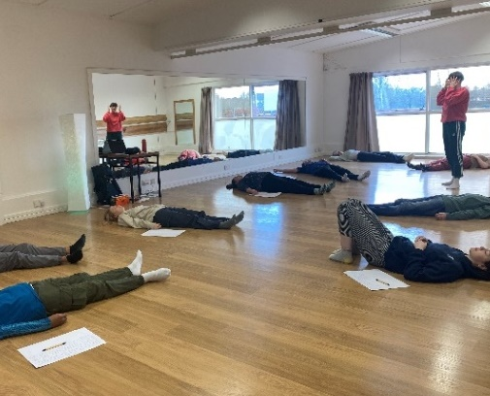
Figure 4. Samples of W2 photography (Move and Create)
Ethical considerations
Ethical approval for the workshops was obtained from the University Ethics committee in which the study was completed. Data collection, protection and storage were in line with GDPR and the University data control, storage and retention policies. Informed consent was obtained from each participant.
An ethical issue was the power imbalance between the researcher, a lecturer, and participatory students. Accordingly, it was important that the workshops were voluntary, not part of classwork and not graded or part of any assessments. Participants were made aware that they could opt out of the research at any point without consequence. It was emphasised that data was being gathered with rather than from participants in accordance with values of “respect for people and for the knowledge and experience they bring to the research process” (Brydon-Miller et al. 2003, p. 15). Having a second facilitator allowed an opportunity to share observations and gain critical feedback on whether the researchers observational findings were fair and balanced.
In order for participants to feel free to express themselves in the creative activities e.g. automatic writing, it was clarified, and communicated to students in advance, that this work would not be collected or used as data. Feedback and responses were anonymised. Video or time-lapse photography were considered inappropriate in order to create a comfortable space for those who may feel self-conscious. Participants were invited to consent to have photos taken and effort was made to ensure that any photography captured during the event was discreet and non-invasive. In W2, the researcher sat in an annex, listening and taking field notes, during the Move and Create stages. Again, this was to reduce any potential feelings of discomfort or self-consciousness that might arise in participants in direct observation by a researcher or lecturer.

Data analysis
Thematic analysis was chosen as an appropriate method to identify patterns and themes across various forms of data. This qualitative approach facilitates an exploration of both shared and individual experiences. First, the researcher studied and became familiar with the written data: questionnaires, group discussion notes, and facilitator observations. Next, quantitative responses were analysed for trends while written narratives were cross-referenced with themes from other datasets. These preliminary steps set the stage for developing initial codes, which were generated inductively from the data. Phrases like "relaxed state," "out of my comfort zone," and "new ideas" became recurring codes across datasets.
Codes were grouped into higher-level themes reflecting the research objectives, including:
- Willingness to engage with embodied practices (WIL)
- Identification of body and sensory awareness (SEN)
- Changes in emotional states (EMO)
- Insights gained through embodied exercises (INS)
- Transference of embodied practices to studio practice (FUT)
Visual content analysis of body mapping data provided further insights, with a comparative analysis of pre- and post-workshop maps. This method enabled the researcher to identify changes in embodied states in individuals and in groups. For the analysis of groups W1 and W2 pre- and post-workshop body maps were converted to transparencies, overlaid and compared. Patterns in markings, intensity, and focus areas were visually analysed for trends, such as increased coherence or integration of embodied states. Questionnaire data, both quantitative and qualitative, supported these findings by highlighting trends.
Observational notes were triangulated with participant feedback to contextualise experiences. Differences between W1 and W2 were examined, considering group composition, familiarity with embodied practices, and how external factors like academic pressures may have influenced individual experiences. This contextual analysis highlighted how receptivity and engagement varied across the two groups.
While thematic and visual content analysis formed primary analysis methods a third approach was found useful. Maggie MacLure’s concept of "hot spots" was used to locate moments of wonder or transformation in the data that resonated with the researcher (2013). This method was found by the researcher to be a more intuitive approach to data analysis and provided valuable data for informing future directions for the larger research project.

Findings
Findings from the two workshops highlight challenges in embodied approaches in HE design and also the transformative potential of embodied practices on students' physical and emotional wellbeing, and access to embodied knowing.
Willingness to engage and receptivity
While twenty-five students and faculty registered to attend the workshops, the final number of participants was fifteen. Four students pulled out citing academic commitments and deadlines, two had family commitments and the remainder did not attend on the day.
In the questionnaire, fourteen participants agreed or totally agreed that the activities helped them move from thinking into bodily awareness. The qualitative datasets inform more nuanced findings. These indicate that while W1 participants were open and responsive to the practices, W2 participants were slower to engage, self-conscious, and required additional facilitator prompts during the Move stage of the workshop. This contrast highlights differing levels of comfort and receptiveness, possibly influenced by group dynamics, the age and level of students, and prior exposure to embodied practices. The movement facilitator observed that W2 participants showed reluctance to movement, particularly during the moving meditation, and that participants didn’t appear to relax until the writing activity. It was observed by the facilitator that a few W2 participants “didn’t get out of their minds and into their bodies” (W2 F2). Several W2 participants admitted to feeling uncomfortable at the start while one admitted they remained self-conscious throughout (W2 P3). One participant (W2 P6) reported feeling “a bit awkward at the beginning” elaborating that “some activities like reading aloud was more uncomfortable than others.” Another W1 participant found that while they were “a bit uncomfortable and self-conscious” at first, they were able to relax and “get out of [their] head” (W1 P3) over time. Meanwhile, observations and other datasets revealed that participants in W1 were more successful in dropping into their bodies.
Many W2 participants reported initial discomfort with the bodily exercises, which gradually transformed into a sense of enjoyment and relaxation. One participant admitted feeling “uncomfortable and self-conscious” at first and later reflecting that “It was nice to get out of my comfort zone and out of my head a bit” (W1 P3). There is an opportunity for more data to be collected on the ‘resistance’ to embodied approaches but also the findings are conclusive that, despite initial reluctance and feelings of discomfort, all participants responded positively to doing this type of exploration again. The ability to break from the cognitive demands of coursework and enjoy explorative, movement-based activities was a recurring theme in the data with participants observing:
I found it so refreshing to let bodily movement take control rather than being plagued by thoughts. (W1 P2)
Making the time to come to […] the class is like showing up for yourself in a real way.” (W2 P9)
Participants also valued a reminder to move more and come back to their bodies. Participants shared how they felt “more grateful” (W1 B5) towards their body and:
I loved this experience. […] it made me realise that I would love for my body to become lighter + healthier so that movement becomes a bigger part of my life. (W1 P1)

Participants valued the workshop’s focus on non-judgmental exploration, with two W1 participants describing the experience as freeing: “It felt free to be ‘me’ in this workshop.” (W1 P1) and “It felt really freeing. Both physically and mentally” (W1 P4). When asked whether they would like to do this type of exploration again participants responses include:
I definitely would like to, I found it very beneficial and I felt great after. (W1 P2)
Yes, definitely. It made me feel rooted and aware and regulated and freed up my mind. (W1 P4)
Yes. It was educational in many different ways and was also fun and enjoyable. (W1 P5)

Enhancing embodiment, sensory awareness, and regulation
Several participants across both workshops reported awareness of bodily sensations (SEN) and emotional states (EMO). Questionnaire data, both quantitative and qualitative, and body maps supported these findings. One participant admitted “I feel aware of every inch of myself” (W2 P8) while another shared:
I really struggle with bodily awareness so these activities were amazing and I found them really helpful in being able to feel my own body within myself and in relation to my environment. (W1 P4)
Others reflected on the calming effect of the practices:
the exercises brought me back to a more natural state that resembles what I was as a child. calm + relaxed + quiet. (W1 P1)
The mindful movement exercise seemed to calibrate my body temp and kept me in a calm state. (W2 P4)
One participant appreciated the reminder to:
do things more intuitively, and listen to my bodys wants and needs (W2 P5)
This participant also shared how the practices:
helped me turn off my thoughts for the time in the studio and solely focus on the here and now, without overthinking what I was doing. (W2 P5)
Other participants noted that they struggled to let go. One shared that:
I’d probably just go back to my over thinking self (W2 P6)
The references towards ‘overthinking’ or being “plagued by thoughts” (W1 P2) in the data links to the prevalence of cognitive, rational and linguistic dimensions in academia and the exclusion of embodied, somatic and alternate ‘ways of knowing’. This research posits that an antidote to ‘overthinking’, burnout and overwhelm experienced in academia (by students and educators) is to create time and space to centre the body.
Visual content analysis of body mapping data provided further insights about participants' embodied experiences. Comparing each participant's pre- and post-body map for visual changes, including mark making, colour and intensity revealed notable shifts. While the pre-workshop body maps reveal more diverse, intense, and high contrast marks, the post-workshop samples reveal increased coherence, integration and lower intensity marks. This, combined with data from written and verbal methods, suggest participants experienced a greater sense of holism, embodiment and integration by the end of the sessions. See Figures 5 and 6.
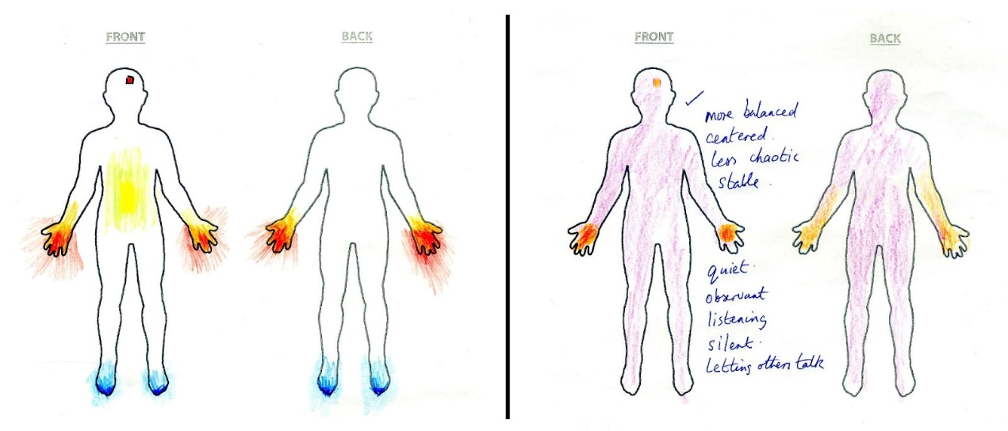
Figure 5. W1 P1, pre- (left) and post-workshop body maps
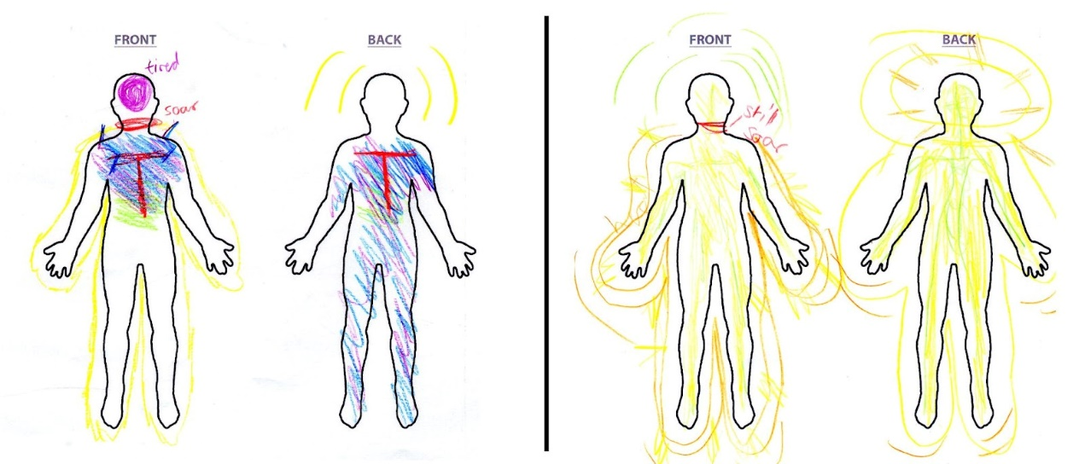
Figure 6. W1 P9, pre- (left) and post-workshop body maps
Following a comparative analysis of individual participants’ body maps, the body maps were combined into four groups, pre- and post- from W1 (B1 and B2) and pre- and post- from W2 (B1 and B2). Here, each grouping of body maps was overlaid as transparencies to form one composite image. Next, each composite was analysed for patterns in markings, intensity, and focus areas. A shift in the pattern of experience can be seen in the composite body maps from W1 (Figure 7). The pre-workshop body maps (W1 B1) have more disparate, isolated and intensity of markings with some areas of the body devoid of any marks. Markings on the post-workshop composite (W1 B2) are subtler and more integrated overall. The increased coherence and visual consistency in the post-workshop composite, together with written and verbal data, suggests the group experienced a greater sense of embodiment, attunement and integration by the end of the workshop.
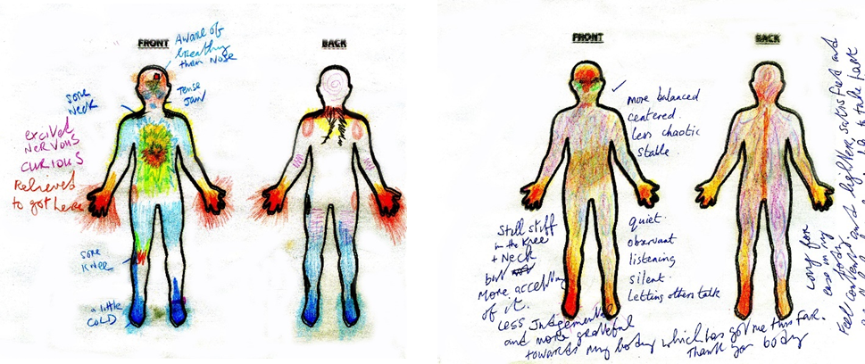
Figure 7. W1 Group Body maps; pre- (W1 B1) and post- (W1 B2)

Embodied knowing and accessing new insights
Findings reveal that participants accessed new ideas and moved past creative blocks during the workshops. For example, one participant described how:
another train of thought came through during the automatic writing that completely counters my long-lived beliefs surrounding a topic that I am invested in. (W1 P1)
This demonstrates how the practices, and specifically automatic writing, allowed them to challenge established ideas, confront “long-lived beliefs” (W1 P1), and find a fresh perspective and new knowledge. Others described feeling "free" and allowing the “mind a blank slate to create whatever” (W2 P1) while one participant reported how the exercises helped them to move past a creative block:
It felt really freeing. Both physically and mentally and I was able to process through a block I was experiencing regarding something I’m working on. I can see forward in a way I couldn’t before. (W1 P4)
W2 participants similarly recognised the activities as opportunities to approach creativity with an open mind enabling a clear focus on present sensations without overthinking. One student observed that the workshop:
helped me turn off my thoughts for the time in the studio and solely focus on the here and now (W2 P5)
Quantitative data from the questionnaire revealed that fourteen participants experienced an insight, shift or new dimension of knowledge.

Potential for Transfer to Design Practice
In relation to the transfer and applicability of the workshop practices to their design process, participants’ responses were mixed but optimistic. Some saw a direct connection, with one participant planning to integrate “swinging arms and stretching” into their studio routine to maintain “life force jumping and alive” (W1 P1). Others recognised the importance of movement to “not get stagnant” (W1 P2) and to address creative block:
I would like to incorporate mindful movement into my work especially at the start of work when there might be a creative block. (W1 P4)
However, some students from W2 were less confident about applying these techniques directly to their design practice, with one writing it was “hard to imagine doing something like this in our studio space.” The studio shared by this group is a long narrow room with fitted desks along two walls and little floor space so there are logistical issues at play here. In addition, a lack of ‘time and space’ came up during the W2 discussion with participants admitting feeling under pressure regarding assessment deadlines and academic workload. To this end, the concept of not enough ‘space’ has both a logistic and systemic dimension.
All fifteen participants had an appetite to do more of these types of practices with one feeling “that it should be complemented more into college life to help relax” (W2 P3) and another recommending others try these workshops to “unlock new ideas” (W2 P10).

Limitations and challenges
Findings from the workshops demonstrate the potential value of embodied practices in design education; however, several limitations and challenges must be acknowledged. A significant limitation was the small sample size, with only fifteen participants across two sessions, restricting the generalisability of the findings. Furthermore, the voluntary nature of participation may have introduced self-selection bias, as those predisposed or with an interest in embodied methods were more likely to attend. This potentially skews the data toward more favourable perceptions of the workshops and limits insight into the broader acceptance of embodied pedagogies in design education.
The setting and structure of the workshops also presented logistical and contextual challenges. The workshops took place in a dance studio, chosen to foster openness and remove participants from their usual academic environments. While this setting proved effective in creating a conducive atmosphere for movement and introspection, its divergence from traditional classroom or studio spaces raises questions about the feasibility of integrating such practices into standard design pedagogy. Participants from W2 expressed difficulty imagining how embodied methods could fit into their crowded and inflexible studio, indicating that physical space constraints and systemic factors in design education present barriers to widespread adoption of these approaches.
Additionally, some participants reported initial discomfort with embodied practices. This resistance underscores the challenge of shifting ingrained societal attitudes toward the body in learning contexts. A factor that came up during the promotion of the workshops reflect common social norms around embodiment - as indicated by a second-year student who declined to participate mumbling “bodies… awkward”.
Ethical considerations, including the researcher’s dual role as facilitator and lecturer, also added complexity. Efforts to mitigate power dynamics—such as making workshops voluntary and ensuring non-assessment—were necessary but may not fully address the influence of hierarchical relationships on participant engagement. These challenges highlight the need for further exploration into scalable, culturally sensitive, and contextually adaptable models for integrating embodiment into design education.

Discussion
The workshops reveal that embodied approaches can play a role in enriching design education by helping students reconnect with their bodies, regulate, and access embodied ways of knowing in the forms of shifts, openings and insights. The findings align with feminist theories that advocate for embodied learning as a pathway to deeper awareness, connection and pluriversality, reinforcing the need for design education to move beyond purely cognitive approaches (Hogan et al., 2023). Designing embodied curricula directly aligned with existing design pedagogy feels like a necessity to bridge the gap between current design pedagogy and more open, expansive approaches. A challenge to centring the body in third-level education is that many students have been conditioned to consider and revert to the intellect as superior. The repetition of ‘overthinking’ in the questionnaire indicates a pattern that is prevalent in academia and possibly wider. The emphasis on intellect as the preferred way of knowing is underpinned by a value system in academia and western cultures, where the felt sense is not addressed, taught, or even known to exist (Eddy, 2017).

Embodied Practices as Tools for Regulation
Participants in both workshops reported benefits of regulation, with many feeling calmer and more centred after the workshops. This prompts questions as to the value of embodied practices for trauma-informed education both within design and more generally in HE. In design education, somatic practices that support regulation have the potential to scaffold students’ when tasked with navigating complex creative tasks and wicked problems (Hogan and Creighton, 2023). Moreover, somatic practices offer design students valuable tools for managing stress and vulnerability associated with creativity, which is often awkward, oppositional, disruptive and antagonistic (Linquist et al., 2017 as cited in Hogan and Creighton, 2023).

Embodied knowing or ‘felt-sense’
These workshops make an essential contribution to dismantling the mind-body split, encouraging students to see their bodies as sources of knowledge and inspiration. Embodied approaches can support creative ideation and decision making by regulating the nervous system and reducing cognitive and affective noise. This ‘noise’, or a tendency to ‘overthink’, can limit one’s design practice, as students negate or override bodily insights that are valuable for the creative process.
The workshops revealed that somatic exercises, particularly automatic writing and conscious movement, brought about new perspectives and insights. As mentioned earlier, one student shared how they encountered “another train of thought [...] that completely counters my long-lived beliefs surrounding a topic I am invested in” (W1 P1) illustrating how embodied practices can bring about deep knowing, realisations and new perspectives. Such findings indicate that embodied learning has potential to serve as a catalyst for breakthroughs.

Applicability and Integration in Studio Practice
Participants were divided on whether these embodied practices could transfer directly to studio-based work, with some expressing uncertainty about integrating such practices into the design studio. Although one student mentioned that it “might be hard to imagine doing something like this in our studio space,” (W2 P8) others indicated openness to incorporating movement to overcome creative blocks or maintain energy. It is worth considering further how to integrate embodied practices into the design studio and design pedagogy. Findings herein present a contribution towards that end, however, further research and exploration is needed to develop this line of inquiry
Although a small dataset was drawn from, findings are conclusive on the value of embodied approaches that foster wellbeing, self-awareness, and embodied knowing. By creating space and opportunities for students to explore embodiment in a supportive, non-judgmental environment, the workshops align with feminist and decolonising methodologies that seek to decentre dominant Western, cognitive-centric paradigms. Participants’ enthusiasm for further sessions signals a readiness to explore educational models that incorporate embodied, situated knowledge. Educators can build upon this by creating spaces and learning approaches that prioritise bodily experience within design education. While further research is needed there are a growing number of designer educators exploring somatics in design. In 2021, The School for Somatic Design Practices, established a collective of international designer-mover-educators engaging with embodied approaches in design education (A—Z presents, 2023).
The workshop described herein is a deliberate intervention removed from the campus. Next steps in the larger project include action research integrating embodied approaches into the design studio. While findings around the potential transfer of embodied approaches into the design studio were inconclusive the researcher is currently doing experiments in the studio integrating embodiment into the design process specifically in places of high affect. This approach explores how embodied approaches can affect resilience and creative confidence. An aim of the ongoing research is to encourage student-designers to connect with inner knowing and ‘felt-sense’ and to explore whether embodied approaches could uncover more nuanced understandings of students' creative processes and situated knowing, offering a more personalised and impactful learning experience.
Longer term research possibilities include integrating a regular recurring somatic practice in design education and exploring the long-term impacts of embodied practices on practitioners, creative processes and design outputs. This could include trials with larger and more varied participant groups to explore scalability in educational curricula.

Conclusion
This study demonstrates that embodied practices have significant potential to enrich design education by fostering deeper self-awareness, emotional regulation, and creative insights among participants. Findings highlight the transformative capacity of somatic methods, enabling participants to explore situated, embodied knowing and engage with design education from a more holistic perspective. Moreover, these approaches align with contemporary societal challenges, resourcing students with tools to navigate complex global issues with reflexivity, resilience, and embodied sensitivity.
Despite these benefits, the study also reveals challenges inherent in adopting embodied pedagogies within higher education. These include logistical constraints, such as the lack of suitable spaces for movement-based activities, and cultural resistance rooted in the longstanding privileging of cognitive over embodied knowledge in academic settings (Rodriguez-Jimenez & Carmona, 2021). Addressing these barriers requires a shift, such as redesigning curricula to incorporate somatic practices and creating environments that normalise and support embodied exploration.
Despite logistical and cultural challenges, findings herein suggest that integrating embodiment into design curricula can support trauma-informed education and foster more sustainable, responsive design practices. By bridging the divide between mind and body, embodied practices offer a pathway to more inclusive, reflective, and innovative design education — one capable of addressing the urgent educational social and environmental issues of our time.

Disclosure statement
All materials included in the article represent the authors own work and anything cited or paraphrased within the text is included in the reference list. This work has not been previously published nor is it is being considered for publication elsewhere. The authors declare that they have no conflicts of interest to disclose.

References
Akama, Y. (2018) ‘Surrendering to the ocean: Practices of mindfulness and presence in designing’, in Egenhoefer, R. B. (Ed.) Routledge handbook of sustainable design. Routledge, Taylor & Francis Group, pp.219-230.
Austerlitz, N., Aravot, I., & Ben-Ze'ev, A. (2002) ‘Emotional phenomena and the student–instructor relationships’, Landscape and Urban Planning, 60(2), pp. 105-115. Doi: https://doi.org/10.1016/S0169-2046(02)00063-4
A—Z presents (2023) The A—Z Collective welcomes the School for Somatic Design Practices on Sunday, November 12 from 14:00 to 16:00 [Instagram] 8th November. Available at: https://www.instagram.com/p/CzYMmhLsjIH/?igshid=N2ZiNzVhMjY2OA== (Accessed: 10 November 2023).
Berger, E. (2019) ‘Embodying Design Practice. Designers’ Experience and the Chakra Model’, International Association of Societies of Design Research Conference 2019. Design Revolutions, Manchester School of Art.
Boehnert, J. (2018) Design, Ecology, Politics: Towards the Ecocene. Bloomsbury Publishing.
Brydon-Miller, M., Greenwood, D. and Maguire, P. (2003) ‘Why action research?’, Action Research, 1(1), pp. 9-28. Doi: https://doi.org/10.1177/14767503030011002
CAST (2018). Universal Design for Learning Guidelines version 2.2. Available at: http://udlguidelines.cast.org (Accessed: 28 January 2024).
Cochrane, A. K., Mah, K., Ståhl, A., Núñez-Pacheco, C., Balaam, M., Ahmadpour, N. and Loke, L. (2022). Body Maps: A Generative Tool for Soma-based Design. Sixteenth International Conference on Tangible, Embedded, and Embodied Interaction. https://doi.org/10.1145/3490149.3502262.
Eddy, M. (2017) Mindful Movement. The Evolution of the Somatic Arts and Conscious Action. Bristol-Chicago: Intellect/The University of Chicago Press.
Escobar, A. (2018) Designs for the pluriverse: Radical interdependence, autonomy, and the making of worlds. Durham and London: Duke University Press.
Gendlin, E. (1982). Focusing. New York: Bantam Books.
Haraway, D. (1988) ‘Situated Knowledges: The Science Question in Feminism and the Privilege of Partial Perspective’, Feminist Studies, 14(3), pp. 575-599.
Hogan, E., and Creighton, E. (2023) ‘A case for Somatic Approaches in Design Education’, in Jones, D., Borekci, N., Clemente, V., Corazzo, J., Lotz, N., Nielsen, L M., Noel, L., (eds.), The 7th International Conference for Design Education Researchers, 29 November - 1 December 2023, London, United Kingdom. https://doi.org/10.21606/drslxd.2024.101
Höök K. (2018) Designing with the body: somaesthetic interaction design. Cambridge, MA: The MIT Press.
IDG Foundation. (2023). IDG. Available at: https://innerdevelopmentgoals.org. (Accessed: 10 February 2024).
Johnson, N. R. (2003). Knowing in our bones: Exploring the Embodied Knowledge of Somatic Educators. MA Teaching and Learning. University of Toronto.
Juhan, D. (1987) Job’s Body: A Handbook for Bodywork. New York: Station Hill Press.
Laursen, L.N., and Haase, L.M. (2019) ‘The Shortcomings of Design Thinking when Compared to Designerly Thinking’, The Design Journal, 22(6), pp. 813–832. Doi: https://doi.org/10.1080/14606925.2019.1652531
MacLure, M. (2013) ‘The Wonder of Data’, Cultural Studies ↔ Critical Methodologies 13 (4), pp. 228–32. https://doi.org/10.1177/1532708613487863.
Marshalsey, Lorraine (2017) An investigation into the experiential impact of sensory affect in contemporary Communication Design studio education. PhD thesis, The Glasgow School of Art.
N-Tutorr. (2024) About Us - Online Learning Platform for TU | N-TUTORR. Available at: https://www.transforminglearning.ie/about/ [Accessed: 9 December 2024].
Noel, L.-A. and d.school, S. (2023) Design Social Change. Ten Speed Press.
Place, A. (2024) Scratching the Surface. [podcast]. Available at: https://scratchingthesurface.fm/246-alison-place (Accessed: 20 February 2024).
Rodriguez-Dono, A. and Carmona, M. (2021) ‘Mixed methods for evaluating embodied processes in higher education’, in Tantia, J. F. (Ed.) The Art and Science of Embodied Research Design. Routledge, pp. 229-241.
Sfligiotti, S. (2021). Why we need more somatic culture in design. Medium. Available at: https://silviasfligiotti.medium.com/why-we-need-more-somatic-culture-in-design-5302a8bc024b (Accessed: 1 October 2022)
United Nations (2015) The 17 GOALS–Department of Economic and Social Affairs Sustainable Development. Available at: https://sdgs.un.org/goals (Accessed: 11 November 2023).

