Reflexivity, methodologies and collaboration in art practice: Plough Through and The Air We Breathe

Marina Velez Vago and Sarah Strachan
Anglia Ruskin University

Corresponding Author: marina.velez@marinavelez.com

Abstract
Being a practicing artist and conducting practice-based research today may involve re-framing and re-thinking beyond discipline boundaries. It can be said that art prospers from such spillage, which can create opportunities for collaborations where knowledges and meanings can be articulated in new and innovative ways.

Keywords: collaboration, art practices, environmental art, transdisciplinary, socially engaged art

Introduction
In their separate reflections, Marina and Sarah respond to their own experiences of collaboration through the lens of two of their respective works, Plough Through, and The Air We Breathe. Each narrative is allowed its own voice by acknowledging each individual’s practice and reflective process in their own right. The authors’ decision to keep the two papers separate responds to feminist theoretical frameworks and the refusal to separate the pursuit of knowledge from the question of who produces this knowledge and the intersectional terrain in which such knowledges are created (Anderson, 2005, Fricker, 2009, Haraway, 1988, Stengers, 2010). As such, each paper is constructed around one work to try to reflect on art practices’ creative processes and how each artist employs different strategies to position herself in “the terrain that makes us think” (Stengers, 2010, p. 78). Placing these two reflections side by side leaves some space for the reader to create a dialogue between the two works.

Taking as a starting point the concept of value and subjecting it to scrutiny through her own collaborations with farmers in rural Spain, Marina positions situated knowledges central to her paper in which she explores value and knowledge production, employing her own work Plough Through and the works of other artists such as herman de vries, Ana Mendieta, Fina Miralles and Agnes Denes. She investigates art practices’ strategies for collaboration as thinking-with, working-with and sensing-with, and looks at ways of producing healthy collaborative work through the lens of Deborah Bird Rose’s concept of shimmering.

In her paper, Sarah explores aspects of artistic practices which work collaboratively, as well as the differences in terms used to describe these collaborations such as multi- inter- and trans- disciplinary. She investigates what it entails to re-think discipline boundaries, venturing beyond into other specialists' areas in her conversations with a mathematician and environmental scientist. In relation to The Air We Breathe they discuss air quality, health, inter-generational justice and the specific ‘languages’ of science and art.

Plough Through
By Dr Marina Velez Vago

This essay will be constructed around the work Plough Through, which emerged out of my experiences of working-with farmers and shepherds in rural Spain. Plough Through employs photography, video and dialogical methodologies to create spaces to explore cartographies of value(s) and human relations to the environment. This essay will explore artistic practice-based research in the context of the natural world, environmental degradation and climate change, through the lens of my own work contextualised by the work of artists such as herman de vries, Fina Miralles and Agnes Denes. I will look at art practices as alternative ways of knowledge making through research and collaborative adventures; and propose that art practice strategies can become catalyst for partial healings and reparations to the entanglements of life and environmental degradation. This paper proposes that higher levels of creativity are needed to address increasingly complex problems and that art practices can provide alternative visions based on new values, for shimmering and thriving in a multi-species biodiversity.

Making Values Visible
Tate defines Land Art as part of the conceptual art movement, tracing its beginnings to the 1960s and 1970s, and citing Robert Smithson and Richard Long as the most representative artists. It describes Land Art as “usually documented in artworks using photographs and maps which the artist could exhibit in a gallery.” (Wilson & Lack, 2008, p. 116). Both artists cited as examples are men. Both are sculptors and tend to create statement works in isolation. Giving these two artists such a prominent place in recent art history promotes the idea that Land Art is about big gestures, sometimes permanently inscribed in the landscape, made mainly by male artists. Even though there is no mention of eco-feminism in the Tate glossary, figures such as Long were not the only ones making work about, and responding to, the natural world.
Female artists such as Ana Mendieta, Fina Miralles and Agnes Denes have opened the path for practices like mine to engage with current preoccupations and problematics relating to the natural world. But my art projects are not necessarily similar to the works of the artists who inspired me. Based on the idea that the artwork is “partly located in real space and partly in psychological space” (Burgin, 1969, p. 118), I take from artists such as these qualities which are present in the nature of the work but not in its formal manifestation. In other words, I do not necessarily use the same means as those artists, but I am inspired by the spirit in which they tackle subjects that resonate with me. I borrow from Ana Mendieta a certain intuitive feminine force, as well as spiritual and physical impulses to connect artist and nature which are present in her body-earth traces works. Spanish artist Fina Miralles brings the exploration of the feminine in land art closer to my research context, and I draw from her work the strength to seek communion with, and the understanding of, nature, even in challenging circumstances. Miralles’ work arose in the context of Franco’s authoritarian dictatorship; a regime which had a strong negative impact on women’s social and political positions and even worse repercussions on female artists who, like Miralles, did not conform to impositions of power and oppression.
Denes is regarded as a pioneer of environmental and ecological art, whose large-scale ecological projects address her preoccupations around food, social justice and human relationship with the land. Her work Wheatfield - A Confrontation forces the viewer to consider food security, land mismanagement and misplaced priorities, and this feeds into my work as thinking through the many artistic strategies to put the focus on value issues. Wheatfield - A Confrontation consisted of planting and harvesting a field of wheat in a vacant lot in Lower Manhattan, a land worth millions of dollars, and then distributing the harvest among 28 cities worldwide to contribute to the international art show for the end of world hunger. This work invites people to question the value of land and food as well as the value paradoxes of global trade.
Alan Sonfist is another American artist who made work by repurposing land in New York City. His work Time Landscape involves the recreation of a pre-colonial forest in the shape of an urban park. In my conversations with Sonfist, with whom I shared an art residency at the Festival for the Earth in Venice in 2016 (Image 1), he was very critical of Denes’ wheat field work, and he argued that wheat has no relation to pre-colonial American land as it had originated in other parts of the globe and that it was the wrong plant to use in the art intervention. I believe, on the other hand, that this is precisely how Denes deliberately decided to approach decolonising thinking in her work.
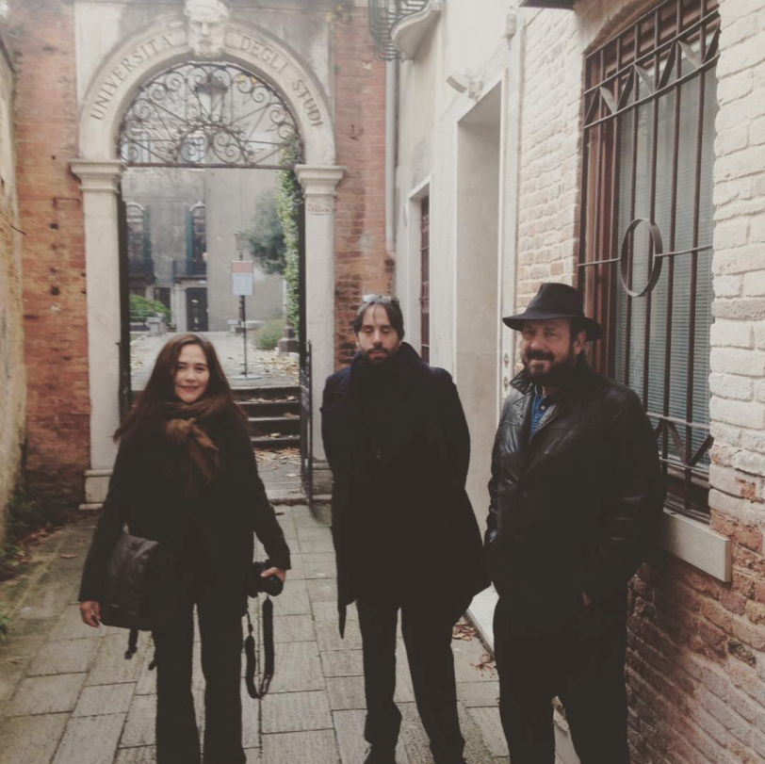
Image 1 Ca’Foscari, Venice, 2016. From left to right: Marina Velez Vago, Giuseppe Laspada, Alan Sonfist. Image credit Clive Adams.

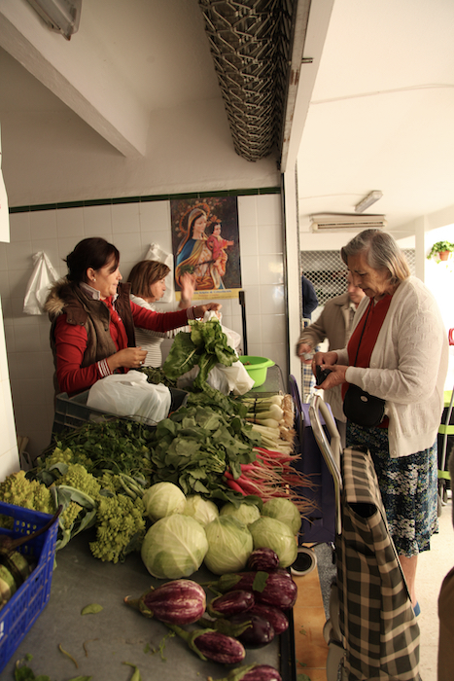
But Wheatfield - A Confrontation does not pretend to speak solely of decolonial thinking, engaging instead in a wider conversation about the value of land, access to, and ownership of, soil on which to cultivate, which of course indirectly addresses the issue of land expropriated from the First Nations. It also expands the idea of environmental art intervention as a singular object, be this a park for Sonfist, a spiral jetty for Smithson or a line made by walking for Long. Wheatfield - A Confrontation demystifies the work as contemplation and acts on several different levels simultaneously, raising questions of where the artwork actually is. Is it the field? Is it the artist in the field? Is it the process of cultivation? Is it the harvest, or perhaps the artwork is the distribution of the wheat to highlight world hunger? This dismantling of the work of art as identifiable and singular, whilst embracing ambiguity as to what the work is, informs my practice and my art projects. Similar questions can be asked about my work Plough Through. Where is the artwork, is it in the market intervention? (Image 2). Is it in working the land? (Image 3). Or is it in the photographing of the farmers at work and using the printed pictures as wrapping paper for the vegetables? (Image 4).

Image 2 Indoor market in Belalcázar, 2012. Marina Velez Vago, MariCarmen García Chacón, the Virgen de la Alcantarilla and some customers. Image credit Jonathan Brow.

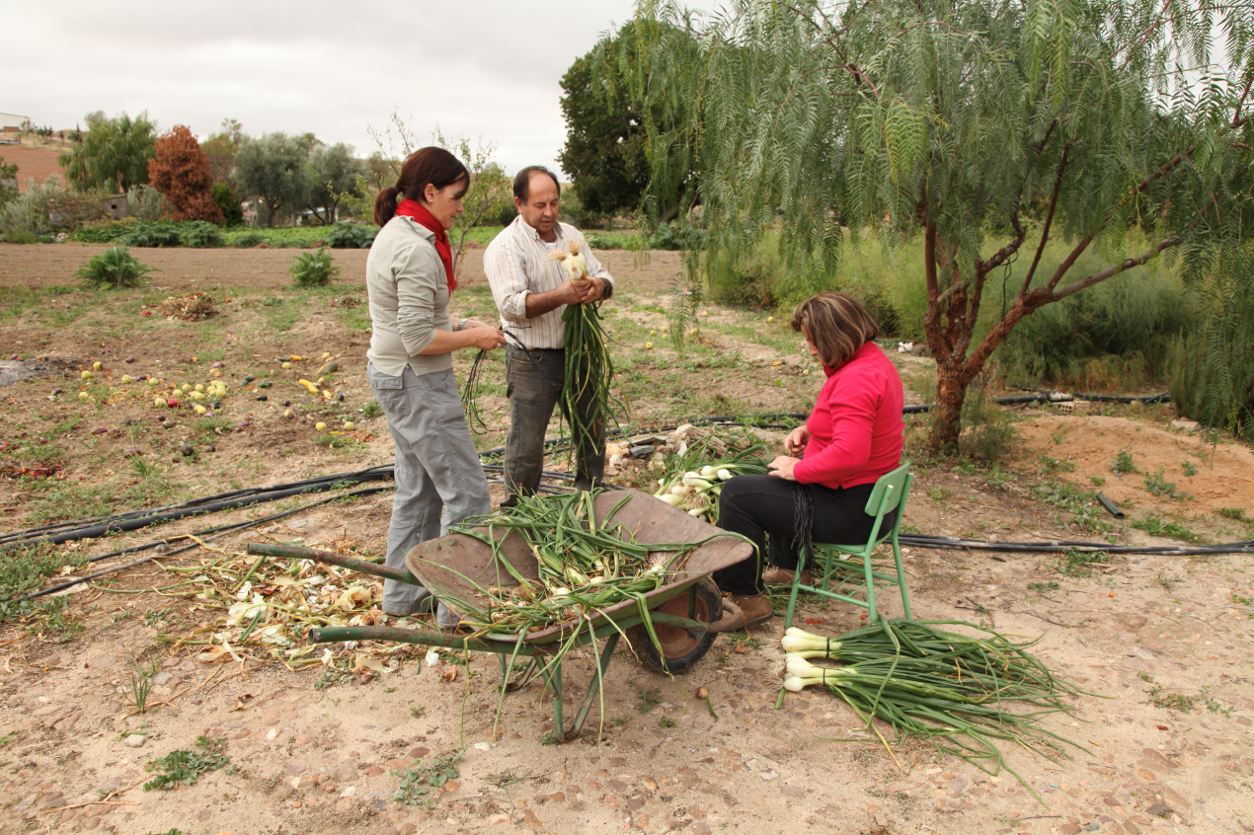
Image 3 Belalcázar, 2012. From left to right, Marina Velez Vago, Antonio Muñoz Molina and MariCarmen Garcia Chacón. Image credit Jonathan Brown.
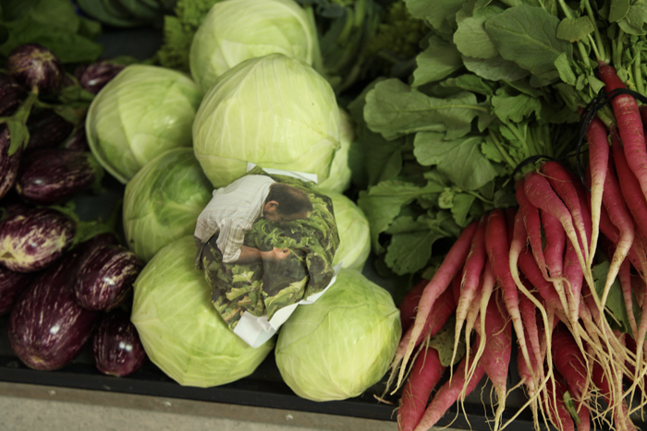
Image 4 Market interventions, 2012. Image credit Marina Velez Vago.

In my projects I use photography and video, but unlike the image production of other artists working on environmental art, the photographs and videos do not exist for the sake of documentation. The project Plough Through for example, explores access to land and water, biodiversity and knowledge diversity and the value of food and food sovereignty. In projects like this one I use images to map out cartographies of knowledges and experiences, which open up spaces for dialogical practice tracing complex entanglements of people, land, animals and plants, and prioritise making-with others over the creation of the image, whether this is for documentation or otherwise.
Land Art has its roots in conceptual art and, in full circle, I come back to the relevance of the concept behind the work in my practice. As the works open up spaces for revising and questioning values, it is pertinent to sustain the concepts behind the work be they photographs, interventions, videos or site responsive works because “it matters what concepts we think to think other concepts with” (Haraway, 2016, p. 118). In other words, meaning matters.

Shifting Value
Meaning can be seen as integral to value making and the way in which humans connect to, and make sense of, the world. Anthropologists Whorf and Sapir postulated in 1954 that “there is an intimate connection between the categories and structure of language and the ways in which humans are able to experience the world” (Eriksen, 2001, p. 227). For example, they noticed that the language of the Native American Hopis lacked standard nouns and verb conjugations and they attributed this to the fact that Hopis’ language is oriented to movement and process, whereas European languages, such as English, are oriented towards things.

Based on the idea that, to express themselves and solve tasks, people will develop meaning-making tools which are intimately connected to sustained values, and that values affect behaviour, it is important to understand how values are created and maintained if behaviour patterns are requested to change. Seeing humans as separate from nature or seeing nature as kin can be regarded as a culturally specific product of values which, in disciplines such as art, do not depend on received or internalised values, but can be created by the artist within her own practice. Dutch artist herman de vries, for example, has been an active collaborator in the human-nature continuum narrative all his career. Exploring de vries’ practice in the light of Whorf and Sapir’s argument, one needs to ask: How does the artist experience the world and what is it that he perceives as necessary in his practice?

For de vries, going out every day to have communion with nature is as much of a necessity as it is to find the poetry of things in the things themselves. In an interview for the exhibition to be all ways to be at the Dutch Pavilion in The Venice Biennale in 2015, de vries expresses that he wants to show the process to the viewer and that he wants to create art that is simple. Using nature as primary, he brings soil, plants, rocks and flowers, from the outside world into the gallery space. De vries shows the gallery visitor what he finds relevant and invites them to notice it, using the gallery as a space for this observation to take place. He wants visitors to develop awareness and to foster a closer relationship with nature. Awareness is regarded a very high value in de vries’ personal system of values and he confesses that his teacher is the squirrel, and that he wants to be, like a squirrel, always awake and aware of his surroundings. De vries’ practice is, ultimately, based on the idea that the artist’s job is to communicate her experiences.

I saw his work at the Venice Biennale Dutch Pavilion in 2015 where he showed a book with the names of all the plants which he could remember having consumed at some point. This work is called flora incorporata, and it clearly articulates de vries’ inner and outer cognitive process: he knows himself to the extent that he knows the world, which he incorporates into his own being. He becomes the plants and the plants become him. He is in the world. He cognises it. And then, he communicates this to the viewer.

Visiting that Dutch Pavilion as an artist and viewer allowed me to sense de vries’ experiences through his work. De vries’ work gives me the space to reflect on my job as an artist and my job as a human being. The work flora incorporata prompts me to think of the plants which I have consumed and transformed into energy, and it makes me reflect on the profound connection between nature, my own being and what I need to be alive. It also makes me reflect on the value that plants have for me and for all of humanity.

Another one of his works, sculptures trouvées, comprises collected stones from different landscapes. I saw this work at his exhibition in GroundWork Gallery in the UK, and the text accompanying the work explained that de vries believes that every stone is individual and has its own character and process of change; that we are changing, the stones are changing, and that we have something in common (Images 5 and 6). De vries experiences his connection with nature as something beautiful and he invites the viewer to access his work through the sense of beauty.
The shift in value that de vries wants the viewer to experience is accessible and direct. What is the value of a stone, one might ask? The stone is the same stone that de vries found in his walks, but as the stone goes through the artist’s experiential process it is transformed. The aesthetic gesture of the artist as he presents the stone as a singularity in all its rareness and richness enhances each stone visually and conceptually. De vries’ action to place each stone on a wooden plinth elevate them, actually and metaphorically.
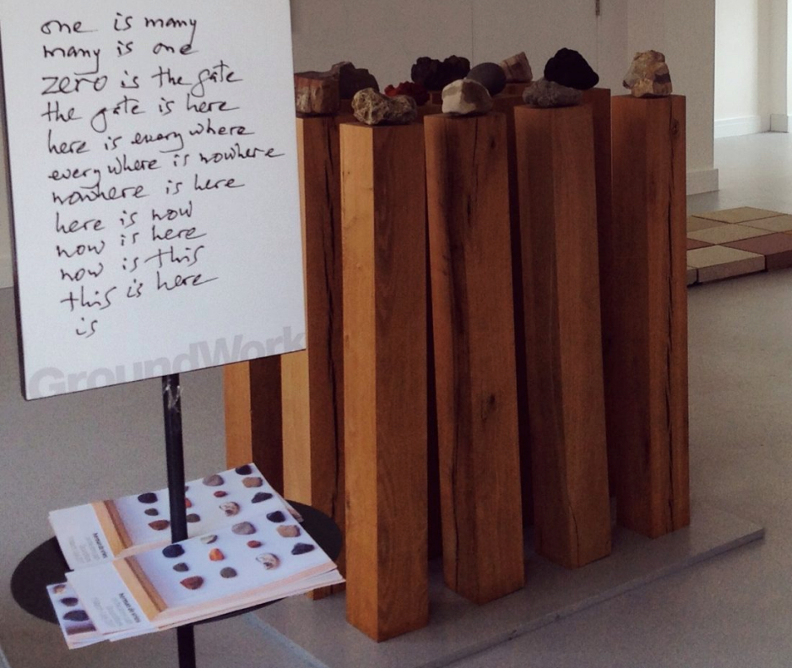
Image 5 - work by herman de vries, image courtesy of GroundWork Gallery, from the exhibition ‘on the stony path’, 2017.
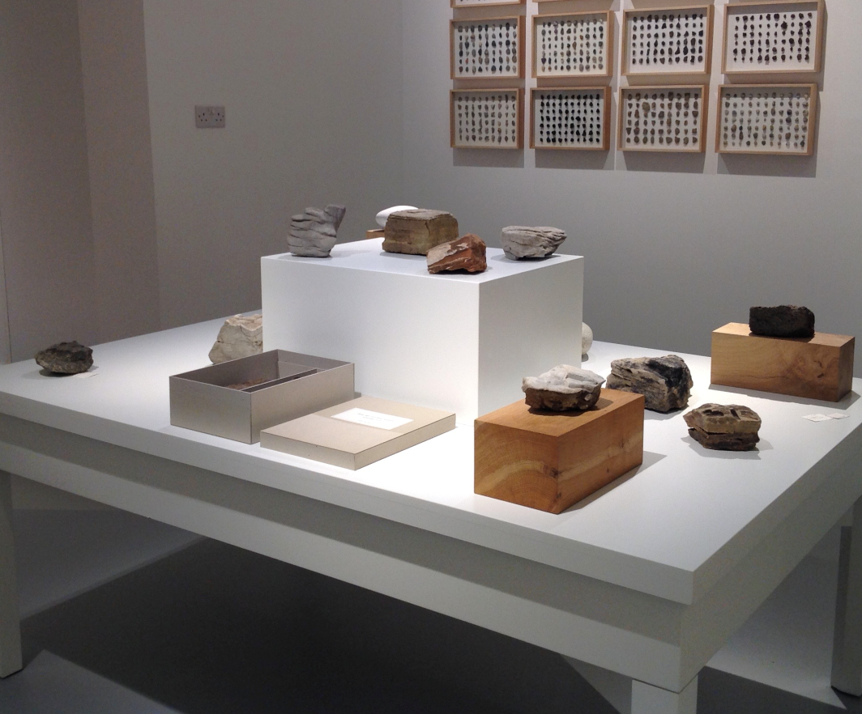

Image 6 - ‘sculptures trouvées’ by herman de vries, image courtesy of GroundWork Gallery, from the exhibition ‘on the stony path’, 2017.
What is the value of the stone now, after it has been touched by the artist’s intervention? Through his aesthetic gesture de vries employed stones as agents, that is as a vehicle to convey both beauty and value. The stones were beautiful before he placed them on a plinth, but perhaps their beauty was overlooked and not necessarily attached to value. In extractive capitalist societies minerals’ value is seen as resources, or matter from where to extract raw materials for human consumption to feed Western-like lifestyles. De vries brings together beauty, value and agency in a unifying gesture that synthesises the intrinsic value of the natural world. A similar value shift will have to happen if humanity is to change the current extractive and polluting model of relating to nature. Such value shift would allow for nature to possess value regardless of whether it is quantifiable as resources to exploit.
De vries’ work allows the viewer to approach and relate to the stone without engaging in extraction models based on financial values. The viewer is invited to relate to the stones engaging aesthetic values through connections of affective proximity. De vries’ work encourages me to engage in this relational experience in a quiet, non-invasive, non-exploitative manner and I am, like the public around me in the exhibition, moved by the beauty of the stones.

Shimmering Together
‘La naturaleza soy yo, yo soy naturaleza’ (nature is I, I am nature), repeats Spanish artist Fina Miralles throughout the video interview created as part of her retrospective at the MACBA, Barcelona, in 2018. She says this whenever she is asked about her work and her practice. Inserting oneself as part of ecosystems and protecting biodiversity from within, positions the artist-researcher politically, culturally and psychologically in both the compost of academia and the compost of life.

Following in the steps of artists like Miralles and de vries, I position my practice-based research within situated knowledges because I believe that urgent current demands for change in habits of thinking and behaviour are needed to prevent further environmental degradation and anthropogenically caused climate change. Furthermore, I believe that changes would only be possible by bringing subjectivities into the picture, as such transformations happen by means of insights, awareness and conscious decisions (Hayes, 2000).

Art practices can offer, in their complex and multi-layered fine-grained sensitivities and embodied experiences, an antidote to research as an objective practice performed by an observer looking from above at dematerialised quantifiable data. This was sharply described by Donna Haraway as the “perverse capacity to distance the knowing subject from everybody and everything in the interest of unfettered power” (Haraway 1988, p. 581).

Looking at my practice-based research as a process that places situated knowledges at its core, positions my artistic research process in a fertile terrain in which there is no need to perpetuate generalised views that impose “the God trick” (Haraway, 1988), creating instead space for a practice that can carefully attend to relations between humans, non-human animals and the environment, particularities and context. Through my art projects in rural Spain I looked at subjectivity as a loosely, individually bound process, further elaborating feminists’ ideas of subjectivity as a co-operative, trans-species effort that takes place transversely and that flows in between binaries (Braidotti, 2018). I applied these ideas by addressing issues such as desertification through the specificity of the farmers and shepherds I worked with in their un-valued knowledges and their experiences of being one with the land. As I brought the question Who? into focus through my projects, the people and the animals I worked with were named and their stories were taken into account in my works.
Bringing agency and subjectivities into the research also allows me to approach multi-discipline collaborations as a horizontal exploration of each other’s compost terrain. I am mostly driven by curiosity and wonder, and the drive to working-with methodology, echoing what would occur in an ecosystem. Professor Deborah Bird Rose explains the brilliance of the biosphere and the “bling of life” using the concept of “shimmer”, which she learnt working-with Aboriginal people in Australia (Bird Rose, 2017). This shimmering, she expands, is a process of “encounter and transformation, not absorption, in which different ways of being and doing find interesting things to do together.” (Bird Rose, 2017. p. G51). Similar to healthy ecosystems where shimmering can be perceived, healthy and balanced collaborations produce a satisfactory sense of shimmering for all involved.

In Western cultures, this shimmering can be compared to the concept of “reciprocal capture” (Bird Rose, 2017), which, according to Isabelle Stengers, is “the production of new, immanent modes of existence, in which neither entity transcends the other or forces the other to bow down” (Stengers, 2010. p. 35).

Through my art practice and research I strive to create opportunities for the transmission and cultivation of living knowledges, and to create spaces for nourishing the appetites and questions in the communities of care and communities of interest in which I am involved. As an artist I aspire to, above all, contribute to the shimmering created with those with whom I work, be they scientists, farmers, animals or land.

Transdisciplinary conversations as reflexivity in art practice
By Sarah Strachan

The Air We Breathe is an ongoing socially-engaged artwork in development since 2018. Inherently collaborative from the outset, the project engaged with families all around the world to explore first-hand experiences of air quality and intergenerational environmental justice. This paper reflects on the role of transdisciplinary collaboration between non-academics and academics in art and science; more specifically on the different dynamics of collaboration at different stages of the artistic process. Developed in the context of institutional art education, and from the perspective of emerging artistic practice, this personal narrative looks to demonstrate the potential contribution of transdisciplinary collaboration to the reflexivity of art practice as well as in its more conventional role in the research and process of art making.

Air is invisible, unknowable and undeniable but it connects us all. Thinking in terms of collaboration, it can perhaps be regarded as one of the most transdisciplinary mediums of them all. And there you have it, the first issue of collaborating between disciplines; language.

Choose your words
The word ‘medium’ means to an artist a material, to a curator a category, to a scientist a growth or transmission medium and to a child a size. But we’re all human and distinctions between disciplines are often arbitrary and worn as badges of one form or another of a knowledge classification (Salter and Hearn, 1997). Particularly in academia, disciplines are both categories of knowledge and a way of controlling or protecting categories (Bruhn, 2000).

Furthermore, the words used in working collaboratively, e.g. multi-, inter- or transdisciplinary, are used interchangeably in contemporary art practice and in the associated literature including installation art (Davies, 1997) and soundscapes (Davies, 2013), as well as many other related disciplines such as music (Tiffon, 2019), art and architecture (Coles and Defert, 1998) design and architecture (Hansen and Mullins, 2014; Celaschi, Formia and Lupo, 2013), computing and media art (Jacobsen and Søndergaard, 2010; Balcisoy and Ayiter, 2006), landscape archaeology (Kluiving and Guttmann-Bond, 2012), art and engineering (Cotantino et al., 2010) and higher education (Borrego and Newswander, 2010). There are many barriers to working across and between disciplines and a lack of clarity in meaning only adds complexity to the cause. Undeterred by the nomenclature, I just know that working beyond the boundaries of disciplines and knowledge feels intuitive and offers me the dynamic plurality of voice required in my work.

It’s not new
The concept of transdisciplinarity is not new. In 1970 Jean Piaget described it as a new space “without stable boundaries between the disciplines” (Piaget, 1972, p. 138); a space that is at once between, across and beyond all disciplines. The Air We Breathe has resulted in collaborations between disciplines (art and science), sectors (health, environment and culture) and artist as mediator between academic and non-academic stakeholders. According to Alex Coles, transdisciplinary has replaced interdisciplinary as a working method where practitioners of today appear to move, more or less, freely across the borders between disciplines (Coles, 2012). Root-Bernstein studied the value of transdisciplinary learning which led to the assertion that creative scientists and artists generally use a key set of cognitive skills that cut across disciplinary boundaries (Root-Bernstein, 1997; Mishra, Koehler and Henriksen, 2011).

A picture is worth a thousand words
Where ‘interdisciplinary arts’ use an interdisciplinary approach involving more than one artistic discipline (Augsburg, 2017), interdisciplinarity may be regarded as a practice oriented to opening more variegated opportunities for thinking and acting in ‘the world’ (Romm, 1998). As opposed to multidisciplinary, as this implies a study or practice which involves many disciplines to come to terms with some issue (Jones, 1997). Figure 1 supplies a useful illustration of these concepts, particularly in clarifying the difference between inter- and trans-disciplinary approaches. Where the inclusion of non-academic knowledge defines The Air We Breathe as a transdisciplinary artwork.

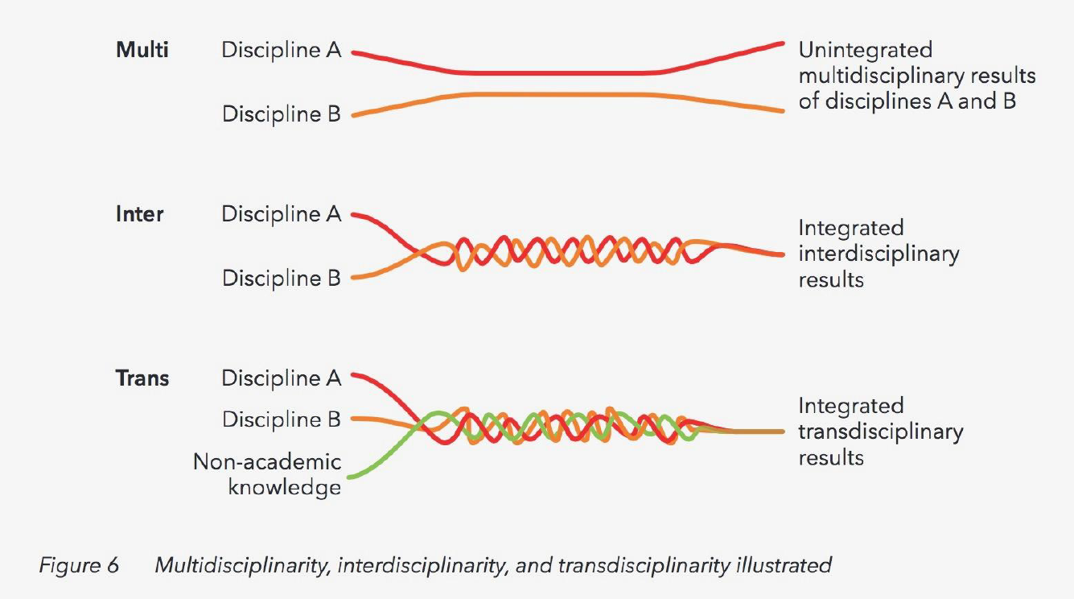
Figure 1. Multidisciplinarity, interdisciplinarity, and transdisciplinarity illustrated (Keestra and Menken, 2016).

Pictures and visualisations are the mainstay of art and science collaborations with the onus often being on the artist to illustrate or communicate complex scientific research; often referred to as the deficit model of science communication (Wynne, 1982). Yet in this project it was the scientists providing the most graphic visualisations of air as shown in Figure 2 below.
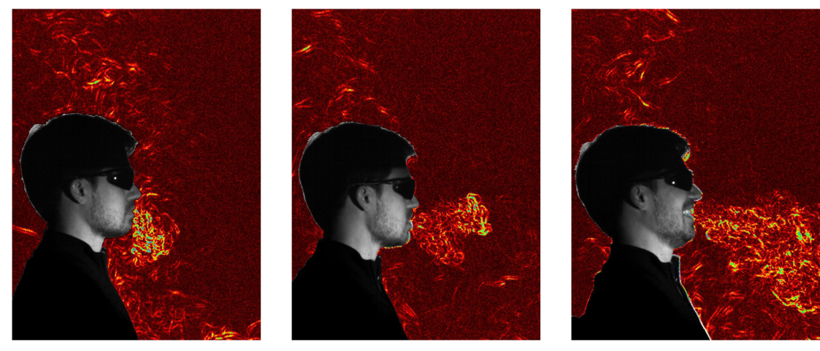
Figure 2. Differential synthetic schlieren images of the thermal plumes

Produced by a person in a quiescent environment, from left to right: the subject is sitting quietly breathing through their nose; saying ‘also’ when speaking at a conversational volume; and laughing (Bhagat et al., 2020).

The children’s responses provided insight into their perspective on air pollution - the vast majority reflecting on outdoor air quality when in fact indoor air pollution is often the most hazardous to health as shown in Figure 3 below (World Health Organisation, 2018).

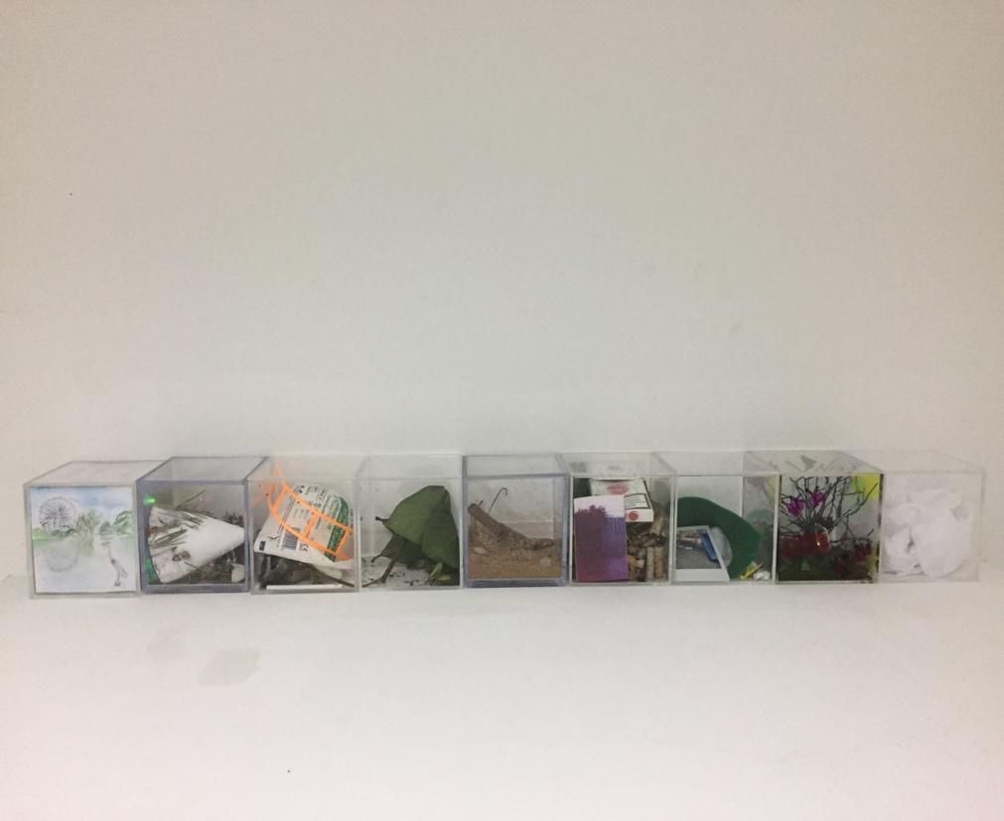
Figure 3. The Air We Breathe, 2019. Image credit: Sarah Strachan.

Beauty is in the eye of the beholder
During collaborative conversations about The Air We Breathe, the scientists seemed more pre-occupied with the output, the sculptural manifestation of the project, in contrast to the other participants and me. Was this because of the stage at which they had become engaged in the project or a sign of their disciplinary perspective on outcome over process? This was a significant point of reflection for me, not least because throughout my art education I’ve been grappling with the importance of the art object to me and the associated cognitive dissonance I experience when trying to reconcile conflicting object-driven objectives and sustaining a sustainable art practice. More recently I’ve come to understand my art practice as more processual or indeed conversational. It involves conversations with materials, land, people and place, acknowledging the environmental discourse or ‘conversational drift’ performed by the Harrisons. As artists they collaborate with leading experts in the sciences, ecology, the arts, public policy and their most important
interlocutor, the earth (Adcock, 1992). I am continuing to address issues of
sustainability through my practice as an event of art (Lafia, 2020) and exploring the object as the permanence of the event (Lomax, 2015) in the context of Hanna Hölling’s object – event – performance continuum art curation and conservation (Hölling, 2018).

Works of art need not be beautiful for us to consider them important. The Air We Breathe, as a socially engaged and collaborative work, operates more in the philosophical frame of relational aesthetics (Bourriaud, 2002) than visual aesthetics. To call something beautiful is not a critical assertion, so it’s deemed of little value to an argument that attempts to understand the morals, politics and ideals of human cultures past and present. As a philosopher might say, beauty is not a necessary condition of the art object. And yet, it is often beauty we perceive in works of art from the past or another culture that makes them compelling. When we recognise the beauty of an object made or selected by another person, we become aware of our mutual humanity through a shared ineffable aesthetic experience.

So, beauty is a connecting feature between art and science. As outlined in conversations with collaborating scientists and acknowledged in the literature, aesthetic considerations feature widely in science (Ivanova, 2021) with the idea of aesthetic appreciation and beauty perceived as an essential feature in the modern scientific process (Engler, 1990). Many scientists claim that aesthetic values guide their activities, motivate them to study nature, and even shape their attitude regarding the truth of a theory. Some scientists also regard the product of their intellectual activities, whether scientific theories, models, or mathematical proofs, as works of art (Ivanova, 2021).

While it is doubtful that any link between beauty and truth can be justified, or even that aesthetic values are indicative of empirical success, it is interesting why we value beautiful explanations and actively search for symmetry, simplicity, and unity in nature and in our representations of the world. Perhaps this illustrates the distinctions between aesthetic value and utility value (Leach, 2011). Reaching a mutual understanding of beauty and aesthetic was a key in our conversations about The Air We Breathe.

Beyond research
Much of the literature focuses on the value of interdisciplinary or transdisciplinary collaboration between art and science as a means of opening up the research to the public, enhancing research outcomes and/or producing more effective science communications. There is certainly a general trend towards interdisciplinarity in research and funding opportunities, but there seems to be a lack of evidence in art and science collaborations of the broader process-based opportunities for all stakeholders.

Research is usually regarded a scientific rather than artistic exploration. However, interdisciplinary research is often an integral part of my practice. In the context of art and science collaboration it is important to differentiate between creativity research as a means of explaining creativity (Sawyer, 2012) and creative research as being the connection between research and artmaking which, to an extent, requires an interpretation of the stages of the creative process. Graham Wallas defines the stages or phases of the creative process as preparation, incubation, illumination and verification, where preparation could be defined to include research (Wallas, 1926). Whereas Mace and Ward describe the complexity and fluidity of the artistic creative process as: conception, idea development, making the art, and completion, (Mace and Ward, 2002; Eubanks, 2012).

the process by which artists generate their work supplies one of the many models available to drive the work’s interpretation. In this sense, the transdisciplinary as an operative model for the artist becomes a theoretical praxis for the critic (Birnbaum and Graw, 2008). The resulting relationship between the critic and its subject is reconfigured and the parameters of critique – long delimiting the activity of the writer – are revised (Foster, 2003; Latour, 2004).

There were two outcomes for me from the art and science conversations; a recognition for art making as research (Sullivan, 2010), but also the potential of transdisciplinary discussion to provide feedback and reflection on the process of art making as much as the outcome. This looking back and reflecting upon the ways in which we engage in processes of knowledge construction is the key to operating a reflexive orientation to/in ‘the world’. I think the discussions around The Air We Breathe allowed me to account for the way my own personhood impacts on the way I conduct my creative practice. If external interdisciplinary perspectives contribute to reflexive inquiry in research practice (Denzin and Lincoln, 1994; Weil, 1996; Romm, 1998), then my own internal interdisciplinary perspectives will also impact my approach. As acknowledged by Jean Claude Rissett: “I think that interdisciplinary never works as good as when it is embodied in the same person...” (Tiffon, 2019, p. 664).

A new object and new language
The next steps for The Air We Breathe are still very much in the incubation (Wallas, 1926) or idea development (Mace and Ward, 2002) phase, but I think I will be embracing more of the interdisciplinary individual within me as an artist and engaging more with my background in health and communications as a means of engagement and inquiry “when the solidarity of the old disciplines breaks down...in the interests of a new object and a new language neither of which has a place in the field of sciences that were to be brought peacefully together” (Barthes and Heath, 1977, p. 155).

A new interdisciplinary hybrid: exploring the intersections and synergies between environment health and art? Acknowledging a trend toward the cultural convergence of art, science and technology (Wilson, 2002) do these boundaries exist only in our minds (Hartmann, 1991)? Reviewing the literature and my experience of institutional art education suggests there is still a long way to go in the transition to these sorts of transdisciplinary or beyond-disciplinary approaches to creative practice, creative research and research creativity.

References
Adcock, C. (1992). Conversational Drif. Art Journal. [e-journal] 51(2), 35-45. Available at: https://doi.org/10.1080/00043249.1992.10791564 [Accessed October 2019].
Anderson, E. S. (2005). Feminist Epistemology: An Interpretation and a Defense. Massachusetts: Blackwell Publishing.
Augsburg, T. (2017). Interdisciplinary arts. In: R. Frodeman, ed. 2017. The Oxford Handbook of Interdisciplinarity, 131-143. Oxford: Oxford University Press.
Balcisoy S., Ayiter E. (2006). Trans-disciplinary avenues in education: Computing and art. In: Pan Z., Aylett R., Diener H., Jin X., Göbel S., Li L. (eds) Technologies for E-Learning and Digital Entertainment. Edutainment 2006. Lecture Notes in Computer Science, 3942. Berlin, Heidelberg: Springer. pp. 80-89.
Barthes, R. and Heath, S. (1977). Image Music Text. London: Collins Fontana.
Bhagat, R.K., Davies Wykes, M.S., Dalziel, S. B. and Linden, P. F. (2020). Effects of ventilation on the indoor spread of COVID-19. Journal of Fluid Mechanics. Cambridge University Press, 903, F1.
Bird Rose, D. (2017). Shimmer: When All Your Love is Being Trashed, London: University of Minnesota Press.
Bird Rose, D. (2011). Wild Dog Dreaming: Love and Extinction, Charlottesville: University of Virginia Press.
Birnbaum, D. and Graw, I. (2008). Canvases and Careers Today: Criticism and Its Markets. London: Sternberg.
Borrego, M. and Newswander, L.K. (2010). Definitions of interdisciplinary research: Toward graduate-level interdisciplinary learning outcomes. The Review of Higher Education, 34(1), 61-84.
Bourriaud, N. (2002). Relational Aesthetics. Dijon: Presses du Reel.
Braidotti, R. & Regan, L. (2017). Our times are always out of Joint: Feminist relational ethics in and of the world today: An Interview with Rosi Braidotti. Women: A Cultural Review. Vol 28(3), 171-192
Braidotti, R. (2002). Metamorphoses: Towards a Materialist Theory of Becoming. Cambridge: Polity Press.
Braidotti, R. (2011). Nomadic Theory, New York: Columbia University Press
Braidotti, R. (2014). This Deleuzian Century. Leiden: Brill.
Braidotti, R. (2018). A Theoretical Framework for the Critical Posthumanities. Utrecht: Utrecht University Press
Bruhn, J.G. (2000). Interdisciplinary research: A philosophy, art form, artifact or antidote? Integrative Psychological and Behavioral Science, 35(1), 58-66.
Burgin, V. (1969). Situational aesthetics. Studio International, Vol 178(915), 118-121.
Celaschi, F., Formia, E. and Lupo, E. (2013). From trans-disciplinary to undisciplined design learning: educating through/to disruption. Strategic Design Research Journal, 6(1), 1-10.
Coles, A. and Defert, A. (1998). The Anxiety of Interdisciplinarity. London: BACKless Books/Black Dog Publishing.
Coles, A. (2012). The Transdisciplinary Studio. Berlin: Sternberg.
Cotantino, T., Kellam, N., Cramond, B. and Crowder, I. (2010). An interdisciplinary design studio: How can art and engineering collaborate to increase students’ creativity? Art Education, 63(2), 49-53.
Davies, H.M. (1997). Blurring the Boundaries: Installation Art 1969-1996. San Diego. Museum of Contemporary Art.
Davies, W.J., Adams, M.D., Bruce, N.S., Cain, R., Carlyle, A., Cusack, P., Hall, D.A., Hume, K.I., Irwin, A. and Jennings, P. (2013). Perception of soundscapes: An interdisciplinary approach. Applied Acoustics, 74(2), 224-231.
De vries, h. An Interview. Available at: https://www.youtube.com/watch?v=MRfl1-J_8Cw [Accessed July 2021].
De vries, h. Video Interviews. Available at: https://www.hermandevries.org/video-audio.php [Accessed October 2019].
De vries, h. (2015). To Be Always To Be. Available at: https://vimeo.com/131465629 [Accessed July 2021].
Denes, A. (1982). Wheatfield-A Confrontation. Available at: http://www.agnesdenesstudio.com/works7.html [Accessed July 2021]
Denzin, N.K., and Lincoln, Y. S. (1994). Handbook of Qualitative Research. Thousand Oaks: Sage Publishing.
Despret, V., Stengers, I. (2014). Women Who Make a Fuss: The Unfaithful Daughters of Virginia Woolf. Minneapolis: Univocal.
Engler, G. (1990). Aesthetics in science and in art. The British Journal of Aesthetics, 30(1), 24-34.
Eriksen, T. (2001). Small Places, Large Issues. London: Pluto Press.
Eubanks, P. (2012). Interdisciplinary study: Research as part of artmaking. Art Education, 65(2), 48-53.
Fina Miralles at MACBA (2021), Fons de Documentació Audiovisual, Museu D’art Contemporani de Barcelona. Available at: https://www.youtube.com/watch?v=L9AQmx2Bth8 [Accessed July 2021]
Foster, H. (2003). Design and Crime: And Other Diatribes. New York: Verso.
Fricker, M. (2009). Epistemic Injustice: Power and the Ethics of Knowing. Oxford: Oxford University Press.
Hansen, E.K. and Mullins, M., eds (2014). Designing with knowledge through trans-disciplinary experiments. In: Jensen, L. B., & Thompson, M. K. (eds) (2014). Proceedings of the 3rd International Workshop on Design in Civil and Environmental Engineering. Copenhagen: Technical University of Denmark. pp. 76-82.
Haraway, D. (1988). Situated knowledges: The science question in feminism and the privilege of partial perspective. Feminist Studies Vol 14(3), 575-599.
Haraway, D. (1991). A Cyborg Manifesto: Science, Technology, and Socialist-Feminism in the Late Twentieth Century. New York: Routledge.
Haraway, D. (1994). A game of cat's cradle: Science studies, feminist theory, cultural studies. Configurations 2(1), 59-71.
Haraway, D. (2015). Anthroposcene, capitaloscene, plantationoscene, chthuluscene: Making kin. Environmental Humanities 6(1), 159–165.
Haraway, D. (2016). Staying with the Trouble: Making Kin in the Chthulucene. Durham: Duke University Press.
Hartmann, E. (1991). Boundaries in the Mind: A New Psychology of Personality. New York: Basic Books.
Hayes, N. (2000). Foundations of Psychology. London: Thomson
Hölling, H.B. (2016). The aesthetics of change: On the relative durations of the impermanent. In: Hermens, E. and Robertson, F. (eds), Authenticity in Transition, London: Archetype Publications. pp. 13-24.
Hölling, H.B. (2018). Object, Event, Performance: Rethinking Materiality in Fluxus Intermedia. New York: Bard Graduate Center.
Ivanova, M. (2021). Spotlight: Aesthetics in Science. [on-line] Available at: http://www.thebsps.org/auxhyp/aesthetics-in-science/#:~:text=Many%20scientists%20claim%20that%20aesthetic,proofs%2C%20as%20works%20of%20art. [Accessed May 2021].
Jacobsen, M. and Søndergaard, M. (2010). Mapping the domains of media art practice: A trans-disciplinary enquiry into collaborative creative processes. Technoetic Arts, 8(1), 77-84.
Jones, M. (1997). It all depends what you mean by discipline. In: Mingers, J., and Stowell, F. A. (eds), Information Systems: An Emerging Discipline? London, UK: McGraw-Hill. pp. 97-112.
Keestra, M. and Menken, S., (eds) (2016). An Introduction to Interdisciplinary Research: Theory and Practice. Amsterdam: Amsterdam University Press.
Kluiving, S.J. and Guttmann-Bond, E. (2012). Landscape Archaeology Between Art and Science: From a Multi- to an Interdisciplinary Approach. Amsterdam: Amsterdam University Press.
Lack, J. and Wilson, S. (2008). Tate Guide to Modern Art Terms. London: Tate Publishing.
Lafia, M. (2020). The Event of Art. Earth, Milky Way: Punctum Books.
Latour, B. (2004). Why has critique run out of steam? From matters of fact to matters of concern. Critical inquiry, 30(2), 225-248.
Latour, B. (2016). Reset Modernity. Karlsruhe: ZKM
Latour, B. and Weibel, P. (2020). Critical Zones. London: MIT Press
Leach, J. (2011). The self of the scientist, material for the artist: Emergent distinctions in an interdisciplinary collaboration. Social Analysis, 55(3), 143-163.
Lomax, Y. (2015). Sounding the Event: Escapades in Dialogue with Matters of Art, Nature and Time. London: IB Tauris.
Mace, M. and Ward, T. (2002). Modelling the creative process: A grounded theory analysis of creativity in the domain of art making. Creativity Research Journal, 14(2), 179-192.
Mishra, P., Koehler, M.J. and Henriksen, D. (2011). The seven trans-disciplinary habits of mind: Extending the TPACK framework towards 21st century learning. Educational Technology, 51(2), 22-28.
Piaget, J. (1972). The epistemology of interdisciplinary relationships. In: Apostel, L., Berger, G., Briggs, A. and Michaud, G. (eds), Interdisciplinarity: Problems of Teaching and Research in Universities, Paris, OECD. pp. 127-139.
Romm, N.R. (1998). Interdisciplinary practice as reflexivity. Systemic Practice and Action Research, 11(1), 63-77.
Root-Bernstein, R.S. (1997). The sciences and arts share a common creative aesthetic. In: Tauber, A.I, (ed), The Elusive Synthesis: Aesthetics and Science. Dordrecht: Springer Netherlands. 49-82.
Salter, L. and Hearn, A. (1997). Outside the Lines. Montreal, CA: McGill-Queen's University Press.
Sawyer, R.K. (2012). Explaining creativity. New York: Oxford University Press.
Stengers, I. (2010). Cosmopolitics I. Minneapolis: University of Minnesota Press
Sullivan, G. (2010). Art Practice as Research: Inquiry in Visual Arts. London: SAGE.
Tiffon, V. (2019). Jean-Claude Risset and his interdisciplinary practice: What do (or could) the archives tell us? Proceedings of the 14th International Symposium on CMMR. Available at: https://hal.archives-ouvertes.fr/hal-02371266/document [Accessed May 2021].
Wallas, G. (1926). The Art of Thought. New York: Harcourt, Brace and Co.
Weil, S. (1996). From the other side of silence: new possibilities for dialogue in academic writing. Changes , 14(3), 223-231.
Wilson, S. (2002). Information Arts: Intersections of Art, Science, and Technology. Cambridge, MA: MIT press.
World Health Organisation. (2018). Household Air Pollution and Health. Available at: https://www.who.int/news-room/fact-sheets/detail/household-air-pollution-and-health [Accessed May 2021].
Wynne, B. (1982). Rationality and Ritual: The Windscale Inquiry and Nuclear Decisions in Britain. Chalfont St Giles, Bucks: The British Society for the History of Science.

Statement of disclosure
All materials included in the article represent the authors’ own work and anything cited or paraphrased within the text is included in the reference list.
The work has not been previously published nor is it is being considered for publication elsewhere. There are no conflicts of interest that have influenced the authors in reporting their findings completely and honestly.

Dutch artist herman de vries takes an artistic and personal stand on capitalisation of any name, including his own and titles of his works. His position in relation to this is horizontality and equality, highlighting that hierarchies of any type are imposed and that he does not agree with them. The lack of capitalisation of his name is thus not a grammatical mistake but a gesture from one artist (me) to another (him) to honour and respect his position.
See https://www.youtube.com/watch?v=IBi4d4H0z1c.
See https://www.marinavelez.com/water-nexus, https://www.marinavelez.com/zahori and https://www.marinavelez.com/50095.
See https://www.sarah-strachan.co.uk/single-post/the-air-we-breathe for further details.
‘Conversational drift’ is a term used by artists Helen Mayer Harrison and Newton Harrison to reflect on a process of conversational interchange (Adcock, 1992).
The object – event- performance continuum is a proposed theory of the spatio-temporal continuity of objects (Hölling 2016; Hölling 2018).

